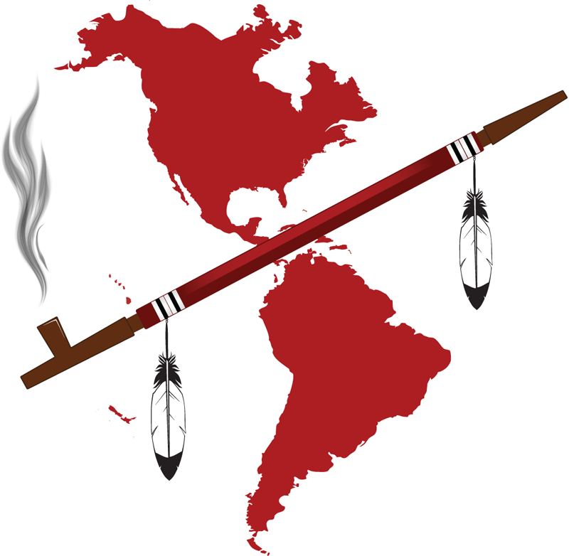
2940 16th Street, Suite 305,
San Francisco, CA 94103-3664
Telephone: (415) 641-4482
Fax: (415) 641-1298
email to: iitc@treatycouncil.org, andrea@treatycouncil.org
International Indian Treaty Council

Submission to the United Nations Expert Mechanism on the Rights of Indigenous Peoples Study on access to justice in the promotion and protection of the rights of Indigenous Peoples by the International Indian Treaty Council, Non-Governmental Organization with General Consultative Status with the United Nations Economic and Social Council, February 11th, 2013

Presented at the Expert Seminar on Access to Justice for Indigenous Peoples including Truth and Reconciliation Processes, Columbia University, New York, 27 February - 1 March 2013 under Agenda Item 10: Indigenous Peoples’ Right to Self-Determination and Other Rights related to Access to Justice: the Normative Framework, February 28th, 2013, by Andrea Carmen

The Normative Framework provided by the United Nations Declaration on the Rights of Indigenous Peoples for Access to Justice, Redress, Restitution and Non-recurrence regarding violations of rights affirmed in Treaties between Indigenous Nations and States

The UN Declaration on the Rights of Indigenous Peoples provides an essential normative framework for the development and implementation of bi-lateral mechanisms for Access to Justice, conflict resolution and redress of Treaty violations with the full and equal participation of both the State and Indigenous Nation Treaty partners. The Declaration also affirms core aspects reflecting the original spirit and intent of Treaties as understood by Indigenous Peoples as sacred agreements entered into by equal partners based on principles of respect, mutual responsibility and free prior and informed consent.

In-depth analysis of the far reaching impacts and applications of this normative framework was presented in two expert submissions to the 3rd United Nations Seminar on Treaties, Agreements and Other Constructive Arrangements between States and Indigenous Peoples, July 16 – 17 2012, in Geneva Switzerland. They are listed below, with links to the webpage of the UN High Commissioner on Human Rights where they are posted also provided:

- “Treaties and Original Spirit and Intent: An Historic Overview, A new Framework and Recent Advances for Conflict Resolution, Redress of Violations and Restoration of Just and Respectful Relations”, by Chief Wilton Littlechild, International Chief for Treaties 6, 7 and 8 and member of the UN Expert Mechanism for the Rights of Indigenous Peoples, and Andrea Carmen, Executive Director, International Indian Treaty Council, [HR/GENEVA/ /SEM/NGOs/2012/BP.15] http://www.ohchr.org/Documents/Issues/IPeoples/Seminars/Treaties/BP15.pdf
- “A Framework for Conflict Resolution, Reparations, Restitution and Redress of Treaty
Violations based on the United Nations Declaration on the Rights of Indigenous Peoples
and Free Prior and Informed Consent” by the International Indian Treaty Council, [HR/GENEVA/ /SEM/NGOs/2012/BP.5], http://www.ohchr.org/Documents/Issues/IPeoples/Seminars/Treaties/BP5.pdf

The IITC requests that these submissions which are directly relevant to the issues under direction in this Seminar and the EMRIP Study on to Access to Justice be considered as resource and reference texts for consideration in the development of the EMRIP Study. Both submissions highlight specific articles of the UN Declaration on the Rights of Indigenous Peoples which form a new rights-based framework for redress, restitution and access to Justice as follows:

Article 27: States shall establish and implement, in conjunction with indigenous peoples concerned, a fair, independent, impartial, open and transparent process, giving due recognition to indigenous peoples’ laws, traditions, customs and land tenure systems, to recognize and adjudicate the rights of indigenous peoples pertaining to their lands, territories and resources, including those which were traditionally owned or otherwise occupied or used. Indigenous peoples shall have the right to participate in this process. The process be fair independent, impartial, open and transparent, be established and implemented in conjunction with the indigenous peoples concerned and give due recognition to indigenous peoples’ laws, traditions, customs and land tenure systems

Article 28: 1. Indigenous peoples have the right to redress, by means that can include restitution or, when this is not possible, just, fair and equitable compensation, for the lands, territories and resources which they have traditionally owned or otherwise occupied or used, and which have been confiscated, taken, occupied, used or damaged without their free, prior and informed consent. 2. Unless otherwise freely agreed upon by the peoples concerned, compensation shall take the form of lands, territories and resources

Article 40: Indigenous peoples have the right to access to and prompt decisions through just and fair procedures for the resolution of conflicts and disputes with States or other parties, as well as to effective remedies for all infringements of their individual and collective rights. Such a decision shall give due consideration to the customs, traditions, rules and legal systems of the indigenous peoples concerned and international human rights.

Together with Article 3 (Right to Self Determination); Treaties Agreements and Constructive Arrangements (Article 37); Right to Participate in Decision Making (Article 18) and various articles affirming Free Prior and Informed Consent, these provisions in the UN Declaration provide a principled, rights-based but as yet unimplemented normative framework for access to Justice based on the internationally recognized minimum standard for such processes.

It is important for the EMRIP Study to include examples in which the UN Declaration has been affirmed as a guideline for the interpretation and implementation of relevant international standards to which States are legally obligated, in particular the International Convention for the Elimination of all Forms of Racial Discrimination (ICERD). The role of the Declaration in this regard was specifically affirmed in 2008 in the recommendations of the Committee on the Elimination of Racial Discrimination (“CERD”, the Treaty Monitoring Body for the ICERD) to the United States, as follows:

“While noting the position of the State party with regard to the United Nations Declaration on the Rights of Indigenous Peoples (A/RES/61/295), the Committee finally recommends that the declaration be used as a guide to interpret the State party’s obligations under the Convention relating to indigenous peoples.”

In another historic step in advancing Access to Justice using the UN Declaration as the “minimum standard”, on April 20, 2012, States attending the 14th session of negotiations for the proposed American Declaration on the Rights of Indigenous Peoples in Washington DC adopted by consensus Article XXIII on Treaties, Agreements and other constructive arrangements. It states in paragraph 1:

“Indigenous peoples have the right to the recognition, observance, and enforcement of the treaties, agreements and other constructive arrangements concluded with states and their successors in accordance with their true spirit and intent, in good faith, and to have the same be respected and honored by the States. States shall give due consideration to the understanding of the Indigenous Peoples in regards to treaties, agreements and other constructive arrangements. When disputes cannot be resolved between the parties in relation to such treaties, agreements and other constructive arrangements, these shall be submitted to competent bodies, including regional and international bodies, by the States or indigenous peoples concerned.”

Other important advances have taken place to support the establishment of international mechanisms for redress and restitution, notably the new UN Special Rapporteur on the promotion of truth, justice, reparation and guarantees of non-recurrence established by the UN Human Rights Council’s 18th session in September 2011. This mechanism can also make important contributions utilizing the UN Declaration on the Rights of Indigenous Peoples as a normative framework as well as the final recommendations in the EMRIP Study on Access to Justice, in particular pertaining to redress, reparations and non-recurrence regarding violations of the Treaties between Indigenous Peoples and States as they are understood and interpreted by the Indigenous Peoples.

In conclusion, we respectfully submit the following recommendations:
- That the EMRIP Study recognize, support and affirm the OAS Declaration Text Article XXIII, relevant CERD recommendations and other advances in the international arena affirming the rights in Treaties as understood and interpreted by Indigenous Peoples and advancing redress and access to justice in this regard.
- That the EMRIP Study recommend that States and UN system implement bi-lateral, fully participatory processes for redress and restitution of rights affirmed in Treaties, respecting their original spirit and intent as understood and interpreted by the Indigenous Peoples and utilizing the normative framework provided by the UN Declaration on the Rights of Peoples.
- That the ERMIP Study recommend that the development of such effective, participatory international processes to resolve conflicts and redress violations related to Treaties and Agreements be included as focus for the 2014 World Conference on Indigenous Peoples.

Cheoque Utesia, Thank you very much.

Committee on the Elimination of Racial Discrimination Seventy-second session Geneva, 18 February - 7 March 2008, Concluding observations, United States of America, UN Doc. CERD/C/USA/CO/6, 8 May 2008, para. 29.

