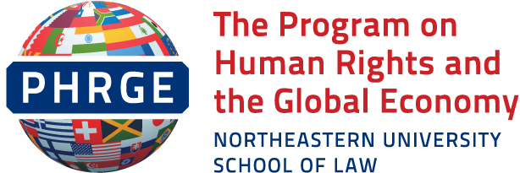
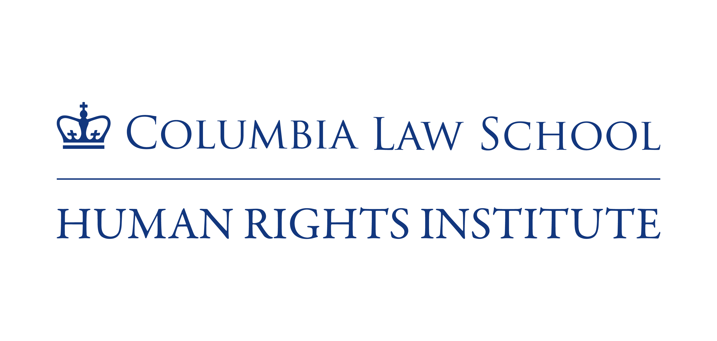

Submission of the Program on Human Rights and the Global Economy of Northeastern University School of Law and the Columbia Human Rights Institute to the Office of the High Commissioner for Human Rights Concerning Local Government and Human Rights Implementation

We are pleased to respond to the OHCHR’s call for input regarding local government and human rights. Both of our academic programs have extensive experience working with local governments, local advocates, and others in the United States seeking to achieve realization of human rights at the local level. In this submission, we draw on those experiences to: (1) describe several initiatives promoting human rights at the municipal level, including Cities for CEDAW and Human Rights Cities; (2) provide information regarding the challenges for state and local engagement with human rights monitoring and reporting; and (3) offer recommendations for specific reforms arising from our experiences as advocates and scholars.
Cities Taking the Initiative: Cities for CEDAW and Human Rights Cities
Cities have a critical role to play in realizing human rights in the United States. Under the constraints of the United States’ federal system, much of the actual implementation of human rights norms takes place at the local level, under the leadership of local government; this is particularly true of economic and social rights. Thus, United States’ compliance with its international human rights obligations requires effective coordination between federal, state, and local governments, including governors, states attorneys general, mayors, state legislators, city council members, law enforcement, city, county and town executives, and boards of supervisors (collectively, “state and local governments” or “subnational governments”).
Many urban actors, both inside and outside of local government, are actively engaged in promoting local human rights implementation and realization. For example, one important locally-focused initiative is Cities for CEDAW, which attempts to use local laws to fill the normative void in domestic law created by the U.S. failure to ratify CEDAW. While CEDAW would require pro-active attention to structural and systemic barriers to equality, much of U.S. anti-discrimination law focuses on providing redress for individual acts of discrimination. Cities for CEDAW was launched in 2013, with the NGO Committee on the Status of Women, the Women’s Intercultural Network, and the San Francisco Department on the Status of Women as founding partners.
As described on its website, Cities for CEDAW “provides tools and leadership to empower local women’s, civil and human rights organizations and municipalities to effectively initiate CEDAW within their city, county, town, or state.” It is a loosely affiliated group of activists and some local government officials advocating to bring a rights-based gender lens to local governance in order to advance gender equity. One of the aims of Cities for CEDAW members is to secure local CEDAW ordinances. These typically have three components, growing out of the first CEDAW-based law passed in San Francisco in 1998: (1) a gender analysis of city departments and operations; (2) an oversight body to monitor the implementation of a local CEDAW ordinance; and (3) funding to support the implementation of the principles of CEDAW, though the laws in some jurisdictions have been changed to reflect the local context. More detailed information on the Cities for CEDAW and the nine jurisdictions with CEDAW laws is set out in the Institute’s publication Gender Equity through a Human Rights Lens: Local Efforts to Advance the Status of Women and Girls in the United States.
When it was initially launched, the Cities for CEDAW campaign announced an ambitious goal of enlisting 100 Cities for CEDAW in just a few months. The reality has been much slower. In many communities, there remains a lack of awareness of human rights norms and mechanisms. Thus, proposed CEDAW legislation attracts opposition from those who oppose local engagement with human rights, as well as those concerned about the modest spending necessary to make a CEDAW ordinance effective. Still, Cities for CEDAW has taken root in a number of cities in the U.S., from Pittsburgh to Los Angeles, where cities have enacted ordinances that require affirmative efforts by local government to address gender inequities. In addition to the nine laws that have passed, at least 30 cities and counties have made aspirational commitments to CEDAW. Cities where advocates are actively engaged in passing laws based on CEDAW include Buffalo and Denver, and Cities for CEDAW has been endorsed by the US Conference of Mayors and the International Association of Official Human Rights Agencies. Yet, the advocacy and awareness-raising needed at the local level is a slow process. There is no federal support or guidance for these initiatives, which require sustainable funding to support ongoing monitoring mechanisms.
Beyond Cities for CEDAW, a number of U.S. communities have endorsed the proposition that violence against women is a human rights violation, pledging to take steps to address the issue consistent with international human rights requirements. Further, some U.S. cities are taking a broader view, looking to embrace the full range of human rights obligations at the local level. Many of these cities have officially identified themselves as Human Rights Cities, with varying degrees of human rights engagement. Self-proclaimed Human Rights Cities include Boston, Washington, D.C., and Santa Clara, California. Eugene, Oregon, identifies itself as an “aspiring” human rights city. And even cities that have not embraced the Human Rights City label may be active in addressing climate change and achieving benchmarks consistent with the Sustainable Development Goals. These communities recognize the impacts of local policies on human rights. In the absence of national leadership, these and other cities are making efforts to work directly with the international community on these issues. Existing efforts by cities are encouraging examples of local human rights monitoring, but they remain ad hoc and subject to political will.
State and Local Engagement with Human Rights Reporting
Even as local governments become more actively engaged with human rights norms and human rights implementation, their efforts to recognize and realize human rights may be frustrated by lack of coordination, information-sharing and limited resources. Within the U.S., there is no coordinated approach to human rights promotion and protection that crosses the boundaries of federal, state, and local jurisdictions. In contrast to other countries around the world, the U.S:
* Lacks an institutionalized federal infrastructure or dedicated agency to support human rights education, monitoring or implementation, or provide guidance on human rights and translate international standards into domestic practice.
* Lacks a national human rights institution or federal focal points to gather information on human rights compliance or disseminate and follow up with state and local actors regarding recommendations from UN treaty bodies, the UPR, or UN Special Procedures.
Unfortunately, promising practices developed under prior administrations to engage subnational governments in UN human rights activities such as the UPR or treaty reviews appear to have completely stopped under the current administration, which has failed to report to treaty bodies to date. During President Obama’s administration, local government representatives such as mayors or state attorneys general were included as members of U.S. delegations to UN periodic reviews; a practice appears to have ended under the current administrations. Likewise, prior efforts to collect local government information on human rights implementation and compliance as part of the U.S.’s country monitoring reports – a promising practice adopted in response to UN urging -- appears to have completely ceased under the current administration.
At the same time that local governments face lack of coordination at the national level, the international human rights governance and monitoring system is also largely closed to the local governments that are implementing human rights “close to home.” Since there are few mechanisms for local government reporting and monitoring, local governments engaged in human rights work – including Cities with CEDAW, Human Rights Cities, and cities addressing climate change and other human rights issues -- have forged creative pathways to connect with the international community to support and critique their efforts. San Francisco, for instance, has reported on its gender equity work to the UN Commission on the Status of Women, even though the Commission has no formal oversight role over a city initiative; San Francisco also participated in the 2014 Human Rights Committee Review of the United States. Other cities, such as New York City and Berkeley, have filed ad hoc reports with UN bodies in an effort to participate in dialogue with those engaged in human rights implementation internationally. Associations of state and local governments, such as the International Association of Official Human Rights Agencies, which represents statutory civil and human rights and human relations agencies, have also participated in treaty compliance reviews and the UPR, submitting shadow reports, and sending representatives to Geneva. These opportunities, are however, infrequent and resource intensive.
Over the past decade, one important and effective way in which local governments and their constituents have benefited from international engagement is through the Special Procedures. As the “eyes and ears” of the UN, Special Rapporteurs and Working Groups visiting the U.S. often spend significant time in cities, sometimes interacting with city governments to address pending human rights issues. In the past, Special Rapporteurs sometimes engaged directly with local governments. For example, in 2011, the UN Special Rapporteur on the Right to Water and Sanitation communicated directly with the city of Sacramento regarding its failure to provide for homeless individuals’ sanitation needs. In 2009, the Special Rapporteur on Adequate Housing met with officials from Illinois, hosted by the State Department on Human Rights, providing a platform to identify how human rights standards can be applied locally. Such local dialogues can be extremely productive in encouraging local officials and communities to achieve greater realization of human rights.

Conclusions and Recommendations
Based on these observations of municipal efforts to engage with human rights, we offer the following recommendations:
- National coordination is critical. The current situation in the U.S., where the national government has largely halted any engagement with domestic human rights implementation, underscores the importance of independent federal mechanisms, including a National Human Rights Institution, to serve an education, information-sharing and coordination function. Such mechanisms are key to ensure that the many local government entities in the U.S. can learn from, and support, each other in efforts to realize human rights.
- In addition to greater federal coordination, UN engagement (including by treaty bodies and OHCHR) with cities must increase, and mechanisms must be developed that are tailored to that purpose. Many cities are interested in promoting human rights norms in local contexts, but they lack adequate guidance from UN bodies on how to play a meaningful role in the international human rights system.
- Subnational governments have a particularly critical part to play in domestic implementation of economic, social and cultural rights, since they have a leading role in developing policies on housing, water, and other such critical rights. Implementation guidance from the UN tailored to local governments is of special importance in these substantive areas. Likewise, the UN should consider developing new monitoring mechanisms that are specially tailored to supporting local implementation.
Respectfully submitted,
Martha F. Davis
Program on Human Rights and the Global Economy
Northeastern University School of Law
416 Huntington Avenue
Boston, MA 02115
m.davis@northeastern.edu

JoAnn Kamuf Ward
Columbia Human Rights Institute
435 West 116th Street
NY, NY 10027
jward@law.columbia.edu

The Program on Human Rights and the Global Economy of Northeastern University School of Law supports cutting edge human rights scholarship and movement-building and works with students to ensure that human rights perspectives will continue to be vital to future generations of scholars and advocates. PHRGE has a specific programmatic focus on local human rights, including supporting human rights cities. More information is available at https://www.northeastern.edu/law/academics/institutes/phrge/about/index.html The Human Rights Institute at Columbia Law School advances international human rights through education, advocacy, fact-finding, research, scholarship, and critical reflection. We work in partnership with advocates, communities, and organizations pushing for social change to develop and strengthen the human rights legal framework and mechanisms, promote justice and accountability for human rights violations, and build and amplify collective power in the United States and throughout the world. We have a US project that focuses on building the capacity of state and local agencies and officials to understand and use global human rights norms to foster racial and gender equity. See https://www.law.columbia.edu/human-rights-institute.
More information is available at http://citiesforcedaw.org/background/.
http://citiesforcedaw.org/background/
https://www.law.columbia.edu/sites/default/files/microsites/human-rights-institute/gender_equity_through_human_rights.pdf
A regularly updated list of these resolutions is available at https://www.lawschool.cornell.edu/Clinical-Programs/global-gender-justice/DV-Resolutions.cfm.
See Kenneth Neubeck, In the State of Becoming a Human Rights City: The Case of Eugene, Oregon, in Martha Davis, et al., Human Rights Cities and Regions: Swedish and International Perspectives (2017), available at https://rwi.lu.se/app/uploads/2017/03/Human-Rights-Cities-web.pdf.
See Columbia Law School Human Rights Institute & IAOHRA, Closing the Gap: The Federal Role in Respecting & Ensuring Human Rights at the State and Local Level: Response to the Fourth Periodic Report of the United States to the United Nations Human Rights Committee (2013), at https://web.law.columbia.edu/sites/default/files/microsites/human-rights-institute/files/State%20and%20Local%20Shadow%20Report%20(ecopy).pdf
The US CERD report was due in 2017.

