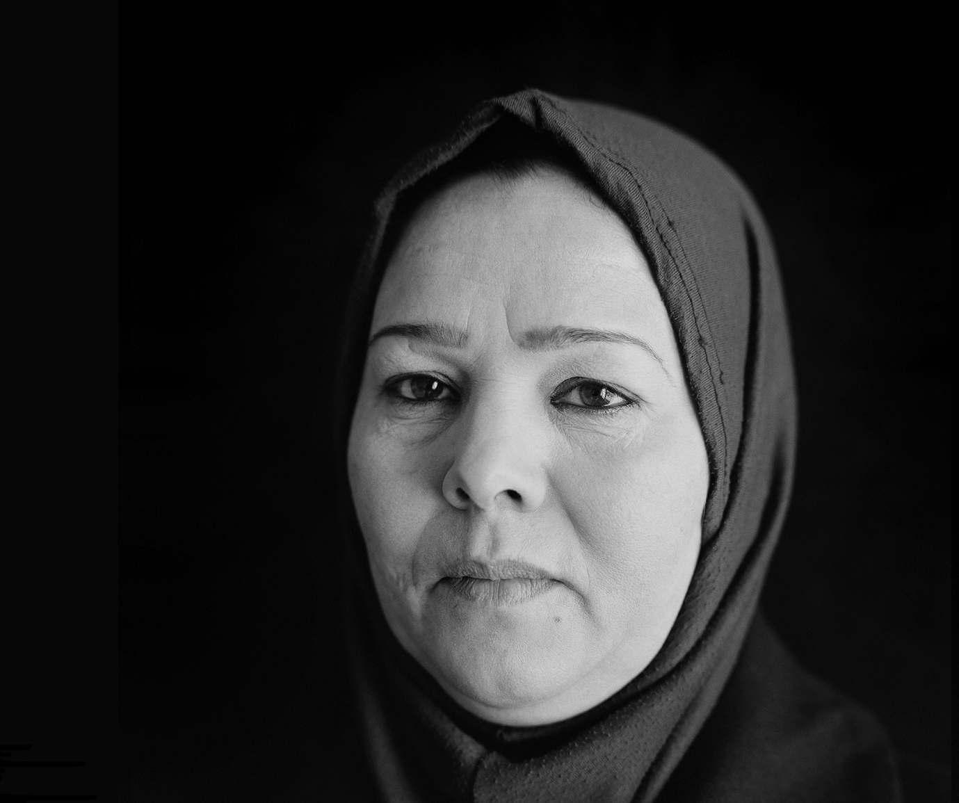
Private Actors in Warfare: Stories from victims of private military and security companies and foreign fighters
15 September 2016
13 :00 – 15 :00
Room XXIII
Palais des Nations
A project of the UN Working Group on the use of mercenaries as a means of violating human rights and impeding the exercise of the right of peoples to self-determination

Contact: mercenaries@ohchr.org

