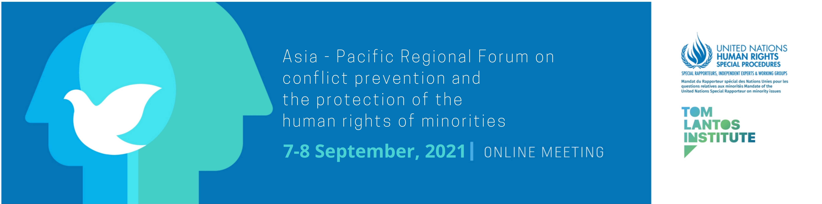

In cooperation with:

Programme of Work

(DRAFT – subject to change)

Day 1 7 September 2021
07:00-08:00 (UTC/GMT+02:00 - Geneva) Opening Session
10:00-11:00 (UTC/GMT+05:00 - Islamabad)
13:00-14:00 (UTC/GMT+08:00 - Kuala Lumpur)
17:00-18:00 (UTC/GMT+12:00 - Wellington)

Welcoming remarks (5 minutes)

Opening Remarks (50 minutes)

Rules and Guide to Proceedings (5 minutes)

08:00-08:15 (Geneva, UTC +2) Technical Break

08:15-09:15 (Geneva, UTC +2) High-Level State Panel

09:15-09:30 (UTC/GMT+02:00 - Geneva) Technical Break

09:30-11:00 (UTC/GMT+02:00 - Geneva)
Thematic Session 1: Substantive root causes of contemporary conflicts involving minorities

12:30-14:00 (UTC/GMT+05:00 - Islamabad)
15:30-17:00 (UTC/GMT+08:00 - Kuala Lumpur)
19:30-21:00 (UTC/GMT+12:00 - Wellington)

11:00-12:00 (UTC/GMT+02:00 - Geneva) Break

12:00-13:30 (UTC/GMT+02:00 - Geneva)
Thematic Session 2: Normative framework: the human rights of minorities and conflict prevention

15:00-16:30 (UTC/GMT+05:00 - Islamabad)
18:00-19:30 (UTC/GMT+08:00 - Kuala Lumpur)
22:00-23:30 (UTC/GMT+12:00 - Wellington)

Day 2 8 September 2021

07:00-08:30 (UTC/GMT+02:00 - Geneva)
Thematic Session 3: Obstacles to implementing the rights of minorities and early effective conflict prevention

10:00-11:30 (UTC/GMT+05:00 - Islamabad)
13:00-14:30 (UTC/GMT+08:00 - Kuala Lumpur)
17:00-18:30 ((UTC/GMT+12:00 - Wellington)

08:30-09:30 (UTC+02:00 – Geneva) Break
Thematic Session 4: Ways forward towards addressing gaps in human rights mechanisms to protect minorities and prevent conflicts

09:30-11:00 (UTC/GMT+02:00 - Geneva)
12:30-14:00 (UTC/GMT+05:00 - Islamabad)
15:30-17:00 (UTC/GMT+08:00 - Kuala Lumpur)
19:30-21:00 (UTC/GMT+12:00 - Wellington)

11:00-12:30 (UTC/GMT+02:00 - Geneva)) Break

12:30-13:30 (UTC/GMT+02:00 - Geneva) Presentation of Recommendations
15:00-16:30 (UTC/GMT+05:00 - Islamabad)
18:00-19:30 (UTC/GMT+08:00 - Kuala Lumpur))
22:00-23:30 (UTC/GMT+12:00 - Wellington)

13:30-14:00 (UTC/GMT+02:00 - Geneva) Concluding remarks
16:30-17:00 (UTC/GMT+05:00 - Islamabad)
19:30-20:00 (UTC/GMT+08:00 - Kuala Lumpur)
23:30-00:00 (UTC/GMT+12:00 - Wellington)

Working language is English

