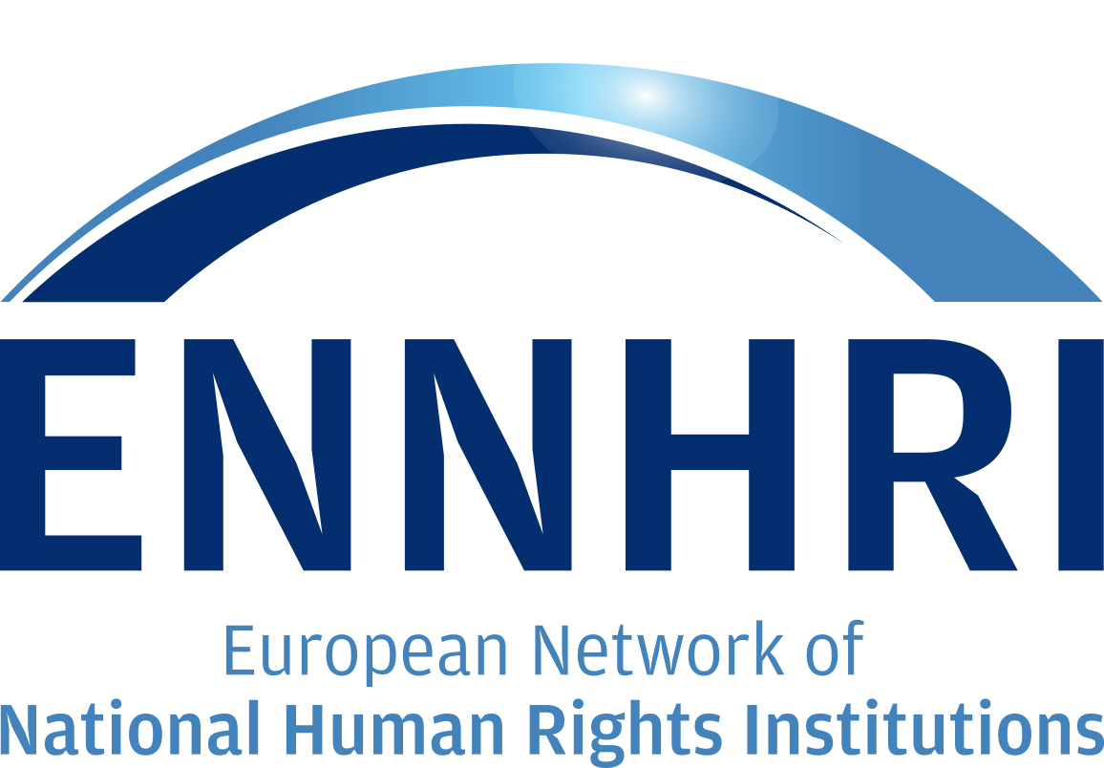
Human Rights of Older Persons: Review of Previous NHRI Findings
September 2015

1. Introduction
Over the last five years, almost all ENNHRI members have engaged in work to protect and promote the human rights of older persons in their jurisdiction. This chapter summarises the findings from these reports, outlining the most common breaches of human rights of older persons in receipt of long-term care and the most common causal variables.
A total of 11 have written special reports in the area of long-term care for older persons, based on detailed monitoring investigations. All of the reports, bar one, were dedicated investigations into residential care for older persons; the Equality and Human Rights Commission of Great Britain conducted a large inquiry into the delivery and commissioning of home care services for older persons in England. Three of the reports (Austria, Lithuania and Ukraine) were carried out as part of the institution’s National Preventative Mechanism (NPM) function, established under the Optional Protocol to the UN Convention Against Torture. Many of the visits carried out through the NPM function were unannounced, giving a good indication of how care is usually provided within the setting. The investigations were organised in different ways – several NHRIs conducted a small number (3-4) intensive site visits, with large teams detailing all aspects of the care provided within the home, while others carried out a larger number (100+) of shorter visits, looking at the overall trend within the sector.

2. International Human Rights Framework
Each of the reports clearly identified the national and international human rights legislation they used to establish whether the rights of older persons in care were being upheld or breached. Altogether, a total of 12 binding conventions were referenced, and 7 soft law provisions were cited (see Table below). Altogether, On each report cited 4.8 international treaties/conventions, both binding and “soft law” provisions. This suggests that there is a lack of clarity as to which instrument best protects the rights of older persons, which stands in contrast with other groups, such as persons with disabilities. While this highlights the lack of cohesiveness of the international human rights framework overall, it also illustrates the particular challenges facing human rights organisations within Europe in ascertaining the extent to which the rights of older persons are upheld.

Table X: International Human Rights Conventions referenced in Members’ Previous Work
Binding Conventions
EU
EU Charter of Fundamental Rights
Council of Europe
European Convention on Human Rights)
European Social Charter
European Convention for the Prevention of Torture and Inhuman or Degrading Treatment or Punishment
Convention on Human Rights and Biomedicine
United Nations
International Covenant on Economic, Social and Cultural Rights
UN International Covenant on Civil and Political Rights
UN Convention on the Rights of Persons with Disabilities
Convention Against Torture
Optional Protocol to the Convention against Torture and other Cruel, Inhuman or Degrading Treatment or Punishment
The Convention on the Elimination of All Forms of Discrimination against Women
The International Convention on the Elimination of all forms of racial discrimination
The International Convention on the Protection of the Rights of all Migrant Workers and Members of their Families
Soft Law Provisions
Council of Europe
Recommendation CM/Rec(2014)2 of the Committee of Ministers to member States on the promotion of human rights of older persons
Recommendation Rec(2006)5 on the Council of Europe Action Plan to promote the rights and full participation of people with disabilities in society
Recommendation CM/Rec(2009)6 of the Committee of Ministers to member states on ageing and disability in the 21st century: sustainable frameworks to enable greater quality of life in an inclusive society
Recommendation (2004)10 concerning the protection of the human rights and dignity of persons with mental disorders
United Nations
UN Declaration of Human Rights
UN Resolution 46/91 (UN Principles for OP)
The Political Declaration on Ageing and the Madrid International Plan of Action on Ageing (MIPAA)
UN Principles for the Protection of Persons with Mental Illness and the Improvement of Mental Health Care

3. Human Rights and Long-term Care
Overall, the care settings visited as part of each investigation had an overall high standard of care, with teams showing a great willingness to co-operate with the study team. Most had an open and positive atmosphere. Moreover, the majority of caregivers instinctively used a human-rights based approach to inform their work, placing a high priority to valuing older care users as individuals; respecting their dignity and independence and understanding the value of social interaction. Yet, all eleven of the NHRIs reported breaches of the rights of older persons in receipt of long-term care. While all of the human rights relevant to long-term care were reported to have been breached by at least one NHRI, rights relating to safety and protection were overall better protected. In contrast, NHRIs reported significant failings in terms of choice and autonomy, participation, privacy and dignity.
All together, the worst cases included older persons not being fed or being left without access to food and water, or in soiled clothes and sheets. Other breaches, such as a resident being left with their glasses or hearing aid out of reach, appeared to have been caused by a lack of understanding of the human rights of older persons. This indicates the need for more training and awareness-raising amongst care providers, care workers and older persons themselves about human rights and how these can be applied in long-term care settings.

Right to an adequate standard of living
In one incident, an able-bodied, healthy 32-year-old female member of staff stood and watched as a 76-year-old woman with advanced cancer struggled from the lounge to the kitchen to microwave this dish herself, because the worker could not do this ‘because of health and safety’; although apparently this did not preclude the worker from dishing up the microwaved meal onto a plate. These ‘small’ acts of cruelty are being enacted, possibly unthinkingly, every day:
It is hard to think of a reason or excuse big enough adequately to cover such a fundamental lack of care from one adult to another at such a basic level as the provision of food.
Daughter of woman in 70s, self-funded
Equality and Human Rights Commission UK, 2010, Close to Home: An inquiry into older people and human rights in home care.

However, in some cases, NHRIs highlighted the fact that consistent breaches, even if they appear insignificant or trivial, could conceivably be regarded as a serious breach. For example, the failure by staff to engage in certain activities due to each inadequate staffing levels, such as assist residents’ to eat or drink, could be regarded as a breach of the right to life – it may lead to malnutrition or dehydration, which could in turn put their lives at risk.

Right to life
There is supposed to be a juice round about 11 o’clock. They are supposed to get offered a cold or hot drink but they never get the choice of a hot drink because the dishes are never back up from the kitchen in time. [...] But then, as I say, again sometimes we are that busy there is nobody there to give them their juice [...]. Sometimes, it’s just forgot[en] about unless somebody specifically asks.
Care worker, residential care setting
Sometimes when I go up I will give Mummy her own juice and she will drink two or three glasses all at a go some days, so I know she is so thirsty.
Interview with resident’s daughter
Northern Ireland Human Right Commission, 2012, In Defense of Dignity: The Human Rights of Older People in Nursing Homes, Belfast.

Similarly, as Article 3 of the ECHR imposes a positive obligation on public authorities, including nursing homes, to take reasonable steps to ensure that individuals are not subjected to inhuman and degrading treatment or torture, when a resident has difficulty with daily tasks such as washing or dressing, the failure by a care home to assist, resulting in discomfort or unsanitary living conditions may potentially contravene the prohibition on inhuman and degrading treatment.

Freedom from torture, violence and abuse
Interviewees revealed that they cannot always respond to residents’ requests [immediately]. They explained that there is often a delay in responding during meal times when staff are helping other residents to eat:
You are having to say, ‘I can’t take you, there is nobody here to help me’, you now; and it is maybe taking somebody 20 minutes, half an hour to get back so that they can [help] but by that time it is too late, you know that way. There is not enough staff to meet their needs at times.
Care worker, residential care setting

Similarly, a lack of funding and a failure to organise services adequately meant that residents’ right to life-long education and stimulation was breached in many homes.

Right to life-long education
During our visits, several beneficiaries set in the common premises and “watched TV”. All attempts to animate them or at least make them react on our questions remained unsuccessful. Even after several hours of our visit to the home, we found them in the same condition, no one went out to the garden…
Impression of the members of the monitoring team
Association of Citizens Amity, 2013, Deprived of Rights out of Ignorance, Report on Monitoring of the Human Rights of Older People in Residential Care in Serbia. Belgrade, Association of Citizens Amity.

4. Barriers to the Protection and Promotion of Human Rights
Attitudes by management to residents and to human rights was identified by a number of NHRIs as the key issue driving the extent to which the human rights of residents were either protected or breached. Overall, management of the care setting played a key role in determining the atmosphere and the level of attentiveness and respect by the staff towards residents. Management also influenced the extent to which care staff were able to determine the needs and wishes of residents in order to be able to respond to them effectively. When management was poor or weak, staff turnover was high, with frequent absences due to illness, which generated a lack of continuity of care, and a sense amongst residents that they were not well cared for. Moreover, poor management also led to staff feeling incapable of bringing about improvements to residents’ well-being.
In addition, the staff ratio was a key factor in determining the extent to which residents’ rights were upheld. When staffing levels were inadequate, individual staff often simply did not have enough time to carry out all tasks, leaving residents’ needs and wishes unfulfilled. This was largely related to the overall funding of the care setting, which to a large extent related to national policies on long-term care. Inadequate funding also often meant limited access to external healthcare professionals, limited activities and training for staff.
Another important barrier was a lack of knowledge about human rights amongst both the management and staff of the care setting. Similarly, staff and residents often had markedly different interpretations of human rights issues, and of the duties of care staff to protect and uphold these rights. For example, one monitoring team found a number of cases where severe restrictions were made on the freedom of movement of residents, with staff making care decisions in the interest of giving residents the best healthcare possible.

Freedom of movement and restraint
A visiting delegation encountered a resident with dementia who had washcloths tied around both hands to prevent her from scratching her body. During the follow-up visit, it was found that, after this was criticised, the woman had received anti-itch medication and was now able to move her hands freely without injuring herself.
Austrian Ombudsman Board, 2014, Annual Report on the activities of the Austrian National Preventive Mechanism (NPM), Vienna.

5. Initiatives by NHRIs to promote the rights of older persons and long-term care
As noted above, there is evidence that most care workers instinctively use a human rights-based approach to their work in long-term care settings. Often, rights violations are due to a shortage of resources or a lack of clear knowledge by duty bearers of their human rights obligations, both positive and negative. As such, initiatives by NHRIs tend to focus on informal advice at the micro level, training programmes for the care sector, engagement with policy-makers and other awareness-raising initiatives to inform the general public and other stakeholders of the long-term care sector.
In and of themselves, the monitoring investigations were a good mechanism for raising awareness of the human rights issues in long-term care. Many monitoring teams noted how they were able to give informal advice and recommendations to the homes they investigated. This helped to give care home management and staff another perspective on their work and practices, as well as developing a collaborative relationship between the care sector and NHRIs generally. The Austrian Ombudsman noted that simple recommendations were often quickly instated, such as purchasing new equipment (e.g. hospital beds to allow ease of movement) and measures to increase privacy. Other, more systemic, recommendations were slower to be implemented, such as increasing the staff complement or changing the “corporate culture”.

Recommendations to individual care homes
It should be positively highlighted that institutions and facilities perceive and accept the commissions’ suggestions as feedback and have provided assurances that improvements will be made. Whether these assurances have been fulfilled is monitored by the NPM during follow-up visits or subsequent investigative proceedings carried out by the AOB. It has been found that recommendations that can be realised more easily are often acted upon. For example, screens to protect privacy and lower beds to avoid measures to restrict freedom have been purchased and seating has been acquired that is used to transfer persons in wheel chairs to prevent decubitus and to allow them to participate in interaction in the kitchen/dining/communal areas. In some institutions and facilities, information in pictograms was made available for persons with dementia, measures were taken to achieve barrier-free accessibility, animation programmes and leisure time activities were expanded, more specific continuing education programmes were provided, etc. Besides, in several homes measures were taken to improve documentation and complaint management as a reaction to concluding discussions with the commissions. In some cases, increased measures to prevent falls or improve pain assessments were recommended and implemented. It often becomes clear during commission visits that measures which restrict freedom are often not promptly reported to residents’ representatives as is required under the Nursing and Residential Homes Residence Act (Heimaufenthaltsgesetz). This makes these restrictions per se inadmissible. Therefore, there were corresponding “ex post facto reports” in several cases.
Austrian Ombudsman Board, 2014, Annual Report on the activities of the Austrian National Preventive Mechanism (NPM), Vienna.

Other NHRIs used the monitoring reports as an opportunity to engage with policy-makers at national and regional level, and other stakeholders involved in the organisation and delivery of long-term care (healthcare professionals associations; training institutions). For example, the Ombudsman’s Office of Bosnia and Herzegovina organized consultative meetings with representatives of relevant ministries once it had completed its visits to long-term care settings, with the aim of both collecting information on the policy context, and liaising about potential measures to improve the human rights situation. This helped them to understand the systemic challenges involved in improving the human rights situation in the long-term care sector, as well as highlighting some of their concerns, including the absence of any official policy on the long-term care sector and the limited resources available for the sector as a whole.
Other NHRIs (the German Institute for Human Rights, the Norwegian Centre for Human Rights) used desk-based research to investigate the human rights situation within the long-term care sector as a whole, looking at the policy context, surveys of the care sector and the outcomes of human rights monitoring bodies of the UN and regional bodies to analyse how well the rights of older persons are protected and what breaches tend to occur. The findings of these surveys can also be used to raise awareness of any shortcomings in how the sector as a whole takes human rights into account.
The Equality and Human Rights Commission UK also conducted a follow up study to its inquiry on home care, assessing how local authorities (municipalities, who commission and manage long-term care), Government, the regulator for long-term care and the Local Government Ombudsman have done in response to recommendations from the original study. Two years after its initial investigation, the EHRC found that, although a high number of local authorities were willing to engage in relation to the follow up study, only a few municipalities had consciously changed their practices to the commissioning of home care to publicly and purposely ensure that the human rights of older people needing or receiving home care were better protected. In contrast, the majority of local authorities had not taken the recommendations into account. Furthermore, the EHRC found that in general, the way home care is commissioned by local authorities in England may be increasing the risks of older people suffering human rights abuses. In particular, the rates that some local authorities pay care providers do not always appear to cover the actual costs of delivering care, a significant proportion of which is workers’ wages which should include travel time.
Not only did this follow-up study afford the EHRC the opportunity to raise awareness of human rights issues in the long-term care sector once again, it also highlighted the extent to which the sector needed to remain a priority for the institute over the longer term, working with local authorities, the Government, the care regulator and care providers to put systems in place to ensure care is organized according to a human-rights based approach, as per legal requirements. It also led to related projects, including the provision of guidance to the care regulator and research on advocacy and personalisation.
A number of NHRIs also developed training programmes for various stakeholders within the long-term care sector. For example, the Scottish Human Rights Commission developed a programme, Care About Rights, in 2010. The programme sought to empower older persons and their families to have their rights upheld; to build the capacity of care workers to use a human rights-based approach in their work and to make policy makers and regulators aware of their obligations, particularly around accountability. Using the national Human Rights Act, the European Convention on Human Rights and other international human rights standards as the starting point, the training programme provided information on how to take the rights of individuals into account when making decisions about their care and daily lives, providing a range of examples and guidance on the issues to consider pertinent to each example. The SHRC developed the FAIR approach to act as a user-friendly guide for care workers and family members.

The FAIR Approach
- Facts: What is the experience of the individuals involved and what are the important facts to understand?
- Analyse rights: Develop an analysis of the human rights at stake
- Identify responsibilities: Identify what needs to be done and who is responsible for doing it
- Review actions: Make recommendations for action and later recall and evaluate what has happened as a result.
Scottish Human Rights Commission, 2010, Care About Rights

The Austrian Ombudsman Board; the Federal Migration Centre of Belgium; the Equality and Human Rights Commission of Great Britain; the Office of the Commissioner for Fundamental Rights of Hungary; the Seimas Ombudsmen’s Office of the Republic of Lithuania; the Commission Consultative des Droits de l’Homme of Luxembourg; the Netherlands Institute for Human Rights; the Northern Ireland Human Rights Commission; the Protector of Citizens of the Republic of Serbia; and the Office of the Ukrainian Parliament Commissioner for Human Rights.
NPMs are the national component of the preventive system established by the OPCAT. They are mandated to conduct regular visit to all types of places where persons are deprived of liberty and potentially subjected to ill-treatment, including residential care settings for older persons.
Murphy, M. 2012, Strengthening the Rights of Older People Worldwide: Building Greater European Support, http://www.helpage.org/silo/files/conference-report-on-strenthening-the-rights-of-older-people-worldwide-building-greater-european-support.pdf

