Human Rights Council, 30th session
Side-Event:
The human rights of older persons: best practices in the implementation of
existing law

Tuesday 15 September 2015, 11h00-13h00
Geneva, Palais des Nations, Conference Room XXIV

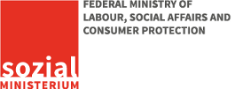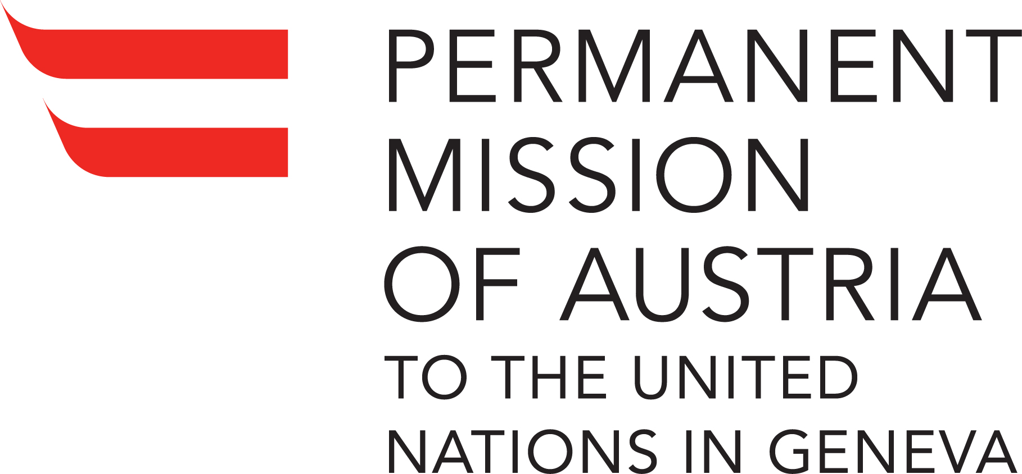

- Background

Population ageing constitutes one of the most significant demographic transformations of the 21st century. This side-event aimed to provide a better understanding of the challenges faced by States in the implementation of existing law related to the promotion and protection of the rights of older persons, and to identify and share best practices and recent developments in this area. It allowed for an open dialogue with the aim of formulating concrete recommendations for an effective and integrated response at the national and global level. The event was co-organized by the Office of the High Commissioner for Human Rights (OHCHR) and Austria. It was also sponsored by Argentina and Slovenia, and by the NGO Committee on Ageing- Geneva, and the International Longevity Centre Global Alliance.

- Side-Event

- Participants
Opening remarks:
-H.E. Thomas Hajnoczi, Ambassador and Permanent Representative of Austria to the UN in Geneva;
-Ms. Rosa Kornfeld-Matte, Independent Expert on the enjoyment of all human rights by older persons.

Panellists:
-Mr. Bernhard Jungwirth, M.Ed., Older persons and digital media;
-Ms. Charlotte Strümpel, Austrian Red Cross, Valuing older people’s skills and experience: The ‘Sustainable Learning in the Community’- projects;
-Mr. Johannes Wallner, Making Quality Visible. National Quality Certificate for old people’s homes and Nursing Homes in Austria;
-Ms. Nevena Peneva, Agency for Fundamental Rights, Equal Treatment Directive (Horizontal Directive);
-Mr. Marcelo Cima, Minister, Deputy Representative of the Permanent Mission of Argentina;
-Mr. Aleš Kenda, Ministry of Labour, Family, Social Affairs and Equal Opportunities of Slovenia.

Moderator: Ms. Silvia Perel-Levin, Chair NGO Committee on Ageing, Geneva.

b) Member States and other stakeholders attending the side-event:
Around 60 people attended the event, including representatives of Andorra, Argentina, Australia, Austria, Botswana, Brazil, Canada, Costa Rica, Ghana, Iraq, Namibia, Russia, Singapore, Slovakia, Slovenia, Spain, and the USA, as well as representatives of UNECE, UNFPA and ICRC.

c) Key issues raised by Speakers:

H.E. Thomas Hajnoczi Ambassador and Permanent Representative of Austria to the UN in Geneva

• Around 700 million people, or 10 per cent of the world’s population, are currently over the age of 60. It is estimated that by 2050, the number will have doubled. In Austria, almost 20% of the population is currently 65 years of age, or above, and there will be a significant increase in the number of very old people, those aged 80 and above. This constitutes one of the most significant transformations of the coming decade. For the first time in history there will be a point when there will be more older persons than children.
• Population ageing is a new topic for the Human Rights Council, with the creation, in 2013, of the UN mandate of the Independent Expert on the enjoyment of all human rights by older persons. The idea for the side event arose during the Independent Expert’s country visit to Austria, with the aim of proposing concrete recommendations that will help better prepare States to deal with the challenges of demographic change.
• The idea for the side event arose during the Independent Expert’s country visit to Austria, with the aim of proposing concrete recommendations that will help better prepare States to deal with the challenges of demographic change.
- Austria has already co-sponsored a side event, held during the last Human Rights Council session in June 2015, on the topic of violence against older women, and will continue supporting the mandate of the Independent Expert.

Ms. Rosa Kornfeld-Matte, Independent Expert on the enjoyment of all human rights by older persons

• The Independent Expert referred to her comprehensive report, which will be submitted to the Human Rights Council a year from now. This report will identify best practices in the implementation of existing laws for the promotion and the protection of the human rights of older persons.
• Population ageing is one of the greatest challenges that has been observed worldwide, from Africa - that faces the fastest increase in the number of older persons - to Western Asia - where the size of the population aged 60 or older is projected to more than quadruple over the next 40 years - and to the Latin American and Caribbean countries that present similar trends. Europe has the oldest population of all regions: by 2050 the percentage of older persons is projected to rise to 34%.
• The Independent Expert had adopted a comprehensive approach to ageing in order to address the heterogeneity of older persons and the complexity of ageing.
• Ms. Kornfeld-Matte also mentioned that when assessing best practices, she includes several aspects, such as a particular method, a whole programme or a specific intervention, that is measurable and replicable, as well as practices that have not yet been implemented but show promise and could have a positive impact on the promotion of the rights of older persons.
• Concluding, the Independent Expert encouraged all stakeholders to complete a questionnaire that she would be issuing, for the identification of best practices and gaps in the implementation of existing laws.

d)Main issues discussed by panellists:

Mr. Bernhard Jungwirth, Austrian Institute for Applied Telecommunications
Older persons and digital media
• Mr. Jungwirth focused on the importance of digital inclusion of older persons in order to allow them to participate actively in the political, social, economic and cultural life of their communities.
• He stated that services offered via the Internet can reduce one’s expenses on average by 3%, and that older persons should be able to take advantage of the current trends.
• The mission of the NGO is to help older persons become competent, safe and confident Internet users. The Austrian government has already taken several initiatives, such as the Senior Citizen Plan, a life-long learning strategy and also the work program of the Austrian Federal Government.
• The fact that older persons are the fastest growing group of Internet users is important because it provides an opportunity to team up with industry that can, in turn, focus its attention on this important group.
• There are two main groups of older persons: those who are motivated to learn and those who say that this is not for them anymore. There are many ways of giving them ideas on how they can use the Internet in their daily routine without being afraid of becoming victims of digital fraud and data privacy issues. It is crucial to provide specific support to older persons. The study conducted in Austria entitled ‘Policy for Senior Citizens in a Digital World’, explores various aspects of assisting older persons in their use of digital media.
• He underlined the importance of developing user-friendly and informative websites, for example, on patterns and trends that older persons could recognize in a common flyer. Policies aimed at familiarizing older persons with the Internet needed to reflect their different lifestyles and learning approaches. There was no ‘one-size-fits-all’ solution for this group.
•The NGO prepares brochures for companies, such as Austria’s largest telecom provider, because it is important to get the message out. It also produces guidelines for trainers with concrete lesson plans, presentations, workshops and training.
• Concerning fraud, it had created the so-called WatchList Internet that informs people, on an almost daily basis, of the current traps on the Internet, and also tries to explain these traps as easily as possible.
• At the beginning of 2015 the NGO established a Forum that seems to be proving very useful in supporting older persons, by allowing them to share experiences and identify common challenges. According to Mr. Jungwirth “A bottom-up strategy is very useful to support older persons. It doesn't make sense to create a national strategy, if there is no support available to all the small regional and local initiatives”.
• Next year, the NGO will also offer quality standards for educational programs designed to teach older persons how to use the Internet and other digital-based competences, which will include modules on the basic principles of senior education (geragogics), including needs and challenges as well as digital media topics relevant to seniors; training skills and methodology for teaching IT skills to older people; digital developments; and, know-how: organization, marketing, financing, development of different learning settings and formats.
• He concluded by saying that that are still many things to be done, including the expansion of the range of initiatives at the local and regional level; the establishment of innovative learning-settings and device-testing points for older persons; the development of target-group related course content and the promotion of older persons as a target group for businesses. He also suggested the launch of a ‘CEO-coalition’ by telecom providers or Internet service providers to offer support to potential future users.

Ms. Charlotte Strümpel, Austrian Red Cross
• Referred to a series of four projects, coordinated by the Austrian Red Cross and promoted by the Austrian Ministry, under the title of ‘Sustainable Learning in the Community’, designed for people aged over 55, and intended to engage them in participating more actively in the community.
• The main purpose of the projects was to develop programs that would allow older persons to value the skills and experiences gained through volunteering and their relevance for employment. The projects are rooted in Austrian policies and programmes, such as the Federal Senior Citizens Act (2008), the Austrian Federal Senior Citizens Advisory Council and the Senior Citizens Plan (2012), all of which are aimed at promoting and ensuring opportunities for older persons to participate in social, political, economic and cultural life, active ageing as well as promoting lifelong learning in order to help people to deal with constantly changing circumstances, requirements and challenges.
• The Senior Citizens Plan covers 14 different fields, including education, health and the employment of older persons. The first project, launched in 2007, included a two-day workshop on the self-assessment of skills as well as on exploring volunteering opportunities by looking at the wishes of senior citizens concerning their engagement in such activities.
• The second project, supported by the European Union, the Austrian Government and five important providers of healthcare and welfare in Austria, including the Red Cross, involved holding workshops across Austria on the topic of volunteering and active ageing.
• The third project was about training older persons to run the two-day workshops themselves. They trained peer facilitators where younger people either coach other young people or teach them about certain topics, such as those concerning persons with disabilities.
•A fourth project is under implementation in Austria. It also concerns peer facilitator training and requires the peer facilitator training to run further workshops. In addition, activities for persons over 80 years of age are being developed in order to include them in volunteering programmes and in supporting others. It is considered important to promote volunteering opportunities for older persons so that they can share their experience and so continue to contribute to their society.
• Methods used in workshops:
-self-reflection on creating a skill profile through mind-mapping procedures or card games to determine individual skills and experience;
-memory maps, different kinds of methods using cards, among others;
-group competence flower by choosing somebody to initiate an activity on behalf of the group;
-older volunteers presenting themselves and answering questions;
-participants exchanging their volunteering opportunities;
-staff members from volunteering agencies presenting different types of volunteering opportunities;
-participants engaging in an Internet search or having, as homework, to find out about local volunteering organizations; and
-an action plan named Tree of Dreams where people brainstorm what they would like to do and turn it into a realistic action plan.
•Since it is important that best practices are continually evaluated and assessed, there is always an evaluator who administers questionnaires and interviews. Main benefit for both participants and peer facilitators was that their levels of self-confidence were boosted.
• Some recommendations:
-To provide information about new volunteering activities because this is very well received, as well as the exchange of experiences.
-To coordinate workshops in collaboration with different international, national or local organizations in order to strengthen local networking so as to offer the best opportunities for volunteer work.

Mr. Johannes Wallner, National Quality Certificate for old people’s homes and Nursing Homes in Austria
• Presented the National Quality Certificate for old people’s homes and Nursing Homes (NQC) aimed at giving transparency to and improving the quality of long-term care in residential facilities in Austria.
• He referred to the universal allowance system for long-term care financed by the federal government, and social services for long-term care provided by provincial governments (Länders). There was a need to implement a uniform system at the national level to allow external evaluation of the life of users in old people’s homes and nursing homes. This was essential in order not only to verify the quality of services in a comparable way, but to tailor care services to the needs and preferences of older persons in a transparent way, respecting their autonomy and privacy.
• The development of the NQC started with the support of the European Union, the Ministry of Labour, Social Affairs and Consumer Protection and the federal association of older persons. Following the implementation of pilot projects, a strategy was adopted for regular operation -the Law on Older Senior Assessment- and afterwards the NQC organisation - an association to improve quality of life of older persons - was created.
• The NQC is not mandatory but is a positive incentive system.
• Every 3 years a reassessment takes place by assessing the extent to which 30 criteria have been met, as part of a five-phase certification process:
- Submission of the application and presentation to the NQC organization;
-Pre-audit;
-On-site inspection;
-Preparation of the certification report; and
-Approval and Issue of the certificate.
• To be awarded the NQC, care facilities must have a quality management system with a self-assessment process that involves all relevant stakeholders and includes a survey of customer satisfaction.
• The goal is to make it possible for the residents to live as if they were in their own home.

Ms. Nevena Peneva, Equality Sector of the EU Agency for Fundamental Rights (FRA)
• Spoke about the efforts of the Agency to gather legal and social surveys from all EU States in order to provide evidence-based advice to advance the protection and promotion of human rights in the European Union.
• There were relevant Treaty provisions at the EU level and a secondary law, namely the Employment Quality Directive. There was also currently a proposal for an Equality Treatment Directive because such protection under the EU is still not a fact, even though the proposal was handed to the Commission in 2008.
• Discrimination based on age is prohibited in general terms by the Treaty on the Functioning of the European Union, in particular Article 19. Additionally, the Charter of Fundamental Rights of the European Union, which is legally binding on European Union institutions and European Union Member States, also prohibits age discrimination, in particular Articles 21 and 25, which recognize the right of the elderly to lead a life of dignity and independence, and to participate in social and cultural life.
• However, to-date, specific legislation against age-based discrimination at the European Union level exists only in the area of employment. In fact, in terms of secondary or specific legislation, the only field in which there is a prohibition against age discrimination is that related to employment and occupation, namely through ‘The Employment Equality Directive’ of 2000. However, the Directive attracts criticism because it allows for differential treatment of older persons if two conditions are met: first, if there is a legitimate aim for such differential treatment; and, secondly, if the means to achieve that aim is appropriate and necessary. Some argue that the test is too lenient and can be applied unevenly.
• Although discrimination on the basis of age is prohibited in many European Union Member States at a national level in respect of access to goods and services, the proposal of the Equality Treatment Directive of 2008 would extend the prohibition to other categories such as disability, religion and belief as well as sexual orientation, to social protection including social security, health care and education, and access to goods and services, including housing. This proposal is still being debated in the European Council and to-date a unanimous agreement between all 28 Member States has still not been reached.
• As of 2014, 18.5 % of Europeans are aged 65 or over, and the size of this group is increasing in every European Union Member State; Eurostat predicts that the percentage of the EU population aged 65 or over will rise to 30% by 2060. Over the same period, the proportion of those aged 80 and over will more than double from 5% to 12 % of the population, becoming almost as numerous as young people under the age of 15.
• So far, the FRA has worked on the Convention on the Rights of Persons with Disabilities and discrimination on the basis of disability and its work is expanding to cover all equality issues, including those concerning digital media access or lack of accessibility, be they physical, related to access to information or even understanding.
• The next project of the FRA is focused on the independence of persons living with disabilities, based on Article 19 of the Convention on the Rights of Persons with Disabilities. This project will pay particular attention to older persons with disabilities, and it will assess the criteria, for example, for eligibility for support with technical devices, if there are age limits as is the case in some Member States. The result of this work, including indicators, will be published in 2016.
• The FRA plans to develop further its work on age discrimination and to address this gap in knowledge based on the first-hand experience of older persons who encounter discrimination and legal and practical barriers in accessing services. The FRA also aims to map measures and promising practices in the European Union Member States to help ensure the equal participation of older persons in society.

Mr. Marcelo Cima, Minister, Deputy Representative of the Permanent Mission of Argentina
• In 2013, Argentina proposed the resolution that established the mandate of the Independent Expert on the enjoyment of all human rights by older persons. Also, Argentina is the Chair of the Open-ended Working Group on Ageing in New York.
• Argentina has put in place a number of measures in favour of older persons, for example:
- Universal coverage of the health system;
- Universal coverage of the pension system;
- Creation of a Federal Council on older persons;
- Development of a tutorial for home-care personnel;
- Development of a social volunteer network; and,
- Launch of a campaign to fight discrimination against older persons.
• It was time to move on from the Madrid International Plan of Action on Ageing that was agreed 13 years ago. A binding convention for older persons had been signed in July 2015 by five Latin American countries, and Argentina would continue to push for an international convention that will protect the rights of older persons.

Mr. Aleš Kenda, Ministry of Labour, Family, Social Affairs and Equal opportunities of Slovenia
• In 20 years time, there will be ten times more people aged 100 or over in Slovenia. Hence, longer life expectancy presents new challenges to both society and individuals.
• Slovenia recognises that ageing is included in several documents and policies of the United Nations, such as the Madrid International Plan of Action on Ageing, and has participated in a few European projects, such as the Charter of Rights for People in Need of Long Term Care and Assistance.
• Slovenia’s first strategy was launched about 20 years ago, and it was for the care of the elderly. From today’s perspective the title seems inappropriate, but that is part of our lessons learned. It dealt with the scope of social protection but also tackled the development of different forms of community care as a response to predominately institutional care.
•The second strategy, launched nine years ago, was no longer related exclusively to the social area but included almost all government ministries, civil society, NGOs and research sectors. It represented a much broader response to demographic change and pointed to the need for adjustment of different systems such as pension, health care and long-term care. This strategy was based on intergenerational solidarity.
• During Slovenia’s Presidency of the European Union Council, Slovenia organized a conference on Intergenerational Solidarity for Cohesive and Sustainable Societies. This conference was organized together with NGOs, such as AgePlatform Europe. One of the conclusions of the conference was that the title of the European Year of Active Ageing 2012 should not only be focused on active ageing but also on intergenerational solidarity. After a long procedure, this proposal was adopted in 2011 by the European Parliament. It included the issue of the personal safety and security of older persons, but did not include the rights of older persons. This triggered the creation of the Council for Good Intergenerational Relations and Quality Ageing, headed by a representative of an NGO. In September 2015 a new strategy will be launched, which will include a section on the rights of older persons.
• In Slovenia, there are separate laws to support older persons, such as those on social protection, pensions, disability, health care and health care insurance, and there is the Family Violence Prevention Act. In the latter instance, persons over 65 years old enjoy a specific protection. On the basis of this law, cooperation with the Ombudsman and coordination among various Ministries and the police has been intensified. Annual training programmes have also been offered for professionals who have to deal with the issue of domestic violence and the rights of older persons.
•There is also a project where older volunteers visit older citizens in their neighbourhoods in order to identify the needs of the elderly, and in cases of violence or abuse, to alert the relevant social work centre or police of the need to take action.
• In the past, Slovenia considered that the rights of older persons were sufficiently enshrined in existing international instruments. Nowadays, however, it supports the idea of a binding international document that would help in addressing the vulnerability of older persons.

e) Interactive discussion

- A representative of the Sustainability Organization was interested in the educational part of the workshops on digital media. The participant commented on the idea of young people teaching their elders as well as the initiative of helping them. Mention was made of the importance of strengthening intergenerational solidarity, which could also cost less for organizations.

- A representative of the International Association for Hospice and Palliative Care highlighted how little discussion had taken place around the right to death, although it was a matter of concern to most countries. She added that the reluctance to deal with this taboo matter, as well as the few policies that exist for the end of life and pain management, created a vacuum in the advocacy of the right to die, especially for older persons with disabilities, as all persons deserve to die with dignity. Additionally, training programs should be offered to physicians and other health care workers in order to address the needs of older persons as they near the end of their lives.

- A representative of the Health Aid International stated that the rights of older persons were not properly articulated either at the international or regional level. He addressed a question to Mr. Jungwirth concerning firstly the extent to which the barriers that he was describing were the result of a unique intersection between old age, or attitudes towards old age, and digital access, and, secondly, what Governments could do in order to remove the barriers faced by older persons to digital access.

-The moderator, Ms. Silvia Perel-Levin, addressed a question to all experts about the extent to which education on the human rights of older persons is included in their projects.

-In his closing comments Mr. Jungwirth mentioned that collaboration between the young and older persons could be a good idea, but it would take a lot of effort and, in some countries, this work could cost more than leaving trained professionals to work with older persons. He also stated that additional funding was needed in order to implement programs that address digital access, with individual educational programs for older persons. Finally, he mentioned the importance of creating a “hot line” where people could seek help regarding Internet access.

-Ms. Strümpel’s final comments underlined the importance of intergenerational solidarity and work, not only between older persons and the young but among all generations in the community, overcoming stereotypes. She also said that there were initiatives in Austria that looked at ageing from all possible perspectives, including pain management and the training of volunteers on elder abuse.

-Ms. Peneva’s closing comment drew attention to the many programs based on the Convention on the Rights of Persons with Disabilities that have been adopted by EU countries, such as by making websites and political participation accessible, which could also be of benefit to older persons.

f) Photo of the Side-Event

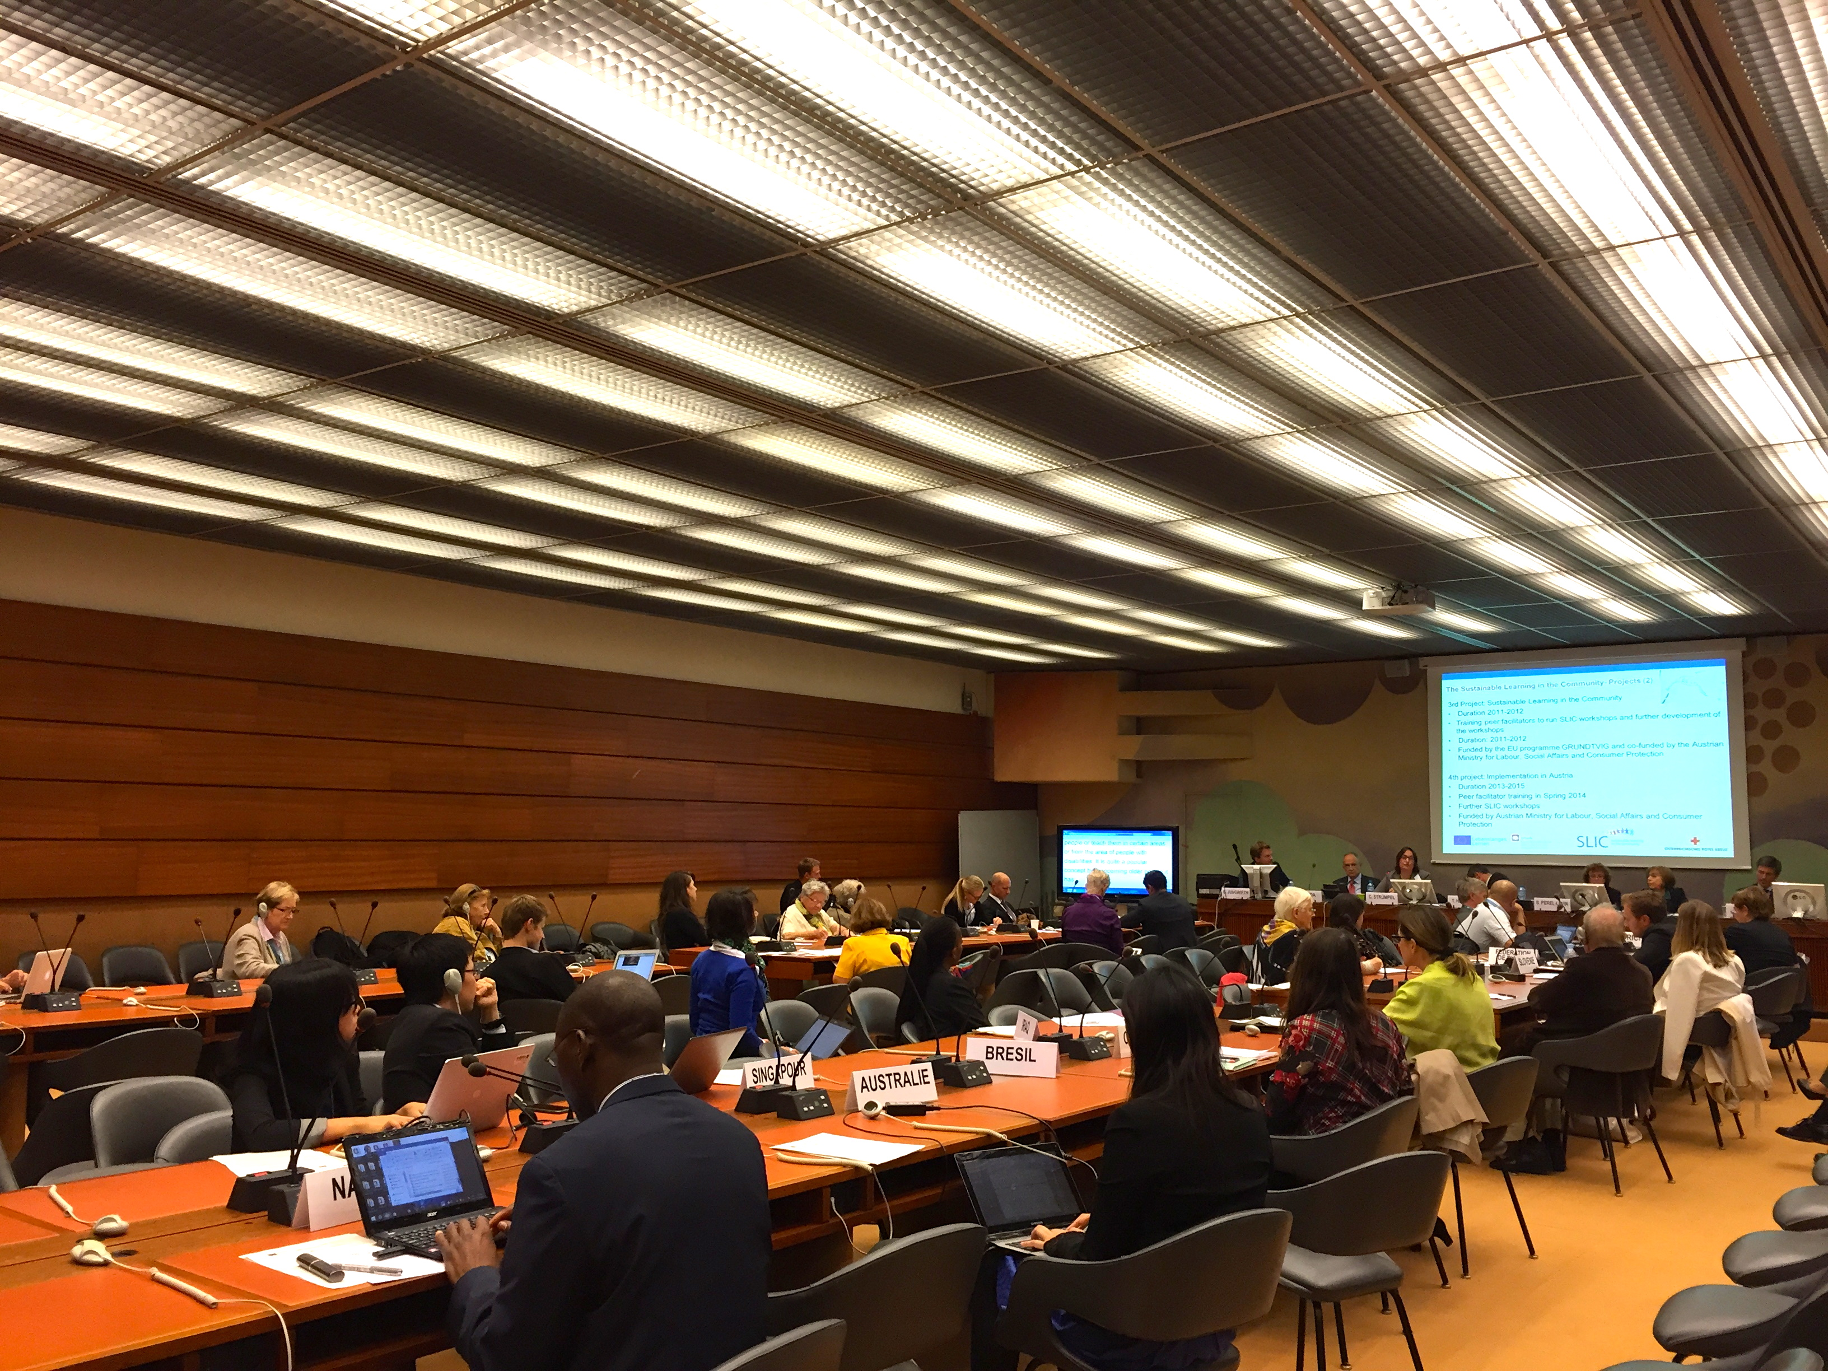

See Executive Summary: https://www.saferinternet.at/fileadmin/user_upload/Senioren_digitalen_Welt/Executive_Summary_Study_Policies_for_senior_citizens_in_a_digital_world.pdf

