Socioeconomics of the Penan Community at Belaga District, Sarawak, Malaysia
by
Assoc. Prof. Dr. Doris Padmini A/P S. Selvaratnam
Faculty of Economics and Management
Universiti Kebangsaan Malaysia
Email: pegasus@ukm.edu.my
Mobile: +6019-6682726

Introduction
The Penan are the native community of Sarawak, Malaysia. In Miri Division alone, there are about 68.51 % of total Penan residing along upstream areas of Tutoh and Magoh in the Baram District, while the others are found in Bintulu, Limbang and Belaga (Miri Resident Office, 2008). The following is a result of research project FRGS/2/2013/SS07/UKM/02/1 “Indigenous Community Skills and Competency Transtheoretical Modeling for Social Business”.

Methodology
The approach undertaken in this project is respecting local culture, respecting local knowledge and harnessing holistic social entrepreneurship model (DP Selvaratnam, et.al., 2013) through active engagement with multi-stakeholders and also capitalizing social capital and local skills and talents. Asset mapping exercise through the Assessment Based Community Development Approach is utilized to maximise the potential of the local talents.

Penan Community at Belaga District, Sarawak
The Penan community in Belaga District (6 hours from Bintulu Airport, with good highway) are the displaced community of the jungles that was flooded for the Baram Dam. They are located at Sg. Asap, Long Urun and Long Ketuat (Long Wat). Already being displaced for about 20 years most of the Penans were still not skilled for the modern manufacturing and construction sector. The source of life at the virgin jungles is no more accessible to them but adjusting to the modern lifestyle, social setting and economic activity has not been easy. Although various development and economic activities have been conducted, they were all totally new and the mentoring and hand holding period has not been sufficient. Therefore, majority of the Penan just laid back and relied on any handouts. Some took up menial jobs in the construction and plantation sector. But this did not bring enhanced livelihood nor an improved lifestyle compared to their previous lifestyle in the jungle. Mean income is less than USD100 per month. While Sg Asap is still relatively near to the grocery stores and health clinic, (which are 10 minutes away), on the other hand, Long Urun and Long Ketuat are located within plantations and nearest town or clinic is more than 30 minutes away. Most of the Penan do not have own transport, hence they rely on loggers or plantation administrators who occasionally visit the village.

Reference
Doris Padmini Selvaratnam, Hamidah Yamat, Sivapalan Selvadurai, Novel Lyndon. (2015). Getting The Malaysian Native Penan Community Do Business For Inclusive Development And Sustainable Livelihood. PROSIDING PERKEM 10, (2015) 434 – 443 ISSN: 2231-962X.

Appendix

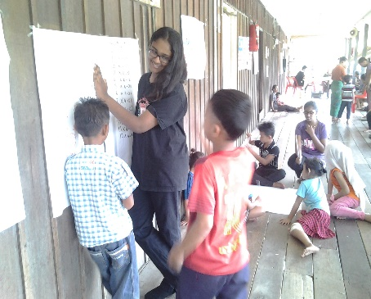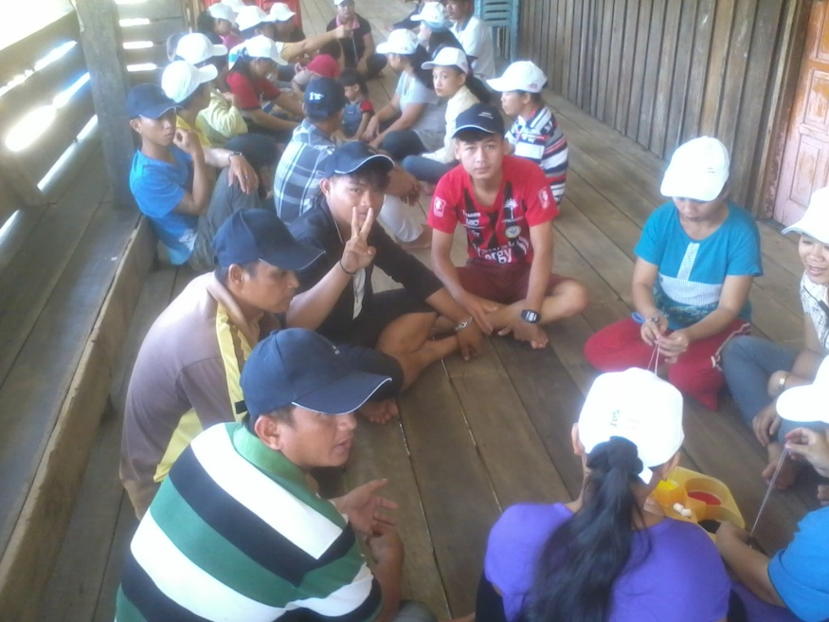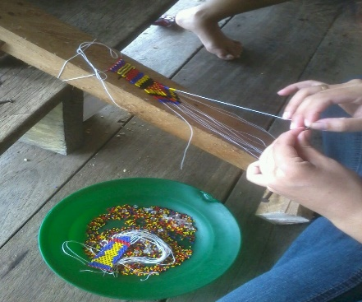
Education for the kids. Community social entrepreneurship & revival of beading art.
Source: Field Survey, Sg. Asap, 2013 & 2016.

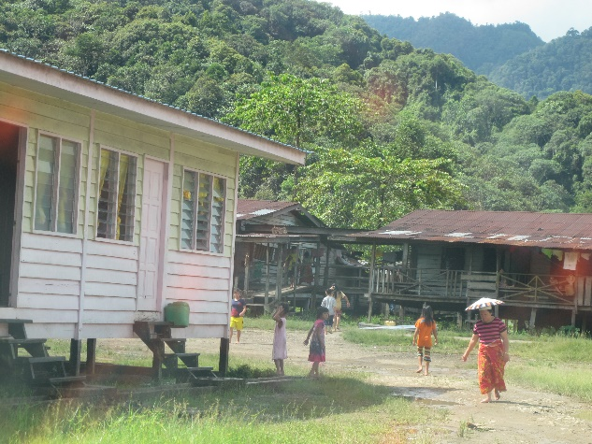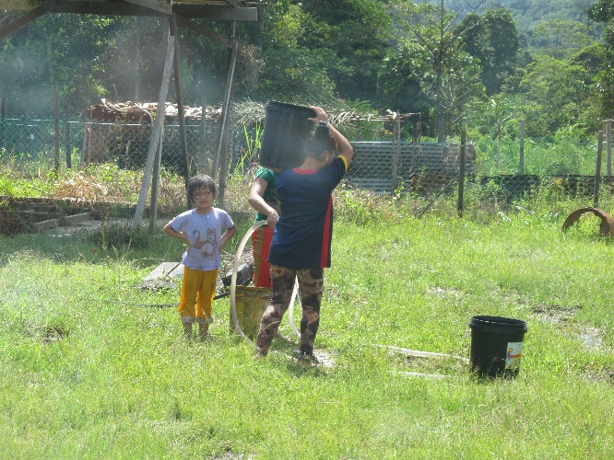
Traditional and modern long houses. Source of water at Long Urun.
Source: Field Survey, Long Urun, 2016.

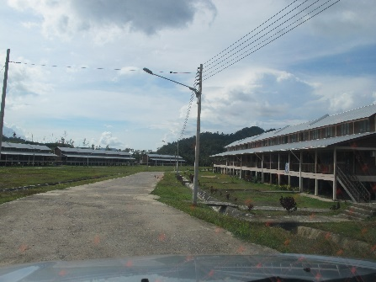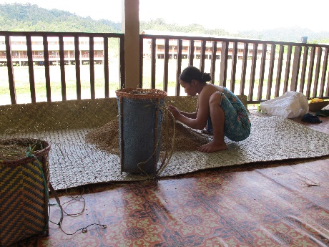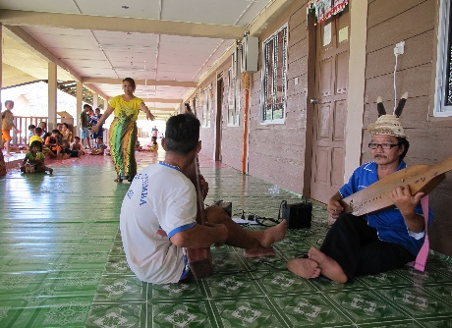
Modern long houses. Traditional mat & baskets. Traditional music and dance.
Source: Field Survey, Long Ketuat, 2016.

