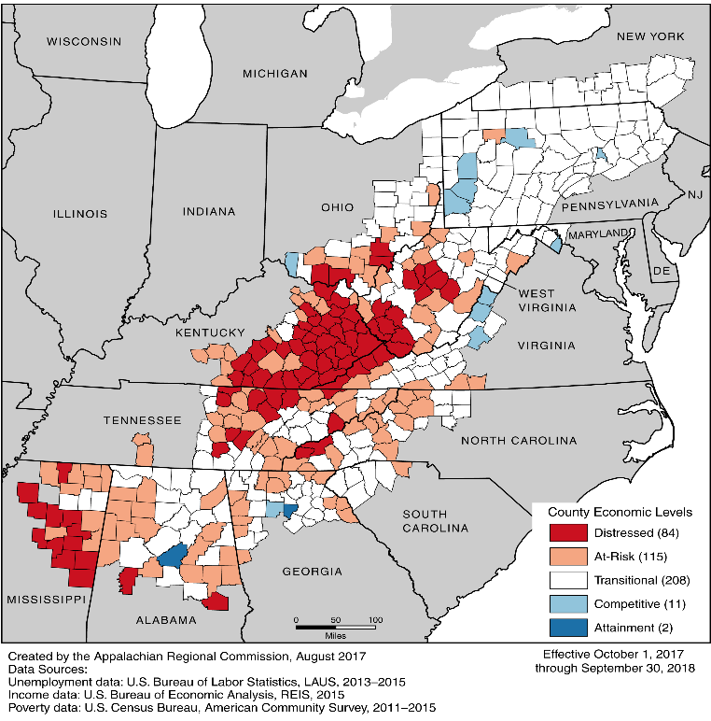
The War on Drugs, ongoing since the 1970s, has created numerous human rights issues that have failed to be addressed. These failures, alongside strengthened drug laws have devastated the Appalachian region of the country.
Appalachia is no stranger to drug problems, nor its consequences; these consequences include babies born with addiction, disease spread from the use of dirty needles, and lack of employment opportunities for those with drug convictions, etc. There are many stories. A West Virginian named Alan who was injured in the mines and prescribed pain medication for his injury but rarely takes them due to the devastation he has seen. Not everyone is so lucky; Brian, another West Virginian, began taking prescription pain medication which lead to an addiction, forcing him to take heroin once he could no longer afford the prescription medications.
Many communities, with and without medical expertise, consider addiction to be a mental illness. Yet, the U.S. still believes that criminal punishment is the right path to deal with addiction despite organizations, such as the U.N., having recognized this route’s negative effect on employment outcomes which can contribute to a cycle of drug abuse. Moreover, these notable issues affect the human rights of many low-income Appalachians. Both the right to health and the right to an adequate standard of living of people living in poverty are negatively impacted due to the consequences of drug use.
When analyzing the consequences of drug abuse, the right to health is the most obvious right affected. In the U.S. both expense and access are significant issues, particularly for poor, rural areas. Mental health and substance abuse treatment are no different, with 88% of treatment facilities being private facilities and/or for-profit businesses, while only around 12% of facilities in operation are government entities. This creates a culture that places priority on profits and revenues over patient health. These factors, along with a general lack of access in rural areas, cause difficulties for many Appalachians. In fact, most clients must go to outpatient facilities where they may not get the intensive care they need and deserve. Interestingly, the U.S. has accepted its responsibilities to provide both food and good health to all who live within its borders. With their UPR Recommendation ¶ 195, the U.S. took the position that though they were not a party to the International Covenant on Economic, Social and Cultural Rights, they “understand that these rights are to be realized progressively.” A pertinent example of the positive effect of decriminalization is Portugal. Once home to one of the worst drug problems in the world, Portugal shifted the perception of addiction from a criminal justice issue to a health issue. It decriminalized drug use, which has caused drug cases to decrease 75%, overdose rates to plummet, and drug-related HIV infections to drop 95%.
Furthermore, sentencing addicted individuals to prison, jail, or probation, not only can impact their health by denying them access to quality care, but can insert individuals into environments that encourage increased criminal activity. If individuals cannot find employment and instead turn to crime, it harms the economic outlook of the individual and region, affecting their right to an adequate standard of living. While not directly addressing the issues stemming from drug convictions, the Working Group of Experts on People of African Descent noted that there are serious disadvantages that people with criminal records face, including gaining employment, adequate housing, healthcare, and welfare assistance. Moreover, the Working Group noted that some authorities have realized the ineffectiveness of incarceration in curbing the negative impact of drug abuse. In fact, the National Institute of Justice funded a study which analyzed over 38,000 different statutes pertaining to criminal convictions; over 80% acted as barriers to employment. Due to these barriers to employment, within three years close to 2/3 of prisoners are rearrested. The situation within Appalachia is even worse. Unemployment and poverty are higher than the national averages, making employment difficult for all, especially people who have drug-related convictions. It is important to note that the conviction does not have to be a felony to harm employment prospects; misdemeanor convictions, of which many low-level drug convictions are, can trigger similar consequences. Nazgol Ghandnoosh, a Sentencing Project analyst, noted “[misdemeanor convictions] sends people down a route that limits their life chances and sets up conditions that can lead them to commit additional crime. It makes it hard for people to have stability in their life. It’s not good crime policy and it doesn’t help to promote public policy.”
We respectfully ask that the Special Rapporteur recognize that the criminalization of drug laws in the U.S. violates the right to health and the right to an adequate standard of living, and call on the U.S. to decriminalize the use of drugs and promote addiction as a health issue. Moreover, the U.S. should significantly increase funding into mental healthcare and drug addiction.
Recommendations for Observations:
The Rapporteur notes that the only way to protect the rights of people and positively impact afflicted communities is to stop incarcerating individuals for drug possession and use. Decriminalization allows these individuals to be given drug rehabilitation and mental health treatments they might otherwise not receive. Moreover, this would prevent individuals from gaining the stigma that drug convictions and abuse normally receive and would help them re-integrate into society.
The State Party should take steps to increase funding to drug abuse and mental health treatment and decriminalize the use and possession of narcotics. Furthermore, the federal government must end the failed war on drugs. With the combination of these techniques, the issues associated with the drug epidemic should ease. People will be more open to seeking help with their addiction and be safer when using drugs, in turn cutting down on HIV and hepatitis rates. Decriminalizing the use and possession of drugs is a win for both the people and the government as it eases the burden on the human rights of people who are caught in this unfortunate cycle, as well as decreasing prison and healthcare costs throughout the U.S.

Though this paper only delves briefly into the significant personal health issues stemming from the use of drugs, instead focusing on issues stemming from access, they, too, significantly impact an individual’s right to health.
While it is noted that there have been attempts to mitigate the effects of these arrests, those attempts are underfunded to meet the needs of the numerous people released from prison each year.
E.g., James B. Becker MD, The Crisis of Opiates in Appalachia, 2 Marshall J. of Med. Iss. 1, Art. 2 (2016) (discussing impact of drug abuse in Appalachia), http://mds.marshall.edu/cgi/viewcontent.cgi?article=1033&context=mjm.
Juliet Escoria, The Hard Times, Struggles, and Hopes of Addicts in Appalachia, Vice (May 1, 2016), https://www.vice.com/en_us/article/nneykb/the-hard-times-struggles-and-hopes-of-appalachian-addicts-ang.
Id.
See generally UNODC, World Drug Report 2016, Ch.2, U.N. Sales No. E.16.XI.7 (2016).
Cf., e.g., Alicia Ely Yamin, The Right to Health Under International Law and Its Relevance to the United States, 95 Am. J. Pub. Health 1156 (2005), https://www.ncbi.nlm.nih.gov/pmc/articles/PMC1449334/. (analyzing the right to health within the U.S. and its origins through the World Health Organization constitution, the International Covenant on Economic Social and Cultural Rights, and the UN Convention on the Rights of the Child).
National Survey of Substance Abuse Treatment Services (N-SSATS): 2016, SAMHSA, 11-12 (2016), https://www.samhsa.gov/data/sites/default/files/2016_NSSATS.pdf.
Id.
Report of the Working Group on the Universal Periodic Review, United States of America, A/HRC/30/12, ¶ 195 (July 20, 2015).
E.g., Lauren Frayer, In Portugal, Drug Use Is Treated As A Medical Issue, Not A Crime, NPR (Apr. 18, 2017), http://www.npr.org/sections/parallels/2017/04/18/524380027/in-portugal-drug-use-is-treated-as-a-medical-issue-not-a-crime.
Id.
See Rep. of the Working Group of Experts on People of African Descent on its mission to the United States of America, Note by the Secretariat, U.N. Doc. A/HRC/33/61/Add.2, ¶ 33 (2016).
Id. at
Amy L. Solomon, In Search of a Job: Criminal Records as Barriers to Employment, 270 Nat’l Inst. Just. J. (June 2012), https://www.nij.gov/journals/270/pages/criminal-records.aspx#note35.
Id. at ¶ 34.
See generally, e.g., Unemployment Rates 2015, Appalachian Regional Council, https://www.arc.gov/reports/custom_report.asp?REPORT_ID=30; Poverty Rates 2011-2015, Appalachian Regional Council, https://www.arc.gov/reports/custom_report.asp?REPORT_ID=70.
Maya Rhodan, Misdemeanor Convictions Can Lead to Same the Troubles as Felonies, Time (April 24, 2014), http://time.com/76356/a-misdemeanor-conviction-is-not-a-big-deal-right-think-again/.
Id.

