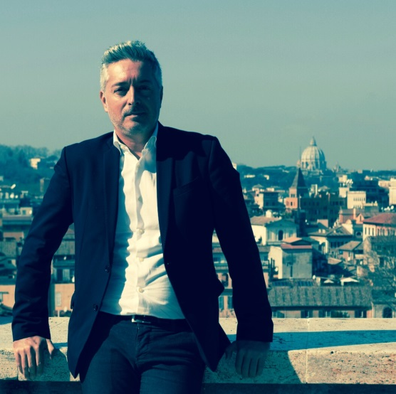
Benedetto Zacchiroli
Born in Bologna (Italy) in 1972, graduated in Theology at Pontifical University San Tommaso d’Aquino in Rome.
A tireless traveler, cosmopolitan by vocation, mainly focusing on human rights, he always prefers the
administration and the public space as a range within which to govern global processes. Since more than ten years, mainly for the community of Bologna, the city where he was born and raised, he is trying to connect the global and the great visions of the future with the local, where those visions are concretely experienced.
As responsible for foreign affairs of the city, he was the 'Bologna way of life' ambassador in the world, conscious of representing a city that historically has achieved notable primacies. Be born in the city that invented the university in 1088 and that was the first, in 1256, to abolish slavery, marks the civic DNA of the person. Growing up in a community that combines the medieval architecture with the modern lines of the techniques expressed by some of the world excellences as Lamborghini, Maserati and Ducati, creates people who are not afraid to face the world and its changes and its challenges, placing their communities at the center of global action, aware that they can win global challenges on their own territory.
In the last years he has decided to put his passion, his experience and his knowledge at the service of Bologna within the political government of the city. First elected City Councilor, then elected as Metropolitan Councilor, finally, called by the mayor to serve as the Deputy Mayor for economic and social development, ICT innovation and international relations at the level of the metropolitan city which now has 1 million citizens.
To complete the picture, since the spring 2015 he acts as President of ECCAR (European Coalition of Cities Against Racism and Discrimination), a role he interprets in a global political way, recognizing networking as source of strength for every government policy that wishes to be called humane and just.
In the spring 2016 was appointed by The President of the Council Matteo Renzi to be his Chief of Cabinet till the end of his government in December 2016.
From 2017 is advisor for the General Secretary of the Presidency of the Council for the relations between the State and the religion confessions.
In brief

2004-2009
- Mayor's Political Advisor for Foreign Affairs in the City of Bologna
- Responsible of the Candidature of Bologna Unesco Creative City of Music, Titled OBTAINED in 2006
2009-2011
- Political Advisor of Cultural and International Affairs in the Fortaleza Mayor's Cabinet (Brasil)
2011
- Elected Bologna City Councilor
2014
- Elected Councilor of the Metropolitan City of Bologna
2015
- Appointed Deputy Mayor for Economic and Social Development, ICT Innovation and International Relations of the Metropolitan City of Bologna
- Elected President of the European Coalition of Cities against Racism ECCAR
2016
- Chief of Cabinet of the Italian Prime Minister
2017
- Secretary general advisor for the relations between the State and the religious confessions

