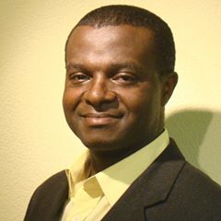
Chidozie Celeste Ugochukwu, President African Diaspora Council of Switzerland
Mr Ugochukwu studied Philosophy and Sociology at the University of Ibadan, Nigeria and Law at the University of Fribourg, Switzerland.
He worked at different Law firms in Geneva (Python Schifferli, Peter & Associés) and in Biel (Suter & Partner), then at the Juvenile court in Biel.
He is currently a legal counselor in migration law and consultant in African investment, migration and development
He led different integration, migration and development projects in his capacity as:
President, African Diaspora Council of Switzerland and Coordinator of the International Decade for People of African Descent in Switzerland
Director, African Foundation for Migration and Development
Member, Swiss Federal Commission against Racism
Member, African Union Diaspora Expert Support Group (African Institute of Remittances)
Member, United Nations Selection Committee on Global Compact

Contacts:
cugochukwu@yahoo.com
+4179 476 74 83

