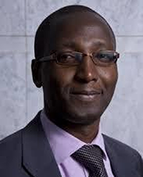
Mr. Mutuma Ruteere, Special Rapporteur on contemporary forms of racism, racial discrimination, xenophobia and related intolerance

Mutuma Ruteere is Kenyan and is currently, the UN Special Rapporteur on contemporary forms of racism, racial discrimination, xenophobia and related intolerance. He also serves as Director, Centre for Human Rights and Policy Studies, a research centre based in Nairobi, Kenya. Ruteere holds a PhD in political science (with a specialization in human rights) and has published widely on human rights.

In November 2011, he was appointed by the UN Human Rights Council as the Special Rapporteur on contemporary forms of racism, racial discrimination, xenophobia and related intolerance. In this role, he has undertaken studies on profiling and racism; xenophobia; role of data and statistics in combatting racism and xenophobia; Internet governance and racism and xenophobia; sports and the challenge of racism; profiling in law enforcement; role of education in combatting racism and xenophobia; and glorification of Nazism and threat of extremist movements, among others. The Special Rapporteur has undertaken official visits to countries in the various regions of the world.

