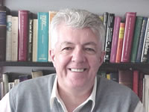

Patrick Thornberry is Emeritus Professor of International Law at Keele University, and Honorary Professor of Law at the University of Nottingham. From 2001-2014, Professor Thornberry was the UK member of the (UN) Committee on the Elimination of Racial Discrimination (CERD), and acted as Rapporteur of that Committee from 2002-2008.

Among his publications, works such as International Law and the Rights of Minorities, Indigenous Peoples and Human Rights, and (with M.A. Martin Estébanez) Minorities in Europe, are prominent in the field of international law and human rights. In 2016, Oxford University Press published his commentary on the International Convention on the Elimination of All Forms of Racial Discrimination.

Professor Thornberry is a former Chairman of Minority Rights Group International and has worked as legal consultant to a variety of intergovernmental and non-governmental organizations. In Queen Elizabeth’s 2006 New Year Honours list, Professor Thornberry was awarded a CMG – Companion of St Michael and St George – for services to international human rights, on the nomination of the Secretary of State for Foreign and Commonwealth Affairs.

