Michal Balcerzak (Poland), Chairperson
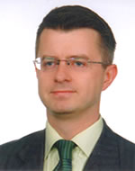

Mr. Mr. Balcerzak is a professor of international human rights law at the Nicolaus Copernicus University in Poland. His research areas include international human rights law, protection of national minorities, international judiciary and litigation and diplomatic protocol. He is currently alternate Member of the Management Board of the European Union Agency for Fundamental Rights. He has also served in various committees of the Council of Europe as an expert on thematic human rights issues.

