The authors submitted the op-ed published by the New York Times via racism inbox

Opinion

DNA Collection at the Border Threatens the Privacy of All Americans
We’re one step closer to the “genetic panopticon” that Antonin Scalia warned us about.
By Daniel I. Morales, Natalie Ram and Jessica L. Roberts
Mr. Morales is a professor at the University of Houston Law Center. Ms. Ram is an associate professor of law at the University of Maryland Francis King Carey School of Law. Ms. Roberts is the director of the Health Law & Policy Institute at the University of Houston Law Center.
- Jan. 23, 2020

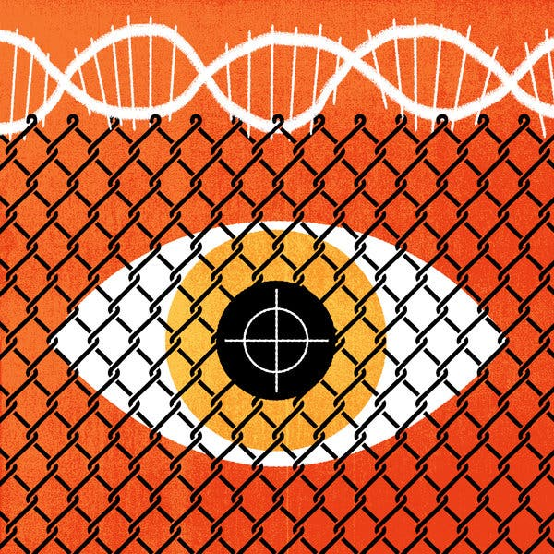
Credit...The New York Times
What if the United States government took the DNA of vast numbers of Americans for use without their consent? The Trump administration has just brought us one step closer to that dystopia. On January 6, the federal government began collecting DNA from any person in immigration custody — previously, it had required only fingerprints. With this move, the federal government took a decisive step toward collecting and tracking large numbers of its citizens’ genetic information too.
The federally administered CODIS, or Combined DNA Index System, has expanded dramatically in scope since its inception. Virginia established the first forensic DNA database in 1989, with the federal government following suit in 1994. Today, all 50 states, the District of Columbia and the federal government collect, store and share genetic information through CODIS. Initially, many states limited DNA collection to sex offenders. But today, nearly all states compel DNA from all convicted felons, while many states collect DNA from individuals convicted of mere misdemeanors. Most states also collect DNA from some individuals merely arrested on charges of, but not yet convicted of, a crime.
The Supreme Court blessed the expansion to arrests in “Maryland v. King,” a narrowly divided 2013 decision, over a furious dissenting opinion by Justice Antonin Scalia, three years before his death. Justice Scalia’s opinion railed against the civil rights implications of expanding CODIS in this way. The Trump administration’s recent immigration policy is the latest development in a worrying trend of escalating DNA surveillance.
Despite these significant expansions in CODIS, one constant has remained: Until now, CODIS’s crime-solving components have contained genetic profiles only of individuals connected with criminal activity, whether accused or convicted. Now, for the first time, CODIS will warehouse the genetic data of people who have not been accused of any crime, for crime detection purposes. Noncitizens in immigration custody are not criminals as a rule. The vast majority of immigration infractions that land an immigrant in detention are civil in nature, akin to the I.R.S. asking a citizen to pay a penalty when she fails to withhold enough money from her paycheck. And in the case of refugees seeking asylum (a large and increasing proportion of the detained noncitizen population), international and domestic law expressly allow these individuals to enter the United States to claim the right to refuge. By severing the longstanding prerequisite of prior (alleged) criminal conduct for compelled DNA collection, the government puts us all at risk.
How we treat the people that cross our borders speaks to our identity as a nation. Immigrants are Americans of the future and the criteria we use to select or bar immigrants reflect our aspirations for the society we wish to become. The new DNA collection program may yet revive darker, eugenic impulses in immigration history. Modern, quota-based immigration law was born of a desire to improve the “quality” of America’s racial stock by drastically limiting immigration from peoples “scientifically” believed to be less intelligent than other groups. Italians and other southern European immigrants, for example, were granted fewer visas based on this false science.
It is a small leap from requiring immigrants to submit their DNA to verify familial relationships, or to mitigate future criminal risk (the pretexts the government has cited to justify its recent policy change) to requiring DNA screening of immigrants for health, disability, intelligence or disease. These screens for “fitness”— likely based on questionable science — could ultimately be used to deny entry into the United States or, if discovered later, as a basis for expulsion. Regardless of reliability we would not support genetic screening for fitness. Courts have usually failed to protect immigrants from such impulses, so it is up to citizens to learn from this history and decide that building a society this way is unacceptable.
More broadly, once you break the norm requiring criminal conduct for inclusion in CODIS, it is difficult to re-establish. That is why many civil rights groups have long objected to forced mass collection even in criminal contexts. In arguing that collecting DNA from arrestees should be unconstitutional, the ACLU, Electronic Freedom Foundation and others have worried about precisely this shift from forced criminal DNA collection to forced DNA collection from law-abiding individuals. With every expansion in CODIS’s reach, the government has shown that these concerns about eroding privacy were well placed.
The Supreme Court justices who dissented in “Maryland v. King” saw this threat clearly as well. Justice Scalia’s dissenting opinion foresaw the construction of a “genetic panopticon,” a DNA watchtower that the government could use to monitor all of its people. This new immigration policy moves us toward completion of that dystopian tool: a genetic database that will ultimately encompass anyone within United States borders, including ordinary Americans neither convicted nor even suspected of criminal conduct.
History has repeatedly shown that freedom from the government’s prying eyes is essential for liberty. Resistance to government overreach has relied on the government’s less-than-perfect ability to identify and discipline its subjects. The Constitution takes this as a bedrock principle, with the Fourth Amendment forbidding the government from engaging in “unreasonable searches and seizures.”
Anonymity can be of real social value. Being able to stay unknown enables people to do important things, like protest the government. If the government has the genetic profiles of all Americans, it may be able to trace us wherever we go. That raises significant constitutional and other concerns even if accurately deployed. Among other possible misuses, such a comprehensive DNA database would empower the White House to crack down on civil protest or monitor political critics and opponents.
And what if the government gets things wrong? A comprehensive DNA database may lead law enforcement to lean even more heavily on genetic technology. But forensic genetics can point to the wrong suspect. A contaminated specimen of crime scene DNA might well result in a false match. Counterintuitively, as DNA analysis becomes more sensitive, forensic genetic analysis may be more likely to falsely implicate a person in a crime. We constantly shed our DNA, and it can travel from place to place on the objects we touch. In the future, simply sneezing somewhere that becomes a crime scene could be enough to make you a suspect. As with many other forms of data collection, the more complete the information database, the more suffocating, dehumanizing — and potentially totalitarian — the society.
We as Americans should take heed of how these quiet expansions in genetic surveillance may threaten our democratic way of life. The courts and Congress have been largely complicit in amplifying these threats to individual and collective liberty. It will be up to citizens themselves to make clear to those who wield power in their names that they do not wish to live under the gaze of a genetic panopticon.
Daniel I. Morales is an immigration law theorist and a professor at the University of Houston Law Center. Natalie Ram is a genetic privacy scholar and an associate professor of law at the University of Maryland Francis King Carey School of Law. Jessica L. Roberts is a bioethicist and law professor who specializes in people’s legal rights in their genetic data. She is the director of the Health Law & Policy Institute at the University of Houston Law Center.
The Times is committed to publishing a diversity of letters to the editor. We’d like to hear what you think about this or any of our articles. Here are some tips. And here’s our email: letters@nytimes.com.
Follow The New York Times Opinion section on Facebook, Twitter (@NYTopinion) and Instagram.
Advertisement
Continue reading the main story

