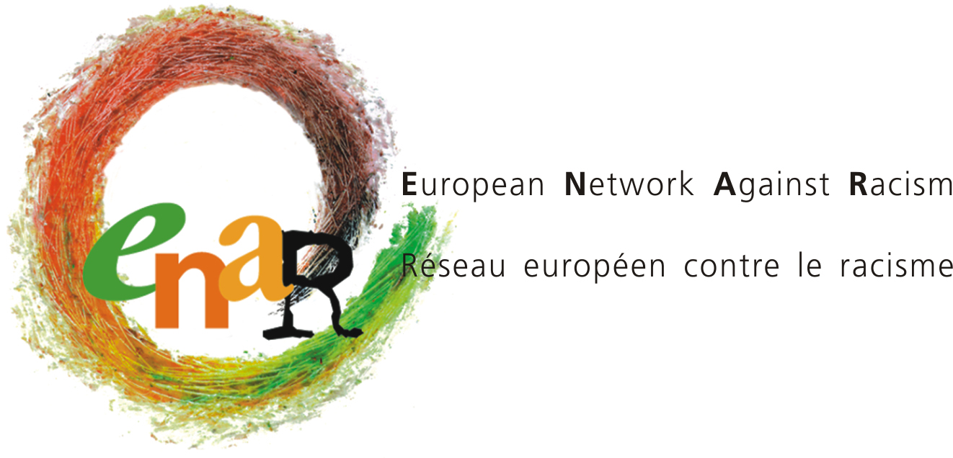

UN member states must step up efforts to combat Afrophobia
Recommendations for the Outcome Document of the Regional meeting of Europe, North America, and Central Asia of the International Decade for People of African Descent
United Nations Geneva, Switzerland 23-24 November 2017

Despite international human rights standards, as well as regional mechanisms and since the proclamation of the UN Decade for People of African Descent in 2015, little progress has been made to recognise and combat Afrophobia, the particular form of racism faced by people of African descent.
On the occasion of the Regional Meeting of Europe, North America and Central Asia for the International Decade for People of African Descent, the European Network Against Racism (ENAR) – a network of 150 anti-racism organisations in Europe – call on the outcome document to foresee strong commitments from Member States to start implementing the Decade and its programme of Action and conform to international human rights standards.

The UN should:
- Encourage Member States to adopt national plans against racism with the aim of promoting the rights of people of African Descent.

- Include recommendations toward the European Union regarding: the protection of people of African descent in anti-discrimination law, migration policy, protection against hate crimes and hate speech and social inclusion measures.

- Expand the knowledge base on the situation of People of African Descent, including its link with past injustices and its legacies, with a global report.

- Develop permanent structures to advance the rights of people of African descent, including a Permanent Forum for People of African Descent with a procedure to track, in a consultation with civil society, progress made on the objectives of the Decade.

will be wanting this international farm to discuss progress made opportunities for continued progress and presentations on the adoption of national action plans by member states With an opportunity for input from soul society regarding those plans and the progress that has been made

Member States should:
- Develop and implement national action plans against racism to document and address the specific and comparative situation of discrimination and exclusion experienced by People of African Descent. Such action plans should include, as a minimum:
  - Concrete policies setting out measurable activities, timeframes, monitoring and responsible ministries.
  - Include the collection of equality data on race and ethnicity across indicators which align with the Sustainable Development Goals and track progress in all areas.
  - Take an intersectional approach, recognising the multiple forms of discrimination experiences by people of African descent.
  - Recognise continuing legacies of colonialism and the transatlantic slave trade.
  - Mandate a comprehensive review of people of African descent in the criminal justice system.

- Take steps towards official recognition of histories of enslavement and colonialism and their continuing effect on people of African descent. Such recognition could come in the form of memorial sites, museums, official apologies to actively contribute to restoring dignity of victims and their descendants. Support to NGOs working on such goals should be made available.

- Ensure safe, legal routes for migration and ensure people can safely claim asylum, refrain from the criminalisation of asylum-seekers, end the detention of migrants, respect the principle of non-refoulement and eliminate all forms of discrimination in migration policies.

- Improve relations between the police and Black communities including through: formal and informal police/communities contact, mandatory anti-racism training, sanction of abusive behaviours, national legislation and police guidelines prohibiting racial profiling, proper investigation, prosecution and sanction of racist crimes and the development of clear and truly independent oversight mechanisms to monitor all action that impacts on rights and freedoms such as counter-terrorism measures, raids, surveillance and arrests.

- Promote knowledge and recognition of the cultures, histories and heritages of people of African descent, including through research and education and funding for exhibitions and programmes at museums and cultural centres.

- Take steps to combat racism, individual and structural in the education system. This should include: providing vocational training on non-discrimination and diversity for school administrators and teachers; conducting independent reviews of grades and records of Black students being sent to ‘special education’; providing counselling, student mediation and psychological services to Black student victims of racism; ensuring proper representation of teachers and professors of African Descent; and ensuring the school curriculum teaches accurately on the transatlantic slave trade, and colonialism.

- Take positive measures to address structural disadvantages for people of African descent in the field of employment, including: establishing public duties to promote equality and increase diversity within all public bodies; developing special measures and traineeships for people of African descent/Black Europeans; create subsidised government schemes and guidelines that encourage diversity in private companies at all levels; strengthen rules and practices of labour inspections to combat exploitation of migrants and reinforce complaint mechanisms for access to legal redress for migrants.

- Conduct health outreach activities with African descent populations to better inform communities of how they can better utilise health systems.

- Ensure opportunities for people of African descent to have an effective voice in decision making. Consider in particular the creation of special arrangements for seats or measures for appropriate representation in civil service, cabinets, parliaments and representative bodies at central and local levels and establish advisory bodies such as a cross-government working group to tackle Afrophobia.

For further information, please contact Sarah Chander, ENAR Advocacy Officer at sarah@enar-eu.org

Annex 1 – Background on afrophobia

In 2016 ENAR published the first pan-European report on the situation of people of African descent in the European Union – Afrophobia in Europe: ENAR Shadow Report 2014-2015. This report compiled the available data from governments and civil society relating to people of African descent or Black Europeans. The main findings from the report are:
- General: Lack of data collection makes it hard to understand the situation of people of African descent in Europe: numbers; instances of discrimination; overlap between PAD European citizens and more recent migrants. Problems with data collection.
- Criminal justice, Police brutality and ethnic profiling: reported as an issue particularly in Bulgaria, Cyprus, Estonia, Finland, France, Greece, Germany, the Netherlands, Portugal, Sweden and the United Kingdom
- Education: Students of African descent face discrimination and exclusion from teachers, counsellors, administrators and other students based on their skin colour, ranging from negative stereotyping to unduly placing Black children in segregated, special and/or vocational education schooling.
- Employment: Data trends demonstrate that PAD/BE people systematically have higher unemployment rates than the national average in all countries.
- Public and political participation: The under-representation of people of African descent in leading positions in political, public, private and non-profit sectors of society continues to be a barrier to combating racism and exclusion
- Media: Media disproportionately presents people of African descent in a stereotypical and negative manner, while failing to give accurate, positive and balanced portrayals of people of African descent, and to include historical periods and practices such as enslavement and colonialism
- Health: Racism has been reported to impact on the health of PAD/BE, particularly mental health (as reported in Germany, the Netherlands and the UK
- Housing: PAD/BE are reported to live in the older parts of urban areas; in poor quality and cramped housing; and face significant discrimination in the private rental market
- Migration policy: Changes in migration and asylum policies and practices impact both people of African descent who are recent migrants as well as Black Europeans with a migration background.

See also ENAR’s strategy document ‘Towards an EU Framework for National Strategies to combat Afrophobia and Promote the Inclusion of People of African Descent and Black Europeans’.

