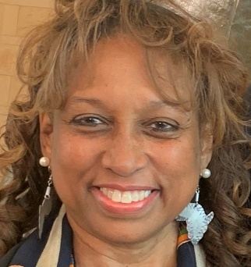

Dr. Angelique Walker-Smith

Rev. Dr. Angelique Walker-Smith is Senior Associate for Pan African and Orthodox Church Engagement at Bread for the World in Washington D.C. She brings global, national and local experience as a faith thought leader, journalist, speaker, and author. President Clinton, Senator Richard Lugar, former Indiana Governor (VP) Mike Pence and two of her alma maters, Yale Divinity School and Kent State University have awarded her with high distinctions of leadership. She received her doctorate degree from Princeton Theological Seminary and is former Executive Director/Minister of the Church Council in Indianapolis, Indiana, is related to the National Baptist Convention USA, Inc., a governance member with World Council of Churches and a President of Historic Black Churches at one of the widest represented ecumenical bodies of Christianity in the USA, Christian Churches Together (CCT).

