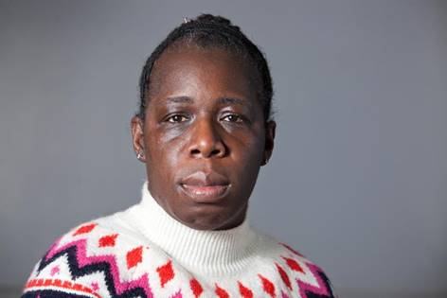

**Rosamund Kissi-Debrah**, mother of Ella Kissi-Debrah

Rosamund Adoo Kissi Debrah is a World Health Organization advocate for health and air quality and co-founder of the Ella Roberta Family Foundation, based in London. A former teacher, Rosamund became a clean air advocate after her 9-year-old daughter, Ella, died in 2013 from a rare and severe form of asthma. Rosamund spent several years campaigning for a second coroner's inquest into Ella's death to determine whether it was linked to air pollution. In a landmark decision in December 2020, the coroner ruled that it was. Ella is now the first person in the UK, and possibly the world, to have air pollution listed as a cause of death on her death certificate. Rosamund intends to continue advocating to secure the right for children around world to breathe clean air.