Forensic Architecture
Goldsmiths University of London
8 Lewisham Way
London SE14 6NW
United Kingdom
T+44 (0) 20 7078 5387

www.forensic-architecture.org

Dominique Day
Chair, Working Group of Experts on People of African Descent
Office of the High Commissioner for Human Rights
United Nations

Re: WGEPAD 28th virtual public session and report to the Human Rights Council on Environmental Justice, the Climate Crisis and people of African descent

London, 22 March 2021

I write on behalf of Forensic Architecture (FA), an investigative agency based at Goldsmiths, University of London, and in light of my experience as an environmental justice activist from New Orleans, Louisiana, USA. Our mission at FA is to innovate tools that merge grassroots knowledge and activist strategy with innovative technology and research methods to investigate state and corporate violence. As we communicate our findings, our work enters courtrooms, people’s tribunals, cultural centres, and media.

We are in the middle stages of a major investigation into environmental racism in Louisiana’s “Cancer Alley.” This effort aims to support the resistance efforts of fence-line community groups, such as RISE St. James, by drawing the invisible layers of 300 years of environmental racism into the visible register, revealing the past as an active force in the shaping of the present and the future. We plan to release a report in time for the 26th UN Conference of Parties (COP) in November 2021 and will submit the document to the Working Group of Experts on People of African Descent, the Committee on the Elimination of Racial Discrimination, and the Office of the High Commissioner for Human Rights.

Context

In December 2019, Rise St. James, a fence-line community activist organization in St. James, Louisiana, along with the Center for Constitutional Rights (CCR), their legal counsel, made an announcement: Four cemeteries holding the remains of historically enslaved Africans had been uncovered on the construction site of a 3.5 square-mile plastic feedstock facility owned by Taiwanese company Formosa Plastics.

How had this happened? The petrochemical construction site is an amalgam of several fallow sugarcane plantations. In the 19th century, the 150-mile stretch of land straddling the Mississippi River between Baton Rouge and New Orleans was known as “Plantation Country”—named for the slave plantations that lined the river’s banks.

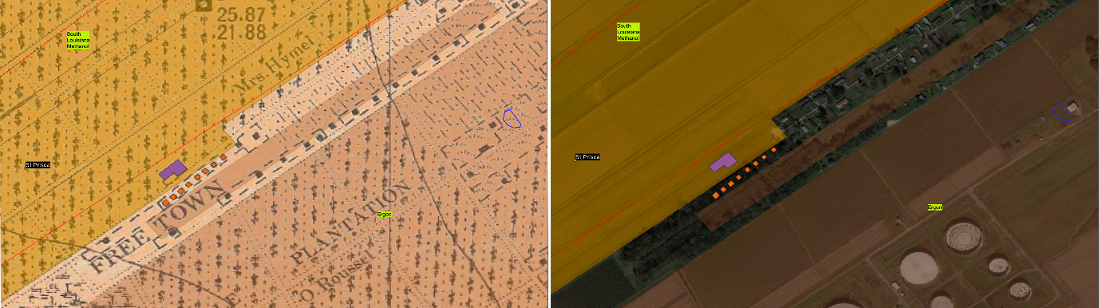The postbellum Black community of Freetown in St. James, Louisiana, is hemmed in by industrial facilities. Coloured shapes indicate extant and permitted petrochemical properties (2021).

Today, it is called the Petrochemical Corridor, named for the two hundred petrochemical plants, tank farms, and refineries that now occupy the footprints of fallow sugarcane fields, their boundaries often following the original plantation property lines.

Each year, millions of tons of carbon dioxide and carcinogens are emitted from facilities producing petroleum and plastic products, industrial chemicals, and fertilizer. Emissions of PM 2.5, ammonia, benzene, ethylene oxide, and chloroprene impair reproductive organs, the skin, and the respiratory system; some are mutagenic carcinogens. Louisiana ranks among the states with the lowest air quality standards and the highest rates of cancer in the US.

In the 1980s, local environmental justice activists nicknamed the region “Cancer Alley.” In recent years, activists with RISE St. James and the Concerned Citizens of St. John have re-branded the region once again—as “Death Alley.”

Historically, sugarcane was known as the most dangerous crop to cultivate and Louisiana’s sugar districts bore a negative birth rate among the enslaved population. Today, majority-Black freetown communities that grew from slave cabins after the Civil War are encroached upon by toxic facilities.

In 2014, the St. James Parish Council passed a comprehensive land use plan. It begins by reminiscing about the bygone era of “luxurious living, sumptuous entertainment, and delightful ease” when “acreage was counted by thousands and slaves by hundreds.” The plan goes on to re-designate the parish’s majority-Black 4th and 5th districts as “existing residential/future industrial,” a change that precipitated the closure of local post offices, schools, and businesses.

As industry expands, hundreds of cemeteries are at risk. Many have already been destroyed by pipelines, waste retention ponds, and industrial “borrow pits,” which displace sediment for use in construction projects; in the case of the Acadia Plantation Cemetery—one of the burial grounds on Formosa’s construction site—FA’s preliminary research has indicated that human remains may have been included in sediment used to maintain the levees that will protect the plastics facility from flooding.

RISE St. James and other local descendants of the interred recognize that these sacred sites must be located so that they can be protected and honoured, in line with recent national legislation calling for a National African American Burial Grounds Network Act. But they also recognize that these sacred sites are the frontlines in the struggle for environmental and climate justice.

Working class, Black descendants of historically enslaved people live in closest proximity to these facilities and are therefore the most vulnerable. But as RISE’s founder Sharon Lavigne notes, toxic air and water do not obey political borders.

One hundred years of extraction in Louisiana’s wetlands have eroded 2,000 square miles from Louisiana’s coast, leaving communities vulnerable to increasingly powerful and frequent hurricanes. Fertilizer produced at Mosaic Faustina—a diammonium phosphate facility where one of the burial grounds was identified in 2019—travels to up-country farms but returns to the Mississippi River in the form of run-off that poisons Louisiana’s drinking water, enters the Gulf of Mexico, and creates the largest dead zone in the US. Hexachloroethane, a known carcinogen produced at the Occidental Chemical Corporation in Death Alley, is also used by federal law enforcement as a riot control agent against Black Lives Matter protesters, notably in Portland. Plastic produced in Death Alley pollutes beaches in South Asia and is found in the foetal tissue of babies in Europe. And carbon dioxide that enters the atmosphere from Death Alley fuels global climate change.

Death Alley reveals the depth of the crisis and the stakes involved: environmental racism is a planetary crisis. Climate change, cancer, and coastal erosion are the end-products of colonialism and slavery.

Climate justice demands ecological reparations.

Investigation

FA was invited by RISE, CCR, and a coalition of activists, historians, genealogists, and lawyers to contribute to their combined struggle against the continued expansion of the petrochemical industry. FA’s cross-disciplinary investigation has so far entailed examining the chemical content of airborne industrial emissions, historical mapping of the region, remote sensing, video geolocation and analysis, citizen-led monitoring, and digital modelling.

In studying the morphologic and economic transition of the region, FA aims to develop a predictive methodology to locate cemeteries of historically enslaved people across Death Alley, supporting local efforts to recover erased Black cultural heritage sites and to push for a moratorium on the expansion of industry in Death Alley.

Conclusion

While our investigation is ongoing, it is already evident that the production of Death Alley, from the era of slavery to today, should be considered as a grand crime against humanity. Our research continues to reveal the ways in which the racism of antebellum Louisiana’s economic, environmental, and spatial practices quite literally laid the groundwork for the toxic overburdening of descendant communities. Several human rights violations are self-evident.

Organs of the United Nations including WGEPAD, CERD, and OHCHR must continue to both apply pressure on US governing bodies to cease their 300-year assault on Louisiana’s Black communities by denying permits for further petrochemical development, and urge the payment of reparations that can, in part, redress this legacy of violence and fund a just transition to a healthier, more dignified economy and environment for Louisiana.

Please find enclosed a document outlining our research methodology. We believe that our ultimate findings will underscore the urgency of these preliminary conclusions. Given this urgency, we will continue to update the WGEPAD as our research develops.

Sincerely,

Imani Jacqueline Brown

A community that neighbours industrial facilities.

