

**Annual report 2019**

The Interfaith Encounter Association is dedicated to promoting peace in the Middle East through interfaith dialogue and cross-cultural study. We believe that, rather than being a cause of the problem, religion can and should be a source of the solution for conflicts that exist in the region and beyond.

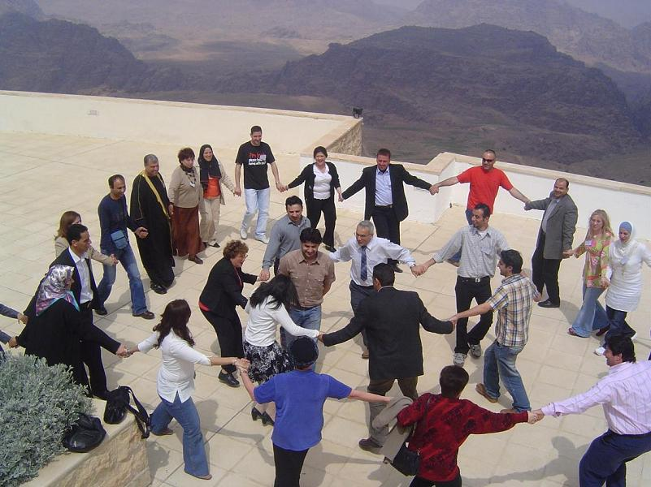

**Activity Report**

Although a challenging 2019 the Interfaith Encounter Association (IEA) has continued to spread hope and building peaceful relations in the Holy Land. We face all our challenges with optimism and believe that interfaith dialogue must be at the center of peacebuilding and is the key to a sustainable peace not only in the Holy Land, but around the world.   
 This year has seen over 4000 people coming together in 384 encounters in 105 different groups and the creation of several new groups. 8 of these groups were youth interfaith encounter groups. The encounters have taken place all over the Holy Land and involved a wide range of different group, from youth, university, and women’s groups to music groups, groups focusing on nonviolence and groups consisting of religious leaders. There are groups that constitutes people from both the West Bank and Israel, which however faces some difficulties as a result of the permit system for the Palestinians living in the occupied territory. However, we believe that our encounters can be part of something big and contribute to a real and sustainable peace in the Holy Land, since changes at the macro level first requires a transformation in people attitudes on the ground.   
 Every group discuss issues suitable to them in a respectful manner and in an open atmosphere characterized by curiosity, in order to increase understanding about the other. The most active encounter groups this year were the Model UN YIE and the Bearer of Peace Group in Hebron, which both met a total of 119 times throughout the course of the 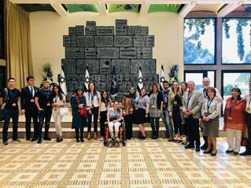year. The Model UN group has among other things hosted guest lecturer from NYC, held workshops on MUN skills at the US embassy, visited other countries for camps and meetings with local MUN groups, met with the UN mission in Israel and run negotiation simulations. The Debate for Peace Encounter Group has also been very active with a delegation of 9 students to the TIQVAMUN conference, with a number of students winning awards. Music in Felm has also been very active with 50 meetings thought the year.

In addition to the groups located in the Holy Land, two groups met throughout the year in Teaneck, NJ and in Keya.

In March we had the honor to participate at the conference on “Freedom of religion or belief, gender equality and the Sustainable Development Goals: Enabling positive synergies”, at the United Nations in Geneva Switzerland.

**General program**

People are regularly meeting to discuss their different perspectives on different issues and topics of their interests though active listening in a friendly, informal and open environment. They exercise the art of active listening which is extremely helpful in understand the other. Individuals connect on a personal level and the meeting and discussions are formed in a way that encourage understanding and learning and the exploration of commonalities and bridgebuilding rather than cleavages. Some groups focus on social activities, like sharing meals and engaging in sport- and cultural activities together, while others focus more on discussion of issues at the heart of the members of the group, while most groups focus on religious exchange. There are a few groups that focus on the political situation, although this is not a focus of our organization. Examples of issues of discussion are traditions, holidays, fasting, food, family life, workers’ rights health, God and visions for peace.  
 The nonviolent group has met regularly and discussed and practiced techniques of nonviolent communication, held retreats and hosted guest lecturers. The Music Interfaith Encounter group met 45 times this year and produced music in Arabic and Hebrew. The group in Hebron continues to meet and keep an optimistic spirit. Also, Leahs group continues to have inspiring meeting, with not only discussion of challenging topics, like identity, but also hosting tourists that shares their experiences and perceptions on issues. Scopus youth 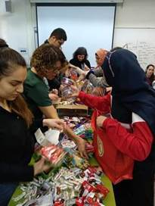interfaith encounter has met several times for different activities like meals, listening to singers and poets and learning about each other’s holidays and traditions. Moreover, religious leaders have been meeting to discuss religious texts and topics to uncover misunderstandings. One of the new groups is “the Tower of David forum” that is made up of religious leaders discussing everything from family values to peacebuilding and   
Bar Ilan U. group prepare  
gift bags for children for Purim. environmental protection. Moreover, the startup of the new group in Kenya has been a success.

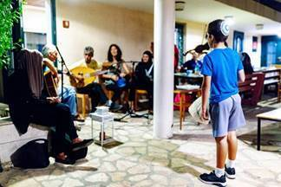In June, IEA traditionally held the Joint IEA-Iftar at the FELM center in Jerusalem. Around 130 local and international guests had a festive gathering with meal, conversations and music from the Interfaith Encounter Band. Quest of the night were Sheikh Hafiz Abdullah Muhammad from London  
Joint IEA-Iftar

**Israeli-Palestinian Dialogue**

IEA encourage encounters and dialogue between Israelis and Palestinians as a way of eliminating out-group hostility, misperceptions and stereotypes and as a method of striving for peace. A focus throughout IEA’s groups is to understand the other people and try to learn their language, traditions and religion. They meet to discuss similarities and differences in order to find common grounds. The members of the Bar Ilan University group stressed how much they learned about each other and how many commonalities they found although their different religions, and what an eye-opening experience that has been. This highlights the aim of our work, namely, to realize and experience the strength in the many more commonalities, we as humans have, than what divides us. One of the students said: " we did not discuss politics explicitly and it enabled building a seed of the desired situation. I am completely secular but see the power of religion as bridge-builder". This highlights another of our principles, namely, to keep discussions of politics out. Our goal is not to argue about what is right and wrong but to find commonalities, bridge divides and build grassroot peace. First when understanding and being able to empathy with the other, when relations are healed and trust and peace exists at the grassroot level, it is possible to discuss political issues in an effective way.  
 [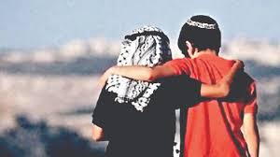](https://www.google.se/url?sa=i&url=https://jewishnews.timesofisrael.com/israel-palestine-coexistence-efforts-to-be-showcased-at-the-british-library-by-dclg/&psig=AOvVaw12KIMdM7Nm9YmMCeqQRIV2&ust=1586502921849000&source=images&cd=vfe&ved=0CAIQjRxqFwoTCNCtqZbm2ugCFQAAAAAdAAAAABAD)Moreover, the group in Hebron, has an important role in its fragile context, by discussing current issues and how to improve the conditions in the city. The Interfaith Listening Group with its unique focus on people sharing their stories in regard to the Israeli- Palestinian conflicts has contributed to eye opening experiences for many people.

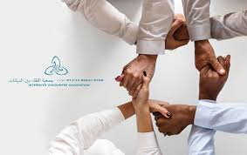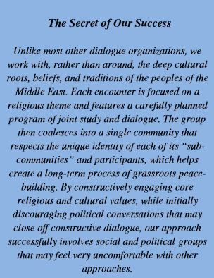

**Women’s Interfaith Encounter (WIE)**

Women´s encounter and their role in peacebuilding is crucial. These groups focus on the role of women in the society and in the creation of a more peaceful society. They shared meals and exchange experiences and challenges.   
 The most active WIE has been the Haifa Women’s group with 8 encounters. They have for example been to exhibitions together and traveled to Rabin Square in Tel Aviv where a festive rally took place to open the Mother´s Tent, which had meetings, talks and discussions that represented women´s wish for peace in the Holy Land. Also Yeruham-Rahme WIE met to talk about their lives and listen to workshops about for example health issues.  
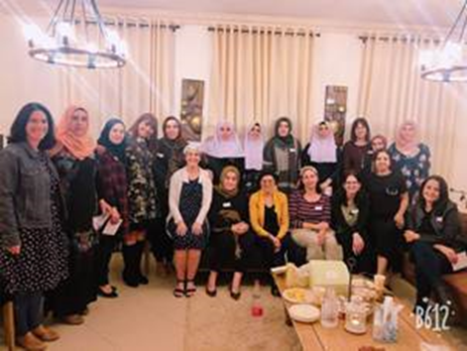Oranit-Kfar Kasem Women's Interfaith Encounter group had several gatherings where the women shared their visions for the future, values and opinions on different topics and listened to women awareness lecturer.   
 Midwives for peace also had several encounters. They addressed the lack of basic needs for women and sexual violence. This year a couple of women went to Canada and to the conference “Women Deliver 2019” on gender equality, women health and their empowerment. They also, held a conference for Palestinian Midwives and Nurses on the topic “sexual violence, trauma and women health”, and of how to identify, treat and care for sexual abuse survivors around birth. Focus was on awareness raising and solutions. The participants shared their experiences and discussed the issue in an enlightening way. The success of the conference and the need for discussing these issues, made them start planning on another study day.

**Youth Interfaith Encounters (YIE)**

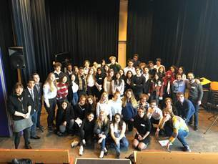The most active groups were the youth interfaith encounter groups. To make positive interaction with the other a normal part of life in the early age is essential for openness towards the other and peaceful coexisting.   
 The most active group, Model UN YIE, with 63 meetings have for example held workshops on MUN skills at the US embassy, met with MUN groups in Sweden, had meeting with the Italian and Belgian embassy where they learned about their work and discussed challenges with coexistence of diverse identities in one country and the role of social media in conflict resolution. They have also hosted a lecturer from NYC who talked about Islam and Judaism, and run a negotiation simulation with delegations from Georgia, Sweden and the UK. Furthermore, 5 students participated in the intercultural TOKA summer camp in Kosovo. Moreover, they visited the UN headquarters in Jerusalem, held a meeting with the UN Special Coordinator for the Middle East Process and met with the head of mission of UNTSO and learned about the UN peacekeeping missions on Israel’s borders.   
Debate for Peace Interfaith Encounter group has also been very active. For example, a delegation of 9 students went to the TIQVAMUN conference, with a number of students winning awards. In addition, a delegation of 10 students went to MEDIMUN in Cyprus to compete in the conference and meet with the UN mission in Cyprus. Before they attended the conference, they participated in a training session and had a meeting with the Ambassador of Cyprus in Tel Aviv.  
 Moreover, in addition to competing in the conference, the YALEMUN delegation visited NYC, Connecticut and the UN. They have also had a briefing with the Ambassador of Guatemala and Costa Rica in Tel Aviv. The Empathy Storytelling Delegation also visited the Netherlands, where they spoke at schools and visited Anne 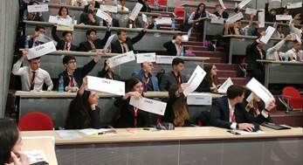Franks House and met with local interfaith groups.   
 They also participated in the RESOLVE Youth exchange in London, with peers from Georgia, Sweden and the UK, had a delegation to the GALMUN conference in Nazareth and held volunteering session in south Tel Aviv with refugee children.

**Special events**

On the 7th March 2019, our Executive Director Yehuda Stolov was participating in the conference on “Freedom of religion or belief, gender equality and the Sustainable Development Goals: Enabling positive synergies” at the United Nations in Geneva Switzerland.  
 Yehuda Stolov introduced the work of IEA: “Our main task is to create and maintain groups 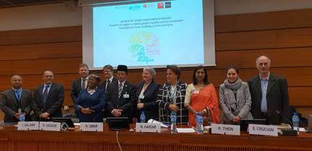made of people from different religious backgrounds throughout the Holy Land. We are building bridges among communities and neighborhood. We have thousands of participants across the Holy Land”.

 When asked about how to enable synergies, Dr. Stolov highlighted the importance of dialogue: “active dialogue, when participants share their depths, their beings, their souls... we believe in open and sincere conservations, with mutual respect, and without dictating to the other what to do or to think. It is important to talk and to listen to each other, with respect, and to share our own view in the same way…. Of course, you do not ignore the disagreements. Again, the key is respect. Listening and learning from someone you disagree with is very enriching. You learn how to be able to interact with other views, and this makes you think and rethink yours”. He stressed the key role of religions: “We aim for peaceful relationships made of mutual friendship and care. We do this by using religions as our main tool. As you know, religions can be a powerful tool that can be misused to create negativity, but it is also a powerful tool which could create positive and effective synergies”.   
 The conference launched a one-year expert consultation process, to which Yehuda Stolov has been appointed to participate. The purpose of the process is to explore the positive synergies, dilemmas and obstacles that may emerge in this relationship, and to discuss and draw up indicative examples of possible future projects showcasing the positive synergies identified.

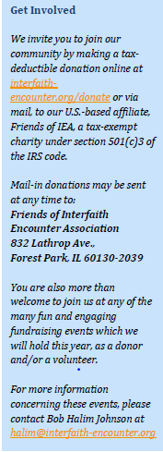*“Peace between countries must rest on the solid foundation of love between individuals”  
- Mahatma Gandhi*

This year had its challenges and our growth was slowed down by various problems   
but thanks to so many caring partners we made a lot of progress!    
 Thanks to all of you who supported us financially as well as   
participated physically in encounter groups.   
 We look optimistic at the future. We strive for reaching more people   
in 2020 and we hope that you will continue to partner with us in promoting peace in  
the Middle East and around the world. Peace in Israel/ Palestine is not only   
important for the region but for the whole world.

Our goal is a culture of peace in the Holy Land, and you are welcome to contribute   
to this.

**Every gift counts**

$30 covers printing and communication costs for one encounter

$100 pays for transportation for Palestinian youth to come to Israel for an  
encounter session

$250 allows us to retain trained coordinators for one encounter session

$500 covers all of the costs for one Palestinian and Israeli Youth Encounter for a year

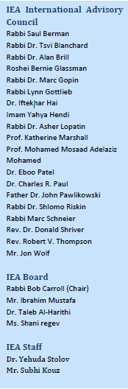**Interfaith Encounter Association**

2 HaSoreg Street, PO Box 3814

Jerusalem 91037, Israel

Phone: +972-2-651-0520

Fax: +972-2-651-0557

Email: office@interfaith-encounter.org

[www.interfaith-encounter.org](http://www.interfaith-encounter.org)