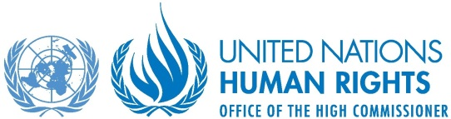

Intimidation and reprisals against those engaging with the UN on human rights: Examining trends and patterns

24 October 2018, 1.15 - 2.30pm
UN Headquarters, New York - Conference room 12
“We should all be deeply shocked and angered by the extent to which civil society actors suffer reprisals, intimidation and attack because of their work, including when they engage with the United Nations system … Intimidation and reprisals affect not only the individuals and groups directly impacted, but are alarming also for the message they send to other actors and individuals, whether from government or civil society, who wish to engage with the United Nations and express their views freely … Punishing individuals for cooperating with the United Nations is a shameful practice that everyone must do more to stamp out.”
– UN Secretary-General António Guterres (A/HRC/39/41, para. 78-79; 87)

The report of the Secretary-General on “Cooperation with the United Nations, its representatives and mechanisms in the field of human rights” identifies multiple ongoing trends and patterns in intimidation and reprisals which undermine individual and group participation with the UN. In December 2017 the UN General Assembly adopted - by consensus - a resolution in advance of the 20th anniversary of the UN declaration on human rights defenders, which condemned all acts of intimidation and reprisal by State and non-State actors and strongly called upon all States to give effect to the right of everyone, individually and in association with others, to unhindered access to and communication with the UN (A/RES/72/247).

Please join us for a discussion on current risks and trends facing people engaging or seeking to engage with the UN on human rights, with a focus on the response from governments and civil society, including good practices.

Speakers:
- Mr. Andrew Gilmour, UN Assistant Secretary-General for Human Rights
- H.E. Ms. Aud Marit Wiig, Norwegian Ambassador and Special Representative for freedom of religion and relief
- Ms. Eleonor Openshaw, New York Co-Director, International Service for Human Rights
- Ms. Isha Dyfan, Director of International Advocacy, Amnesty International

