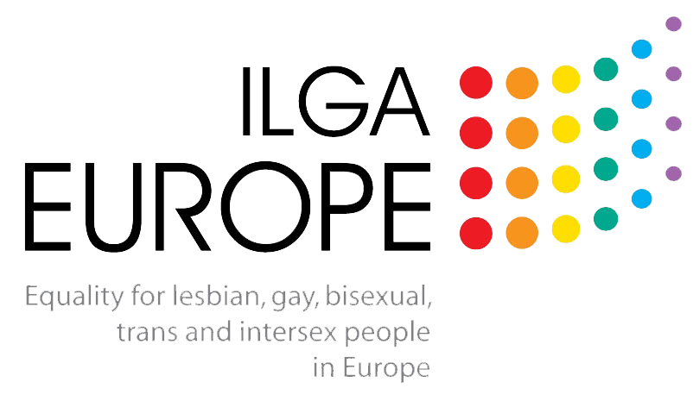
Submission to the Call for Inputs: Report of the Independent Expert on protection against violence and discrimination based on sexual orientation and gender identity with focus on practices of so-called “conversion therapy”
Prepared by ILGA-Europe
December 2019

This submission provides input to the Call for Inputs: Report of the Independent Expert on protection against violence and discrimination based on sexual orientation and gender identity with focus on practices of so-called “conversion therapy”, dated 21 November 2019 on behalf of the European Region of the International Lesbian, Gay, Bisexual, Trans and Intersex Assocation (ILGA-Europe), which holds special consultative status with the UN ECOSOC. Our responses to the prompts are include below in bold.

1. What different practices fall under the scope of so-called “conversion therapy” and what is the common denominators that allow their grouping under this denomination?
The common denominator, in our view, is that a practice is designed to induce change in sexual orientation, gender identity, and/or gender expression. Beyond this, there are a wide variety of methods and modes. This commonality, though, is of particular importance when considering the moral questions underlying legislative bans and restrictions on the practices.

Specifically, if a child or minor should not be subjected to practices that encourage a change in SOGIGE (given their inability to offer personal and informed consent), we must quesiton why these practices are allowed when discussing other vulnerable populations for whom “consent” and “free will” are limited, such as prisoners and those in detention, those deemed mentally ill or intellectually disabled (including those with autism, for whom some explicit treatment practices, accepted by medical professions, attempt to change gender expression), the elderly (particularly those in long-term care facilities), etc.

2. Are there definitions adopted and used by States on practices of so-called “conversion therapy”? If so, what are those definitions and what was the process through which they were created or adopted?
In our opinion, the current best practice definition of that of MALTA, which states:
Article 2. In this Act, unless the context otherwise requires:
"conversion practices" refers to any treatment, practice or sustained effort that aims to change, repress and, or eliminate a person’s sexual orientation, gender identity and, or gender expression; such practices do not include -
(a) any services and, or interventions related to the exploration and, or free development of a person and, or affirmation of one’s identity with regard to one or more of the characteristics being affirmed by this Act, through counselling, psychotherapeutic services and, or similar services; or
(b) any healthcare service related to the free development and, or affirmation of one’s gender identity and, or gender expression of a person; and, or
(c) any healthcare service related to the treatment of a mental disorder;

We support a broad definition with exclusions, so as to allow the most comprehensive interpretation possible. This is because we believe that laws of this nature serve both to clarify what kinds of practices are or are not acceptable, but also to progress societal discourse on the function of SOGIE in the personality of an individual, as well as to clarify that practices which seek to fundamentally change and individual on the basis of their SOGIE should be stopped.

3. What are the current efforts by States to increase their knowledge of practices of so-called “conversion therapy”? Are there efforts to produce information and data on these practices?
The German government recently concluded a large-scale scoping process in the development of a law banning conversion practices, which has since resulted in a draft law.

4. What kinds of information and data are collected by States to understand the nature and extent of so-called “conversion therapies” (e.g. through inspections, inquiries, surveys)?
The UK conducted data collection processes in 2019 that were inclusive of conversion practices exposure, finding that 2% of respondents were survivors of these practices.

7. Are there any State institutions, organizations or entities involved in the execution of practices of so-called conversion therapy? If so, what criteria have been followed to consider these as a form of valid State action?
Yes; one specific circumstance we wish to highlight is in the context of “gender clinics”, particularly in contexts wherein highly medicalised models are the norm, and pathologisation and gatekeeping are explicitly included in the trans-specific healthcare protocols. These kinds of methodologies, which regularly include a subjective assessment by the provider of the individual seeking gender-affirming healthcare, coerce trans and gender diverse people into particular gender identities and expressions with the goal of appeasing the provider and their pre-determined set of what makes a person “trans enough” or deserving of access to care. Barriers are particularly high for racialised individuals, those who do not identify as heterosexual or solidly within the gender binary, persons with disabilities (including physical, mental and intellectual), and those experiencing poverty. Within trans and gender diverse communities, it is widely understood that both access to gender-affirming healthcare and to legal gender recognition depend all too often on the inherent bias and stereotypes held by the provider or judge.

ILGA-Europe are an independent, international non-governmental umbrella organisation bringing together nearly 600 organisations from 54 countries in Europe and Central Asia. We are part of the wider international ILGA organisation, but ILGA-Europe were established as a separate region of ILGA and an independent legal entity in 1996. ILGA itself was created in 1978. www.ilga-europe.org

Available from https://meae.gov.mt/en/Public_Consultations/MSDC/Pages/Consultations/2016_Conversion_Therapy.aspx (accessed 13 December 2019)
Available from https://mh-stiftung.de/wp-content/uploads/Abschlussbericht_BMH_neu.pdf (accessed 13 December 2019)
Available from https://www.bundesgesundheitsministerium.de/konversionstherapienverbot.html (accessed 13 December 2019)
Available from https://www.gov.uk/government/publications/national-lgbt-survey-summary-report (accessed 13 December 2019)
See for example https://tgeu.org/wp-content/uploads/2017/10/Overdiagnosed_Underserved-TransHealthSurvey.pdf (accessed 13 December 2019)

