The Global State of Conversion Therapy - A Preliminary Report and Current Evidence Brief

This brief draws on data collected from a collaborative effort between the LGBT Foundation and Hornet Gay Social Network to conduct a rapid survey of a global, non-representative sample of LGBTQ+ individuals regarding their exposure to conversion therapy.

What is so-called “conversion therapy”?
The term “conversion therapy” is most widely used to describe practices attempting to change, suppress, or divert one’s sexual orientation, gender identity, or gender expression. Such practices are also called: reorientation therapy, reparative therapy, sexual orientaion change efforts, ex-gay/ex-trans therapy, gay cure therapy, or more recently, support for unwanted same-sex attraction or transgender identities.

Throughout history, members of the LGBTQ+ community have been subjected to efforts to convert or change their identities, either forcefully or by coerced choice. In the US alone, 19 states and numerous local jursidictions have implemented bans on conversion therapy for minors, and it is estimated that almost 700,000 LGBTQ+ adults have experienced some form of conversion therapy. More than 75,000 youth (ages 13-17) will receive some form of conversion therapy before the age of 18. Countless professional associations and multinational organizations – the American Medical Association (AMA), American Psychological Association (APA), and the Pan American Health Organization (PAHO)/World Health Organization (WHO) – have publicly announced opposition to the practice, as it lacks medical and scientific justification, and have condemned its use around the world. Additionally, 24 countries have taken steps towards limiting the use of this intervention, from complete bans to those that only prohibit the practice for minors. But to date, no analysis has looked at the burden of conversion therapy globally.

The term conversion “therapy” is itself a misnomer, given that this practice has been shown to have negative long-term health impacts. The practice aims to “convert” the patient from what is seen to be their homosexual lifestyle, and to eventually have them pursue a heterosexual, cis-gender identity that adheres to existing social norms and expectations. Broadly speaking, conversion therapy falls into four distinct categories: psychotherapuetic, medical, faith-based, and punitive. Practitioners who employ these approaches range from professional counselors and medical providers with public or private practices, to religious organizations, parents, school personnel, and even government agents (police, military, etc.). Numerous studies have found associations between experiences of conversion therapy and depression, suicidality (Ryan et al 2018), and other health outcomes (APA 2009). The persistence of these practices remains a stain on the world’s progress toward full equality for LGBTQ+ individuals and serves to undermine future efforts on this front.

To better combat the practice of conversion therapy, it is first necessary to understand its scope, geography, and methods.

What is the Status of Conversion Therapy Globally?

A survey was developed and integrated into the online social networking platform Hornet, and users were prompted to voluntarily participate in a series of questions regarding numerous topics. The survey was developed by combining existing measurement tools with newly designed questions to gauge experiences with conversion therapy. The survey consisted of a series of 44 questions covering a range of topics, including personal experience with conversion therapy, types of therapy experienced, long-term impacts, mental health, human rights, faith, and others. The survey was provided in several languages, including English, Arabic, Traditional and Simplified Chinese, and others. The survey was made available beginning on April 8, 2020. Any Hornet user was able to voluntarily participate in the survey.
8092 individuals from over 100 countries participated in the survey, ranging in age from under 18 to 85+. Of the 5820 individuals who responded to the question “Does conversion therapy happen in your country?”, 1851 participants responded “yes,” that they were aware conversion therapy occurs in the country where they live, and 1227 (21.08%) and 1263 (21.70%) responding that they were unsure or maybe, respectively. 1627 (20.09%) of respondents indicated that either they or someone they know (family member, friend, etc.) have been in conversion therapy. Additional preliminary findings broken down by topic are included below.

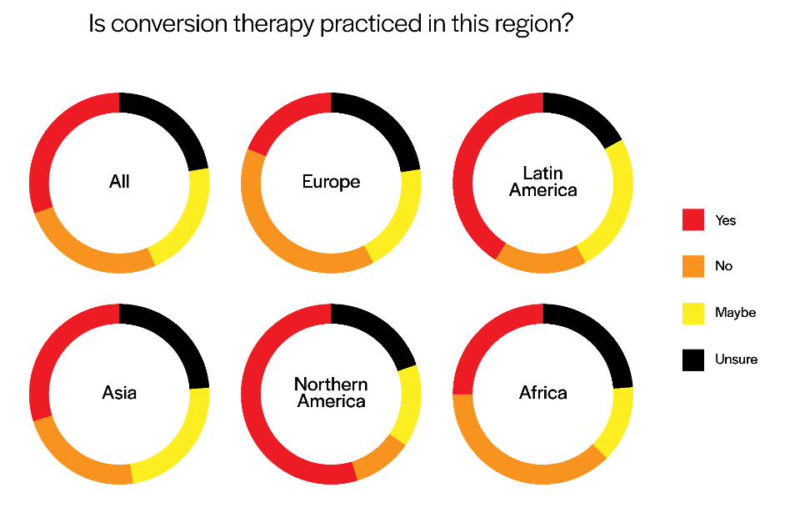
The Practice of Conversion Therapy

Participants report being exposed to a wide array of practices related to conversion therapy. The breadth of these practices aligns with the previously mentioned classifications: psychotherapeutic, medical, faith-based, and punitive. Using existing information about conversion therapy, 28 options were provided in the survey, but since fourteen individuals who had responded that conversion therapy existed in their country specified “none of these,” these options may not have been exhaustive in nature.

Perpetrators

The majority of practitioners who led conversion therapy were mental health providers, followed by religious authorities or their associates. Perhaps most concerning were the ~5% of respondents who indicated that government agents employed these harmful techniques. Additionally, 4% of reports involved school personnel, which may put LGBTQ+ youth at further risk.

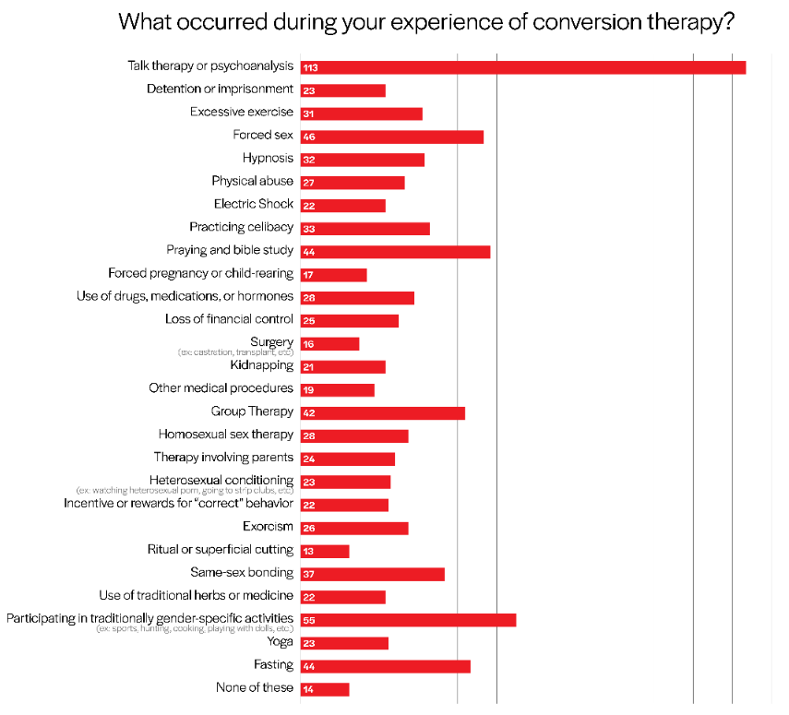
Motivation to Seek Conversion Therapy

Nearly a quarter of respondents expressed that they had sought out conversion therapy on their own, while the rest responded that the decision was largely outside of their control or made on their behalf by their school, family, or employer. The results for these questions reflect patterns similar to those in the previous section. This survey did not, however, ask further questions regarding coercion or forced participation, but given that there were reports of punitive measures taken, it is important to consider this possibility.
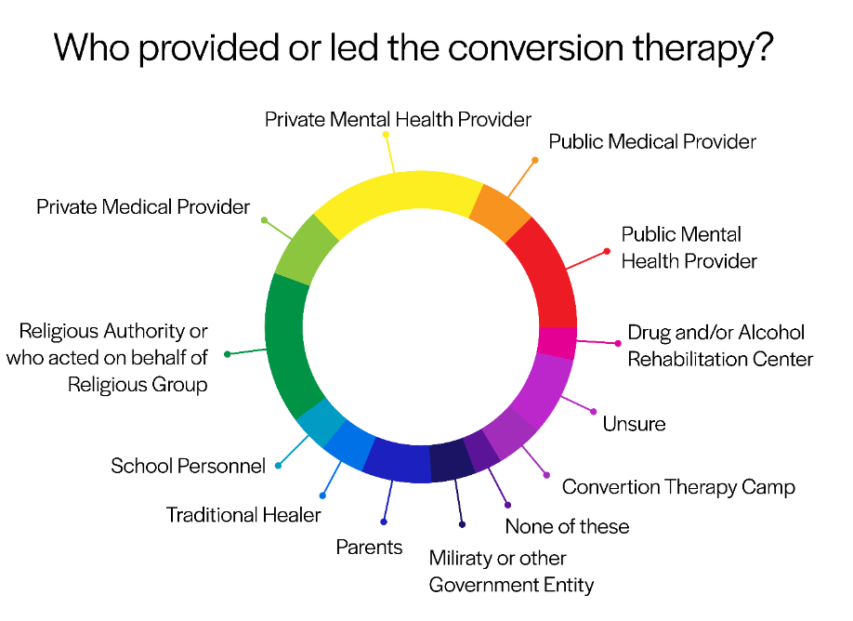

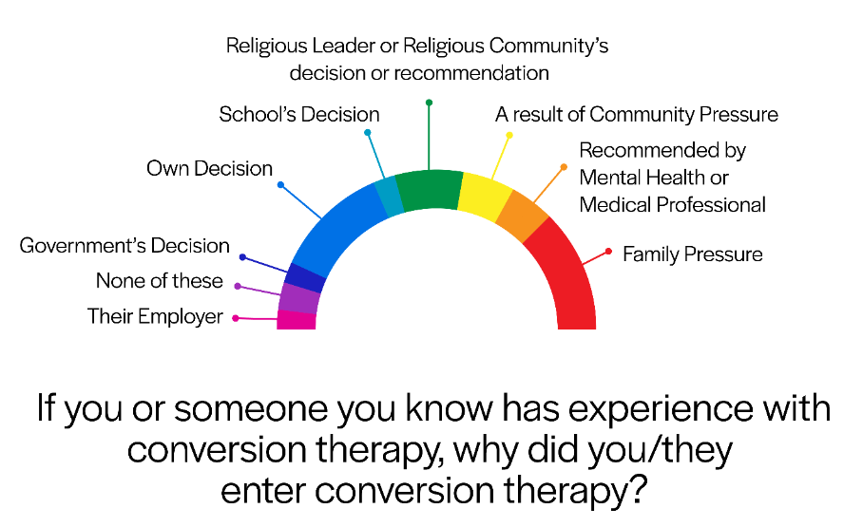
The Lasting Impact of Conversion Therapy

In addition to the major multilateral organizations that have put forward statements and recommendations regarding the practice of conversion therapy, countless professional medical and mental health organizations have denounced the practice. These resounding condemnations are due to the lack of medical justification for conversion therapy, the discrimination and pervasive societal bias that such practices perpetuate, and the vulnerability to long-term, negative health impacts such as depression, anxiety, substance use disorder, homelessness, suicidal ideation, post-traumatic stress disorder, and others. Minors are particularly susceptible, given their developing sense of self and vulnerability to coercion from family, peers, or other authority figures. This survey sought to collect additional quantitative data on a wide range of impacts resulting from conversion therapy.

Discussion
Participants reported being subjected to a range of different conversion therapy practices, all of which fall under the outlined categories (psychotherapuetic, medical, religious, and punitive). They also reported an array of practitioners who provided the therapy. Of particular concern, the indication that government actors are taking an active role in perpetuating this harmful practice may warrant further investigation. Long-term health impacts reported by individuals included suicidality, anger, depression, unwanted memories, and avoiding reminders of conversion therapy.
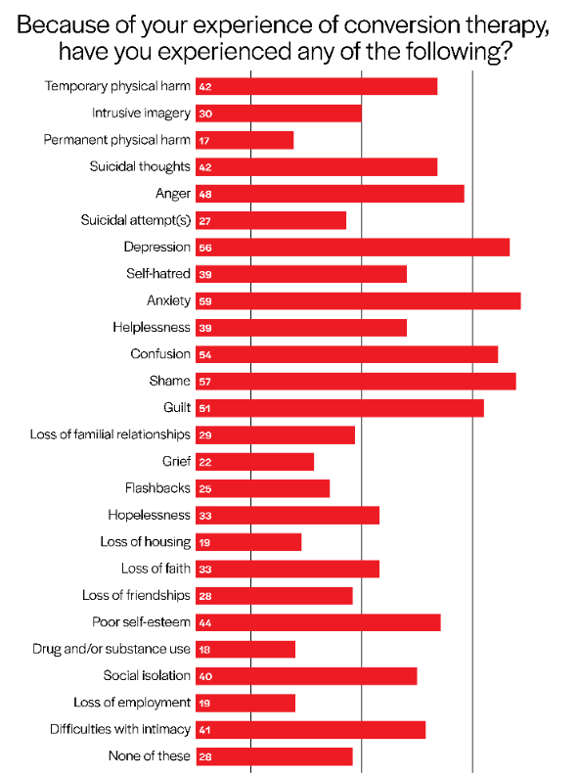
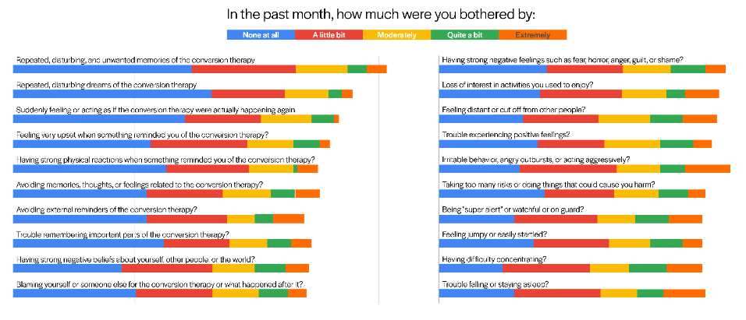
Some limitations of this first investigative effort to better understand the global extent of conversion therapy include that this initial survey was only offered in a few languages, thus participation was limited to those who know those languages. Using an application-based survey disproportionately selects for those who have access to the resources necessary to use the application, such as a cellphone or computer, internet or network, and others. Furthermore, given that there are areas of the world that actively limit, monitor, or censor the use of the internet, access to digital applications may be restricted. Lastly, individuals who are not “out” may choose to avoid using such applications out of fear for their safety, among other reasons.

These findings with a large global sample reveal that the practice of conversion therapy continues to be utilized around the world despite broad consensus on its harmful effects and lack of scientific justification. The results underscore the necessity for continued data collection to better understand the scope, geography, and methods of conversion therapy practices.

Authors:
Tyler Adamson
Sean Howell, CEO, LGBT Foundation
Alex Garner, Senior Health Innovation Strategist, Hornet
Marguerite Hanley, Program Director, Tech4HIV
Special thanks:
Sara Wallach, Stef Baral, Chris Beyrer

Appendix:

Region | Yes | No | Maybe | Unsure | Total
All | 1708 | 1395 | 1206 | 1186 | 5495
Europe | 305 | 524 | 271 | 341 | 1441
LATAM | 362 | 144 | 193 | 126 | 825
Asia | 832 | 649 | 687 | 622 | 2790
N.America | 172 | 37 | 38 | 62 | 309
Africa | 37 | 41 | 17 | 35 | 130

What occurred during your experience of conversion therapy? |  |  | n (%)
TempoT Talk therapy or psychoanalysis | 113 (12.99%) | Detention or imprisonment | 23 (2.64%)
Excessive exercise | 31 (3.56%) | Forced sex | 46 (5.29%)
Hypnosis | 32 (3.68%) | Physical abuse | 27 (3.10%)
Electric Shock | 22 (2.53%) | Practicing celibacy | 33 (3.79%)
Praying and bible study | 44 (5.06%) | Forced pregnancy or child-rearing | 17 (1.95%)
Use of drugs, medications, or hormones | 28 (3.22%) | Loss of financial control | 25 (2.87%)
Surgery (ex: castration, transplant, etc.) | 16 (1.84%) | Kidnapping | 21 (2.41%)
Other medical procedures | 19 (2.18%) | Group therapy | 42 (4.83%)
Heterosexual sex therapy | 28 (3.22%) | Therapy involving parents | 24 (2.76%)
Heterosexual conditioning (ex: watching heterosexual porn, going to strip clubs, etc) | 23 (2.64%) | Incentive or rewards for “correct” behavior | 22 (2.53%)
Exorcism | 26 (2.99%) | Ritual or superficial cutting | 13 (1.49%)
Same-sex bonding | 37 (4.25%) | Use of traditional herbs or medicine | 22 (2.53%)
Participating in traditionally gender-specific activities (ex:sports, hunting, cooking, playing with dolls, etc.) | 55 (6.32) | Yoga | 23 (2.64%)
Fasting | 44 (5.06%) | None of these | 14 (1.61%)

Who provided or led the conversion therapy? |  |  | n (%)
TempoT Public mental health provider | 227 (13.83%) | Public medical provider | 96 (5.85%)
Private mental health provider | 309 (18.83%) | Private medical provider | 120 (7.31%)
Religious authority or who acted on their behalf | 230 (14.02%) | Police, military, or other government entity | 73 (4.45%)
Traditional Healer | 80 (4.88%) | A drug and/or alcohol rehabilitation | 61 (3.72%)
Conversion therapy camp | 78 (4.75%) | School personnel | 72 (4.39%)
Unsure | 121 (7.37%) | Parent(s) | 114 (6.95%)
None of these | 60 (3.66%)

If you or someone you know has experience with conversion therapy, why did you/they enter conversion therapy? |  |  | n (%)
It was a result of family pressure | 325 (21.97%) | It was their school’s decision | 74 (5.0%)
It was a result of community (ex: neighbors, friends) pressure | 163 (11.01%) | It was recommended by a mental health or medical professional | 143 (9.66%)
It was my/their own decision | 391 (26.42%) | It was the government’s decision | 60 (4.05%)
It was their religious leader or religious community’s decision or recommendation | 176 (11.89%) | None of these | 95 (6.42%)
It was their employer’s decision | 53 (3.58%)

Because of your experience of conversion therapy, have you experienced any of the following? |  |  | n
TempoT Temporary physical harm | 42 | Intrusive imagery | 30
Permanent physical harm | 17 | Suicidal thoughts | 42
Anger | 48 | Suicidal attempt(s) | 27
Depression | 56 | Self-hatred | 39
Anxiety | 59 | Helplessness | 39
Confusion | 54 | Shame | 57
Guilt | 51 | Loss of familial relationships | 29
Grief | 22 | Flashbacks | 25
Hopelessness | 33 | Loss of housing | 19
Loss of faith | 33 | Loss of friendships | 28
Poor self-esteem | 44 | Drug and/or substance use | 18
Social isolation | 40 | Loss of employment | 19
Difficulties with intimacy | 41 | None of these | 28

In the past month, how much were you bothered by: | Not at all | A little bit | Moderately | Quite a bit | Extremely
Repeated, disturbing, and unwanted memories of the conversion therapy | 78 (47.85%) | 45 (27.61%) | 23 (14.11%) | 8 (4.91%) | 9 (5.52%)
Repeated, disturbing dreams of the conversion therapy | 87 (58.78%) | 32 (21.62%) | 18 (12.16%) | 6 (4.05%) | 5 (3.38%)
Suddenly feeling or acting as if the conversion therapy were actually happening again (as if you were actually back there reliving it) | 75 (52.82%) | 33 (23.24%) | 22 (15.49%) | 10 (7.04%) | 2 (1.41%)
Feeling very upset when something reminded you of the conversion therapy? | 60 (43.48%) | 42 (30.43%) | 20 (14.49%) | 12 (8.70%) | 4 (2.90%)
Having strong physical reactions when something reminded you of the conversion therapy (ex: heart pounding, trouble breathing, sweating, etc.)? | 67 (50.38%) | 36 (27.07%) | 19 (14.29%) | 2 (1.50%) | 9 (6.77%)
Avoiding memories, thoughts, or feelings related to the conversion therapy? | 58 (43.28%) | 33 (24.63%) | 21 (15.67%) | 11 (8.21%) | 11 (8.21%)
Avoiding external reminders of the conversion therapy (ex: people, places, conversations, activities, objects, or situations)? | 58 (45.67%) | 35 (27.56%) | 12 (9.45%) | 9 (7.09%) | 13 (10.24%)
Trouble remembering important parts of the conversion therapy? | 66 (50.77%) | 28 (21.54%) | 17 (13.08%) | 10 (7.69%) | 9 (6.92%)
Having strong negative beliefs about yourself, other people, or the world (ex: having thoughts such as - I am bad, there is something seriously wrong with me, no one can be trusted, the world is completely dangerous)? | 47 (36.43%) | 40 (31.01%) | 18 (13.95%) | 14 (10.85%) | 10 (7.75%)
Blaming yourself or someone else for the conversion therapy or what happened after it? | 54 (42.19%) | 33 (25.78%) | 20 (15.63%) | 13 (10.16%) | 8 (6.251%)
Having strong negative feelings such as fear, horror, anger, guilt, or shame? | 47 (37.60%) | 33 (26.40%) | 21 (16.80%) | 15 (12.0%) | 9 (7.20%)
Loss of interest in activities you used to enjoy? | 44 (36.07%) | 36 (29.51%) | 19 (15.57%) | 8 (6.56%) | 15 (12.30%)
Feeling distant or cut off from other people? | 37 (30.58%) | 32 (26.45%) | 23 (19.01%) | 14 (11.57%) | 15 (12.40%)
Trouble experiencing positive feelings (ex: being unable to feel happiness or have loving feelings for people close to you)? | 43 (36.13%) | 29 (24.37%) | 24 (20.17%) | 15 (12.61%) | 8 (6.72%)
Irritable behavior, angry outbursts, or acting aggressively? | 35 (29.91%) | 42 (35.90%) | 19 (16.24%) | 11 (9.40%) | 20 (8.55%)
Taking too many risks or doing things that could cause you harm? | 46 (39.66%) | 30 (25.86%) | 19 (16.38%) | 13 (11.21%) | 8 (6.90%)
Being "super alert" or watchful or on guard? | 33 (28.70%) | 36 (31.30%) | 17 (14.78%) | 14 (12.17%) | 15 (13.04%)
Feeling jumpy or easily startled? | 41 (35.65%) | 33 (28.70%) | 18 (15.65%) | 14 (12.17%) | 9 (7.83%)
Having difficulty concentrating? | 28 (24.35%) | 38 (33.04%) | 17 (14.78%) | 16 (13.91%) | 16 (13.91%)
Trouble falling or staying asleep? | 33 (28.45%) | 37 (31.90%) | 16 (13.79%) | 12 (10.34%) | 18 (15.52%)

Murphy, T. F. (1991). The ethics of conversion therapy. Bioethics, 5(2), 123-138.
Christy Mallory, Taylor Brown & Kerith Conron, The Williams Institute on Sexual Orientation and Gender Identity Law, UCLA School of Law, Conversion therapy and LGBT youth (Jan. 2018)
American Medical Association, “LGBTQ Change Efforts (so-called “conversion therapy”) https://www.ama-assn.org/system/files/2019-12/conversion-therapy-issue-brief.pdf
American Psychological Association. (2009). APA task force on appropriate therapeutic responses to sexual orientation. Report of the Task Force on Appropriate Therapeutic Responses to Sexual Orientation, 1-130
Pan American Health Organization (PAHO) (2012) Cures for An Illness that Does Not Exist https://www.paho.org/hq/dmdocuments/2012/Conversion-Therapies-EN.pdf
Ariel Shidlo & Michael Schroeder, Changing Sexual Orientation: A Consumers’ Report, 33 Professional Psychology: Research and Practice 3, 249-59 (2002).
Ryan, C., Toomey, R. B., Diaz, R. M., & Russell, S. T. (2018). Parent-initiated sexual orientation change efforts with LGBT adolescents: Implications for young adult mental health and adjustment. Journal of Homosexuality, DOI: 10.1080/00918369.2018.1538407.
American Psychological Association, supra note 3

