27 March 2020

Open letter on COVID-19 to the LGBT community

Dear friends,

This day, more than any other, I write these words with the sincere hope that this letter finds you well. I would like to express my solidarity with all of you, and acknowledge the unprecedented challenges that we are facing due to the COVID-19 pandemic. For some weeks now we have been dealing with shock, uncertainty, loss and anguish. I suspect that many of us share the disconcerting notion that this crisis will not pass quickly, and that we might be living through a significant change of the world as we know it.

In times like this, I remain acutely aware that the members of our communities, peoples and populations are amongst the most marginalized and excluded because of stigma and discrimination, and they are and will continue to be among those most at risk. We know, for example, that COVID-19 represents greater risk to persons living with compromised immune systems, therefore impacting particularly some persons living with HIV/AIDS, as well as older persons. Homeless persons, among whom LGTB persons are many, face exacerbated exposure to contagion. Those who already faced discrimination in accessing the health sector will only see existing barriers worsen. I also suspect that isolation may impose greater challenges upon those who carry out sex work and other types of informal work, as well as refugees, asylum seekers and other persons on the move. Many LGBT youth will now be forced to isolation within hostile environments with unsupportive family members or co-habitants. I also know that many among us lack proper access to paid sick leave, and that many others fear approaching public services because of stigma and criminalization.

All these challenges must meet our great determination. We must continue shedding light over them and promoting that measures taken by States adequately address them, just like we must increase our understanding of how this crisis affects other communities and peoples. I, for one, believe that this moment demands the type of conviction and discipline that I know the LGTB movement(s) can deploy, because I have seen them deployed time and time again. I also believe that our strength and tenacity, and our capacity for kindness and compassion will be among our unique contributions to the manner in which this great adversity will be met.

I am also eager to do my bit, by supporting you in any way possible, which might include the amplification of your voice and your lived experience. If you feel that this might prove to be useful, please do not hesitate to help me better understand how the COVID-19 pandemic affects your communities, how it impacts on your lives, your rights, and your freedoms, and I am also eager to hear if there are any other ways in which you think the mandate can contribute to supporting you through these uncertain times.

You can contact me at: ie-sogi@ohchr.org

Stay strong and safe my dear friends,

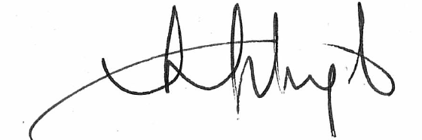
Victor Madrigal-Borloz
Independent Expert on protection against violence and discrimination
based on sexual orientation and gender identity

