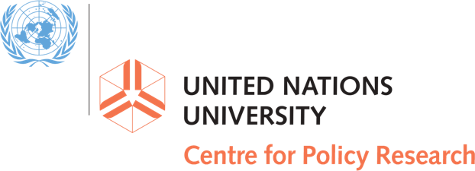

https://delta87.org/2019/03/tomorrows-slavery/

Addressing Tomorrow’s Slavery Today

Survey overview

Delta 8.7 is conducting a public consultation to seek inputs to feed into the research and drafting of an upcoming report of the UN Special Rapporteur on Contemporary Forms of Slavery, Ms Urmila Bhoola.

The report will consider how contemporary forms of slavery are changing, and being shaped by socioeconomic, environmental and technological dynamics. Based on an understanding of these dynamics, the report will consider whether contemporary anti-slavery efforts are well organized to address tomorrow’s slavery, and what opportunities and challenges there may be for strengthening governments’ and other stakeholders’ response.

We invite all interested parties to submit their views by completing the survey at this link (https://delta87.org/2019/03/tomorrows-slavery/) or by sending a document of no more than 10 pages to antislavery@unu.edu. Submissions **will** be made public, through posting on this page in PDF format after the submission period closes on Friday, 29 March 2019 at 00.00 EST, unless you specifically request non-publication. All submissions will be used by the research team in preparation of the report and may be referenced or quoted in the final report (with identifying information removed, if necessary).

Questions
Q1: Please provide a name or affiliation to be associated with the submission.

Q2: Please provide an email address at which we can reach the author.

Q3: Do you consent to the submission being published on this site?

Q4: What can we expect from tomorrow’s slavery?

The report will consider current trends and dynamics in contemporary forms of slavery. We welcome concise inputs addressing:
- current prevalence estimates and patterns,
- modeling of risks and vulnerabilities, to better understand major risk factors for modern slavery
- analysis of how slavery is being impacted by major socioeconomic, technological and political developments, such as:
  - conflict trends,
  - labour market changes,
  - demographic developments,
  - climate change,
  - shifting gender norms,
  - any other relevant major social trends.

Please share your views on (1) major slavery risk factors, (2) oncoming risk-multipliers and (3) how you predict these will change what slavery will look like in the future.

Please also feel free to share relevant sources you think should be considered.

Answers in the box below, up to 1,000 words, or as part of a single 10-page submission to antislavery@unu.edu.

Q5: Today’s anti-slavery.

This section will take stock of the current anti-slavery movement and provide an overview of what we know about what works in tackling modern slavery at the national, regional and global level. The section will then analyze what this tells us about which aspects of tomorrow’s potential slavery might be tackled and/or prevented by today’s anti-slavery strategies, and which aspects may require new strategies.

Please share your views on (1) what is known about ‘what works’ in anti-slavery policy, programming and strategies, (2) whether contemporary anti-slavery efforts are organized in a way that reflects this understanding of effective strategies, and (3) what might need to be changed in anti-slavery efforts to better build on ‘what works’ and/or address gaps in our programming and strategies.

Again, please feel free to share relevant sources you think should be considered.

Answers in the box below, up to 1,000 words, or as part of a single 10-page submission to antislavery@unu.edu.

Q6: Tomorrow’s anti-slavery.

This section will explore how the anti-slavery movement can adapt to effectively tackle current and future drivers of modern slavery, including new technologies, methods and partnerships.

Please share your views on the new methods and partnerships as well as technologies and tools, including potential risks, that are emerging that could help tackle tomorrow’s slavery, today.

Once again, please share relevant sources you think should be considered.

You can either provide answers of up to 1,000 words in the box below or e-mail antislavery@unu.edu

We thank you for your generosity with your time and insights.
The Delta 8.7 team

