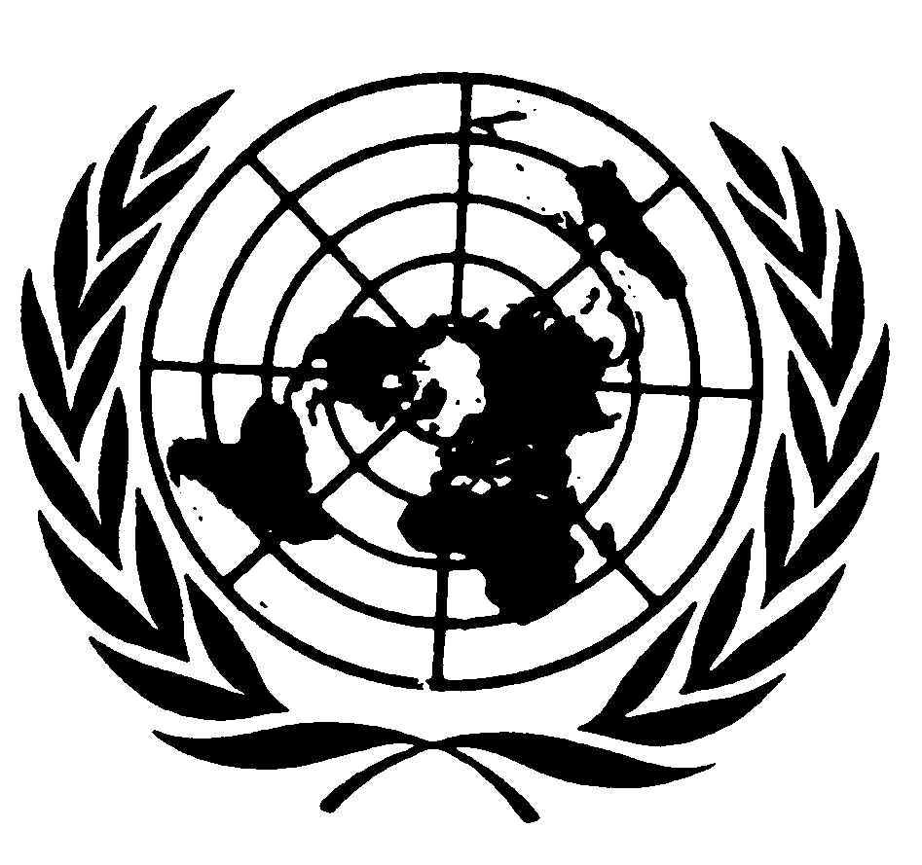

Remarks of the Special Rapporteur on the promotion and protection of human rights and fundamental freedoms while countering terrorism to the Open Briefing of the Counter-Terrorism Committee on “Integrating Gender into the work of the Committee and CTED”

November 1, 2019

Excellencies, Ladies and Gentlemen

I am very pleased to have this opportunity to address you today. I commence by underscoring the significance of holding an Open Briefing on gender integration into the work of the Committee and UN CTED, and in particular the openness of the Committee to addressing the role of women’s civil society organizations in countering terrorism and violent extremism.
When I was appointed Special Rapporteur in 2017, I identified a number of strategic priorities for the mandate, one of which was supporting the role of civil society organizations and civic space in advancing human rights and rule of law-based counterterrorism. Moreover, I wanted to highlight and bring attention to the protection and support required by civil society and where necessary revealing the misuse or overreach of counter-terrorism law and practice, specifically the negative effects that such actions would bring on the collective goal we share of protecting and promoting human rights while countering terrorism.
Civil society organizations are the heartbeat of communities around the globe. There is an old Irish phrase “ar scáth a chéile a mhairaann na ndaoine”, literally translated as “people live in each other’s shadows”, and I use it here to denote the intricate inter-dependence of successful counter-terrorism efforts with meaningful, direct and sustained positive relationship to peoples and specifically women’s lived lives. An engaged, supported, independent and robust civil society is critical to effective counter terrorism. Civil society organizations have been at the core of supporting, enabling and embedding conflict resolution, conflict transformation and bringing an end to cycles of violence that have plagued many parts of the world – a reality I am positively aware of, having lived much of my adult life in Belfast, Northern Ireland.
Civil society plays an integral part in countering violent extremism, preventing extremism and bringing the response to terrorism into balance with the broader human rights and international law obligations of states. It seems obvious to say that healthy civil society is an indicator of the well-being of individuals and contributes to the functionality and dignity of communities and people. Civil society organizations give voice to the marginalized and vulnerable, including victims of terrorism whose experiences are often channelled through civil society, and civil society organizations provide a constructive route to accountability and transparency in counter terrorism.
Civil society is also an essential cornerstone for engaging women and girls in civic discourse, public life and enabling the full capabilities of women and girls to be realized. As we know empirically, women’s engagement in public political life in many states has been historically limited, but women’s engagement in civil society activism has been sustained, vivid and unfailing across the globe. Women’s organizations and female actors are over-represented statistically in civil space, and so when we talk about supporting civil society, particularly in conflicted and violent societies we are in fact talking about supporting women and their voices. I would also underscore that when extremism and violence emerge, women are the canary in the coalmine, often they and their bodies are the first targets of violence and the first voices raised in civic space about the harms, the pathways and the need for accountability. During and after violence, civil society and women human rights defenders are first in line demanding accountability and calling us out when we fail to provide it. Civil society is also an essential independent entity to resist and prevent violence telling us all the uncomfortable things we don’t want to hear about the causalities and functionalities of extremism.
For all these reasons we collectively need and must defend independent civil society. But let me share some of the mandate’s concerns about our limitations in that regard and the imperative to do better. Last March I presented my annual Report to the Human Rights Council. In it, I directed my attention at the use and misuse of counter terrorism and preventing violent extremism law and practice against civil society actors and civic space. I did so in the knowledge that since 2001 on a number of markers civil society space around the globe is shrinking. We are aware that civil society is stigmatised, sometimes discriminated against and experiences a range of challenges both procedural and substantive -- and here I underscore again given the predominantly female hue of civil society; the effects of this shrinkage and harm are gendered My HRC Report was a move away from anecdotal stories (although those are important) about particular HRDs or civil society actors and an attempt to statistically track the use of such measures. My Report tracked the linkage between expanding global, regional and national security frameworks and the parallel diminishment of civil society.
Since its inception, 66 per cent of all relevant communications sent by the mandate of the Special Rapporteur have related to the use of counter terrorism, preventing and countering violent extremism (PCVE) or broadly defined security-related measures on civil society. For the last two years, the number is slightly higher, at 68 percent. This is an extraordinarily high figure, which underscores the misuse of counter-terrorism measures against civil society and human rights defenders over a decade and a half. I stress again that given the gendered makeup of civic space this finding has an obvious gender component. This robust empirical finding measured from 2005-2018 affirms that targeting civil society is not a random and suggests the hard-wiring of misuse into the use of counter-terrorism measures globally.
I bring these trends, statistics and patterns to our conversation in part to sensitize us all to the global pitfalls and to deepen our collective knowledge about the work ahead. Most obviously, given this important step by the Counter-Terrorism Committee to discuss the value and importance of civil society to effective counter-terrorism, hand in hand with the commitment to integrate gender into the work of the Committee and CTED -- there is an immediate and critical identification of one essential intersection where this integration work can be done. States every day know they need civil society actors to address the causes and conditions conducive to extremism and terrorism as identified by the UN Global Counter-Terrorism Strategy, and in the United Nations’ agenda on preventing and countering violent extremism. What this really means in many countries is that we need female led and constituted organizations to be our partners. Thoughtful States know every day that resilience in a society to extremism will only be embedded through a robust and healthy civil society and doing that work will be gendered. It will involve women and girls, boys and men who are at the heart of civil society work in every community on the planet. I have seen that demonstrated in the leadership and passion of victims of terrorism organizations that I meet in every country I visit; I see it in the women’s rights groups advocating for women’s full and equal participation in political life in countries beset by violence; I have seen it in the women around the globe leading human rights organizations and calling for accountability and justice because they understand that without these things were are in a Symphisian fight to counter-terrorism effectively.
Protecting and promoting independent civil society is one of the best inoculators for violence and extremism. Doing the opposite, namely targeting women’s civil society organizations is wholly inconsistent with meaningfully attending to genuine terrorist threats. Civil society is critical to -- channelling discontent and allowing for constructive engagement with States -- and the role of women’s civil society organizations is at the forefront of those efforts. We need them and I hope that this Open Briefing gives us the inspiration and the determination to engage such organizations in a spirit of partnership, generosity, equality, and the recognition of shared interests and values. I will close with the words of poet Rupi Kaur and say that:
"Our work should equip
the next generation of women
to outdo us in every field
this is the legacy we'll leave behind"

