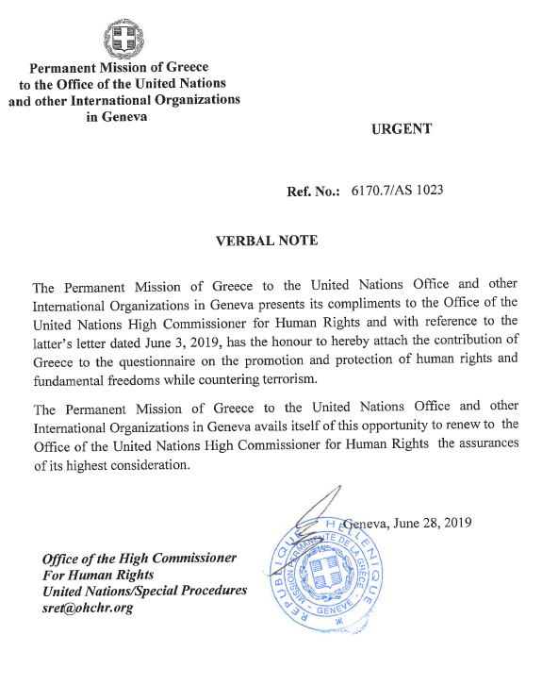

Hellenic Republic is working on the fight against terrorism on the basis of a legislative framework with main priority to strengthen the capabilities of the relevant agencies and to protect the individual rights and democratic freedoms of all citizens living in Greek Territory.
Competent Services for terrorism issues, in accordance with the P.D. 178/2014, are:
• The State Security Division of the Hellenic Police Headquarters, which has the general coordination on terrorism and radicalization issues at strategic level. It gathers information from all the competent Services (Law Enforcement Services, Intelligence Services and Third countries’ Authorities) in order to develop a comprehensive picture of terrorism issues and then guides the competent Services to deal with issues more effectively and coordinate their actions.
• The Special Violent Crimes Division (DAEEV), which consists of five sections, two of which focus on combating terrorism (one on domestic counter-terrorism and one on international counter-terrorism). A third section, the Special Operations and Controls Department, is responsible for various activities, including crisis management. DAEEV is based in Attica and includes a subdivision for Northern Greece, based in Thessaloniki.
• The Special Anti-Terrorist Unit (EKAM), which is under the Directorate of Special Police Forces. Its mission is the deployment of forces to deal effectively with serious and extremely dangerous situations, such as terrorist acts, armed conflicts, organized robberies, hijackings, kidnappings and general cases requiring intervention by specially trained and fully equipped with modern weaponry and material means of police forces.
• The Hellenic Police Intelligence Division (HPiD), is the Central Intelligence Hub of the Hellenic Police, focusing on combating all forms of crime, but mainly Serious and Organised Crime and Terrorism. The mission of the HPiD includes intelligence support and analysis of data deriving from preliminary judicial procedures to all Hellenic Police Agencies as well as to other National Security Authorities, Law Enforcement Agencies and Judicial Authorities. HPiD orientates its actions towards the prevention, identification or investigation of criminal activities, either in the framework of independent operational-intelligence activities, or through intelligence-support to other Authorities or Agencies, regarding serious and organized criminal behaviors inter-alia with cross border and trans-European dimensions.
The Hellenic Police Services, in the performance of their duties, attach great importance to the human rights field by combating, as far as possible, any action that violates fundamental human rights, which are preserved through a framework of constitutional, criminal and procedural provisions, demonstrating the sense of law governing Greek society. To this end, reports, recommendations of agencies for the prevention and treatment of acts of ill-treatment of individuals, as well as the jurisprudence of the European Court of Human Rights and the UN Human Rights Commission, are taken into account.
In this context, the Hellenic Police cooperates with competent authorities, such as the Council of Europe Committee for the Prevention of Torture and Inhuman or Degrading Treatment or Punishment (CPT), the National Commission on Human Rights, the Greek Ombudsman, the United Nations High Commissioner for Refugees (UNHCR), non-governmental organizations (NGOs) etc, to inform and educate police officers on human rights issues, as well as to provide support to refugees, migrants, vulnerable social groups and prisoners.

