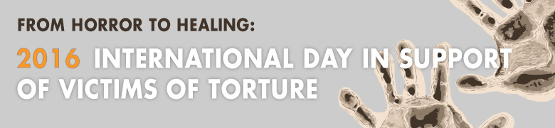

Key Messages on UN International Day in Support of Victims of Torture

Why 26 June?
- 26 June marks the UN International Day in Support of Victims of Torture. The day is an opportunity to call on all stakeholders including UN Member States, civil society and individuals everywhere to unite in support of the hundreds of thousands of people around the world who have been victims of torture and those who are still tortured today.
- 26 June is the day in 1987 when the UN Convention Against Torture and Other Cruel, Inhuman or Degrading Treatment or Punishment, one of the key instruments in fighting torture, came into effect. Today, the Convention is ratified by 159 UN Member States. This year, 2016, also marks the 35th anniversary of the UN Voluntary Fund for Victims of Torture, a unique victim-focused mechanism that channels funding for the assistance to victims of torture and their families.

Torture still endemic
- Torture still exists and victims of torture are in all regions of the world. Surveys show a shocking number of people even favour its use.
- On this day, we stand together to honour the victims, to show that they are not alone, and to renew our mission to work for a world without torture.

Laws regarding torture
- No circumstances ever justify the use of torture or other forms of cruel, degrading and inhuman treatment and punishment -- whether a state of war, a threat of war, internal political instability, or any other public emergency or national security situation.
- Providing assistance to victims of torture is not charity; it is the law. Article 14 of the Convention Against Torture stipulates the obligation of States to ensure that a victim of torture under their jurisdiction obtains redress, including the means for as full rehabilitation as possible.
- States must take effective legislative, administrative, judicial or other measures to prevent acts of torture in any territory under their jurisdiction. States must also provide effective and prompt redress, compensation and rehabilitation for all torture victims.

Effects of torture and the work of rehabilitation centres
- Torture’s pervasive effect on societies lies in spreading fear and intimidation; its consequences often go beyond the isolated act on an individual. The trauma of torture can be transmitted through generations and lead to cycles of violence and revenge.
- Recovering from torture requires prompt and specialized programmes. However, rehabilitation is possible through the doctors, lawyers, therapists and social workers who work with victims of torture, including children and adolescents every day. The work of rehabilitation centres and organisations around the world has demonstrated that victims can make the transition from horror to healing.

The UN Fund for Victims of Torture’s work
- The UN Voluntary Fund for Victims of Torture, administered by the UN Human Rights Office in Geneva, serves as a unique bridge between victims, practitioners and UN Member States in the field of redress and rehabilitation of victims of torture.
- In 2016 alone, the UN Fund is providing funding of US$7.1 million to 178 projects that will assist over 50,000 victims, both adults and children, in over 81 countries.
- On 26 June as on every day, the UN Fund stands by the victims around the world. This day is to honour them, and the many dedicated professionals that put their expertise at the service of those who have endured this gross violation of human rights.

