Biographies of Panellists

49th Session of the United Nations Voluntary Fund for Victims of Torture

Fifth Annual Public Panel

Surviving Torture and Fighting Stigma:
The road to recovery for victims of sexual and gender-based torture

3 April 2019, 11:00 am – 12:30 pm, Salle VII, Palais des Nations, Geneva
Mikolaj PIETRZAK  Chairperson, Board of Trustees, UN Voluntary Fund for Victims of Torture  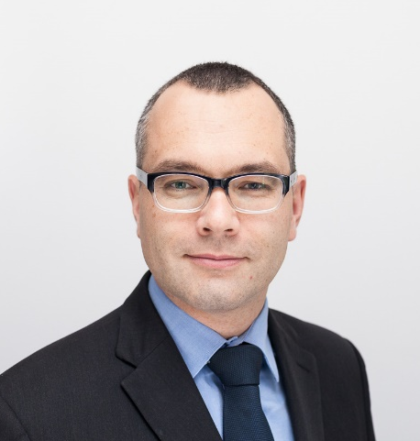 | Mr. Pietrzak is an advocate specialising in criminal law and human rights. He is a partner in the Pietrzak & Sidor Law Office in Warsaw and the Dean of the Warsaw Baw Association. He is the former Chairperson of the Human Rights Committee of the National Bar Council of Poland. He has extensive experience in trans-jurisdictional criminal cases, as well as human rights cases; he has represented both defendants and victims in domestic and international courts. He is a member of the Programme Committee of Amnesty International Poland and a member of the Social Council at the Office of the Commissioner of Human Rights in Poland.  Mr. Pietrzak received the 2018 Human Rights Prize of the Council of Bars and Law Societies of Europe (CCBE). He has been a member of the Board of Trustees since 2016, and its current Chairperson since April 2018.
Peggy HICKS  United Nations Office of the High Commissioner for Human Rights  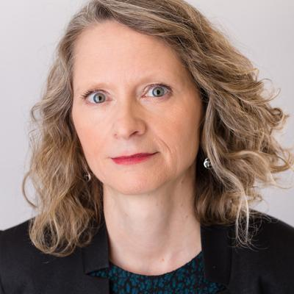 | Since January 2016, Ms. Hicks has served as Director of the Thematic Engagement, Special Procedures and Right to Development Division at the UN Office of the High Commissioner for Human Rights. From 2005 to 2015, she was global advocacy director at Human Rights Watch, where she was responsible for coordinating the organization’s advocacy team and providing direction to its advocacy worldwide.  Ms. Hicks previously served as Director of the Office of Returns and Communities in the UN Mission in Kosovo and as Deputy High Representative for Human Rights in Bosnia and Herzegovina. She has also worked as the Director of Programs for the International Human Rights Law Group (now Global Rights), clinical professor of human rights and refugee law at the University of Minnesota Law School, and as an expert consultant for the UN High Commissioner for Human Rights. Ms. Hicks is a graduate of Columbia Law School and of the University of Michigan.
Siris del Carmen RENTERIA RODRIGUEZ  Fundación Círculo de Estudios, Colombia  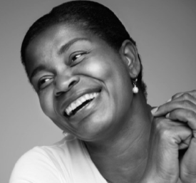 | Ms. Renteria Rodriguez is currently working with the Centre for Attention to Victims in Chapinero, Colombia. She is an advocate, accompanying victims of sexual violence in their rehabilitation process, and she is a survivor as well. She is originally from the department of Chocó, in the Pacific region; one of most affected Colombian regions most affected by the armed conflict and with the highest rates of poverty. For more than two years, she received psychosocial support offered by Fundacion Círculos de Estudios. Her legal case is also represented by the Foundation, thanks to the support of the UN Voluntary Fund for Victims of Torture. She is also featured in the photo exhibit, “El derecho de Voz(s)” (The Right to Voice) on display in Palais des Nations from 27 March to 5 April 2019 at the corner between buildings A and C.  Fundación Círculo de Estudios has worked since 2008 in the area of sexual violence and human rights violations in the context of the armed conflict in Colombia. They have designed a methodology of psychosocial accompaniment and human rights training, which the organization implements in its programmes. This methodology addresses three concepts: rehabilitation on an individual level, reintegration in society and the preventionof re-victimization. In addition, they have designed a rehabilitation process, which is based on the specific needs of the lesbian, gay, bisexual, transsexual and intersex (LGTBI) community and the causes of gender-based violence. Fundación Círculo de Estudios organized the above mentioned photo exhibit, “El derecho de Voz(s)”.
Aimé MONINGA  Men of Hope Refugee Association and  Refugee Law Project, Uganda | Mr. Moninga is a refugee from the Democratic Republic of Congo and an internationally renowned advocate for male survivors of conflict-related violence. As elected President of the Men of Hope Refugee Association, Mr. Moninga works with hundreds of male survivors who are in need of medical care and psychosocial support. To-date, he has seen the group grow from a handful of courageous male survivors, to its current membership of over 160 members who continue to push the boundaries on discussions relating to conflict-related sexual violence. As a methodology of work, Mr. Moninga is keen to shape people’s attitudes through the use of video clips highlighting the plight of male survivors of conflict-related sexual violence, as well as national and international advocacy. He has been provided with psychological and legal support by the Refugee Law Project, a grantee of the UN Voluntary Fund for Victims of Torture.  The Refugee Law Project (RLP) was established in 1999 to provide legal aid to asylum seekers and refugees in Uganda. Since then, the provision of legal aid has been supported by adding a psycho-social unit which provides clients with counselling and referrals on a range of non-legal matters, including sexual and gender-based violence, access to medical care, housing and education. The provision of direct support is complemented by education and training activities. Their Gender & Sexuality Programme works to ensure that all people can access and enjoy their sexual and gender being and rights, and to raise global awareness of the close relationship between violations of sexuality and gender, and patterns of forced migration.
Sonali GUPTA  Center for Victims of Torture (CVT) United States of America | Ms. Gupta is a licensed clinical psychologist with a specialization in trauma and international psychology. She has been involved in direct service provision to survivors of torture, refugees, victims of human trafficking and gender based violence, training and teaching, and program development and implementation. Ms. Gupta has over 10 years of experience working within torture treatment programs in the USA and with survivors of torture within conflict settings in the Middle East. Within these contexts, she has served as a therapist to individual survivors of sexual and gender-based torture. As the current lead of the Center for Victims of Torture’s (CVT) Gender Based Violence Working Group, she coordinates its activities and contributes to its deliverables, which include documentation of CVT’s expertise and approach to working with survivors of sexual and gender-based violence, including those amounting to torture.  The Center for Victims of Torture (CVT), an international organization based in the USA, provides direct services to survivors of torture, many of whom have experienced sexual and gender-based torture. CVT data indicates that approximately 43 per cent of clients in the CVT centre in Minneapolis, USA and 22 per cent of clients in its center in Atlanta, USAreport experiencing some form of sexual and/or gender based violence, including torture. Services provided are holistic and integrated in nature, and recognize that survivors of torture can have a broad range of needs and concerns. Services are comprised of group and individual mental health services, case management, and referral and linkage to other key services including health and legal services. The UN Voluntary Fund for Victims of Torture has been supporting CVT since 1988 and is currently funding its project on clinical services for victims of torture.
Jane CONNORS  Assistant Secretary-General  UNVictims' Rights Advocate  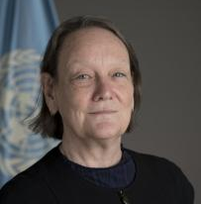 | Ms. Connors was appointed by Secretary-General António Guterres as the first Victims’ Rights Advocate for the United Nations on 23 August 2017. As Victims’ Rights Advocate, Ms. Connors will support an integrated, strategic response to victim assistance in coordination with United Nations system actors with responsibility for assisting victims. She will work with government institutions, civil society, and national and legal and human rights organizations to build networks of support and to help ensure that the full effect of local laws, including remedies for victims, are brought to bear. Ms. Connors brings to the position a long and multi-faceted career in human rights advocacy as well as human rights and humanitarian assistance in the academic, United Nations and civil society spheres.  Prior to this appointment she was International Advocacy Director Law and Policy for Amnesty International in Geneva. Prior to that, she was Director of the Research and Right to Development Division at the United Nations Office of the High Commissioner for Human Rights (OHCHR). In 2002 she joined OHCHR, where she worked in the Human Rights Treaties Division and as Chief of the Special Procedures Branch. From 1996 and 2002 she was the Chief of the Women’s Rights Section in the Division for the Advancement of Women in the Department of Economic and Social Affairs in New York.

