|  |  |  |  |
| --- | --- | --- | --- |
|  | United Nations | A/HRC/45/12/Add.4 | |
| _unlogo | **General Assembly** | | Distr.: General  17 September 2020  English only |

**Human Rights Council**

**Forty-fifth session**

14 September–2 October 2020

Agenda item 3

**Promotion and protection of all human rights, civil,   
political, economic, social and cultural rights,   
including the right to development**

Report of the Special Rapporteur on the implications for human rights of the environmentally sound management and disposal of hazardous substances and wastes on his visit to Brazil

Comments by the State[[1]](#footnote-2)\*

Report of the Special Rapporteur on the implications for human rights of the environmentally sound management and disposal of hazardous substances and wastes (Advance Unedited Version) — Comments from Brazilian authorities

1. The present document is a manifestation of the Brazilian state concerning the preliminary version of the report on the visit of the United Nations Special Rapporteur on Waste and Toxic Substances, Baskut Tuncak, to Brazil, held in December 2019. It is based on comments from the National Agency of Health Surveillance (Anvisa[[2]](#footnote-3)), Brazilian Institute of the Environment and Renewable Natural Resources (IBAMA), Ministry of Health (MS), and Ministry of Justice and Public Security (MJSP).

Duties and responsibilities to protect life and prevent exposure  
(Pesticides, Forest Fires and Industrial Chemicals)

2. First, it is necessary to present information about the pesticides regulation in Brazil. According to Law 7,802, of July 11, 1989, the regulatory process for pesticide products is a complex act involving the Ministry of Agriculture, Livestock and Supply (MAPA), the Ministry of the Environment (MMA), through IBAMA, and the Ministry of Health, through Anvisa. Each agency analyzes the registration request according to its competence. MAPA, as the registering body, is responsible for issuing the registration certificate.

3. The toxicological assessment for the sake of safety in the use of a pesticide is a highly specific and complex technical report. In this context, due to this particularity of the process, the evaluation is multidisciplinary and interdependent. Such practice contributes to the safe assessment of a product used in the production process, which can affect Brazilian society through occupational exposure or dietary exposure to its residues in food. Hence, it is necessary to estimate, as precisely as possible, the amount of pesticides to which individuals are exposed.

4. From the consumer's point of view, this estimate is made by assessing dietary risk, which involves analyzing the likelihood of adverse effects on human health, resulting from the ingestion of food containing pesticide residues. From this assessment, different parameters are established, among which the Dose of Acute Reference (DRfA), the Acceptable Daily Intake (IDA), and the Residue Maximum Limit (LMR) in food. Therefore, the assessment of dietary risk is part of Anvisa's assessment routine.

5. Anvisa also monitors the levels of pesticides in food within the Food Pesticide Residue Analysis Program (PARA). The Program is an action of the National Health Surveillance System (SNVS), coordinated by the Anvisa, in conjunction with the state health surveillance agencies and the Central Public Health Laboratories (Lacen). Created in 2001, initially as a project, it became a program in 2003, through the Resolution of the Collegiate Board - RDC 119, of May 19, 2003. Since then, the Project analyzed more than 35 thousand samples of various foods representative of the diet of the Brazilian population.

6. The program's main objective is to monitor pesticide residues in food, aiming to mitigate the health risk resulting from exposure to these substances through the diet, evaluating irregularities and health risks, based on the analysis of samples collected across the country.

7. Anvisa evaluates the program's analysis outcomes and maps the distribution of pesticide residues in food so that mitigating measures are adopted when irregularities or health risks are verified. Consequently, it contributes to food security, guiding the production chains on the existing non-conformities in their production process, and encouraging the adoption of Good Agricultural Practices (BPA). PARA publishes the results in detailed reports, available on the Agency's electronic portal[[3]](#footnote-4).

8. In 2019, a report published the results of the first cycle of the 2017-2020 Multi-Year Plan of PARA. In all, 4,616 samples of 14 foods of plant origin representative of the diet of the Brazilian population were analyzed: pineapple, lettuce, garlic, rice, sweet potato, beet, carrot, chayote, guava, orange, mango, bell pepper, tomato, and grape. The samples were collected in retail establishments in 77 Brazilian municipalities, and up to 270 different pesticides were researched in the analyzed samples.

9. Of the total samples, 3,544 (77%) were considered satisfactory regarding the researched pesticides. In 2,254 samples (49%), no residues were detected, and 1,290 samples (28%) presented residues with concentrations equal to or less than the Maximum Residue Limit (LMR), established by Anvisa. 1,072 samples (23%) were considered unsatisfactory in relation to compliance with the LMR.

10. Considering the results obtained in the 2017/2018 cycle, all detected pesticide residues with an established Dose of Acute Reference (DRfA), an acute toxicological safety parameter, were submitted to an acute risk assessment. This evaluation indicated that 0.89% of the analyzed samples had an acute health risk potential.

11. Regarding the chronic risk assessment, considering the data obtained from 2013 to 2018, there were no situations of potential risk to consumers' health for the group above ten years of age, which is the population covered by the last published survey of food consumption data in the country (Household Budget Survey POF/IBGE 2008-2009).

12. Thus, the results of monitoring and risk assessment compiled in this report, corresponding to the analysis of various foods that are part of Brazilians’ basic diet, indicate that the foods consumed in Brazil are safe as regards the potential risks of acute and chronic intoxication arising from dietary exposure to pesticide residues. The registered acute risk situations are punctual and of known origin. So, Anvisa has been taking steps to mitigate the identified risks and develop standards that enable the control and proper use of pesticides by the different food production chains. It should be noted that the results regarding the identified risks are similar to those obtained in the European waste control program conducted by the European Food Safety Authority (EFSA).

13. It should also be noted that the analysis methodology adopted by Anvisa for the assessment and toxicological re-evaluation of pesticides is in line with the best international regulatory practices. All tests and trials must be carried out under the specifications issued by the World Health Organization (WHO), the International Chemical Safety Program (IPCS/WHO), the International Agency for Research on Cancer (IARC/WHO), the Pan American Center for Human Ecology and Health (ECO/PAHO), the United Nations Food and Agriculture Organization (FAO), the International Registry of Potentially Toxic Substances of the United Nations Environment Program (IRPTC/UNEP), the Organization for Economic Cooperation and Development of the European Economic Community (OECD/EEC) and the United States Environmental Protection Agency (EPA).

14. Next, excerpts from the preliminary version of the Special Rapporteur's report that deserve comments and clarification will be highlighted.

*30. Pesticides prohibited by other countries because of environmental or health risks remain in use in Brazil. Forty-four percent of active ingredients in Brazil are not approved in the EU (p. 8).*

*58. Brazil’s laws and policies have not eliminated many hazardous substances and processes forbidden around the world. To the contrary, the Government’s deregulatory agenda has increased the hazards confronting workers (p. 14).*

*(n) Develop time bound plants to urgently reduce pesticide and toxic industrial chemical use and exposure, including: (vi) Ban the use of industrial chemicals forbidden from use in OECD countries (p. 63)*

15. **The data is obsolete. It should be noted that the exclusion of several active ingredient monographs by Anvisa, according to the original reference, dated July 31, 2019[[4]](#footnote-5), was not taken into account. It means 47 active ingredients of pesticides have been eliminated and are no longer authorized in Brazil.** Anvisa adopted this measure due to the absence of registered products based on these active ingredients.

16. Besides, the survey did not point out that some monographs of substances authorized in Brazil and considered prohibited in the European Union are allowed exclusively for use as a household cleaning agent or wood preservative, not being classified as pesticides, that is, they are not authorized for agricultural use in Brazil. The European information bank used in the consultation presents results for substances used exclusively as pesticides. Therefore, the updated information would be the one described below, in the right column, adopting the literal translation of the term used by the European Commission (approved or not approved). It is noteworthy that this is dynamic data and should be updated periodically.

| *Cited reference information* | *Information updated by Anvisa on 7/31/2020* |
| --- | --- |
|  |  |
| Of the 353 active ingredients authorized in Brazil:  - 194 (55%) are AUTHORIZED in the European Union;  - 155 (44%) are FORBIDDEN in the EU.  - 22 (14,2%) of the forbidden substances are BANNED in Europe. | Of the 393 active ingredients authorized in Brazil:  -277 (70%) are approved in the European Union;  - 116 (30%) are not approved in the EU. |

Anvisa (2020).

17. It is essential to clarify that the non-approval of an active pesticide ingredient in a given country can be associated with several reasons, not necessarily resulting from a restriction related to risks to human health. Local characteristics related to the type of cultivation, the climate, and the pests faced in the field can be decisive to define the real needs for agricultural practices in each country. Eventual environmental impacts can also cause restrictions to minimize risks. Failure to comply with all legal requirements may prevent the registration or renewal of the use of an active ingredient in a particular country.

18. In this sense, it is noted that it is inappropriate, in technical terms, to mention the information in item 30 of the draft without considering the entire context linked to such mention.

19. One must also consider the amount in which each of these active ingredients is being marketed in Brazil.

20. Data from the pesticide marketing report issued by Ibama for the year 2018 show that, of the ten most commercialized active ingredients in Brazil, which correspond to about 71% of the volume of pesticides sold in the country, all are approved in the United States, and only three are not approved in the European Union. Of these, two were recently reassessed by Anvisa and obtained a series of measures to mitigate health risks.

21. In the last ten years, thirteen active ingredients of pesticides were reevaluated, of which eight were banned in Brazil, and several restrictions have been established to mitigate the identified risks. On August 26, 2019, Anvisa published a new list of pesticide ingredients that will undergo the toxicological reassessment process. This list was defined through an objective assessment, the score based on hazard and risk criteria, to identify pesticides with reassessment priority.

22. The list, drawn up with broad participation from society, was established based on danger and risk to human health. The choice of criteria prioritized the risks to consumers and rural workers.

23. The statement mentioned on page 8 of the preliminary report is also noteworthy, namely:

*8. Brazil continues to use and export sulfuramid to other countries, a pesticide banned in other jurisdictions for decades, which degrades into “forever chemical” substances contaminating people around the world.*

24. The source of information highlighted regarding the export of the substance “sulfluramide” by Brazil has not been identified.

25. In any case, it is vital to inform that “sulfluramide” is 81st among the active ingredients marketed in Brazil in 2018, according to Ibama’s Pesticide Marketing Bulletin. According to the bulletin mentioned above, the volume of sulfluramide sold corresponds to 0.01% of the total amount of active ingredients sold in 2018.

26. Another relevant fact is that researches for the active ingredient sulfluramide in more than seven thousand samples of different foods, from 2013 to 2018, within the scope of the PARA program, did not detect residues in any sample. Currently, the substance is authorized in Brazil as an insecticide and ant killer in the control of ants of the species *Atta spp* or *Acromyrmex spp*.

27. Also, page 9 of the preliminary report indicates the following:

*To the contrary, Brazil has increasingly pursued deregulatory measures to authorize additional hazardous pesticides through legislative and regulatory changes promoted by industry.*

*In recent years, the “flexibilization” of pesticides regulations points to a tendency of misplaced interests. In 2019 alone, Brazil permitted the introduction into the market of 474 new pesticides products.*

28. It is recalled that the registration of pesticides, their components, and the like is an assignment shared between three federal agencies: the Ministry of Agriculture, Livestock and Supply, the Ministry of Health, represented by Anvisa, and the Ministry of the Environment, represented by Ibama. All have equal decision-making power over whether or not to grant registration, safeguarding their respective areas of activity and institutional competencies.

29. It is essential to highlight that the three federal agencies have been looking for solutions specific to their internal realities, to obtain increased productivity when evaluating pesticide registration requirements. As a result of this joint effort, it is natural that there will be an increase in the number of assessed products and, in many cases, registered, following the trend of growth in demand for registration presented by the regulated sector.

30. In this context, it must be reiterated that all registered products are previously subjected to a rigorous technical evaluation carried out by those bodies concerning aspects related to health and the environment. Thus, the number of products registered per year should not be considered a negative indicator, since it refers only to the insertion in the market of new safe alternatives for rural producers, including chemical and biological products, which were approved because they met the requirements toxicological criteria.

31. The chart below shows the total number of evaluation requests filed by companies interested in obtaining their registration, the number of favorable analyzes by type of registration and the number of analyzes not granted, as they were registered or rejected, which, added together, total the number of requests processed by Ibama:

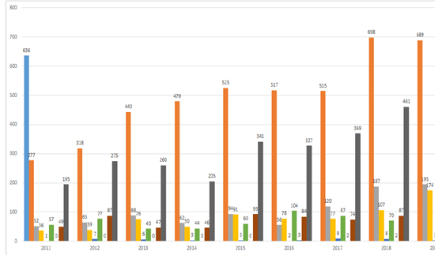

Analysis requests submitted previous to 2011

Analysis requests

PF (Formulated Product)/PFE (Formulated Product based on Equivalent Technical Product with access letter)

PFC (Formulated Product with access letter)/PFEC (Formulated Product based on Equivalent Technical Product with access letter)

PT (Technical Product)

PTE (Equivalent Technical Product)

PM (Premix)

Denied and filed requests

Total of concluded requests

32. During the period considered in the graph, investments were made in information technology tools, personal inputs, and management systems, which led to a reduction in individual processes' analysis time.

33. In this way, the figures should be interpreted considering that since 2011, Ibama and the other competent bodies have improved and harmonized several administrative routines, which interfere with process management's dynamics to streamline the workflow.

34. It is important to stress that these changes do not represent the “flexibilization” of technical and scientific criteria used to evaluate products. On the contrary, over the years, there has been an increase in technical rigor for completing environmental assessments, such as the application of additional and more sophisticated analysis methodologies for New Technical Products (Risk Assessment), the definition of criteria for a product more toxic to the environment not to be approved when another product for the same purpose is already in the market[[5]](#footnote-6), and the establishment of criteria for risk assessment aimed specifically at protecting pollinators[[6]](#footnote-7).

35. It should also be noted that these numbers correspond to the analyzes made by Ibama, but not necessarily all resulted in products registered by MAPA. A product may have met the environmental criteria and be considered suitable for registration by Ibama, but it may not have met the health criteria and be deemed unfit for registration by Anvisa. And vice-versa.

36. Due to the great demand for evaluation requests received by Ibama and other federal agencies involved in the pesticide registration process, MAPA published, in the Official Union Gazette of August 12, 2015, Ordinance 163, of August 11, 2015. **It establishes criteria for prioritizing pesticide products' analysis with a view to the health of plants, taking into account the most dangerous pests, the main crops, and the list of active ingredients, agricultural products and technologies subject to registration**. In 2016, 2017 and 2019, MAPA published the agrochemical products for priority evaluation, considering the Brazilian agronomic relevance[[7]](#footnote-8).

37. About the technical assessment of pesticides carried out by Ibama, there are two stages: the Assessment of the Environmental Hazard Potential (PPA) and the Environmental Risk Assessment (ARA).

38. Normative Ordinance IBAMA 84/96 regulates the former, carried out since 1990, which allows the knowledge of the intrinsic characteristics of each product, its behavior, and environmental destiny.

39. The evaluation and classification of a pesticide PPA are based on the inherent toxicity of the product (toxicity to soil microorganisms, earthworms, algae, fish, microcrustaceans, bees, birds, and mammals) and the behavior of its active ingredient in the environment, about its persistence, bioaccumulation, and transport.

40. he final PPA classification of the evaluated product is carried out according to ranking methodology, resulting from the sum of the individual ratings attributed to each of the results of the toxicity tests to non-target organisms, as well as the tests related to environmental behavior, observing the weighting criteria (assigned weights), and results in the product being classified into four possible environmental classes, according to article 3 of Ibama Ordinance n° 4/96.

41. The pesticides potentially most dangerous to the environment, in a global calculation, are those that receive the classification I - Product Highly Dangerous to the Environment, followed by Class II, III, and IV.

42. According to the single paragraph of article 3 of Ibama Normative Instruction 84/96, pesticides, their components and the like that meet at least one of the following criteria will be granted the classification of "Impeditive Hazard Product to Obtaining Registration":

*a) there is no availability in the country of methods for deactivating it and its components, as stipulated in item a, of paragraph 6, of article 3, of Law 7.802 and item*

*I, of article 22, of Decree 98.816;*

*b) presents mutagenic, teratogenic or carcinogenic characteristics referred to in item c, of §6 °, of article 3, of Law 7.802 and items III, IV and V, of article 22, of*

*Decree 98,816;*

*c) the PPA classification and/or environmental risk assessment indicate unacceptable levels of hazard and/or risk, considering the proposed uses.*

43. The Environmental Risk Assessment, which occurs after the assessment of the PPA, is also based on the inherent toxicity of the product and the behavior obtained in laboratory tests but adds to the evaluation the potential exposure of non-target organisms factor, that is, it becomes necessary to evaluate several other variables, including how the product will be used in practice and its possible consequences. For ARA, the method and time of application, doses, culture, climate, and several other factors are of great importance in the evaluation, making it more comprehensive and realistic, and therefore more complex.

44. It is also observed that there are different types of registration, which demand different levels of complexity and specific requirements in the legislation, resulting in different analysis times, and the conclusion of the analysis - approval or rejection - must be published in the Federal Official Gazette, regardless of whether the typology reaches the final consumer.

45. Regarding the use of pesticides, on page 24 of the Report, there is the following recommendation:

*(n) Develop time bound plans to urgently reduce pesticide and toxic industrial chemical use and exposure, including:*

*(…)*

*(ii) Phase out the use of highly hazardous pesticides, including glyphosate and atrazine;*

46. Anvisa is finalizing the toxicological re-evaluation of glyphosate. The agency has carried out the analysis of toxicological studies and monitoring data for residues and intoxications and issued a re-evaluation preliminary Technical Note as a subsidy for the decision to be made.

47. Anvisa's decision was submitted to public consultation (CP 613, of February 28, 2019), together with the Collegiate Board's Resolution Proposal on the maintenance of the active ingredient glyphosate in agrochemical products in the country and the measures resulting from its toxicological evaluation[[8]](#footnote-9).

48. It should be noted that the analysis methodology used by Anvisa for the toxicological assessment of pesticides is in line with the best international regulatory practices. The American (USEPA), Canadian (PMRA), and European (EFSA) regulatory agencies reached the same conclusions as Anvisa's public consultation proposal and proposed maintaining glyphosate-based products in their countries.

49. In this regard, it is worth mentioning that glyphosate is not prohibited in any country to date.

50. The risk assessment for workers, operators, residents, and passers-by carried out by Anvisa pointed out, in the mentioned Technical Note, the need to adopt measures to ensure higher safety for people who are in contact with products containing glyphosate, such as the use personal protective equipment, inclusion of safety information in package inserts and monographs; prohibition of application rates and formulation types; and education and management programs for users of these products.

51. The glyphosate reevaluation process is in its final stage and should be resolved soon by the Anvisa Collegiate Board (Dicol). The decision will be published through a Resolution of the Collegiate Board of Directors in the Federal Official Gazette, which will complete Anvisa's toxicological reassessment process for this active ingredient and define the risk mitigation measures to be adopted.

52. Regarding atrazine, this active pesticide ingredient has not been approved in Europe since 2004 due to environmental risk, but not to health. It was concluded that there is no evidence that the limit of 0.1 μg / L in groundwater is not exceeded.

53. In Brazil, the active ingredient is authorized for use in pre-emergence and post-emergence of weed plants in pineapple, sugar cane, corn, millet, pine, rubber, sisal, and sorghum crops. This ingredient was monitored in 14,958 food samples from 2013 to 2018, having been detected in 11 samples (0.07%).

54. Given the above, Anvisa's role in the toxicological assessment carried out before the registration of pesticide products in Brazil remains clear, following transparent criteria and in line with the best scientific and regulatory practices adopted internationally. It is also worth mentioning the Agency's active role in post-marketing actions for these products, through the evaluation of data from the pesticide residue-monitoring program and the toxicological reassessment of active ingredients used in agriculture.

55. Also, concerning improving regulatory science on the analysis of pesticides and the like, IBAMA has intensified its efforts through five projects:

I - Pesticide monitoring in environmental matrices: surface water, rainwater and soil;

II - Implementation of the environmental risk assessment to protect life from the risks associated with the use of pesticides;

III - Improving the effectiveness and transparency of pesticide registration systems in Latin American and Caribbean countries;

IV - Research and development in pollination services, biodiversity and relationship with agriculture for pollinating insects; and

V - GEF Pro Species: all against extinction.

56. The projects were developed so that the regulatory science is based on the best criteria available and applicable to Brazil, allowing the attribution of that body to be fulfilled within the established legal deadlines.

57. As for the recommendation described on page 24 of the report, regarding “ban aerial spraying especially over inhabited areas,” Anvisa is working on a regulation to establish guidelines for an extended assessment of occupational risk, which comprehends residents and passers-by.

58. Regarding the themes presented by the Rapporteur in the topic “Duties and responsibilities to protect life and prevent exposure,” it is indicated that data produced by the National Institute for Space Research (INPE) demonstrate that the hot spots detected in 2019 in the Amazon and Cerrado biomes are below the average of the historical series (except August in the Amazon biome), measured by the Institute since 1998[[9]](#footnote-10):

**Biome monthly comparison: Amazon**

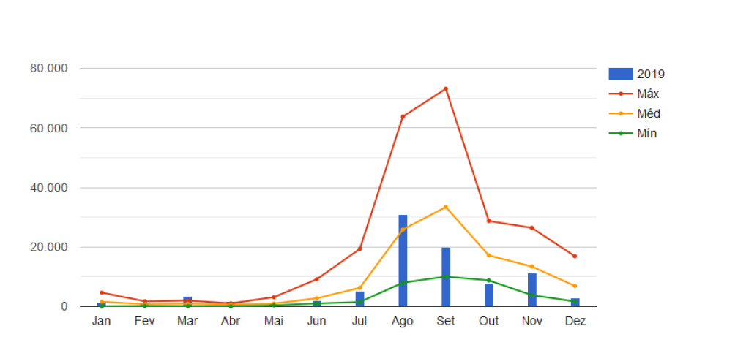

*2019 data comparison with the maximum, average and minimum values, in the period from 1998 to 12/22/2019, for the Amazon biome.*

**Biome monthly comparison: Cerrado**

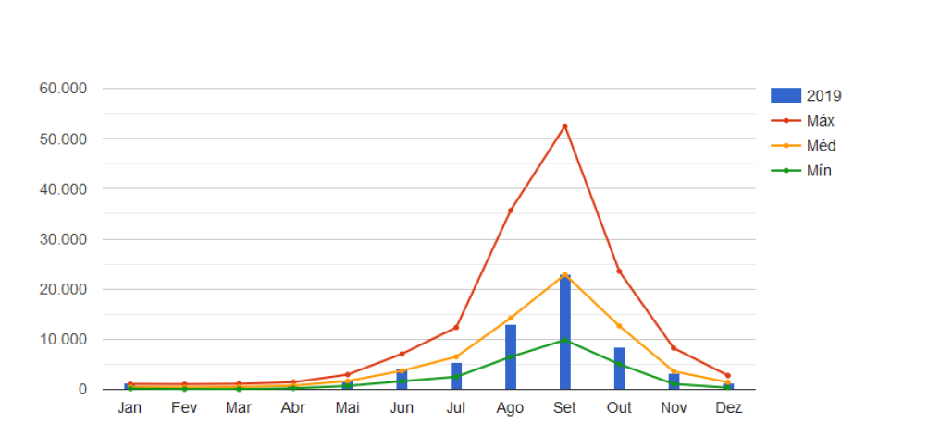

*2019 data comparison with the maximum, average and minimum values, in the period from 1998 to 12/22/2019, for the Cerrado biome.*

59. Despite an increase of hot spots detection compared to previous years, the total number of records in 2019 was similar to that of 2017[[10]](#footnote-11):

| *Biome* | *2017* | *Difference (%)* | *2018* | *Difference (%)* | *2019* |
| --- | --- | --- | --- | --- | --- |
| Amazon | 106.872 | -37% | 67.356 | 31% | 88.876 |
| Caatinga | 10.555 | 4% | 11.021 | 33% | 14.753 |
| Cerrado | 66.497 | -41% | 39.043 | 62% | 63.534 |
| Atlantic Forest | 15.555 | -28% | 11.195 | 60% | 17.990 |
| Pampa | 912 | -19% | 734 | 90% | 1.401 |
| Pantanal | 5.773 | -70% | 1.681 | 492% | 9.952 |
| Total | 206.164 | -36% | 131.030 | 50% | 196.506 |

*Brazil's biomes comparative annual table - from 1 January to 22 December.*

60. In the graph below, one sees that only in August and November 2019 the number of hot spots detected was higher when compared to the same months of 2017[[11]](#footnote-12):

**Active hotspots detected between 2017 and 2019**

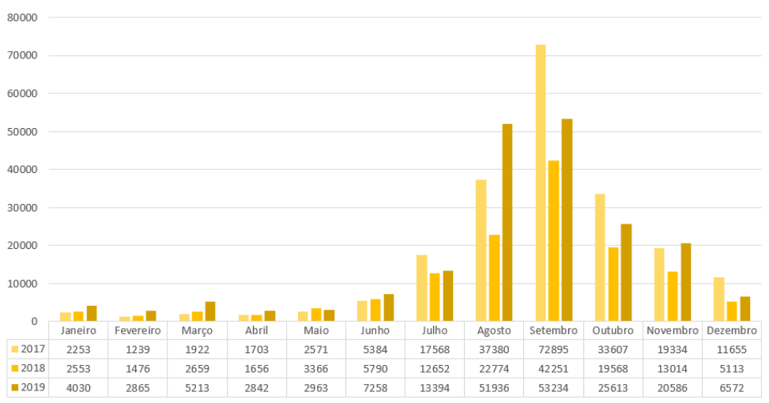

*Monthly comparison of total active hotspots detected by the reference satellite in the period from 2017 to 12/22/2019.*

Disasters with Tailings Dams

61. About the recommendation (m) “Improve accountability, access to justice and an effective remedy for victims” and its subparagraphs, concerning the breach of the Fundão dam, in Mariana/MG, the creation of the Interfederative Committee (CIF) deserves attention. It is a follow-up, monitoring, and inspection agency for the programs proposed and executed by the Renova Foundation following the signing of the Term of Transaction and Conduct Adjustment (TTAC) celebrated among federal bodies and agencies, the states of Minas Gerais and Espírito Santo, and the companies SAMARCO, VALE, and BHP, in the context of the judicial proceedings in a course in the 12th Federal Court of the Judicial Section of Minas Gerais.

62. Additionally, the Adjustment Term signature called "TAC Governança" expanded affected people's participation in the CIF System. This TAC ensures the right to voice and vote in the Committee and its Technical Chambers (CTs), as well as in the boards of the Renova Foundation, and provides technical assistance to support communities exercising qualified participation in these spaces.

63. The CIF is composed of representatives of the Union, the governments of Minas Gerais and Espírito Santo, the impacted municipalities, the affected population, the Federal and State Public Prosecutor's Offices, the Public Defender's Offices of the Union and the States, as well as the Doce River Hydrographic Basin Committee. Presided by Ibama, it brings together about 130 institutions, to guide and inspect the repair of the damages caused by the rupture of the dam in Mariana/MG.

64. The 42 socio-economic and environmental programs established in the TTAC will run until 2031. Eleven Technical Chambers were created, in an advisory capacity, to support the CIF. They are composed of representatives of recognized technical excellence from the institutions that make up the Committee.

65. The Technical Chambers provide advice to the CIF members, supporting the deliberations through studies and technical notes. They also evaluate the program's execution and propose adjustments and corrections to the Committee for the best progress of the reparation and compensation actions.

66. Currently, the CIF meets regularly eight times a year, as does each of the eleven Technical Chambers. All agendas discussed at the CIF are supported by technical notes produced at the TCs, based on their meetings, or by the Renova Foundation's manifestations.

67. Regarding the right to information (p. 16), it should be noted that government actions related to the dam rupture in Mariana were guided, from the beginning, by transparency, with immediate creation, by government entities, of an information portal to society. This principle was also observed in the Transaction and Conduct Adjustment Term. Since the first analyzes of the Fundão dam rupture, environmental agencies have clarified the extent of the impacts. In this sense, an excerpt from Note 01/2016 stands out, which provides the following:

*Preliminary Technical Report concluded on November 26, 2015, points out that ‘the level of impact was so profound and perverse across the different ecological strata that it is impossible to estimate the time for fauna to return to the site.’ (...) “The strength of the volume of tailings released with the dam rupture may also have revolved and suspended the bottom sediments of the affected watercourses, which, due to the history of use and reports in the literature, already contained heavy metals.*

68. Although the data demonstrated that the type of material deposited in the dam was preliminarily inert, Ibama warned, on its page, that the passage of the tailings wave could have revolved contaminants present in the bed and on the banks of the affected rivers, highlighting the expected impacts in every stretch of the Doce River basin.

69. Regarding the studies on the impacts on human health, it should be noted that the hiring of Ambios company was based on a term of reference validated by the Health Technical Chamber. It is an advisory body for CIF decisions, composed of professionals from States Health Secretariats and the Ministry of Health. It is pointed out that, as explained in Technical Note ‘CT-Saúde 11/2017’, the Human Health Risk Assessment Study (EARSH) aims to define contaminants of interest, routes of exposure and exposed population **to guide the Epidemiological and Toxicological Studies, and therefore not as an end in itself.**

70. Once the final report is available, health agencies start a technical evaluation. It may request clarifications, point out inaccuracies, make recommendations, and even request complementing the information presented in the document so that EARSH fulfills its objective of guiding health and monitoring population follow-up studies actions. The CIF Deliberation that determined the preparation of the Study 106 established as references the Guidelines of the Ministry of Health and the Minimum Bases document from the ‘*CT-Saúde*.’

71. After the assessment, actions and strategies are developed to preserve the citizens' health. In the process of elaborating these measures, Public Authorities' action consists of making information available **in a timely and reasonable manner**.

72. It is further clarified that, in September 2018, CIF Deliberation 197 revoked the Renova Foundation's determination of intellectual property on Epidemiological and Toxicological Studies, as well as the need for prior authorization from the Renova Foundation, together with CT-Saúde, for their dissemination. The only prohibition for disclosing the data was and still is for the contracted company.

73. Therefore, **it should be clarified that no ownership clause allows the Renova Foundation to omit the studies' data. What is forbidden is that the company hired for its preparation makes its disclosure without an evaluation by relevant bodies**.

74 It should also be stressed that all remedial actions must be approved by the CIF, which is governed by the principles of legality, impersonality, and morality, with no interest in benefiting or harming contracted consultants.

Protecting the most vulnerable

75. The Rapporteur mentions Barra Longa deposition of waste in an area belonging to a peripheral neighborhood with a predominantly Afro-descendant population as a possible case of racial discrimination:

*“Low-income families, including Afro-Brazilians, suffered disproportionate exposure to dust and heavy metals in mud heaped in Barra Longa following the Mariana dam collapse by agents of the companies and the Renova foundation.” (page 12)*

76. In this regard, it is important to mention that the CIF applied several sanctions to the Renova Foundation regarding the tailings management program present in the TTAC. It should also be noted that decisions on the location and disposal of waste follow environmental legislation, and the CIF does not endorse any discrimination, guiding itself by technical assessments.

77. About the protection of the vulnerable, it is recalled that the General Coordination for Occupational Health (CGSAT) of the Ministry of Health participated effectively in the technical meetings held during the visit of the Rapporteur, and informed him that it has been working continuously to promote the integral health of all workers, especially those most vulnerable, such as those exposed to chemical substances.

78. For this purpose, CGSAT has been strengthening the National Network of Comprehensive Attention to Occupational Health (Renast), structuring existing programs and developing new actions to promote health, prevent and monitor risk factors and injuries, to intervene in determinants of exposure to chemicals that interfere with human health.

79. Among the initiatives of CGSAT, the CAREX Brasil Project stands out, an international information system for elaborating an occupational exposure matrix whose objective is to estimate the proportion of workers exposed to carcinogens and support intervention actions in the territories.

80. The project is undergoing review and adjustments before the inclusion of new agents. However, its preliminary version demonstrated consistency, when analyzing the exposures to the pesticides Clorotalonil, Malation, and Glyphosate, to Asbestos, to Silica, to Benzene, and ionizing radiation.

81. Exposure to pesticides is an essential topic in the public health area, and a priority to CGSAT, which promotes various policies and programs aimed at agricultural workers, such as the National Policy for Comprehensive Health of the Rural and Forest Populations (PNSIPCF) and the Health Surveillance Program for Populations Exposed to Pesticides (VSPEA).

82. Furthermore, a registering and monitoring system for workers exposed to Asbestos in Brazil is in preparation, with the possibility of monitoring data in real-time. The platform is already at a very advanced stage and has the participation of several specialists and the Federal Public Prosecutor Office's support.

83. Regarding the rupture of mining tailings dams, CGSAT participates, together with the General Coordination of Environmental Health Surveillance (CGVAM), in several initiatives aimed at the care of the affected populations, intending to ensure the monitoring of the health situation and the reception of these families by the Unified Health System (SUS), in compliance with local dynamics of life and work.

84. In protecting indigenous peoples, the Federal Police has, within its organizational structure, the Division for the Suppression of Crimes against Social Rights and Citizenship (DDSC), which counts on the Service for the Suppression of Crimes against Indigenous Communities (SRCCI / DDSC / CGDIHC / DICOR / PF).

85. At various points, the report mentions the issue of the Yanomami peoples, as in the following excerpt:

*“Renegade artisanal gold miners continue to poison the Yanomami people leaving irreversible impacts on children and a toxic legacy of disease and disability for future generations” (p. 12)*

86. Specifically, concerning the Yanomami Indigenous Land, the Federal Police and the Ministry of Justice and Public Security are developing a plan of integrated actions to curb crimes of any nature in their interior, which will include the fight against water pollution crimes in that IL.

87. It should also be noted that, within the structure of the Federal Police, there is the Division for the Suppression of Crimes Against the Environment and Historical Heritage (DMAPH/CGPFAZ/ DICOR/PF), a unit linked to the Directorate of Investigation and Combat against Organized Crime (DICOR), which aims, among other objectives, to coordinate and align operational actions carried out in these areas by all units in the country.

88. Each of the Regional Superintendencies, installed in the capitals of all states of the Federation, has a Regional Police Station for the Suppression of Crimes Against the Environment and Historical Heritage (DELEMAPH/DRCOR/SR/PF/UF), responsible for the coordination of these same activities at the state level. It is also essential to consider that all Federal Police stations in the country also act to repress crimes committed against the environment, according to their limitations and the demands presented.

89. In the Legal Amazon, the Federal Police has nine Police Stations for the Repression of Crimes against the Environment and Historical Heritage and another 19 Decentralized Police Stations that also act in the repression of crimes against the environment in a non-specialized way. In addition to the units mentioned above, the Federal Police intends to install three bases for use by Sensitive Environmental Investigations Groups (GIASEs) and an Outpost in an area considered strategic for the suppression of deforestation in the south of the Amazonas state, in Santo Antônio do Matúpí.

90. Through the Division for the Suppression of Crimes against the Environment and Historical Heritage, the Federal Police presented three actions to deal with the challenges in the area of repression of environmental crimes:

1. Implementation of the Legal Amazon Sensitive Environmental Investigations Group;
2. Planning and execution of a coordinated and integrated calendar of actions for the Operation Legal Amazon;
3. Definition of a methodology for sharing deforestation alerts for the Police Stations for the Suppression of Crimes against the Environment and Historical Heritage and the Decentralized Police Stations.

91. Also, a unit specialized in tackling environmental crimes committed by criminal organizations, GIASE is being implemented. Its institution can occur whenever there is a need for complex and priority investigations, with transnational or interstate characteristics.

92. The focus of this group's activities is the arrest of leaders of criminal organizations that practice environmental crimes in the Legal Amazon. The group also aims to carry out the freezing and confiscation of assets and values arising from the money laundering of organized environmental crime, with a strong bias of international cooperation in the area of environmental crimes.

93. Monitoring and issuing alerts on deforestation and other environmental crimes are carried out, based on a methodology defined by the central body and the Regional Superintendencies, based on the use of geographic information systems and the extraction, analysis and crossing data contained in indexed or accessible to the Federal Police banks, to assist the development of the actions mentioned above.

94. It should be noted that, in the **Legal Amazon**, 364 operations to repress environmental crimes and 105 Judicial Police special operations were carried out in the last five years.

**Conclusion**

95. Given the above, the Brazilian state reaffirms its commitment to protecting the environment, the health of its population, and traditional peoples and communities, and makes itself available for any clarifications that the Special Rapporteur may consider necessary for the process of finalizing his report on the visit to Brazil.

1. \* The present document is being issued without formal editing. [↑](#footnote-ref-2)
2. Note on translation: the initials and acronyms of Brazilian governmental bodies, agencies, projects, and programs reflect their original names in Portuguese. [↑](#footnote-ref-3)
3. <http://portal.anvisa.gov.br/programa-de-analise-de-registro-deagrotoxicos-para>. [↑](#footnote-ref-4)
4. <https://contraosagrotoxicos.org/wp-content/uploads/2020/02/AGROTOXICOS-BRASIL-UE-JUL-2019.pdf> [↑](#footnote-ref-5)
5. Normative Instruction 27, of 12/27/2018 and amendments by NI 3/2019. [↑](#footnote-ref-6)
6. <https://www.ibama.gov.br/phocadownload/agrotoxicos/reavaliacaoambiental/2017/2017-07-25-Manual-IBAMA-ARA-Abelhas-IN0217-WEB.pdf>. [↑](#footnote-ref-7)
7. <https://www.gov.br/agricultura/pt-br/assuntos/insumos-agropecuarios/insumos-agricolas/agrotoxicos/informacoes-tecnicas>. [↑](#footnote-ref-8)
8. All documents are available and accessible in http://portal.anvisa.gov.br/consultaspublicas#/visualizar/391760. [↑](#footnote-ref-9)
9. <http://queimadas.dgi.inpe.br/queimadas/portal-sta_c/estatisticas_estados/>. [↑](#footnote-ref-10)
10. <http://queimadas.dgi.inpe.br/queimadas/portal-sta_c/situacao-atual/>. [↑](#footnote-ref-11)
11. http://queimadas.dgi.inpe.br/queimadas/portal-sta\_c/esta\_s\_cas\_paises/. [↑](#footnote-ref-12)