Check against delivery

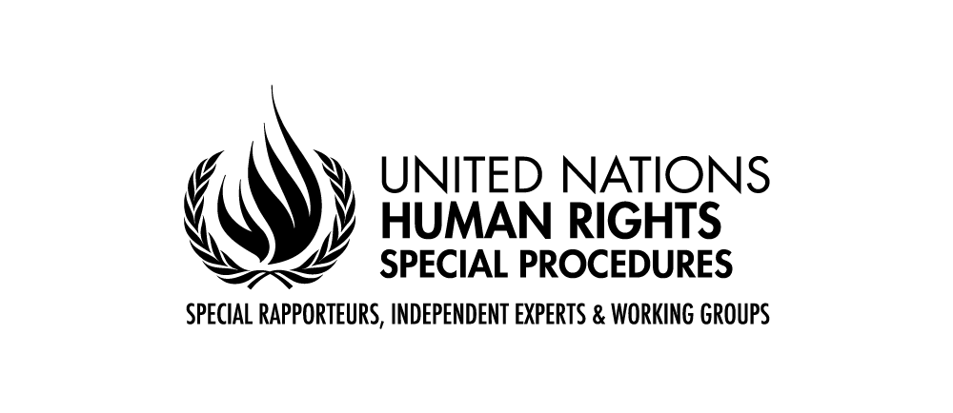

Statement by Ms Maria Grazia Giammarinaro

Special Rapporteur on trafficking in persons, especially women and children

74th session of the General Assembly

25th October 2019

New York

Mr. Chairperson,
Distinguished Representatives,
Delegates and Observers,
I would like to thank the General Assembly for this opportunity to present my report on access to remedy for victims of trafficking for abuses committed by businesses and their suppliers.
Before going into the details of the report, allow me to give a warm thank you to all those that have contributed to the report with their insights and feedback into these questions and in particular the Dutch road transportation trade union, FNV, who facilitated a field visit to obtain first-hand information on the situation and challenges faced by workers in the road transportation sector. The report is based on first-hand information obtained through an extensive on line consultation and interviews with workers. Moreover, the report reflects different points of view on controversial issues, and is therefore a contribution to innovative and effective solutions.
Mr. Chairperson, the human rights of persons subjected to trafficking and severe labour exploitation should be at the centre of all efforts to prevent and combat trafficking. However, many concerns arise regarding access to justice and the remediation for victims.
For most workers, victims of trafficking and/or labour abuse, their main concern is to recover unpaid wages, maintain working contracts and improving conditions at the workplace. However, in most cases, resorting to grievance mechanisms, whether state or non-state based, will result in a loss of jobs for workers and uncertain results regarding recovering wages and other due payments.
In addition, fear of migrant workers to be deported prevents them from making complaints to the authorities, particularly following repeated threats from employers that their visa, work permit and residence permits depend on their contract with that employer. This is a consequence of current migration policies in many jurisdictions, which promptly remove undocumented migrants, without allowing time for an initial assessment aimed at identifying potential victims of trafficking.

For these reasons, workers will very likely not regard the offered avenues for complaints as being accessible and trusted. Judicial procedures in most countries are costly and time consuming. In fact, successful complaints have been filed by non-governmental organizations or trade unions - such as the Federation of Road Transportation FNV in the Netherlands or the Federation of Agricultural Workers FLAI in Italy - that have the professional and financial resources to afford and navigate judicial proceedings.
Transparency legislation passed in a few Member States – since the California and the UK laws have paved the way to others such as Australia and France - has succeeded in putting trafficking in persons on the radar for many companies. Awareness of the risks of trafficking in businesses operations and supply chains is greater today, at both the State level and in companies. While some consider its impact limited, I wish to underline that transparency legislation is obliging companies to exercise some level of monitoring over their operations and those of their suppliers.
However, it is now necessary – this is my first main message - to go beyond minimal reporting obligations and require a higher level of commitment from companies.
Firstly: Companies must be required to adopt a plan based on risk mapping, procedures to assess the situation of subsidiaries, subcontractors or suppliers, actions to mitigate risks, an alert mechanism on actual risks and a monitoring scheme.
Secondly: Monitoring measures must address the direct operations of the company, those of companies it controls, as well as operations of the subcontractors or suppliers.
Thirdly: Companies should establish grievance mechanisms enabling workers to report trafficking and exploitation without fear of being fired or deported, and provide for reparations if exploitation has been found.
Finally: Companies should be held liable when they fail to comply and be obliged to compensate for the harm that could have been avoided had due diligence been exercised.
States, the private sector, trade unions and civil society stakeholders – this is my second main message - must find a balance in a smart mix of public and privately led efforts. Legislation should provide for basic obligations, including reporting, addressing risks and establishing the civil liability of companies failing to comply with their due diligence obligations to protect human rights in their operations and supply chains. The French duty of care legislation is a step in the right direction. However efforts must continue to ensure that companies comply with the requirements and publish detailed risk mapping and alert mechanisms to ensure workers and stakeholders can hold them accountable when violations occur. Businesses on the other end, need to establish more effective mechanisms aimed at identifying situations of trafficking and exploitation including in their supply chains, and provide for remediation.
This effort however - and this is my third main message – can be successful only if the workers’ voice is integrated in social compliance mechanisms. To this purpose, businesses need to establish procedures aimed at enabling workers, including workers in their supply chains, to access grievance mechanisms and report exploitation. Such initiatives should also provide workers who have denounced and/or are found to be in situations of exploitation with viable solutions, such as through a plan imposed on a subcontractor to improve working conditions and provide redress to workers or, when a contract with a subcontractor has been terminated, by providing workers with reparations, opportunities for alternative employment and, in cooperation with host governments, with residence status if needed.
The obligation of companies to establish effective grievance and redress mechanisms, as recognised in the Guiding Principles on Business and Human Rights, does not preclude workers and their representatives from taking the lead and establishing worker-led tools, as for example in the case of the very effective Immokalee Workers experience in Florida (US)
Finally, I encourage companies to engage with workers and their representatives to develop mechanisms based on the cooperation between public institutions, businesses and social actors. Grievance mechanisms and other internal redress mechanisms should be easily accessible to workers and be based on trust. This trust can be achieved only when workers and workers’ representatives are involved as central actors in the design, implementation and monitoring of remediation tools.
I thank you for your kind attention and I look forward to a fruitful interactive dialogue

