The United Sates illegal unilateral sanctions cause “sufferings and death” in the target countries

The United Sates illegal unilateral sanctions cause “sufferings and death” in the course of Covid-19 Pandemic

After 12 years of talks, finally in July 2015 the Islamic Republic of Iran and the group known as 5+1 (Russia, China, Britain, France, Germany and the United States) reached an agreement on the peaceful Iranian nuclear programme “Joint Comprehensive Plan of Action” or JCPOA. Through suspension of some nuclear activities of Iran, the agreement lifted some of the heavy sanctions imposed on the country. The agreement received its official support by the UN Security Council through Resolution 2231 which placed JCPOA in international law, and made it enforceable.
Right from the outset, the United States failed to stay fully committed to lifting the nuclear related sanctions against the Iranian people and ultimately in May 2018 US President Donald Trump pulled out of the agreement. He announced that severe sanctions, “unprecedented in history” would be re-imposed on Iran.
Despite the objection of the rest of the JCPOA signatories and 12 IAEA reports unequivocally confirming Iran’s commitment to the agreement, the United States imposed even harsher sanctions against Iran, and what is usually overlooked in this unilateral and unfair measure is the adverse human rights consequences of such sanctions and “collective punishment” of Iranian people, though the “economic warfare” .
This booklet is a brief glance at the pain and sufferings of the ordinary Iranians under the unlawful unilateral sanctions imposed by the United States. We hope we reach a day that with the help of the United Nations, NGOs and human rights activists, the illegal, inhuman “unilateral coercive measures” are erased from the international relations literature ending the unjust sufferings of civilians.

1

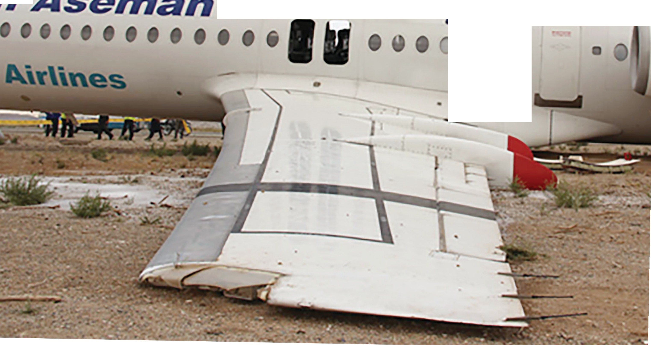

i}/01,u/

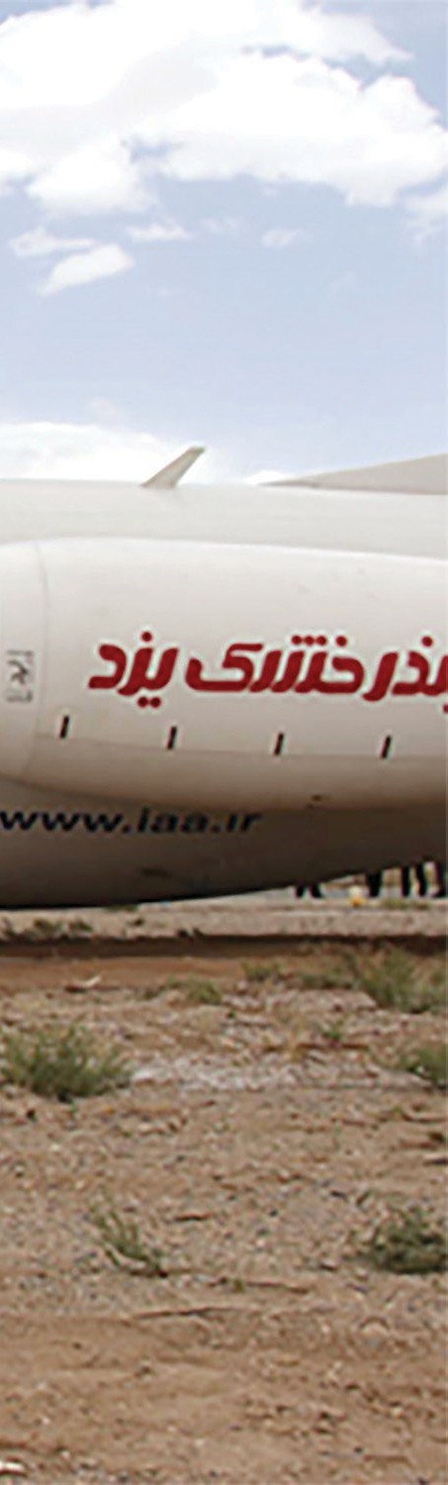
JCPOA/ Paragraph 22 The United States will
… allow for the sale of commercial passenger aircraft and related parts and services to Iran

Sanctions of Iran's Civil Aviation Industry
Sanctions on Iran aviation industry has made many aircrafts in the country's aviation network inactive, due to lack of access to engines, spare parts and components.

3

Sanctions & Violation of the Right to Development
Some of the companies that stopped working with Iran in the field of green technology under US sanctions are: Danish Company (Vestas) on Wind Turbines
Malaysian Company (SolarBee) on Solar Powered Water Treatment Plants German Company (VARTA) on Solar Battery
Norwegian Company (Stadtoil) on reduction of CO2 emission
Sustainable Development Goal 7: Ensure access to affordable, reliable, sustainable and modern energy for all

4

Sanctions of Iran’s Oil Export
The sanctions on Iran’s oil export are considered as violation of the common Article 1 of ICESCR and ICCPR, as well as the ICJ ruling.

The International Court of Justice notes that Iran
ICESCR and ICCPR, Article1: All peoples may, for their own ends, freely dispose of their natural wealth and resources without prejudice to any obligations arising out of international economic co-operation, based upon the principle of mutual benefit, and international law. In no case may a people be deprived of its own means of subsistence.
v. US oil production is a vital part of the country’s economy and constitutes an important
component of its foreign trade

ICJ, Iran us, case concerning oil platforms, judgment of 12 December 1996, para 51; ICJ, Iran v. us, case concerning oil platforms, judgment of 6
.November 2003, para 83

5

Violation of the Right to Development

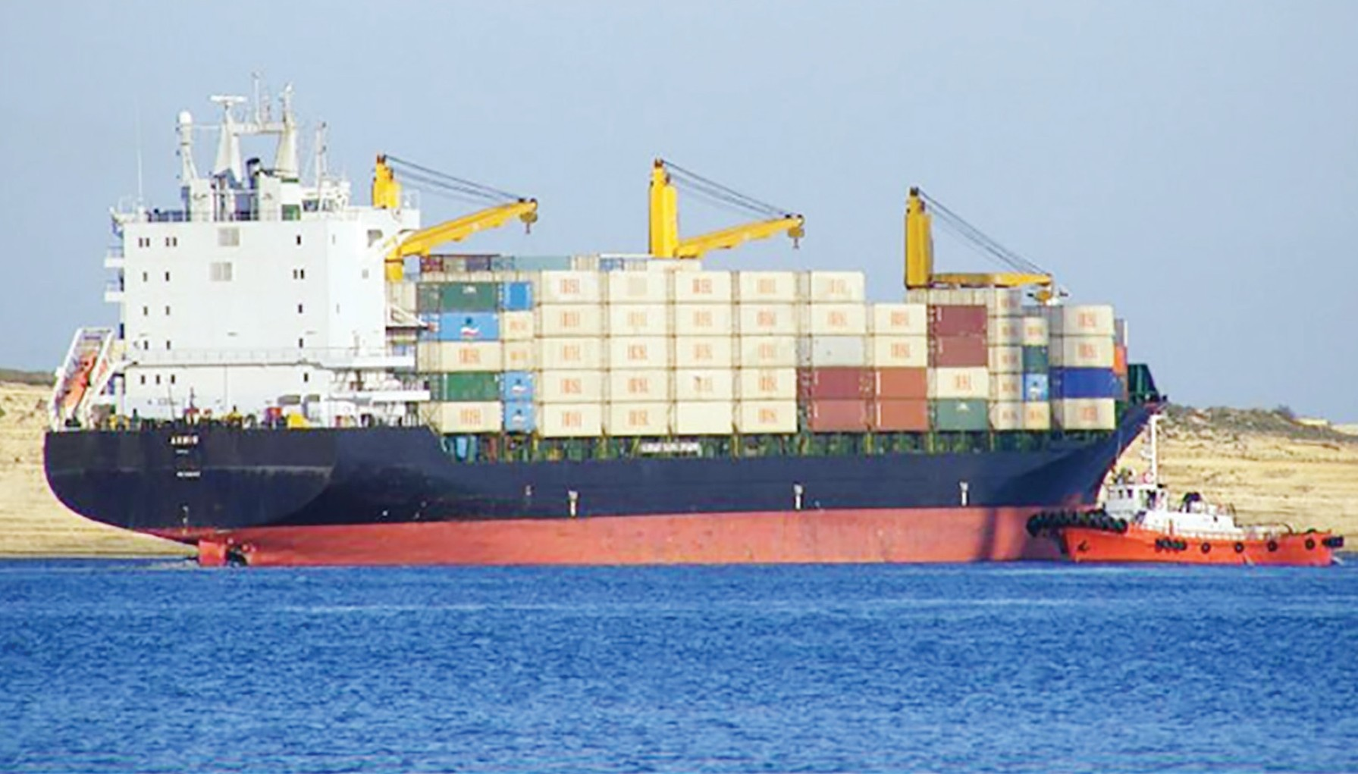
Global Maritime Companies such as Maersk Line and Mediterranean
REUTERS/Thomas White @ Copyright
the International Maritime Organization’s Council in London, following an inquiry into Iran’s proposed document against US sanctions, called on the United States and other member states to refrain
from taking any action that endangers the safety and security of international shipping and shipping freedom.”
The Iranian Ambassador to the UK Hamid Baedinejad, Twitter, 22nd Nov. 2018
Shipping Company limited their cooperation with Iran following the USA withdrawal from JCPOA

Dozens of maritime insurance companies and about 200 Iranian vessels are on the US sanctions list. The vessels are critical to Iran economy .

6

Violation of the Right to Health

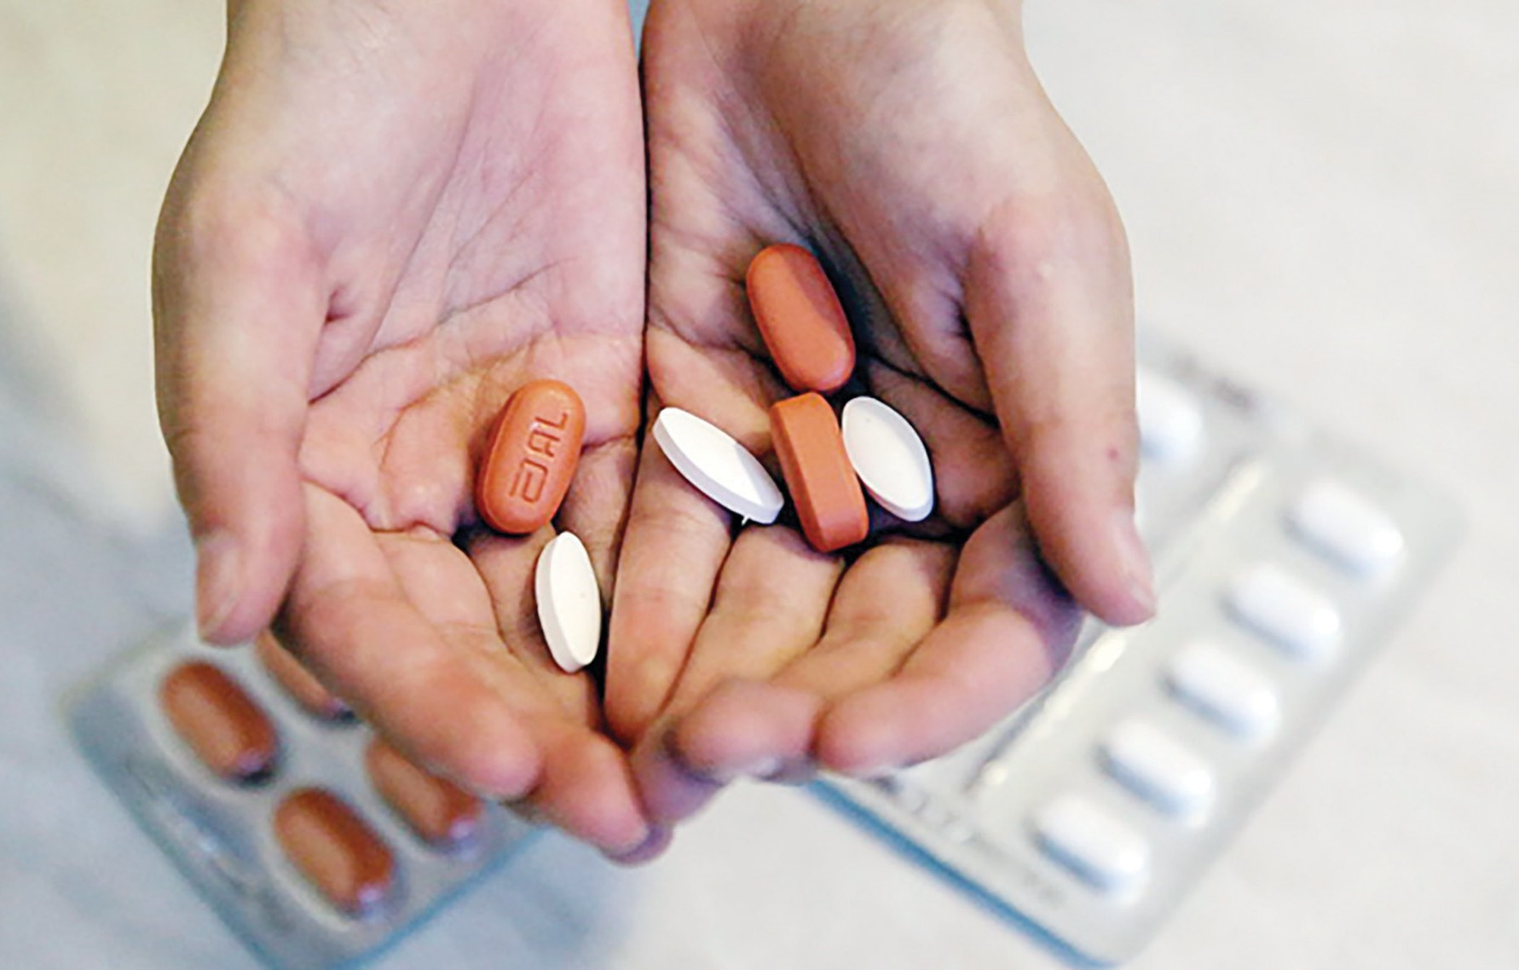
Ghazal, a student, was thinking of purchasing Warfarin - an anticoagulant mostly imported from Finland - when a pharmacist
Read more: http://www.al-monitor.com/ pulse/originals/2018/11/iran-sanctions- medicine-jcpoa-trump-nuclear-deal-patients. html#ixzz5ZBL1Qoig

“Under economic sanctions, people also die but from lack of food and medicine, rather than from explosive devices. This form of warfare that relies on starvation and disease deserves the same concern from the international community as any other conflict.” Special Rapporteur on UCM, Nov, 8th, 2018.
in Tehran told her, “You better buy it today, or tomorrow you might not find it anymore.” In only a few months, the price of the drug has tripled due to the currency devaluation triggered by the US exit from the nuclear deal.
While US President Donald Trump on Nov. 2 amused his Twitter followers with a “Game of Thrones”-themed announcement of the re-imposition of a second wave of penalties targeting Iran’s economy, Ghazal and millions
of other Iranians are suffering the real-life consequences of his politics.

7

Violation of the Right to Health

To Me
Limitation of Access to Medicine Means “Silent Death”

http://cancer.baydakh.com/2016/04/17/9-things-the-mom-of-a-child-with-
Article 12 of ICESlCR recognises the right of everyone to "the enjoyment of the highest attainable standard of physical and mental health".
cancer-wants-you-to-know/

8

Violationof the Right to Health
Surgery gloves and Suture material are the basics of emergency and essential surgical care.
US sanctions on swift limit Iranians’ access to basic healthcare .

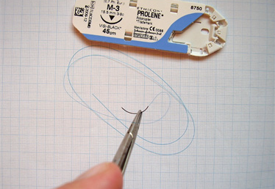

41. States parties should refrain at all times from imposing embargoes or similar measures restricting
the supply of another State with adequate medicines and medical equipment. Restrictions on such goods should never be used as an instrument of political and economic pressure. CESCR General Comment No. 14: 11 August 2000

9

Violation of the Right to Health

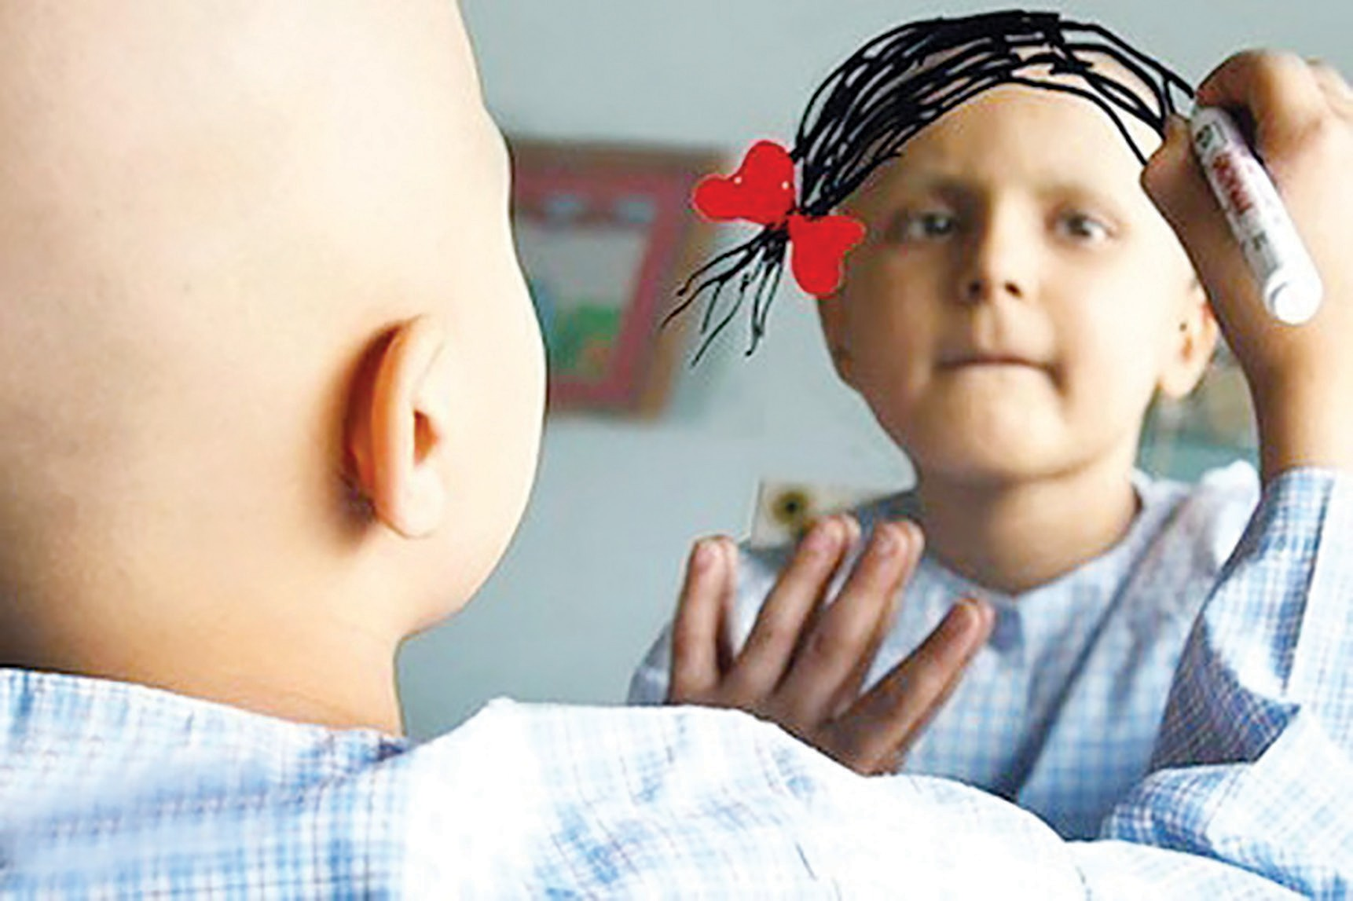
Pars Isotope Company, the only supplier of nuclear medicine in Iran, is enlisted in the list of US sanctioned companies, therefore one million people using nuclear medicine are directly targeted.

10
According to the ICJ ruling the United States of America… must remove … any impediments arising from the measures announced on
8 May 2018 to the free exportation to the territory of the Islamic Republic of Iran of (i) medicines and medical devices; (ii) foodstuffs and agricultural commodities

Violation of the Right to Health
Is Walking Taken for Granted?
Sanctions limit access to medical equipment by preventing financial interbank transactions.
a

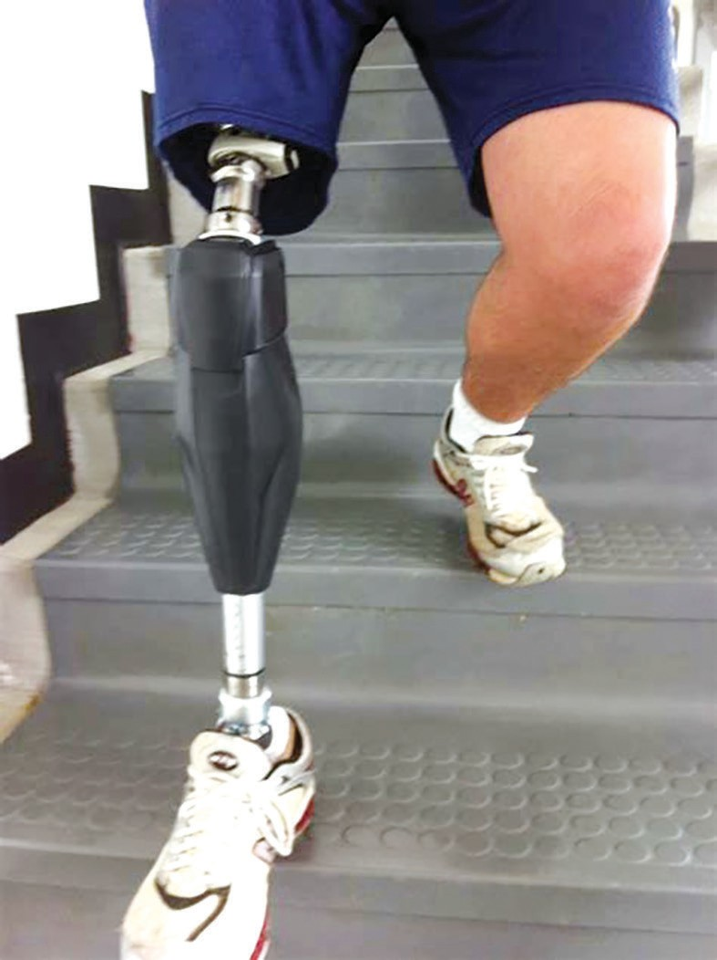
 | Article 25 of on the Righ Disabilities with disabil right to the highest att health with on the basi | the Convention ts of Persons with  states that persons ities have the enjoyment of the inable standard of out discrimination s of disability

11

Sanctions are “unjust and harmful”

H. E. Mr. Idriss Jazairy;
The former Special Rapporteur on the Negative Impact of the Unilateral Coercive Measures on Human Rights:

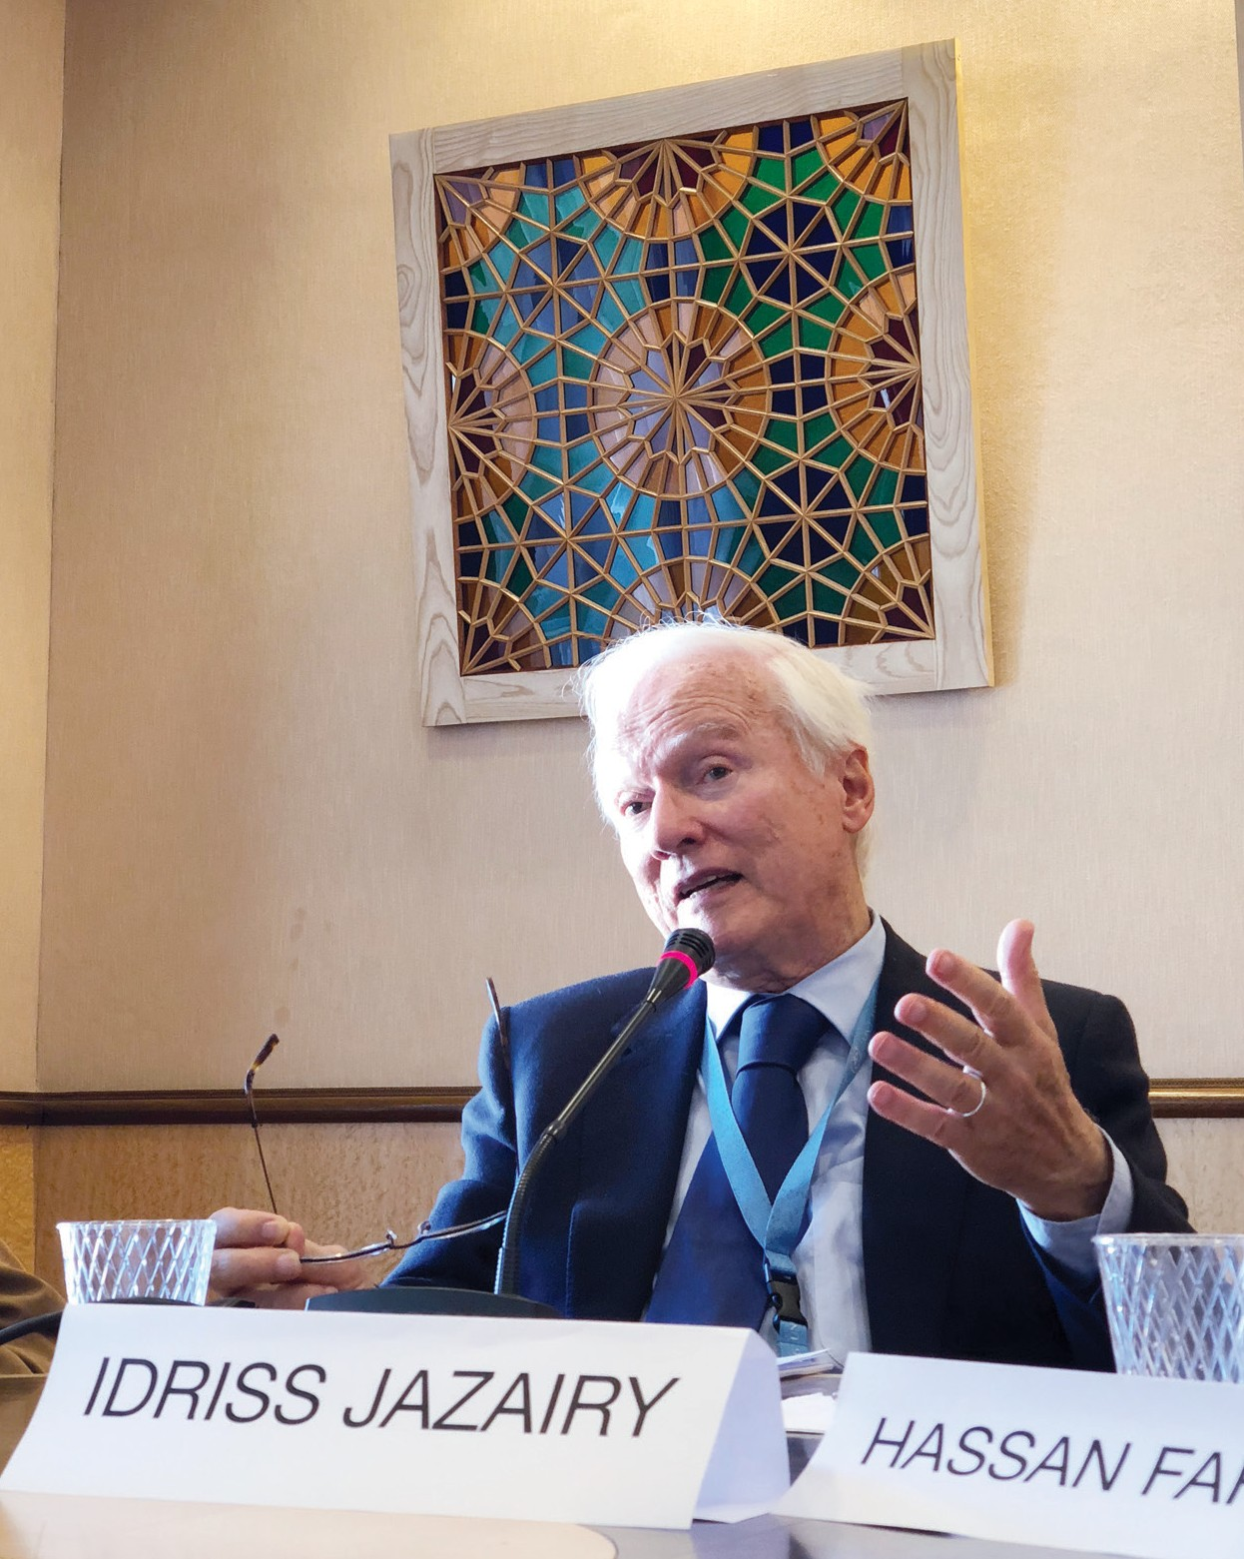
The United States’ sanctions are “unjust and harmful … destroying the economy and currency of Iran, driving millions of people into poverty.” 22 August 2018
“There is a need for differences between States to be resolved through peaceful means as advocated by the UN Charter, while avoiding exposing innocent civilians to collective punishment. Causing hunger and disease through economic instruments should not be accepted in the 21st century.” 8 November 2018
“There can be no justification for not including blanket protections for the importation of food, medicine, and other necessities of life without first requiring lengthy and complex approval processes,” 8 November 2018
“Under economic sanctions, people also die but from lack of food
and medicine, rather than from explosive devices. This form of warfare that relies on starvation and disease deserves the same concern from the international community as any other conflict.” 8 November 2018

12
Sanctions are “unjust and harmful”

UN Special Rapporteur on the Negative Impact of the Unilateral Coercive Measure on Human Rights, Alena Douhan:

According to the UN Special Rapporteur on the Negative Impact of the Unilateral Coercive Measure on Human Rights, Alena Douhan: “Unilateral sanctions attack fundamental human rights, … sanctions are preventing the purchase of vital medical equipment during Coronavirus in Iran, … unilateral sanctions are attacking fundamental human rights such as the right to health and the right to education….” 28 Oct, 2020.
“Sanctions are bringing suffering and death in countries like Cuba, Iran, Sudan, Syria, Venezuela and Yemen. People cannot protect themselves against #COVID19 or get medicine. ”7 Aug, 2020.
“Expanding practice of the application of unilateral sanctions…undermine the rule of law and causes enormous human sufferings….”; the States, the population of States shall never be deprived of their means of subsistence”; “unilateral measures shall never be turned into means of collective punishment”, “…unilateral sanctions affect all human rights in the course of the pandemic…”; “…the role of the United Nations cannot be undermined by unilateral sanctions,” 22 Sep, 2020.
“I shall assess as absolutely inadmissible, the attempts, for example, to (undermine) the role of the UN Security Council as it has been taken … by the United States when announcing the renewal of the UN Security Council sanctions against Iran without any decision of the UN Security Council”, 22 Sep, 2020.

Lack of access to various apps
Iranians can not use some google servises and other apps!

Sanctions Prevent Target Countries from Using “Zoom” Service for Webinars in the Course of the Pandemic

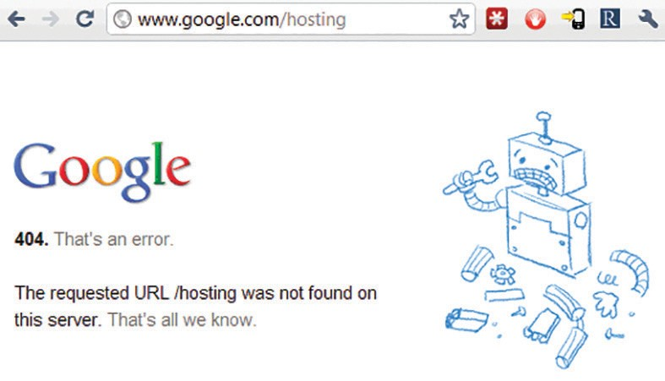

“Actors from countries targeted by United States sanctions are prevented from using online services. In particular, the Zoom service agreement specifies that the service cannot be used by subjects registered in Cuba, the Democratic People’s Republic of Korea, Iran (Islamic Republic of) and other States targeted in accordance with United States legislation, even to establish virtual meetings and webinars involving, inter alia, education and training for doctors or to implement telemedicine services.”Alena Douhan, 21, July
2020.

13

Blockade of International Financial Transaction
Society for Worldwide Interbank Financial Telecommunication (SWIFT) disconnected on 5 November 2018 on Iranian banks.
Financial interbank transactions are the most important pre requisit for import of food, medicine and humanitarian goods.
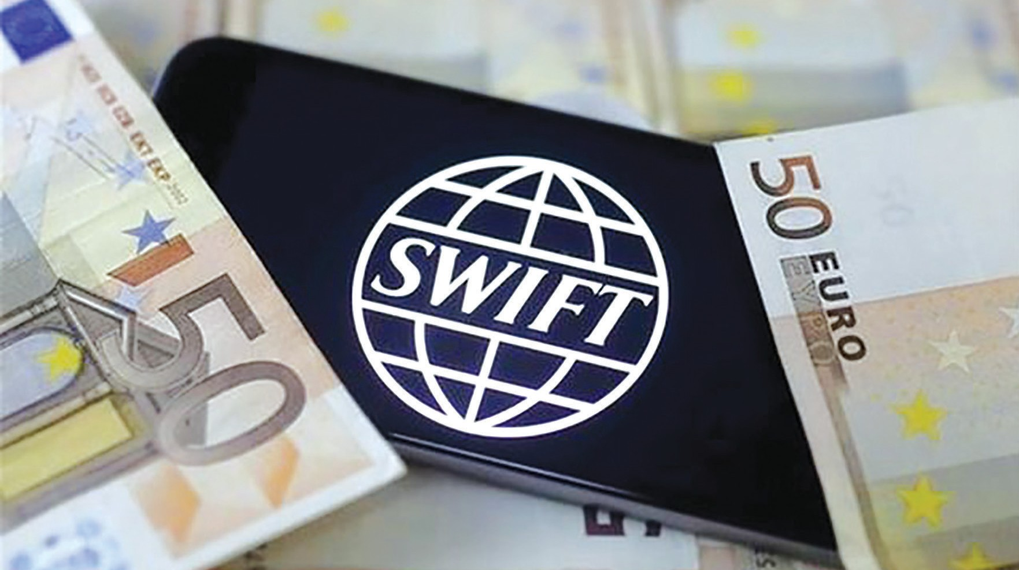

INTERNATIONAL COURT OF JUSTICE 89. Furthermore, the Court notes that …as a result of the measures, certain foreign banks have withdrawn from financing agreements or suspended co-operation with Iranian banks. Some of these banks also refuse to accept transfers or to provide corresponding services. It follows that it has become difficult if not impossible for Iran, Iranian companies and nationals to engage in international financial transactions that would allow them to purchase items not covered, in principle, by the measures, such as foodstuffs, medical supplies and medical equipment.
14

Lack of access to online education
Iranian’s access to many education websites has been limited.
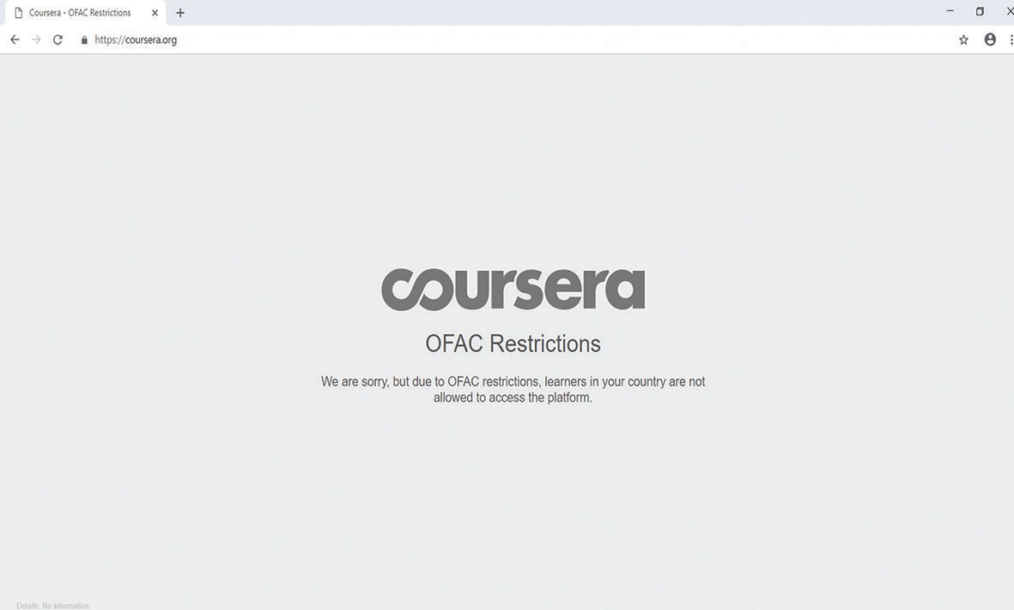

ICESCR, Article 13, 2 (c)
Higher education shall be made equally accessible to all, on the basis of capacity, by every appropriate means, and in particular by the progressive introduction of free education;

15

The Right to Education
Due to the sanctions imposed by the United States, Iranian students are facing numerous challenges including, receiving visas, transferring money and being banned from enrolment in some university courses.

The US government and private banks pay student loans to the people who are enrolling in American universities, while Iranian students are not eligible for such loans.
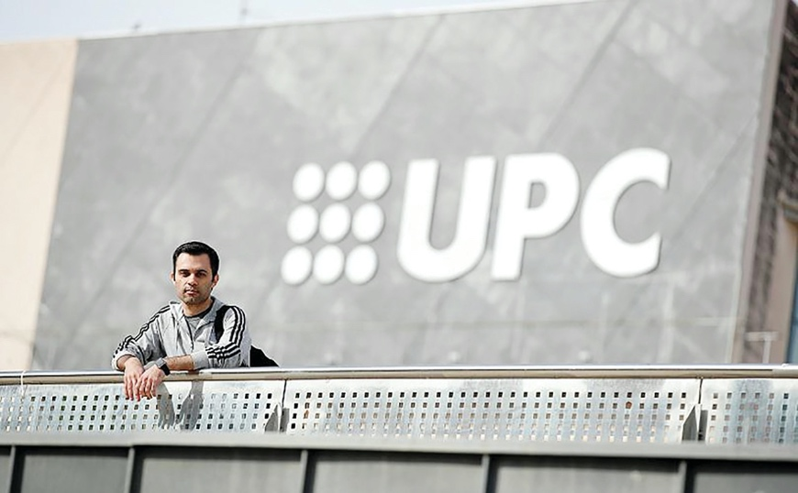
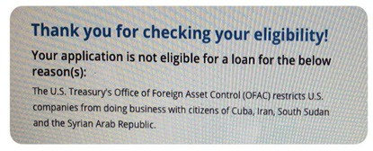

Universal Declaration of Human Rights
Article 26: Everyone has the right to education
... Technical and professional education shall be made generally available and higher education shall be equally accessible to all on the basis of merit.
REUTERS/Albert Gea

16

