Submission for the 3rd Human Rights Youth Challenge

This situation contravenes the normative content of the rights to water and sanitation – these migrants suffer not only from a lack of access to sufficient water and sanitation, but also from stigma and denial of privacy and dignity.
-Catarina de Albuquerque, Former UN Special Rapporteur reporting on the access to water for migrant fishermen in Thailand in 2013

All people have the right to access to clean water for “drinking, personal sanitation, washing of clothes, food preparation, personal and household hygiene,” however, migrant fishermen in Taiwan are often denied this right when working in the private sector. This year, I had the unique opportunity to fight human trafficking while working with the Yilan Migrant Fishermen Union (YMFU). The union has about three hundred members from Vietnam, Indonesia, and the Philippines, and they are stationed in a town with about two thousand other migrant fishermen. Union workers experience several indicators of forced labor: working overtime without pay, being denied time off, verbal and physical abuse, and wage-debt from employers and brokers. The union also raised concerns about access to potable water, toilets, and showering facilities. With their guidance, I wrote a report outlining their issues in accessing water in public and private spaces, and we submitted it to the Special Rapporteur in February of 2019. Here, I will draw on my last report to show how private sector employers often deny employees access to free potable water and decent sanitation facilities. I will also discuss how employers first deny access to water and then silence employee complaints, and force them to stay at their place of employment.

Private sector businesses must provide water and sanitation facilities to employees who live at their place of employment. Employment contracts for fishermen typically state that employers will supply meals and accommodation; however, employers often fail to provide any or enough water. It is generally thought among fishermen and advocates that under the agreement to provide “meals and accommodation,” employers should also provide water. “Accommodation” is a term that should indicate housing as well as sanitation facilities. Even though Taiwan’s Foreign Worker’s Living Care Service Plan requires employers to provide sanitation facilities for foreign national employees, provisions frequently fall short of regulations. When employers are responsible for housing their employees, they must provide access to potable water, toilets, and shower facilities.

Potable water options for migrant fishermen in Taiwan provided by employers have been scarce and unsanitary. Employers should provide fishermen with unlimited access to clean water, but some fishermen experience limits put on the amount of water they receive each month. The United Nations states that fishermen require 2.5 liters of water per day for drinking and cooking, but some employers do not even provide that much water for one day. As stated in our last report, one union member and five other crew members were only given one box of water (600 ml in a bottle, 24 bottles in a box) each month, approximately, 2.4 liters of water per person for a full month. Other fishermen have reported that the water provided by their employers has a ‘fishy’ taste. Fishermen believe the water tastes fishy because their employers repurpose melted ice water that was used for preserving fish as drinking water. This water almost certainly has containments that are hazardous to one’s health. Limited access to water or access to unsanitary water is a serious health risk, and a violation of these fishermen’s right to access water.

Fishermen have limited access to toilets on and off of their ships. All boats have some toilet facility, but many are low quality and function poorly. Toilets on-board are usually the main bathroom access point for fishermen during and after work. Many toilets on boats also do not have a sink nearby. Taiwanese law calls for employers to provide a suitable hand washing area near sanitation facilities, but employers rarely meet this requirement. To wash their hands after using the restroom, fishermen will either use the shower or go to the communal kitchen. If fishermen use the kitchen sink to wash their hands, they typically must walk through ship corridors and then climb a ladder to a different level of the boat to access that area. When fishermen are working on land, there is often a lack of private or public toilets that can meet the needs of so many individuals. Often the only option for fishermen is to urinate in the ocean, often in front of colleagues, bosses, or tourists. This option violates their privacy and their right to access water.

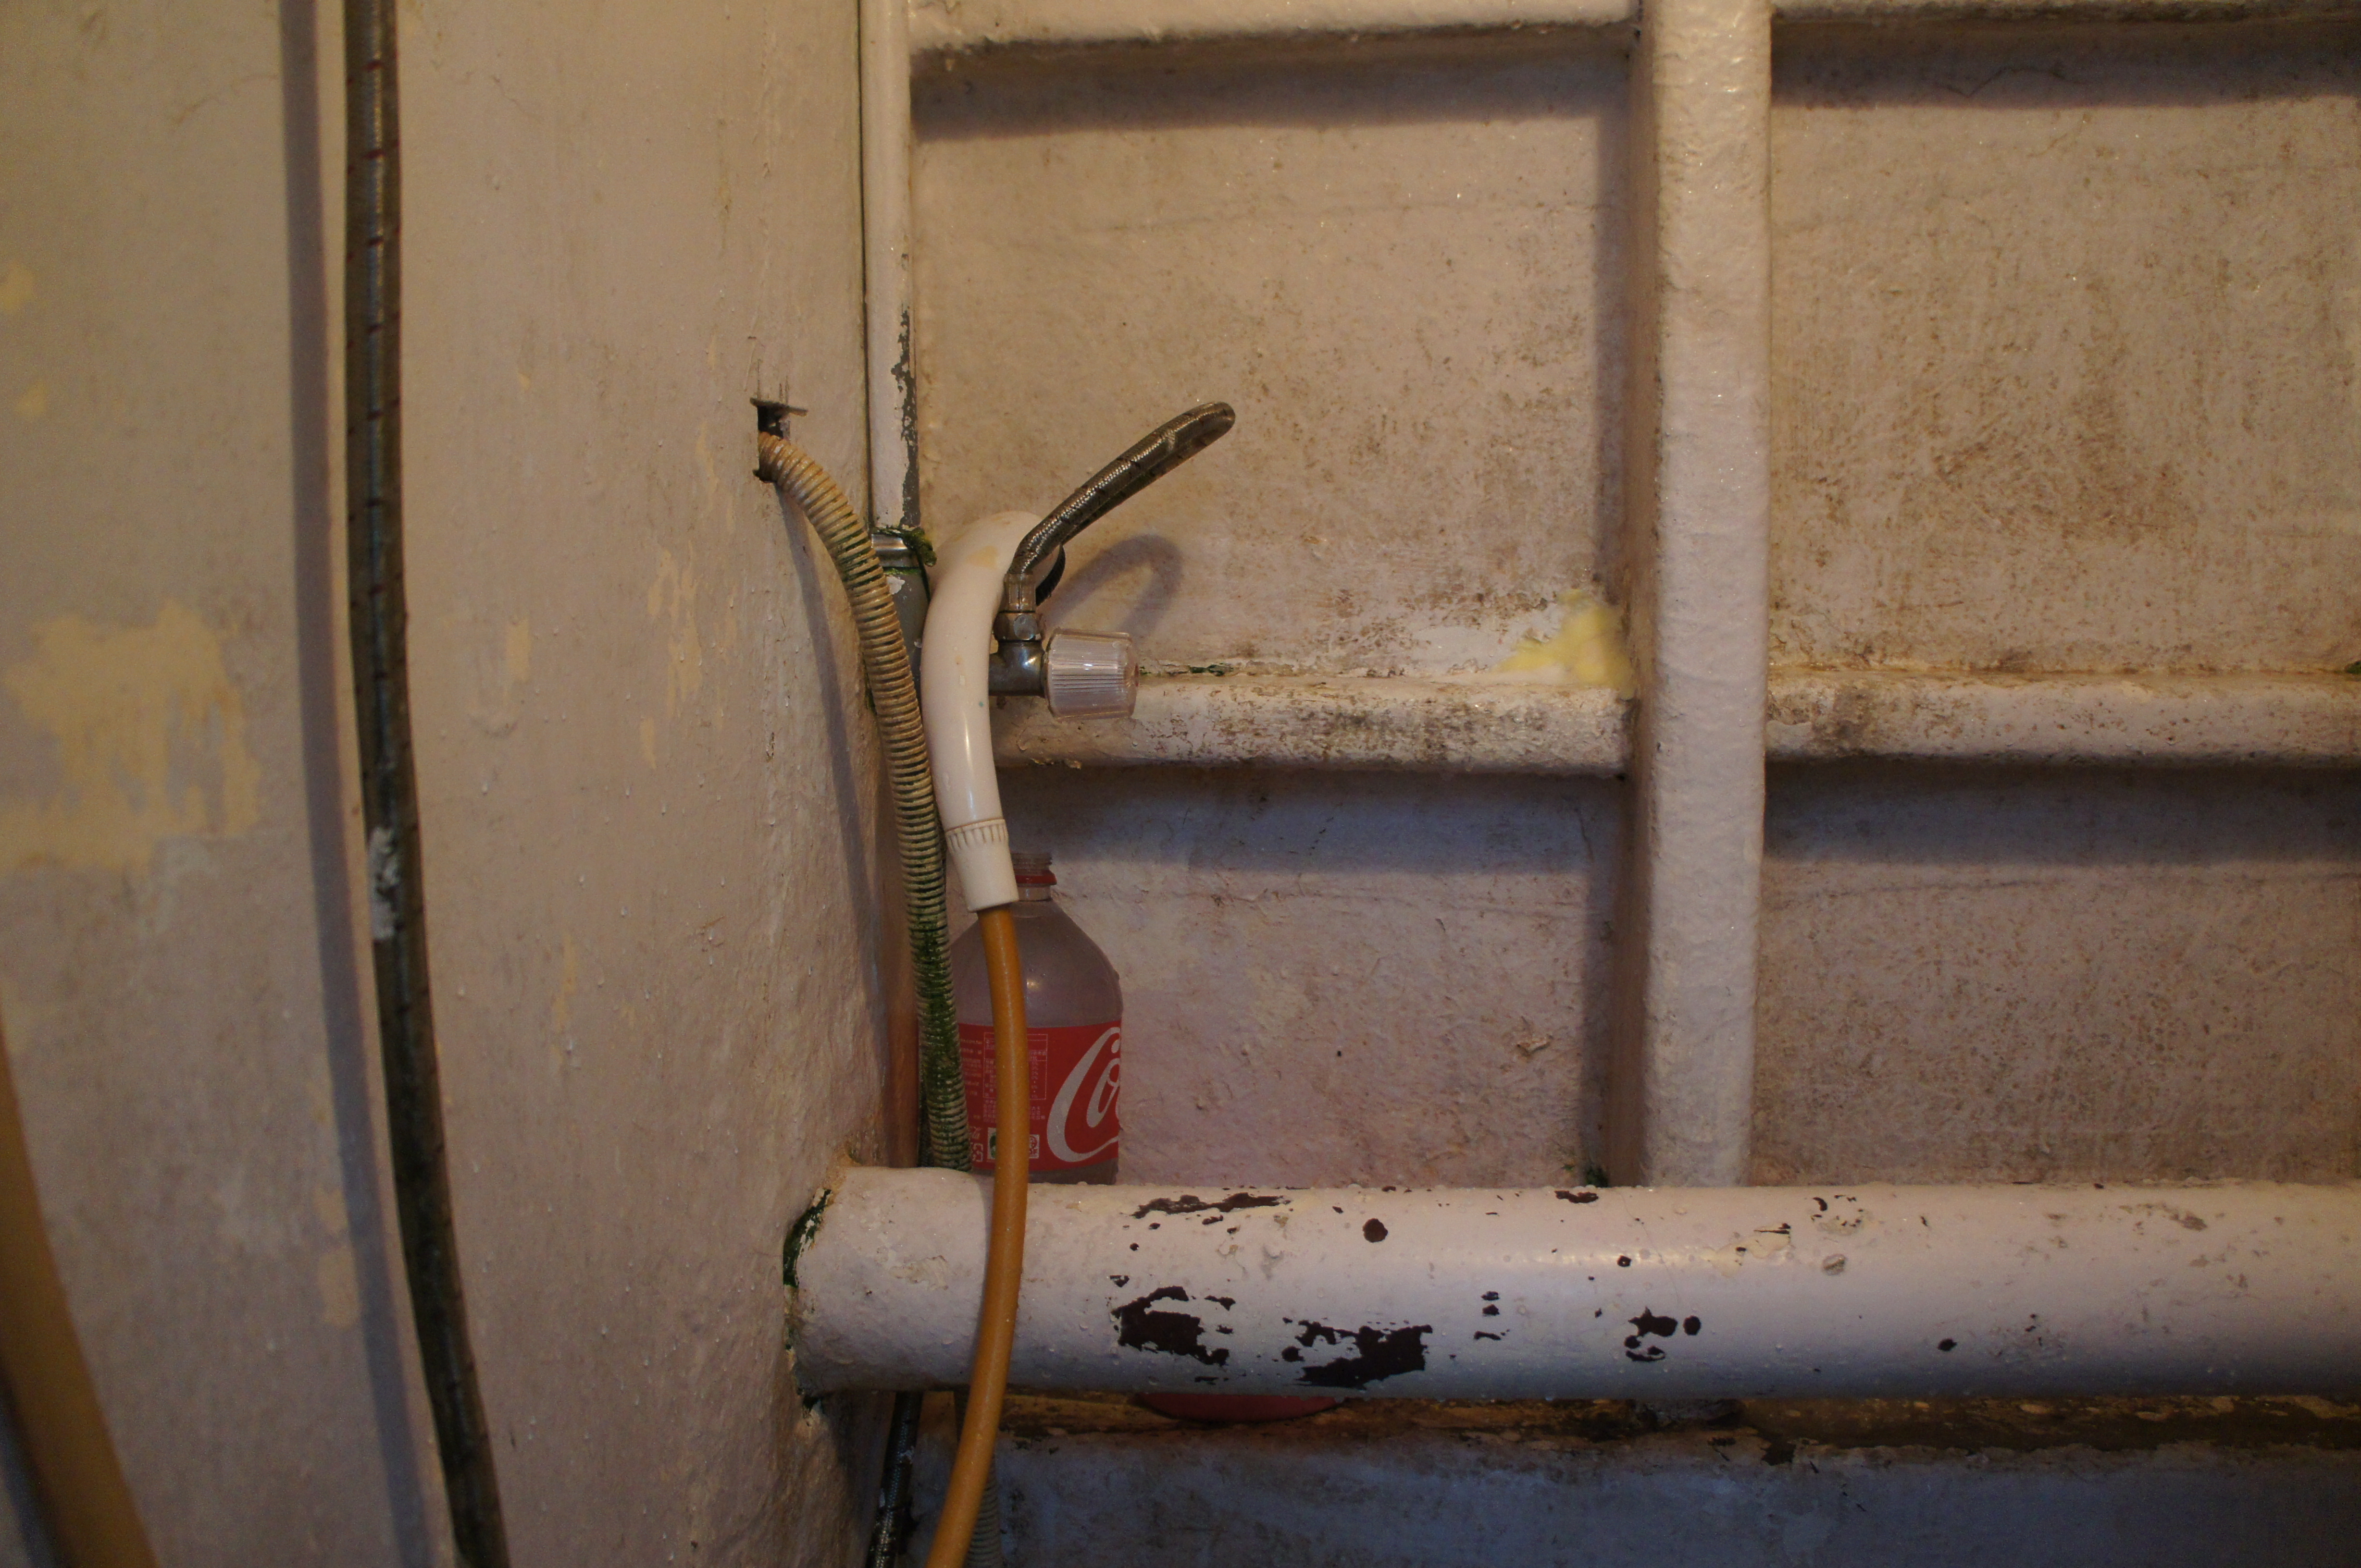
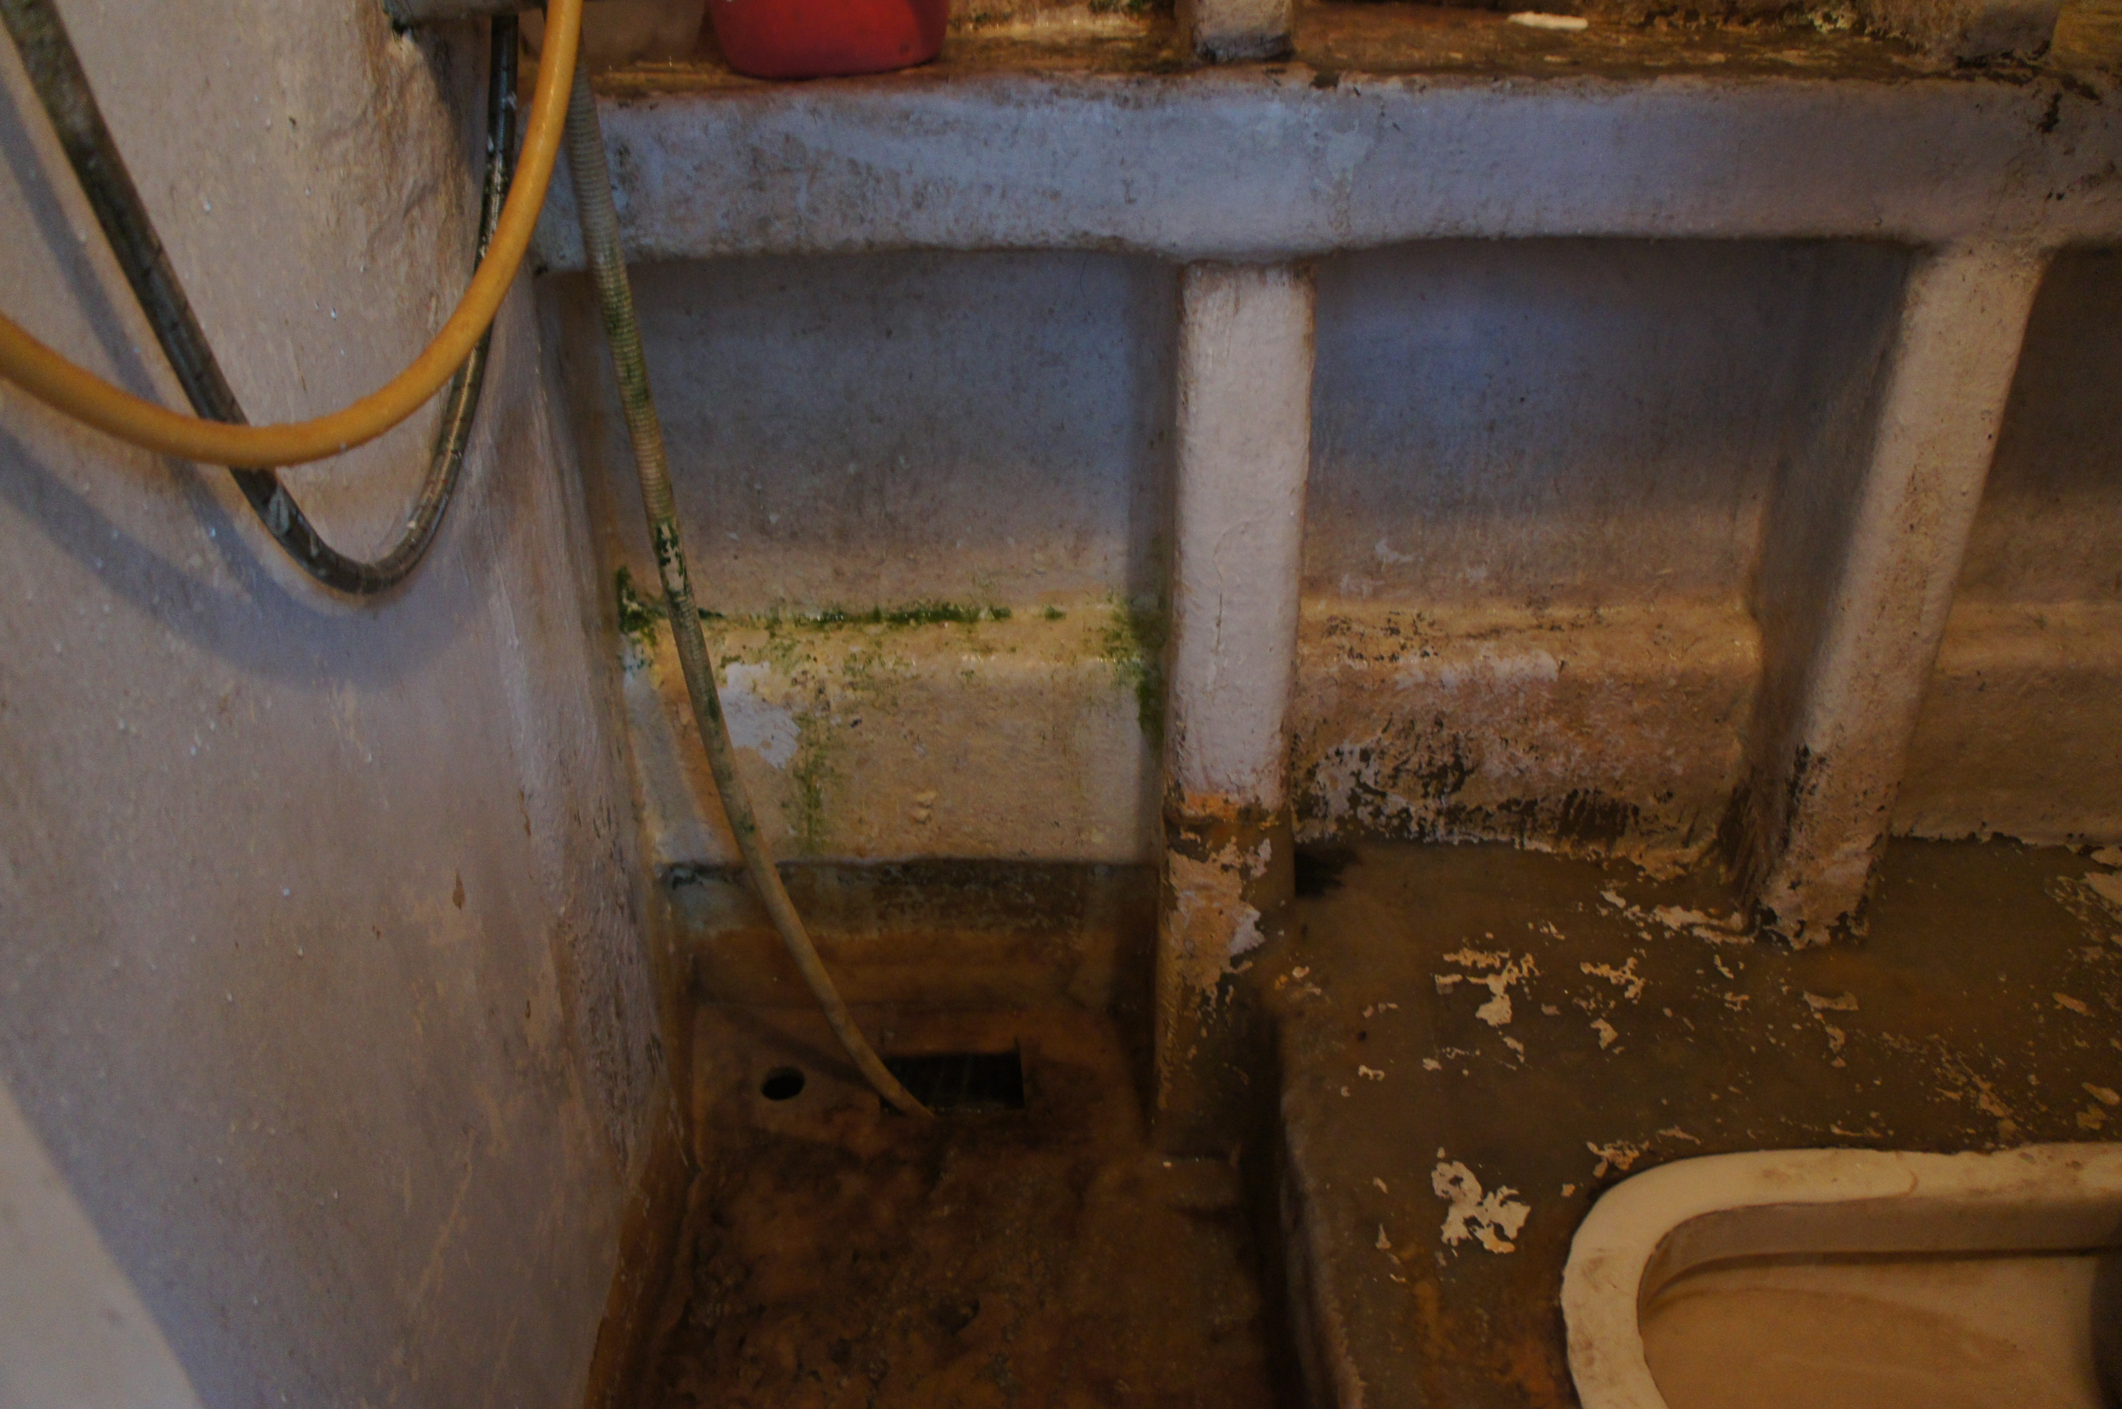
Where there should be a sink next to the toilet, there is just a shower head. Both photographs are show the area of the bathroom where a sink should be. Photograph taken by author on board a boat in Yilan in February, 2019.
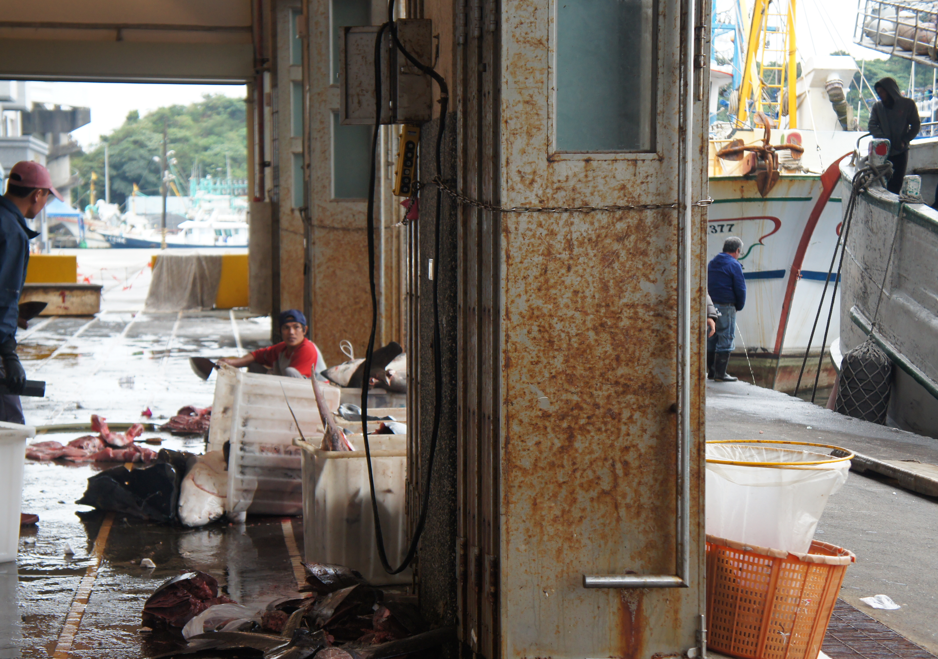
A fishermen takes a break from filleting fish and urinates in the ocean. Fisherman can be seen on the right side of the photograph. Photograph taken by author in February, 2019.

Migrant fishermen have experienced limited access to showering facilities. The YMFU has witnessed that some boats do not have shower access, and many boats lack access to hot water.
According to international guidelines and local law, all boats should have shower access.
When showers are unavailable, union members have resorted to scooping seawater from the ocean and using this method to shower on the docks publicly. Other fishermen utilize tap water from public restrooms to shower. Access to sanitation facilities should not only be considered a matter of human dignity, but also an important aspect of public health. Usually, eight to twelve fishermen live together on a boat, and the ship is where laborers sleep, cook, clean their clothes, and hypothetically, use sanitation facilities. Boats are often packed together in harbors with crews from various boats visiting each other. With such close contact amongst fishermen in ports, inadequate sanitation facilities, and minimal access to healthcare, the risk of illness is high. Proper sanitation facilities are a necessary part of ensuring the health and wellbeing of all people stationed in a harbor.

Migrant fishermen face the injustice of denial to their right to water, and when they attempt to improve their access, they are often silenced. Most migrant fishermen come to Taiwan legally with the help of brokers who place them with employers. Once the fishermen arrive, they pay brokers a monthly fee, and in return, brokers are tasked with acting as monitoring bodies to help laborers mediate work disputes. However, brokers often operate in the interest of the employer. When employees complain about their treatment, like their access to water, brokers will continuously transfer victims to new employers, they will threaten to cut all ties to employment opportunities, threaten to deport victims who complain, and verbally abuse and intimidate victims. All of these broker tactics are used to avoid resolving employee complaints. Even situations as grotesque as the ones detailed in this report rarely get resolved in court or in mediation. Fighting against broker’s attempts to squash issues, language barriers, financial debt, and inability to take off from work, migrant workers often do not have the option to fight employers. When brokers avoid a court case, they benefit financially by keeping their monthly fee for mediation and show their loyalty to the employer, which promises business together again in the future. Here, human trafficking and denial of access to water intersect: when employees try to gain access to water, employers force them to continue working, often with absolutely no improved access to water. Here, fishermen are trapped for year or until they can find a way to escape sooner.

In order to prevent human trafficking and improve water access, Taiwan must ensure that all private and public sector employers uphold the International Covenant on Economic, Social and Cultural Rights which Taiwan ratified on April 22, 2009. In this case, the government should especially focus on Article 7 and 11 which recognize the “right of everyone to the enjoyment of just and favorable conditions of work,” “the right of everyone to an adequate standard of living for himself and his family, including adequate food, clothing and housing, and to the continuous improvement of living conditions.” According to General Comment Number 20, Paragraph 30, “The Covenant rights apply to everyone including non-nationals, such as refugees, asylum-seekers, stateless persons, migrant workers and victims of international trafficking, regardless of legal status and documentation.” Taiwan must uphold all Articles of its ratified ICESCR for everyone working and residing in Taiwan. When the private sector fails to uphold these rights, the government must hold those employers accountable.

Catarina de Albuquerque (Special Rapporteur on the human right to safe drinking water and sanitation), Report of the Special Rapporteur on the human right to safe drinking water and sanitation on her mission to Thailand. U.N. Doc. A/HRC/24/44/Add.3 (Feb. 18 2013).
Office of the High Comm’r of Human Rights, Covenant of Econ. and Social Rights, Gen. Comment No 15, Paragraph 12(a). (January 20, 2003).
Yilan Migrant Fishermen Union, Violations to the Access of Safe Drinking Water and Sanitation for Migrant Fishermen in Public Spaces, Submitted to the United Nations Special Rapporteur on Water and Sanitation (Feb. 28, 2019). Page 1. Available at: https://www.ohchr.org/EN/Issues/WaterAndSanitation/SRWater/ Pages/PublicSpaces.aspx
Food and Agriculture Org. of the United Nations, SAFETY RECOMMENDATIONS FOR DECKED FISHING VESSELS OF LESS THAN 12 METRES IN LENGTH AND UNDECKED FISHING VESSELS (2012), Available at: http://www.fao.org/3/i3108e/i3108e.pdf
Yilan Migrant Fishermen Union, Violations to the Access of Safe Drinking Water and Sanitation for Migrant Fishermen in Public Spaces, Submitted to the United Nations Special Rapporteur on Water and Sanitation (Feb. 28, 2019). Page 1. Available at: https://www.ohchr.org/EN/Issues/WaterAndSanitation/SRWater/ Pages/PublicSpaces.aspx
Article 11 of Taiwan’s Drinking Water Management Act which calls for drinking water to “meet drinking water quality standard.”
Taiwan Ministry of Labor, Taiwan’s Occupation Health and Facilities Law, Article 319.7 (January 1, 2009)
Yilan Migrant Fishermen Union, Violations to the Access of Safe Drinking Water and Sanitation for Migrant Fishermen in Public Spaces, Submitted to the United Nations Special Rapporteur on Water and Sanitation (Feb. 28, 2019). Page 2. Available at: https://www.ohchr.org/EN/Issues/WaterAndSanitation/SRWater/ Pages/PublicSpaces.aspx
International Labour Organization, Recommendation No. 115 of 1961 on Workers’ Housing cites: “The supply of safe water in the workers’ dwelling in such ample quantities as to provide for all personal and household uses” Article 19-1 of Taiwan’s Regulations on the Permission and Administration of the Employment of Foreign Workers calls for “Food and housing safety and sanitation.”
Ann Maxon, Poor treatment of fishers ‘embarrassing’: lawmaker, Taipei Times (January 11, 2019), Available at: http://www.taipeitimes.com/News/taiwan/archives/2019/01/11/2003707725 These anecdotes were gathered by the Yilan Migrant Fishermen Union and shared with local lawmakers. They were publicly announced at a press conference in January 2019.
Yilan Migrant Fishermen Union, Violations to the Access of Safe Drinking Water and Sanitation for Migrant Fishermen in Public Spaces, Submitted to the United Nations Special Rapporteur on Water and Sanitation (Feb. 28, 2019). Page 3. Available at: https://www.ohchr.org/EN/Issues/WaterAndSanitation/SRWater/ Pages/PublicSpaces.aspx
International Covenant on Economic, Social and Cultural Rights, Article 12 states: The States Parties to the present Covenant recognize the right of everyone to the enjoyment of the highest attainable standard of physical and mental health, (b) The improvement of all aspects of environmental and industrial hygiene; (c) The prevention, treatment and control of epidemic, endemic, occupational and other diseases.
Yilan Migrant Fishermen Union, Violations to the Access of Safe Drinking Water and Sanitation for Migrant Fishermen in Public Spaces, Submitted to the United Nations Special Rapporteur on Water and Sanitation (Feb. 28, 2019). Page 3. Available at: https://www.ohchr.org/EN/Issues/WaterAndSanitation/SRWater/ Pages/PublicSpaces.aspx

