The suggestion for improving the human rights on water and sanitation through private sector participation on water services

Introduction
“Access to safe water and sanitation for all people,” is touted as a human right.The UN Committee on Economic, Social and Cultural Rights of the general comment No. 15 on the right to water states that “The human right to water entitles everyone to sufficient, safe, acceptable, physically accessible and affordable water for personal and domestic uses.” It also insists that access to sanitation is "fundamental for human dignity and privacy.” Therefore, “access to safe water and sanitation,” is an essential element of human life and this can be one of the factors that ensures human life.

Water and sewage services have an important role to play in guaranteeing people’s human rights. According to the European Commision (2004) water and sewage services are essential for "access to safe water and sanitation for all people." It has been shown that public interest, represented by equity and affordability to the socially vulnerable, as well as continuity, represented by financial efficiency and technology transfer, are one of the biggest factors in achieving "access to safe water and sanitation for all people."

In Japan, municipalities have traditionally operated water and sewage services in the public interest. As a result, Japan's water supply penetration rate (2017) is 98% and sewage penetration rate (2018) is 79.3% (wastewater treatment rate is 91.4%), making it possible for many citizens to enjoy ”safe water and sanitation.” However, Japan is facing water and sewerage management challenges unique to developed countries, which threatens continuity.

The water supply and sanitation facility for each person must be continuous and sufficient for personal and domestic use. This is one of the UN's elements to achieve "safe drinking water and adequate sanitation," thus continuity cannot be ignored. In order to improve continuity, participation of private sectors in the operation of water and wastewater treatment plants through Public–Private Partnership (PPP) and Private Finance Initiative (PFI) has been actively discussed in Japan. As a result, the first contract with performance order for a 20-year period (called the Concession Scheme in Japan) was concluded between Hamamatsu City and the Hamamatsu Water Symphony (HWS).

In this essay, we will examine the Hamamatsu Concession Scheme and consider how Hamamatsu City and HWS are trying to improve both public interest and continuity through the Concession Scheme in order to achieve "access to safe water and sanitation for all people."

Outline of the Concession Scheme in Hamamatsu City

Hamamatsu City is located in western Shizuoka Prefecture and is one of the 21 ordinance-designated cities in Japan. The sewerage population is about 645,000 while the total population is around 800,000. Thus, the sewerage population penetration rate is 80%, which is low among ordinance-designated cities (average 97.2%). In Hamamatsu City, there are two major wastewater treatment plants, the Chubu and the Seien Wastewater Treatment Plant.

Japan's first Concession Scheme contract (similar to an Affermage in France) was signed between Hamamatsu city and HWS, with the aim of efficiently operating the Seien Wastewater Treatment Plant. Combining the knowledge of the private sector with the public sector, the operation began in April 2018. The Concession Scheme area included two pumping stations and one wastewater treatment plant with a sewage population of 465,000, the largest sewarege population in Hamamatsu City.

Why did Hamamatsu City sign a Concession Scheme contract? There are primarily three problems unique to developed countries and outlined by the Ministry of Internal Affairs and Communications (2019): declining water service revenues due to a declining population, aging facilities represented by pipelines, and declining staff working on water and sewerage. Japan is not immune to these and is currently facing them.

Analysis of Gaps in Human Rights Protection

Public interest
An important challenge to public interest in public and private partnerships is that private business owners may prioritize their own interests and inappropriately increase tariffs without the municipalities’ permission.

In order to avoid this, there are many considerations that should be made before starting a Concession, including not only the scope of the facilities covered and which revenue-generating projects are allowed, but also the percentage of payments to private sectors and discussions on fees and water demand risks.

In the case of Hamamatsu City, the Concession has been carefully formed, considering examples of Concessions overseas, as well as the laws and national subsidies in Japan. As a result, the responsibility was divided between Hamamatsu City and HWS (as shown in Table 1), with Hamamatsu City taking charge of fee revision and monitoring, and HWS taking charge of maintenance and refurbishment.

Table.1: Risk Sharing between Hamamatsu City and HWS

Hamamatsu city | HWS
- Planning  (Both Hamamatsu and HWS)  - Monitoring  - Fee revision  - Asset owenerships  - Network renewal | - Planning  (Both Hamamatsu and HWS)  - Approval  - Tariff collection  - O&M  - Facility refurbishment

Continuity
Another challenge to business continuity was identified as HWS’ position in the private sector which leaves it at risk of bankruptcy or withdrawal.

In Japan, there has been no private sector contracting of long-term performance orders, and municipalities have been responsible for all water and sanitation services. As a result, no companies in Japan have accumulated experience in outsourcing long-term performance order contracts. Therefore, bankruptcy or withdrawal is a real possibility.

Under a Concession, water treatment plants will be operated at the discretion of the private sector for extended periods of time. Therefore, by monitoring the contractually agreed upon service performance indicators (water quality, qualified employees, fundraising etc.) and financial statements, along with checking the management, it will be possible to ensure proper operation of the water treatment plants by providing corrective guidance in advance.

In this contract, three types of monitoring systems have been established: self-monitoring by the operator, monitoring by Hamamatsu City, and monitoring by a third-party organization. In addition, the "Seien Conference" has been set up to mediate in the event of disputes regarding results of the monitoring. It is possible to reduce the likelihood of private sector bankruptcy or withdrawal by setting up three monitoring systems and continually correcting its management situation. Moreover, the monitoring and evaluation items, procedures and results have been made public, and there is adequate accountability to the public.
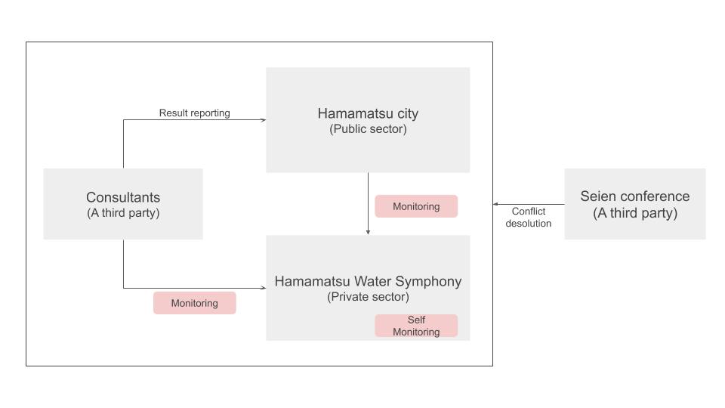
Fig.1 Monitoring system for the Concession of the Seien Wastewater Treatment Plant
(Source:Hamamatsu City Water and Sewerage Service Department )

Impact on the Realization of the Human Rights to Water and Sanitation

Public interest
One may wonder, how does Hamamatsu City and HWS aim to achieve “access to water and sanitation” through the Concession Scheme?

An important element that shapes public interest is affordability for the socially vulnerable. HWS aims to increase affordability for the socially vulnerable by contributing in small ways to the revitalization of the local economy in Hamamatsu City and contributing to the bottom line of income.

For example, in order to contribute to the revitalization of the local economy in Hamamatsu City, HWS utilizes local companies and supports social entrepreneurs. By outsourcing the procurement of materials and the removal of sludge to local companies, HWS aims to revitalize the economy in Hamamatsu City. Initially, a target was set for 30% of orders to go local companies but HWS exceeded this target by reaching 37% in the first year.

Furthermore, by supporting the start-up and development of social entrepreneurs who use business to solve local issues in Hamamatsu City, HWS helps not only reduce the social issues Hamamatsu City is facing, but also creates new industries to replace the city's famous musical instrument and automobile industries, thereby contributing to the diversification of income sources for citizens.

Continuity
Financial efficiency and technical succession are important factors in managing continuity. By keeping operating costs down through this Concession, it is believed that this will contribute to increased financial efficiency, and technical skills will be accumulated in Hamamatsu City through the hiring and training of local people.

Factors that will lower operating costs include a 20-year refurbishment plan and the use of the right amount of consumables based on data. In the past, many contracts were outsourced in a single year or a few years, so the private sector did not invest on a large scale. However, since the project period is 20 years, it is expected that long-term investment will be made, such as whether to extend the service life of each machine by repairing it, or whether to introduce more efficient machines to reduce electricity costs.

In the past, a certain amount of consumables (e.g., deodorants and flocculants) have been consumed for daily maintenance. Therefore, equipment was introduced to use the right amount of consumables based on available data. By moving away from relying on human intuition for maintenance, it has become possible to keep utility costs down.

As a result, between April 2018 and March 2019, HWS made a profit of 166 million yen, which is a good start to achieving a goal of 14.4% Value For Money for 20 years (referred to as the cost reduction effect, which was assumed to be 60.5 billion yen over the 20 year period, while HWS aims to operate at 51.39 billion yen, which is 14.4% lower).

The HWS aims to hire 80% of new employees from those living in Hamamatsu City. It is possible to train local people to develop the skills necessary to work in and run the Seien Wastewater Treatment plant in Hamamatsu City by the local people cultivating technical experience in the Seien Wastewater Treatment Plant.

In addition, HWS accumulates expertise, skills and experience, and shares it with Hamamatsu City employees. HWS holds special courses on low-pressure electricity handling and pump maintenance, aiming to improve technology in the entire Hamamatsu City area.

Conclusion
This essay describes human rights to water and sanitation as "Access to safe water and sanitation for all people", and discusses how important both public interest and continuity are to realizing human rights. It also describes how Hamamatsu City is attempting to ensure both public interest and continuity through working with the private sector.

Rate setting in terms of public interest and the risk of private withdrawal in terms of continuity were raised as issues when the private sector entered the water and sewerage industry. Hamamatsu City and HWS are attempting to solve the problems of private sector participation by clarifying the division of responsibility in the contract and setting up a sufficient monitoring system. In addition, the private sector participation makes it possible to improve the public interest by contributing to the development of the local economy in Hamamatsu City, and to improve continuity by decreasing operating costs and cross training City employees.

While the private sector participation in the water and sewerage sector brings various benefits, it is essential for municipalities to manage the risks. In order to achieve "access to safe water and sanitation for all people," by making the most of the ingenuity of the private sector, as in Hamamatsu, it is important for the government to design a solid system. It is hoped that future water and sewerage services will be built to enhance the public interest and continuity and achieve "access to safe water and sanitation for all people."

"Human right to water and sanitation | International Decade for ...." https://www.un.org/waterforlifedecade/human_right_to_water.shtml. Accessed 13 Apr. 2020.
"Progress since the 2004 White Paper on services of general ...." 20 Nov. 2007, https://www.eerstekamer.nl/eu/documenteu/sec_2007_1515_progress_since_the/f=/vhq3obyx4bk9.pdf. Accessed 14 Apr. 2020.
"水道普及率の推移［PDF形式：698KB］." https://www.mhlw.go.jp/content/000501638.pdf. Accessed 16 Apr. 2020.
"平成30年度末 都道府県別 汚水処理及び下水道処理人口普及率." http://www.mlit.go.jp/common/001304471.pdf. Accessed 16 Apr. 2020.
"The Human Right to Water and Sanitation - the United Nations." https://www.un.org/waterforlifedecade/pdf/human_right_to_water_and_sanitation_media_brief.pdf. Accessed 16 Apr. 2020.
"Privatisation of Water: A Historical Perspective - ResearchGate." 12 Aug. 2014, https://www.researchgate.net/publication/228385198_Privatisation_of_Water_A_Historical_Perspective. Accessed 17 Apr. 2020.
"General Comment No. 15: The Right to Water (Arts ... - Refworld." 20 Jan. 2003, https://www.refworld.org/docid/4538838d11.html. Accessed 18 Apr. 2020.
"浜松市公共下水道終末処理場（西遠処理区） 運営事業 公共施設 ...." 30 Oct. 2017, https://www.city.hamamatsu.shizuoka.jp/g-sisetu/gesui/seien/documents/jisshikeiyakusho_20171030.pdf. Accessed 18 Apr. 2020.
"浜松市における 下水道事業へのコンセッション方式 ... - 国土交通省." https://www.mlit.go.jp/common/001202606.pdf. Accessed 18 Apr. 2020.
"8-1-2 都道府県別汚水処理人口普及率 8-1-3 都道府県・政令市別 ...." http://www.mlit.go.jp/river/toukei_chousa/kasen_db/pdf/2018/8-1-2_8-1-3.pdf. Accessed 14 Apr. 2020.
"浜松市における 下水道事業へのコンセッション方式 ... - 国土交通省." https://www.mlit.go.jp/common/001202606.pdf. Accessed 13 Apr. 2020.
"水道事業の課題と取組について - 総務省." 24 Apr. 2019, https://www.soumu.go.jp/main_content/000618172.pdf. Accessed 15 Apr. 2020.
"浜松市公共下水道終末処理場（西遠処理区）運営事業の ...." 31 Mar. 2020, https://www.city.hamamatsu.shizuoka.jp/g-sisetu/gesui/seien/monitoring.html. Accessed 17 Apr. 2020.
"浜松市公共下水道終末処理場（西遠処理区）運営事業の ...." 31 Mar. 2020, https://www.city.hamamatsu.shizuoka.jp/g-sisetu/gesui/seien/monitoring.html. Accessed 17 Apr. 2020.
"本文及び添付資料1から6（PDF：1151KB） - 浜松市." https://www.city.hamamatsu.shizuoka.jp/g-sisetu/gesui/seien/documents/mainand1-6.pdf. Accessed 15 Apr. 2020.
"浜松市公共下水道終末処理場（西遠処理区） - 浜松ウォーター ...." 2 Mar. 2020, http://hw-symphony.jp/wp/wp-content/uploads/2020/03/92c4f0a08088ef5313acc29dcd916665.pdf. Accessed 15 Apr. 2020.
"シンフォニー通信 Vol 3 - 浜松ウォーターシンフォニー株式会社." http://hw-symphony.jp/data/newsletter_vol03.pdf. Accessed 15 Apr. 2020.
"損益計算書." http://hw-symphony.jp/wp/wp-content/uploads/2019/08/HWS-financial-statements-FY2018.pdf. Accessed 15 Apr. 2020.
"総務省｜地方自治制度｜指定都市一覧." 26 Oct. 2016, https://www.soumu.go.jp/main_sosiki/jichi_gyousei/bunken/shitei_toshi-ichiran.html. Accessed 26 Apr. 2020.

