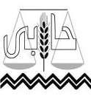
Habi Center for Environmental Rights
Registered No. 5301 Cairo

Right to Water
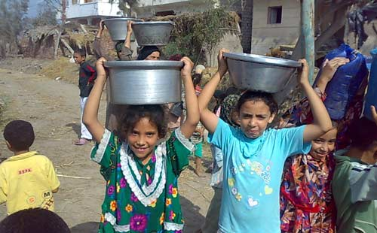

"Stigmatization in the Realization of the Rights to Water and Sanitation"

Egypt

2010 – 2011
Violating human right to access to a safe drinking water is one the most sever violations to the human dignity. This had been committed by the last regime during thirty years by wasting millions of pounds for developing water stations that had not been completed. The result, in turn, was that 56% of citizens in rural regions had been deprived from their right to access to fresh safe drinking water as it is always cut off and is often undrinkable which is highlighted in Habi Center for Environmental Rights' 2010 and 2011 reports and case studies.

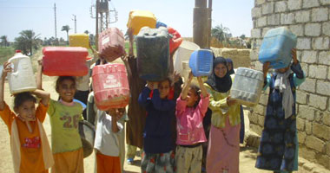
Habi Center for Environmental Rights has issued Right to Water reports in 2010 and 2011 which highlight the violations undergone by citizens in accessing safe drinking water and with appropriate cost. The reports depend on several newspapers and electronic ones which the center regards as the most deliberated newspapers and the most interested in the topic. This monitoring process aims at coming out with general indicators illustrating the status of citizens' right to drinking water. The reports tackle a number of points that shed light on right to drinking water, right to water with high quality and right to water with appropriate cost. This report highlights the citizens' sufferance because of water problems, reasons of water cut off, how citizens express their resentment, the different governances that suffer from water problems and right-to-water case studies that Habi has conducted.

The reports reflect the citizens' sufferance from water cut off that may extend to hours, days, months or years. Also they complained from its quality and many times it is polluted. The monitoring process had revealed the different reasons behind water cut off which varied as following: (1) the main water line is being cut; (2) the main pipe has been broken out; (3) changing a damaged trap; (4) sanitation pipes have been broken out; (5) water line break out; (6) a common pipe breaking; (7) electricity cut led to water cut off.
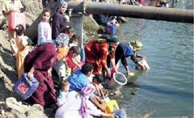
The reports and Habi's case studies have revealed the different protestations forms that expressed the citizens' resentment of water problems. These protestations' forms have varied among protests, demonstrations, banditry and reporting. This, in fact, reflects the changes undergone by Egypt generally and the increasing of protestation culture. The following table illustrates the citizens' protestations concerning water.
Table (1) Different Protestations' Forms
Serial | Protestation's Form | Protestations' number
1 | A Protest | 15
2 | Banditry | 8
3 | Threatening with banditry | 4
4 | Reporting | 2

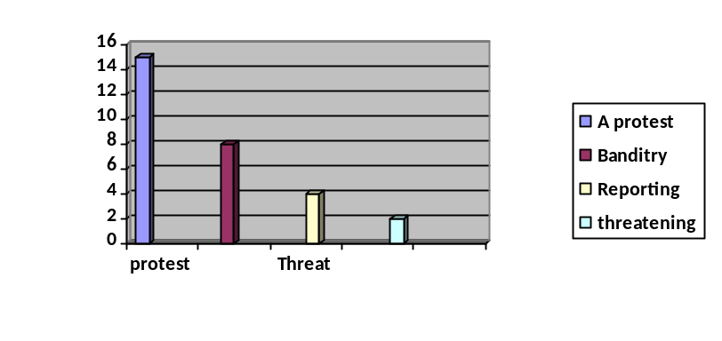

Moreover, Habi has monitored the governances that suffer water problems all over Egypt. The following table sheds light on the governances suffer water access, quality or cost.
Table (2) Governances suffer water problems
Serial | Governance | Water Access | Water pollution | Water Cost
1 | Minia
2 | Asuit
3 | Halaib and Shaltin
4 | Giza
5 | Al Daqahlia
6 | Aswan
7 | Bani Souif
8 | Al Sharkia
9 | Ismailia
10 | Kafr El Sheikh
11 | Fayuom
12 | Luxor
13 | Al Arish
14 | Port Said
15 | Alexandria
16 | Damietta
17 | Al Qualubia
18 | Al Bihara
19 | Al Gharbia
20 | Sohag
21 | Sharm El Sheikh
22 | Marsa Matroh
23 | Al Wadi El Gidid
24 | Al Bahr El Ahmr
25 | 10th Ramadan
26 | Qina
27 | Suez
28 | Hurghada

Right-to-water case studies conducted by Habi Center for Environmental Rights
Habi Center for Environmental Rights has conducted right-to-water case studies which have illustrated violation of citizens' right to water that affect their right to health and many environmental rights which have been guaranteed by international charters, constitution and law.

"Faqos"
More than 50 thousands people live in Arab Darwich village in Faqos/ El Sharqya province. They have suffered from lack of fresh pure drinking water and they have submitted a lot of complaints to the official bodies but in vain. Habi has formed a legal team to visit the village and meet the officers in the water company to discuss the problem, knowing its reasons and solve it. It has been obvious to the center's team that the problem's reason is that the village is geographically higher than other villages and water line, and that drinking water cannot be accessible except by a "motor". The village already has a motor but it is broken down after being ignited. The team visited the local unit that is responsible for operating the motor where the general secretary has informed the team that the electricity company is responsible for operating the motor and that the budget is not enough since it requires high cost. The general secretary called the officer in the electricity company the informed him of the team attendance, then he promised to solve the problem immediately. Following up with the residents, the center knew that drinking water has become accessible and that the motor operated well. But, currently, the residents complain from bad quality of water, although their neighbor villages have access to fresh drinking water with high quality. The center is now preparing for another visit to the village to know the real reasons and solving the problem.
"Sohag"
Habi Center for Environmental Rights has received a letter from The Holding Company of Drinking Water and Sanitation in 28th February 2010. The letter contains the company's plan to finish surface water station serves the villages of Sohag by June 2010. This letter came as a response to the letter sent to it tackling the necessity of providing surface water to these villages and working upon finding rapid solutions for ground stations. The residents of these villages live miserably because of polluted drinking water which is provided by affiliated company through ground stations. In addition, they complained a lot from water cut off for long periods, its bad quality and they pay for it! The Center has formed a team to study the problem and visit these victim villages, a drinking water expert accompanied the team who visited the water stations, checking them and their operation ways, then he wrote a technical report about them.

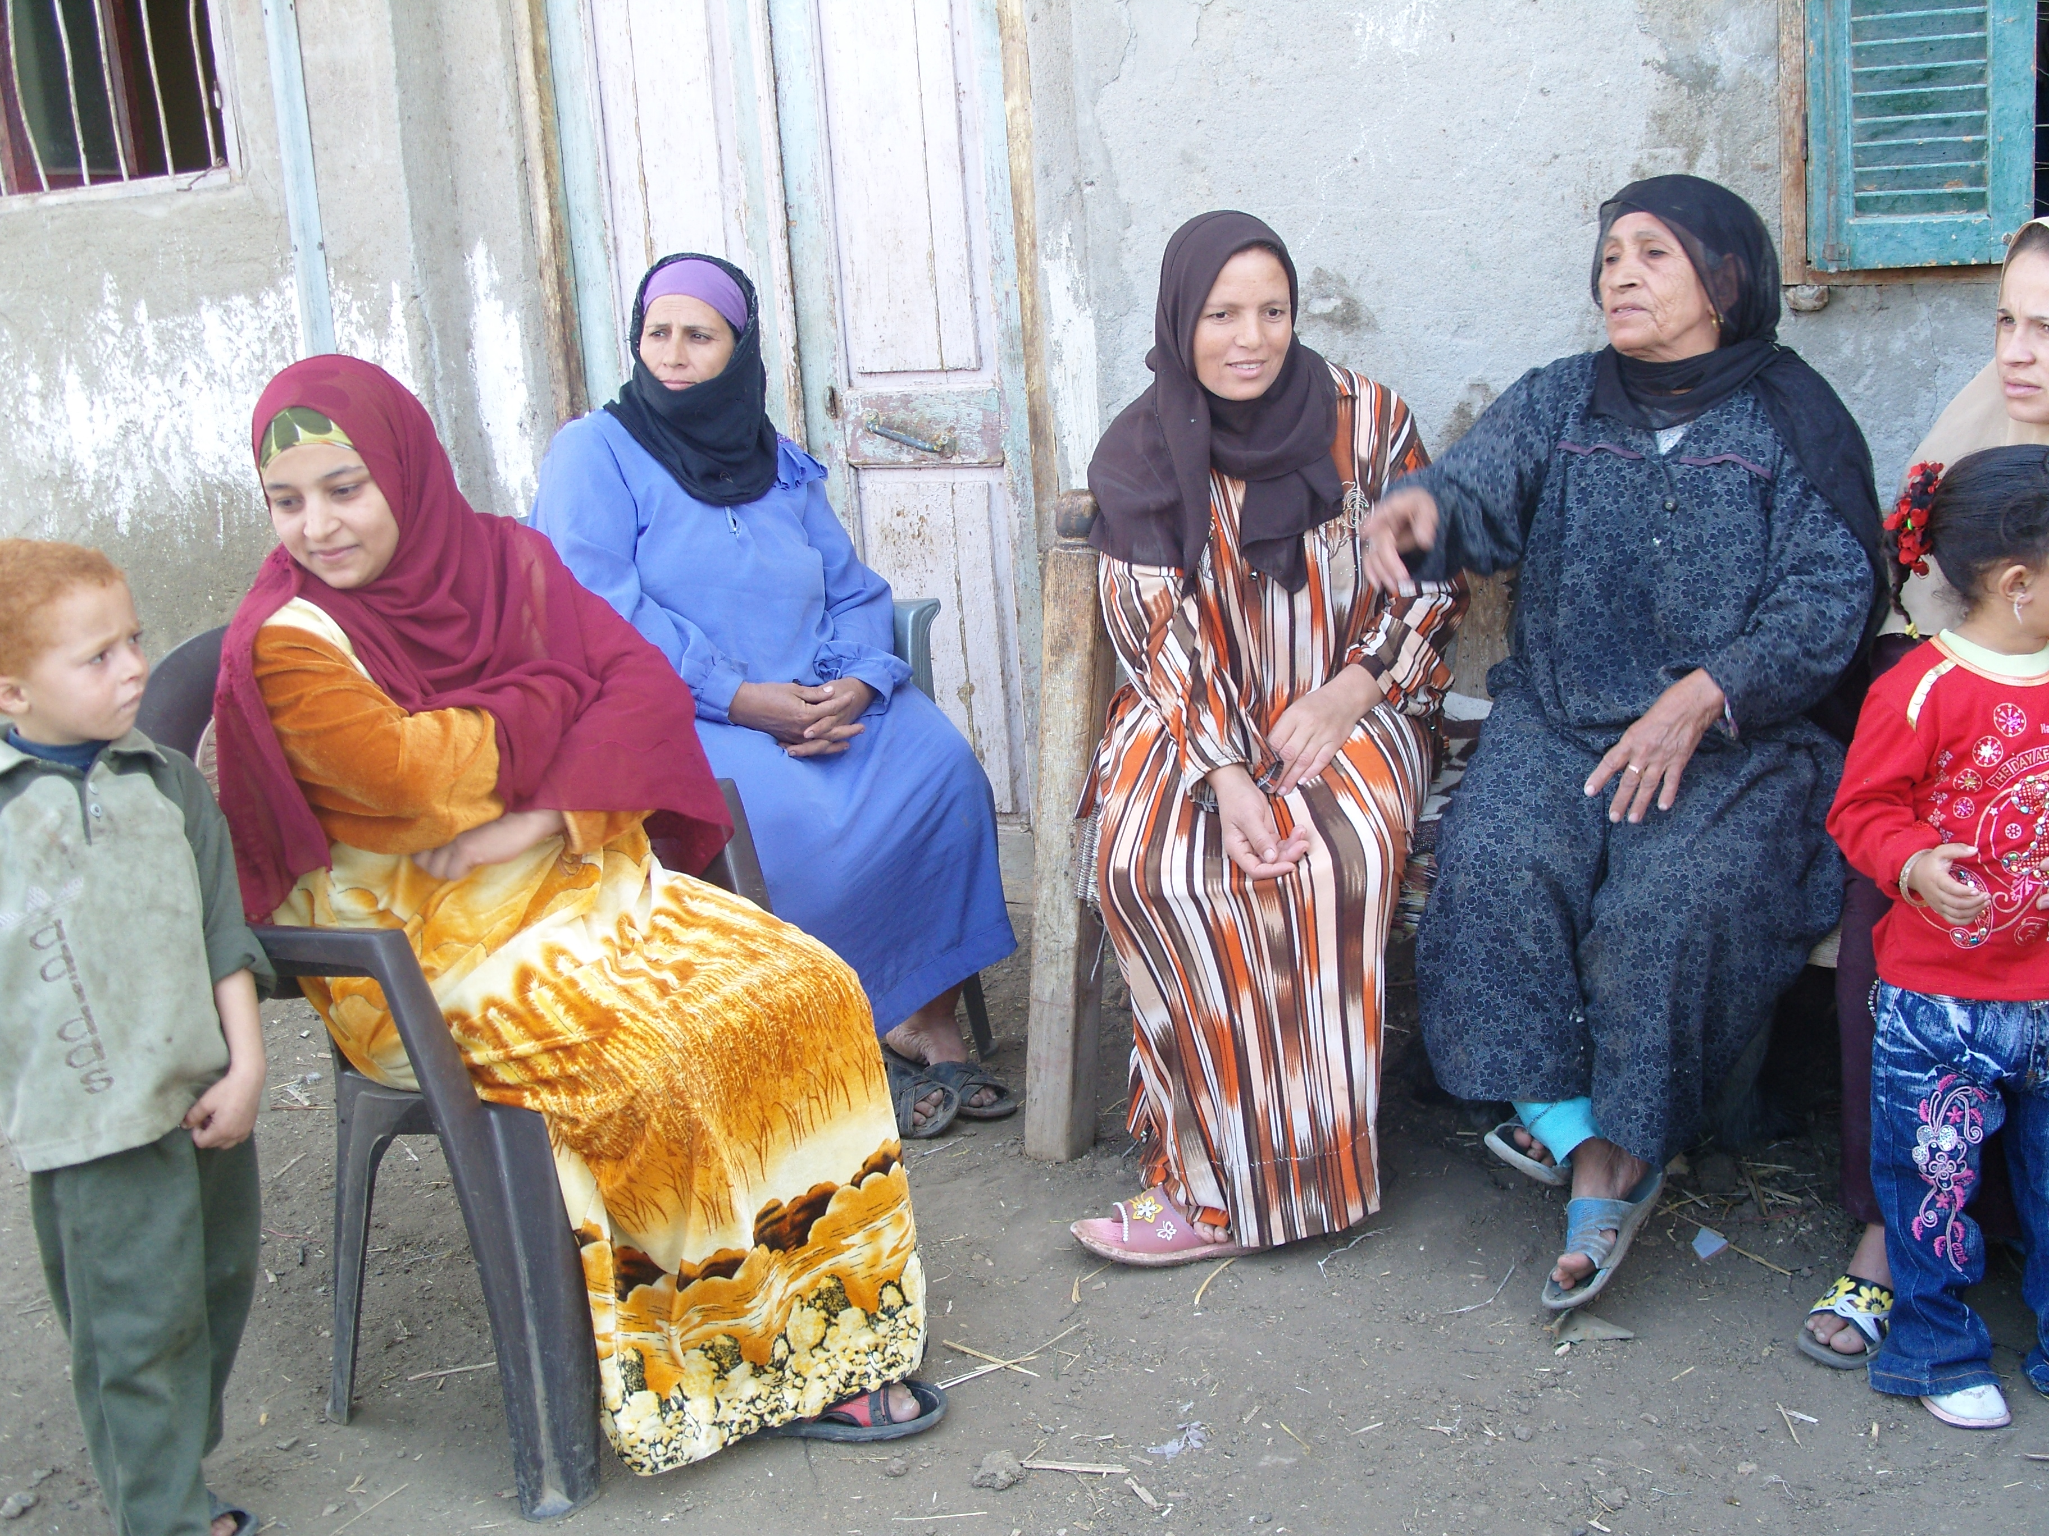
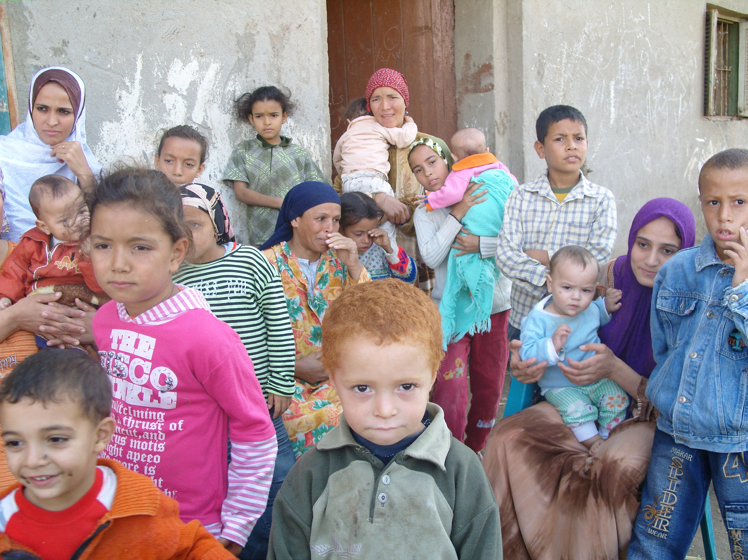
The center has sought the help of one of NGOs there that helped it in conducting focus groups through which the expert explained water treatment methods by simple ways that enable rural woman to provide drinking water to her house as a rapid solution for the problem. By analyzing the problem's elements and by the field visit, it was obvious that the most categories label to right to water violation in this area are children and women.
This is what has urged the center to address the company to necessarily provide fresh drinking water for the area residents and the company has responded assuring to provide health and safe surface drinking water.

”Al Baradaa"
The Egyptian newspapers have published the outbreak of typhoid fever among Al Baradaa village's reseidents in Al Qalubia. The center has known from newspapers that the official bodies have ordered cut off drinking water in this village, and that the disease has broken out due to drinking water pollution and being mixed with sanitation water. As soon as the water cut off, the mayor of Al Qalubia has ordered the removal of pumps in houses justifying that by saying they are the reason behind the disaster. The center has issued a statement by the necessity of providing fresh water for the residents; it also calls the officers to announce all facts about the disaster. Also the center has issued another statement for Al Baradaa students in which they call for the necessity of delivering health water for Al Bardaa students.

"Lsa Al Gamalia"

In 4th September 2011, Al Ahram newspaper has published a piece of news about area called "Lsa Al Gamalia" in Al Daqahlia. The piece of news reports that the residents whose number reached 30 thousands citizens are deprived from drinking water five months ago. However, the officers and Drinking Water and Sanitation Company there assured the access of fresh drinking water to all cities, villages and manors in Al Daqahlia. Yet thirst invaded the area located on Al Manzala Lake between Al Gamalia and Taraa Al Salam cities.

Habi Center for Environmental Rights has formed a team to go to lsa Al Gamalia and monitor the situation there. Already Habi's team went to Lsa Al Gamalia in 10th September and met citizens there. Habi monitored the violations suffered by citizens there. One of lsa Al Gamalia's residents said that they suffer a lot to get one drop of clean water after it has been cut off for five months without any known reasons. This has pushed them to use the water of Al Salam and Al Samara canals to fulfill their needs, which led to that some of them infected with diseases. On the other hand, some residents have resorted to carry fresh water from a neighbor city in flask and transported them in trucks and carts. This costs a family 20 L.E daily, however; they pay the water bills regularly while they do not have access to it. Another citizen said that water access in this area was regular before the revolution, but water has cut off completely five months ago and the matter reached its peak now. In addition, the residents reported that they did not know the reason behind water cut off, and that they have complained and accessed water for just one day after the complaint and then cut off again. Habi has concluded the violations suffered by citizens as followed:
- Continuous water cut off and when they access water it is only one or two hours at night.
- Using motors to access water which costs them electricity.
- The financial burden since every family bears more than 10 L.E daily to buy water.
- Pay water bills regularly although it is inaccessible.
- The breaking out renal failure in this area.
- The accessible water at night has taste, smell and impurities.

Habi has addressed The Holding Company for Drinking Water and Sanitation, The Ministry of Housing and Environment Protection Body.

"Al Rozayqat"
In cooperation with a number of associations in Luxor and Qina, Habi Center for Environmental Rights went to Al Rozayqat village to conduct a field monitoring about drinking water. The team composed of Habi Center and other three local associations, monitored citizens' right to water in three areas in Al Rozayqat village. During the monitoring, the citizens complained of water quality since it is so salty and affects their organs especially kidneys and vesica. Residents have submitted complaints for competent bodies since they access artesian well water pumped by the governmental water company in Luxor. The residents also complained of the erosion of pipes and meters because of water saltiness. Yet, when they asked for changing them, the government actually changes them, however; citizens should pay for the meters and pipes'. Habi also has noticed that women are who suffer the most since they talked about their and their children's sufferance. Besides, the residents reported that they suffer many years ago. It is worth mentioning that Al Rozayqat village is a young area formed after 1994 floods which hit many villages in Qina and led to displacement of a lot of citizens and for whom houses were built in that area. Since 1994, according to residents, they access salt water which erodes their bodies, pipes and meters. In addition, the residents revealed that they pay water bills as if they access fresh drinking water. Also the monitoring team has met some local officials there who said that there are exerted efforts to deliver fresh water to this area. But these efforts face some problems which they are trying to overcome them.
After the end of the monitoring, Habi and the other three local associations agreed upon some steps to be followed in the next period in mountainous areas in Upper Egypt which suffer the same problems. These steps are represented in the following: (1) warning the water company to stop collecting water bills till residents access health and fresh water; (2) writing a complaint containing signatures and to be sent by hand to different bodies and get their signatures upon the receipt; (3) submitting formal request for water company to hold listening sessions; and (4) analyzing water samples and writing reports about analyses results.

Taken measures to address and overcome stigmatization
It is worth mentioning that the reports have revealed some steps forward overcoming the water problem. All are represented in establishing drinking water and sanitation projects in victim villages and regions which are under progress or actually finished. At the same time, the government has decreased the budget dedicated to establish drinking water stations by 25%, the matter which threatens the right to access to drinking water.

Moreover, CSOs have played very important role in solving the water problem. Habi Center for Environmental Rights has condemned the Ministry of Housing slowdown in publishing the drinking water draft law to organize drinking water and sanitation sector. Also, The Egyptian Association for Business Youth has announced the launching of new societal initiative to provide clean water for all. On the other hand, NGOs and citizens (the victims of water lack) had prosecuted Drinking Water and Sanitation Holding Company to the attorney general.

