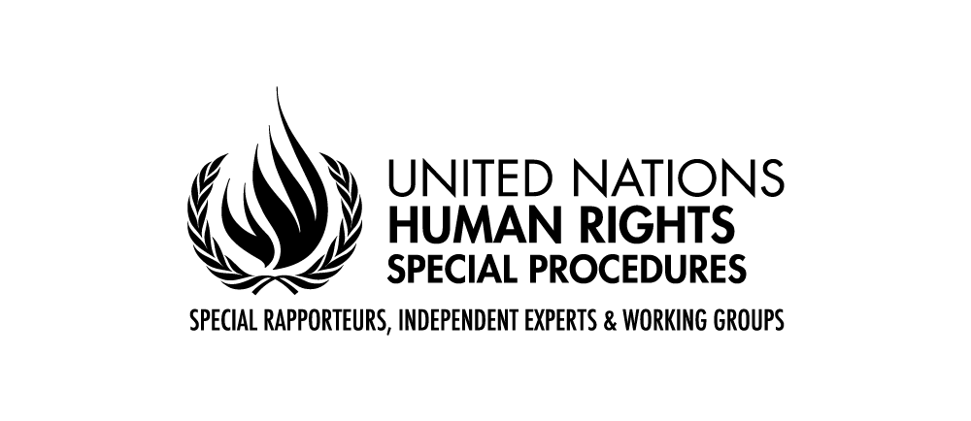
Mandate of the Special Rapporteur on the human rights to safe drinking water and sanitation

Report to the 75th session of the UN General Assembly in 2020
The Special Rapporteur’s thematic report to the General Assembly to be presented in October 2020 will focus on privatization and the human rights to safe drinking water and sanitation. For general guidance, the following tabel summarizes the limits of the report scope, clarifying what situations will or will not be included on it:
The scope of this report includes: | The scope does NOT include :
- Private sector actors (for-profit organizations) | - Non-profit organization that undertake service provision  - Informal service providers  - Community-led service provision  - State-owned enterprises
- Enterprises that government owns capital and shares in, but where a large proportion of shares are owned by private investors. | - State owned-enterprises, i.e., any corporate entity in which the government owns almost all the capital or the voting shares
- Private sector participation with specific focus on service provision | - Private sector participation in subsidiary activities across the whole water and sanitation cycle by, inter alia, supplying materials and equipment, developing engineering designs and building infrastructure
- Impact of remunicipalization and risk of private sector participation | - Comparative analysis on risks and advantages of water and sanitation provision by public and private entities
- Both water and sanitation services
- Assess the level of risks and reasons behind those risks that private sector participation brings when for-profit organizations are heavily involved in service provision | - Whether human rights dictates a specific type of model or service provision

Questionnaire - non-State actors
The Special Rapporteur would welcome answers to the following questions:
- Please describe briefly the role and responsibilities of your organization in the water and sanitation sector, particularly concerning assessment or promotion of private provision.
Current situation and trends
- In your view, what the role has the private sector played in the water and sanitation provision in the countries your organization works in (or at the global level)? How has this role evolved in recent decades? Please provide examples.
- Why do public authorities allow or even attract privatization of water and sanitation services? What would be the alternatives for public authorities?
- In your view, have International Financial Institutions (IFIs) recently encouraged privatization? Could you provide concrete examples?
- In case of economic crises, have the promotion of privatization increased?

Private provision
- In your experience, if the private sector is involved in provision of water and sanitation services, what process was undertaken prior to the decision to adopt this model of provision? What types of concerns have been considered in such decisions?
- How could public authorities use the features of private providers to foster the realization of the human rights to water and sanitation (HRtWS)? Is private provision positive for the progressive realization of the human rights to water and sanitation? If yes, in which circumstances?
- How have instruments and mechanisms in place allowed the users (and non-users) to complaint and get remedy from private providers?
- Do private providers advocate for stronger regulation? If so, why?
- How has been the relationship between private providers and public authorities at the local level? What are potential concerns public authorities and users face vis-à-vis private providers?
- How have private providers contributed to or harmed the realization of the HRtWS? Please give examples.
- What is the nature of the information available on service provision? Does it allow for the adequate accountability of private providers and public authorities?
- Who monitors the performance of private providers in respect to the normative content of the HRtWS and how? Who intervenes when there are risks of human rights violations and how is it done? Who imposes penalties in case violations occur?
- What are the main challenges public authorities face regarding availability, accessibility, quality and affordability when private actors provide water and sanitation services? Please give examples.
- Do you know any case of corruption involving private provision of water and sanitation services? Please give the necessary details.
- Has the private sector shown more capacity to mobilize funds than the public sector? Could you please give concrete examples?
- In your opinion, is there power imbalance in a public-private partnership? Could you please give concrete examples of effects of this relationship?
- When there is private participation in the water and sanitation sector, to what extent the private actor brings its own financial resources to the service?

Remunicipalization
- Have you studied any case of remunicipalization? Why and how has it occurred? What types of difficulties has the public authority faced to establish the new municipal provider? Please, provide details of those processes.

