Mandate of the Special Rapporteur on the human rights to safe drinking water and sanitation

Urgent call by the Special Rapporteur on the human rights to safe drinking water and sanitation

Recently, it was announced that water will be traded on the Wall Street futures market. The futures market is a favourable space to promote speculative financial strategies on vital resources, which are people’s basic needs, such as water, energy or food. This in turn, generates business opportunities but at the same time, results in disastrous impacts on the people in most vulnerable situations and the future generations.

In response to this announcement, I must emphasize that water is the blue soul of life.

Water is essential for human life and it is a basic need for people, a widely understood known reason that led the UN to declare access to clean water and sanitation as human rights.

It is a basic piece of public health, as demonstrated today in the vital role access to water plays in the fight against the COVID-19 pandemic.

It is a key element of the livelihood of people and the social well-being that is critical to the functioning of the family, community and the society and to the democracy at large.

It is also a fundamental resource for vulnerable economic sectors, especially in agriculture, considered to be of general interest to society. In addition to its value as a resource, water functions as the backbone of territories through rivers, wetlands, lakes and aquifers, on whose sustainability our lives depend today more than ever in the scenarios outlined by ongoing climate change.

In short, water has a set of vital values for our societies that the logic of the market does not recognize and therefore, cannot adequately manage, let alone in a financial space so prone to speculation.

For all these reasons, I call on everyone to start a global debate on the values of water that UN Water proposes for the next World Water Day, on 22 March 2021, under the slogan #water2me.
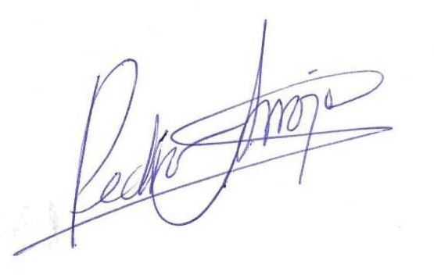
Pedro Arrojo-Agudo
Special Rapporteur on the human rights to safe drinking water and sanitation

