Expert Consultation on the principle of accountability in the context of the human rights to drinking water and sanitation

Organized by the UN Special Rapporteur on the human rights to safe drinking water and sanitation, Léo Heller
14-15 May 2018, Geneva
OHCHR Palais Wilson, Room 1-016
BACKGROUND
Pursuant to Human Rights Council Resolution 33/10 of 2016, the Special Rapporteur on the human rights to safe drinking water and sanitation, Mr. Léo Heller, is mandated to work on identifying challenges and obstacles to the full realization of the rights, as well as protection gaps, good practices and enabling factors. The Special Rapporteur is elaborating a report on the principle of accountability in the context of the human rights to safe drinking water and sanitation. The report will be presented to the UN General Assembly at its seventy-third session in 2018.
As part of the consultation process, the Special Rapporteur invited States and non-State actors to contribute their views and perspectives in writing through a questionnaire. (States - English | French | Spanish; non-States - English | French | Spanish) A total of 28 submissions were received.
SCOPE and STRUCTURE OF REPORT
The principle of accountability as a core human rights principle does not have a set and agreed definition and depending on the context, several descriptions and definitions exists. (See Annex I for list of different definition of accountability). The Special Rapporteur departs his initial analysis on the topic from a broad interpretation of the principle of accountability and focuses on the roles of actors – both State and non-State actors - in the realization of the human rights to safe drinking water and sanitation. This includes not only access to remedy and justice and the institutional mechanisms that are in place for individuals to claim their rights and have the rights enforced. The scope is broader and the report aims to address how to hold accountable the actors that undertake the role to provide drinking water and sanitation, regulate services, among others.
The report addresses the principle of accountability from three dimensions. Accountability implies that actors involved in provision and regulation of water and sanitation services must have clearly defined duties and responsibilities and performance standards (“responsibility”); actors must be answerable to affected people and groups for their actions and decisions, which includes access to information in a transparent manner (“answerability”); and mechanisms should be in place that monitors actors’ compliance with established standards, imposes sanctions and ensures that corrective and remedial action are taken (“enforceability”).
DAY 1 PROGRAMME: 14 May 2018 (Monday)
Introduction | 9:30 – 10:00
Speaker: Special Rapporteur and participants
- Purpose and objective of the expert consultation
- Tour de table: Introduction of participants

SESSION 1: ‘Responsibility’ as a dimension of accountability | 10:00 – 12: 30
Accountability implies that actors involved in provision and regulation of water and sanitation services and those who are tasked to realize the human rights to safe drinking water and sanitation must have clearly defined roles and responsibilities. In addition, performance standards of those roles and responsibilities will allow their actions and decisions to be assessed transparently and objectively. Therefore, the ‘responsibility’ as dimension of accountability is addressed in view of the following elements: ‘what’ are the roles and responsibilities to realize the human rights to safe drinking water and sanitation, ‘who’ carries those roles and responsibilities and ‘how’ the performance of those roles and responsibilities are assessed.
In relation to water and sanitation service provision, varieties of actors are involved. State institutions responsible for water and sanitation include different ministries at the central government level, authorities, regulatory actors and public service providers at the local or sub-national level. At times, the responsibilities are divided among different institutions and ministries, often without much clarity. This often results in situations where several bodies are tasked with fragmented aspects of drinking water and sanitation services to the population, resulting in a patchwork on how the government addresses the human rights framework and a lack of clarity on who is hold accountable (see Annex II for a practical example). Furthermore, in addition to formal State providers, various types of informal providers deliver water and sanitation services. Service providers can be both State and non-State and the nature can be public, private or hybrid. This can make it difficult for people to know whom to turn to for assistance and whom to hold accountable for realising their human rights to water and sanitation.
In addition, in the context of development cooperation in the water and sanitation sector, other actors are involved: the funder, the partner State and, when it exists, the implementing entity (A/72/127, para. 14 – 19).
Guiding questions:

- What are the roles and responsibilities of key actors, regarding the accountability in the context of the full realization of the human rights to drinking water and sanitation?
- What are the practical barriers and challenges in ensuring a clear allocation of roles and responsibilities of government entities involved in water and sanitation service provision? Can you provide positive and negative examples?
- In addition to service provision and development cooperation, which other contexts require more analysis to identify different roles of actors?
- What performance standards are in place to assess the roles and responsibilities of actors?
- What roles can civil society play in monitoring the rights to water and sanitation, how does this positively impact the dimension of responsibility?
Introductory remarks: Benjamin Meier on ‘roles and responsibility’ for State actors (5 min). Sean Furey on ‘roles and responsibility’ for non-State actors (5 min).
Discussion among participants
Lunch break | 12:30 – 14:00

SESSION 2: ‘Answerability’ as a dimension of accountability | 14:00 – 16: 00

‘Answerability’ as element of accountability requires that actors provide explanations and reasoned justifications for their actions and decisions to the people affected by as well as the public at large and to institutions mandated to provide oversight.
Monitoring and evaluating the implementation of policies and plans is central to ensuring States to explain their policy directions and is a prerequisite element to hold States and other actors accountable for violations of, and progress in realising the human rights to water and sanitation. Service providers can implement internal monitoring and evaluation structures for facilitating accountability, including performance and impact assessments. These constitute valuable sources of information for both the State and rights-holders affected by the provider’ performance, giving insights on whether performance is in line with, and contributes to fulfilling the human rights to water and sanitation. Internal monitoring and evaluation structures for facilitating accountability may include approaches in which non-state actors assess and report on its performance through stakeholder dialogues.
Transparency, access to information and participation are another set of essential elements that must be present for actors to fulfil the answerability dimension of accountability. These elements enable rights-holders to assess whether justifications are reasonable and voice their opinions. Actors must therefore ensure active, free and meaningful participation of rights-holders in decision-making on policies and plans that impact the realisation of the rights to water and sanitation.

Guiding questions:
- What are practical examples where the role of monitoring contributed to ensuring answerability of actors responsible for the realization of the human rights to safe drinking water and sanitation? What type of institution is best placed to undertake this role?
- What are practical examples and ways in which the right to information influences answerability, and what are common challenges observed for realizing access to information that hampers holding actors accountable?
- What are practical examples in the water and sanitation sector of explanations and reasoned justifications of actions and decisions provided by actors to the people affected by, as well as to the public at large and to institutions mandated to provide oversight?
- Are there any additional elements that can contribute to implementing the ‘answerability’ dimension of the principle of accountability?
- How should informal service providers give explanations and reasoned justifications for their actions and decisions to users and towards the State regarding violations and the progressive realization of the human rights to water and sanitation?
- What are the greatest challenges observed in ensuring answerability dimension of accountability?
- In which ways has the participation of civil society organisations led to improved answerability for the realization of the human rights to water and sanitation?
Introductory remarks: Al-Hassan Adam (5 min)
Discussion among participants
Coffee Break | 15:45 – 16:00

SESSION 3: ‘Enforceability’ as a dimension of accountability | 16:00 – 18:00

Enforceability mechanisms in the context of accountability is not limited to judicial or quasi-judicial mechanisms but also includes non-judicial mechanisms. The right to access to justice, often referred to as the right to a remedy, is central to putting the principle of accountability into practice. Enforceability makes it possible to address individual or collective grievances, and sanction wrongdoing by the individuals and institutions responsible.
- Complaint mechanisms at the level of service providers often constitute an accessible avenue for people to complaint and receive redress. Companies and non-governmental organisations often have complaint mechanisms in place, including hotlines, advisory services or mediators to resolve problems or conflicts.
- Administrative or regulatory bodies should safeguard the right of individuals to submit complaints when the enjoyment of their rights to water and sanitation has been compromised.
- National human rights institutions and ombudspersons can examine the human rights situation on their own initiative, and issue recommendations to harmonize national law and practice with international human rights.
- States must ensure access to competent and effective judicial bodies including courts and tribunals for violations of the rights to water and sanitation by both State and non-State actors.
- Regional and international human rights mechanisms, including courts and commissions (and committee) provide another avenue for accountability when all national mechanisms are exhausted. United Nations human rights treaty bodies can also hear individual complaints.
- “Social accountability” is used to refer to a broad range of activities in which individuals and civil society organisations act directly or indirectly to mobilize demand for accountability. There are many activities that can reinforce accountability in several ways. Activities driven by civil society have the potential to empower people who have traditionally been excluded or marginalized to claim entitlements and rights more effectively. Monitoring activities and advocacy by civil society can itself generate accountability through increasing the pressure on duty bearers to explain and justify their policies and actions. In order to abide by the principle of accountability, States need to ensure that there are a range of well-defined opportunities for effective engagement of civil society in decision-making and review mechanisms.

Guiding questions:
- What are the strengths and weaknesses of the different mechanisms in place aiming to actors at all levels are subject to enforceable sanctions or remedial actions in relation to the violation or abuse of the human rights to safe drinking water and sanitation?
- What are the main challenges in ensuring remedial action for violations or omissions for the rights to water and sanitation, including for all types of (informal) service provision?
Introductory remarks: Amanda Loeffen (5 min)
Discussion among participants

DAY 2 PROGRAMME: 15 May 2018 (Tuesday)
SESSION 4: Dimensions of accountability | 9:30– 10: 30

Guiding questions:
- Among many definitions of the principle of accountability, what elements are relevant in the context of the human rights to safe drinking water and sanitation?
- What are specific features of the water and sanitation services that require attention when we address the definition of accountability?
- Do the 3 dimensions of accountability adopted as the main structure of the report require additional principles to encompass all relevant specificities of the human rights to water and sanitation?
Introductory remarks: Alejandro Jiménez (5min)
Discussion among participants
Coffee Break | 10:30 – 10:45

SESSION 5: Barriers to an enabling environment for accountability in the human rights to drinking water and sanitation | 10:45 – 12: 00

The implementation of a number of elements can catalyse accountability in the water and sanitation sector, including aligning the human rights to the services with other interdependent human rights. There are also a number of elements that can hinder accountability towards the realization of the human rights to water and sanitation by actors involved. Some of these elements include corruption, a lack of follow-up and compliance with rulings and recommendations, conflicting demands for accountability (for example NGOs accountability towards their constituencies and towards funders).
Adequate institutional framework in the water and sanitation sector, the coordination of the several public agencies involved, the regulatory environment and a clear role of subnational levels of government are also some elements for an enabling environment in that context.
Guiding question:
- What key factors are determinant for the creation of an enabling environment to exercise the three dimensions of accountability in the realisation of the human rights to safe drinking water and sanitation?

Introductory remarks:
Frank van der Valk (5 minutes): corruption in the WASH sector
Matheus Valle Oliveira (5 minutes): key challenges of regulators
Samson Malesi Shivaji (5 minutes): key challenges observed by civil society organizations
Discussion among participants

Recommendations and wrap up | 12:00 – 13:00

Speaker: Special Rapporteur and participants
- Remaining issues to be discussed
- Closing the session by the Special Rapporteur

List of Participants
N. | Name | Organization
1 | Alejandro Jiménez | SIWI
2 | Amanda Loeffen | WaterLex
3 | Frank van der Valk | Water Integrity Network (WIN)
4 | Sean Furey | Rural Water Supply Network (RWSN)
5 | Elizabeth Andvig | Office of the High Commissioner for Human Rights
6 | Al-Hassan Adam | End Water Poverty
7 | Benjamin Meier | University of North Carolina
8 | Samson Malesi Shivaji | Kenya Water and Sanitation CSOs Network (KEWASNET)
9 | Mohamed Shafie Ameermia | South African Human Rights Commission
10 | Lucy McKernan | The Global Initiative for Economic Social and Cultural Rights
11 | Matheus Valle Oliveira | Fundaçao Oswaldo Cruz Fiocruz Minas
12 | Natalia Uribe Panda | Action Against Hunger, French Water Coalition (Coalition Eau)
13 | Catherine Brölmann | Department of International Law, University of Amsterdam
14 | Priscila Neves Silva | Fiocruz - MG
16 | Madoka Saji | Office of the High Commissioner for Human Rights
17 | Ahreum Lee | Office of the High Commissioner for Human Rights
18 | Laura van de Lande | External assistant of the mandate of the Special Rapporteur

Annex I
- Accountability as a core human rights principle can be approached trough a preventative or a corrective role. It seeks to influence decisions related to policy, provision and regulation of water and sanitation services, making it more responsive to the needs of rights-holders and it helps to determine whether the responsible actor is on track in progressively realising the human rights to water and sanitation. Accountability also serves a corrective function, making it possible to address individual or collective grievances, and sanction wrongdoing by the individuals and institutions responsible.”
- “the means by which individuals and communities take ownership of their rights and ensure that States as primary duty-bearers, respect, protect, and fulfil their international and national obligations. This is fundamental to the individual empowerment and personal dignity that lies at the heart of international human rights.”
- The Committee on Legal Affairs and Human Rights explains: “The essential basis of accountability is to scrutinise the performance of power wielders by seeking information, explanation and justification.”
Annex II
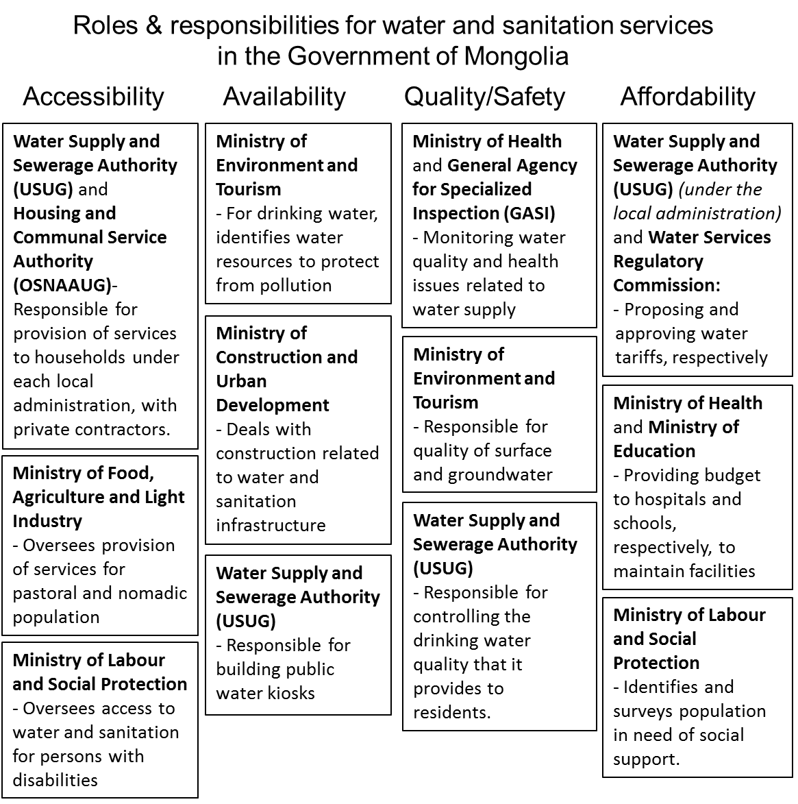

Non-State actors may include, but are not limited to: businesses, private actors, development organisations, non-governmental organisations, among others.
Office of the High Commissioner for Human Rights, “Who will be accountable? Human Rights and the Post-2015 Development Agenda” (2013), p. 10 available from http://www.ohchr.org/Documents/Publications/WhoWillBeAccountable.pdf
This is observed by the Special Rapporteur in many of his country visits, including in his recent one to Mongolia: http://www.ohchr.org/EN/NewsEvents/Pages/DisplayNews.aspx?NewsID=22957&LangID=E Reports of country visits where unclear roles and responsibilities for water and sanitation service provision was addressed, include: A/HRC/12/24/Add.1, A/HRC/15/31/Add.3, A/HRC/18/33/Add.3, A/HRC/21/42/Add.2, A/HRC/24/44/Add.1, A/HRC/33/49/Add.2.
Alnoor Ebrahim, Accountability In Practice: Mechanisms for NGOs, World Development Vol. 31, No. 5, p. 822-823
OHCHR, Who will be accountable? Human Rights and the Post-2015 Development Agenda, page 44
OHCHR, Who will be accountable? Human Rights and the Post-2015 Development Agenda, page 44
In a recent e-discussion organisation by the Rural Water Supply Network, the question of accountability of NGOs / CSOs was raised, both in terms of external accountability (to citizens and communities), but also internal (failure of organizations’ reporting chains leading to covering up issues about staff misconduct or abuse and preventing appropriate action to be taken). It was discussed that in contexts where services are heavily subsidized, service providers and governments may be more accountable to donors than their citizens. (www.rural-water-supply.net/_ressources/documents/default/1-797-4-1521131175.pdf)
Roaf and De Albuquerque, On the right track - good practices in realising the rights to water and sanitation, page 187. OHCHR, Who will be accountable? Human Rights and the Post-2015 Development Agenda, page 15
Roaf and De Albuquerque, On the right track - good practices in realising the rights to water and sanitation, page 177.
Council of Europe, Committee on Legal Affairs and Human Rights, Accountability of international institutions for human rights violations, page 1

