OFFICE OF THE HIGH COMMISSIONER FOR HUMAN RIGHTS
Response to the call for input on femicide from the Special Rapporteur on violence against women, its causes and consequences

April 2021, Geneva, Switzerland
Submission by:

ADF International
Rue du Pré-de-la-Bichette 1
1202 Geneva, Switzerland

Web: www.ADFinternational.org
Email: UN@ADFinternational.org

ECOSOC Special Consultative Status (2010)

Introduction
- ADF International is a faith-based legal advocacy organization that protects fundamental freedoms and promotes the inherent dignity of all people before national and international institutions.
- In response to the call for inputs issued by the Special Rapporteur on Violence Against Women, its causes and consequences (hereinafter, the “Special Rapporteur”) on progress made to prevent and combat femicide, this submission calls attention to the need to formally recognize and prohibit all forms postfertilization sex selection as femicides. Furthermore, it stresses the need to integrate and adapt an age perspective in the collection and analysis of data on femicide in all its forms in order to inform global, regional, and national prevention and response strategies. This submission also identifies examples of best practices at the legislative and policy level to tackle the underlying roots of son-preference and promote the equal dignity of all women and girls, including awareness-raising and educational initiatives undertaken by governments and civil society organizations. Finally, it suggests specific recommendations to be included in the Special Rapporteur’s report on femicide, to be presented at the 76th session of the UN General Assembly.
- Sex-selective Practices and Femicide
- For the purposes of this submission, the term sex-selective practices (SSPs) refers to all practices that involve the direct or indirect killing of girls because they are female, ranging from the destruction of fertilized female embryos and sex-selective abortion, to infanticide and fatal neglect. While postnatal SSPs are commonly regarded as femicides, this designation must unequivocally be extended to prenatal forms of sex selection as well.
- Whether before or after birth, SSPs constitute an egregious violation of the dignity and human rights of girl children, including their human rights to life and non-discrimination. Article 6 of the Convention on the Rights of the Child recognizes the inherent right to life of every child and establishes the obligation of states to “ensure to the maximum extent possible the survival and development of the child.” Article 2 further requires states to "respect and ensure” every child’s rights “without discrimination of any kind, irrespective of the child's … sex [or] birth.”
- According to Article 1 of the Convention, a child is defined as “every human being below the age of eighteen years unless under the law applicable to the child, majority is attained earlier.” This provides an upper limit as to who is a child, but does not provide a lower limit on when the status of “child” attaches. Viewed in the context of the Preamble of the Convention, which recognizes that, “the child … needs special safeguards and care, including appropriate legal protection before as well as after birth,” these provisions clearly imply the recognition of the personhood of the unborn child, and the rights attached to that status. Accordingly, states are under an obligation to take positive action to prevent and prohibit SSPs in all their forms and manifestations, including to eliminate their root causes.
- States’ duty to protect girls from this often overlooked violation of human rights is echoed in several international agreements. The Beijing Platform for Action calls on states to “enact and enforce legislation protecting girls from all forms of violence, including female infanticide and prenatal sex selection.” In addition to clarifying that there is no human right to abortion, the Programme of Action of the International Conference on Population and Development (ICPD) states that, “in no case should abortion be promoted as a method of family planning,” including evidently when motivated by sex selection.
- Besides the necessary legal prohibitions, as well as regulations on the use of technology for sex-selection purposes, states must also pursue preventative strategies aimed at eliminating discriminatory laws and practices, scaling up girls’ access to education and achieving equal opportunities for girls through female empowerment initiatives. The acceptance and perpetuation of SSPs is rooted in a culture of son preference, which discriminates against women and girls by viewing tham as inferior, or subordinate, to men and boys. Parents themselves, and particularly mothers, often become secondary victims of these practices, as they are coerced into neglecting or even killing their own girl children as a result of communal pressures and, in some cases, overt threats of violence from within their own families.
- In the Programme of Action of the ICPD, States committed to “eliminate … the root causes of son preference, which results in harmful and unethical practices regarding female infanticide and prenatal sex selection.” This requires “an integrated approach that addresses the need for widespread social, cultural and economic change, in addition to legal reforms.” To this end, States must initate, invest in, and support awareness-raising and education campaigns aimed at reshaping harmful socio-cultural narratives and affirming the inherent dignity and equal status of women and girls.
- As stated inter alia in the Beijing Platform for Action, governments should also collaborate with a range of actors to develop programmes aimed at “the elimination of harmful attitudes and practices, including … son preference.” In this regard, a decisive and crucial role in the prevention, response, and elimination of SSPs is played in particular by civil society organisations, international institutions, the media, and the private sector. As legislative measures and policy initiatives must be geared towards tackling the entrenched social and cultural barriers that legitimize son-preference and perpetuate SSPs, bottom-up, community-inclusive initiatives stand the best chance of delivering effective outcomes.
- Data Collection on Sex-Selective Practices
- The UNFPA 2020 State of World Population report estimates that the number of “missing women” in the world has more than doubled over the past 50 years, rising from 61.0 million in 1970 to an estimated 142.6 million in 2020. These numbers reflect “sex ratio imbalances at birth as a result of sex-selective abortion combined with excess female mortality stemming from postnatal sex selection.” China and India together make up over 80% of the estimated missing female births worldwide. While revealing broad social trends on sex selection, the measure is inadequate for the identification of specific practices and informing evidence-based responses.
- As the Special Rapporteur noted in her 2016 report on femicide, the collection of reliable and comparable data is essential in preventing violence against women. Regrettably, statistical research on femicide does not include data on SSPs. As such, there is a need for greater inclusion and prioritization of these practices in relevant collection and monitoring programs.
- Statistical data on femicides is generally limited in scope. The UN Office on Drugs and Crime 2019 Global Study on Homicide included a distinct booklet on “gender-related killing of women and girls.” It relied on national homicide statistics and as such was primarily focused on “intimate partner/family related homicide.” While making reference to female infanticide and sex-selective abortion, no concrete data was given on these, citing the lack of national data. The European Institute for Gender Equality, in a report on data terminology, notes that while some EU states measure elements such as FGM-related deaths, none include female foeticide as a component of femicide statistics.
- The absence of adequate data collection on SSPs is generally attributed to the lack of accurate reporting methodologies. Even in countries where sex-selection is strongly prevalent, the most prominent measure employed are population sex ratios, disaggregated by age.
- In this regard, ADF International wishes to stress the importance of reviewing data collection methodologies on femicide, notably by systematically collecting and categorizing disaggregated data on SSPs, to provide a strong evidentiary basis for developing and implementing preventative and response strategies at all levels.
- Case Study: India
- The case of India illustrates several good practices in tackling SSPs, while also casting light on some of the challenges faced in designing and enforcing relevant prevention and response strategies.
- In 2019, India had an estimated 110 boys for every 100 girls in the 0-4 years old bracket, the 5th most skewed ratio in the world. While the infant mortality rate for girls has been improving, the sex ratio at birth has been consistently worsening in the past decades. According to a recent study, “the most cogent explanation for missing female births is prenatal sex determination followed by selective abortion.”
- The most notable piece of legislation for tackling SSPs in India is the Pre-Conception Pre-Natal Diagnostic Techniques (Prohibition of Sex Selection) Act of 1994. In addition to prohibiting all forms of sex selection, the Act also regulates the use of prenatal diagnostic techniques by requiring medical practitioners to produce and keep the relevant records for at least two years, ensuring accountability for their use. Notably, in case of violations, the mother is presumed to be under coercion by her spouse or relatives in the relevant criminal proceedings.
- The absence of accurate investigation methods and a lack of accountability of the implementing authorities represent substantive challenges in the enforcement of the Act, and have been further compounded by the the COVID-19 pandemic. Proposed improvements include the introduction of accountability mechanisms, improved training and sensitization programs, and greater inclusion of local law enforcement for better implementation.
- In 2015, the Indian government launched the Beti Bachao, Beti Padhao scheme. This is an ongoing nation-wide campaign aimed at tackling the prevalence of SSPs as well as addressing related problems perpetuating the culture of son-preference, such as child marriage, dowry, and unequal access to education. It comprises a broad media campaign as well as district-specific programs, such as children’s camps and initiatives to reduce girls’ school drop out rates.
- Indian civil society also plays a crucial role in shifting deeply rooted social sentiment via education campaigns and local advocacy. Since 2008, the 24th of January has been commemorated as National Girl Child Day in India. On that day in 2021, Vanishing Girls, in collaboration with several other civil society organizations, launched the “Isn’t She Precious” Campaign aimed at addressing the prevalence of sex-selective abortion. The 40-day initative included a variety of awareness activities and trainings for local leaders, culminating on International Women’s Day.
- In January 2021, the Indian government reported tentative success in combating SSPs, with an improvement in the national sex ratio at birth from 918 girls per 1000 boys in 2014-15 to 934 in 2019-2020. Some districts experienced a rise in female births of over 150 more girls per 1000 boys. Improvements also were seen in the areas of maternal health and education rates for girls. In order to facilitate evidence-based interventions, the importance of gathering more disaggregated and locally relevant data in the upcoming 2022 census has been identified as critical.
- Recommendations
- In light of the aforementioned, ADF International suggests that the following recommendations be included in the Special Rapporteur’s report on femicide, to be presented at the 76th session of the UN General Assembly.
- The Special Rapporteur should call on States to:
  - Enact, implement, and enforce legislation prohibiting and preventing all forms of femicide, including prenatal and postnatal sex-selective practices, in accordance with relevant obligations under international human rights law;
  - Review and amend existing legislation on violence against women, including sex-selective practices, in order to strengthen the prevention and ensure the prosecution of such acts;
  - Launch and support awareness-raising and educational initiatives, in partnership with civil society, the mass media, the private sector and international institutions, to eliminate prejudices, customary practices and cultural patterns of conduct that perpetuate the culture of son preference and undermine the equal and inherent dignity of women and girls;
  - Integrate and adapt an age perspective in the collection and analysis of data on femicide in all its forms, including by collecting and disaggregating data on sex-selective practices;
  - Cooperate to establish a common methodology for the collection of comparable data on sex-selective practices at the global, national and regional levels.
- The Special Rapporteur should also call on the international community and relevant entities within the United Nations system to formally recognize sex-selective practices as acts of femicide, and redouble commitment to their eradication.

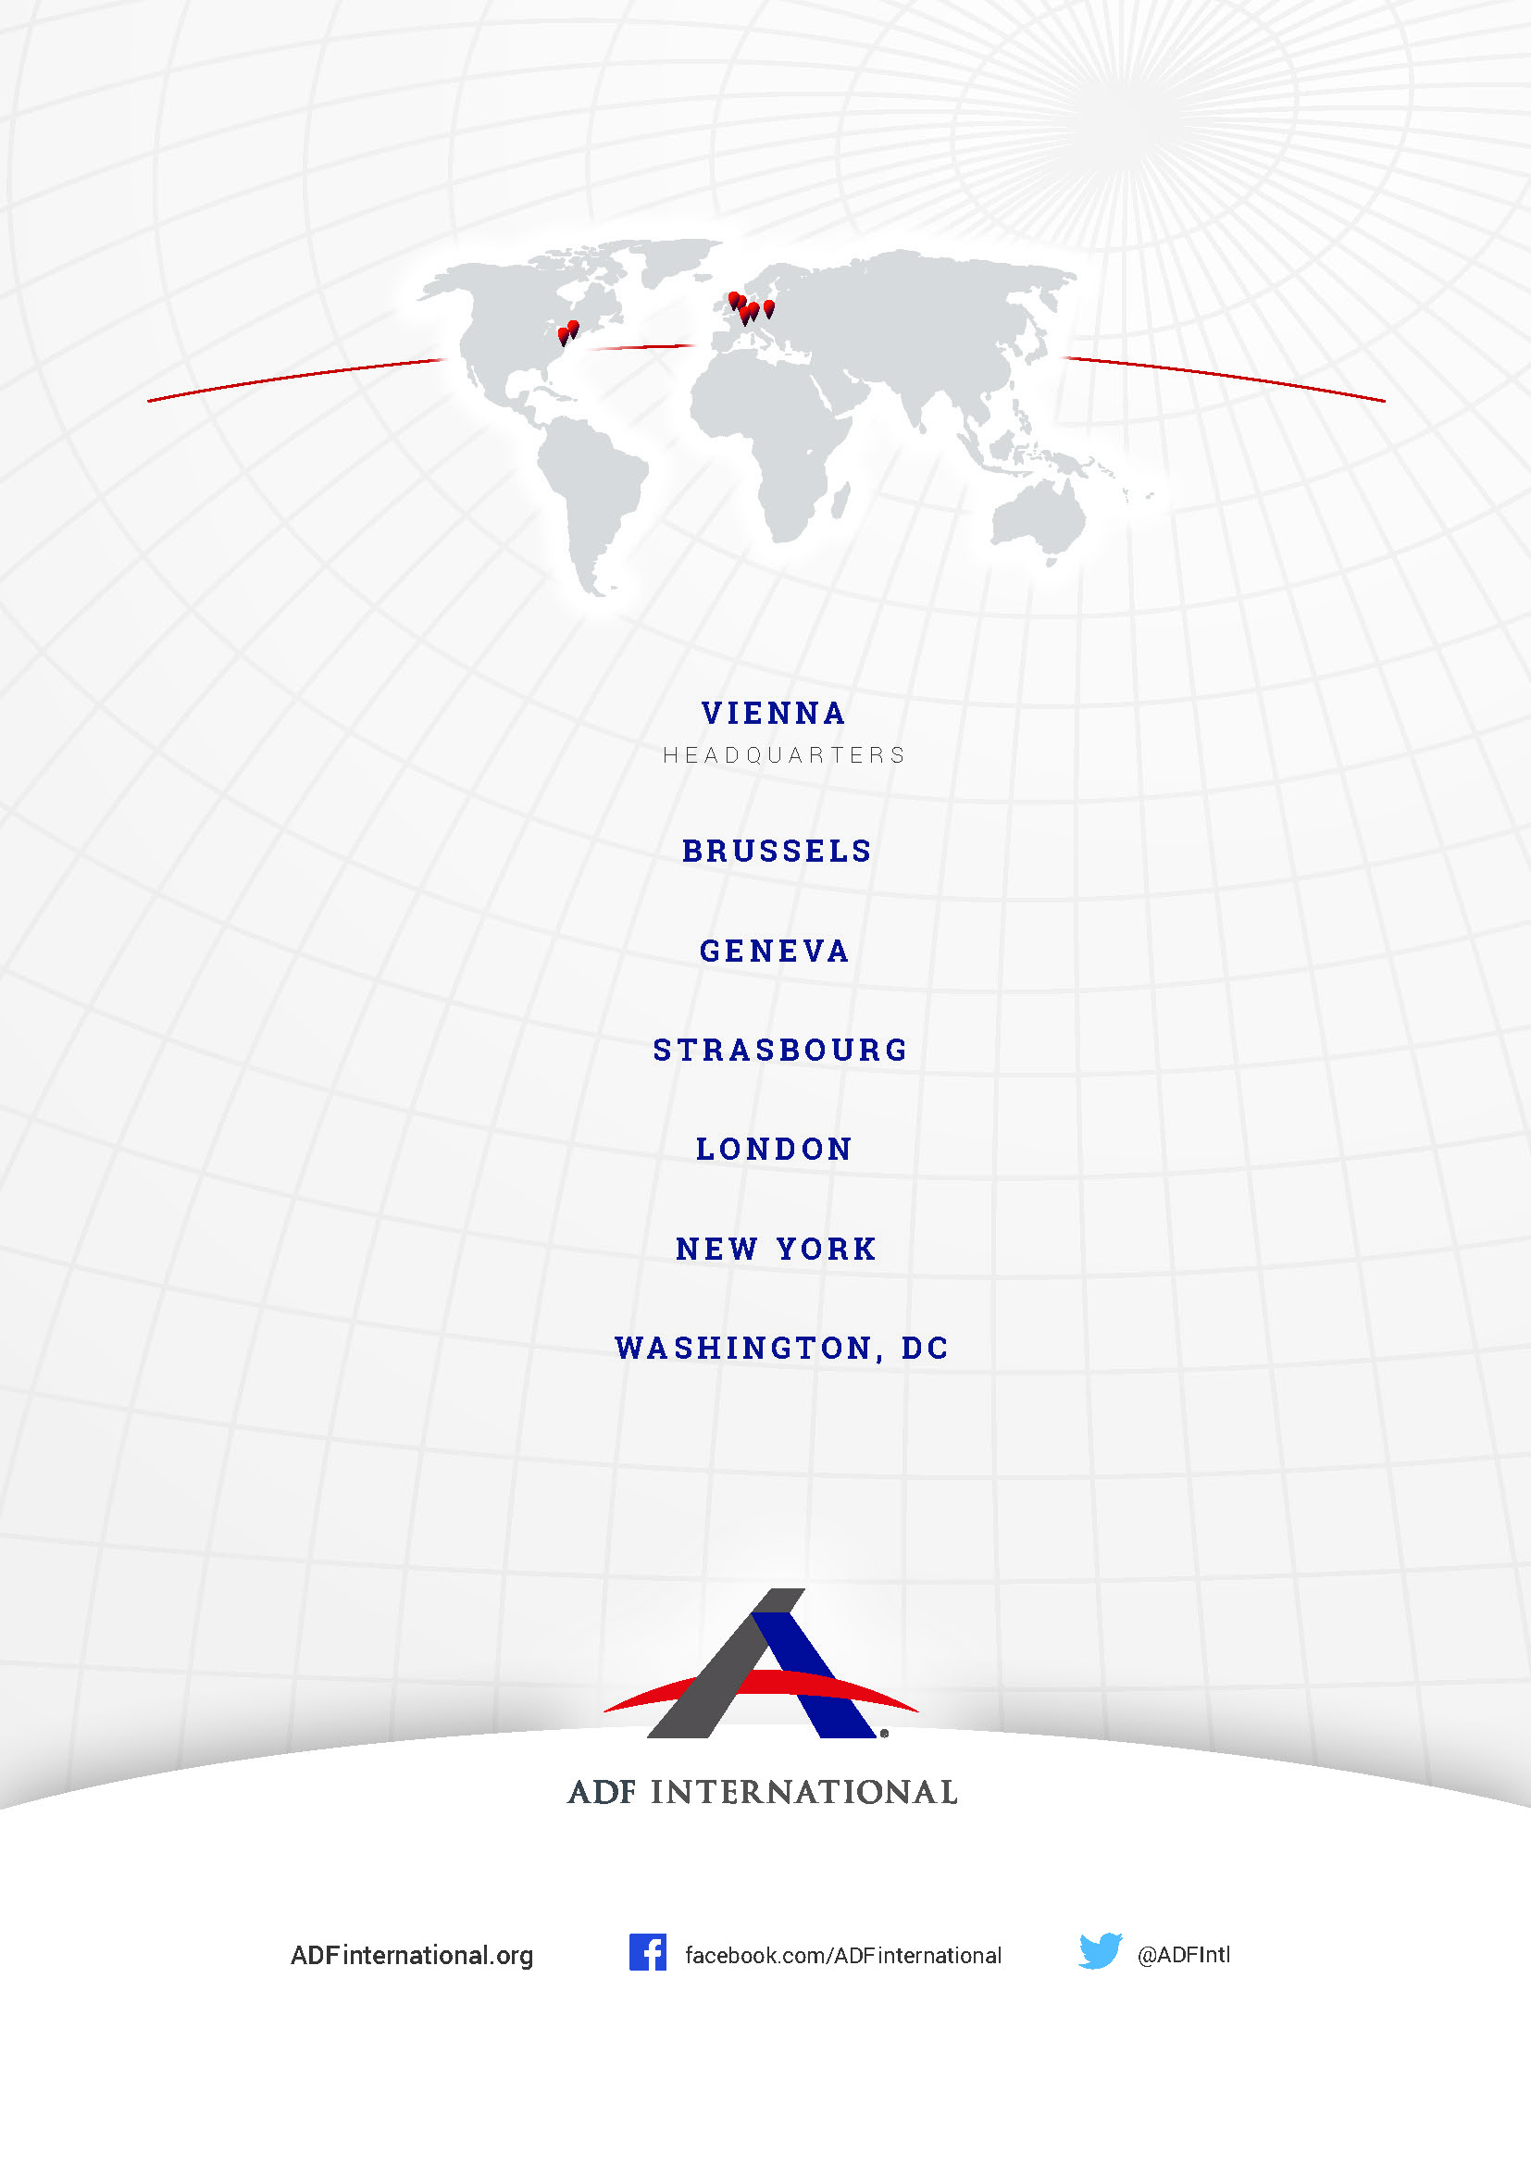

Convention on the Rights of the Child (adopted 20 November 1989, entered into force 2 September 1990) 1577 UNTS 3 (CRC), art. 6.
Id., art. 2.
Id., Preamble.
World Conference on Women ‘Beijing Declaration and Platform for Action’ (1995), art. 283(d).
International Conference on Population and Development, ‘Programme of Action’ (Cairo, 1994), art. 8.25.
ICPD, ‘Programme of Action’ (Cairo, 1994), art. 4.16(a).
ICPD, ‘Key Actions for the Further Implementation of the Programme of Action of the International Conference on Population and Development’ (New York, 1999), art. 48.
UN Population Fund ‘State of World Population 2020’ (2020), 49-51.
UN General Assembly ‘Violence against Women, its causes and consequences’ (September 2016) UN Docs A/71/398, para. 48.
UN Office on Drugs and Crime ‘Global Study on Homicide, Booklet 5: Gender-related killing of women and girls’ (2019).
European Institute for Gender Equality ‘Terminology and indicators for data collection: Rape, femicide and intimate partner violence’ (2017), 45.
Statistics Times ‘Gender ratio in India’ (2021) <https://statisticstimes.com/demographics/country/india-sex-ratio.php>.
N. Saikia et al. ‘Trends in missing females at birth in India from 1981 to 2016’ (April 2021) The Lancet <https://doi.org/10.1016/S2214-109X(21)00094-2>.
India Pre-Conception Pre-Natal Diagnostic Techniques Act 1994.
Vanishing Girls ‘Pre-Conception Pre-Natal Diagnostic Techniques (Prohibition of Sex Selection) Act, 1994’ <https://vanishinggirls.in/pcpndt-act/>.
Transl. “Save the girl child, educate the girl child”
Ministry of Women and Child Development, Govt. of India ‘Beti Bachao Beti Padhao’ <https://wcd.nic.in/bbbp-schemes>.
Ministry of Information & Broadcasting, Govt. of India ‘Beti Bachao, Beti Padhao: DFP’s Awareness Campaign in 75 Critical Districts’ <https://wcd.nic.in/sites/default/files/WCDReportfinal.pdf>.
Vanishing Girls ‘Isn’t She Precious? Daughters Deserve Life’ (2021) <https://vanishinggirls.in/precious/>.
Ministry of Women and Child Development, Govt. of India ‘Beti Bachao Beti Padhao Scheme Increases Awareness and Sensitize the Masses on Gender Equality’ (January 2021) <https://pib.gov.in/PressReleaseIframePage.aspx?PRID=1691725>.
N. Saikia et al. ‘Trends in missing females at birth in India from 1981 to 2016’ (April 2021) The Lancet <https://doi.org/10.1016/S2214-109X(21)00094-2>.

