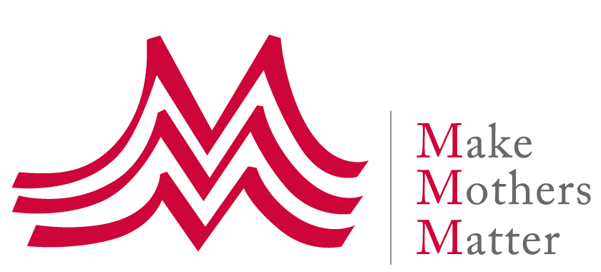
Consultation of the UN Special Rapporteur on violence against women
on Mistreatment and violence against women during reproductive health care
with a focus on childbirth

Additional Submission of Make Mothers Matter (MMM)
Example of best practice to prevent obstetric violence – Maternity preparation workshops "Por venir" organized by CEPRODIH in Uruguay

The following describes how the maternity preparation workshops organized by CEPRODIH, an MMM member organization working with vulnerable women in Uruguay, effectively contributes to the prevention of obstetric violence.

Like in most countries, obstetric violence is a reality for many women in Uruguay.

CEPRODIH aims to protect and give tools to women in a situation of vulnerability and their companions, so that they can identify acts of obstetric violence and act accordingly. CEPRODIH organizes maternity preparation workshops where, among other things, several tools are provided including a birth plan that the future mothers design by themselves, and printed materials with the relevant laws so that they can be aware of their rights. From 2010 to 2016, 350 women attended those workshops. These women lived in a Ceprodih home that existed until 2016. This house was closed due to lack of funding. From 2017 to the present the preparation consist of 10 workshops conducted by a social assistant, a midwife and some volunteers.

1st tool: the birth plan

The birth plans are focused on both vaginal delivery and Caesarean; the pregnant women have options for them to choose, and blank spaces can be used to add other things they want or do not want to happen during labor, delivery or cesarean section and puerperium. It is important to have the C-section in the birth plan since it can always happen. Otherwise women feel vulnerable because they do not know how to act. In this way preparing the two forms of birth, they have options at all times and know their rights in both cases.

Once individual birth plans are established, two copies are provided: one will be given to the person who receives them in the institution and the future mother keeps the other copy with the signature of the person from the institution that acknowledges receipt of it, that its contents was read and the wishes of the woman and her companion understood.

2nd tool: knowledge and understanding of the laws and rights

The use of relevant laws is also discussed during the maternity workshops, including the law of "accompaniment during labor and delivery" and the "law of clinical history". These laws are explained so that women understand all their rights, and in which ways these can be claimed. The pregnant women receive a printed copy of theses Laws so that they have them with them at the moment of hospitalization in case a problem arises.

Within the framework of these rights, it is emphasized that childbirth is theirs, as long as there is no obstetric emergency that may require rapid and effective intervention.

With these 2 tools, they arrive at the moment of birth knowing that they can choose how to give birth, and with whom to give birth. That if something or someone makes them feel uncomfortable or vulnerable they can speak up, and even ask for a professional change. They understand that any maneuver that the health professional wants to perform on their body or on that of their newborn child should be first explained to them, is subject to their permission, and that in cases where it is not an emergency intervention they can even refuse it.

The results

100% of the women who benefited from the 6 cycles of these maternity preparation workshops that CEPRODIH conducted so far, had the delivery they wanted - even those whose pregnancies ended in a cesarean delivery. These women felt they owned their body, and that their desires and expectations were respected, even in case of caesarean sections.

In spite of the small scale, these results show that the key to preventing obstetric violence is that women are prepared and educated on what to expect and on their rights around childbirth. Also a key element is that they are empowered to keep ownership of the situation and their body.

The experience also hints at the potential use of the so-called “home-based records for maternal, newborn and child health” which often take the form of integrated maternal and child health handbooks. These handbooks could also include awareness raising information on obstetric violence, birth plans, and legal information on women’s rights around childbirth.

Annexes:
- CEPRODIH activity Report of 9 May 2019
- Printed Law material distributed to the participants of the workshops

About CEPRODIH - http://ceprodih.org/

CEPRODIH is a non-profit civil association, founded in Montevideo, Uruguay in 1998, whose the mission is to serve and support the most vulnerable families, especially women with children, in situations of high social risk: unemployment, domestic violence, or helplessness during pregnancy. These situations undermine the dignity of women and directly impact the living conditions of children.

See also: - Press article on obstetric violence in Uruguay, 05.04.19 https://www.subrayado.com.uy/violencia-obstetrica-cuando-el-nacimiento-un-hijo-se-convierte-patologia-n530602 - Press article about the book "The dark side of giving birth. Women as victims of obstetric violence" by Gabriel Sosa https://www.elpais.com.uy/vida-actual/violencia-parto-situacion-comun.html - Interview with the author https://www.youtube.com/watch?v=9MGscmMtYi0
In 2018 the World Health Organisation (WHO) issued guidelines on home-based records for maternal, newborn and child health. These are now promoted as effective tools to improve health literacy and maternal and child health outcomes, and to empower women and families to take ownership of their health.

