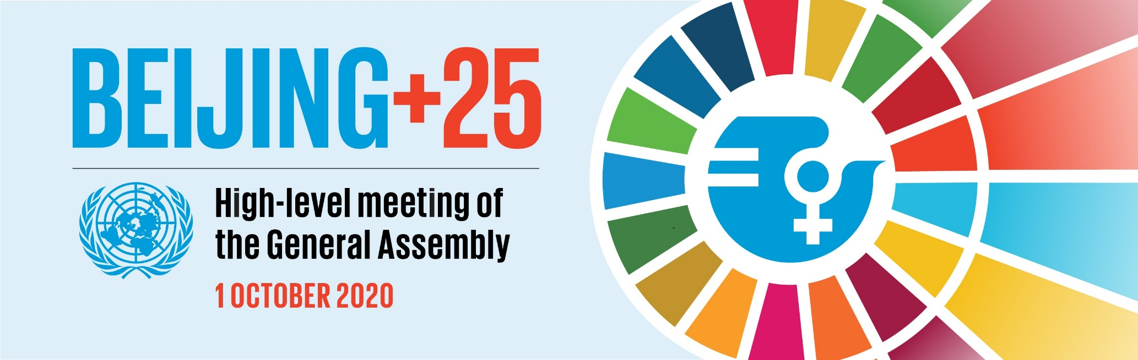

Statement by Elizabeth Broderick, Chairperson of the Working Group on Discrimination against Women and Girls at the Opening Segment of the High-level Meeting of the General Assembly

Excellencies,
Distinguished delegates and participants,
Twenty-five years ago, the world came together to agree on the landmark Beijing Declaration and Platform for Action, the most visionary plan yet for gender equality and women’s and girl’s human rights. That plan is as important today as it has ever been.
Beijing was never about tinkering around the edges or simply adding women to the existing structures. It was about transformation – about deep systemic change - about reimagining all spheres of life.
So today, in recognition of our shared vision in Beijing, and in remembering the optimism and determination of that historical moment, the Working Group dedicates these remarks to all girls born at that time, everywhere in all their diversity - the young women whose futures we imagined 25 years ago.
You were born in a moment when the world’s leaders finally acknowledged that women’s rights were human rights; and that with intentional action, one day men and women would walk side by side as equals. When you turned fifteen, States and women’s rights organisations met again. There was a shared understanding that if the vision of Beijing was to be realised, the creation of an additional dedicated UN human rights mechanism on women was necessary, and so the Working Group was born in 2010.
You are twenty-five now. Have the promises made to you at your birth been realised?
Yes, important progress has been made. Today, globally, girls are as likely as boys to finish primary school, although their chances of completing secondary and tertiary education are still dependent on location and wealth.
Worldwide women’s work opportunities have expanded, although even today the quality and conditions of women’s employment remains a concern. You now have new possibilities in political life - indeed women’s political representation has doubled.
Today in many countries there are laws criminalizing violence against women and a number of countries ensure protection of women’s sexual and reproductive rights.
But there is still so much to do. Twenty-five years on, discrimination against women and girls and impunity for violations persists.
Now, in 2020 as we struggle through a pandemic which is having a disproportionately negative impact on women, anti-gender equality actors across all regions are threatening our hard-fought progress. They are unwinding the very essentials we fought so hard for, the standards we negotiated so rigorously, the plan that gave form to our belief and optimism that this world could be a more equal place.
On behalf of the Working Group, my question to you today is this - how you will use your power and influence? What promises will you make to the girls born today, and how will you deliver on those promises?
Because right now we have a choice – a choice to once again come together collectively as we did in Beijing – to prevent rollback and reassert gender equality – to recommit to the vision on which Beijing was born.
We can’t change the past, but we can, and we will change the future. I call on all of you here today to use your power and influence to ensure that the future we committed to 25 years ago for every woman and girl, everywhere, becomes her lived reality.

