**GA/R/73/153 “Child, early and forced marriages”**

**Report - Portugal**

**Questions 1 and 2**

Since the last report of the UNSG (A/73/257) the following measures are in place in Portugal:

Law no. 83/2015 established the crime of female genital mutilation (FGM) as an autonomous crime including its preparatory acts (punishable by a prison sentence of 2 to 10 years) and introduced the crimes of persecution (imprisonment up to 3 years or fine) and the crime of forced marriage including its preparatory acts (imprisonment up to 5 years), in compliance with the provisions of the Istanbul Convention[1]. The applicable penalties may be increased depending on the level of cruelty involved, the relationship with the victim, and other aggravating circumstances.

According to the Criminal Code, offences of FGM and forced marriage are punishable in Portugal even if committed out of the Portuguese territory (principle of extraterritoriality), provided the offender is found in Portugal and cannot be extradited nor surrendered pursuant to the execution of an European arrest warrant or of another instrument of international cooperation binding upon the Portuguese State. This is applicable even if the offender is not a Portuguese national and the offence has been committed in his/her country of origin.

While the age of majority is 18, the legal minimum age for marriage in Portugal is 16 years for both women and men. If either of the spouses is a minor (16-18) the consent to marry from a parent or guardian is required (Civil Code, 1966). The registrar may waive the parental permission requirement if there are important reasons for the marriage to be celebrated and if the minor is sufficiently mature physically and psychologically (Civil Code, art 1612). Marriage of persons under 16 is, in any case, forbidden.

As mentioned, someone who forces another to contract marriage or a union comparable to marriage commits a crime. Whenever there is a suspicion of forced marriage, the Registrar shall refuse its registration and, if a child is involved, report the case to the National Commission for the Promotion of Rights and the Protection of Children and Young People (CNPDCJ)[2]. Any marriage contracted under constraint may be declared void.

In 2018, the Government adopted the National Strategy for Equality and Non-Discrimination 2018-2030 “Portugal + Igual” (ENIND), by a Resolution of the Council of Ministers. Aligned with the 2030 Agenda, ENIND started a new cycle in the promotion of women’s rights and in eliminating discrimination, based on a systemic and comprehensive approach to public policy in three major areas: a) promoting equality between women and men; b) preventing and combating violence against women and domestic violence (VAWDV) - including harmful practices such as female genital mutilation (FGM) and forced and early marriages; c) combating discrimination on the basis of sexual orientation, gender identity and expression, and sex characteristics. Each of these three areas corresponds to an action plan. For the first time, Portugal has an umbrella long-term equality and non-discrimination national strategy that brings together and articulates these three areas.

These three action plans are based on the definition of strategic objectives translated altogether into 131 concrete measures for the first four years of the strategy’s implementation (2018-2021), to be revised every four years. In turn, these measures translate into indicators with measurable yearly targets, following an approach that is more action-based and operational.

Also, for the first time, the National Equality and Non-Discrimination Strategy emphasizes the multidimensional nature of disadvantage stemming from the intersection of various discrimination factors, such as sex with age, disability, race and national or ethnic origin. It expressly mainstreams intersectionality as a transversal approach to all three plans, creating specific actions that recognize the specific intersectional needs of women and girls.

In this context, the Action plan to prevent and combat violence against women and domestic violence (2018-2021)[3] includes an autonomous section on harmful practices, recognizing them as violence against women and girls, in alignment with the Istanbul Convention.

This section establishes several measures, especially in what concerns the prevention and combating of FGM and early and forced marriages, such as:

* Integrating these themes into the educational and training contents under the National Strategy for Citizenship Education.
* Training professionals that intervene in relevant sectors.
* Supporting the work of associations towards the empowerment of women from risk groups and the prevention of harmful practices.
* Developing a national campaign on early, child and forced marriages.
* Integrating these themes in the area of development cooperation.
* Producing, updating and disseminating technical orientations and procedures in cases of early, child and forced marriages.

Two awareness-raising sessions on forced and early Marriages were promoted, in 2018, targeting professionals who work directly or indirectly with migrant and Roma communities, in the National and Local Support Centres for the Integration of Migrants and in the Choices Programme (a Programme that aims to promote the inclusion of vulnerable children and youth, and foster equality and social cohesion).

A factsheet entitled “Casamentos infantis, precoces, forçados e combinados - uma questão de direitos humanos e desenvolvimento” (Child, early, forced and arranged marriages – a matter of human rights and development) was produced in 2017 by the non-governmental organisation P&D Factor, with the support of the Government of Portugal and the UNFPA. This factsheet includes a description of the problem, estimates on prevalence and applicable national legislation, and it is therefore an important resource for professionals and the wider audience. Available online: <https://popdesenvolvimento.org/folhas-informativas/descarregar-ficheiro.html?path=Factsheet_Out2017_CompactoCasamentosInfantis.pdf>

There are several local projects run by civil society organizations with the support of public funds that keep a close contact with vulnerable groups of the population, paying special attention to various risks affecting young girls. In particular, eight projects are running since March 2019 with support of the Commission for Citizenship and Gender Equality (CIG) within a specific call for projects to prevent female genital mutilation (50 thousand Euros). The activities developed by these projects so far include training professionals, raising awareness and empowering young girls and women, with a focus on female genital mutilation but also addressing interconnected forms of violence such as child, early and forced marriage. This form of intervention at community-level is especially relevant insofar as it enables detection and intervention on situations of girls at risk.

This year, a set of emergency priority actions to prevent and combat domestic violence were defined on the basis of joint coordinated efforts of different areas, and which include a specific focus on children and youth.

Two resolutions of the council of ministers were approved. In March, the Government created a technical multidisciplinary committee charged with presenting proposals, within 3 months, to improve actions in this area (Resolution 52/2019). Based on these proposals, in August, the Government approved a resolution (139/2019) with concrete measures, namely on improving collection and treatment of official data on homicides and other forms of VAWDV, including age and sex disaggregated indicators; improving victim protection mechanisms within the 72 hours after a complaint is lodged; improving and diversifying training models which should include modules that are common to the various sectors and value analysis of concrete cases, including with regards to intervention with children and youth.

Also under Resolution 139/2019, and focusing on domestic violence prevention, a common guide is being produced for professionals that work with children and youth to enable an intervention that is integrated across the different sectors, from equality, health, education, children and youth, social security, security forces and justice. The aim is twofold: to promote children and youth’s interpersonal competences and a non-violent culture which is free from gender stereotypes (primary prevention), and, on the other hand, to reinforce intervention in terms of identification, protection and referral in domestic violence cases (secondary prevention).

The purpose is to define, for the first time, a common prevention guide for the various professionals and sectors that work with children and youth, based on harmonized concepts and procedures, which enables an articulated and more adequate intersectoral action in cases of domestic violence. On the basis of this guide, technical guidelines will be produced for each involved sector, considering their technical specificities.

The High Commission for Migration (ACM) is a Public Institution directly dependent of the Presidency of the Council of Ministers. ACM works towards the promotion of human rights amongst vulnerable groups, as its mission is to collaborate on determining, executing and assessing public policies concerning migration, on the integration of the immigrants and ethnic groups, and on managing and valuing the diversity between cultures, ethnics and religions.

1. Choices Programme (Programa Escolhas)

Created in 2001, the Choices Programme aims to foster equality and social cohesion by promoting the social inclusion of children and young people from more vulnerable socioeconomic backgrounds, particularly of migrant descendants and Roma children and young people. This programme is under the Presidency of the Council of Ministers, and is part of the ACM.

The projects are designed by local consortia composed by public and private institutions (migrant and Roma communities organisations representatives, amongst others), concerning three strategic areas: 1) Education, Training and Qualification; 2) Entrepreneurship and Empowerment; 3) Community Boosting, Participation and Citizenship.

Currently in its 7th Generation, 103 projects are under development all over the country. In 2019 first semester (January-June 2019), 12.594 individuals have already been involved, 10.407 of whom were children and young people (54% male and 46% female).

As examples, we would like to highlight the following projects initiatives, locally based, that focus mainly on awareness-raising among children and teenagers about their rights, on promoting school attendance and the communities’ awareness and attitudes on this issue, and on reinforce girls and women empowerment and skills development:

* *Agitana-te Project*
  + Parents Workshop – Aimed to stimulate the Roma communities’ parents’ engagement on their children’s school attendance as well as on their health and wellbeing.
  + Social Ironing – By providing ironing services for a competitive price, this initiative intends to promote non-formal professional qualification of women with low educational levels and long-term unemployed, enhancing their economical emancipation and reducing their dependence on social benefits.
  + Intercultural Mediation – Intended to boost a group of young girls and boys as intercultural mediators to combat negative stereotypes and prejudice and to promote gender equality, cooperation and intercultural communication, among Roma communities and with the society at large.
* *Project Tecla’s Generation*
  + Active youngsters – By training young people on personal and social skills, this initiative intends to develop in these youngsters an active citizenship posture, by assuming themselves as references and models within their communities.
  + + Woman – Workshops concerning skills development and the enhancement of Roma women, covering several thematic areas such as maternal health, sports, and beauty.
  + Football and Other Sports Club – As part of this initiative, a Roma women's football team was created.

1. National Roma Communities Integration Strategy (ENICC)

The *National Roma Communities Integration Strategy* (ENICC) was initially approved for 2013-2020. The ENICC monitoring process also showed the need to review the Strategy’s definition and the identification of priority intervention areas. As a result, its implementation was extended to 2022 to allow a deeper intervention and to introduce new measures (Resolution of the Council of Ministers no. 154/2018). The ACM is the coordinating body of ENICC since its approval in 2013.

The guiding principles of ENICC’s revision are interculturalism, non-discrimination, cooperation and participation, territorialisation, and gender equality.

As priorities, this public policy upholds: the improvement of schooling, professional integration and housing conditions of Roma people; recognise and enhance intervention in cultural mediation; improve information and knowledge; combat discrimination against Roma people; reinforce Roma integration in the political and public agenda and coordinate the different sectors that promote this integration; highlighting the central role of local policies in integrating vulnerable Roma populations.

We emphasize that ENICC 2013-2020 is in line with other national strategies, such as the *National Strategy for Equality and Non-Discrimination 2018-2030 “Portugal + Equal”* (ENIND, aligned with the 2030 Agenda, and approved in 2018 by the Resolution of the Council of Ministers no. 61/2018), namely in recognising the specific circumstances of Roma people and their experiences of discrimination, and facilitates compliance with international commitments, such as the *2030 Agenda for Sustainable Development*.

Within this Strategy, there are several strategic objectives meant to promote *inclusive citizenship*, *gender equality*, and *access to education and to health care services*. In this path, ENICC includes measures and indicators such as *campaign on early marriages*, and *training initiatives for intercultural mediators including the issue of marriages and early pregnancies and their consequences on health and school pathway*. Further, 3 *studies on ethnic and racial minorities and gender regarding Roma communities* will be held in December 2019. Concerning the *promotion of health literacy among Roma people*, 14 initiatives were launched in 2019, under the Choices Programme.

1. Roma Educa Programme

Thru this programme, scholarships are offered to Roma Secondary Education students, preferentially those living in territories covered by local projects funded by the Choices Programme, as a way to avoid school dropout and to support students pursuing higher education. For the 2019/2020 school year, 58 scholarships were awarded, and 17 of those scholarships went to girls.

1. Operational Programme for the Promotion of Education (OPRE)

The OPRE Programme supports the University admission and permanence of students from Roma communities. It aims to lessen the barriers between these communities and the formal education system, as well as preventing early dropout of this course of studies.

Participants and their families benefit not only from a scholarship but also from training, mentoring, and follow-up. OPRE has an innovative component by demanding a representation of 40% of each sex thus promoting gender parity. We emphasize the strong participation of Roma girls in this Programme.

* 1st edition (2016/2017):
* 24 scholarships;
* 13 women, 11 men;
* From several academic fields but mostly from social sciences;
* Success rates: 71% (77% women, 64% men).
* 2nd edition (2017/2018):
  + 32 scholarships;
  + 28 fellows concluded the Programme;
  + 12 women, 16 men;
  + From several academic fields but mostly from social sciences;
  + Success rates: 64% (75% women, 56% men).
* 3rd edition (2018/2019):
* 33 candidates,
* 17 women, 16 men;
* Success rates: 88% (82% women; 94% men).

1. Awareness-raising sessions and workshops

In 2018, four awareness-raising sessions and workshops regarding *Gender Equality*, *Violence against Women* and *Domestic Violence* – including *Traditional Harmful Practices* – were held by ACM. These sessions targeted professionals who work directly or indirectly with migrant and Roma communities, in the ACM’s National and Local Support Centres for the Integration of Migrants and in the Choices Programme (which aims to promote the inclusion of vulnerable children and youth, and foster equality and social cohesion):

* “*Forced and Early Marriages”* – 2 awareness-raising sessions, with 27 participants (24 women and 3 men);
* “*Gender Equality”* – 2 workshops, with 57 participants (46 women and 11 men);
* *“Domestic Violence”* – 3 workshops, with 72 participants (58 women and 14 men);
* “*Human Trafficking”* – 2 awareness-raising sessions, with 38 participants (36 women and 2 men).
* *“Roma children and the right to education”* – Workshop held in November 2018, jointly organised by the ACM and the *National Commission for the Promotion of Rights and the Protection of Children and Young People* (CNPDPCJ), was attended by several Roma communities representatives as well as members from *Centre for Judicial Studies* (CEJ) and from *Directorate-General for Education* (DGE).
* *“Talking Circles for Roma Women”* – Launched in 2019, this ACM’s initiative brings together Roma women to debate and share positions on the women’s role and situation nowadays.

1. Other initiatives

In cooperation with the *Commission for Citizenship and Gender Equality* (CIG) and civil society, ACM promoted the Conference “*Girls and Women, Tradition and Islam*”, focusing namely on the abandonment of harmful practices. This Conference took place on the 13 April 2019. The initiative contributed towards the ENIND – National Strategy for Equality and Non-Discrimination 2018-2030 – and stands within the framework of promoting meetings of/with religious leaders from communities in risk of female genital mutilation, child marriages and rights of women and girls and gathered various religious leaders active in Guinea-Bissau and in Portugal.

**Question 3**

In the past two years, Portugal endeavored to create the National Strategy for the Rights of the Child (2019-2022), in an effort coordinated by the National Commission for the Promotion of Rights and the Protection of Children and Young People, hereinafter referred to as “National Commission”, whose mission is to contribute to the planning of State intervention and the coordination, monitoring and evaluation of the action developed by public entities and by the community to promote the rights and protect children and young people , namely by the 310 Local Commissions of Protection of Children and Young People (CPCJ), scattered nationwide.

This strategic document aims at promoting and protecting the rights of the child through a holistic and integrated approach that involves public and private entities, as well as the civil society. The document is based on a diagnosis carried out to identify the main challenges to children's rights in Portugal and covers all areas of the rights of the child and their protection, also encompassing the prevention and protection against the violation of such rights, including early and forced marriages, as in the case at stake.

This National Strategy will become the basis of a new planning cycle regarding childhood and youth issues, while designing an integrated, comprehensive and systemic vision towards the collaborative construction of a common, structuring and sustainable future, as also set out in the 2030 Agenda for Sustainable Development.

The National Strategy for the Rights of the Child (2019-2022) was launched for public consultation on November 20, 2019, symbolically seizing upon the celebration of the 30th anniversary of the United Nations Convention on the Rights of the Child. All stakeholders and citizens may deliver their contributions to this National Strategy up to January 20, 2020, at https://www.consultalex.gov.pt/.

**Question 4**

One of the structuring measures of the National Strategy for the Rights of the Child (2019-2022), referred in the answer to question 3, aims at “preventing and combatting all kinds of violence against children and young people or promoted by them, including exploitation, trafficking, early and forced marriages and female genital mutilation” and encompasses the development of cooperative work involving the relevant entities to specially address the phenomenon of early and forced marriages.

Proposals and suggestions from all entities and the civil society may enrich the set of actions to be taken namely to prevent and combat early and forced marriages.

**Question 5**

In line with the most relevant international documents on children rights - the UN Convention on the Rights of the Child -, the National Commission not only coordinated the elaboration of the above referred National Strategy for the Rights of the Child (2019-2022), but also launched the National Council of Children and Young People, on November 20, 2019.

The National Council of Children and Young People will be a permanent consultation forum that will impact public policies and social transformation through the action of children and young people, who, as national representatives, can voice their experiences, concerns, needs and expectations, thus also building bridges between them and the corresponding local communities.

Until January 20, 2020, children aged between 8 and 17 may apply to become national representatives of the National Council. The selected candidates will meet other children and youngsters of their region between March and November 2020. In November 2020, the regional groups will elect their national representatives.

**Question 6**

Portugal, associated with migratory flows through regional institutions, has developed various frameworks and contexts, for example, “Good practices”, against discrimination, gender violence, sex education and consequent protection.

2009- Sex education in Portugal is legally based on the Law 60/2009, which establishes in Portuguese schools the sex education regime, the school environment framework and defines the sex education aims.

2010- Ordinance 196A/2010 defines the contents of sex education for each education levels.

2014- Health Promotion and Education Support Program (PAPES)

The PAPES Programme aims to universalize and qualify health education in schools by supporting projects in hundreds of schools upon application and often involving other community entities such as the Health Centers. The Programme proves that the vast majority of Schools (95%) makes a diagnosis of the situation in the beginning, with 78% of the Health Centers / Health Units involved, and also 69% of the pupils and parents.

The data provided allows us that sex education and health education have been reinforcing the collaboration between the national, regional and local Education and Health structures, promoting health literacy and the adoption of healthier behaviors.

The work carried out in the various subthemes is also highlighted: gender identity, responsible attitude towards sexuality, gender violence, promotion of self-esteem, adolescence and risk behaviors, affection and interpersonal relationships, and holistic work to prevent addictive behaviors, prevention of alcohol consumption, and resilience.

The sub-theme “sexually transmitted infections” or “responsive attitude in sexuality” is marginal in the 1st and 2nd cycles of primary education (primary education, international typology), its approach is generalized in the 3rd cycle and secondary education (upper and lower secondary education international typology).

2016 - The monitoring that the Directorate-General for Education has been doing confirms the application of the Law 60/2009. Thus, according to data from the Report of the Support Program for Health Promotion and Education (PAPES), in 2016, all participating schools (about 1/3 of the school network) are implementing the theme “Emotions and Sex Education".

“Emotions and Sex Education” in Subtheme 6 – Regarding sexual and reproductive rights, it is stipulated that children from the 2nd cycle of Basic Education should Identify situations of violation of sexual rights, namely dating violence, sexual harassment and abuse and Female Genital Mutilation.

2017- National Strategy for Citizenship Education (ENEC)

Since 2017, sex education has been supported by the publication of the Health Education Framework, based precisely on a greater collaboration, not only with the Health area, but also with the Human Rights and gender equality areas.

The “Health Education Framework” includes the theme Emotions and Sex Education as one of four themes to work on. It starts from the perspective that sexuality is present in our daily lives and, therefore, its approach cannot be confined to a “subject”, but seen as a transversal subject in the curriculum.

Plan of Action to Prevent and Combat Violence against Women and Domestic Violence -PAVMVD

The Ministry of Education is involved in the implementation of this action plan with regard to preventing and combating harmful traditional practices, namely Female Genital Mutilation (FGM), child, early and forced marriage.

2018- National Strategy for Equality and Non-Discrimination - Portugal + Equal (ENIND)

In the scope of ENIND, in 2018, a significant set of training was provided to teachers in this area, certified by the Scientific-Pedagogical Council of Continuing Education. A total of 1676 teachers participated in these trainings (936 in the National Strategy for Citizenship Education, 513 in the area of sexual orientation, gender identity and expression, 224 in equality between women and men, and 194, specifically, in the area of domestic violence and violence against women).

2019- Monitoring and Evaluation of the Law n. º 60/2009 implementation

According to Article 13 of the Law n. º 60/2009, of August 6th, the Ministry of Education is responsible for ensuring the monitoring, supervision and coordination of health education and sex education in schools.

In this regard, the Directorate-General for Education has developed an instrument (an online form) for monitoring and evaluating the work which is being done by schools and the results have been analysed in a 2019 written report.

The report reflects the importance of sex education being worked holistically and integrated into the National Strategy for Citizenship Education, always in alignment with families, promoting the well-being of all and contributing to some of the areas of competences defined in the Students' Profile by the End of Compulsory Schooling, namely, Interpersonal Relationship, Personal Development and Autonomy, Well-being, Health and Environment.

**Question 7**

In 2008, the Ministry of Health structured a more specific response model with the aim of preventing child and youth abuse, by forming the National Network of Support Centres for Children and Youths at Risk, according to Order 31292/2008, of December 5th, which established the Health Action for Children and Youths at Risk (ASCJR)119.

Intervention in this field is mentioned in detail in the Practical Guidebook for Approach, Diagnosis and Health Intervention/Action for Children and Youths at Risk-DGS-2011120, for which reason it will not be detailed in this referential. However, we shall mention, below, the Mission, Aims, Attributions as well as computer instruments available to support this specific response in the field of Health.

Mission of ASCJR

Supporting and guiding the intervention of health with children and youths at risk, aiming at a more effective prevention of the phenomenon of abuse and at a significant improvement of the quality of the response of the NHS to this problem.

Aims of ASCJR

»» Promoting the rights of children and youths, in in particular health, by preventing the occurrence of abuse, through early detection of contexts, risk factors and signs of alarm, follow-up and provision of care and signalisation and/or referral of identified cases.

»» Suiting the organisational models of services in that sense, incrementing the technical preparation of professionals, combining response mechanisms and promoting the timely circulation of the pertinent information.

The National Network of Support Centres for Children and Youths at Risk is composed of the Support Centres for Children and Youths at Risk (NACJR) and the Hospital Support Centres for Children and Youths at Risk (NHACJR), which are multidisciplinary teams that polarise motivations and knowledges about child and youth abuse, supporting professionals of the institution in their interventions in this field, establishing an interface for the articulation and cooperation between services and institutions.

Hence, in each geographic area corresponding to Health Centres (Functional Units of ACES) and Hospital with paediatric assistance there must be a NACJR/NHACJR.

Structure of ASCJR

Centrally, ASCJR is composed of a follow-up commission, centrally, with offices in DGS and tasked with (Figure 13):

»» Ensuring, in articulation with the ARS, monitoring and assessment of the operation process of the existing NACJR/NHACJR;

»» Creating, in articulation with the ARS, conditions for resources and articulation mechanisms to last throughout time and gain an own statute in the dynamic of institutions;

»» Promoting, in articulation with the leading structures of ACES, hospitals, the creation of centres in health centre and hospitals with paediatric-age assistance where they do not exist, and increment the quality of performance in those already operating;

»» Defining guidelines for continued training of the teams that constitute the Centres and follow-up the process.

They are also tasked with:

»» Defining and publicising the principles of good practice, namely by issuing adequate technical and normative documentation;

»» Proceeding with the preparation of Action Protocols at different levels and structures within the NHS;

»» Promoting the creation of cross-sector Action Protocols within this scope;

»» Ensuring interconnection of this project with other programmes within the National Health Plan;

»» Promoting, with the support of the Central Administration of the Health System (Administração Central do Sistema de Saúde, I.P. – ACSS), a plan to implement supporting software for the «Health Action for Children and Youths at Risk», based on the structure and software already existing in the Ministry of Health and managed by ACSS, allowing collection, treatment, monitoring and assessment of essential data;

»» Proceeding to monitor and periodically assess the «Health Action for Children and Youths at Risk».

»» Presenting to superiors biannual reports about the development of the programme, in particular the elements of epidemiologic characterisation of the phenomenon of abuse concerning the activity carried out by the centres.

The follow-up of the Action at the regional level is carried out by a regional correspondent appointed in each ARS, who is tasked with ensuring articulation at the central level, through the follow-up commission of DGS.

**Questions 8 and 9**

Training professionals of the promotion and protection systems of children and young people has been considered key to raise the protection of children and young people's rights. Therefore, since 2014, particular attention has been addressed by the National Commission to reinforce professionals' knowledge, namely on the following subjects:

• Forced and Early Marriages, based on the UE Roadmap for Referral Pathways on Early/Forced Marriage for the frontline professionals - EU FEM Roadmap;

• Intervention with children and young people in situations of domestic violence;

• Female Genital Mutilation;

• Human Trafficking;

• Prevention of Child Sexual Abuse;

• Hearing of the Child; and on

• Coordinating the proximity between the systems of juvenile justice and of the promotion and protection.

In 2016, the National Commission published a revised version of the Handbook of Procedures for Local Commissions for the Protection of Children and Young People entitled "Actively collaborating in the prevention and elimination of Female Genital Mutilation", first published in 2014.

There are several measures to protect, provide reparation and assist victims of domestic violence.

We recall specifically:

Law no. 112/2009, of 16 September on the legal regime applicable to the prevention of domestic violence, the protection and assistance of its victims; and Law no. 104/2009, of 14 September, on compensation regime to victims of violent crimes and domestic violence.

We would also like to draw the attention to:

- Council of Ministers Resolution no. 52/2009, of 6 March, creating a Multidisciplinary Technical Committee to improve the prevention and fight against domestic violence which has already presented its Final Report:

<https://www.portugal.gov.pt/pt/gc21/comunicacao/documento?i=relatorio-final-da-comissao-tecnica-multidisciplinar-para-a-melhoria-da-prevencao-e-combate-a-violencia-domestica>;

- National Network for supporting victims of Domestic Violence, including the public administration body responsible for citizenship and gender equality, the ISS, I.P., shelter sprees, emergency reception responses and care structures (<https://www.cig.gov.pt/2018/07/apoio-as-vitimas-violencia-domestica-distancia-um-clique/>) ;

And finally, to the work of the:

- Retrospective Analysis Team of Homicide in Domestic Violence which makes the retrospective analysis of homicide situations that occurred in the context of domestic violence and which have already been the subject of a judicial decision carried out in court. Their aim is to draw conclusions enabling the implementation of new preventive proceedings methodologies and also to elaborate recommendations to public or private entities with intervention in this area.

Reports of this Commission are freely available mostly in Portuguese language at:

<https://earhvd.sg.mai.gov.pt/RelatoriosRecomendacoes/Pages/default.aspx> .

POLICE

1. **ANALYSIS**
2. Taking into account the dignity of the protected legal assets and the need to protect potential victims, the following criminal phenomena of priority prevention have been considered:
3. Crimes against sexual freedom and self-determination;
4. Crimes committed against children and youth, the elderly and other vulnerable persons;
5. Domestic violence;
6. Crimes in school environment;
7. Crimes motivated by racial, religious and sexual discrimination.
8. The *Guarda Nacional Republicana* integrates the citizen security protection system. GNR intervention in citizen protection begins straightaway through the appropriateness of the policing model, is fundamental for the GNR to be able to meet the current challenges.
9. In this context, in carrying out its administrative police mission, the GNR develops a series of activities aimed at ensuring public order, security and tranquillity, protecting persons and goods, preventing crime and helping to ensure the normal functioning of democratic institutions, the regular exercise of citizens’ fundamental rights and freedoms and respect for democratic legality.
10. In order to satisfy the requirements imposed by the Law in question, the GNR has developed a number of actions, which are mirrored in the different monitoring and evaluation tools (RASI, QUAR, *Guarda* 2020, Plan and Activity Report)[4].
11. Thus, in summary, the following measures have been adopted to enforce the Law on Criminal Policy on Crime Prevention:

|  |  |
| --- | --- |
| **Priority prevention crimes** | **Actions** |
| Crimes against sexual freedom and self-determination | Awareness-raising actions on the theme of Citizenship, Equality and non-discrimination (**9,539 children and youth**), Human Rights (**10,116 children and youth**). |
| Crimes committed against children and youth, the elderly and other vulnerable persons | Actions carried out within the framework of Programs pertaining to Senior Safety, Safe School and Support to Persons with Disabilities |
| Domestic violence | The Domestic Violence Prevention Program was created in 2017. |
| Crimes of human trafficking for purposes of sexual or labour exploitation or trafficking in human organs | **Safe Field Operation**, the Local Contract of Security in Serpa and the distribution of leaflets drawn up within the framework of the **CLS and Serpa** and the **leaflets provided by the Observatory on Trafficking in Human Beings.** |
| Crime in school environments | Awareness-raising actions and patrolling carried out within the framework of the Safe School Program.  Within the context of this program, **15,971 awareness-raising actions** were carried out in 2018 on various themes, including **493 demonstrations of means** and capabilities and visits from 200 schools to several GNR quarters, covering a universe of 5,097 schools and 643,270 students.  **52,628 children and youth** were sensitized on (general) **crime prevention**. |
| Crimes motivated by racial, religious and sexual discrimination | Awareness-raising actions on the theme of **Citizenship, Equality and non-discrimination** (**9,539 children and youth**), **Human Rights** (**10,116 children and youth**). |

1. Also approved was circular no. 03/2017-P, dated 02 June 2017, which aims to disseminate internal guidelines pertaining to the protection and promotion of crime victims’ rights, namely the procedures which should be adopted in receiving complaints and accusations, in accordance with the current regulatory regime, in particular that provided for under the Victim Status.
2. In this context, the restructuring of the Special Programme Sections to Criminal Prevention and Community Policing Sections (360 military personnel) has enabled enhancing their action to meet the aforementioned priorities, through staff training, in approving the specific specialization course entitled: Course on Crime Prevention, Community Policing and Human Rights.
3. The GNR carried out a number of awareness-raising actions directed towards population groups who are more vulnerable to the risks identified as priorities, namely children and youth, with the aim of preventing, alerting and raising citizens’ awareness of fundamental aspects of their security by promoting the adoption of safe behaviours.
4. Social networks were used during the awareness-raising and information actions to spread and extent the coverage, having also invited several media.
5. The Guarda Nacional Republicana has been promoting a monthly visit of children to the GNR School in Queluz, which aims to increase the interaction of children with the GNR, both in the preventive educational aspect and to promote knowledge and rapprochement to the institution.
6. Also within this scope, in order to promote and ensure better security and peace conditions, through community policing based on the prevention of specific crime, the GNR sensitized 9,593 persons with the objective of encouraging them to adopt protection and prevention measures against the commission of crimes and raised awareness of 9,539 children and youth to issues on citizenship and non-discrimination related to Persons with Disabilities.

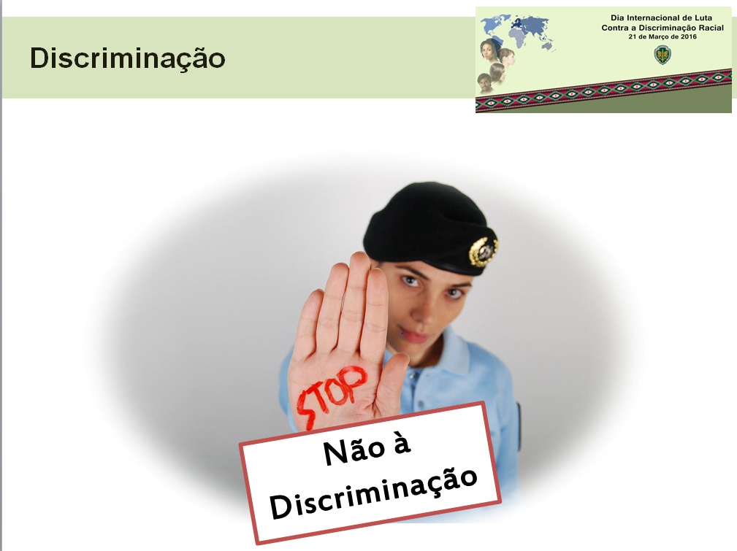

Illustration 1 – Image used for prevention action

1. Within this context, it should be highlighted that awareness was raised pertaining to the following issues and target audience throughout 2018.

Illustration 2 – Number of citizens sensitized

1. The GNR has invested in the prevention of domestic and gender based violence over the past 15 years, through the design and implementation of the IAVE (Investigation and Support of Specific Victims) project, with a special focus on vulnerable victims (women, children, the elderly, persons with disabilities, LGBTI populations and ethnic minorities).
2. With this project, the *Guarda Nacional Republicana* recognizes crimes committed against women, children, the elderly, disabled persons, LGBTI persons and other particularly vulnerable victims as one of the most delicate challenges posed to criminal investigation, within the scope of their legally established duties and competences.
3. On 31 December 2018, the GNR had a total of **534 military personnel assigned to the IAVE (Investigation and Support of Specific Victims) project** (437 men and 97 women), of which **98 were assigned to the Nuclei of Investigation and Support of Specific Victims (NIAVE) and 436 to the Territorial Post Inquiry Sections**.
4. In addition to the aforementioned military personnel, there are also **360 military elements** who carry out duties in the **GNR Criminal Prevention and Community Policing Sections**.
5. The investment in the training and qualification of these professionals is guided by the quality of the service rendered to citizens, always bearing in mind the defence of non-discrimination, and the protection of citizens’ human rights.
6. In 2018, the **GNR registered 11,913 incidents of domestic violence**, hence an increase over the previous year, whereby this type of unlawful act has a tendency to represent one of the highest crime rates registered in the last ten years, and one of the incidents with highest prevalence pertaining to crimes committed against persons:

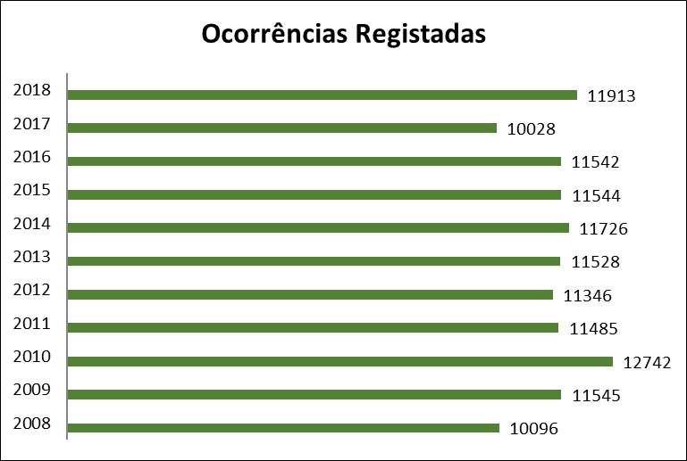

Illustration 3 – Evolution of no. of DV incidents (2008-2018)

1. With regard to the offences laid down in crime 152 of the Penal Code, the fact is that in 2018, out of the 11,913 incidents reported, domestic violence against spouses or intimate partners prevailed with 10,207 occurrences, followed by 1,512 incidents of other types of domestic violence, and 194 occurrences registered against minors.

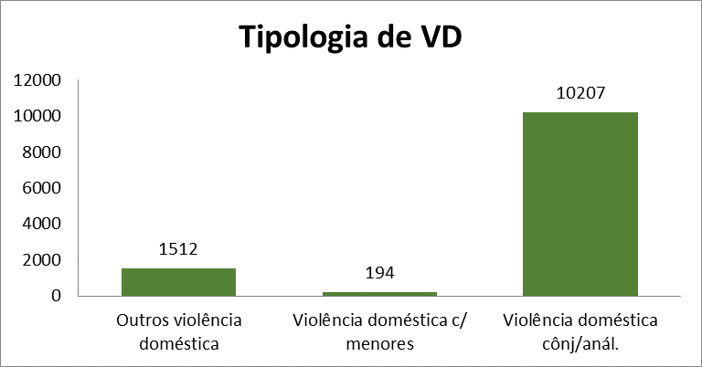

Illustration 4 – Domestic violence offences (2018)

1. Awareness campaigns of this nature play a role of social responsibility in the aim of the National Plan for the Prevention and Fight against Domestic and Gender based Violence. Considering the importance of the need to prevent violent behaviours in the Portuguese society, these actions have been developed throughout the year by the SPC, whereby the GNR also seeks to promote carrying out National Operations, which, due to their dimension and visibility, contribute to the objective of making society aware of this reality, from which we highlight:

* From 29 to 31 January 2018 the *Guarda Nacional Republicana* promoted 451 awareness-raising actions among the school community, with the objective of sensitizing to the need to prevent violent behaviour, having this action reached **14,625 children and youth**.
* Between 06 and 09 February 2018, the *Guarda Nacional Republicana* promoted awareness-raising actions among the school community and groups of elderly persons, in order to sensitize to the need to prevent risk behaviours inherent to the use of the Internet, namely violent behaviours, having sensitized **27,645 citizens**.
* To mark **International Women’s Day** on 08 March 2018 the GNR distributed bookmarkers alluding to the prevention of violent behaviours against women. The initiative aimed to sensitize as many people as possible to gender equality by promoting a non-violence culture, thereby enhancing women’s effective security and sense of safety. This action was developed in partnership with the *Associação Corações com Coroa* (Hearts with a Crown Association), which is founded and chaired by the United Nations Population Fund (UNFPA) Goodwill ambassador, Catarina Furtado.
* Every year, on 20 November, the **International Children’s Rights Day** is celebrated, with the aim of highlighting and publicizing the rights of children around the world. Sexual abuse and exploitation of children constitute serious violations of their rights and tend to have lasting harmful consequences throughout victims’ lives, thus the Committee of Ministers of the Council of Europe has established a new **European Day on the Protection of Children against Sexual Exploitation and Abuse**, which will be marked on 18 November in all 47 Member States of the Organisation. Thus, from 20 to 22 November 2018, the *Guarda Nacional Republicana* promoted 517 awareness-raising actions, with the aim of raising awareness of children’s rights and preventing child sexual abuse and exploitation, reaching **16,982 children**.
* 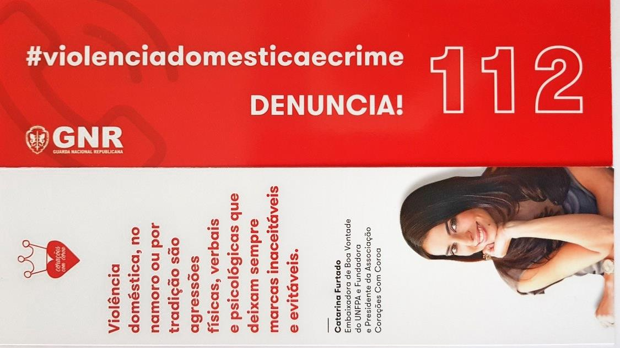In 1999, the United Nations (UN) officially set 25 November as the **International Day for the Elimination of Violence against Women**. Within the scope of Community Policing, between 25 and 28 November 2018, the *Guarda Nacional Republicana* promoted awareness raising actions, with the objective of enhancing awareness of the need to prevent violent behaviours against Women, reaching **8,751 citizens**.

Illustration 5 – Sample of a bookmarker distributed in awareness actions

* In addition to training these specialists in investigation and support of specific victims, the GNR is also concerned with the answer given by its employees, having invested in the training of its staff, in accordance with the modalities of initial and ongoing training, appreciating knowledge update and skill enhancement, organising and planning community policing and domestic violence models in accordance with the responsibilities and levels of police action, without prejudice to the importance of Personal Security Plans and the improvement of spaces with comfort and privacy conditions to assist crime victims. In complementarity, within the framework of the violence risk assessment and management, an integrated response is sought, which has allowed the GNR to carry out quality work in secondary prevention of revictimization of domestic and gender based violence victims:

|  |  |
| --- | --- |
| **Victim support rooms** | **2018** |
| No. of existing posts with territorial jurisdiction | 474 |
| No. of existing posts with territorial jurisdiction with victim support rooms | 275 |
| No. of other existing victim support rooms at the level of other units/subunits other than those with territorial jurisdiction | 20 |
| Total existing victim support rooms | **295** |

1. In 2018, the GNR registered **8,413 communications of victim status** (provided for in article 14 of Law no. 112/2009, of 16 September).
2. Within the compass of its responsibilities to protect children, in 2018 the GNR **flagged 2642** children and youth and began **32 urgent proceedings**.
3. The national level Safe School program is particularly targeted to safeguard the entire school community.
4. Aware of the violence-related phenomena in school environments, through the Safe School Nuclei, the GNR has developed and enhanced its actions among the school community (students, teachers, parents, guardians and educational action assistants) in order to sensitize them and involve them in issues on safety in school environments.
5. With this purpose in mind, several activities were carried out, namely policing and awareness-raising actions among schools, complemented by the distribution of pamphlets alluding to matters like crime prevention, road prevention, prevention of violent behavior, namely bullying, domestic violence, dating violence, sports violence, mistreatment, and sexual abuse and children’s rights. These actions were targeted at the entire school community.
6. Within the context of this program, **15,971 awareness-raising actions** were carried out in 2018 on various themes, including **493 demonstrations** of means and capabilities and visits from 200 schools to several GNR quarters, covering a universe of 5,097 schools and 643,270 students.

Illustration 6 - Safe School – Number of actions (2018)

1. Also within the framework of the Safe School Program, the “Back to School in Security” Operation, which took place from 12 to 21 September, committed 1,899 military elements, encompassed 1,330 schools and involved 55,020 students, in order to convey safety tips, and made public the contacts of the military personnel of the Criminal Prevention and Community Policing Sections.
2. From the actions developed by the GNR within the compass of the Safe School Program, it should be noted that in the 2017/2018 school year **1,373 incidents** were reported **in school environments,** including public, private and cooperative schools, whereof **700 were of a criminal nature**.

Illustration 7 - Total participations (2017-2018)

1. Article 144.º A - Female genital mutilation

   * Anyone who genitally mutilates, totally or partially, a female person through clitoridectomy, infibulation, excision or any female genitalia harmful practice for non-medical reasons is punished with a prison sentence of 2 to 10 years.
   * The preparatory acts of the crime under the preceding paragraph shall be punished with prison sentence up to 3 years.

   Article 154.º -B - Forced marriage: Anyone who compels another person to marry or other similar union is punished with a prison sentence up to 5 years.
2. <https://www.cnpdpcj.gov.pt/>
3. <https://www.cig.gov.pt/wp-content/uploads/2018/07/Resol_Cons_-Ministros_61_2018.pdf> p. 2238
4. 1. GNR Strategy (*Guarda* 2020), Plan and Activity Reports are available at: <http://www.gnr.pt/estrategia.aspx> and <http://www.gnr.pt/IG_Principal.aspx>

   2. National Strategy for the Integration of Homeless People and Execution report are available at: <http://www.enipssa.pt/enipssa>

   3. National Strategy for the Integration of Roma Communities (ENICC) and Execution report are available at: <https://www.acm.gov.pt/pt/-/estrategia-nacional-para-as-comunidades-ciganas-enicc-concig>

   4. National Strategy for Equality and Non-Discrimination - Portugal + Equal and Execution report are available at: <https://www.cig.gov.pt/documentacao-de-referencia/doc/portugal-mais-igual/>

   Action Plan for Reducing Addictive Behaviours and Dependencies - Horizon 2020 and Execution reports are available at: <http://www.sicad.pt/PT/Publicacoes/Paginas/default.aspx>

   5. National Plan to Prevent and Combat Human Trafficking is available at:

   <https://www.cig.gov.pt/planos-nacionais-areas/trafico-de-seres-humanos/>

   6. Annual Internal Security Report is available at:

   <https://www.portugal.gov.pt/pt/gc21/pesquisar?f=relat%C3%B3rio+anual+seguran%C3%A7a+interna>