Call for submission: Report of the Office of the High Commissioner for Human Rights on engaging men and boys in preventing and responding to violence against all women and girls, pursuant to Human Rights Council resolution 35/10 of the Human Rights Council

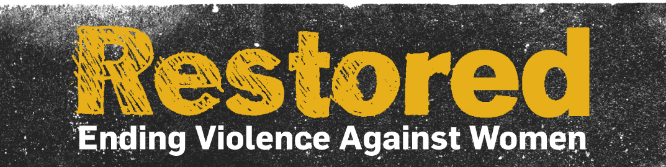

3 November 2017

Submission from Restored (www.restoredrelationships.org).

Restored is an international Christian alliance working to transform relationships and end violence against women.

Restored has 99 member organisations spread across 27 countries. A full list of our members is available here. Restored has observer status at ECOSOC.

What are the concrete steps your Government or your organization has taken, at normative, institutional and programme levels, to engage men and boys in promoting and achieving gender equality and challenge gender stereotypes and the negative social norms, attitudes and behaviours that underlie and perpetuate violence against women and girls? You may wish to refer to various aspects of such effort indicated in the operational paragraphs 9 and 10 of the resolution. Please also elaborate on the impact these steps have had.

Restored was founded in 2010 based on the two questions: where is the church and where are the men when it comes to ending violence against women? We have sought from the very beginning to model men and women standing together to address issues of violence against women. In 2011 we started our men’s campaign, First Man Standing, which calls on men to do three things:

- To respect women in all dimensions of their lives;
- To challenge other men as to their attitudes and behaviour; and
- To sign up to the White Ribbon pledge “never to commit, condone or remain silent about violence against women”.

FMS is the only Christian men’s movement working to end violence against women. We have 1200 sign ups to a monthly e-mail which addresses issues of masculinity, sexism and relationships and reflects on items in the news. The concepts of FMS have also been central to the design of interventions with our member organisations in India, Southern Africa and Latin America. The simple principles underlying FMS are applicable across all cultures while also allowing for significant local contextualisation in different communities. We work actively in a range of global networks including We Will Speak Out (https://www.wewillspeakout.org/) and Micah Global (http://www.micahnetwork.org/) to address theses issues.

First Man Standing is very conscious of the experiences of sexual harassment and abuse experienced by women as recorded on the Everyday Sexism site and through the current #MeToo hashtag. In 2015 we expanded the FMS concept to produce the FMS website which is designed to model positive stories of masculinity in answer to the question: “What does good look like?” People are invited to post stories about men who are modelling gender equality and challenging sexism and violence against women. Special campaigns have been run fro Valentine’s Day and Fathers’ Day to raise awareness. We have over 2,900 followers on twitter. Discussions were held in the summer of 2017 with the United Nations HeForShe campaign about the FMS model.

Restored interacts with men who are signed up to FMS through conferences and church-based men’s meetings. In this way we are able to hear about the actions that men have taken in response to FMS. These include:

- intervening as bystanders to stop violence,
- educating themselves as to the issues
- getting professional training to allow them to better address VAW in their work situations
- strengthening their own relationships and marriages; and
- speaking out against all forms of abuse against women and girls.

What are the challenges that your Government or your organization faces, at normative, institutional programme levels, in engaging men and boys in promoting and achieving gender equality, in particular efforts to challenge gender stereotypes and the negative social norms, attitudes and behaviours that underlie and perpetuate violence against women and girls? Please elaborate on the nature of these challenges and the steps taken to address them.

Our work concentrates on faith communities. In this context we face many of the issues and challenges that are common to all such work with men

- Man’s lack of awareness of the issues
- A lack of willingness to listen to women’s voices
- Denial and minimisation of abuse
- Active resistance
- A disproportionate emphasis on women’s violence against men
- Apathy

In addition, however, there are specific issues that we need to address in the Christian context. These include

- Patriarchy in churches. Most Christian leaders are men. Although this is changing in some denominations, it remains an issue for many churches. Women’s roles and contribution are sometimes undervalued creating a context of male power and privilege in which abuse is less likely to be challenged.
Restored seeks to address this by church training and resources that challenge male power structures. The Restored Church Pack, downloadable free of charge at www.restoredrelationships.org/churchpack, provides a comprehensive guide as to how churches can respond to both survivors and perpetrators of abuse. Our own structures (including male and female Co-Directors and a gender-balanced Board of Directors) seek to model women and men working together. We focus on ending violence against women and are willing to work with any churches committed to this goal. We do not want to drive away the very churches that need most to hear the messages and teaching that we are bringing.

- Theology. Debates continue within Christian churches about the interpretation of Biblical texts with respect to gender roles and relationships between men and women. Once again, we provide alternative interpretations of Scripture on which to develop church doctrine and practice which model gender equality, while seeking to work with churches that have a range of different theological views.

On a more positive note, we find that we are able to draw substantially from the Bible and from the life of Jesus Christ as a model of masculinity. The Bible portrays God as a God of justice committed to those who are oppressed and holding perpetrators to account. The emphases within the Christian gospel on the giving up of power, serving others and respect for all human beings are powerful drivers in developing new models of masculinity and relationships.

We have developed a series of seven Bible Studies for individual men and men’s groups, which are being piloted in 2017/18 prior to finalisation and wider rollout in 2018. These cover issues of masculinity, relationships, violence against women and raising boys and girls. They can be downloaded here.

Are women and girls, including women’s rights organizations, involved in the efforts by your Government or your organization to engage men and boys in promoting and achieving gender equality, in particular efforts to challenge gender stereotypes and the negative social norms, attitudes and behaviours that underlie and perpetuate violence against women and girls?

First Man Standing is embedded within the work of Restored. The men’s work is accountable to both the Co-Directors (one women and one man) and the Board, which is chaired by a woman. The principles of Restored include the following:

1. We believe that men and women are equal in the sight of God.

2. We believe that Violence Against Women (VAW) in all its forms is unacceptable, inexcusable and intolerable.

3. We believe that the safety of women and children is paramount and that any interventions to address VAW must reflect this.

4. We believe that relationships can be restored and that people can be transformed through the power of God.

5. We believe that the genuine transformation of individuals must precede the possible restoration of relationships.

6. We believe that men and women should work together to transform relationships and end VAW.

7. We believe that the church has a vital role in transforming relationships and ending VAW both amongst Christians and in the community.

Restored is a member of the UK Gender and Development Network. We draw heavily from resources produced by women’s organisations to develop and critique our own resources. We identify with pro-feminist men’s organisations and work closely with White Ribbon Campaign. We are members of the MenEngage alliance.

Restored’s wider work includes a survivors’ network.

Restored works extensively in advocacy and played a role in the development of conclusions at the UN Commission on the Status of Women in 2013, which had the theme of ending violence against women and the global summit on ending sexual violence in conflict in 2014. Both these meetings identified the positive role for faith-based organisations in addressing violence against women.

We have supported positive developments within Christian denominations, helping to sponsor a motion at the general Synod of the Church of England to address violence against women and supporting the Anglican Consultative Council resolution 15:7, which recommended including men and boys in the response to gender-based violence.

