Submission by Sonke Gender Justice towards the Report of the Office of the High Commissioner for Human Rights on engaging men and boys in preventing and responding to violence against all women and girls, pursuant to Human Rights Council resolution 35/10 of the Human Rights Council

About Sonke: Sonke Gender Justice (Sonke) was established in 2006 by a group of progressive gender justice activists who recognized the need for multifaceted interventions for achieving gender equality across Africa. Sonke’s vision is a world in which men, women and children can enjoy equitable, healthy and happy relationships that contribute to the development of just and democratic societies. Sonke works across Africa to strengthen government, civil society, and citizen capacity to promote gender equality, prevent domestic and sexual violence, and reduce the spread and impact of HIV and AIDS. Sonke is the co-coordinator of the MenCare Global Fatherhood Campaign, a founding member of the MenEngage Alliance, a consortium member in the Prevention+ initiative, and acts as secretariat for MenEngage Africa. Building on this work, Sonke was involved along with partner organisation in the tabling of the abovementioned resolution in 2016.

Scorecard on Laws and Policies in Africa that engage men in preventing Gender Based Violence.
Overview: This report provides an assessment of whether national policies (1) and laws in the African region attempt to engage men and boys in the prevention and elimination of gender-based violence (GBV). This report analyses policies and laws from eleven African countries: the Democratic Republic of Congo (DRC), Ethiopia, Kenya, Malawi, Rwanda, Sierra Leone, South Africa, Tanzania, Uganda, Zambia and Zimbabwe. (2) It identifies various strengths and gaps within the region’s GBV policies and laws with regards to their inclusion of language relating to the proactive and progressive engagement of men and boys. Furthermore, it offers recommendations for how such policies can increase the commitment and capacity of men and boys to play a proactive role in preventing and eliminating GBV. While this scorecard reviews the content of GBV related laws and policies, it does not evaluate the extent to which laws and policies are being implemented.
Why engage men in preventing violence? The elimination and prevention of all forms of violence against women and girls was the priority theme for the 57th session of the UN’s Commission on the Status of Women (CSW) in 2013. (3) Although there has been much progress in this area, evidence and interventions increasingly show that in order to end GBV, it is important to work with men and women to change the social norms that perpetuate GBV, including providing alternative and non-violent role models for young men and boys, and supporting men to take a stand against GBV. It is well established that masculine gender norms contribute to GBV. (4) These include socialization processes which encourage men to use violence as a means to resolve conflict whilst discouraging expressions of emotion or vulnerability; the pressure to consume alcohol; and the notion that it is not only acceptable for men to control and dominate women, but that such behavior is indeed necessary for men to demonstrate their masculinity. Given this, a number of organizations, particularly those within the MenEngage alliance, (6) have been working to eliminate violence against women, and GBV, by working with men and boys. These organizations also recognize that the gender norms, which contribute towards violence against women, also contribute to homophobic violence and discrimination against LGBTI people. It is therefore also necessary to engage men to challenge homophobia and to promote the rights of LGBTI communities. This is especially important in the African region, where homosexuality is criminalized in many countries, and levels of discrimination and violence towards LGBTI people are extremely high. (7)
The role of laws and policy Laws and policies significantly define and sustain gender norms by clearly establishing a country’s national priorities and setting aside resources for their implementation. Thus, because of their national impact, laws and policies have the potential to lead to large-scale changes in men’s behaviors and attitudes relating to gender and health, and to challenge social norms and institutional cultures that continue to perpetuate inequalities and violence. (8) In order to achieve this and be most effective, laws and policies should be gender transformative (9) and gender (10) synchronized so as to ensure they do not reinforce negative societal values and norms. (11) Nevertheless, it is important to remember that policies and laws alone cannot effect long-term and sustained change. While they are an integral first step, they must be followed up by effective implementation. This report aims to provide the HRC with a better understanding on the importance of engaging men and boys in the elimination of GBV and offers an opportunity to address the gaps and priorities identified in existing laws and policies. It can also be used to identify key areas and priorities for policy advocacy. The table below represents the rankings of eleven African countries based on whether their laws and policies include language on the proactive and progressive engagement of men and boys in the area of GBV. The following pages provide more detail on the key strengths and gaps of GBV legislation in these countries.
Methodology: In evaluating each country’s GBV legislation, relevant criteria were weighted based on the extent to which policies and plans include language on men and boys. Percentages denote the total number of points earned in regards to each of these criteria.
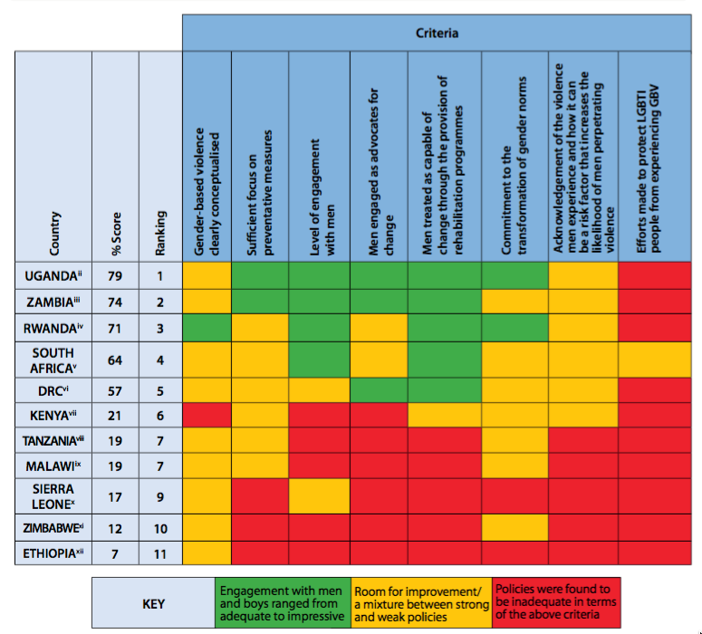

Findings of policy analysis: The gaps outlined below indicate that many national policies dealing with GBV in Africa need to be strengthened in terms of engaging with men and boys. While a few pieces of legislation articulate the importance of engaging men and boys for the elimination and prevention of GBV, with some notably mentioning the need to shift negative masculine norms and behaviors, there are hardly any which emphasize the need for Information, Education and Communication (IEC) or Behavior and Communication Change (BCC) strategies in order to effectively operationalize this aim. In many of the policies, men are viewed primarily as perpetrators of GBV and are not engaged as potential advocates for change.
Strengths: Most policies analyzed offer a comprehensive definition of GBV which is not limited to physical and sexual assault but includes cultural and psychological harm or suffering that occurs by way of threats, intimidation, economic deprivation, rape, trafficking and forced prostitution. Rwandan legislation on GBV is the most comprehensive and nuanced as it clearly defines GBV as not being motivated purely by someone’s sex but by someone’s gender role. (12) Rwanda’s GBV policy also recognizes that GBV both ‘reflects and reinforces inequities between men and women’. (13) Several policies acknowledge that GBV is facilitated by social norms of male superiority, male sexual entitlement and men holding attitudes and beliefs supportive of sexual and other forms of violence as articulated in South Africa’s National Sexual Assault Policy. (14) A number of countries recognize the need to do gender transformation work in order to reduce rates of GBV. For example, in Uganda, most policies focus on sensitizing males and females on harmful values and beliefs on male dominance and female subordination and are committed to promoting gender equality in society. (15) Many policies and plans note the importance of developing prevention strategies as opposed to only focusing on punishment. Malawi’s National Response to Combat Gender-based Violence outlines adequate prevention measures focused on GBV education targeted at civil society, government and poor women who tend to be the main victims of GBV. (16) This includes a focus on schools and educational institutions in the hope that this will “...lead to the creation of a violence-free generation/society.” (17) Within some legislation, it is noted that men who are exposed to violence (for instance, in conflict and post conflict settings) are more likely to use physical and sexual violence against their partners and children. This is discussed in DRC’s National Action Plan to Prevent and Combat Violence against Women (2008- 2012). (18)
Gaps: While most forms of GBV are criminalized and punishable by law, marital rape is not criminalized in seven of the eleven countries evaluated, specifically the DRC, Ethiopia, Kenya, Malawi, Tanzania, Uganda and Zambia. Many policies and plans recognize that GBV is fuelled by negative masculine behaviors but do not provide detailed and explicit plans to address them, including the pervasive belief that men are superior to women and that they have the right to use physical and/ or sexual violence to maintain their dominance. There are minimal IEC and BCC strategies that seek to challenge these attitudes, which are often the root cause of GBV. There are very few plans in place that encourage men and boys, particularly those in leadership positions, to speak out publicly against GBV and act as advocates for change. In most countries, GBV is synonymous with violence against women (VAW). As a result, there is minimal acknowledgement of the violence that men and boys experience, particularly at a young age, and how this often leads to violence against women and children as well as other men, especially marginalized men such as men who have sex with men (MSM) and men in detention settings. Male rape in particular is barely discussed in policies dealing with GBV. Given that homosexuality is illegal in most African countries, the needs and concerns of LGBTI persons are not acknowledged or accounted for in legislation dealing with GBV. Most policies do not commit their governments to developing adequate rehabilitation programs (such as batterer interventions) for men seeking to address their aggressive behavior, whether in prison settings or in their communities.
Recommendations
- Marital rape should be criminalized and the definition of rape broadened. Relevant pieces of legislation should be amended so that marital rape is criminalized and punishable by law across Africa. Existing definitions of rape should be expanded to include male rape. In addition, the forms of GBV faced by LGBTI persons should be articulated and accounted for.
- Policies and plans should pay adequate attention to GBV prevention, including a focus on gender norms transformation work. Legislation tends to understandably be punitive in its approach to GBV. While this is extremely important, and much work should focus on ensuring that GBV o enders are brought to justice, detailed strategies that aim to address root causes of GBV should also be prioritized. Prevention measures should include gender norms transformation work which focuses on transforming notions of masculinity that encourage violent behavior, the objectification of women, and excessive alcohol consumption, as well as the development of positive role models who encourage men to be engaged in GBV prevention.
- Men should be encouraged to speak out publicly against GBV. Men, whether former o enders, ordinary men or men in high positions such as political and traditional leaders, should be called upon to speak out publicly against GBV, thereby challenging the culture of impunity that surrounds GBV.
- Policies should recognize the violence that men experience, particularly at a young age, in conflict and in prison settings. Policies and laws should seek to provide psychosocial support for boys and men who witness and/or experience violence, as this can be a risk-factor that increases the likelihood of men perpetrating violence against women, children or other men. When acknowledging the violence that men experience, this should never detract focus from preventing violence against women; and it should always be acknowledged that men usually experience violence at the hands of other men.
- Strategies aimed at ending a culture of violence should be developed. Plans that seek to combat GBV should take into consideration the general levels of violence in society, including male-on- male violence, and how this contributes to GBV. Prevention strategies should address violence at a societal level in order to transform attitudes towards violence.
- Youth focused GBV prevention initiatives should be rolled-out in schools. In order to influence socialization processes and attitudes towards violence, programs that address gender norms transformation and raise awareness on gender equality and human rights should be integrated into school curricula. Special efforts should be made to prevent violence in schools.
- Legislation should recognize and address the link between discrimination against LGBTI people and GBV. Laws that criminalize homosexuality should be repealed, as they foster homophobic violence and offer no opportunity for victims to seek legal recourse. Hate crimes should be criminalized as part of a state’s constitutional duty and in a direct effort to address the perpetration of violence against men and women who do not conform to repressive gender roles and stereotypes.
Acknowledgements Sonke derived this scorecard from a series of policy reports, which was produced in collaboration with its MenEngage partners and United Nations Agencies. That project was made possible by the generous financial support provided by the United Nations Development Programme (UNDP), the United Nations Population Fund (UNFPA), the United Nations Trust Fund to End Violence against Women administered by UN Women on behalf of the UN system, (19) and the Swedish International Development Cooperation Agency (SIDA). (20) The authors were Tanya Charles, Tim Shand, Dean Peacock and Hayley Thomson at Sonke. Grateful thanks also go to Gentil Kasongo Safari for his work in the DRC, and to Rachel Lyn Okun-Kozlowicki for her work on the scorecard.
References and Notes
- When this document refers to policies, it should be understood that this refers broadly to policies, laws, frameworks, guidelines and plans.
- This scorecard is derived from several policy reports that Sonke has been producing since 2010 in collaboration with the MenEngage Africa Network. The detailed country reports can be accessed at www.genderjustice.org.za
- See http://www.un.org/womenwatch/daw/csw/57sess. htm
- UNFPA website, Gender Equality, Ending Widespread Violence Against Women, http://www.unfpa.org/gender/ violence.htm
- Findings within “Programming to address violence against women, 10 Case Studies”, UNFPA, p. vi, http:// www.unfpa.org/webdav/site/global/shared/documents/ publications/2007/vaw_10cases.pdf
- See www.menengage.org
- “Homosexual Africans face prison, intolerance and the death penalty, In Africa 38 out of 53 countries have criminalised consensual homosexual sex”, Fran Blandy, The Telegraph, 11 January 2010, http://www.telegraph.co.uk/ expat/expatnews/6951539/Homosexual-Africans-face- intolerance-prison-and-the-death-penalty.html..
- “What men have to do with it: Public Policies to Promote Gender Equality”, Men and Gender Equality Policy Project, coordinated by the International Center for Research on Women and Instituto Promundo, pp. 8-9; “Policy Approaches to Involving Men and Boys in Achieving Gender Equality and Health Equity”, prepared by Sonke Gender Justice for the Department of Gender, Women and Health, World Health Organization, (June 2010), p. 10.
- “Gender transformative” refers to action that seeks to promote equitable relationships; challenge male gender norms; transform traditionally accepted norms associated with being a man or a woman; and change gender relations. Adapted from Gupta GR, Whelan D, Allendorf K. Integrating gender into HIV/AIDS programmes: review paper for expert consultation. Geneva: WHO, 2003, http://www. who.int/gender/hiv_aids/en/Integrating%5B258KB%5D.pdf (accessed January 2012).
- “Gender-synchronized approaches are the intentional intersection of gender transformative efforts reaching both men and boys and women and girls of all sexual orientations and gender identities. They engage people in challenging harmful and restrictive constructions of masculinity and femininity that drive gender-related vulnerabilities and inequalities and hinder health and well-being.” Margaret E. Greene and Andrew Levack, Synchronizing Gender Strategies, A Cooperative Model for Improving Reproductive Health and Transforming Gender Relations, 2010, For the Interagency Gender Working Group (IGWG), http://www.engenderhealth.org/ les/pubs/ gender/synchronizing_gender_strategies.pdf
- “Policy Approaches to Involving Men and Boys in Achieving Gender Equality and Health Equity”, op cit, p.12.
- Rwanda’s National Policy Against Gender-based Violence, p. 8.
- South Africa’s National Sexual Assault Policy, 2005, p.5-6.
- South Africa’s National Sexual Assault Policy, 2005, p.5-6.
- Uganda’s National Action Plan on Gender Based Violence, p. 8-9..
- Malawi’s National Response to Combat Gender-Based Violence, p.3.
- Ibid.
- DRC’s National Action Plan to Prevent and Combat Violence against Women, 2008-2012, p. 3.
- The United Nations Trust Fund in Support of Actions to Eliminate Violence against Women (UN Trust Fund) is a multi-lateral grant-making mechanism supporting country-level e orts of governments and non- governmental organizations to end violence against women and girls. Established in 1996 by General Assembly resolution 50/166, the UN Trust Fund is administered by the United Nations Entity for Gender Equality and the Empowerment of Women (UN Women) on behalf of the United Nations system.
Declaration: The views expressed in this document are those of the authors and do not necessarily reflect the official views and positions of UNDP, UNFPA, SIDA, UN Trust Fund, UN Women, the United Nations or any of its affiliated organizations. The information provided can be made available on the OHCHR website.

