Together for Girls Submission: OHCHR call for submissions on engaging men and boys in preventing and responding to violence against all women and girls
Together for Girls (TfG) is a partnership between national governments, UN agencies and private sector organizations, working at the intersection of violence against children (VAC) and violence against women, with special attention to sexual violence against girls. TfG works across three pillars of action:
- Nationally representative Violence Against Children Surveys (VACS) and other relevant data;
- Nationally-led multi-sectoral VAC prevention and response;
- Global advocacy and awareness-raising.
We apply a gender and life-course perspective to our work and seek to identify the specific needs and vulnerabilities of both girls and boys. We pay particular attention to adolescent girls because they often remain invisible or fall through the cracks in the development of policies and programs to end VAC and violence against women and girls (VAWG). We also recognize that boys experience violence, and that focusing on them is essential—both because their rights and well-being are equally important and because they play an important role in breaking cycles of violence.
Examples, promising practices and lessons learned for engaging men and boys in VAWG work:
VACS: The VACS, led by CDC through the TfG partnership, collect nationally-representative data on emotional, physical and sexual violence against girls and boys, including prevalence data on violence before age 18 (among 18-14 year olds) and 12-month incidence data (among 13-17 year olds), as well as on the circumstances and perpetrators of violence, reporting and service use, and health and well-being outcomes. The process is led by a multi-sectoral task force of government ministries, civil society and Together for Girls partners, and the data informs and leads into long-term violence prevention and response policy and program implementation. Governments and civil society lead long-term policy and program response across sectors to reduce violence in childhood and increase gender inequality, and respond to violence when it occurs.
Previous to the VACS there was limited data on VAC in most countries, and where it is existed it was often not nationally representative, not comparable across countries, or limited in scope and inclusiveness (e.g. only represented older adolescents, only included females). To date 10 countries have launched VACS findings, with more surveys in planning, process or analyses. With growing coverage, for the first time the VACS provide a baseline for rates of VAC within and across countries, along with nuance on variations among genders and age groups. In most settings, the VACS represents the first comprehensive national data on VAC. The same questions are asked of both males and females, and as a result VACS results feature nuanced data for both boys and girls on violence in childhood (see Graphs 1-3 for examples), particularly adolescence; perpetrators, reporting and service seeking (Graph 4). Recently launched VACS (Malawi and Nigeria, with additional countries to launch results soon) included questions on perpetration as well, allowing for the analysis of the relationship between childhood violence and intimate partner violence perpetration in adulthood. These data illustrate the relationship of VAC and VAWG at it evolves through adolescence; and the importance of understanding violence in adolescence to contribute to monitoring and tracking progress against the SDGs. The updated VACS core questionnaire includes updated questions on intimate partner violence, marriage and cohabitation, and other areas related to gender and violence that increase alignment with surveys from the VAWG sector, and will enhance comparability of data.
The data on boys is included in all reports, and used by national partners to plan the transition from data to action, resulting in national action plans that are comprehensive, cross-sectoral, and long-term. As the first comprehensive data available on violence, the VACS can be used as a baseline to track progress. Results provide detailed information on how violence evolves across, and intersects with, the lives of girls and boys, and in doing so provides a guide to how to engage males in the important work of ending violence and building gender equality. Under this model, the data and evidence-based response guides countries, regions and global advocates and organizers to engage males on a number of levels: as vulnerable parties themselves, needing tailored prevention and response efforts; as allies and champions in ending VAWG; and as vital to engage to prevent IPV and VAWG perpetration and end cycles of violence both within and across generations. At a global level, Together for Girls promotes understanding of how violence impacts girls and boys, particularly in adolescence, through events, graphics, blogs, the TfG website, and other communications and advocacy platforms that use data and stories to raise awareness about the issue and showcase stories of male survivors, champions and advocates; and works with partners to undertake additional analyses of publicly available VACS datasets to better understand how violence progresses across adolescence and young adulthood for females and males. Our advocacy promotes work with men and boys while highlighting the importance of data, and the importance of a nuanced discussion on violence that continues to center gendered vulnerability.
Coordinated action: The Together for Girls partnership promotes a holistic model that engages sectors across social welfare, legal/justice/policing, health, education, gender and others to intervene across the individual, family, community and political/social contexts for social norms change. With strong data to guide the way, under the leadership of national governments, with overall coordination and technical support led by UNICEF, and significant financial investments from PEFPAR, USAID and the Government of Canada, we work to develop, strengthen and expand comprehensive, evidence-based national actions. We focus on both violence prevention and response. The success of the model is illustrated by Tanzania, which conducted the VACS in 2009. Following the launch of its VACS report in 2011, the government implemented a 1-year, costed multi-sectoral plan that bridged to a 3-year National Plan of Action to Prevent and Respond to VAC. The plan focussed on scale-up of district level child protection systems and investments in capacity development, and included accountability mechanisms for tracking progress and expenditures against the plan. Achievements include expansion of child protection teams to 47 local government authority areas; reaching 700,000 boys and girls; 1,151 workers trained in 498 health facilities; training of police, social welfare, magistrates; and national hotlines and campaigns. In 2016 Tanzania completed and evaluated the plan, linking to the launch of a new combined National Plan of Action to Prevent and Respond to Violence Against Women and Children in Tanzania, expansion to new regions in 2017 and 2018 and commitment to further reduce violence through work as a Global Partnership to End Violence Pathfinder country.
Promoting evidence-based action: Increasing evidence demonstrates the impact of girls’ empowerment on violence--but without male engagement and interventions that promote positive masculinities and change harmful gender and violence norms, prevention of VAWG will not be possible. Examples include:
- Led by WHO, Together for Girls worked with partners from TfG and the Global Partnership to End VAC to develop and launch the INSPIRE strategic package. Across seven strategic areas, the package recommends evaluated programs to reduce VAC, including numerous interventions emphasizing male engagement to end VAWG, as well as to end violence against both boys and girls. Together for Girls promotes the interventions in INSPIRE and other proven, promising and prudent practices for engaging men and boys in work to reduce VAWG, and promoting the important work of Promundo and other organizations working to build the evidence base on engaging men and boys in VAWG prevention: These include:
- Improving social norms around violence and gender: SASA! (demonstrated reductions in IPV), Stepping Stones, Coaching Men into Boys; Yari-Dosti; and others
- The Good School Toolkit reduced violence at school for both boys and girls, using a whole school approach
- Self-defence and empowerment: No Means No Worldwide studies in Malawi and Kenya showed that girls’ self-defence and empowerment courses can decrease rape by 50%. The programs included male engagement components focussed on changing norms around masculinity and consent.
- Systems improvement: Training providers in the social welfare, health and justice sector to provide age and gender-sensitive care to survivors of violence. This includes the creation of gender- and child-desks to receive survivors of violence reporting to the police; one stop centers where children who experience violence can receive all services from trained providers; child friendly courts; and scaling up adolescent-friendly services. In ensuring these services are effective, service providers must have access to guidance and training on serving the specific needs of boys and girls; they must also understand how gender inequality and norms around violence shape experiences of violence, services, and their own thinking, in order to provide survivor-centered services. TfG promotes development of technical guidance and best practices; for example, the recently launched WHO Guidelines for Responding to Children and Adolescents Who Have Been Sexually Abused.
A clear lesson-learned from the first years of TfG is the importance of coordinated, multi-sector national actions, whether as multi-year plans, strategies, agendas or in other forms. These plans have high-level government commitment, clear divisions of labor, concrete accountability measures and are gender-responsive. As a partnership, we prioritize investments in coordination to fully develop, implement, monitor and evaluate these plans. Investment in the coordination function at the lead government ministry with support, generally from UNICEF, is essential. To measure the impact of the partnership at the global, regional and national level, TfG developed an internal results framework that measures progress for the partnership at the national and global levels in researching, preventing and advocating on VAC, which is gender-sensitive and where possible age- and sex-disaggregated.
Annex: VACS Data Graphs
Graph 1: Sexual violence prevalence in childhood
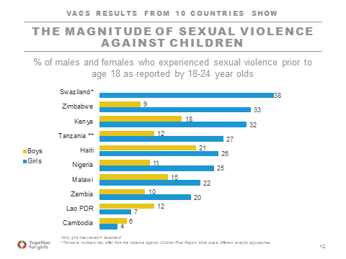
Graph 2: Physical violence prevalence in childhood
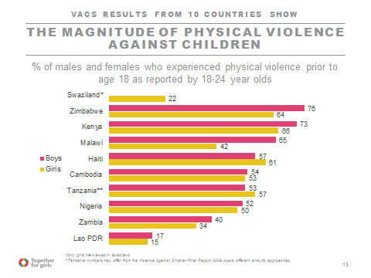

Graph 3: Past-year sexual violence among 13-17 year olds
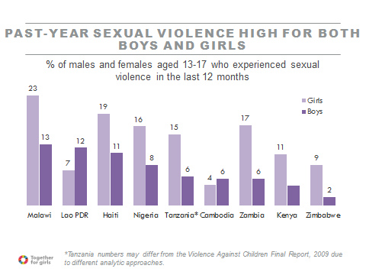
Graph 4: Reporting, service seeking and access
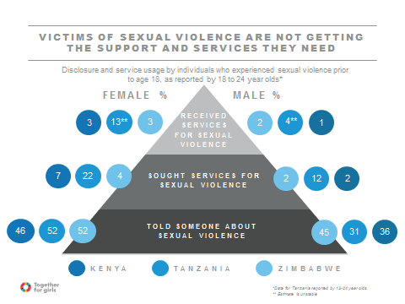

Sources:
CDC, Interuniversity Institute for Research and Development, Comité de Coordination. Violence against Children in Haiti: Findings from a National Survey, 2012. Port-au-Prince, Haiti: Centers for Disease Control and Prevention, 2013

Chiang LF, Kress H, Sumner SA, et al. Injury Prevention 2016;22:i17–i22.

Ministry of Women’s Affairs, UNICEF Cambodia, US Centers for Disease Control and Prevention. Findings from Cambodia’s Violence Against Children Survey 2013. Cambodia: Ministry of Women’s Affairs, 2014.

Ministry of Gender, Children, Disability and Social Welfare of the Republic of Malawi, United Nations Children’s Fund, the Center for Social Research at the University of Malawi, and the Centers for Disease Control and Prevention. Violence Against Children and Young Women in Malawi: Findings from a National Survey, 2013. Lilongwe, Malawi: Government of Malawi, 2014.

National Commission for Mothers and Children, Lao Statistics Bureau and UNICEF Lao PDR. National Violence against Children Survey in Lao PDR. Preliminary Report. Lao PDR: National Commission for Mothers and Children, 2016.

National Population Commission of Nigeria, UNICEF Nigeria, and the U.S. Centers for Disease Control and Prevention. Violence Against Children in Nigeria: Findings from a National Survey, 2014. Abuja,
Nigeria: UNICEF, 2016.

Republic of Zambia. Policy Brief: Zambia Health and Wellbeing (H-WELL) Survey 2014. 2016.

UNICEF Swaziland and CDC. Findings from a National Survey on Violence Against Children in Swaziland. CDC, Atlanta. 2007.

UNICEF Tanzania, CDC, and Muhimbili University of Health and Allied Sciences. Violence against Children in Tanzania: Findings from a National Survey 2009. Dar es Salaam, Tanzania. 2011.

UNICEF Kenya, CDC, and Kenya National Bureau of Statistics. Violence against Children in Kenya: Findings from a 2010 National Survey. Nairobi, Kenya. 2012.

Zimbabwe National Statistics Agency. National Baseline Survey on Life Experiences of Adolescents in Zimbabwe 2011. Preliminary Report. 2012.

Swaziland (girls only), Tanzania, Kenya, Haiti, Cambodia, Malawi, Nigeria, Laos, Zimbabwe, Zambia
Botswana, Rwanda, Uganda, Honduras, Guatemala, El Salvador, Colombia, Mozambique, Cote d’Ivoire, Namibia, Lesotho, Moldova
The VACS in Nigeria and Malawi demonstrated significant associations between experiences of VAC and perpetration of physical and sexual IPV by males; similar links have shown up in numerous studies across Sub-Saharan Africa, Asia-Pacific and LAC.
In Latin America and Moldova, the International Organization for Migration is playing this role.

