To the attention of:

Office of the High Commissioner for Human Rights
United Nations Office at Geneva
CH 1211 Geneva 10
Switzerland
Vienna, 13 December 2016
Ref: 2016-outgoing-001741

Subject: Report on ‘Addressing the impact of multiple and intersecting forms of discrimination and violence in the context of racism, racial discrimination, xenophobia and related intolerance on the full enjoyment of all rights by women and girls’

To whom it may concern,

The European Union Agency for Fundamental Rights (FRA) very much welcomes the opportunity to contribute to the preparation of the abovementioned study, by providing evidence from its research. All the publications mentioned in this submission can be downloaded from the Agency’s website.

FRA published a dedicated report on multiple discrimination drawing from the results of its first European Minorities and Discrimination Survey (EU-MIDIS), the first survey of its kind collecting comparable data on the discrimination and criminal victimisation experiences of selected ethnic minority and immigrant persons resident in the EU. The findings indicate that twice as many ethnic minority/immigrant women compared with ethnic minority/immigrant men experienced discrimination on the basis of gender revealing that minority women are in more vulnerable situation to experience multiple discrimination.

The second wave of this survey, EU-MIDIS II, aims to assess progress made over the last five years and collected similar data from over 25,500 respondents in all 28 EU Member States. The survey includes questions on experiences of discrimination based on different grounds in employment, education, housing, health and when using public or private services, as well as on the extent of reporting such incidents. In addition, the survey gathered data on experiences of crime victimisation (including hate crime) and rights awareness and knowledge of available redress mechanisms. Upcoming reports based on the EU-MIDIS II data will systematically include a gender perspective, including among others a special focus of experiences of Muslim women.

The first report based on EU-MIDIS II results focused specifically on the situation of Roma surveyed in nine EU Member States. The results show that only one in four Roma aged 16 years or older reports ‘employed’ or ‘self-employed’ as their main activity at the time of the survey. Roma women report much lower employment rates than Roma men – 16 % compared with 34 %. Overall, the survey shows paid work rates for Roma aged 20-64 years to be 30 %, which is well below the EU average of 70 % in 2015. The situation of young people is substantially worse: on average, 63 % of Roma aged 16-24 were not employed, in education or training at the time of the survey, compared with the 12 % EU average on the NEET rate for the same age group. For this age group, the results also show a considerable gender gap, with 72 % of young Roma women not employed, in education or training, compared with 55 % of young Roma men.

Furthermore, 28 % of all Roma women surveyed indicate ‘domestic work’ as their main activity, compared with 6 % of all Roma men. This ratio is high for Roma women when compared with women of the general population, which could be explained in terms of expectations of traditional gender roles.

Previously, FRA published two thematic reports based on another FRA large scale survey on Roma conducted in 2011, concerning the experiences of Roma women in particular: Analysis of FRA Roma survey results by gender and Discrimination against and living conditions of Roma women in 11 EU Member States. These reports present statistical records on the situation of Roma women in 11 EU Member States with regard to education, employment, housing, health and other policy areas. The results, among others, show that the average situation of Roma women in core areas of social life is worse than that of Roma men. For example, more Roma men than women (85% and 77 %, respectively) said that they could read or write and more Roma women than men (19 % and 14 %, respectively) said that they had never been to school.

The issue of multiple discrimination affecting women is also addressed in the Agency’s report on Inequalities and multiple discrimination in access to and quality of healthcare. The research explores the nature, context and effects of multiple discrimination due to the interplay of age, sex, ethnicity and disability in the area of healthcare. Among others, the research indicates that young women with a migrant or ethnic minority background are especially at risk of multiple discrimination when it comes to sexual and reproductive care. Examples include sterilisation of Roma women and women with disabilities; and forcing gynaecological examinations on young Muslim women in school settings to check if they have undergone female genital mutilation (FGM).

The evidence suggests that EU Member States should invest efforts in accommodating the needs of women belonging to ethnic minorities who wish to be treated by female healthcare professionals. Data also suggests a need to fund community-based mobile outreach programmes targeting different ethnic communities and groups among them – such as older people, women and persons with disabilities – to promote healthcare and raise awareness of entitlements and available health services; and allocate more time for medical consultations with persons belonging to these groups due to their special needs.

In view of the increasing numbers of refugees, asylum seekers and migrants entering the EU, the Agency has been collecting data about the fundamental rights situation of people arriving in nine Member States that have been particularly affected by large migration movements. A number of particular issues have been addressed, including family tracing and reunification, trafficking, and the situation of children or migrants with disabilities. Two report listed below are of particular relevance to the topic of the study.

A report on Gender-based violence examines the situation of migrant women and girls in four areas: reporting and data collection; identification, referral of cases and training; protection and prevention as well as medical and legal support services. A recent field assessment of risks for refugee and migrant women and girls identified instances of sexual and gender-based violence, including early and forced marriage, transactional sex, domestic violence, rape, sexual harassment and physical assault in the country of origin and during the journey to Europe.

Similarly, a report looking specifically at hate crime against asylum seekers and migrants reveals that women who are visibly Muslim are especially targeted – both for being women and for being Muslim. The paper demonstrates that attacks against Muslim women are reported in a number of countries, for instance, in France 74 % of the 905 Islamophobic acts in 2015 targeted women whereas in the Netherlands out of 158 complaints in 2015, 90 % of victims were women.

Another issue which has been a focus of FRA research addresses forced marriages, defined as a form of domestic violence that violets the right to freely decide whether, when and whom to marry. The report describes the phenomenon of forced marriage, examines selected legislative measures taken to address it in five EU Member States and lists promising practices for the prevention of forced marriage and for supporting victims.

In 2017, in addition to findings from the EU-MIDIS II survey, the Agency will also publish results from its research on social inclusion and migrant participation in society, which provides a comprehensive mapping of relevant law and policy tools on equality, non-discrimination and social inclusion across the EU Member States.
Preliminary analysis show lack of attention to gender related specificities in national integration action plans and strategies as well as lack of gender disaggregation in data collection. That said, the research also collected examples of promising initiatives and activities ensuring the gender dimension in integration policies.
I hope the information provided is useful for the preparation of your study. The Agency remains at your disposal to provide further information if necessary under equality@fra.europa.eu.

With best regards,

Ioannis N. Dimitrakopoulos

Head of Equality & Citizens’ Rights Department
European Union Agency for Fundamental Rights (FRA)

cc: OHCHR Regional Office for Europe
FRA reports addressing, in particular,
multiple and intersection discrimination

FRA product |  | Short description | Languages
 | Thematic focus: Gender-based violence | There is increasing evidence that gender-based violence is a major issue for migrant women and girls. A recent field assessment of risks for refugee and migrant women and girls identified instances of sexual and gender-based violence, including early and forced marriage, transactional sex, domestic violence, rape, sexual harassment and physical assault in the country of origin and during the journey to Europe. | en
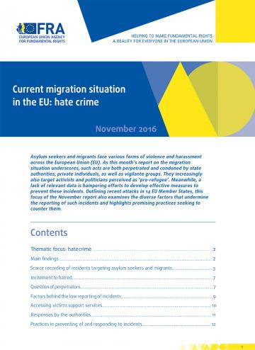 | Current migration situation in the EU: hate crime - November 2016 | Asylum seekers and migrants face various forms of violence and harassment across the European Union (EU). As this month’s report on the migration situation underscores, such acts are both perpetrated and condoned by state authorities, private individuals, as well as vigilante groups. They increasingly also target activists and politicians perceived as ‘pro-refugee’. | en
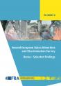 | Second European Union Minorities and Discrimination Survey (EU-MIDIS II) Roma – Selected findings | Some 80% of Roma surveyed live below their country’s at-risk-of-poverty threshold; every third Roma lives in housing without tap water; every third Roma child lives in a household where someone went to bed hungry at least once in the previous month; and 50 % of Roma between the ages of six and 24 do not attend school. This report underscores an unsettling but unavoidable reality: the European Union’s largest ethnic minority continues to face intolerable discrimination and unequal access to vital services. | en
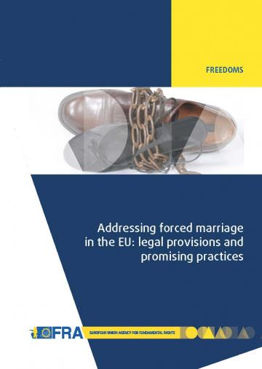 | Addressing Forced marriage in the EU: legal provisions and promising practices | Primarily using data and information collected from five EU Member States, this paper briefly describes the phenomenon of forced marriage and selected legislative measures taken to address it. It lists promising practices for the prevention of forced marriage and for supporting victims. | en
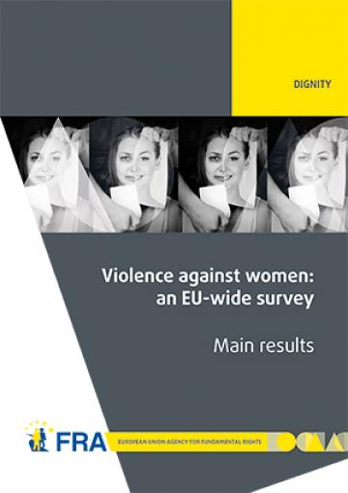 | EU-wide survey on violence against women | This report is based on interviews with 42,000 women across the 28 Member States of the European Union (EU).It shows that violence against women, and specifically gender-based violence that disproportionately affects women, is an extensive human rights abuse that the EU cannot afford to overlook. | en
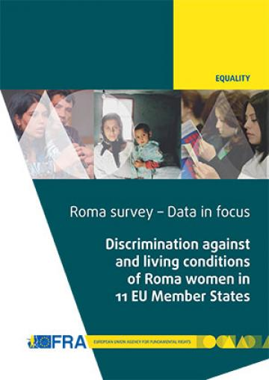 | Discrimination against and living conditions of Roma women in 11 EU Member States | Equality is one of the five values on which the European Union is founded; yet women here face inequalities in many respects. Extreme poverty, exclusion and discrimination burden Roma women even further. The European Union Agency for Fundamental Rights (FRA) researched the situation of Roma women in 11 EU Member States. | de – en – fr
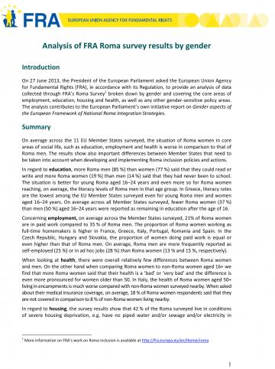 | Analysis of FRA Roma survey results by gender | This paper provides an analysis of data collected through FRA’s Roma Survey broken down by gender and covering the core areas of employment, education, housing and health, as well as any other gender‐sensitive policy areas. | en
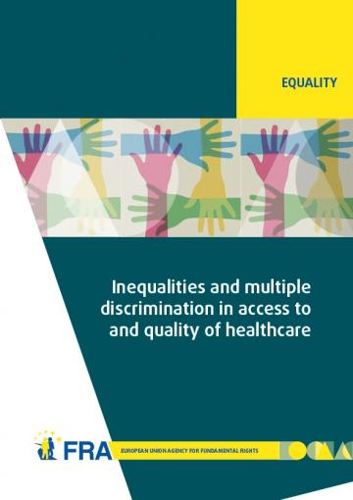 | Inequalities and multiple discrimination in access to and quality of healthcare | Certain people are seen as particularly vulnerable to unequal treatment, because they share a combination of characteristics that may trigger discrimination. A Roma woman sterilised without her informed consent, for example, has suffered discrimination not just because of her sex, as all women do not face this treatment, nor just because she is Roma, as Roma men may not face this treatment. The discriminatory treatment is based specifically on the intersection of her sex and ethnic origin. | en
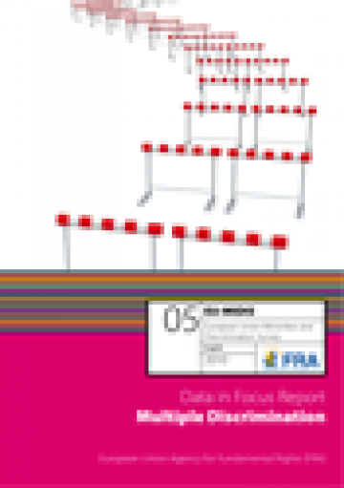 | EU-MIDIS Data in Focus Report 5: Multiple discrimination | The Fundamental Rights Agency publishes its first report on multiple discrimination: EU-MIDIS Data in Focus 5: ‘Multiple Discrimination' which focuses on perceptions of multiple discrimination experiences by respondents of ethnic or immigrant origin, compared with the general population. | de - en - fr

Information on Agency’s activities and reports on racism and related intolerances is available at: http://fra.europa.eu/en/theme/racism-related-intolerances

All publications are available at:
http://fra.europa.eu/en/publications-and-resources

