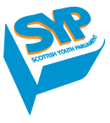
Call for Input: Office of the High Commissioner for Human Rights Study on Youth and Human Rights
Submission from the Scottish Youth Parliament
January 2018
Introduction
The Scottish Youth Parliament (SYP) represents Scotland’s young people. Our vision for Scotland is of a nation that actively listens to and values the meaningful participation of its children and young people. Our goal is to make this vision a reality, in order to ensure Scotland is the best place in the world to grow up.
We are a fundamentally rights-based organisation, and our mission, vision and values are grounded in the United Nations Convention on the Rights of the Child (UNCRC). In particular, our purpose embodies Article 12: that young people have the right to express their views freely and have their opinions listened to in all matters affecting them. As a completely youth-led organisation, the words and sentiment of Article 12 have a profound importance for our work.
Our democratically elected members listen to and recognise the issues that are most important to young people, ensuring that their voices are heard by decision-makers. We exist to provide a national platform for young people to discuss the issues that are important to them, and campaign to effect the change they wish to see.
SYP’s Values are:
- Democracy – We are youth-led and accountable to young people aged 12 to 25. Our democratic structure, and the scale of our engagement across Scotland gives us a mandate that sets us apart from other organisations.
- Rights – We are a fundamentally rights-based organisation. We are passionate about making young people aware of their rights, and ensuring that local and national government deliver policies that allow those rights to be upheld.
- Inclusion – We are committed to being truly inclusive and work tirelessly to ensure the voices of every young person from every community and background in Scotland are heard.
- Political Impartiality – We are independent from all political parties. By working with all stakeholders, groups, and individuals who share our values, we can deliver the policies that are most important to young people.

Our approach
SYP welcomes the opportunity to provide input to the United Nations Office of the High Commissioner for Human Rights’(OHCHR) study on ‘the implementation of human rights with regards to young people, the identification of cases of discrimination against young people in the exercise of their human rights, and best practices in the full and effective enjoyment of human rights by young people’.
This submission is based on SYP’s current national campaign 2017-18 entitled Right Here, Right Now on young people’s rights, and relevant SYP Policy (http://policy.syp.org.uk/) on rights. It is structured around the annexed specification for the OHCHR study, and will highlight rights challenges and examples of discrimination for young people in Scotland (Section 1); policies aimed at supporting young people to realise their rights (Section 2); how youth-led organisations are involved in shaping youth policy in Scotland (Section 3); international measures which would support young people to realise their rights (Section 4); and other issues (Section 5).
As a youth-led organisation, this response has been approved by SYP’s democratically elected Board and Conveners Group. The Board comprises seven young people: a Chair, a Vice Chair, and five Trustees, advised by professional external advisors. The Conveners Group comprises ten young people who take the lead on policy and campaigning at SYP, convening the ten Subject Committees of which every Member of the Scottish Youth Parliament (MSYP) is a member.

Background to our national campaign on young people’s rights: Right Here, Right Now
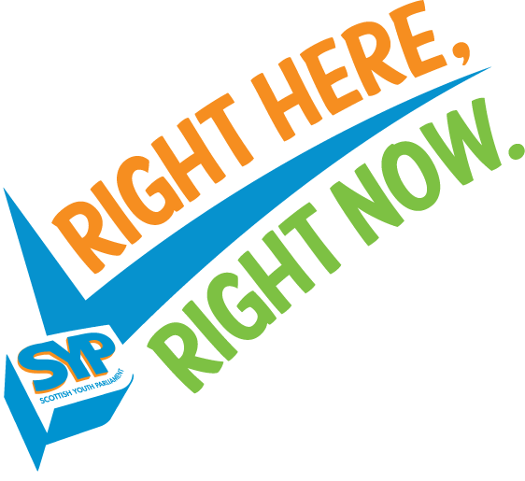
The rights of young people living in Scotland must be upheld, respected, and taken into account by our nation's decision-makers, and the Scottish Youth Parliament's campaign, Right Here, Right Now, seeks to do just that.
Following a consultation with more than 5,000 young people across the nation, Members of the Scottish Youth Parliament (MSYPs) voted at the June 2017 Sitting in West Dunbartonshire to focus all their efforts on the rights of young people in Scotland.
SYP’s 2016-21 youth manifesto, Lead the Way, which received more than 74,744 consultation responses, found that 76% agreed that ‘The United National Convention on the Rights of the Child (UNCRC) should be fully incorporated into Scots law, and the rights of children and young people should be protected and promoted’.
As a result, Right Here, Right Now will work to ensure that Scotland’s young people are aware of and understand their own rights, and are empowered to take action to defend their own rights and those of others. Furthermore, Right Here, Right Now calls for Scotland’s decision-makers to take a human rights based approach to all policy-making, service provision, and planning, ensuring young people’s voices are at the heart of decisions affecting them.
Campaign themes:
The campaign has three main themes: Advocacy, Action, and Awareness.
Advocacy: This is the overarching campaign theme, aiming to influence law, policy, and practice in order to strengthen the protection of young people’s rights.
Action: Focusing on Article 12 of the UNCRC, this theme will seek to strengthen and enhance the status of MSYPs at a local level and within national voluntary organisations, and improve the links SYP has with other institutions, such as the Scottish Parliament.
Awareness: Promoting young people’s rights to young people and those responsible for upholding these rights, and empowering individuals to defend their own rights and the rights of others.
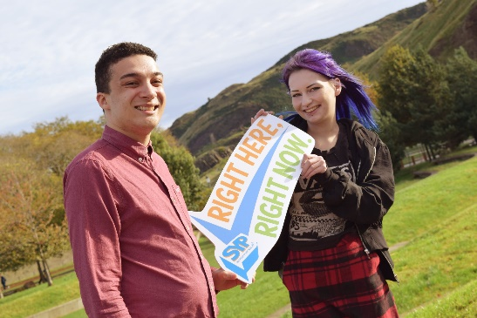
As SYP recognises that the UNCRC only relates to young people under the age of 18, and the charity represents young people up to the age of 25, this campaign will look at rights mechanisms wider than just the UNCRC, including those at international level, and to ensure this older age group is recognised and young people in Scotland are aware of and know how to claim their legally binding rights under the Human Rights Act 1998 and the European Convention on Human Rights.
Amy Lee Fraioli MSYP for Rutherglen & Chair of SYP, with Thomas McEachan MSYP for Glasgow Pollok & Trustee, when the campaign launched in October 2017.

Campaign objectives:
There are four main objectives which Right Here, Right Now plans to achieve by the end of the campaign:
- To influence law, policy, and practice in order to strengthen the protection of young people’s rights.
- To improve links between SYP, public bodies, and national institutions, such as the Scottish Parliament, to respect, protect, and promote young people’s rights.
- To promote young people’s rights, and empower individuals to defend their own rights and those of others.
- To strengthen and enhance the status of MSYPs as the voice of Scotland’s young people at a local level, and to strengthen the role of voluntary organisation MSYPs nationally.
- Challenges faced by young people in Scotland
There are many rights challenges faced by young people in Scotland, and the scope of the related rights advocacy we have been, and are planning on working on as part of our young people’s rights campaign is extensive.
Nevertheless, for the purposes of this study, we have selected from the many some specific challenges faced by young people in Scotland which we are currently focussing on as part of the Right Here, Right Now campaign.

Our UNCRC rights are guiding, not binding
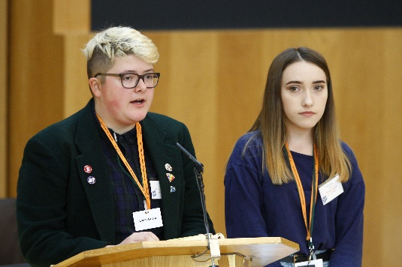
Children and young people's rights are being breached in Scotland. It is now the ‘Year of Young People’ in Scotland, an opportunity for generations to come together and celebrate Scotland’s young people. With this in mind, and for Scotland to truly be the best place to grow up – SYP believes that it is time to incorporate the United Nations Convention on the Rights of the Child (UNCRC) into Scots law Right Here, Right Now, to ensure young people's rights are properly respected, protected and fulfilled.
Zee Timmins MSYP &
Kasha Cepok MSYP, both for LGBT Youth Scotland, speaking at the Scottish Parliament at SYP’s 64th National Sitting in the Debating Chamber on 27-28th October 2018.
UNCRC rights currently guide, not bind, all decision-makers in Scotland. SYP wants to change that, and make UNCRC rights binding, not guiding. Young people in Scotland want UNCRC rights to be legally enforceable in Scottish courts and tribunals. Importantly, incorporation will ensure the early protection of UNCRC rights in policy-making - preventing rights abuses in the first place.
Incorporation will help SYP succeed in achieving its mission to further Article 12 of the UNCRC – for young people to have the right to express their views freely and have their opinions listened to in all matters affecting them. As previously stated, young people are actively calling for incorporation and the need to be heard - in SYP's Lead the Way Manifesto (2016-2021), 76% of 74,744 consultation responses agreed with UNCRC incorporation.
SYP believes that incorporation will bring about a culture of respect for children and young people's rights, as well as a culture of compassion, tolerance, broad-mindedness and equality. Young people will be treated with dignity. It will also ensure UNCRC principles and a human rights based approach (HRBA) apply when laws and policies affecting young people are made in Scotland, and when services are provided. For example, if a local authority wants to create a policy to install anti-loitering devices which indiscriminately target under-25s in public areas ('mosquito' devices), an HRBA would ensure young people are consulted, empowering them to object to this decision, and call on Government to ban them as per its UNCRC and other anti-torture and discrimination obligations.
Incorporation will provide a platform for UNCRC rights to be realised in non-legal ways, such as through rights-based approaches and empowering education and training. This will promote a culture of respect for young people's rights. It's an opportunity for Scotland to really listen to the UN’s reviews of the UK's children and young people's rights record, and put into action its Concluding Observations and General Comments.
Incorporation of the UNCRC could also be a platform for incorporation of economic, social and cultural rights. There is currently a protection gap for economic, social and cultural rights (ESCR) in the UK, such as the right to education, to food and to social security. These rights are mostly aspirations and not reality for many young people across Scotland.
Incorporation of UNCRC will bind the Scottish Government and public bodies to ensure young people up to the age of 18 will have access to all these rights, and more. Incorporation of the UNCRC could also catalyse incorporation of ESCR for young people aged 18-25 and beyond (e.g. incorporation of the International Covenant of ESCR or the European Social Charter).
SYP is calling for incorporation of the UNCRC as a line over which the UK and Scottish governments cannot step when introducing austerity measures. For example, any cuts to services such as health care, education or youth work, which disproportionately violate young people's rights, would be illegal.
SYP believes that if we incorporate the UNCRC into Scots law, Scotland will be a world leader of young people's rights protection on a global stage.

Brexit and young people’s rights
Young people in Scotland are highly concerned that Brexit could weaken the existing human rights framework, as the European Union (EU) Charter of Fundamental Rights, which goes further than the European Convention on Human Rights (ECHR) and the Human Rights Act (HRA) in some ways, is likely to no longer apply in the UK. Under Brexit, the UK Government will make changes to EU citizens’ rights. Rights protection will be less binding as the European Court of Justice may no longer have final say on EU rights.
SYP Policy on Brexit and young people’s rights, based on local consultation within Scotland’s 32 Local Authorities and 11 National Voluntary Organisations, sheds more light on young people’s views in this area:
- The Scottish Youth Parliament believes that the Scottish and UK Parliaments have an obligation under Article 12 of the UNCRC to fully and meaningfully engage with young people in discussions over Scotland’s and the rest of the UK’s future relationship with the European Union. (Committee Motion passed 26th March 2017 - 97% agreement).

- The Scottish Youth Parliament believes that the rights of young people in the workplace should be a priority in Brexit negotiations by both the Scottish and UK Governments, and that these rights should be respected and upheld as a key part of any exit from the EU. (Committee Motion passed 26th March 2017 - 92% agreement).

- The Scottish Youth Parliament believes that, given the UK’s membership of the Council of Europe, the UK should remain party to the European Convention on Human Rights. (Members’ Motion passed 16th October 2017 - 90% agreement).
However, incorporation of the UNCRC could provide an opportunity to strengthen rights which could be lost during the Brexit process, especially economic, social and cultural rights such as fair working conditions. Any further devolution as a result of Brexit (for example, of equalities and of a rights-based immigration regime) would also make incorporation of the UNCRC in Scotland even more relevant.
Through the Advocacy theme of SYP’s Right Here, Right Now national campaign on young people’s rights, SYP are conducting a sideline campaign to defend the rights of young people during the Brexit negotiations.
MSYPs across Scotland:
- Are calling for the incorporation of the UNCRC to act as a shield against Brexit’s impact on rights.
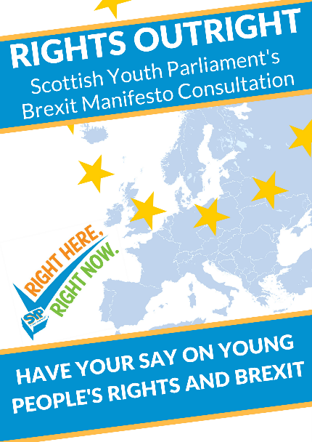
- Are preparing Rights Outright: SYP’s Brexit manifesto – an advocacy tool prepared from a consultation with around 500 young people containing a list of statements on Brexit and young people’s rights (on issues such as cross border family law, climate change, health, free movement, parliamentary scrutiny and political education around Brexit). This will launch in January 2018 and be used by MSYPs to influence their local and national MPs to inform the House of Lords in their review of the EU (Withdrawal) Bill that month.

- Are getting their local authorities and national voluntary organisations to sign up to the Scottish Declaration on Human Rights. This is a statement from civil society calling on Scottish and UK Governments, and the EU, to protect, progress, and not regress rights through Brexit. This will be presented to the House of Lords at the end of January 2018.

- Supported the European Union (Withdrawal) Bill - Amendment NC44 which aimed to implement an independent evaluation of Brexit on the health and social care sector. More than fifty third sector organisations across the UK signed up in support of this amendment, including SYP, however it was voted down in December 2017 at the House of Commons.

- Are signing up to YouthLink Scotland’s #KeepErasmusPlus campaign to keep the Erasmus+ programme post-Brexit in Scotland. SYP is a partner to this campaign, with MSYPs being encouraged to show their support and share positive stories about Erasmus+ experiences.

Period Poverty
Also through the Advocacy theme, to prevent breaches of young people’s rights in Scotland, MSYPs are seeking to persuade MSPs and others to support legislative and policy mechanisms, such as the Proposed Sanitary Products (Free Provision) (Scotland) Bill.
Period Poverty is a violation of human rights, which can particularly affect young people who menstruate. On 26th March 2017, SYP approved the following policy statement with 99% agreement, the highest current percentage of agreement for any SYP policy:
The Scottish Youth Parliament believes that access to menstrual hygiene products is a basic human right, and that more effort should be made to ensure that those in disadvantaged financial situations have access to these products. - Members’ Motion by Suki Wan MSYP for Glasgow Shettleston.
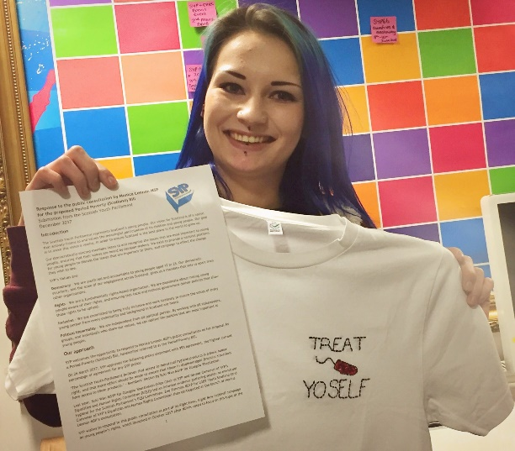
In December 2017, SYP officially responded to Monica Lennon MSP’s public consultation on her proposals for legislation to end period poverty in Scotland, and give everyone who menstruates the ability to access sanitary products when they need them.
Amy Lee Fraioli MSYP for Rutherglen & Chair of SYP, holding SYP’s response to the Period Poverty consultation in December 2017.
SYP’s response was highly informed by a Consultation Workshop on Period Poverty Monica Lennon MSP co-facilitated with Zee Timmins MSYP at our 64th National Sitting at the Scottish Parliament on Friday 27th October 2017. This captured the views of 30 Members of the Scottish Youth Parliament (MSYPs), as well as 81 responses from young people collected prior to the workshop in a ‘PreSYP64 Consultation Survey’, which was designed for MSYPs to capture a wider cross-section of young people’s views across Scotland and represent these at the Sitting and in SYP’s official response.
The proposal is to place a duty on schools, colleges and universities to provide products, for free, to their students, and to also place a duty on Scottish Ministers to create a universal system of free access to sanitary products. This legislation would mean Scotland becomes a world-leader in giving all citizens the right to access sanitary products.
Suki Wan MSYP led an informal evidence gathering session on menstrual hygiene for the Scottish Parliament’s Equalities and Human Rights Committee in early 2017, and Zee Timmins MSYP for LGBT Youth Scotland participated at the launch of the consultation in August 2017. MSYPs across Scotland have been raising the issue locally, such as Cailyn McMahon MSYP for Cowdenbeath who created ‘a presentation for schools, gained the support of other MSYPs, councillors and teaching staff, and is willing to speak to head-teachers, elected members and council officers to further the campaign’. During Rights Week (see page 16), Chloe Carmichael MSYP for East Kilbride and Katie Talent MSYP for Uddingston and Bellshill collected menstrual hygiene products and donated them to their local food banks, and encouraged others to do the same.

Mental health
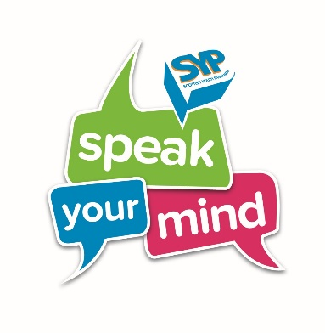
The final challenge SYP would like to raise in the OHCHR’s study is mental health and young people’s rights. SYP discovered through research as part of our previous national campaign Speak Your Mind (2015-17) on this issue that nearly three in four young people do not know what mental health support or services are available locally. We also found that one in five young people in Scotland do not know where to go for support and advice for a mental health problem. These findings are particularly concerning in terms of young people’s rights to life and health, and mental health was described by one respondent as ‘Our Generation’s Epidemic’ - which subsequently became the title of our research report.
SYP made a series of recommendations as part of this report, which collected 1483 responses, in relation to mental health information, services, support and rights. Some rights recommendations included:
NHS Education for Scotland, in partnership with organisations such as the Mental Welfare Commission, should work with young people to develop a booklet and/or online resource about young people’s rights when accessing mental health support. On first accessing mental health support, all young people should be presented with this resource in an accessible form. (Policy Recommendation passed 1st July 2016 and extended by Conveners Group in August 2017).
All GP surgeries and mental health services should clearly display age-appropriate information about young people’s rights when accessing mental health support, particularly regarding confidentiality rights and their right to an independent advocate. (Policy Recommendation passed 1st July 2016 and extended by Conveners Group in August 2017).
Although the Speak Your Mind campaign has now ended, we are still promoting mental health rights through the Right Here, Right Now campaign - with young people still at the heart of influencing the Scottish Government’s Mental Health Strategy. In particular, we managed to secure agreement that Child and Adolescent Mental Health Services (CAMHS) services should be extended from 18-25 years-old.
SYP and the Scottish Government are also working together on the Mental Health Strategy 2017-2027 to improve quality on anticipatory care planning approaches for children and young people leaving the mental health system entirely, and for children and young people transitioning from CAMHS to Adult Mental Health Services. SYP is leading an investigation team of ten young people who are looking into producing a transitions care plan and guidance to support and improve this transition.
However, there is still a lot of work to be done to improve mental health waiting times in Scotland (where almost a fifth of children and young people are waiting longer than 18 weeks to get help for their mental health), to reduce the number of CAMHS rejected referrals (where over one in five young people are rejected) and promote more positive conversations around young people’s mental health.

- Examples of discrimination against young people in the exercise of their rights
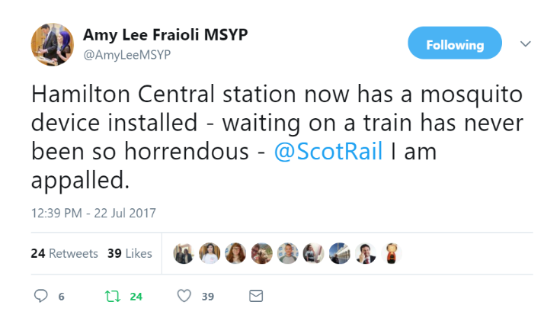
‘Mosquito Devices’
‘Mosquito devices’ emit a highly-irritating, high-pitched sound usually only audible to those under the age of 25, and are frequently used in public spaces to deter young people from gathering. SYP has been campaigning for the removal of these devices for at least 11 years since its policy was introduced: The ‘Mosquito’, a device that makes an unpleasant high-pitched noise that only those under 25 can hear, should be banned. (Change the Picture Manifesto Commitment passed 31st October 2010 and extended twice, mostly recently on 23rd April 2017 – 67% agreement). The Children and Young People’s Commissioner Scotland (CYPCS), Bruce Adamson, has described the use of such devices as a ‘breach of human rights’, and has supported SYP’s call for a ban.
Following our current Chair Amy Lee Fraioli MSYP experiencing these devices in operation at Hamilton Central Train Station in the summer of 2017; MSYPs across the country met with local and national decision-makers to campaign against their use. As reported in Together’s (Scottish Alliance for Children’s Rights) State of Children’s Rights Report 2017, Amy Lee arranged a meeting with Scotland’s national train operator ScotRail’s Managing Director, at which she spoke about her experi ence of encountering the device and urged ScotRail to remove it and any others they currently use. ScotRail has agreed to review their use of mosquito devices. This has resulted in ScotRail issuing a blanket ban on the use of ‘mosquito devices’ at their stations across Scotland.
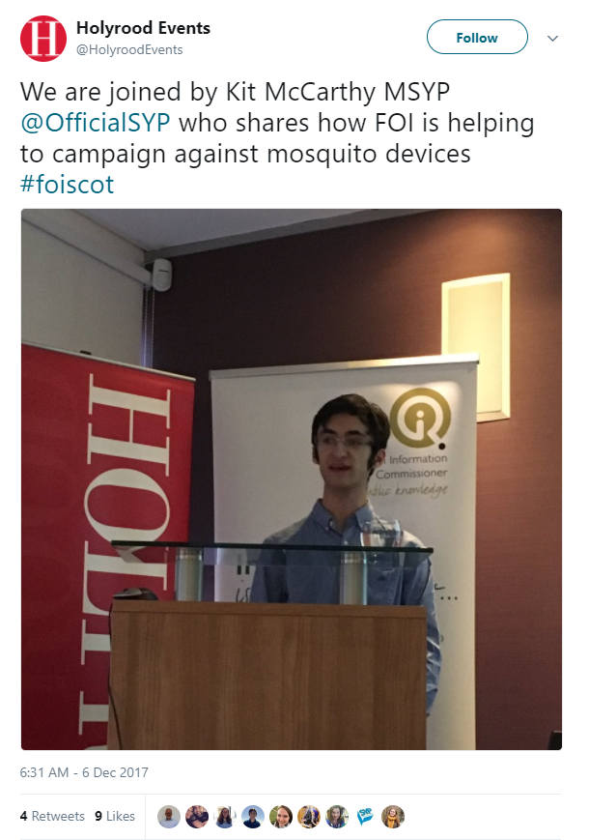
Amy Lee’s tweet about the devices resulted in widespread media coverage of the use of mosquito devices. Consequently, the Minister for Community Safety and Legal Affairs released a statement to make it clear that Scottish Government is opposed to the use of mosquito devices and that local authorities can set a good example by banning the devices on council buildings. The Minister also noted the recommendation made by the UN Committee last year which expressed concerns over how the devices might impact on children and young people’s rights.
Kit McCarthy MSYP for North-East Fife has submitted Freedom of Information (FOI) requests to every local authority in Scotland to find out if any of them are aware of any mosquito devices being used in their area. After discovering that there were devices in operation at Benarty Primary School and Glenrothes High School, Kit McCarthy MSYP enquired into the nature of the devices and how often they were in use. As a result, Fife Council removed the devices from both schools and a device currently in use at Dunfermline bus station will also be removed. Fife Council is considering a Council-wide ban on the devices. Perthshire MSYPs Fraser Macdonald, Robert McCall and Luca Delpippo also managed to influence decision-makers to disconnect mosquito devices at eight schools and institute a ban in their area, including seven primary schools and one high school. SYP and its members are continuing to campaign for an outright ban on all of these devices in Scotland.
Equal Protection
Also through the Advocacy theme of the Right Here, Right Now campaign, to prevent breaches of young people’s rights in Scotland, MSYPs are seeking to persuade MSPs and others to support legislative and policy mechanisms, such as the Children (Equal Protection from Assault) (Scotland) Bill.
SYP believes that children and young people deserve the same protection from assault as adults, by removing the defence of ‘justified assault’ in Scots law. Physical punishment is a violation of children and young people’s rights, as has been identified repeatedly by the UN human rights committees, the Council of Europe and the EU. It breaches Scotland’s human rights obligations, and goes against the Getting It Right for Every Child policy.
One of our Lead the Way (2016-2021) Manifesto Commitments is: All physical assault against children should be illegal. (82% agreement).
Scotland cannot be regarded as the best place to grow up when our law gives children and young people less protection from assault than anybody else in society. We think they merit equal, if not greater, protection from assault. It is discriminatory, and only by changing the law can children and young people have the same legal rights and protection from assault as adults.
Research shows that changing the law will:
- Reduce child abuse, improve mental health, shape public attitudes, and reflect society’s declining support and use of physical punishment.
- Bring Scotland in line with its international human rights obligations.
- Allow Scotland to catch-up internationally as one of only four European Union member states which still permits the physical punishment of children.
- Send out a clear message that our society does not tolerate violence, and that we treat each other with dignity and respect.
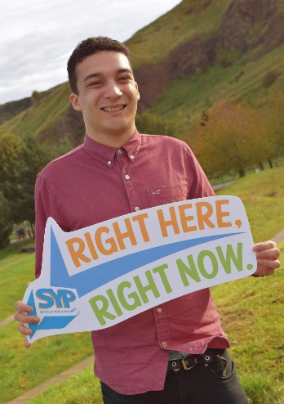
SYP fully supported John Finnie MSP’s proposed Children (Equal Protection from Assault) (Scotland) Bill, by MSYPs responding widely to and sharing the public consultation over the summer of 2017. SYP also submitted an official response to the consultation.
Thomas McEachan MSYP for Glasgow Pollok was a keynote speaker at the launch of the consultation and a seminar on Equal Protection organised by leading campaigners on the issue, including (Children 1st, Barnardo’s Scotland, NSPCC Scotland, and Children & Young People’s Commissioner Scotland). MSYPs are also raising the issue of equal protection in their local work.
SYP welcomes the fact that the Scottish Government have announced in October 2017 in their Programme for Government that they will support the Bill proposal and ensure it becomes law – but MSYPs will continue campaigning until this actually happens.

Prejudice-based Bullying and Hate Crime
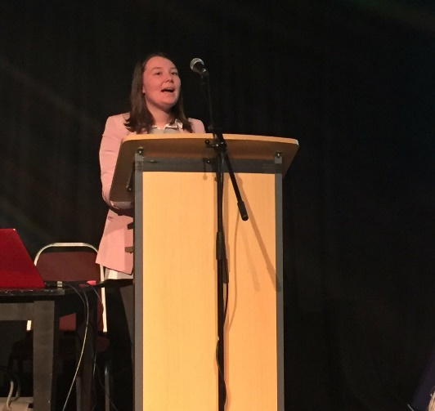
Young people in Scotland are highly concerned about, and working to eradicate, many different forms of bullying and discrimination, such as: gender-based violence, violence against women and girls, sexism, gender-based discrimination, disability discrimination and hate crime, racial and religious discrimination and homophobic bullying.
This is clear from relevant SYP Policy on the issue:
- Action should be taken to tackle gender-based violence, violence against women and girls, sexism, and gender-based discrimination. (Lead the Way Manifesto Commitment passed on 12th March 2016 – 90% agreement).
Madeleine Brown MSYP for Girlguiding Scotland & Convener of the Culture and Media Committee speaking about the Right Here, Right Now campaign at the RespectMe Anti-Bullying Week Practice Exchange Event on Monday 13th November 2017.

- SYP opposes any form of discrimination against people as a result
of their disability, and supports initiatives that tackle disability
hate crime. (Policy statement – 13th March 2016 – 94% agreement).

- SYP also believes that action should be taken to tackle all forms of racial (90%) and religious (83%) discrimination. (Lead the Way Manifesto Commitment passed on 12th March 2016 – 90% agreement).

- There should be increased LGBTI+ education and information in all schools to reduce stigma and homophobic bullying (Change the Picture Manifesto Commitment passed on 31st October 2010 – 71% agreement).
SYP’s last campaign on young people’s mental health, Speak Your Mind, hosted a Discussion Day with the Scottish Government to influence its mental health strategy, and young people told us that bullying has a significant impact on mental health and that they should be tackled together. The impacts of bullying are also exacerbated for young people who experience more than one form of discrimination – intersectional bullying or multiple discrimination.
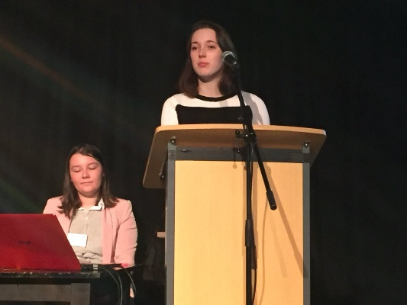
Through our campaign Right Here, Right Now, we think it’s important that young people are aware of and able to understand their own rights, and are empowered through human rights education. This kind of education can give young people the knowledge, skills and behaviours needed to tackle the prejudice and discrimination at the root of bullying, not to be bystanders, and it would promote a wider culture of tolerance, equality and respect.
Cailyn McMahon MSYP for Cowdenbeath & Deputy Convener of the Equalities and Human Rights Committee speaking about the SYP and Scottish Parliament committee work on prejudice-based bullying at the RespectMe Anti-Bullying Week Practice Exchange Event on Monday 13th November 2017.
A holistic, youth-led approach is key to tackling bullying. Young people’s voices need to be at the heart of any conversation to eradicate bullying, to ensure the measures to combat it work for them.
Lastly, youth participation is also key when tacking bullying. Approaches should fulfil Article 12 UNCRC. For example, at a national level, it is imperative that the Scottish Government get young people involved in the review of personal, social and health education. At a local level, co-design and co-production of sessions on bullying in schools and youth groups etc. will ensure they address particular issues affecting young people such as mental health, sexism, consent and healthy relationships, racism and homophobia, biphobia and transphobia.
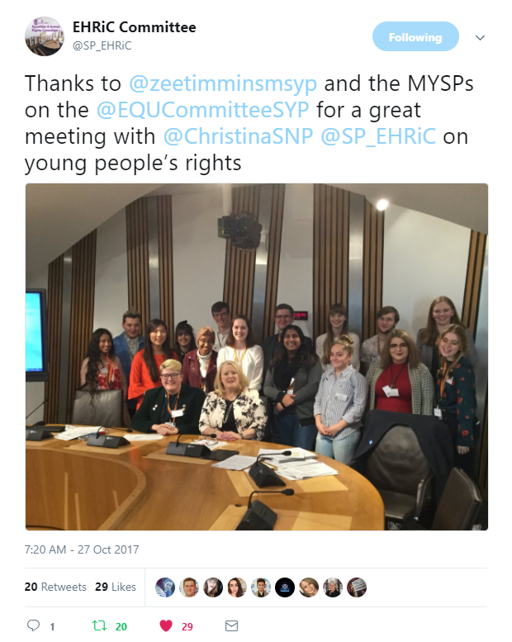
In October 2017, at the 64th National Sitting of the Scottish Youth Parliament at the Scottish Parliament, SYP’s Equalities and Human Rights Committee held a joint committee session with their equivalent Scottish Parliament Equalities and Human Rights Committee, where the common priority of prejudice-based bullying and joint working approaches were discussed. Work which followed included a statement SYP submitted to inform an Education and Skills Committee and Equalities and Human Rights Committee joint parliamentary debate on prejudice-based bullying in schools on 15th November 2017:
Young people have the right to be safe, heard and healthy at school and free from discrimination. Prejudice-based bullying is a breach of young people’s rights. Through their new national campaign on young people’s rights called Right Here, Right Now; the Scottish Youth Parliament calls for a youth-led, rights-based approach to tackling bullying in school. For example, 76% of our membership think there should be increased LGBT+ education in all schools to reduce stigma and homophobic bullying.
Bullying must be tackled through education and training on rights and all types of prejudice-based bullying, ensuring young people and those responsible for upholding their rights are aware of, and able to defend, their rights and those of others.
In November 2017, the Scottish Parliament Committee’s Equalities and Human Rights Committee formally agreed to refer the findings and recommendations of its inquiry on prejudice-based bullying and the harassment of children and young people to the Independent Review of Hate Crimes Legislation being undertaken by Lord Bracadale. The Committee also endorsed a draft submission from the Scottish Youth Parliament’s Equalities and Human Rights Committee to the Hate Crimes Review. The Committee submitted both its report and the Scottish Youth Parliament’s submission to the Hate Crimes Review as a joint submission.

Votes at 16
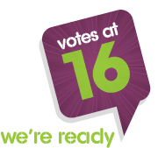
The voting age should be lowered to 16 for all elections and referendums in Scotland, the UK, and Europe. – (Lead the Way Manifesto Commitment passed 12th March 2016 – 70% agreement).
While we are delighted that, as a result of our tireless campaigning for our past campaign Votes at 16 (2012-13), 16 and 17-year-olds enjoyed their right to vote in Scottish Parliament and local government elections, as well as the Scottish independence referendum, we regret that this franchise has not been extended to all 16 and 17-year-olds across the UK, in particular for the UK European Union membership referendum on 23rd June 2016 and the General Election on 8th June 2017. Unfortunately, the proceedings for Jim McMahon MP’s Private Members’ Bill, the Representation of the People (Young People's Enfranchisement and Education) Bill, which would have extended the vote to 16 and 17-year-olds, were short of time for it to complete its Second Reading in November 2017.
We have accordingly renewed our call for ‘Votes at 16’, as our own election turnout – over 80,000 votes – is irrefutable proof of the fact that young people are currently more engaged in the democratic process than ever. We really need the backing of key political decision-makers to make sure that 16 and 17-year-olds are given the right to vote in future elections - so that they can exercise their right to participate and have their say in decisions which will affect the rest of their lives.

  - Policies and programmes aimed at supporting young people to realise their rights

SYP’s Right Here, Right Now campaign is specifically aimed at working to ensure that Scotland’s young people are aware of and understand their own rights, and are empowered to take action to defend their own rights and those of others. SYP was very much inspired by the Universal Declaration on Human Rights Education and Training on education about, for and through human rights.

MSYPs received an Activity Pack for the campaign linking them to various national and international resources and activity ideas on young people’s rights. Relevant activities include:

- Co-design and delivery of a series of engagement workshops, and associated resources, launching January 2017. MSYPs are being training to support them to deliver these campaign workshops locally.
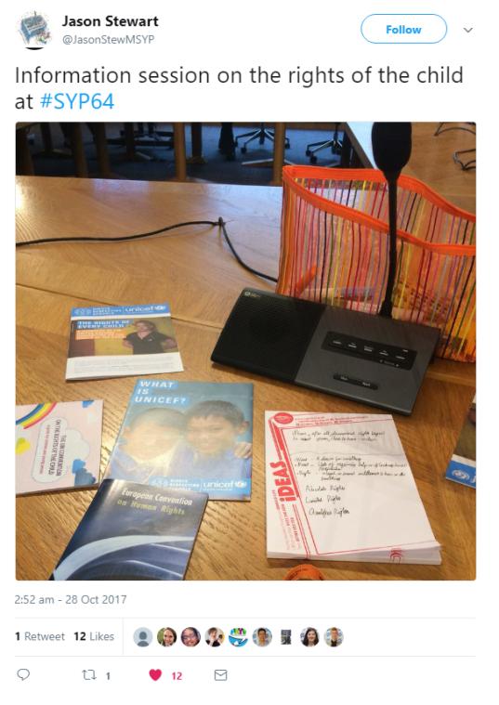
- All MSYPs received training at the 64th National Sitting at the Scottish Parliament on 27-28th October 2017 on ‘an introduction to young people’s rights’ - developed by Unicef UK, and delivered by staff from Unicef UK and SYP. They each received a copy of the UNCRC and the ECHR.

- MSYPs will receive further interactive, experiential training on the HRA and the ECHR at the 65th National Sitting in North Ayrshire on 3rd-4th March 2018. These sessions will help MSYPs articulate their legally binding rights, know how to claim them, and also encourage others to do so.

- SYP has also been working with UNICEF to promote its Rights Respecting Schools Award, with Right Here, Right Now being kindly supported and promoted by UNICEF colleagues.

- To celebrate Human Rights Day 2017, and to promote Right Here, Right Now, SYP ran a ‘Rights Week’ – a national week of action taking place from Sunday 3rd December 2017, ending on Human Rights Day (Sunday 10th December 2017).

During Rights Week, MSYPs, young people, and other brilliant rights defenders got involved by meeting with decision-makers, speaking to schools and youth groups, consulting young people for Rights Outright: SYP’s Brexit manifesto, signing up to our campaign Thunderclap which received 557 supporters and 981,790 social reach by Human Rights Day; collecting food and sanitary products for local food banks; attending events; making videos; writing blog posts; and, of course, taking to social media to shout about young people’s rights.

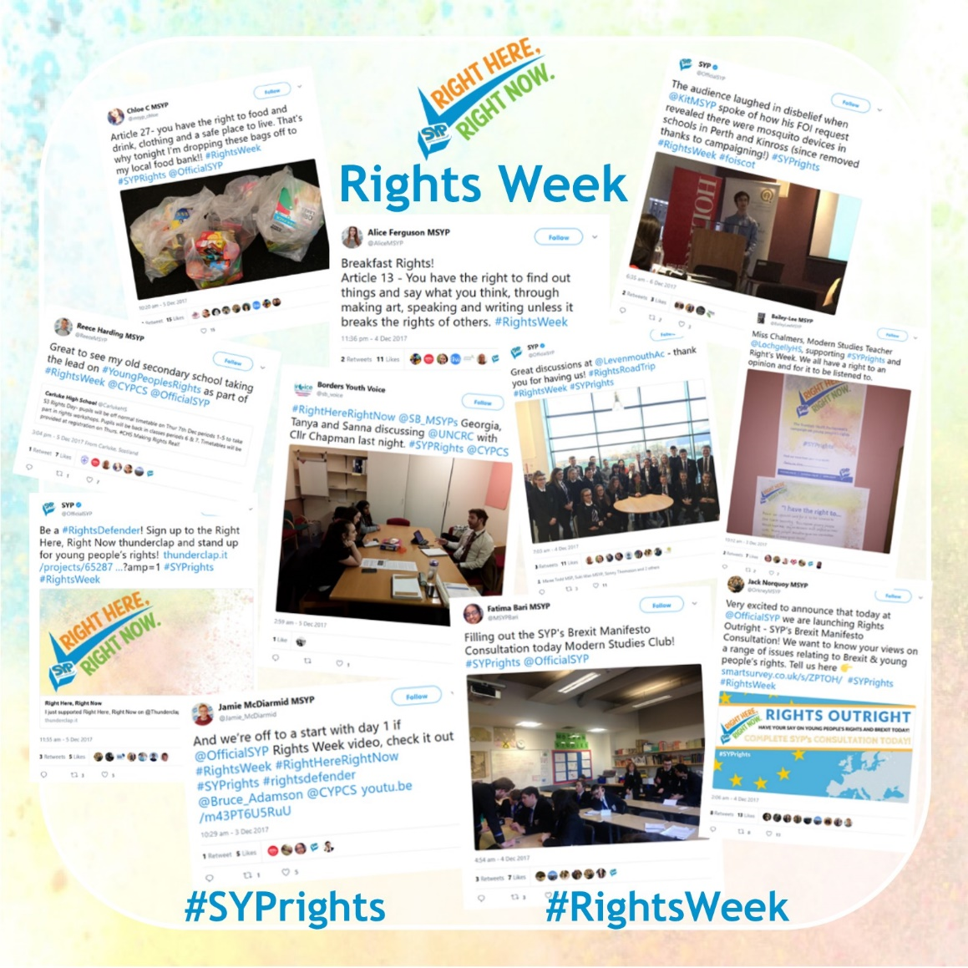

  - How SYP is involved in developing, implementing, monitoring and/or evaluating policies and programmes on youth in Scotland

As described in page 1 of this response, SYP exists to provide young people with a national platform to campaign for the change they wish to see. SYP supports young people to take part in local and national advocacy, campaigning and specific projects and engagement sessions and has recently influenced policy on issues such as mental health (see page 8) and young people’s rights.

In particular, Right Here, Right Now calls for Scotland’s decision-makers to take a human rights based approach to all policy-making, service provision, and planning, ensuring young people’s voices are at the heart of decisions affecting them. The Action theme of the campaign focusses on Article 12 of the UNCRC, seeking to strengthen and enhance the status of MSYPs at a local level and within national voluntary organisations, and improve the links SYP has with other institutions, such as the Scottish Parliament. Relevant activities include:

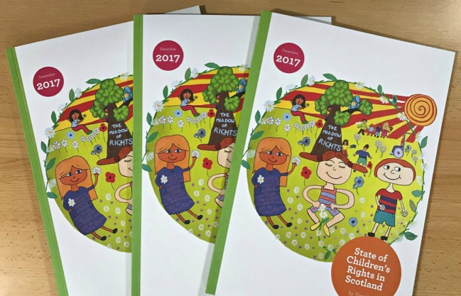
- Calling for a rights-based approach to local and national decision-making, service provision, and planning, using best practice case studies. SYP is partnering with Together, an alliance of Scottish children's charities that works to improve the awareness, understanding and implementation of the UNCRC, to share the 2017 State of Children’s Rights Report with local decision-makers, to discuss the report and the human rights based approach, and calling on them to make a #RightsResolution, committing to take action to embed children and young people’s rights in their area. This will take place on social media from Monday 15th January 2018 (the anniversary of UNCRC coming into force in the UK).

- The aforementioned joint committee sessions which were held at SYP’s 64th National Sitting.

- The joint committee response to the hate crime review (see page 13).

- Further joint work with the Scottish Parliament committees.

Furthermore, the reporting requirement on Scottish Ministers under the Children and Young People (Scotland) Act (CYP[S])A) places a statutory duty on Scottish Ministers to consider steps which could be taken to further the UNCRC, to raise awareness and understanding about children and young people’s rights, and to take the views of children and young people into account. They also have to report to the Scottish Parliament every three years on any changes made to the implementation of the UNCRC in Scotland and what they plan to do in the next three years.
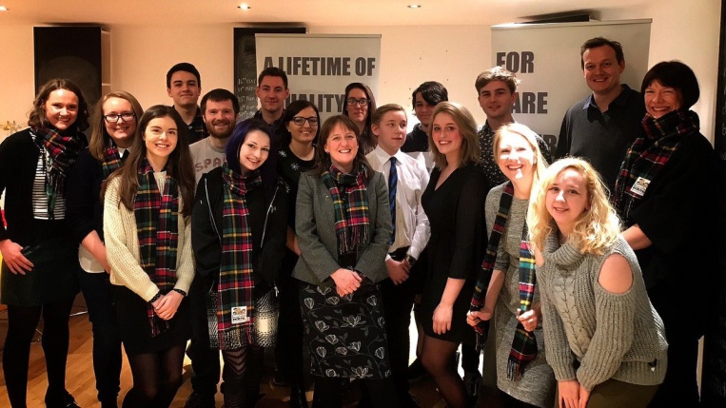
SYP is calling for the 2018 report to be called a: 'Children and Young People' s Rights National Action Plan' (CYPRNAP). This will set out ambitious goals to stop young people's rights being breached in Scotland. For example, it could set out plans for how to ensure disabled young people can fully realise their right to education.
Through Right Here, Right Now, SYP is calling for young people’s voices to be at the heart of the CYPRNAP. It is influencing this policy process in two ways, with the Scottish Government, Together and the CYPCS’ support:
The Rights Road Trip stop in Glasgow at Who Cares? Scotland with the Minister Maree Todd MSP and corporate parent, to listen to care experienced children and young people talk about their experience of rights. at Levenmouth Academy in Fife with the Minister Maree Todd MSP to hear directly from secondary school pupils about their rights.

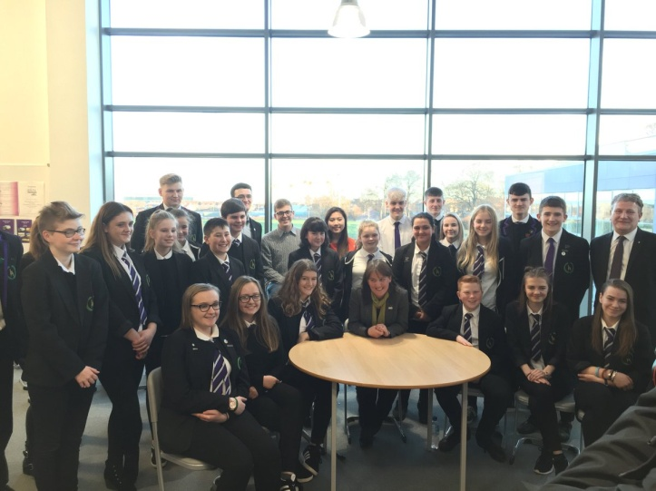
1) Rights Road Trip – two events took place on Monday 4th December 2017 (led by SYP), and on Friday 15th December 2017 (led by Together). Each day was attended by three representatives of the SYP Board and Maree Todd MSP, Minister for Childcare and Early years. During the road trip, participants visited groups working with young people in Fife (4th December) and Glasgow (15th December) to identify their views on young people’s rights. The findings from these visits will inform the draft CYP(S)A report.

2) SYP Rights Review – SYP staff are currently developing the plans for this event with the Scottish Government. It will invite MSYPs to present to decision-makers on young people’s rights in their area/organisation, using a briefing on the Government’s draft report and human rights, and basing their presentations on consultation with their constituents.
The Rights Road Trip stop at Levenmouth Academy in Fife with the Minister Maree Todd MSP to hear directly from secondary school pupils about their rights.

SYP was inspired by the United Nation’s Universal Periodic Review (UPR) process. With the SYP Rights Review, MSYPs from all local authorities and voluntary organisations across Scotland will review the young people’s rights record of Scotland, making a series of recommendations to Scottish Ministers to influence their 2018 report. This will ensure it is as reflective as possible of young people’s rights issues, as captured by MSYPs across Scotland, and is as ambitious as possible.

When influencing the policy-making process or running youth engagement and participation projects, SYP endeavours to ensure participation with young people is meaningful, following the CYPCS’ seven golden rules for participation.

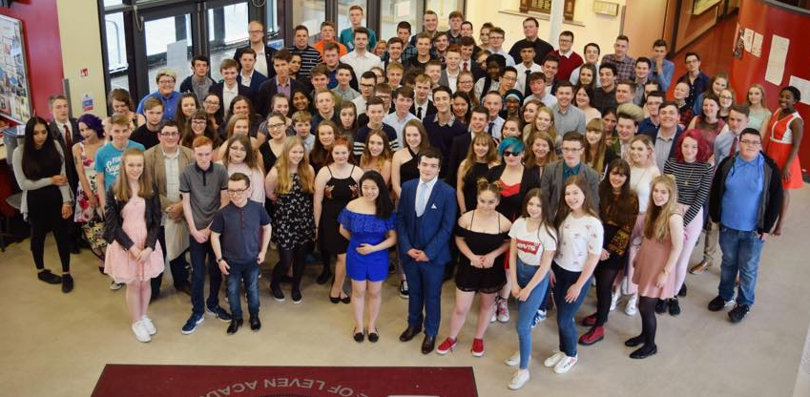

The full SYP membership at the 63rd National Sitting and AGM at Vale of Leven Academy in West Dunbartonshire (24th-25th June 2017).

5. What measures at international level would facilitate/support the realisation of young people’s rights

At international level, SYP would welcome the following measures of support to help young people in Scotland realise their rights:

- Offers of technical support and expertise from international organisations to help Scottish decision-makers implement SYP and others’ calls for the incorporation of the UNCRC, and calls for an ambitious Children and Young People’s Rights National Action Plan.

- Further advice on how to influence and participate in national action plans, and effectively call for a human rights based approach to policy-making, service provision and planning.

- International cooperation in relation to Brexit and young people’s rights, to ensure that human rights are protected, progressed and not regressed during the Brexit process.

- Enhanced opportunities for young people to feed into international human rights monitoring processes. An excellent example of this was when the Children and Young People’s Commissioner Scotland invited SYP and Together to host a visit from Ms Amal Aldoseri, Vice-chairperson of the Committee on the Rights of the Child, to listen to the voices, views and experiences of children and young people here in Scotland. The findings informed the Fifth Periodic Report to the UN Committee on the Rights of the Child from the UK Government.

- MSYPs currently represent the views of all young people in their constituencies, and ensure those views are accounted for at a national, local and community level. SYP would like to learn of any international funding opportunities to facilitate the sharing of these views at international level, or to facilitate the mutual sharing of good practices with other countries’ youth parliaments.

- In summation, support at international level for our Right Here, Right Now campaign on young people’s rights would be highly appreciated by all our MSYPs, whether via. social media or other means. Please follow @OfficialSYP and #SYPrights for our work.

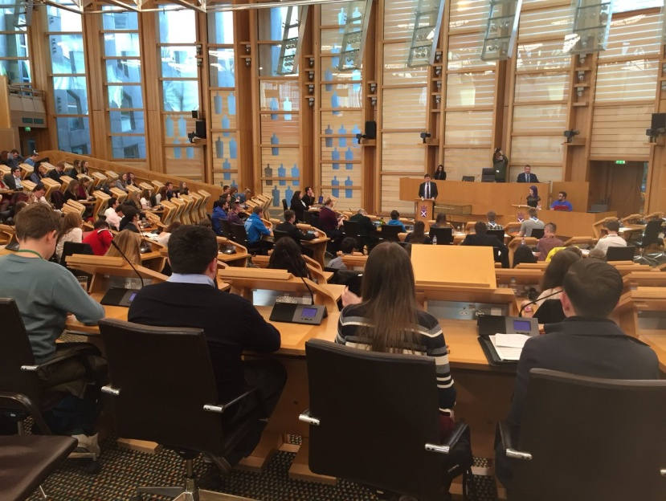

The full SYP membership at the 64rd National Sitting at the Scottish Parliament (27th-28th October 2017) – where the Presiding Officer Ken MacIntosh MSP co-chairs for the first time ever with Amy Lee Fraioli MSYP.
6. Other issues

- SYP, and Amy Lee Fraioli MSYP for Rutherglen and Chair of SYP in particular, are very much looking forward to the proposed UN Committee on the Rights of the Child Day of General Discussion (DGD) on 'Children as Human Rights Defenders'. Amy Lee is excited to be part of the sub-team on content and to carry on helping to plan this event to champion children and young people as rights defenders – holding decision-makers to account for their rights obligations.
- SYP’s Policy Log is available at: http://bit.ly/2CRj7V7.

- Our Lead the Way Manifesto (2016-2021) received 74,744 consultation responses from young people all over Scotland and provides SYP with an incredible mandate to represent the views of young people. It is available at: http://bit.ly/1RhENsA.

- SYP’s current census is available at: http://bit.ly/2xYYiV6.

Conclusion

SYP hopes that the above examples of youth-led participation, advocacy and influence in policy-making as related to young people’s rights implementation and realisation provide a valuable contribution to the OHCHR’s study. We would very much appreciate the OHCHR’s support for the Right Here, Right Now campaign.

Should you require any further detail to the information in this submission, please do not hesitate to contact SYP. We look forward to reading the final report from the High Commissioner when submitted to the Human Rights Council before its thirty-ninth session in September 2018.

Contact

Laura Pasternak
Public Affairs Officer
laura.p@syp.org.uk
0131 524 0818
Visit us: www.syp.org.uk
Follow us on Twitter: @OfficialSYP
Annex – Specification of the OHCHR Study

‘Human Rights Council Resolution 35/14 on youth and human rights, requests the Office of the High Commissioner for Human Rights to conduct a detailed study on the implementation of human rights with regard to young people, the identification of cases of discrimination against young people in the exercise of their human rights, and best practices in the full and effective enjoyment of human rights by young people, highlighting the contribution of empowered youth to the realization of human rights in society, to be submitted to the Council prior to its thirty-ninth session.
The Office of the United Nations High Commissioner for Human Rights would be grateful to receive any relevant information for the preparation of this report. In particular:
- Challenges faced by young people in your country;
- Examples of discrimination against young people in the exercise of their rights;
- Are you aware of policies and programmes aimed at supporting young people to realise their rights? If so, please describe them;
- How are youth organisations or youth-led structures involved in developing, implementing, monitoring and/or evaluating policies and programmes on youth in your country?;
- What measures at international level would facilitate/support the realisation of young people’s rights;
- Any other issue you would like to share with OHCHR.
Information should be sent to Imma Guerras-Delgado, Office of the United Nations High Commissioner for Human Rights (e-mail: registry@ohchr.org, cc: iguerras-delgado@ohchr.org) by 12th January 2018 at the latest. The information provided will be made available on the OHCHR website.’

Study being conducted as per Human Rights Council Resolution 35/14 on youth and human rights.
See Conveners Trustee Jack Dudgeon MSYP for Eastwood’s speech from the week of the campaign launch in October 2017 here: http://bit.ly/2CT0nEZ.
SYP, ‘Right Here, Right Now’, available at: http://bit.ly/2B34VrI.
Year of Young People 2018, available at: http://bit.ly/2zTRexT.
SCVO, HRCS, SHRC and EHRC, ‘Scottish Declaration on Human Rights’, available at: http://bit.ly/2CPoMeD.
YouthLink Scotland, ‘Keep Erasmus+’, available at: http://bit.ly/2BcPjEm.
SYP’s response to the Proposed Sanitary Products (Free Provision) (Scotland) Bill; (December 2017); available at: http://bit.ly/2CZkHs7.
Central Fife Times, ‘Council to back campaign to end period poverty after move by chair of Area Committee’, (13th October 2017), available at: http://bit.ly/2gzZ6c9.
SYP, ‘Speak Your Mind’, available at: http://bit.ly/2D2jG1D.
SYP, ‘Our Generation’s Epidemic’, (July 2016), available at: http://bit.ly/29vx9MF.
Ibid.
The Scottish Government, ‘A Nation with Ambition: The Government’s Programme for Scotland 2017-18’, available at: http://bit.ly/2eZDh5E.
SAMH, ‘Scottish Government urged to review CAMHS’, (Tuesday 7th March 2017), available at: http://bit.ly/2FpolZU.
See SAMH’s consultation for the Scottish Government’s audit on rejected CAMHS referrals at: http://bit.ly/2jYZEcY.
Together, ‘State of Children’s Rights Report 2017’, (December 2017), p.33, available at: http://bit.ly/2mk9Uhc.
Ibid.
Ibid.
Ibid.
Equal Protection: NSPCC Scotland, Children 1st, Barnardo’s Scotland and the CYPCS, ‘Equally Protect’, (November 2015), available at: http://bit.ly/2w9asuh; and Together, ‘Equal Protection from Assault for Children Briefing’, (July 2017), available at: http://bit.ly/2tyWSBb.
SYP’s response to the Children (Equal Protection from Assault) (Scotland) Bill; (August 2017); available at: http://bit.ly/2w9asuh.
The Scottish Parliament’s Equalities and Human Rights Committee, (14th November 2017), available at: http://bit.ly/2mrXSD8.
The Scottish Parliament’s Equalities and Human Rights Committee, ‘Minutes: 28th Meeting, 2017 (Session 5)’, (23rd November 2017), available at: http://bit.ly/2D1fIGw.
The Scottish Parliament’s Equalities and Human Rights Committee and the Scottish Youth Parliament’s Equalities and Human Rights Committee, ‘Joint submission to the Independent Review of Hate Crimes Legislation’, (November 2017), available at: http://bit.ly/2mpczam.
SYP, ‘Votes at 16’, available at: http://bit.ly/2DkSCIZ.
In particular, Article 2.
Unicef UK, ‘Rights Respecting School’
The Thunderclap made the following statement: ‘I support the Scottish Youth Parliament's campaign “Right Here, Right Now”! Will you? #SYPrights #rightsdefender’ (10th December 2017), available at: http://thndr.me/KrC7CA.
For example, see Helen Johnson MSYP (for Who Cares? Scotland)’s blog post at: http://bit.ly/2A4APHl.
This is with a view to implement the Commission on Parliamentary Reform’s recommendations R71 and R72 for closer working between MSYPs and MSPs, and SYP Committees and Scottish Parliament Committees, available at: http://bit.ly/2xnb6oY.
CYPCS, ‘CYPCS’ 7 golden rules for participation’, available at: http://bit.ly/2DkfFDz.
CYPCS, SYP & Together, ‘UN Taskforce on the Rights of the Child visit Scotland’ (2nd-3rd September 2015), available at: http://bit.ly/2yzGX6D.

