- Challenges faced by young people in your country
Young people between the age of 15 and 29 years represent 15,5 % of Slovenian population, while the projections forecast nearly 1 % decrease (to 14,8 %) of the young population by the year 2030. A country that fails to recognize the needs and aspirations of youth through its development policies and programs would pay a multi-dimensional and long-lasting high cost. Investment in youth strongly impacts the present and contributes to our common future.
Overview: The Key Challenges of Youth in Slovenia

 | 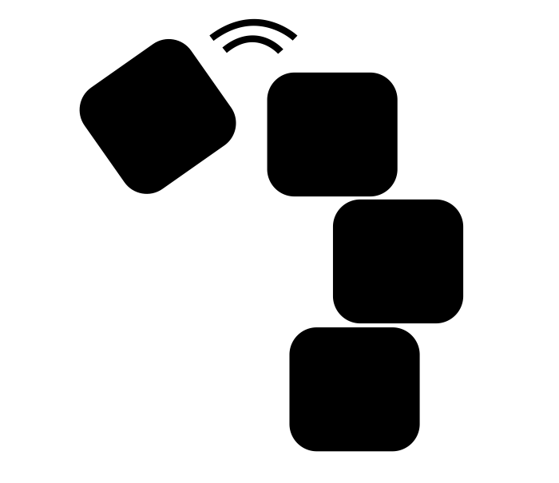 | 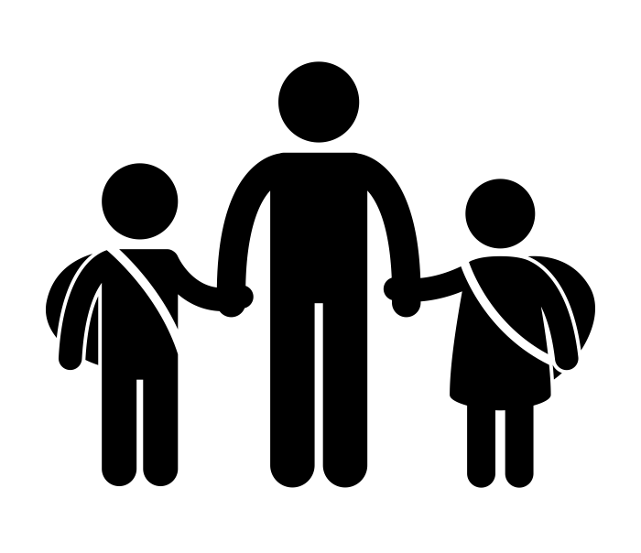 | 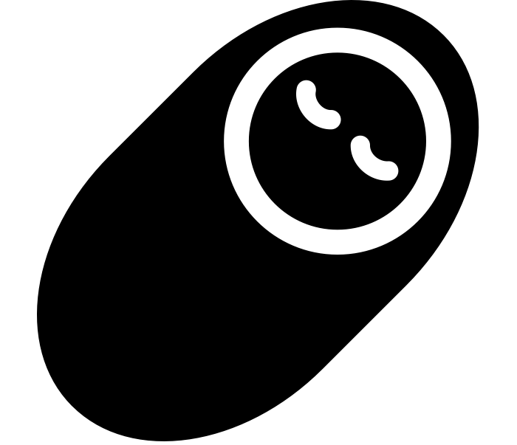 | 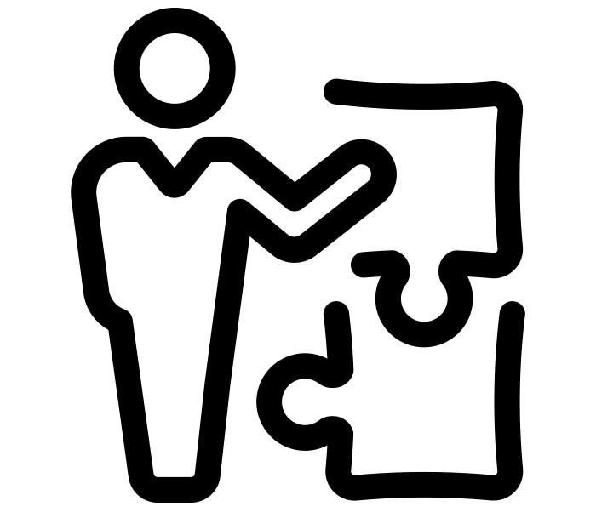
Structural unemployment | Unstable employment | Delayed transition to adulthood | Low fertility and aging population | Lack of skills and competencies that employers seek

Overview: The Key Strengths of Youth in Slovenia

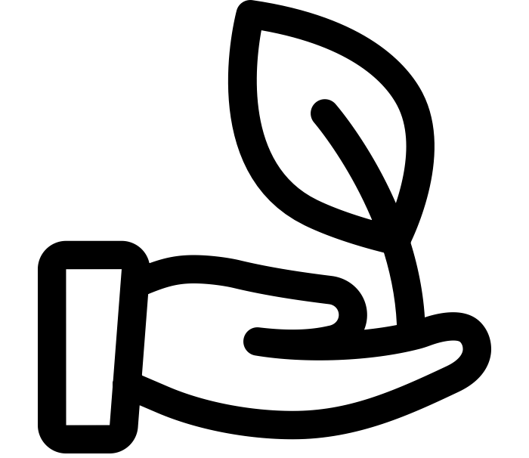 |  | 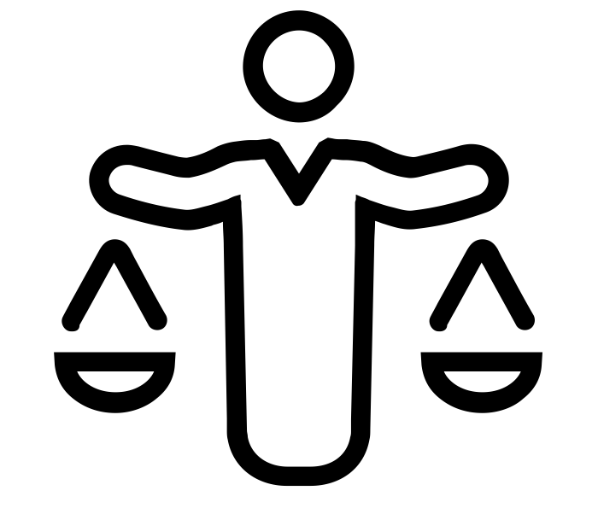 |  | 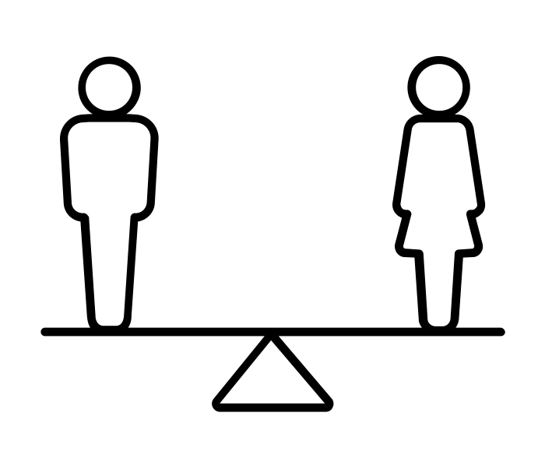
Awareness of global citizenship and active volunteering | Well-recognized youth sector and state support | Participation of youth in decision-making | Highly educated population | High level of gender equality

- Examples of discrimination against young people in the exercise of their rights
Accommodation and Housing
Resolution on the National Housing Programme 2015-2025 has been adopted in 2015 and Action Plan 2015-2025, which is why it was expected to see the reforms in the Housing Act, too. Non-profit housing rent is of crucial importance for youth in Slovenia, since the employment is of precarious nature and therefore limits the ability of young people to access profitable rents or purchase their own housing.
Young Women and Employment
Young women often face discrimination in the job market, where the employers favour young male employees – indicated reasoning is in potential motherhood, family planning and maternity leave. Young women therefore face obstacles when accessing job market, which also resulted in higher unemployment rates among females in comparison to males. In addition, family creation is delayed (while women decided for the first child on average at the age of 23 in 1970, they have their first child on average at the age of 29).
Although the legislation against discrimination is in place, labour legislation is often violated through latent practices. Young women are asked about their marital status, number of children, family planning in the job interviews. There are indicated cases of women whose contract was suspended preliminary due to announced motherhood, maternity leave or child care.
Unpaid internships
The Government of Slovenia promised to take a decisive step in preventing unpaid internships with a reform of the Civil Servants Act back in 2015, which has not taken place. Voluntary and unpaid internships are unacceptable and prevent young people from becoming autonomous and independent.
Voluntary internships should be prohibited by law, but a support system should follow, establishing a long-term commitment for financing of paid internships and construction of a nation-wide system of quality trainings.
In June 2015 the Government prepared an analytical document Analysis of internships in the Republic of Slovenia, which lacked any concrete steps and solutions in the future. Up until today, there has been no visible steps undertaken towards the solution of this discriminatory practice.
Precarization in the Labour Market
Among the key objectives of the labour legislation from 2013 was flexibility of the labour force through erasing the differences between various forms of work contracts. The result that we observe is less contracts for employments for indeterminate term and an increase in agency work, student work and other precarious work forms. These are especially widespread among young people, who instead of quality employment where they could contribute with their potentials and ideas for the development of the society, suffer weak social, economic and legal security. Project Group on Precarious Forms in the Job Market has been established in March 2015. A report For Decent Work has been published in 2016, yet no concrete measures have been taken.
LGBT Youth
Analysis Legal Status of Same-Sex Partnerships and Parenting in Slovenia conducted in 2016 found out 70 cases of discrimination in legal acts and laws in Slovenia. Legislation is discriminatory in the field of unregistered couples, often also registered same-sex couples – estate, social, family and labour relations. Especially problematic is discrimination toward transsexual persons, which is not covered in the legislation.
Everyday Life of Gays and Lesbians in Slovenia Research shows that violence and discrimination on the basis of sexual orientation in schools grew from 20 percent to 43 percent in the last 10 years. 91 percent of the victims of physical, psychological or sexual violence on the basis of sexual orientation did not report their case.
Political Participation and Exclusion of Youth
Youth representatives should become part of all decision-making processes and bodies to truly follow the youth mainstreaming approach. Recently, we presented our proposal for the inclusion of youth representatives into the Institute of Pension and Invalidity Insurance of Slovenia (pension system), the Assembly of the Health Insurance Institute of Slovenia (healthcare system), and the National Council of the Republic of Slovenia (upper house of the parliament with the representatives of social, economic, professional and local interest groups in Slovenia). Furthermore, we propose youth quotas in the electoral system.
- Are you aware of policies and programmes aimed at supporting young people to realise their rights? If so, please describe them. How are youth organisations or youth-led structures involved in developing, implementing, monitoring and/or evaluating policies and programmes on youth in your country?
Importance of Participation and Inclusion
Participation and inclusion of young people in the civil society and youth organizations leads to active and responsible citizenship and improves the quality of young people’s lives. It not only enables acquiring learning outcomes, skills and competences, but also transfers values and promotes social responsibility. The activities of youth sector increase the quality of life of youth and foster new ideas, boost intercultural and intergenerational solidarity, initiate change and development.
Youth Sector and Legislation
Youth work, youth policies and youth sector in Slovenia are normatively governed by two pieces of legislation from 2010 – the Public Interest in Youth Sector Act and the Youth Council Act.

The Public Interest in Youth Sector Act defines terms that are needed to understand and implement the legislation; it established the public interest in youth sector; defined the stakeholders and subjects in the public interest; established the terms of eligibility for the organizations holding the status of the public interest in the youth sector and the procedures to gain the status; it defined the responsibilities of the governing board responsible for youth; established the grounds for the work of the Council of the Government of the Republic of Slovenia for Youth; defined the procedures for financial support of the programmes in youth sector; enabled financial support for the projects and established the legal grounds for the work of the National Programme for Youth; in addition, it established the autonomy of the youth sector on the local level.

In 2016, the Ministry of Education, Science and Sports prepared the reform of the Public Interest in Youth Sector Act. It did not develop fundamental conceptual reforms, but rather corrections of the definitions that were causing issues when being used in the practical work of the youth sector and the terms that were misunderstood or misinterpreted.

In 2013, the Public Interest in Youth Sector Act led to the Resolution on the National Programme for Youth 2013-2022. It defines the areas of work in the youth policy, goals and determinants, and also the stakeholders that are responsible for each of the areas. Each year, Slovenia passes the Action plan for the National Programme for Youth and a report for the previous year.

Both the Public Interest in Youth Sector Act and the National Programme for Youth devote attention to the young members of minorities. Additional attention is devoted to the young people with fewer opportunities through the National Programme for Youth.

Structured Dialogue
Slovenian youth sector is highly engaged and active. One of the programmes of the National Youth Council of Slovenia is a Structured Dialogue programme in which young people have the opportunity to sit at the same table with the decision-makers and present their views, solutions, and suggestions. Our task is to encourage both sides to engage in responsive and open result-oriented discussions that lead to concrete policy reforms and projects on all levels of governance.
Voluntary National Report and Agenda 2030
This year a unique form of cooperation was established in the process of preparation of the VNR on the Agenda 2030. By involving the youth sector (the National Youth Council of Slovenia) in the process of preparation of the national review, Slovenia showed its commitment to inclusive multi-stakeholder partnership both internally and externally. Building a strong public and civil society partnership is the decisive step towards effective educational and awareness-raising approach.
Youth and Employment
The biggest developments in the past few years were achieved in the field of youth employment. With the support of European funds and partially the funds from the public purse, numerous active employment policies programmes were established. Under the umbrella of the European programme Youth Guarantee, young people were enabled to get in touch with the job market faster (the programmes include job trainings, employment subsidies etc.). European funds also contributed to the financial schemes for the traineeships and internships in education and social work before young students undertake the professional exam.

The Government also prepared a special call for the increase of competences in youth sector, through which some of the youth organizations gained additional staffing. Although such calls ensure a positive effect in the short term, the youth sector in Slovenia calls for a long-term and system-wide financial scheme that will not depend on the success in the EU fund-raising.

Non-Formal Education

The youth sector has been striving for a greater recognition of informal education and a connection between the youth/non-governmental sector and formal education. In 2016, the Institute of the Republic of Slovenia for Vocational Education and Training (CPI) confirmed the quality of the proposal that was prepared by the youth sector – the national vocational qualification of the youth worker was accepted. The role of the youth work was therefore confirmed; however, we are waiting for the systemic implementation.

Ineffectiveness of Youth Policies (Court of Auditors Report)

We would like to expose the Audit Report by the Court of Auditors of Republic of Slovenia. The Court agreed in its report on the Effectiveness of the Youth Policies with the National Youth Council of Slovenia in its critique of the responsible state institutions. The National Youth Council has repeatedly exposed the fact that the planning of the youth policies in Slovenia lacks appropriate analyses and therefore fails to address the most crucial areas, among others, so the Court of Auditors, the monitoring of the NEET (a young person who is no longer in the education system and who is not working or being trained for work). NEETs are a vulnerable group of young people and their absence from the job market in Slovenia caused a loss of 1,31% of GDP only in year 2011. Additionally, the lack of proper analysis reflects in the inappropriate solutions to the challenges of young generations.

The Court of Auditors found out that the Government, the Ministry of Education, Science and Sports and the Office of the Republic of Slovenia for Youth have not been effective in their planning and monitoring of financial resources devoted to the youth policies. The institutions lack a comprehensive overview of the funds that were used on the national and local level for particular measures and projects in the framework of youth policies (the time frame of the report was 2014-2015). The National Youth Council of Slovenia pointed out that the standards for the selection of the recipients of the public funds in the youth sector are not clear. Financing is based on the projects and increasingly depends on the European funds and ad hoc decision-making. The standards are rather unclear and unsystematic and tend to be short-sighted. The Court of Auditors confirmed the findings and exposes the lack of comprehensive overview.

The suggested strategic measurement that needs to be taken is a comprehensive analysis of the situation, establishment of the standards of financing and efficient cooperation between the ministries and state institutions, which will reduce the duplication and inadequate responses to the challenges of youth.

- Advocate of the Principle of Equal Treatment

Advocate of the Principle of Equal Treatment was established with the Protection Against Discrimination Act in May 2016 and the first Advocate was named in October 2016, all of this as a result of the EU Directive that Slovenia hasn’t followed since its accession to the EU. The Advocate is an independent and autonomous body tasked to prevent discrimination and promote equality.

The Act grants a rather wide mandate (in public and private sector) and a vast spectrum of authorizations (awareness-raising and inspection). Slovenia has not shown a political will for effective and sufficient operation of the body and has allocated the lowest financial input among the EU Member States (currently 500.000 EUR annually), while it possesses the widest mandate among the states (the biggest amount of potential discrimination circumstances, including an open clause: other personal circumstances; a wide variety of fields, including the goods and services market).

Since age is one of the circumstances (youth, to be particular) successful operations of the Advocate are crucial for addressing discrimination and human rights violations. We strongly believe that the current state of affairs regarding the Advocate and his Office shows a clear disinterestedness from the Government’s side in addressing the issues described above.

SURS, 2017.
EUROPOP, 2008.

