 |  | A/HRC/40/CRP.3
 | Advance Version |  | 21 March 2019  English only
Human Rights Council
Fourtieth session
25 February–22 March 2019
Agenda item 10
Technical assistance and capacity-building
Report on the human rights situation in Ukraine 16 November 2018 to 15 February 2019
Contents
Page
I. Executive summary 4
II. OHCHR methodology 6
III. Impact of hostilities 7
A. Conduct of hostilities and civilian casualties 7
B. Civilian casualties in 2018 8
C. Civilian casualties during the entire conflict period 9
D. Economic and social rights of conflict-affected persons 10
IV. Right to physical integrity 14
A. Access to detainees and places of detention 14
B. Arbitrary detention, enforced disappearance and abduction, torture and ill-treatment 14
C. Situation of pre-conflict prisoners 16
V. Accountability and administration of justice 18
A. Administration of justice 18
B. Accountability for human rights violations in eastern Ukraine 20
C. Accountability for cases of violence related to riots and public disturbances 20
VI. Democratic/civic space and fundamental freedoms 21
A. Freedom of opinion and expression and freedom of the media 22
B. Freedom of peaceful assembly and association 22
C. Freedom of religion or belief 23
D. Discrimination, hate speech, racially-motivated violence and manifestations of intolerance 24
VII. Human rights in the Autonomous Republic of Crimea and the city of Sevastopol, Ukraine, temporarily occupied by the Russian Federation 24
A. International Humanitarian Law violations 25
B. Administration of justice, intimidation and harassment of human rights defenders 25
C. Freedoms of religion, opinion and expression 26
D. Illegal population transfers and freedom of movement 27
E. Forced conscription 28
VIII. Technical cooperation and capacity-building 29
IX. Conclusions and recommendations 29

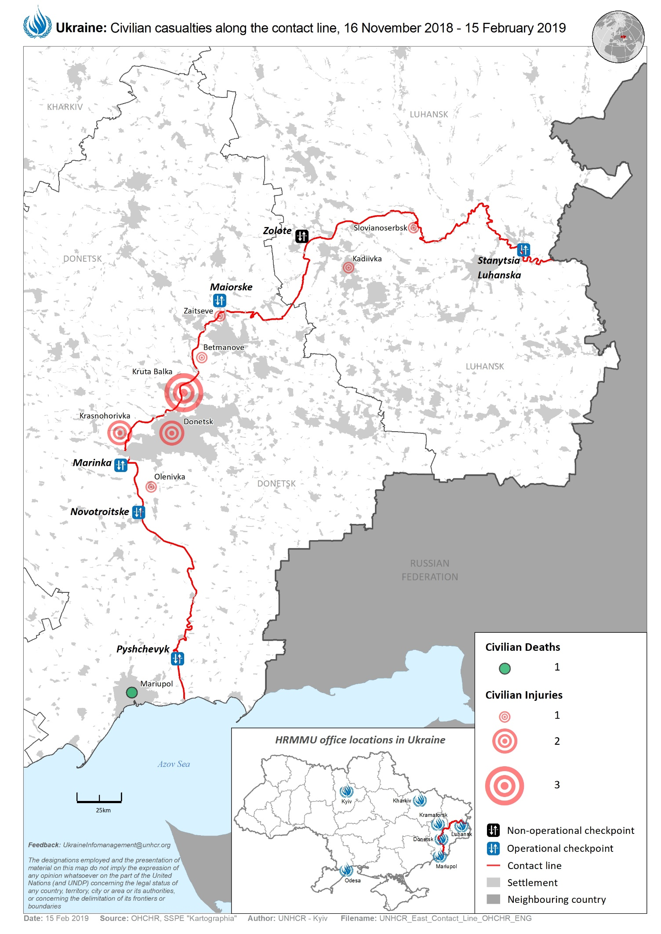
I. Executive summary
1. This twenty-fifth report on the situation of human rights in Ukraine by the Office of the United Nations High Commissioner for Human Rights (OHCHR) is based on the work of the United Nations Human Rights Monitoring Mission in Ukraine (HRMMU), and covers the period from 16 November 2018 to 15 February 2019.
2. OHCHR documented 315 human rights violations during the reporting period, which affected 202 victims. This represents an increase of documented violations compared with those documented during the previous reporting period of 16 August to 15 November 2018. Of the violations documented in this report, 221 violations occurred during the reporting period.
3. Of the violations documented by OHCHR, the Government of Ukraine was responsible for 126 violations, the self-proclaimed ‘Donetsk people’s republic’ and self-proclaimed ‘Luhansk people’s republic’ for 154, and the Government of the Russian Federation (as the occupying Power in the Autonomous Republic of Crimea and the city of Sevastopol, Ukraine, temporarily occupied by the Russian Federation) for 35.
4. Throughout the reporting period, OHCHR operations in territory controlled by ‘Donetsk people’s republic’ and ‘Luhansk people’s republic’ continued to be restricted. Ongoing discussions through regular meetings with representatives of both ‘Donetsk people’s republic’ and ‘Luhansk people’s republic’ have yet to secure the full resumption of OHCHR operations in the territory they control, as well as unimpeded confidential access to detainees in this territory.
5. The armed conflict in eastern Ukraine continued with ongoing hostilities in a number of hotspots along the contact line. Overall, OHCHR noted a trend of decreasing conflict-related civilian casualties, which in 2018 were 53 per cent lower than in 2017, and were at their lowest for the entire conflict period. The total civilian death toll of the conflict reached at least 3,321 as of 15 February 2019. More than 80 per cent of these occurred before mid-February 2015, reflective of the long-term positive impact of the Package of Measures to implement the Minsk Agreements on the decline of hostilities and civilian casualties since the adoption of the latter and United Nations Security Council Resolution 2202 in February 2015.
6. During the reporting period, OHCHR documented 16 conflict-related civilian casualties: two people were killed and 14 injured, which represents a 68 per cent decrease compared with the previous reporting period from 16 August to 15 November 2018. Shelling and small arms and light weapons (SALW) fire injured ten civilians – one of the lowest figures for the entire conflict period. Of these, nine were recorded in territory controlled by armed groups and are attributable to the Government, and one was recorded in government-controlled territory and is attributable to armed groups of ‘Donetsk people’s republic’. During the reporting period, OHCHR did not record any mine-related civilian casualties.
7. More than five million people, including over 1.3 million registered internally displaced persons (IDPs) and persons living in isolated communities along the contact line in eastern Ukraine continue to bear the brunt of the armed conflict and its consequences. The hardship they endure is exacerbated by the lack of access to basic services, social support, as well as remedies and reparations for injured persons and relatives of those killed and for destroyed property. A dozen civilians died in the first few weeks of 2019, mainly due to serious health complications, while crossing the contact line. During the winter months, the lack of adequate heating remained one of the main challenges for civilians, especially those living along the contact line. Despite consistent court decisions in favour of individuals who lost access to their pensions, the Government has failed to implement the judgments and continues to link access to pensions to IDP registration. Further, OHCHR noted the continued need for broader protection of conflict-affected civilians, including IDPs, regardless of where they reside in Ukraine, and realization of their economic and social rights to pave the way for restoring peace and stability in eastern Ukraine.
8. In government-controlled territory, OHCHR had access to official places of detention and conducted confidential interviews with detainees in accordance with international standards. In territory controlled by ‘Donetsk people’s republic’ and ‘Luhansk people’s republic’, OHCHR continues to call for confidential access to detainees to be granted to OHCHR and international observers.
9. OHCHR welcomes the transfers of 88 pre-conflict prisoners from territory controlled by ‘Donetsk people’s republic’ and ‘Luhansk people’s republic’ to government-controlled territory that took place in December 2018 and February 2019. Of them, seventy-five were transferred from territory controlled by ‘Luhansk people’s republic’ for the first time since the outbreak of the conflict.
10. OHCHR is concerned about the practice of arbitrary arrest, incommunicado detention, torture and ill-treatment of civilians in government-controlled territory. During the reporting period, OHCHR documented two cases of arbitrary detention of civilians allegedly by officers of the Security Service of Ukraine (SBU). Individuals in territory controlled by ‘Donetsk people’s republic’ and ‘Luhansk people’s republic’ continued to be subjected to ‘administrative’ arrest and ‘preventive’ arrest, respectively, which may constitute enforced disappearance.
11. In conflict-related cases, due process and fair trial violations persist as a result of the pervasive practice of prolonged pre-trial detention, and the use of force and coercion to obtain confessions or to accept plea bargains. Interference into the work of courts in conflict-related and other high-profile trials continued during the reporting period. Five years after violent clashes between law-enforcement and Maidan protestors, the killings of protestors and law-enforcement officers remain largely unaddressed by the Government. Delays in the investigation and trial proceedings related to the 2 May 2014 violence in Odesa continue.
12. Safeguarding civic space and protecting people’s rights to freedom of opinion and expression, media and peaceful assembly and association is key in ensuring that the upcoming presidential and parliamentary elections in Ukraine are peaceful and inclusive. OHCHR documented 16 violations of the afore-mentioned freedoms, as well as the right to non-discrimination, a decrease in keeping with the seasonal lull occurring every New Year period. OHCHR remains concerned about the failure of the Government to bring perpetrators of attacks against media professionals, political and civil society activists to account. Space for freedom of expression and freedom of the media remains highly restricted in territory controlled by ‘Donetsk people’s republic’ and ‘Luhansk people’s republic.’
13. During the reporting period, OHCHR followed closely the developments around the granting of autocephaly to the newly established Orthodox Church in Ukraine and the introduction of a 30-day martial law in some regions of Ukraine on 26 November 2018, following the naval incident near the Kerch Strait.
14. The Russian Federation, the occupying power in Crimea, has still not granted OHCHR access to the peninsula in line with UN General Assembly resolution on the territorial integrity of Ukraine 68/262 and resolutions 71/205, 72/190 and 73/263. OHCHR monitors the human rights situation on the peninsula from mainland Ukraine. The Russian Federation continues to apply its laws, in violation of international humanitarian law applicable to an occupying power, resulting in grave human rights violations, disproportionately affecting Crimean Tatars. OHCHR also notes that Ukrainian crew members apprehended by Russian authorities in the Kerch Strait on 25 November 2018 could be considered as prisoners of war and protected under the Third Geneva Convention.
II. OHCHR methodology
15. This report is based on 152 in-depth interviews with victims and witnesses. Findings are included in the report where the “reasonable grounds” standard of proof is met. The standard is met when a sufficient and reliable body of information from primary sources collected through interviews (with victims, witnesses, relatives of victims and lawyers), site visits, meetings with Government representatives, civil society and other interlocutors, and trial monitoring is consistent with information from secondary sources assessed as credible and reliable, such as reviews of court documents, officials records, open-source material, and other relevant materials. OHCHR applies the same due diligence and standard of proof when documenting conflict-related civilian casualties. Consent is sought from sources on the use of information, ensuring confidentiality as appropriate. Specific attention was paid to the protection of victims and witnesses, assessing the risk of reprisals.
16. During the reporting period, OHCHR continued to be present, albeit with limited operations, in territory controlled by ‘Donetsk people’s republic’ and ‘Luhansk people’s republic’, and was able to obtain and verify information through various means.
17. While OHCHR cannot provide an exhaustive account of all human rights violations committed throughout Ukraine, it is able to document patterns of human rights violations and abuses based on individual cases.
III. Impact of hostilities
I have already forgotten when I slept in a night robe. We go to bed in sports pants and sports jumpers so we don’t have to run naked when the shelling starts.
We go to sleep and wonder if we are going to wake up or not.
I wish I could have a good night rest at least once.
- Resident in Kamianka, a village near the contact line.

18. During the reporting period, hostilities continued to affect the civilian population in the conflict zone of eastern Ukraine. Against the backdrop of a decreasing number of ceasefire violations as reported by the OSCE Special Monitoring Mission to Ukraine, exchanges of fire across the contact line continued to impact residential areas and result in civilian casualties and damage to civilian property and infrastructure, including water facilities and electricity lines. Deteriorating factor was the continued placing of military positions in immediate proximity to residential areas and decreasing distances between the positions of Ukrainian forces and armed groups.
A. Conduct of hostilities and civilian casualties
19. Between 16 November 2018 and 15 February 2019, OHCHR recorded 16 conflict-related civilian casualties: two killed and 14 injured, a 68 per cent decrease compared with the previous reporting period of 16 August to 15 November 2018 when 50 civilian casualties (14 killed and 36 injured) were recorded. The number of locations where civilian casualties were recorded decreased from 25 to 11. The reporting period was also marked by the lowest number of civilian casualties compared with same calendar periods (mid-November to mid-February) from 2014 to 2018.
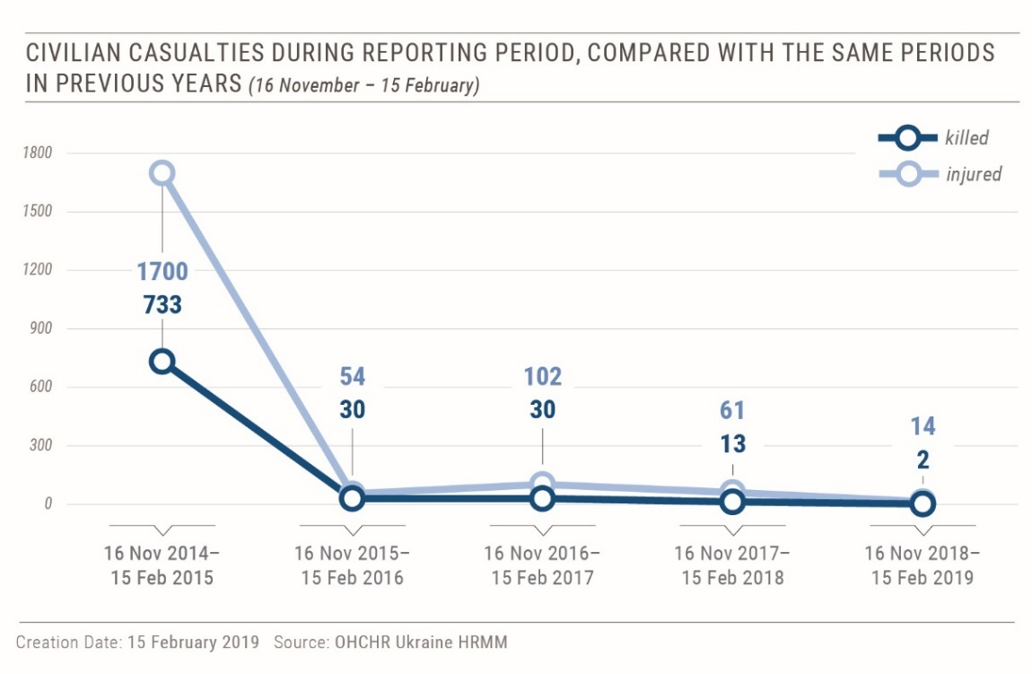
- During the same period, shelling and SALW fire injured ten civilians (eight men and
two women) and killed none. This is a 44.4 per cent decrease with the previous reporting period (six killed and 12 injured), and one of the lowest figures for the entire conflict period. Of the ten civilian injuries caused by shelling and SALW fire, eight were recorded in territory controlled by ‘Donetsk people’s republic’ and one was recorded in territory controlled by ‘Luhansk people’s republic’ and are attributable to the Government, and one was recorded in government-controlled territory and is attributable to armed groups of ‘Donetsk people’s republic’.
21. For instance, on 5 December 2018, a woman was injured by fire from an automated grenade launcher in the armed group-controlled village of Zaitseve (Donetsk region). On 10 January 2019, three male workers of the Voda Donbasa water station received injuries when a vehicle, which they drove to the Vasylivka water pumping station near the armed-group controlled Kruta Balka (Donetsk region) was hit by a rocket or a shell. On 16 December 2018, a man was injured in the government-controlled village of Chermalyk (Donetsk region). On 23 January 2019, the same man’s house came under heavy machinegun fire. The house is reportedly located near positions of the Ukrainian forces.
22. During the reporting period, OHCHR did not record any civilian casualties resulting from mine-related incidents. However, there were six casualties (two killed and four injured) resulting from the handling of explosive remnants of war (ERW), mostly hand grenades.
B. Civilian casualties in 2018

Conflict-related civilian casualties in 2018,
per type of weapon/incident
 | Killed | Injured | Total | Percent
Shelling/SALW fire | 21 | 135 | 156 | 55.9
MRI/ERW handling | 34 | 85 | 119 | 42.7
Drone attacks |  | 2 | 2 | 0.7
Road incidents |  | 2 | 2 | 0.7
Total | 55 | 224 | 279 | 100.0

22. From 1 January to 31 December 2018, OHCHR recorded 279 conflict-related civilian casualties: 55 killed (32 men, 15 women, six boys and two girls) and 224 injured (122 men, 70 women, 16 boys, seven girls and nine adults, whose gender is yet unknown). This is a 53.8 per cent decrease compared with 2017, when 604 civilian casualties (117 killed and 487 injured) were recorded, and the lowest annual civilian casualty numbers during the entire conflict period.
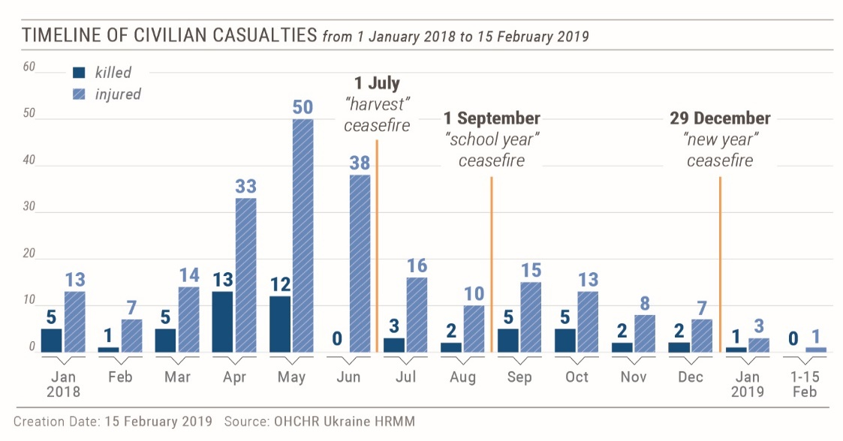
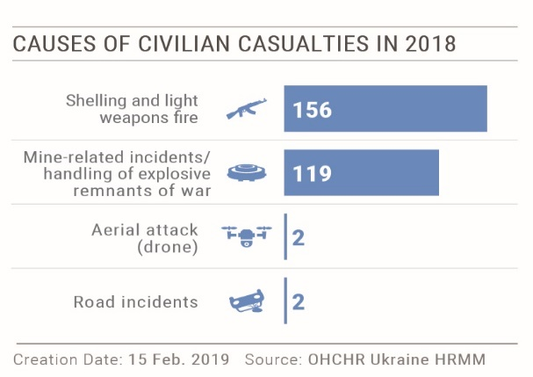
23. From 1 January to 31 December 2018, shelling and SALW fire caused 156 civilian casualties (21 killed and 135 injured), a 54.7 per cent decrease compared with 2017 when 344 civilian casualties (49 killed and 295 injured) caused by shelling and SALW fire were recorded.
24. Of the 156 civilian casualties caused by shelling and SALW fire in 2018: 121 (77.6 per cent) were recorded in territory controlled by armed groups and are attributable to the Government, 28 (17.9 per cent) - in government-controlled territory and are attributable to arme groups, and 7 (4.5 percent) - in ‘no man’s land’.
25. From 1 January to 31 December 2018, OHCHR recorded 119 civilian casualties (34 killed and 85 injured) resulting from mine-related incidents (MRI) and ERW handling. This is a 50 per cent decrease compared with 2017 when 238 civilian casualties (64 killed and 174 injured), resulting from mine-related incidents and ERW handling, were recorded.
C. Civilian casualties during the entire conflict period
26. During the entire conflict period, from 14 April 2014 to 15 February 2019, OHCHR recorded 3,023 civilian deaths (1,794 men, 1,046 women, 97 boys, 49 girls and 37 adults whose gender is unknown). With the 298 deaths on board of Malaysian Airlines MH17 flight on 17 July 2014, the total death toll of the conflict on civilians has been at least 3,321. The number of injured civilians is estimated to exceed 7,000.
Conflict-related civilian casualties during the entire conflict period, per year
 | Killed | Injured | Total
2018 | 55 | 224 | 279
2017 | 117 | 487 | 604
2016 | 112 | 476 | 588
2015 | 954 | >2,000 | >3,000
2014 | 2,082 | >4,000 | >6,000
Total | 3,320 | >7,000 | >10,000

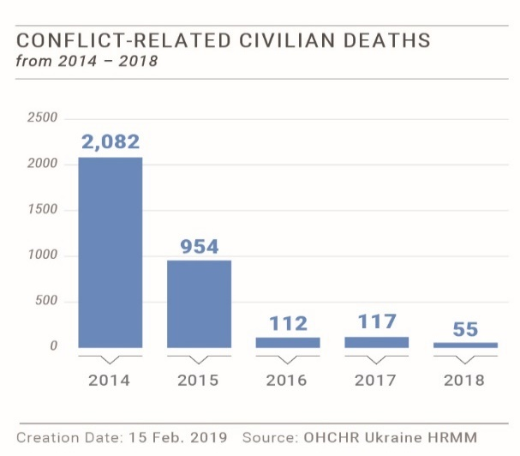
- The reporting period was marked by the fourth anniversary of the Package of Measures for the implementation of the Minsk Agreements, which was signed on 12 February 2015. The ceasefire and disengagement measures stipulated by the Package, though never implemented fully, have over time resulted in a dramatic decrease in conflict-related civilian casualties. The first ten months of the conflict (mid-April 2014 to mid-February 2015) accounted for 81.9 per cent of all civilian deaths (2,713), while the four years after the adoption of the Package accounted for 18.1 per cent of civilian deaths (608).
D. Economic and social rights of conflict-affected persons
We appreciate all the assistance, but nothing brings us joy when there is shelling. I will not survive another escalation. If someone tells you they are not afraid, don’t believe them. It is terrifying.
- A retired coal-miner from the government-controlled village of Zhovanka.

28. About 5,2 million conflict-affected persons, including over 1.3 million registered IDPs and persons living in isolated communities along the contact line continue to suffer due to the lack of access to basic services, such as water and heating, the lack of adequate housing, healthcare, and the absence of mechanisms for remedy and reparations. Displaced persons and those residing in territory controlled by ‘Donetsk people’s republic’ and ‘Luhansk people’s republic’ face difficulties in accessing their pensions and social benefits. In December 2018, as reported by the Pension Fund, only 562,000 pensioners with residence registration in territory controlled by ‘Donetsk people’s republic’ and ‘Luhansk people’s republic’ continued to receive pensions. Notably, this is less than a half of the pensioners registered in those territories as of August 2014.
29. Due to restrictions on freedom of movement, which result, in particular, in long waiting lines at entry-exit checkpoints on the contact line, civilians continue to face difficulties accessing government-controlled territory, to maintain family ties, access their social entitlements or critical services and facilities, such as hospitals. This contributes to the negative impact on the already fragile socio-economic situation and jeopardize prospects for social cohesion and people’s wellbeing.
1. Remedy and reparation for conflict-affected population
30. During the reporting period, OHCHR observed the implementation of the amendments to the law ‘On the status of war veterans and their social protection guarantees’, which expanded the scope of the law to include civilians, who acquired a disability as a result of hostilities. The inter-agency commission to establish the nexus between disability and conflict-related injury has considered in total 30 cases as of 15 February 2019. OHCHR welcomes this development, but remains concerned that provisions of the Law expressly exclude civilians who were injured in territory not controlled by the Government after 1 December 2014. OHCHR is also concerned by the continued lack of a comprehensive state policy of remedy and reparation for civilian victims of the armed conflict.
Court case on reparations for the family member of a person killed
due to hostilities, Luhansk region

The Supreme Court is considering a case of a woman seeking reparation for the loss of her daughter, who died during the armed conflict in eastern Ukraine. The Supreme Court did not suspend the execution of an earlier positive ruling by an appeals court. According to the judgment, the Government of Ukraine is obliged to provide monetary reparation for the family.
OHCHR notes the positive development, which paves the way to ensure reparation for people who have lost their family members in the armed conflict. The Government has yet to develop, establish and ensure proper implementation of a comprehensive mechanism for remedy and reparation for individuals, who have been injured, and to families of those, who lost their family member due to conflict.
2. Right to restitution and compensation for use or damage of private property
31. OHCHR notes the long-standing absence of a unified, comprehensive and inclusive mechanism to enable access to compensation for civilian property damaged and/or destroyed due to hostilities. As of 15 February 2019, there are over 50,000 civilian homes on both sides of the contact line damaged during the hostilities and homes of some 40,000 families, living on both sides of the contact line, are reportedly in urgent need of repairs to protect inhabitants from low winter temperatures.
32. Civilians face multiple obstacles in accessing compensation for the military use of their houses, land and other property in government-controlled territory. Persons told OHCHR the military forces did not sign lease agreements with them for the use of their property. Without such documents, civilians are not able to claim compensation for utility bills and any damages to their property caused during its use by the military. OHCHR has yet to observe the initiation of investigations into acts of looting allegedly committed by officers of the Ukrainian Armed Forces or other ground military forces.
33. On a separate note, OHCHR observed that IDPs, among them persons with disabilities, residing in collective centres in Odesa, Sviatohirsk and Zhytomyr, experience frequent interruptions of adequate heating.
3. Right to social security and social protection
34. OHCHR regrets the absence of changes in Government policy that links payment of social benefits, in particular pensions, with the need to register as an IDP, which would result in inability of Ukrainian citizens to access their fundamental social and economic rights on an equal basis, especially as pensions are recognized as a form of property.
35. Despite three Supreme Court decisions, issued over the past six months, ordering the restoration of rights to pensions and social entitlements, the Government continues to link access to pensions with IDP registration.
36. OHCHR positively notes that national courts followed the Supreme Court’s judgment in an “exemplary case,” restoring pension rights of an IDP. Since the judgement entered into force in September 2018, national courts have issued over 450 rulings in favour of IDPs between October and December 2018. Despite the general court practice on this issue, OHCHR regrets that the Government has so far failed to execute the court rulings, in violation of Ukrainian law.
37. In accordance with a July 2018 ruling of the Kyiv Appellate Administrative Court that invalidated certain provisions of the Cabinet of Ministers Resolutions no. 365 and 637, authorities can no longer carry out home visits for residence verification of IDPs and suspend pension payments on these grounds, when an individual is not found to be in residence. Reports indicate, however, that the practice continues. On 20 December 2018, the Supreme Court upheld the appellate court decision. Welcoming this final ruling, OHCHR reiterates that the Government should review its IDP policy more broadly to ensure equal access to pensions regardless of place of residence or IDP registration.
38. In another positive development, the Government adopted a state programme on physical, medical and psychological rehabilitation, and social and professional re-adaptation of veterans of the armed conflict in eastern Ukraine. This followed the establishment of the dedicated Ministry for Veterans Affairs in November.
39. In accordance with the law “On particular aspects of public policy aimed at safeguarding the sovereignty of Ukraine over the temporarily occupied territory of the Donetsk and Luhansk regions of Ukraine,” the President of Ukraine signed a decree establishing a list of residential areas, which are not controlled by the Government. Meanwhile, Order No.1085 of the Cabinet of Ministers, also indicating these areas, remains in force, which could lead to inconsistent or interrupted payment of pension and social benefits.
4. Freedom of movement, isolated communities and access to basic services
Crossing the contact line is a humiliating experience.
- A resident in Travneve, the village near the contact line.

39. Despite a 2.5-hour reduction in operating hours of the crossing points as of 1 December 2018, enforced as part of a shift to the winter operation mode, during the reporting period, there were over one million crossings of the contact line on average each month. OHCHR notes improvements of conditions at the crossing points made by the Government, however, civilians continue to wait in long queues and are regularly exposed to snow, ice and low winter temperatures, and inadequate sanitary and medical facilities, on both sides of the contact line. Since the beginning of 2019, 11 persons died while crossing the contact line in eastern Ukraine, reportedly due to health condition. Four people died at the only crossing point in the Luhansk region open exclusively to pedestrians, near the government-controlled town of Stanytsia Luhanska. Civilians also face other risks when crossing the contact line. For instance, in December 2018 and February 2019, around 90 people were temporarily trapped in ‘no man’s land’ coming from territory controlled by ‘Donetsk people’s republic’ due to arriving at the Maiorske crossing point shortly before its closure. They were eventually let through by Ukrainian authorities.
40. According to the 2019 Humanitarian Response Plan under a 2019-2020 Strategy, around 3.5 million people in Ukraine need humanitarian aid and protection services. Many conflict-affected civilians in villages on both side of the contact line lack access to basic services. During the winter, heating was one of the main challenges for civilians living along the contact line. The cost of coal, which is traditionally used for heating houses, increased drastically during the winter, forcing civilians to collect firewood in nearby forested areas, making them even more vulnerable to landmines or being subject to fines for cutting down trees.
41. OHCHR notes that the Ministry of Defence has not progressed in finalizing the draft Resolution regulating the procedure for movement of persons and transfer of goods across the contact line. As a member of a working group created by the Ministry of Defence to develop the draft Resolution, OHCHR underlines the necessity to harmonize the draft Resolution with existing national norms and international standards, as well as key recommendations of the international community and civil society.
IV. Right to physical integrity
42. During the reporting period, OHCHR documented at least 172 human rights violations involving unlawful or arbitrary detention, torture, ill-treatment and/or threats to physical integrity, committed on both sides of the contact line. Out of these violations 18 can be attributed to the Government of Ukraine, and at least 154 can be attributed to ‘Donetsk people’s republic’ and ‘Luhansk people’s republic.’ At least 91 violations occurred within the reporting period, which affected 46 victims (40 men and six women).
A. Access to detainees and places of detention
43. In government-controlled territory, OHCHR continued to enjoy access to official places of detention and conducted confidential interviews with detainees in accordance with international standards. OHCHR interviewed 93 conflict-related detainees (85 men and eight women) in pre-trial detention facilities (SIZO) in Bakhmut, Kharkiv, Kherson, Kyiv, Mariupol, Mykolaiv, Odesa, Starobilsk, Vilniansk and Zaporizhzhia.
44. OHCHR follows the ongoing penitentiary reform and welcomes all efforts to transfer medical personnel from subordination of the State Penitentiary Service of Ukraine to the Centre for Health Protection of the State Penal Service of Ukraine. However, the transition process negatively affects the provision of health care at the detention facilities. OHCHR continued to receive complaints regarding the lack of access to health care and adequate food, especially for detainees in need of a special diet due to illness.
45. In territory controlled by ‘Donetsk people’s republic’ and ‘Luhansk people’s republic’, OHCHR did not have unimpeded access to places of deprivation of liberty to visit and speak in private with detainees. The lack of such access raised serious concerns about the treatment of detainees and conditions of detention. First-hand information received from pre-conflict prisoners transferred to serve their sentence in government-controlled territory supports OHCHR concerns (see Situation of pre-conflict prisoners).
B. Arbitrary detention, enforced disappearance and abduction, torture and ill-treatment
46. OHCHR is concerned that the previously identified pattern of arbitrary deprivation of liberty, enforced disappearance, torture and ill-treatment of individuals in government-controlled territory may be re-emerging. In at least two cases, documented during the reporting period, victims were arbitrarily arrested during daytime allegedly by SBU officers.
47. OHCHR received information that several SBU officers in camouflage uniforms, armed with machine guns entered the house of an Armenian national and asylum seeker in Ukraine, in Svitlodarsk on 13 December 2018. SBU searched his house without a warrant and seized his electronic equipment and documents. They threatened to deport him to Azerbaijan or Crimea, and his family to ‘no man’s land’. He told OHCHR that they then handcuffed him, put a bag over his head and took him to a basement, where they interrogated him, accusing him of espionage for the Russian and Armenian intelligence. He said SBU officers periodically beat him, each time for 20-30 minutes, to force him to confess. The man agreed to confess to the SBU accusations on video camera after being threatened at gun point. Two day later, they took him to Kyiv, held him in an apartment and continued to beat him, inflicting severe pain and leaving numerous bruises on his body. On 17 December, SBU officers took him to a hospital for his injuries, registering him under a fake name. He said doctors recommended hospitalization, but SBU officers took him to another apartment and held him there for around two weeks. At one point, he did not receive food for two days. Finally, on 29 December, the SBU released him, telling him to keep silent about his ordeal.
48. In another case, on 15 November 2018, two men, allegedly SBU officers, wearing camouflage and masks detained a Russian citizen in Kyiv. They handcuffed him and took him to an unknown location. On 23 November, after the man’s wife reported his disappearance, the police opened a criminal investigation, but closed it five days later. On 26 December, a prosecutor’s office instructed the police to reopen the investigation. On 30 December, the man’s personal information (name, surname, date of birth, and alleged criminal charges) appeared on the Myrotvorets website. As of 15 February 2019, his relatives have no information about his whereabouts.
49. Late on 21 November 2018, several SBU officers detained a woman in the Kostiantynivka – Kyiv night train. They ordered her to leave the train, seized her passport and mobile phone and drove her from Kostyantynivka to an SBU office in Mariupol. She told OHCHR that the Mariupol SBU interrogated her all night and she learned that the SBU got her name and other identifying personal information from the Myrotvorets website. The woman saw her lawyer a day after her arrest, when she was taken to Kramatorsk to meet a Donetsk Regional Prosecutor in order to receive an act of suspicion. She was charged with creating ‘a terrorist group or organization’. On 23 November, the Zhovtnevyi district court of Mariupol ordered her arrest.
50. OHCHR notes that prompt, timely, effective and transparent investigations of all incidents of arbitrary detention, enforced disappearance, torture and other ill-treatment could help stop the pervasive practice and prevent reoccurrence. In this regard, OHCHR notes that the State Bureau of Investigations (SBI) became operational on 27 November 2018. This body took over the investigative jurisdiction over the crimes involving senior public officials, judges, officers of law enforcement or national anti-corruption bodies, and the crimes related to military service.
51. During the reporting period, in territory controlled by ‘Donetsk people’s republic’ and ‘Luhansk people’s republic’ individuals continued to be subjected to 30-day ‘administrative arrest’ and ‘preventive arrest,’ respectively, which amount to arbitrarily incommunicado detention and may constitute enforced disappearance. In territory controlled by ‘Luhansk people’s republic,’ OHCHR documented cases of ‘preventive arrests’ of civilians, held incommunicado for prolonged periods, before formalizing these ‘arrests.’
52. On 16 November 2018, representatives of the ‘ministry of state security’ (‘MGB’) of ‘Luhansk people’s republic’ detained a Luhansk resident at the entry-exit checkpoint near Stanytsia Luhanska. The man called his mother and told her he had been detained. His mother sent complaints about his detention to the ‘MGB’, ‘head’ of ‘Luhansk people’s republic’, ‘general prosecutor’s office’, and the ‘ministry of the interior’ (‘MoI’), requesting information about her son’s whereabouts. On 26 November, the ‘MGB’ informed her that her son was being held incommunicado under ‘preventive arrest.’ He was released on 4 December 2018.
C. Situation of pre-conflict prisoners
Back in 2016 I could complain to the prison administration for forcing us to work. Now no one would complain for fear of being thrown in the isolation ward and beaten.
- A pre-conflict prisoner transferred from a penal colony
in territory controlled by ‘Luhansk people’s republic’.

53. OHCHR welcomes the transfer of 88 pre-conflict prisoners (83 men and five women) that took place during the reporting period from places of detention in territory controlled by ‘Donetsk people’s republic’ and ‘Luhansk people’s republic’ to government-controlled territory in December 2018 and February 2019. There were two transfers from places of detention in territory controlled by ‘Luhansk people’s republic’ since the beginning of the armed conflict. To date, 274 persons (including nine women) have been transferred from places of detention in territory controlled by ‘Donetsk people’s republic’ and ‘Luhansk people’s republic.’

54. Transferred prisoners told OHCHR that there were more prisoners in territory controlled by ‘Donetsk people’s republic’ and ‘Luhansk people’s republic,’ who wanted to be transferred to government-controlled territory and maintain contacts with relatives living there.

55. Recently transferred individuals from detention facilities in territory controlled by ‘Donetsk people's republic' and 'Luhansk people's republic', including from two female penal colonies, reported a deterioration of detention conditions and prisoner treatment after the outbreak of the armed conflict in 2014. In particular, they mentioned insufficient food supply and the lack of electricity: in 2014-2015 during power outages, lasting from a couple of hours to several months, prisoners had to burn furniture to heat their barracks. They said the situation had improved since 2016, however, ill-treatment by prison staff, the absence of adequate medical treatment, including specialised doctors, such as gynaecologists, and forced labour remain of concern. Prisoners also reported difficulties in maintaining contacts with relatives who live in government-controlled territory.
56. Pre-conflict prisoners were transferred from eight places of detention in territory controlled by 'Luhansk people's republic'. Transferred prisoners said that their detention conditions worsened after the outbreak of the armed conflict. They described inadequate accommodation, such as leaking barrack roofs, low inside temperature during the cold season, and insufficient health care due to the lack of medical staff and medicines (particularly for prisoners living with HIV/AIDS and tuberculosis). In several instances, delays to deliver timely and adequate medical care led to an inmate’s death in custody. In some colonies, prisoners said they had gone “hungry” for several months in 2014 and lacked access to water and electricity.
57. Some of the transferred prisoners complained that in 2014-2015 members of armed groups entered penal colonies, beat prisoners and subjected them to mock executions. Prisoners also reported severe beatings by men in masks and by penal colony staff, who allegedly changed their uniforms and put masks on. The prisoners said it was done to intimidate and ‘discipline’ them, including when the prison administration was understaffed. In some instances, such beatings, allegedly, led to serious injuries requiring medical attention or prisoners’ deaths. Such visits by ‘masked men’ continued till mid-2018, but reportedly stopped since then.
58. OHCHR received allegations of forced labour in most penal colonies in territory controlled by ‘Luhansk people’s republic’. In Sukhodilsk penal colony №36, prisoners said they had to work in two shifts from 6:30am to 9pm, often without days off on weekends and meagre or no compensation. Those, who did not want to work or who did not meet the work requirements, were beaten and put in the isolation ward. The ‘head’ of the colony personally beat prisoners in front of others to intimidate and make them work harder.
59. Individuals, transferred from five penal colonies in territory controlled by ‘Donetsk people’s republic,’ confirmed information OHCHR had received from other transferred prisoners about the lack of food, water, electricity, heating, hygiene items and medicine in 2014-2015. Some reported that the situation had gradually improved in Snizhne female penal colony №127, whereas the situation had remained difficult in male colonies despite minor improvements. Male prisoners alleged that in 2014-2015 a special unit from armed groups of ‘Donetsk people’s republic’ with insignia ‘ROSNAZ’ entered Yenakiieve penal colony №52 on two occasions and severely beat some prisoners. Since 2016, the treatment of prisoners reportedly improved, however a number of issues remain unresolved, in particular, Michurinska penal colony №57 in Horlivka is still affected by shelling.
V. Accountability and administration of justice
A. Administration of justice
While article 176.5 is in force, a person can be held in SIZO eternally. There is no need to prove anything. It’s a very convenient tool.
- A detainee in the Kyiv SIZO.

60. OHCHR notes the persistent practice of prolonged pre-trial detention and the use of pressure to obtain forced confession or plea bargains. OHCHR documented 89 violations of the right to a fair trial in conflict-related criminal cases.
61. During the reporting period, OHCHR continued to observe a worrying trend of convicting individuals affiliated or linked with armed groups of ‘Donetsk people’s republic’ and ‘Luhansk people’s republic’ based on guilty pleas and confessions without material evidence. In 35 out of 60 verdicts in conflict-related criminal cases, defendants pled guilty or admitted guilt. In 24 out of those 35 cases prosecutors presented no material evidence, giving rise to concerns about substantiality of the charges. In four cases defendants were sentenced to as much time as they had already spent in pre-trial detention and were thus immediately released. OHCHR is concerned that defendants could see pleading guilty to a crime as the only way to be released from detention in the context of a protracted trial.
62. The wide application of plea bargains in conflict-related criminal cases is problematic due to the practice of coercing defendants to admit guilt, including through the use of physical violence, as documented by OHCHR. In at least three documented cases, detainees of the Kharkiv SIZO tried on terrorism charges complained of being under pressure. In particular, the SIZO administration repeatedly placed defendants in punishment cells for minor infractions of the SIZO rules and regulations. By conducting excessively frequent searches and seizures of personal items, the administration allegedly provoked other detainees to be violent towards the defendants. One of them was brought to the court with visible injuries on his face and body and told the court that he had been beaten after complaining to the prosecution about this punitive practice by top SIZO officials. He explained to the court that he feared for his life but refused to describe the beating.
There is no way to be released other than to sign a plea bargain.
- A detainee in the Odesa SIZO.
63. According to the information received by OHCHR, the SIZO administration placed the three defendants in punishment cells at least a dozen times, to force them to admit guilt in court, while the prosecution failed to meaningfully investigate the allegations of ill-treatment. OHCHR emphasizes that the right not to be compelled to testify against oneself or to confess guilt comprises the guarantee of absence of any direct or indirect physical or undue psychological pressure with a view to obtaining a confession of guilt.
64. Despite the prohibition of unreasonably lengthy pre-trial detention and the need to reconsider alternatives to pre-trial detention, courts continue to put in custody individuals charged with links or affiliation with armed groups and crimes against national security relying solely on provisions of article 176.5 of the Criminal Procedure Code of Ukraine. OHCHR is aware of at least 46 cases, where defendants had been in pre-trial detention for over two years. In 11 of these cases the defendants have been in custody for over four years – equaling to eight years of imprisonment according to the ‘Savchenko law’. The situation is exacerbated by appeal courts’ heavy reliance on article 176.5 instead of international human rights law and the case law of the European Court of Human Rights. In some cases, defendants could not appeal due to the delay in obtaining court orders of their restraint measures, which violated their right to appeal.
65. OHCHR is also concerned that protracted trials in conflict-related criminal cases might be caused, inter alia, by the lack of judges. In the majority of conflict-related criminal cases, the courts schedule hearings only once every month or two.
66. OHCHR continued to document cases of interference by members of extreme right-wing groups in criminal proceedings of conflict-related and high profile criminal cases through the intimidation of judges, defendants and their lawyers. In three documented cases members of extreme right-wing groups disrupted court hearings by verbally abusing judges and defendants. In one case, they beat a defendant in a conflict-related case outside the courtroom, but police did not stop the beating.
67. OHCHR is concerned about the lack of progress in the criminal case regarding the killing of journalist Oles Buzyna in 2015 and allegations of obstruction of justice. The High Council of Justice is still considering the issue of one of the judge’s removal for failing a qualification test. The judge had previously claimed she was made to fail the test in order to remove her from the case. Although the judge continues to participate in the trial, concerns arise about her bias towards the defendants and a likely re-trial in case of her eventual removal by the High Council of Justice, which would violate the rights of the victim’s relatives and the defendants. The judge’s allegation of the interference into her professional activities merits prompt and effective investigation.
68. In an unrelated case, the car of Valentyn Rybin, a lawyer known for defending conflict-related detainees, was set on fire. According to Rybin, the police is reluctant to investigate the attack.
69. During the reporting period, OHCHR observed violations of the right to a public hearing when judges held hearings of conflict-related criminal cases in their offices instead of courtrooms without making these changes known to the general public and thus obstructing public presence.
B. Accountability for human rights violations in eastern Ukraine
70. OHCHR continued to document Ukrainian authorities’ inaction in prosecuting military officials, suspected of crimes against civilians. OHCHR notes that prosecutors fail to enforce defendants’ presence during trials as a general practice.
C. Accountability for cases of violence related to riots and public disturbances
71. OHCHR noted limited progress in legal proceedings concerning the 2014 Maidan protests and the violent events of 2 May 2014 in Odesa.
1. Accountability for the killings of protesters during the Maidan protests
72. Five years after violent clashes between law enforcement and Maidan protestors, the Special Investigations Department (SID) of the Prosecutor-General’s Office continues its probe into killings during the protests in early 2014. The SID, however, will lose its investigative functions on 20 November 2019. By then, all investigations conducted into the Maidan killings must be completed or transferred to the State Bureau of Investigations, which began its work on 27 November 2018.
73. While the SID continues its work, the investigators have been stripped of labour and social protection guarantees, which, according to the SID Head, has had a negative impact on the work of the department.
74. The Office of the Military Prosecutor completed its investigation into the shooting from the SBU building in Khmelnytskyi on 19 February 2014. The former Head of the Khmelnytskyi SBU, who had allegedly ordered the use of lethal force against the protestors, and the SBU officer, who had allegedly shot and killed one person and injured three protestors, have been indicted on charges of abuse of power, unintentional killing and negligent grave bodily injury. On 18 December 2018, a court ordered house arrest for the SBU officer but he was later released.
2. Accountability for the 2 May 2014 violence in Odesa
75. Delays in the investigation and trial proceedings related to the 2 May 2014 violence in Odesa continue. As of 15 February 2019, almost five years after the events, which led to the deaths of 48 people, none of the state officials have been held accountable.
76. On 16 January 2019, the court of appeals for Odesa region reversed the decision of the Kyivskyi district court of Odesa to return to the prosecutor’s office the indictment against three State Emergency Service officials accused of negligence and ruled to start the trial.
77. OHCHR notes no progress in the case against the only ‘pro-unity’ activist accused of killing: two hearings were adjourned due to the court’s failure to select a jury panel and disruption of the proceedings by ‘pro-unity’ supporters. On 17 December 2018, around 30-40 supporters of the defendant disrupted the hearing in the Malynovskyi district court of Odesa. When the panel of judges attempted to leave the courtroom, one of the supporters approached the presiding judge obstructing his movement and began arguing with him. The judge was only able to leave the courtroom after the defendant and his lawyer interfered.
78. The Prymorskyi district court of Odesa has not started to hear the case against three high ranking police officials accused of negligence and endangering others. On 11 October 2018, the judge ruled to merge the case with another legal proceeding against one of the accused related to the 2 May violence in Odesa. However, on 16 January 2019, the case was returned for retrial due to procedural issues.
VI. Democratic/civic space and fundamental freedoms
79. During the reporting period, OHCHR documented 16 violations of the rights to freedom of opinion and freedom of expression, freedom to peaceful assembly and association, freedom of religion or belief and the right to non-discrimination. While the Ukrainian authorities were responsible for all 16 human rights violations that OHCHR documented during the reporting period, the space for freedom of expression and freedom of the media remains highly restricted in territory controlled by ‘Donetsk people’s republic’ and ‘Luhansk people’s republic’.
80. The 30-day martial law period declared in ten regions of Ukraine did not lead to significant human rights limitations. However, certain martial law restrictions had direct application under national legislation leading to restrictions of electoral rights and the right to peaceful assembly. The prohibition to hold elections resulted in the cancellation of the elections to territorial “hromadas” in the ten regions under martial law. At the same time, the prohibition to hold public assemblies was not strictly enforced. OHCHR observed that public events did take place in the affected regions. Police in Odesa reportedly evoked the martial law when dissolving a public event in order to unblock a traffic jam.
A. Freedom of opinion and expression and freedom of the media
81. Despite the decrease in the number of violations of freedom of expression and freedom of the media during the reporting period, OHCHR continues to document cases of interference in the work of media professionals and physical attacks and acts of intimidation against them. Seven incidents took place during the period under review, which led to nine human rights violations, including the persistent lack of investigations into attacks against journalists and civic activists.
82. On 18 November 2018, members of extreme right-wing groups used pepper spray against a Canadian journalist covering a transgender rights public event in Kyiv and punched him in the face. Police opened an investigation into the attack, classifying the assault as ‘hooliganism’.
83. OHCHR remains concerned about the failure of the Government to bring perpetrators of attacks on civil society activists to account. OHCHR notes the creation of a special parliamentary commission to investigate a lethal attack on a senior staff of the Kherson city council and attacks on other activists. Concerns remain, however, about the lack of effective investigations by law enforcement into these attacks so far.
84. OHCHR documented two attacks against members of political parties during the reporting period. On 28 November 2018, around 30 masked men attacked three political activists in Odesa. On 12 December, a group of approximately 15 perpetrators, with alleged links to extreme right-wing groups, stormed offices of a political party in Kyiv. They beat at least two political activists and searched the offices. The police arrived after the attack when the perpetrators had already left.
85. Space for freedom of expression and freedom of the media remains highly restricted in territory controlled by ‘Donetsk people’s republic’ and ‘Luhansk people’s republic’. OHCHR is concerned that expression of any critical opinion or alternative view could lead to arbitrary detention or other punishment of critics.
B. Freedom of peaceful assembly and association
86. OHCHR continued to document attacks by extreme right-wing groups on peaceful assemblies organized by groups, with whose views they disagree. On 18 November 2018, members of extreme right-wing groups attacked the transgender rights public event in Kyiv. Despite the presence of the police on site, the members of extreme right-wing groups from a counter-rally followed several event participants and attacked them by using pepper spray. Two participants and one journalist received injuries. Instead of isolating perpetrators police asked organizers to stop the event and forced the participants into a nearby subway station. Authorities did not launch an investigation into the disruption of the peaceful event and attacks against the participants. OHCHR notes that such attacks could amount to a form of gender-based discrimination against LGBTQI people.
87. In territory controlled by ‘Donetsk people’s republic’ and ‘Luhansk people’s republic’, OHCHR did not observe any developments with regard to peaceful assembly. In territory controlled by ‘Luhansk people’s republic’, a ‘decree’ remains ‘in force’, according to which organizers of peaceful assemblies are required to seek prior approval of the ‘ministry of state security’ or the ‘ministry of the interior’.
C. Freedom of religion or belief
88. OHCHR continued to monitor developments related to granting autocephaly to the newly established church – the Orthodox Church in Ukraine. On 15 December 2018, members of the Unification Council of the Orthodox Churches of Ukraine formally agreed to create the new church and chose its leader. OHCHR documented incidents that could be perceived as acts of intimidation against members of the Ukrainian Orthodox Church of the Moscow Patriarchate.
89. During the reporting period, the SBU in several regions of Ukraine initiated four criminal investigations into incitement to religious enmity and hatred; one of these cases has an additional charge of high treason, without issuing notices of suspicion. The SBU conducted searches in the premises of the Ukrainian Orthodox Church of the Moscow Patriarchate and places of residence of clergymen, questioning some of them.
90. On 20 December 2018, the Parliament of Ukraine launched a process of mandatory renaming of religious organizations that are affiliated with religious centers in the Russian Federation. OHCHR is concerned that this process is primarily targeting Ukrainian Orthodox Church communities and may be discriminatory. OHCHR is also concerned that the Parliament warranted restrictions on access of the clergymen of such organizations to the premises of the Ukrainian Armed Forces on the basis of national security considerations, which contravenes article 18(3) of the ICCPR.
91. Following the establishment of the new church, a number of religious communities decided to join. OHCHR received reports that in a few cases the transfers were not voluntary and were initiated by state or local authorities or even representatives of extreme right-wing groups, who were not members of those religious communities. Furthermore, on 17 January 2019, the Parliament adopted amendments setting out a procedure for voluntary change of denomination by religious communities.
D. Discrimination, hate speech, racially-motivated violence and manifestations of intolerance
92. OHCHR continued documenting violations related to discrimination, hate speech and/or violence, targeting members of minority groups or those holding alternative or minority opinions. Among two incidents documented that occurred during the reporting period, one involved threats and another direct violence by members of extreme right-wing groups. The failure of the law enforcement to prevent violence, to properly classify these violations as hate crimes, and to effectively investigate and prosecute these crimes violates the right to non-discrimination and creates an environment of impunity. It also denies victims of these attacks equal access to justice.
93. Investigations and prosecution of several attacks against Roma people still lack progress. Positively, on 28 December 2018, prosecutors of the Lviv Regional Prosecutor’s Office charged a man responsible for the killing of a young Roma man outside Lviv in June 2018. In contrast, the Holosiivsky district court of Kyiv cancelled on procedural grounds the note of suspicion against an alleged perpetrator in another violent attack against a Roma settlement in Kyiv in April 2018.
94. OHCHR documented the case of a prisoner with pro-Ukrainian views, who served his sentence in a penal colony in territory controlled by ‘Luhansk people’s republic’ between 2014 and 2018. The prisoner had conflicts with the colony administration for his political views and speaking Ukrainian. The colony administration staff reportedly forced the prisoner “to drop his nationalistic views”, threatened and beat him. In 2016, the colony guards allegedly beat him with batons as ordered by the colony head. After this incident, the prisoner was held in the isolation cell for a year. He said that as a result of his long-lasting intimidation and ill-treatment, he tried to commit suicide in December 2017.
VII. Human rights in the Autonomous Republic of Crimea and the city of Sevastopol, Ukraine, temporarily occupied by the Russian Federation
95. The overall human rights situation in Crimea continued to be marked by restrictions in the exercise of fundamental freedoms and the lack of effective remedies to seek justice. In addition, the continuing failure of the Russian Federation to acknowledge its status as an occupying power in Crimea has resulted in further violations of international humanitarian law committed by its State actors during the reporting period, failing to recognize and ensure obligations related to applicable occupation law.
96. OHCHR continued to record human rights violations, including restrictions on freedoms of opinion, expression, and religion or belief, and violations of international humanitarian law in Crimea. In total, OHCHR documented 38 violations during the reporting period, and of this number 25 violations occurred within the reporting period; with the Government of the Russian Federation responsible for 35 and the Government of Ukraine for three.
A. International Humanitarian Law violations
97. On 25 November 2018, Ukrainian authorities reported an assault of the Russian Federation naval forces on three Ukrainian naval vessels near the Kerch Strait. The Ukrainian vessels were on their way to the Azov Sea through the Kerch Strait, which is the only passage between the Black Sea and the Azov Sea and lies between the Russian Federation and Russian Federation-occupied Crimea. The Ukrainian Government stressed that the Ukrainian ships were attacked in international waters, while the Russian Federation insisted that the ships entered its territorial waters and received repeated warnings to leave the area. The Russian Federation naval forces opened fire on the Ukrainian vessels, seized them, and captured 24 crew members (22 naval officers and two SBU officers).
98. OHCHR notes that by virtue of the continued occupation of Crimea by the Russian Federation, an international armed conflict continues to exist between the two States in Crimea and international humanitarian law continues to apply there. As such, a single hostile encounter between the armed forces or assimilated armed units of two sovereign states, as the 25 November 2018 incident, suffices to trigger the application of international humanitarian law, irrespective of the pre-existence of an armed conflict. Consequently, the rules of international humanitarian law that are applicable to international armed conflict continue to apply.
99. All 24 crew members, including those who had reportedly sustained injuries during the incident, have been charged with illegal crossing of the Russian border, a criminal offence punishable by up to six years of imprisonment, and remanded in custody. Between 29 and 30 November 2018, the Russian Federation authorities reportedly transferred all 24 crew members from Simferopol to Moscow, where they placed them in SIZOs.
100. The Ukrainian Government considers the apprehended crew members to be prisoners of war. Similar statements were made by the crew members and their lawyers, including during court hearings on the measure of restraint. Nevertheless, as of 15 February 2019, the Russian Federation authorities refuse to apply international humanitarian law provisions to the incident and deny the detained crew members the status of prisoners of war.
101. OHCHR notes that based on the provisions of international humanitarian law, the 24 detained crew members could be considered as prisoners of war and protected by the Third Geneva Convention. In any case, they shall enjoy the status of a prisoner of war until a competent tribunal determines otherwise. OHCHR recalls that prisoners of war must inter alia be humanely treated, protected against violence or intimidation, and provided with the medical assistance if needed.
B. Administration of justice, intimidation and harassment of human rights defenders
102. On 7 December 2018, a district court in Simferopol sentenced Crimean Tatar lawyer Emil Kurbedinov, known for defending critics of Crimea’s occupation and alleged members of organizations, banned in the Russian Federation, to five days of administrative detention for disseminating extremist symbols through a social network. During a court hearing, the judge ignored the fact that the impugned content was posted five years ago – prior to the de facto implementation of the Russian legislation in Crimea – and denied over 40 motions of his defense team, including the motion to ensure the presence of a prosecutor, to question an expert witness and recuse a presiding judge. Kurbedinov was released on 11 December after serving his sentence in full.
103. OHCHR notes that Kurbedinov’s conviction follows a series of earlier incidents that indicate a pattern of deliberate intimidation, hindrance, harassment or interference by the Russian authorities in Crimea with his professional activities. In 2017, he was also prosecuted for social media posts. On 6 November 2018, police raided his office in Simferopol to serve him with a “formal warning” against engagement in extremism. OHCHR is concerned that this time, the extremism charges may be used to formally deprive Kurbedinov of his right to practice law in Crimea. On 18 December, the Ministry of Justice of Crimea requested a bar association in Simferopol to renounce Kurbedinov’s membership, which may lead to his disbarment.
104. Emil Kurbedinov’s case reflects the overall hostile attitude of Russian Federation authorities towards human rights defenders and civic activists. Lawyers, who take up defense in sensitive cases against individuals accused of extremism or terrorism in Crimea, risk facing similar charges themselves. OHCHR reiterates its findings on the pressure faced by members of Crimean Solidarity, a non-registered civic group cooperating closely with defense lawyers on the peninsula. The law enforcement have disrupted the group’s meetings and issued formal warnings to Crimean Solidarity members not to engage in illegal activities, including unauthorized public gatherings and extremist acts.
C. Freedoms of religion, opinion and expression
105. Consistent with previous OHCHR findings, the pattern of criminalization of affiliation to or sympathy towards religious Muslim groups, banned in the Russian Federation, continued to disproportionately affect Crimean Tatars.
106. On 24 December 2018, a military court in the Russian city of Rostov-on-Don found four Ukrainian citizens, all Crimean Tatar men previously transferred to the Russian Federation from Crimea, guilty of membership in a terrorist organization and preparation to commit a forcible seizure of power. One man received a 17-year prison sentence, while three others – 9 years of imprisonment each. The accusations were based on the defendants’ alleged membership in Hizb ut-Tahrir, an Islamic movement, which is legal in Ukraine but banned as a terrorist group in the Russian Federation. According to a court ruling, the defendants were prosecuted for four meetings, during which they had discussed Islamic dogmas, Hizb ut-Tahrir ideology and sharia law. In a separate case, on 22 January 2019, the Supreme Court of Crimea found four Crimean residents guilty of membership in Tablighi Jamaat, another Islamic group banned in the Russian Federation. Three defendants received conditional sentences, while the fourth man was sentenced to four years of imprisonment. In both cases, the defendants were found guilty based on their alleged membership in the banned Muslim groups, as well as the fact that they had possessed, read and discussed books deemed to be ‘extremist’ under the Russian law despite the absence of any evidence indicating that they had called for or planned to engage in any form of violence or violation of public order.
107. OHCHR notes with concern that in September 2016, four other Crimean Tatar men received long prison sentences for their alleged membership in the same organization, while at least 11 other Crimean residents are currently on trial on similar charges. OHCHR reiterates that freedom to manifest one’s religion or belief may only be limited on the grounds prescribed by law, which are necessary to protect public safety, order, health, morals or the fundamental rights and freedoms of others.
108. During the reporting period, at least five criminal cases against Crimean residents charged for their alleged anti-Russian statements in social media were closed following the de-criminalization of a single act of “incitement of hatred or violence” under Russian law, which is de facto applied in Crimea. Previously, OHCHR reported extensively about the systematic use by the Russian Federation authorities of the anti-extremism legislation in Crimea against critics of the peninsula’s occupation and vocal pro-Ukrainian activists. OHCHR welcomes this positive step by the Russian Federation, although the extent to which such de-criminalization will be implemented remains to be seen.
D. Illegal population transfers and freedom of movement
109. According to the Russian Federation judicial registry, in 2018, courts in Crimea ordered deportation from the peninsula of at least 435 individuals considered foreigners under Russian Federation laws, including 231 Ukrainian nationals. Of the total number in 2018, at least 50 individuals were “forcibly removed”, a procedure that prescribes placement in temporary detention before deportation. Many of the deported were Ukrainian citizens, whose residence rights in Crimea were not recognized by authorities. In one case, a man, who had relocated to Crimea from Kyiv to undergo medical rehabilitation, was deported after having been compelled to cooperate with law enforcement, or risk detention.
110. Deportations of protected persons from Crimea occur against the backdrop of restrictions imposed on free movement between mainland Ukraine and the peninsula. During the reporting period, the Federal Security Service of the Russian Federation denied entry to a Ukrainian journalist and banned her from Crimea for 10 years. Russian border officials informed the journalist of the ban at one of the crossing points of the Administrative Boundary Line without any explanation of the specific grounds for such decision. Russian authorities issue similar bans to other journalists, civic activists, or other public figures, who are perceived as critics of Crimea’s occupation.
111. Individual or mass forcible transfers, as well as deportations of protected persons from occupied territory to the territory of the occupying Power, or to that of any other country, occupied or not, are prohibited under international humanitarian law, regardless of their motive. International human rights law guarantees to everyone the right to liberty of movement and freedom to choose their own residence within their own country.
E. Forced conscription
112. The reporting period was marked by the eighth conscription campaign of Crimean residents into the Russian Federation Armed Forces since the beginning of the occupation. During the latest campaign, which ended in December 2018, approximately 2,800 men from Crimea were enlisted, bringing the overall number of Crimean conscripts to at least 14,800 men. The number of the enlisted Crimeans has significantly increased from 500 conscripts during the first military draft in 2015.
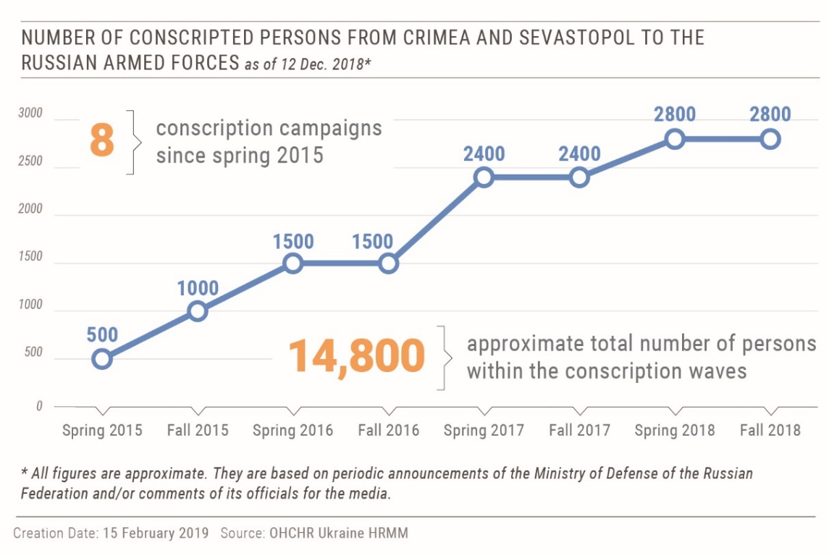
113. Draft evasion is punishable under Russian criminal law by up to two years imprisonment. OHCHR notes that criminal prosecution of Crimean residents for evading Russian military drafts has intensified during 2018, with at least 21 guilty verdicts. One defendant was sentenced to a suspended prison term, while others were fined. Forced enlistment adversely affects the enjoyment of human rights of potential conscripts, restricting their free movement and access to education and employment. In one case, a resident of Crimea was forced at his local military draft commission to leave Crimea or face conscription in the future. Registering at the military draft commission was also a prerequisite for receiving his university diploma in Simferopol.
114. As an occupying power, the Russian Federation must comply with international humanitarian law prohibiting compulsion of Crimean residents into its armed or auxiliary forces. No pressure or propaganda aimed at securing voluntary enlistment is permitted.
VIII. Technical cooperation and capacity-building
115. OHCHR engages in technical cooperation and capacity-building activities to assist the Government of Ukraine and civil society to protect and promote human rights.
116. OHCHR carried out 334 specific follow-up activities to facilitate the protection of human rights connected with the cases documented, including trial monitoring, detention visits, referrals to State institutions, humanitarian organizations and non-governmental organizations (NGOs), and cooperation with United Nations human rights mechanisms. OHCHR referred 34 allegations of human rights violations to specific duty-bearers; to the Government of Ukraine, 19 allegations were raised with two fully and seven partially addressed; to the ‘ombudsperson’ of ‘Donetsk people’s republic’ seven allegations were raised with one fully and one partially addressed; and to ‘Luhansk people’s republic’ seven allegations were raised with three partially addressed.
117. On 30 November, OHCHR, the Geneva Academy of International Humanitarian Law and Human Rights and the Age and Disability Technical Working Group organized a joint capacity-building training session on the Protection of the Rights of Persons with Disabilities (PwD) in the armed conflict in Ukraine. Participants included Government officials and local authorities, staff of international and national organizations, civil society activists and persons with disabilities. The main purpose of the training was to strengthen the protection of persons with disabilities affected by the conflict in Ukraine through raising awareness of international standards, identifying challenges and needs related to protection of PwD and establishing stronger cooperation between key stakeholders.
IX. Conclusions and recommendations
118. OHCHR welcomes the significant decrease in civilian casualties, however, the armed conflict in eastern Ukraine continues, affecting lives and livelihoods not only of more than five million civilians on both sides of the contact line, but the entire country. All parties to the conflict need to fully implement the ceasefire and disengagement provisions of the Minsk agreements to protect civilians, civilian property and infrastructure, and lessen their daily hardships. The Government of Ukraine needs to step up efforts for protection of conflict-affected civilians, including IDPs, regardless of where they reside in Ukraine, as well as for the realization of their economic and social rights to pave the way for a durable reconciliation between communities and restoring peace and stability in eastern Ukraine.
119. The Government must act to protect space for civic expression ahead of Ukraine’s presidential, parliamentary and local elections in 2019 and 2020. Impunity for attacks on media professionals, civil society activists, lawyers and political opponents weakens Ukraine’s democratic institutions and fuels further intolerance, discrimination and violence, and could compromise the integrity of the upcoming elections.
120. As in the previous reporting periods, OHCHR regrets the absence of the meaningful progress in investigations and prosecutions of those responsible for the killings during the Maidan protests and the violence that took place on 2 May 2014 in Odesa.
121. The human rights situation in Crimea continues to deteriorate as a direct result of the Russian Federation authorities applying its laws against residents of Crimea in violation of their obligations as an occupying power under the Fourth Geneva Convention, and other violations of international humanitarian law affecting the protected population. The Russian Federation must address pervasive human rights violations such as restrictions on freedoms of religion, opinion and expression and association, as well as the intimidation and harassment of human rights defenders, disproportionately affecting Crimean Tatars.
122. Most recommendations made in the previous OHCHR reports on the human rights situation in Ukraine have not yet been implemented and remain valid. OHCHR further recommends the following, based on the issues identified from 16 November 2018 to 15 February 2019.
1. To the Ukrainian authorities:
Parliament of Ukraine
- adopt and harmonize the legislation to serve as a base for developing a comprehensive mechanism for restitution and compensation for property, damaged and destroyed during the armed conflict in eastern Ukraine, as well as property, currently in military use;
- revise the Law on War Veterans so that all civilians who acquired a disability as a result of hostilities in eastern Ukraine in 2014-2019 can be eligible for receiving status of war veterans and appropriate social protection.
Cabinet of Ministers:
- develop and adopt a national policy framework that establishes clear institutional authorities and responsibilities for the protection of civilians and civilian objects in hostilities, as recommended in the 2018 United Nations Secretary General’s report on protection of civilians in armed conflict (S/2018/462);
- develop a comprehensive mechanism, including an administrative procedure, for restitution of property and compensation for any damages and destruction of civilian property in the armed conflict in eastern Ukraine;
- develop a non-discriminatory and accessible mechanism for restitution and compensation for property, which is in military use, including keeping records of civilian property and infrastructure in military use;
- allocate financial support to local authorities in order to provide safe and adequate housing to the conflict-affected population and IDPs;
- ensure swift and full implementation of the law ‘On the legal status of missing persons’, in particular by providing sufficient resources for effective realization of mandate of the Commission on Missing Persons;
- ensure that the right to freedom to manifest religion or belief is protected including at premises of the Ukrainian Armed Forces, in accordance with Article 18(3) of the ICCPR.
Ministry of Social Policy:
- adopt a non-discriminatory policy to provide equal access for all citizens of Ukraine to pensions and social benefits, regardless of their place of residence or IDP registration.
Ministry of Defence:
- finalize the draft Resolution regulating movement of individuals and transfer of goods through the EECPs in line with international standards and in consultation with the international community and civil society.
JFO Command:
- build up the capacity of the Working Group for Collection and Consolidation of Information on Injuries and Deaths of Civilian Population;
- facilitate documentation of damages and destruction of civilian property caused by hostilities in eastern Ukraine;
- facilitate documentation (i.e. signing of lease agreements) and ensure compensation for the military use of civilian homes and other property, including when such use caused damage to property.
Military-Civil Administrations of Donetsk and Luhansk regions and local authorities:
- develop, in cooperation with the JFO Command, a response mechanism guaranteeing affected population adequate alternative housing and compensation for damages caused by hostilities or due to the military use of housing, land and property.
Ministry of Justice:
- establish an electronic registry of detained persons, including those who were held in detention facilities in territory controlled by the self-proclaimed ‘Donetsk people’s republic’ and self-proclaimed ‘Luhansk people’s republic’, before the outbreak of the armed conflict in eastern Ukraine.
Judges and court administration:
- conduct rigorous review of all plea bargains and refuse to accept them, when there are reasonable grounds to believe that pleas bargains were obtained by coercion or under psychological pressure due to prolonged pre-trial detention and when no evidence of guilt is presented;
- ensure that there is sufficient number of judges in local courts to administer justice promptly and effectively.
Office of the Prosecutor General and law enforcement agencies:
- ensure prompt, impartial and effective investigation of all alleged incidents of arbitrary detention, torture, ill-treatment and enforced disappearance, including those allegedly committed by State actors or individuals acting with State authorization, support or acquiescence, in line with international standards, including Istanbul Protocol;
- act to stop and effectively prosecute any acts of interference into activities of legal professionals, attacks on defence lawyers, and attempts to exert pressure on judges;
- facilitate prompt trial proceedings in conflict-related criminal cases through, inter alia, requesting courts to ensure the presence of all parties and witnesses during trials;
- condemn all acts of violence and promptly, impartially and efficiently investigate all violent attacks against media professionals, civic and political activists, human rights defenders, political parties, and defence lawyers. Motives of perpetrators and other aggravating circumstances should be considered during initial criminal classification and investigations into these attacks;
- ensure adequate and effective security for all peaceful public assemblies, prevent and stop all acts of violence, while facilitating the exercise of freedom of peaceful assembly without discrimination;
2. To all parties involved in the hostilities in Donetsk and Luhansk regions, including the Ukrainian Armed Forces, and armed groups of the self-proclaimed ‘Donetsk people’s republic’ and self-proclaimed ‘Luhansk people’s republic’:
(a) strictly adhere to the ceasefire and disengagement provisions of the Minsk agreements;
(b) ensure full compliance with international humanitarian law rules of distinction, proportionality and precaution, including by immediately ceasing the use of weapons with indiscriminate effect in populated areas, particularly weapons with wide impact area;
(c) take all possible measures to minimize harm to the civilian population, including by positioning military objects outside of densely populated areas, and refraining from deliberately targeting civilians or civilian infrastructure, such as water facilities and power lines;
(d) create conditions for safe and quick crossing of the contact line by
civilians, including an improved access to the first medical aid at EECPs and near them.
3. To the self-proclaimed ‘Donetsk people’s republic’ and self-proclaimed ‘Luhansk people’s republic’:
(a) ensure unimpeded and confidential access by OHCHR and other international organisations to all places of deprivation of liberty and allow private, confidential interviews with detainees in accordance with international standards;
(b) refrain from practice of ‘preventive arrest’ and ‘administrative arrest’, which may amount to incommunicado detention and provide information on detainees’ whereabouts to their families;
(c) treat all persons in detention humanely in all circumstances and ensure conditions of detention are in accordance with international standards;
(d) continue transfers of prisoners to the government-controlled territory and in doing so prioritize the transfer of those individuals, who had been held in pre-trial custody at the time when the armed conflict broke out.
4. In the context of the Autonomous Republic of Crimea and the city of Sevastopol, Ukraine, temporarily occupied by the Russian Federation, to the Government of the Russian Federation:
(a) implement General Assembly Resolution 73/263 of 22 December 2018, including by ensuring proper and unimpeded access of international human rights monitoring missions and human rights non-governmental organizations to Crimea;
(b) respect the laws in place in Crimea in 2014 before the beginning of the occupation, in particular by refraining from enforcing Russian Federation legislation in Crimea;
(c) ensure unimpeded freedom of movement between Crimea and mainland Ukraine; end the practice of apprehension of protected persons at the ABL and in the territorial waters adjacent to Crimea;
(d) ensure humane treatment, appropriate medical care, unrestricted access of Ukrainian consular officers and defence counsels to 24 Ukrainian crew members detained by the Russian Federation following the naval incident near the Kerch strait on 25 November 2018;
(e) take all necessary steps to ensure that freedoms of expression, peaceful assembly, association, thought, conscience and religion or belief can be exercised by all in Crimea, without discrimination on any grounds;
(f) enable a safe environment for independent and pluralistic media outlets and civil society organizations; ensure unimpeded access of Ukrainian and foreign journalists, human rights defenders and other civil society actors to Crimea;
(g) end the practice of applying legislation on extremism, terrorism and separatism to criminalize free speech and peaceful conduct; stop prosecuting Crimean residents for possession of publications or sharing of social media content that does not constitute calls for discrimination or violence;
(h) take all necessary measures to ensure the independence of the legal profession and to enable lawyers and human rights defenders in Crimea, including Emil Kurbedinov, to perform their professional functions freely and without any intimidation, threat, harassment or interference;
(i) refrain from compelling residents of Crimea to serve in the armed forces of the Russian Federation;
(j) end the practice of deportations and forcible transfers of protected persons, including detainees, outside the occupied territory.
5. In the context of the Autonomous Republic of Crimea and the city of Sevastopol, Ukraine, temporarily occupied by the Russian Federation, to the Government of Ukraine:
(a) respect human rights obligations in relation to Crimean residents; use all legal and diplomatic means available to this end.
6. To the international community:
(a) continue using all diplomatic means to press all parties to immediately end hostilities and implement all obligations foreseen in the Minsk agreements, emphasizing how the active armed conflict causes suffering of civilians and hampers prospects for stability, peace and reconciliation;
(b) use all influence possible to ensure unimpeded access and operation of OHCHR in territory controlled by ‘Donetsk people’s republic’ and ‘Luhansk people’s republic’, and in Crimea;
(c) urge the Russian Federation to comply with its obligations as an occupying power under international human rights and humanitarian law;
(d) continue advocacy for the respect of human rights, including by condemning human rights violations committed by State agents of the Russian Federation in Crimea at bilateral and multilateral forums; conduct, within practical limits, trial monitoring in the Russian Federation in cases involving Ukrainian detainees transferred from Crimea.

HRMMU was deployed on 14 March 2014 to monitor and report on the human rights situation throughout Ukraine, and to propose recommendations to the Government and other actors to address human rights concerns. For more details, see paras. 7-8 of the report of the United Nations High Commissioner for Human Rights on the situation of human rights in Ukraine of 19 September 2014 (A/HRC/27/75).
Between 16 August and 15 November 2018, OHCHR documented 242 human rights violations. Of those, 207 human rights violations occurred in the course of that reporting period. These numbers include civilian casualties caused by the armed conflict.
The increase of violations documented is not representative of a deterioration of the overall human rights situation; it is in part due to a high number of victims of human rights violations OHCHR was able to interview only after their transfer to government-controlled territory in December 2018 and February 2019.
Hereinafter ‘Donetsk people’s republic’ and ‘Luhansk people’s republic.’
Hereinafter Crimea.
279 conflict-related civilian casualties (55 killed and 224 injured) in 2018 versus 604 (117 killed and 487 inured) in 2017.
See United Nations Security Council resolution 2202/2015.
Eight - in territory controlled by ‘Donetsk people’s republic’ and one - in territory controlled by ‘Luhansk people’s republic’.
See Multi-Year Humanitarian Response Plan (HRP) 2019-2020 available from https://www.humanitarianresponse.info/en/operations/ukraine/document/ukraine-2019-humanitarian-response-plan-hrp.
According to Ukraine’s Ministry of Social Policy, as of 5 February 2019 there were 1,361,912 internally displaced persons registered in Ukraine since the beginning of the armed conflict in 2014.
During the last reporting period between 16 August and 15 November 2018, OHCHR documented 59 violations of the fundamental freedoms of opinion and expression, peaceful assembly and association, religion or belief, as well as the right to non-discrimination and equal protection under the law.
OHCHR documents civilian casualties by consulting a broad range of sources and types of information that are evaluated based on credibility and reliability. In analyzing each incident, OHCHR exercises due diligence to corroborate information from as wide a range of sources as possible, including OSCE public reports, victim and witness accounts, military actors, community leaders, medical professionals and other interlocutors. In some instances, documentation may take weeks or months before conclusions can be drawn, meaning that numbers on civilian casualties may be revised as more information becomes available. OHCHR attributes a civilian casualty to a particular party based on the geographic location where it occurred, the direction of fire, and the overall context surrounding the incident.
72,805 ceasefire violations from 16 November 2018 to 15 February 2019 versus 90,771 ceasefire violations from 16 August to 15 November 2018.
A man and a woman.
11 men and three women.
Small arms and light weapons.
OHCHR civilian casualty records.
HRMMU interviews, 28 December 2018 and 28 January 2019.
To compare: of the 344 civilian casualties caused by shelling and SALW fire in 2017: 230 (66.9 per cent) were recorded in territory controlled by armed groups, 113 (32.8 per cent) in government-controlled territory, and 1 (0.3 per cent) in ‘no man’s land’.
Incidents, in which civilians were killed or injured by mines (antipersonnel or anti-vehicle) or explosive devices triggered in the same way, such as booby traps, or by ERW (explosive remnants of war) that are inadvertently detonated by unsuspecting civilians.
Victims of ERW handling manipulated an ERW for a certain period of time and took actions to cause its detonation (for instance, by trying to dismantle it), or were near those, who manipulated an ERW.
Though civilians have been the major focus of OHCHR casualty recording in Ukraine, OHCHR also collects reports/data on casualties among combatants to prevent inclusion of combatants into civilian casualty statistics, and to estimate the total death toll of the conflict. OHCHR estimates the total number of conflict-related casualties in Ukraine (from 14 April 2014 to 15 February 2019) at 40,000–43,000: 12,800–13,000 killed (at least 3,321 civilians and est. 9,500 combatants), and 27,500–30,000 injured (est. 7,000–9,000 civilians and est. 21,000-24,000 combatants). Previous conservative OHCHR estimate of total conflict-related casualties was as of 15 November 2017: at least 10,303 killed, including 2,821 civilians and 7,482 combatants, and at least 24,778 injured, including 7,000 to 9,000 civilians (OHCHR report on the human rights situation in Ukraine covering the period from 16 August to 15 November 2017, paragraphs 29-30). Between 16 November 2017 and 15 February 2019, OHCHR recorded 63 civilian deaths which occurred during that period, and recorded/processed data on 437 civilian deaths that occurred before 16 November 2017, mostly in 2014 and 2015. The increase in the estimate of killed combatants from at least 7,482 as of 15 November 2017 to est. 9,500 as of 15 February 2019 is due to combatants’ deaths that occurred from 16 November 2017 to 15 February 2019 (est. 450) and to recorded/processed data on combatants’ deaths that occurred before 16 November 2017 (est. 1,500), mostly in 2014 and 2015.
Including 298 on board of MH17 flight on 17 July 2014.
See Multi-Year Humanitarian Response Plan (HRP) 2019-2020.
1,278,200 pensioners were registered as of August 2014. UN Briefing Note, Pensions for IDPs and persons living in the areas not controlled by the Government in the east of Ukraine, February 2019.
Law “On amendments to the Law of Ukraine ‘On the status of war veterans and their social protection guarantees’ enhancing the social protection of participants of the anti-terrorist operation, of the Revolution of Dignity and of the family members of such persons,” no. 2203-VIII of 14 November 2017. The law entered into force on 24 February 2018.
See Humanitarian Needs Overview 2019, p. 10 and Multi-Year Humanitarian Response Plan 2019-2020, p. 12.
OHCHR does not assess the military necessity of the use of civilian homes, land or property.
OHCHR monitoring in Odesa, Sviatohirsk and Zhytomyr.
See OHCHR Report on the human rights situation in Ukraine, 16 August - 15 November 2018, paras. 37-39.
Ibid, para. 37.
According to NGO Right to Protection (R2P), there were about 60 positive court rulings during each quarter of 2018. This is more than a 65 per cent increase in comparison to each quarter in 2017. Overall, national courts issued about 550 positive decisions regarding applications submitted in 2018.
The Kyiv Appellate Administrative Court judgment of 4 July 2018, case no. 826/12123/16, available at http://reyestr.court.gov.ua/Review/78808062. See OHCHR Report on the human rights situation in Ukraine, 16 May - 15 August 2018, para. 39.
The ruling rendered inactive the following provisions of Cabinet of Ministers Resolutions no. 365 and 637: the Procedure for exercising control over the payment of social benefits to internally displaced persons at the place of their actual residence/stay and paras. 7-9, 13 of the Procedure for allocation (renewal) of social benefits to internally displaced persons, approved by Cabinet of Ministers Resolution no. 365; as well as para. 1(10) of Cabinet of Ministers Resolution no. 637.
Administrative Chamber of the Supreme Court, judgment of 20 December 2018 case no. 826/12123/16, available at http://reyestr.court.gov.ua/Review/78808062.
Cabinet of Ministers Resolution no. 1021 of 5 December 2018 ‘On approval of the State Target Programme on physical, medical and psychological rehabilitation and social and professional re-adaptation of participants of the anti-terrorist operation and persons taking part in the measures on ensuring the national security and defence, the containment and deterrence of the armed aggression of the Russian Federation in Donetsk and Luhansk regions, for the period until 2022’.
Cabinet of Ministers Resolution no. 986 of 28 November 2018 ‘Issues regarding the activity of the Ministry for Veterans Affairs of Ukraine’.
The text of the law is available at https://zakon.rada.gov.ua/laws/show/2268-19/
The decree establishing “Boundaries and list of districts, cities, towns and villages, parts of these areas, temporarily occupied in Donetsk and Luhansk regions” is available at https://www.president.gov.ua/
Cabinet of Ministers order No.1085 is available at https://zakon.rada.gov.ua/
According to monitoring by national and international organizations, in total, during the reporting period, 13 civilians died when crossing the contact line in eastern Ukraine.
Social media posts by NGOs Right to Protection and Proliska, Representative of the Ombudsperson’s Office in Donetsk and Luhansk regions, and the Joint Forces Operation of Ukraine, 6 December 2018 and 14 February 2019.
See Multi-Year Humanitarian Response Plan (HRP) 2019-2020.
This number encompasses violations in relation to inhuman conditions of detention and treatment in penitentiaries in territory controlled by ‘Donetsk people’s republic’ and ‘Luhansk people’s republic.’ The majority of these violations dated back to 2014-2016. In some colonies, OHCHR documented systematic beatings of prisoners by men wearing masks, which allegedly lasted until mid-2018, and the widespread use of forced labour.
A state institution independent of the management of penal institutions of the State Penal Service of Ukraine.
The process of transfer of the State Penal Service premises for the needs of medical units, as well as medicine and medical equipment to the structural units of the Centre for Health Protection of the State Penal Service in the regions is ongoing. These structural changes lead to the lack of medicines and staff in penitentiary institutions.
OHCHR report on the human rights situation in Ukraine, 16 November 2017 - 15 February 2018, para. 29.
OHCHR interviews, 12 January and 24 January 2019.
No man’s land is commonly described as a territory, where no authorities exercise control, even though it is formally controlled by the Government of Ukraine.
OHCHR interview, 24 January 2019.
Pursuant to Article 284 of the Criminal Code of Ukraine, part 1(2).
The website includes personal data and information available on social media about persons, allegedly involved in activities of ‘Donetsk people’s republic’ and ‘Luhansk people’s republic’. It is allegedly maintained by volunteers but has been actively used since 2014 by Ukraine’s law-enforcement and military. As previously noted by OHCHR, the website also publishes information about members of civil society and journalists, who work in territory controlled by ‘Donetsk people’s republic’ and ‘Luhansk people’s republic.’
In November 2014, she received an IDP registration and had been crossing the contact line from territory controlled by ‘Donetsk people’s republic’ to government-controlled territory on a regular basis.
Pursuant to Article 258-3 of the Criminal Code of Ukraine.
OHCHR interview, 28 November 2018.
The State Bureau of Investigations was established on 1 March 2016 by Cabinet of Ministers Resolution no. 127 of 29 February 2016. However, the Bureau began its work only two and a half year later. By the end of 2018, the SBI had around 843 cases under investigation, nearly 80 per cent of which had been transferred to the SBI from other investigative bodies. According to authorities, in order to prevent the backlog, the investigations opened before 27 November 2018 would not be transferred to the SBI and should be finalized by the prosecutors within a year. The statement of the Head of the SBI, Roman Truba, 21 December 2018, available at https://dbr.gov.ua/news/roman-truba-shtat-slidchikh-dbr-bude-zbilsheno.
Articles 401-435 of the Criminal Code of Ukraine, except for Article 422 ‘disclosing military information constituting a state secret’, which remains under the SBU jurisdiction.
OHCHR interview, 21 January 2019.
OHCHR interview, 5 December 2018.
On 12 December 2018, the transfer of 42 pre-conflict prisoners (39 men and three women) was carried out from territory controlled by ‘Luhansk people’s republic’ to government-controlled territory. On 13 December 2018, 13 prisoners (11 men and two women) were transferred from territory controlled by ‘Donetsk people’s republic’. On 7 February 2019, another 33 pre-conflict prisoners (all men) were transferred from territory controlled by ‘Luhansk people’s republic.’ Based on interview with prisoners, OHCHR was able to verify information about conditions of detention between 2014 and 2018.
Among those transferred on 12 December 2018, two individuals were transferred from the Luhansk SIZO, where they had been held since 2014. One of them had appealed a first-instance court ruling; another was scheduled for transfer from the pre-trial detention to another city for trial, but due to the outbreak of the armed conflict remained there. Moreover, OHCHR is aware of at least three individuals, who were held in a Donetsk SIZO, before the outbreak of the armed conflict in eastern Ukraine. In October 2015, a court in government-controlled territory ordered the release of one of these three individuals, however, he remains in custody.
OHCHR interviews with pre-conflict prisoners, 18-20 December 2018.
Some of the prisoners were also held in other detention facilities for various periods of time.
The prisoners said they received 80-90 RUB a month, whereas a pack of tea cost 180 RUB.
See OHCHR report on the human rights situation in Ukraine, 16 November 2017 - 15 February 2018.
Meaning a “republican special unit”.
The Criminal Code of Ukraine, articles 109-114¹, 258-258⁵, 260, and 261. These crimes constitute “conflict-related crimes”.
Data from the Unified Register of Court Decisions.
According to para.5 Art. 72 of the Criminal Code of Ukraine as of the version amended by Law № 838-VIIІ of 26.11.2015 (also known as the ‘Savchenko law’ after Nadiia Savchenko, a member of the Parliament and an author of the law), a pre-trial detention shall be counted as a part of a sentence at a ratio of 1:2 days. See the Great Chamber of the Supreme Court judgement of 29 August 2018 № 663/537/1.
Cumulative data of OHCHR court monitoring, interviews with victims and their relatives, visits to penitentiary facilities, information provided by governmental bodies upon OHCHR’s requests.
Placing of defendants in punishments cells comes with other restrictions such as prohibition of personal items, receiving packages (on which many detainees depend for food and medications), absence of adequate medical care and poor cell conditions (such as, low temperature).
The most common disciplinary violations were reportedly possessing or bringing to the SIZO a prohibited item, being awake after 10 p.m., interfering with cell searches and arguing with guards.
OHCHR interviews with the victims and their defense counsel, trial monitoring, government data.
See Human Rights Committee, General Comment No. 32. Article 14, para. 41.
See Human Rights Committee, General Comment No. 35 Article 9, para. 37.
Para. 5 Art. 72 of the Criminal Code of Ukraine. In one such case, tried in the Zhovtnevyi district court of Kharkiv, five out of eight defendants are in custody although the court has not yet conducted the preparatory hearing. The defendants complained to OHCHR that the prosecution threatened them with indefinite custody unless they all accept guilty pleas.
According to the High Qualification Commission of Judges of Ukraine, as of January 2019, Ukraine’s judicial system lacked 32 per cent of the judges needed to staff the country’s courts: 5,503 judges were employed out of 7,991 required. The number of judges, authorized to administer justice was even lower, as the tenure of 702 judges had terminated. As a result, 14 courts had no active judges and did not operate, while 124 courts lacked more than half of their judges. The data was proved on 30 January 2019 at OHCHR’s written request.
Court hearings at the Dzerzhynskyi district court of Kharkiv, 12 December 2018, the Ordzhonikidzevskyi district court of Mariupol, 13 December 2018, and the Shevchenkivskyi district court of Zaporizhzhia, 21 January 2018.
OHCHR trial monitoring at the Dzerzhynskyi district court of Kharkiv on 4 January 2019.
Prior to the hearing, members of an extreme right-wing group organized a protest outside the court.
See OHCHR report on the human rights situation in Ukraine, 16 May to 15 August 2018, para. 84.
See High Qualification Commission of Judges decision of 6 August 2018, available at: www.vkksu.gov.ua/
During a session at the High Council of Justice on 9 October 2018, the judge alleged that she was made to fail the test to disqualify her from hearing Buzyna’s case. A video recording of the session is available at: http://www.vru.gov.ua/video/497.
Defense lawyers requested the court to remove the judge from the case due to her allegations at the High Council of Justice on 9 October 2018.
On 9 October 2018, the High Council of Justice postponed the hearing of the judge’s case.
A Сar of a Defence Lawyer Rybin, Who Protected Ruban and Yezhov, Was Burned, UNIAN.
Rybin’s speech on 22 January 2018, available at: https://press.liga.net/press-conf/releases/konferentsiya-peresliduvannya-ta-napadi-na-advokativ-sogodenni-realii-derjavi.
OHCHR trial monitoring at the Kramatorsk city court, 5 December 2018.
Courts must provide for adequate facilities for the attendance of interested members of the public. See Human Rights Committee, General Comment No. 32. Art. 14, para. 28.
Courts must make information regarding the time and venue of the oral hearings available to the public. See Human Rights Committee, General Comment No. 32. Art. 14, para. 28.
In the case of eight members of Aidar battalion tried at the Zhovtnevyi district court of Kharkiv, four years later, the court has not yet started to hear the merits of the case.
In the case of an SBU officer charged with an Avdiivka resident’s killing on 4 March 2017, the prosecutor failed to enforce the dependent’s participation (via videoconference). In particular, he did not request the court to order the defendant’s detention or suspension from service. The defendant continues to serve in the SBU and has access to service firearms.
Parts 1 and 2 of Chapter XI. Transitional Provisions of the Criminal Procedure Code of Ukraine.
According to p. 5 of Transitional provisions of Law of Ukraine “On the Public Prosecutor's Office”, social and pension guarantees for prosecutors are extended to investigators of the Prosecutor's Office until the State Bureau of Investigations starts operating on 27 November 2018.
OHCHR meeting, 13 December 2018.
See the ruling of the Podilskyi district court of Kyiv of 18 December 2018 at http://reyestr.court.gov.ua/Review/78821440.
See the ruling of the Pecherskyi district court of Kyiv of 3 January 2019 at http://reyestr.court.gov.ua/Review/79001111.
The martial law was in force between 26 November and 26 December 2018 in ten out of 25 administrative regions of Ukraine: Vinnytsia, Luhansk, Mykolaiv, Odesa, Sumy, Kharkiv, Chernihiv, Donetsk, Zaporizhzhia and Kherson and the internal waters of the Azov Sea and the Kerch Strait.
Article 19 of Law of Ukraine ‘On the legal regime of martial law’ no. 389-VIII of 12 May 2015.
On 29 November 2018, the Central Electoral Commission of Ukraine cancelled the elections in several territorial “hromadas” (united territorial communities), scheduled for 23 December 2018 in all ten regions under martial law (in total 52 elections).
On 28 November 2018, a group of Odesa residents blocked a public road protesting against an unlawful construction. Police dispersed the protest and apprehended one of the protestors for disobedience. After a few hours in a police station, the protestor was released.
Established on 6 November 2018, the commission conducted numerous meetings with victims of attacks, law enforcement, state and local officials, including in Odesa, Kharkiv and Kherson; OHCHR interview, 18 January 2019.
OHCHR interview, 1 February 2019.
OHCHR interview, 7 February 2019. The police initiated a criminal investigation on charges of hooliganism. However, the victims’ lawyer noted the absence of investigative activities.
OHCHR interviews, 15 January 2019.
See OHCHR report on human rights situation in Ukraine, 16 May - 15 August 2018, para. 100.
OHCHR interview, 17 January 2019. The police launched criminal investigations in Zaporizhzhia, Kyiv, Zhytomyr and Rivne regions.
OHCHR interview, 17 January 2019.
According to law no. 2662-VIII of 20 December 2018, a religious organization that is affiliated with a foreign religious organization, the governing centre of which is located in a country, recognized as an “aggressor state”, should include this affiliation in its name, or risk ceasing its operations. On 18 January 2018, the Verkhovna Rada adopted the law “On the peculiarities of the state policy to ensure the state sovereignty of Ukraine in temporarily occupied territories in Donetsk and Luhansk regions,” which recognizes the Russian Federation as an aggressor state. President Poroshenko signed the law on 20 February 2018.
Human Rights Committee in para. 8 of its general comment No. 22 (1993) emphasized that Article 18(3) of the ICCPR permits restrictions on the freedom to manifest religion or belief only if limitations are prescribed by law and are necessary to protect public safety, order, health or morals, or the fundamental rights and freedoms of others. This paragraph is to be strictly interpreted: restrictions are not allowed on grounds not specified there, even if they would be allowed as restrictions to other rights protected in the ICCPR, such as national security.
OHCHR interview, 25 February 2019.
According to the law, a decision to change subordination is made by two thirds of the community’s quorum. The amendments reaffirm the principle of religious communities’ independent determination of their membership and establish a moratorium on sale or other transfer of the religious community’s property until the registration process is completed.
See OHCHR Report on the human rights situation in Ukraine, 16 May to 15 August 2018, para. 91.
See OHCHR Report on the human rights situation in Ukraine, 16 August to 15 November 2018, para 82.
On 25 February, the Kyiv court of appeal will hear the prosecutors’ appeal of the Holosiivsky district court decision to cancel the notice of suspicion to the alleged perpetrator.
OHCHR interviews, 18 December 2018.
The violations attributable to the Government of Ukraine did not necessarily occur in Crimea itself, but concern events in mainland Ukraine connected to the situation in Crimea. They are related to freedom of movement, access to public services, and the right to property.
OHCHR interviews, 27 – 29 November 2018.
Article 4 (A) (1) and 4 (A) (4) of the Third Geneva Convention and Articles 43 and 44 of Additional Protocol I.
Article 5 of the Third Geneva Convention.
Judgment of the Kyivskyi district court of Simferopol, 7 December 2018, Case No. 5-1148/2018.
This may be viewed as a violation of Article 70, Geneva Convention IV.
OHCHR interview, 7 December 2018.
Earlier, on 26 January 2017, Emil Kurbedinov was sentenced to ten days of administrative detention on similar charges, see OHCHR report on the human rights situation in Ukraine, 16 November 2016 - 15 February 2017, para. 128.
OHCHR second thematic report “On the situation of human rights in the temporary occupied Autonomous Republic of Crimea and the city of Sevastopol, Ukraine”, 13 September 2017 - 30 June 2018, para. 53.
The police disrupted meetings of Crimean Solidarity on 27 January 2018 in Sudak and on 27 October 2018 in Simferopol.
Judgment of the Severo-Kavkazskiy circuit military court of the Russian Federation, 24 December 2018, Case No. 1-42/2018.
Judgment of the Supreme court of Crimea, 22 January 2019, Case No. 1-1/2019.
See OHCHR report on the human rights situation in Ukraine, 16 August - 15 November 2016, para. 164.
See OHCHR report on the human rights situation in Ukraine, 16 May - 15 August 2018, para. 111-112.
ICCPR, art. 18 (3).
Law of the Russian Federation No 519-FZ, 27 December 2018.
See inter alia OHCHR second thematic report “On the situation of human rights in the temporary occupied Autonomous Republic of Crimea and the city of Sevastopol, Ukraine”, 13 September 2017 - 30 June 2018, para. 46.
OHCHR interview, 21 November 2018.
OHCHR interview, 29 November 2018.
See OHCHR first thematic report “On the situation of human rights in the temporary occupied Autonomous Republic of Crimea and the city of Sevastopol, Ukraine”, 22 February 2014 - 12 September 2017, para. 128.
Article 49 of the Fourth Geneva Convention.
ICCPR, Article 12.
All figures are approximate and primarily based on reports of the Ministry of Defense of the Russian Federation.
These are the verdicts verifiable through the Russian Federation court registry. OHCHR has been able to verify three such verdicts in 2017.
OHCHR interview, 15 January 2019.
Article 51 of the Fourth Geneva Convention.

