A/HRC/43/CRP.5
16 December 2019
English only
Human Rights Council
Forty-third session
24 February–20 March 2020
Agenda item 10
Technical assistance and capacity-building
Human rights situation in Ukraine
(16 August–15 November 2019)*
Contents
Page
I. Executive summary 4
II. OHCHR methodology 6
III. Impact of hostilities 9
A. Conduct of hostilities and civilian casualties 9
B. Economic and social rights of conflict-affected persons and freedom of movement 12
IV. Right to liberty and security of persons 15
A. Access to places of detention 15
B. Killings and extrajudicial executions 15
C. Arbitrary detention, torture and ill-treatment 16
D. Situation of pre-conflict prisoners 17
E. Missing persons 18
V. Administration of justice and accountability 18
A. Administration of justice in conflict-related cases 18
B. Accountability for human rights violations 21
VI. Civic space and fundamental freedoms 22
A. Right to vote 22
B. Freedom of opinion and expression and freedom of the media 22
C. Freedom of peaceful assembly and freedom of association 24
D. Freedom of religion or belief 24
E. Discrimination, racially-motivated violence and manifestations of intolerance against
minorities 24
F. Language rights 25
VII. Human rights in the Autonomous Republic of Crimea and the city of Sevastopol, Ukraine
temporarily occupied by the Russian Federation 26
A. Incident near the Kerch Strait 26
B. Situation of detainees released from the Russian Federation 27
VIII. Technical cooperation and capacity-building 30
IX. Conclusions and recommendations 30
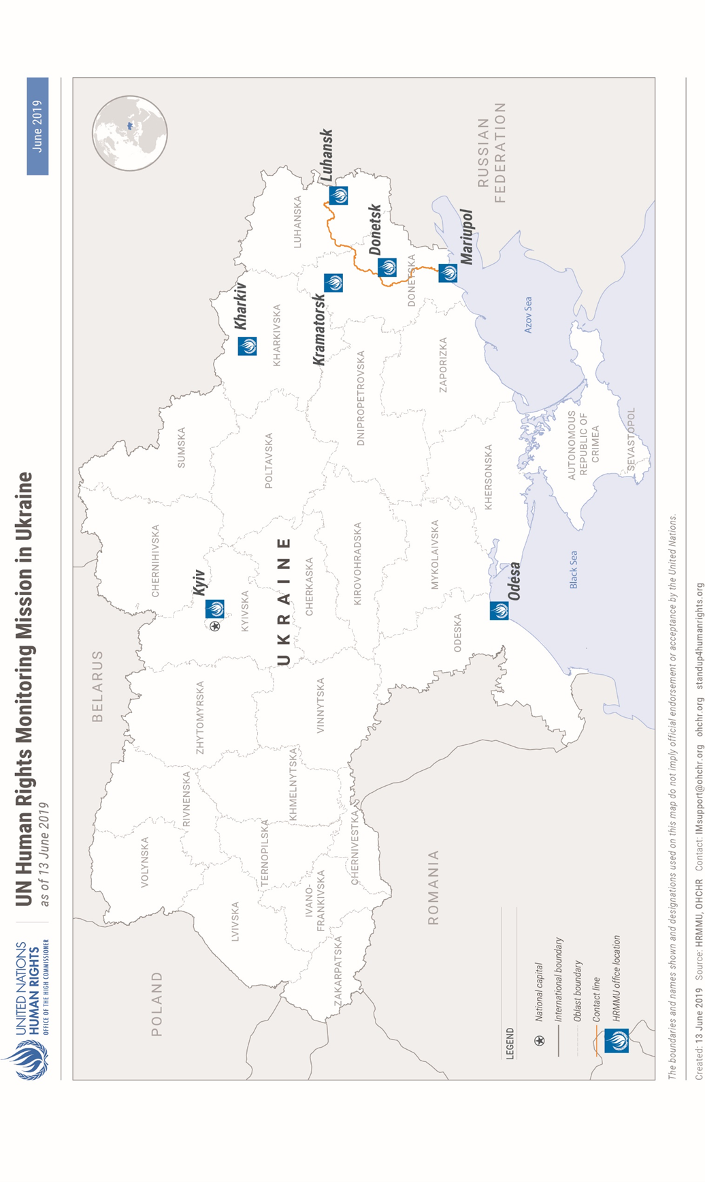

I. Executive summary
1. This twenty-eighth report by the Office of the United Nations High Commissioner for Human Rights (OHCHR) on the human rights situation in Ukraine covers the period of 16 August to 15 November 2019. It is based on the work of the United Nations Human Rights Monitoring Mission in Ukraine (HRMMU).
2. The report is based on 59 visits to settlements along the contact line, 21 visits to places of detention, 151 trial hearings monitored, 19 assemblies monitored, and 117 (with 80 men and 37 women) in-depth interviews, including with victims and witnesses of human rights violations and abuses, as well as relatives of victims and their lawyers, Government representatives, civil society and other interlocutors. It also considers the inherent link between human rights and sustainable development, noting that violations of economic, social, political, civil and cultural rights can impede Ukraine’s progress to deliver on the 2030 Agenda and its sustainable development goals (SDGs).
3. While political efforts to end the conflict continued, the civilian population residing close to the contact line experienced daily hardship due to ongoing hostilities, resulting in the continued degradation of their socio-economic rights. People living in remote communities close to the contact line that are considered “isolated”, due to disruption of road infrastructure, internal checkpoints, the contact line, as well as insecurity continued to experience difficulties accessing social benefits and essential public services, such as healthcare, medicines, and education.
4. During the reporting period, OHCHR recorded 42 civilian casualties (23 men, 12 women, two girls and five boys), six of whom were killed and 36 injured, representing a 38.2 per cent decrease in comparison to the previous reporting period. Twenty-one of these were caused by combat activities: 17 injuries (12 men and five women) were recorded in territory controlled by self-proclaimed ‘Donetsk people’s republic’, attributable to the Government of Ukraine. Two civilian injuries (a man and a woman) were recorded in Government-controlled territory, both attributable to armed groups of ‘Donetsk people’s republic’. A man was also injured in ‘no man’s land’ and a boy was injured in territory controlled by the self-proclaimed ‘Luhansk people’s republic’ with the attribution of these casualties pending as of 15 November. Mines and explosive remnants of war killed three men and three women, and injured five men, three women, four boys and two girls, on both sides of the contact line. In addition, a man was injured in a road incident with the military. The total civilian death toll of the conflict reached at least 3,344(1,807 men, 1,055 women, 98 boys, 49 girls and 37 adults whose sex is unknown, as well as 298 individuals who died on board of Malaysian Airlines flight MH17) as of 15 November 2019. The number of injured civilians is estimated to exceed 7,000.
5. Over 50,000 civilian homes have been damaged or destroyed due to hostilities on both sides of the contact line since mid-April 2014. The Government has failed to provide restitution or, compensation for civilian property lost or destroyed due to hostilities or military use of properties, although the inclusion of a budget line for this purpose in next year’s State budget is a positive sign.
6. OHCHR welcomes statements by various members of Parliament that pensions should be paid to all Ukrainian citizens without any discrimination as to their place of residence or registration. However, no practical mechanism has yet been established. As a result, hundreds of thousands of pensioners continued to be denied access to their pension payments.
7. While repairs were carried out at the bridge at Stanytsia Luhanska, the only entry-exit checkpoint (EECP) in Luhansk region, freedom of movement along the contact line remained affected by the conflict. People in the conflict zone of eastern Ukraine, including in the isolated villages continued to face limitations accessing basic goods and services such as healthcare and medication, food markets, social services and education. The lack of public transportation, employment and livelihood opportunities, in addition to the physical and economic insecurity, including due to mine contamination, further aggravated their situation.
8. Several allegations of extrajudicial executions and killings were received by OHCHR during the reporting period. OHCHR also documented cases of arbitrary detention, torture and ill-treatment in Government controlled-territory and in territory controlled by ‘Donetsk people’s republic’ and ‘Luhansk people’s republic’.
9. On 7 September 2019, a simultaneous release took place between Ukraine and the Russian Federation: 35 individuals were released by the Government of Ukraine, and 35 men by the Government of the Russian Federation, including the 24 Ukrainian crew members seized during the 25 November 2018 incident near the Kerch Strait. Some of the men released informed OHCHR of having been subjected to, inter alia, torture, ill-treatment, arbitrary detention, unlawful use of force and inadequate medical care while detained.
10. OHCHR welcomes the transfer of 54 pre-conflict prisoners (all men) from territory controlled by ‘Luhansk people’s republic’ to Government-controlled territory on 12 September 2019. OHCHR is aware of more prisoners who have expressed their desire to be transferred, and urges the continuation of this practice from territory controlled by both ‘Donetsk people’s republic’ and ‘Luhansk people’s republic’.
11. Violations of the right to a fair trial continued, notably in conflict-related criminal cases, stemming from ineffective judicial control of pre-trial detention, protracted trials and the poor quality of legal aid.
12. OHCHR reiterates once again its concerns regarding lack of accountability for the killings and violent deaths during the Maidan protests and in Odesa on 2 May 2014.
13. The President vetoed the Electoral Code and returned it for revision by the Parliament to ensure that, inter alia, it would enfranchise internally displaced persons (IDPs) in the coming 2020 elections, in line with OHCHR’s past recommendations.
14. OHCHR is concerned that, at least, five new attacks against media professionals and four attacks on civil society activists were documented during the reporting period, while accountability for past attacks is still lacking. In territory controlled by ‘Donetsk people’s republic’ and ‘Luhansk people’s republic’, OHCHR did not encounter any critical media content contradicting the political views supported by representatives of the ‘republics’ Social media is the only platform for public display of opinions, indicating that freedom of opinion and expression is severely restricted.
15. OHCHR commends the generally peaceful environment for OdesaPride and KharkivPride in August and September 2019 respectively. However, in Kharkiv, the police failed to provide sufficient security to participants before and after the event, when four men perceived to be members of the LGBTI community based on their appearance were attacked by extreme right-wing groups. OHCHR remains generally concerned about the human rights of LGBTI persons. During the reporting period, it documented in total eight physical attacks against LGBTI persons and individuals perceived to be members of the LGBTI community. Due to fears of retaliation in territory controlled by ‘Donetsk people’s republic’ and ‘Luhansk people’s republic’, the LGBTI community is compelled to remain invisible. More generally, in territory controlled by ‘Donetsk people’s republic’ and ‘Luhansk people’s republic’, OHCHR did not document any peaceful assembly organised on a voluntary basis. The ability to exercise freedom of religion also remained limited in both ‘republics’ due to restrictions imposed by self-proclaimed ‘authorities’.
16. OHCHR continued to document violations of international humanitarian law and international human rights law in the Autonomous Republic of Crimea and the city of Sevastopol, Ukraine, temporarily occupied by the Russian Federation (hereinafter Crimea), notably torture and ill-treatment and denial of medical care to persons apprehended and detained in Crimea and subsequently deported to the Russian Federation, and impunity in relation to these violations. Among the prisoners simultaneously released on 7 September 2019 were 29 men who had been initially detained in Crimea, including 24 crew members apprehended during the Kerch Strait incident in November 2018. The Russian Federation, as the occupying Power in Crimea, has still not granted OHCHR access to the peninsula, contrary to relevant UN General Assembly resolutions.
17. Technical cooperation and capacity-building activities continued over the reporting period, including regular training sessions for officers of the Civil-Military Cooperation Unit at the Ministry of Defence. Youth and minorities also benefited from OHCHR involvement at a variety of events.
18. While OHCHR has unimpeded access to places of detention in territory controlled by the Government, OHCHR operations in territory controlled by ‘Donetsk people’s republic’ and ‘Luhansk people’s republic’ have been substantively restricted since June 2018 despite ongoing discussions through regular meetings with representatives of both self-proclaimed ‘republics’. The continued denial of access to detention facilities, despite repeated requests prevents OHCHR from monitoring the treatment of detainees and detention conditions. This is particularly concerning in the context of strong allegations of human rights violations. OHCHR therefore reiterates its call for independent international observers, including OHCHR, to have unimpeded, confidential access to places of detention and detainees, in accordance with international standards.
II. OHCHR methodology
19. This report is based on 117 (with 80 men and 37 women) in-depth interviews with individuals, including victims and witnesses. Information was also obtained from relatives of victims and their lawyers, site visits, Government representatives, civil society and other interlocutors, trial monitoring, as well as court documents, official records, open sources and other relevant material. Findings are based on verified information collected from primary and secondary sources that are assessed as credible and reliable. Findings are included in the report where the “reasonable grounds” standard of proof is met, namely where, based on a body of verified information, an ordinarily prudent observer would have reasonable grounds to believe that the facts took place as described and, where legal conclusions are drawn, that these facts meet all the elements of a violation. While OHCHR cannot provide an exhaustive account of all human rights violations committed throughout Ukraine, it obtains and verifies information through a variety of means in line with its methodology, and bases its conclusions on verified individual cases.
20. OHCHR applies the same standard of proof when documenting conflict-related civilian casualties. In some instances, documenting occurrences may take time before conclusions can be drawn, meaning that numbers of civilian casualties are revised as more information becomes available. OHCHR applies the “reasonable grounds” standard in attributing a civilian casualty to a particular party based on the geographic location where it occurred, the direction of fire, and the overall context surrounding the incident.
21. Information in this report is used in full respect of informed consent by all sources as to its use as well as OHCHR’s assessment on the risk of harm that such use may cause. This may entail removing identifying details to ensure confidentiality of sources. In Government-controlled territory, OHCHR has freedom of movement and full, unimpeded access to all locations and individuals. In contrast, OHCHR operations in territory controlled by ‘Donetsk people’s republic’ and ‘Luhansk people’s republic’ are still substantively restricted since June 2018, despite ongoing discussions through regular meetings with representatives of both self-proclaimed ‘republics’.
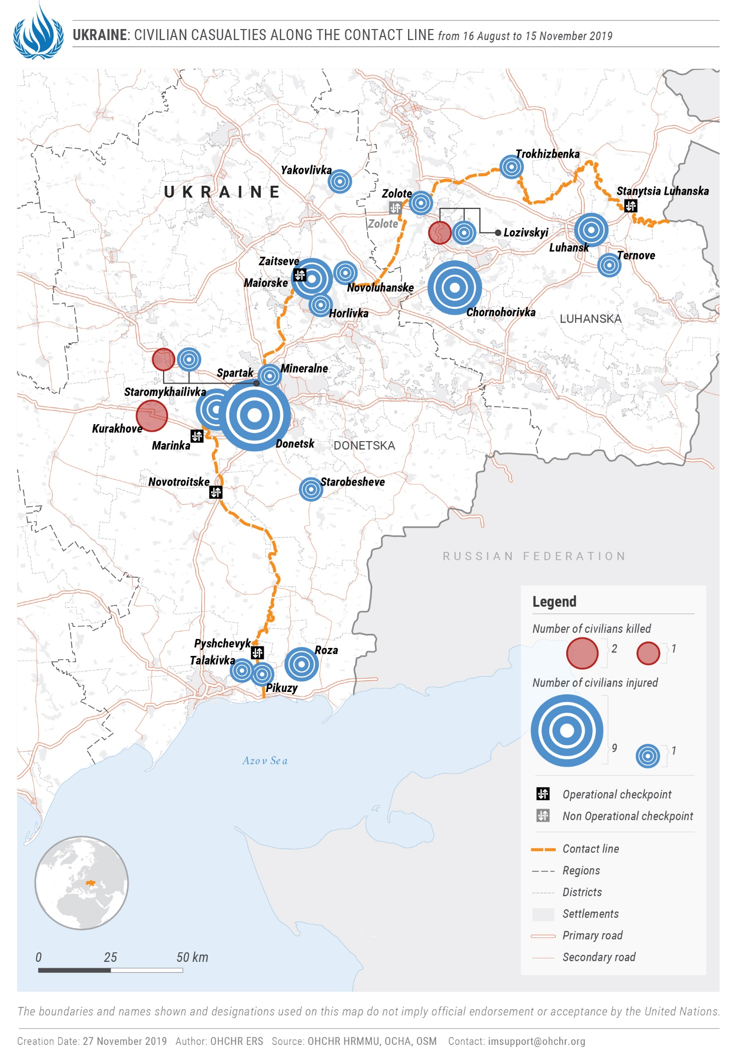
III. Impact of hostilities

A. Conduct of hostilities and civilian casualties
“We are people forgotten by God. Nobody needs us.”

- An older man living in Nevelske, a village affected by the armed conflict.
1. Current reporting period
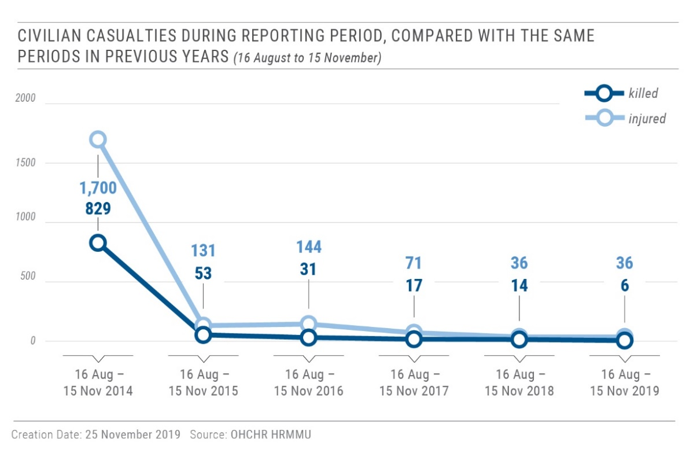
22. From 16 August to 15 November 2019, OHCHR recorded 42 conflict-related civilian casualties: six killed (three men and three women) and 36 injured (20 men, nine women, five boys and two girls). This is a 38.2 per cent decrease compared with the previous reporting period of 16 May to 15 August 2019 when 68 civilian casualties (eight killed and 60 injured) were recorded. This decrease can be attributed to the implementation of the ‘unlimited ceasefire’ since 21 July that was agreed in Minsk.
23. Shelling and small arms and light weapons (SALW) fire injured 21 civilians (14 men, six women and a boy). This is a 62.5 per cent decrease compared with the previous reporting period (five killed and 51 injured). Of them, 17 (12 men and five women) were recorded in territory controlled by ‘Donetsk people’s republic’, all attributable to the Government of Ukraine. Two civilians (a woman and a man) were injured in Government-controlled territory, both attributable to armed groups of ‘Donetsk people’s republic’. A man was also injured in ‘no man’s land’ and a boy was injured in territory controlled by ‘Luhansk people’s republic’ with the attribution of these casualties pending as of 15 November 2019.
24. For example, on 29 August 2019, a woman was injured by SALW fire in Government-controlled Novoluhanske (Donetsk region) while taking cover in her home’s summer kitchen. On 11 September 2019, three male staff of the ‘ministry for emergency situations’ of ‘Donetsk people’s republic’ received fragmentation injuries while putting out a house fire caused by shelling in western Donetsk. One of the men had his arm amputated. On 23 September 2019, a woman was injured during the shelling of armed group-controlled Pikuzy (formerly Kominterove, Donetsk region). She was in her backyard when she heard an explosion and felt pain in her right leg.
25. OHCHR remains concerned that ongoing hostilities continue to affect educational establishments located in close proximity to military positions and/or the contact line. During the reporting period, at least, four functioning schools and two functioning kindergartens (all in territory controlled by armed groups) were damaged by SALW fire. Although the incidents causing damage occurred at times when no children or personnel were present, and the damage was moderate (mostly damaged windows), OHCHR recalls that schools and kindergartens, as civilian objects, are protected under international humanitarian law, unless they are military objectives, and shall not be the object of attack.
26. Mine-related incidents and the handling of explosive remnants of war (ERW) resulted in 20 civilian casualties: three men and three women were killed, and five men, three woman, four boys and two girls were injured. Four civilians were killed in Government-controlled territory, one was killed and nine were injured in territory controlled by ‘Luhansk people’s republic’, and one was killed and five were injured in territory controlled by ‘Donetsk people’s republic’. In addition, a man was injured in a road incident with the military in the Government-controlled territory.
27. For example, on 28 September 2019, three boys and two girls were injured while walking in the woods near armed group-controlled Chornohorivka (formerly Krasna Zoria, Luhansk region), when one of them inadvertently triggered a hand grenade. On 5 October 2019, a man and a woman were killed as a result of the detonation of a hand grenade in their apartment in Government-controlled Marinka (Donetsk region). On 12 October, a woman and her adult son, along with a female friend, were injured when they inadvertently triggered an unidentified explosive while tending to a grave in armed group-controlled Donetsk.
2. Civilian casualties in 2019
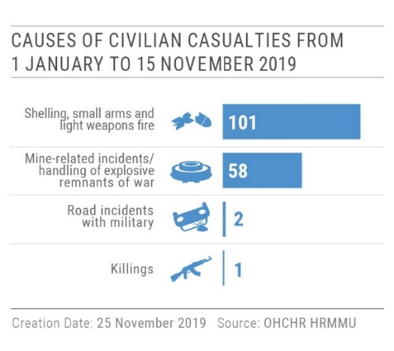
28. From 1 January to 15 November 2019, OHCHR recorded 162 conflict-related civilian casualties: 26 killed (15 men, ten women and a boy) and 136 injured (77 men, 39 women, 11 boys and nine girls). This is a 39.3 per cent decrease compared with the same period in 2018 (23 killed and 214 injured), and the lowest civilian casualties recorded for this calendar period during the entire conflict.
29. From 1 January to 15 November 2019, OHCHR recorded 101 civilian casualties caused by shelling and SALW fire (seven killed and 94 injured), a 32.7 per cent decrease compared with the same period in 2018 (21 killed and 129 injured). Of them, 65 (four killed and 61 injured; 64.4 per cent) were recorded in territory controlled by ‘Donetsk people’s republic’ and 18 (one killed and 17 injured, 17.8 per cent) in territory controlled by ‘Luhansk people’s republic’, 16 (two killed and 14 injured; 15.8 per cent) in Government-controlled territory, and two injured in ‘no man’s land’.
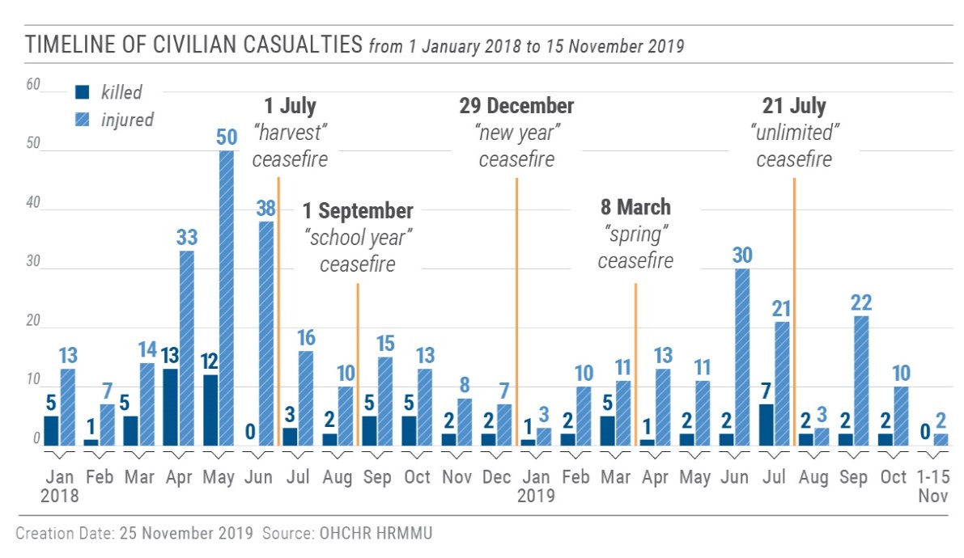
30. From 1 January to 15 November 2019, OHCHR recorded 58 civilian casualties (17 killed and 41 injured) resulting from mine-related incidents and ERW handling. While this is a 51.3 per cent decrease compared with the same period in 2018 (34 killed and 85 injured), these figures show that mine/ERW clearance and education in the conflict zone is still necessary.
3. Civilian casualties during entire conflict period
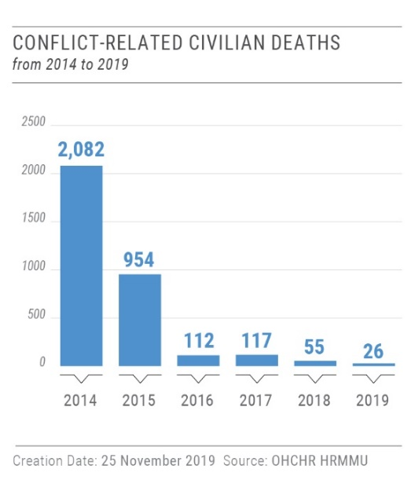
31. During the entire conflict period, from 14 April 2014 to 15 November 2019, OHCHR recorded in total 3,046 conflict-related civilian deaths (1,807 men, 1,055 women, 98 boys, 49 girls and 37 adults whose sex is unknown). Taking into account the 298 deaths on board of Malaysian Airlines flight MH17 on 17 July 2014, the total civilian death toll of the conflict has reached at least 3,344. The number of injured civilians is estimated to exceed 7,000.

4. Remedy and reparation to civilian victims of the conflict
32. OHCHR welcomes the allocation in the State budget of 40 million UAH (16.6 million USD) for compensation to civilian victims of the conflict. This is the first time such an allocation has been made. OHCHR also notes five positive decisions by courts of first instances on compensation to civilian victims of the conflict, awarding approximately 500,000 UAH (21 000 USD) each on average. For example, on 15 October 2019, the Zhovtnevyi district court of Mariupol allocated compensation of one million UAH to the family of a civilian man who was killed as result of hostilities in the village of Shyrokyne (Donetsk region) on 15 February 2015. However, OHCHR notes that a comprehensive State policy of remedy and reparation to civilian victims of the conflict is still lacking, and urges the Government and Parliament of Ukraine to develop such a policy in accordance with international standards.
B. Economic and social rights of conflict-affected persons and freedom of movement
“Our pensions are ridiculous […] I only have 1,500 UAH [63 USD]. How can I survive? I have to pay utility bills and I need 400 UAH just to travel outside the village to see doctors and buy medicine.”

- A pensioner, explaining his problem with the lack of public transport and low pensions in Vidrodzhennia.
33. The socio-economic situation of the conflict-affected population, representing 5.2 million men, women and children, remained bleak. Conflict-affected families, including those living in isolated settlements in the affected areas continued to have limited access to basic goods and services such as healthcare and medication, markets, social services and education. The lack of public transportation, employment and livelihood opportunities, in addition to the physical and economic insecurity, including due to mine contamination, further aggravated their situation. A comprehensive State approach promoting their social and economic rights is urgently required. It would demonstrate commitment to the 2030 Agenda at the national level, giving substance to the President’s decree of 30 September 2019 to ensure compliance with SGDs, and positively impact the pace and effectiveness of local efforts aimed at achieving sustainable development.
1. Housing, land and property rights
34. Over 50,000 civilian homes have been damaged or destroyed due to hostilities on both sides of the contact line since the beginning of the conflict. The Government has provided compensation and/or adequate alternative housing (as a temporary measure), through local authorities to a limited number of affected families. This has not been done in a regular or consistent manner. OHCHR welcomes the commitment of the Cabinet of Ministers to further amend Resolution No. 947 of 18 December 2013 in order to improve the access of the affected population to compensation. OHCHR recalls that Ukraine has committed to providing access to adequate, safe and affordable housing and basic services under SDG 11. However, a comprehensive and non-discriminatory State policy of restitution and compensation for damaged and destroyed housing and property is still lacking.
35. OHCHR continued to document cases of military use of civilian property, which resulted in looting and destruction of property in some cases, and a failure to provide adequate alternative housing and/or compensation. Furthermore, the military failed to pay the bills stemming from their use of utilities such as electricity, leaving owners with large debts.
36. For example, in Government-controlled Verkhnotoretske (Donetsk region), a family of retirees informed OHCHR that in 2014, their home was damaged by shelling and they were forced to leave due to general insecurity. From 2015 to 2018, their home was used by the military and was looted. The family applied to local authorities and the police seeking compensation for the damages and an investigation into the pillage. In the last four years, the police has not effectively investigated the complaint. The local authorities did not provide any compensation or alternative temporary housing to the family. The family was only able to return to their home in 2018, when the house was vacated by the military and partly rebuilt by a humanitarian organisation.
37. OHCHR also documented the case of a family who was forced to leave their home in the part of Zolote-4 that came under the control of armed groups in October 2018 due to the active hostilities at the time. They were forced to move to a rented apartment in Zolote-5, a nearby location. One of the family members then lost his job, placing the family in financial difficulty. The family received no housing support nor have they been able to visit and maintain their property, reportedly due to the presence of mines.
2. Right to social security and social protection
38. OHCHR welcomes the statement by the chair of the Parliamentary Human Rights Committee that pensions should be paid to all eligible individuals without any discrimination based on place of residence or registration. The current policy requiring pensioners registered in territory controlled by ‘Donetsk people’s republic’ and ‘Luhansk people’s republic’ to register as IDPs in Government-controlled territory and regularly undergo verification process to receive pension payments has caused hundreds of thousands of pensioners to lose their pension payments. OHCHR calls on the Parliament and Cabinet of Ministers to undertake practical actions to ensure full access to pensions and social entitlements for all eligible individuals, and to delink the payment of pensions from IDP registration. This would contribute towards Ukraine’s implementation of SDG 10, by ensuring access to social services and reforming pension insurance based on principles of fairness and transparency. It would also contribute to social inclusiveness among the population affected by the conflict.
3. Freedom of movement, isolated communities and access to basic services
39. During the reporting period, civilians crossed the contact line between Government-controlled territory and territory controlled by ‘Donetsk people’s republic’ and ‘Luhansk people’s republic’ more than 3.5 million times, often facing physical difficulties due to the insufficient number of EECPs, especially in Luhansk region, and arduous crossing conditions. Positive developments were observed at the EECP Stanytsia Luhanska (Luhansk region) where a temporary bypass had been functioning from 4 October, and repairs to the broken bridge were in the process of being completed as of 15 November. The repairs to the bridge will significantly facilitate freedom of movement, alleviating the daily suffering that people face while traversing this pedestrian crossing. However, this EECP remains the only crossing point serving the entire region. Efforts to open up additional crossing points must be scaled up.
40. OHCHR welcomes the decision of the Government to terminate the enforcement of the Resolution regulating the movement of individuals and transfer of goods across the contact line pending its revision, including to simplify the crossing of children under the age of 14 who do not have a valid passport. OHCHR recalls that in order to facilitate freedom of movement and the right to an adequate standard of living, individuals should be able to transfer their personal belongings without unnecessary restrictions.
41. Restrictions on freedom of movement in villages close to the contact line, such as Government-controlled Lobacheve, Lopaskyne, and Novooleksandrivka, curb the civilian population’s enjoyment of their socio-economic rights. For example, the approximately 18 residents of Novooleksandrivka have lost access to basic services. Electricity to the village has been cut since the beginning of the conflict, and the roads have been blocked. Ambulances cannot reach the village and there are no hospitals, pharmacies, or public transport in the village. These issues are not being addressed in part due to the Government’s failure to assign responsibility for the village to any local authority.
4. Registration of birth and death
42. On 23 October 2019, the Cabinet of Ministers approved regulations introducing an administrative procedure to simplify the registration of births and deaths occurring in territory controlled by the self-proclaimed ‘republics’. While OHCHR has long recommended that the procedure be simplified, the regulations still require an additional administrative layer in the civil registration process, reportedly to address concerns about the authenticity of documents issued in territory controlled by the self-proclaimed ‘republics’. Thus, the new procedure, which has yet to be tested in practice, does not appear to have any considerable advantages in terms of time and effort over the existing simplified court procedure, except for the absence of fees. The regulations also do not cover births and deaths occurring in Crimea, which still require judicial involvement. OHCHR recalls that birth registration for all is a global SDG target.
IV. Right to liberty and security of persons
A. Access to places of detention
43. OHCHR continued to be denied access to places of detention in territory controlled by ‘Donetsk people’s republic’ and ‘Luhansk people’s republic’, and remains gravely concerned about the treatment of detainees, detention conditions and the lack of independent oversight in light of credible allegations of human rights violations in these facilities.
44. OHCHR continued to be denied access to places of detention in territory controlled by ‘Donetsk people’s republic’ and ‘Luhansk people’s republic’, and remains gravely concerned about the treatment of detainees, detention conditions and the lack of independent oversight in light of credible allegations of human rights violations in these facilities.
B. Killings and extrajudicial executions
45. During the reporting period, OHCHR received several allegations of killings or extrajudicial executions in Government-controlled territory and in territory controlled by ‘Donetsk people’s republic’.
46. For example, on 11 July 2019, a man with a disability residing in armed group-controlled Donetsk visited relatives in Government-controlled Konstantynopolske village (Donetsk region). According to court documents, at least three Ukrainian Armed Forces (UAF) soldiers arbitrarily detained him due to his alleged membership in an armed group. They drove him to a forested area where they threatened to execute him. Afterwards, they drove him to the location of a military unit where they again forced him to confess to his alleged membership in an armed group. When the perpetrators realized the victims was not affiliated with the armed groups, they attempted to conceal their crimes; they drove him to Marinka and shot him dead with at least seven bullets to his head and back. On 2 August, the victim’s body was found in a sceptic tank on the outskirts of Marinka. On 16 August, Zhovtnevyi district court placed three UAF soldiers in custody for sixty days. In October, the Marinskyi district court initiated a trial against UAF soldiers, accused under articles 115-2 (murder), 146-3 (abduction), and 187-2 (brigandism) of the Criminal Code.
47. In another case, on 16 September 2019, a man released from custody to house arrest was shot seven times and killed inside his flat in Mariupol by (an) unidentified individual(s). He was initially detained on 16 September 2017 and charged under article 258-3 (membership in a terrorist group or terrorist organisation) of the Criminal Code. On 5 August 2019, the court released him under house arrest, which triggered public outcry on social media. He was identified as a separatist and labelled an enemy for his participation in armed groups by the Myrotvorets (‘Peacekeeper’) website, which also published his home address. OHCHR recalls that States have an obligation to exercise due diligence to protect persons from threats to their lives by third parties, including by taking adequate measures of protection where they know, or ought to know, that lives are at risk. The investigation into his death should be prompt, impartial and effective, and the perpetrators brought to account.
48. On 22 May 2019, eight UAF soldiers were apprehended by armed groups near Olenivka checkpoint. One soldier was reportedly ‘sentenced’ by a ‘court’ of the ‘Donetsk people’s republic’ and held in Makiivka penal colony No. 97. On 14 October 2019, he was found dead in his cell. Circumstances surrounding the case raise suspicions that his death may have been violent.
C. Arbitrary detention, torture and ill-treatment
49. During the reporting period, OHCHR documented cases of arbitrary detention, torture and ill-treatment occurring in Government-controlled territory, in territory controlled by ‘Donetsk people’s republic’ and ‘Luhansk people’s republic’ and in the Russian Federation after their transfer from self-proclaimed ‘republics’.
50. For example, on 30 July 2019, in Government-controlled territory, approximately ten armed men wearing masks and camouflage without insignia violently searched and abducted a man in front of his family and neighbours. They took him to a garage where he was waterboarded, threatened and severely beaten, although the perpetrators attempted to avoid leaving bruises. They tried to force him to confess to participating in armed groups, to being a Russian agent, and to give them access to his social media accounts. After being detained overnight in the garage, the man was taken home to freshen up whilst under guard before being taken to the old SBU building to give his testimony to a ‘kurator’. Around 10pm, the ‘kurator’ told the man he was allowed to go home on ‘house arrest’ and warned him to stay there or risk further violence. Over the following week, the man was repeatedly taken to the old SBU building and interrogated without a lawyer. He was finally instructed by the ‘kurator’ to make the same confessions when presented to a prosecutor. On 6 August, the Kramatorsk City Court placed him in pre-trial detention for 60 days, charging him under article 258-3 (creating a terrorist group or terrorist organization) of the Criminal Code of Ukraine. On 12 August, his lawyer submitted a complaint to the court about his ill-treatment. However, a criminal complaint under article 365-2 (excess of authority or official powers) of the Criminal Code was only registered by the State Bureau of Investigation (SBI) on 21 August 2019, after the lawyer complained in court about the SBI investigator’s inaction. As of 15 November, he remained under investigation, in pre-trial detention.
51. OHCHR is concerned by the practice of detaining, often incommunicado, and torturing individuals by the ‘ministry of state security’ in ‘Donetsk people’s republic’ or ‘Luhansk’s people’s republic’, before they are expelled to the Russian Federation or transferred to Russia Federation authorities. Incommunicado detention, constitutes arbitrary detention, and increases risk of torture and ill-treatment, as described in the following cases. The expulsions and transfers amount to forced movement of civilians prohibited by international humanitarian law, and where there are substantial grounds for believing that torture may occur, it may amount to a violation of the obligation of non-refoulement.
52. For example, on 17 December 2018, a man was detained by the ‘ministry of state security’ of ‘Donetsk people’s republic’ at the ‘Uspenka’ border crossing point with the Russian Federation in territory controlled by ‘Donetsk people’s republic’. He was detained incommunicado under the 30-day ‘administrative arrest’ procedure, which was prolonged for another 30 days. During his detention, he was tortured, including with electricity, until he confessed to having cooperated with the SBU. On 18 February 2019, ‘ministry of state security’ agents took the man to the border crossing point, where he was forced to cross and was immediately apprehended by the Federal Security Service (FSB) of the Russian Federation. He was driven to Krasnodar in the Russian Federation and charged with administrative offences. After he had served the detention period under the administrative procedure, the court ordered him deported. However, on 30 April 2019, he was charged with arms smuggling and remains detained in Krasnodar.
53. On 26 August 2016, a man was detained near the town of Rovenky in territory controlled by ‘Luhansk’s people’s republic’, by two armed men in military uniform. They brought him to the facilities of a mine, where he was detained overnight, sleeping in an old wooden chair, guarded by an armed man. He was not provided water or food, and was not allowed to use the restroom. A few days later, he was taken to the ‘ministry of state security’ building in Luhansk, where he was detained for several weeks alone in a cell with the lights on all day and night. He was pushed down the stairs, thrown against a wall, and forced to wear a plastic bag over his head whenever he was moved from his cell. Members of the ‘ministry of state security’ threatened further violence to him and to his family if he did not confess to preparing a terrorist attack. During his interrogations, the men slapped and kicked him, and knocked a chair from under him, throwing him to the floor. On 22 September 2016, ‘ministry of state security’ personnel put a plastic bag over his head and took him across the border into the Russian Federation, where they handed him over to the FSB. Between 23 and 27 September, he was interrogated in Morozovsk by FSB officers who tortured and ill-treated him with beatings and electroshocks, causing him to lose consciousness several times. On 27 September, he agreed to confess to preparing a terrorist attack, after which he was held in SIZOs in Rostov-on-Don and in Samara. In November 2017, he was convicted of preparing a terrorist attack and illegally crossing the border and transferred to a penal colony in Irkutsk to serve his sentence, until his release to Ukraine on 7 September 2019.
D. Situation of pre-conflict prisoners
54. OHCHR welcomes the transfer of 54 pre-conflict male prisoners on 12 September 2019 from penal colonies in territory controlled by ‘Luhansk people’s republic’ to Government-controlled territory. OHCHR calls for the continuation of such transfers from penal colonies in territory controlled both by ‘Donetsk people’s republic’ and ‘Luhansk people’s republic’, as OHCHR is aware of additional prisoners who want to be transferred, inter alia, to maintain contact with their relatives living in Government-controlled territory.
E. Missing persons
55. The Commission on Persons Missing due to Special Circumstances, established in April 2019, has yet to launch its work. A step forward in ensuring the implementation of the law on missing persons was the approval by the Cabinet of Ministers, on 14 August, of a regulation on the management of the register of missing persons, which is yet to be created by the Ministry of Justice.
V. Administration of justice and accountability
“As long as you’re making these motions [to acquaint himself with the case materials], you will sit [in detention].”

- The presiding judge, to a defendant in a conflict-related case.
A. Administration of justice in conflict-related cases
56. During the reporting period, OHCHR continued to document violations of fair trial rights in conflict-related criminal cases stemming from ineffective judicial oversight of pre-trial detention, protracted trials, and the poor quality of legal aid.
57. Between 16 August and 15 November 2019, courts of first instance passed 72 verdicts against 72 individuals in conflict-related criminal cases. Of these, two defendants were acquitted, 70 were found guilty, including five in absentia.
58. OHCHR has been monitoring the implementation of the 25 June 2019 Constitutional Court decision to annul a provision requiring automatic pre-trial detention in conflict-related criminal cases. Ukrainian courts must now apply pre-trial detention only as an exceptional measure, in line with international human rights standards.
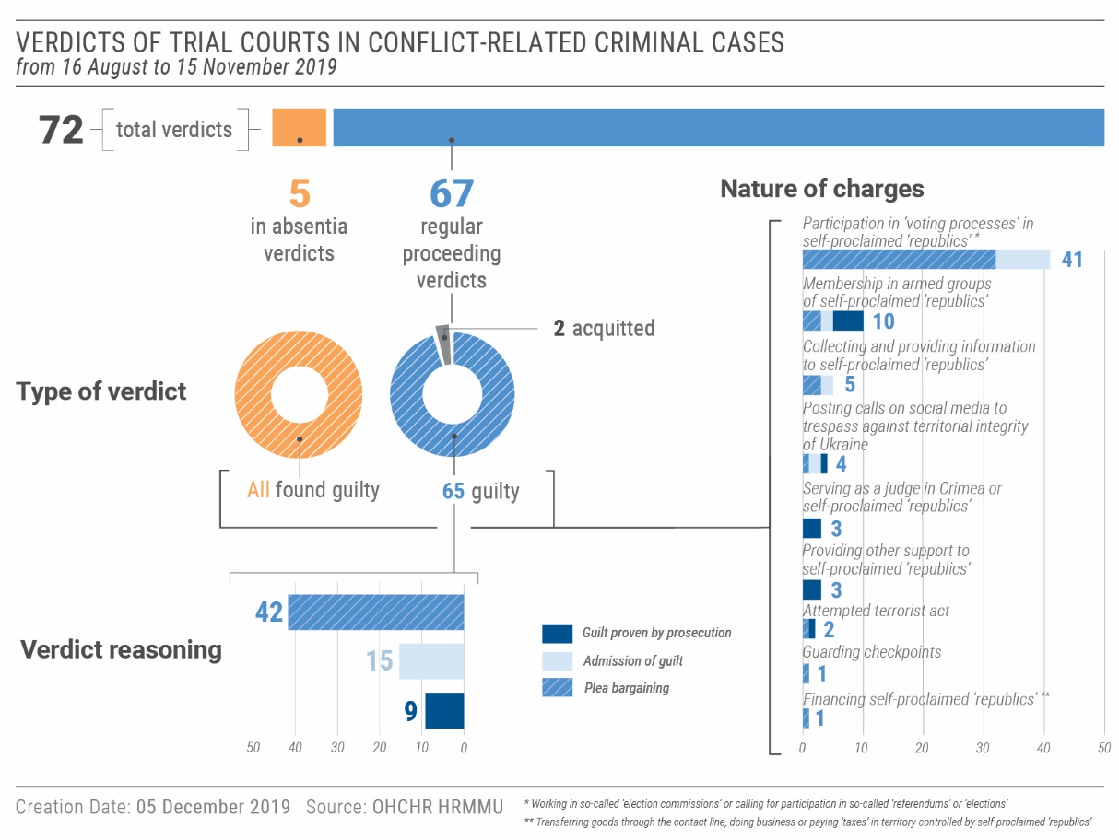
OHCHR is concerned, however, that courts have not granted bail in cases involving non-violent crimes where the defendant had previously complied with bail requirements. In, at least, seven cases during the reporting period, courts denied such individuals release on bail.
59. OHCHR continued to document violations of the right to trial without undue delay. During the reporting period, in three cases OHCHR observed that judges unreasonably failed to consider the merits of conflict-related criminal cases, and held hearings only once every two months, for the sole purpose of extending the defendants’ custody. In 32 cases followed by OHCHR, defendants had been in pre-trial detention for more than three years. Prosecutors’ failure to ensure prompt proceedings also contributed to delays. OHCHR observed that prosecutors in conflict-related cases failed to appear for hearings, and failed to submit evidence or bring witnesses in a timely manner. In one case, a trial court adjourned a hearing for two months in a trial that had already been running for one and a half years due to the failure of the substitute prosecutor to submit evidence to the court. While this blocked consideration of the case on its merits and delayed the trial even further, the prosecutor stated during a hearing that he was only present in court to request the extension of pre-trial detention.
60. OHCHR recalls that expeditiousness is an important aspect of the fairness of trials, particularly in cases where individuals are held in pre-trial detention. It is the duty of Ukrainian courts to guarantee the right of all individuals to a trial without undue delay by ensuring that all parties to the proceedings comply with their procedural duties. The courts must also consider alternatives to pre-trial detention in order to avoid extremely prolonged custody of the defendants. In this context, OHCHR welcomes legislative amendments adopted on 4 October 2019 that annulled rules of the Criminal Procedure Code that caused significant delays in pre-trial investigation and trials and simplified the procedure for conducting preliminary hearings.
61. OHCHR documented violations of the right to legal assistance, which were caused by both a lack of access to legal counsel immediately after apprehension, and the poor quality of legal services provided by free legal aid lawyers. Individuals complained to OHCHR that state-appointed lawyers made no effort to protect them and even gave legal advice that contravened their interests. In one emblematic conflict-related criminal case, a lawyer agreed that a hearing be held in the absence of his client who was not brought to the court from the SIZO, despite the presence of the defendant being mandatory under the criminal procedure code. OHCHR recalls that legal counsel provided by the competent authorities must provide effective representation of the accused. OHCHR therefore encourages the Coordination Centre for Free Legal Aid Provision to conduct effective periodic assessments of the quality of legal services provided by lawyers working with free legal aid centres, and to establish a system for remedial action where required to ensure the quality of free legal aid in individual cases.
B. Accountability for human rights violations
62. OHCHR observed limited progress in the criminal proceedings related to the killings and violent deaths which occurred during the Maidan protests and 2 May 2014 clashes in Odesa.
1. Accountability for killings and violent deaths during the Maidan protests
63. OHCHR notes that some trial hearings in relation to the killings and violent deaths of protestors during the Maidan events were held over the reporting period. However, OHCHR also notes that as of 21 November 2019, the Special Investigation Department (SID) will no longer have investigative functions as the three-month transition period for transfer of some 5,000 investigation dossiers from SID to the State Bureau of Investigations (SBI) commences. OHCHR is concerned that any delays in the transfer of the cases may hamper accountability efforts, as investigations are stalled while the transfers are pending.
2. Accountability for killings and violent deaths in Odesa on 2 May 2014
64. OHCHR notes that trials are ongoing in criminal proceedings related to the killings and violent deaths in Odesa on 2 May 2014, including the trial against the former Head of Odesa regional police.
65. The trial of the pro-unity supporter accused of killing one man and injuring two others also continued. OHCHR observed the presence of a large number of members of extreme right-wing groups supporting the defendant, many of whom had supported him in the past. Recalling earlier attempts of members of the same groups to exert pressure on the judges and disrupt proceedings in this and other 2 May 2014 related trials, OHCHR is concerned that their presence may have a chilling effect on the judges’ and the jury’s independence in this case. Lack of accountability for past attempts to interfere with the independence of judges has contributed to the situation where the judges and jury do not feel protected. OHCHR calls on the police to investigate all previous attacks against judges and to ensure security of the courtrooms during high-profile hearings.
66. No progress was observed in the prosecutions of three high-ranking Odesa police officers, two former deputy heads and two mid-level officers of the Odesa regional department of the State Emergency Service. As of 15 November 2019, the courts had yet to substantially consider these cases.
VI. Civic space and fundamental freedoms
67. While tensions between supporters of different political parties gradually decreased following Parliamentary elections in July 2019, OHCHR documented 16 new attacks in the civic space during the reporting period, against 18 individuals, namely journalists, human rights defenders, activists and members of the LGBTI community.
A. Right to vote
68. On 13 September, the President of Ukraine vetoed the Electoral Code and returned it for Parliament’s revision with his comments, which included the need to enfranchise IDPs in the upcoming 2020 elections and to strengthen the guarantees on accessible voting procedures, facilities and materials for persons with disabilities. These comments reflect recommendations made by OHCHR.
B. Freedom of opinion and expression and freedom of the media
69. OHCHR documented five physical attacks against media professionals (all men). On 31 August 2019, a journalist was physically attacked in Vinnytsia in retaliation for his critical publications towards the leader of a political party who participated in elections. The perpetrators asked the victim before the attack whether he was the author of these critical articles.
70. During the reporting period, OHCHR continued to monitor the situation with TV channels “112”, “NewsOne” and “ZiK”, following the resolution adopted by the Parliament on 17 October 2019 establishing a temporary investigative commission aiming to, inter alia, counter the influence of the Russian Federation in the media. OHCHR encourages the Government to support an environment where different and opposing views can be shared and debated freely, and cautions the Government from placing disproportionate restrictions on freedom of expression, including restrictions that may trigger self-censorship.
71. The National Police closed their investigation into the assault of two Pokrovsk media workers during the election campaign in August 2019, reportedly due to the lack of corpus delicti. OHCHR notes, however, that the police failed to question witnesses and examine video footage of the attack, which could have helped support claims with evidence.
72. On 28 October 2019, one and a half months after receiving a crime report on allegations of online bullying of two female civil society activists who advocate against sexism, the cyber police department of National Police in Kyiv declined to register it in the Unified Register of Crimes and forwarded the report to another police department.
73. OHCHR is alarmed by new acts of intimidation and violence against civil society activists. In one case, on 8 November 2019, two unidentified individuals beat and used tear gas against an anti-corruption activist, a member of a newly-established commission responsible for qualification assessments of prosecutors, near his home in Kyiv. OHCHR calls for an effective investigation into the attack and its motives, as there are grounds to believe it was related to the victim’s professional activities.
74. In the second half of August 2019, OHCHR learnt that several individuals residing in armed group-controlled Donetsk who helped individuals file complaints to the International Criminal Court and European Court of Human Rights were charged under Article 258-3 of the Criminal Code (“creation of a terrorist group or terrorist organization, leadership of such group or organization or participation in it, as well as material, organizational or other facilitating the creation or operation of a terrorist group or terrorist organization”).
75. OHCHR recalls that “everyone has the right, individually and in association with others, to unhindered access to and communication with international bodies”. OHCHR considers that criminal charges based on provision of assistance to exercise this right to be an infringement on a human rights activity. It also appears to demonstrate an abusive recourse to counter-terrorism legislation. OHCHR is also concerned that these charges have already had a chilling effect on the enjoyment of the right to seek legal redress in international courts by residents of Ukraine.
76. In territory controlled by ‘Donetsk people’s republic’ and ‘Luhansk people’s republic’, several interlocutors informed OHCHR that media professionals residing in this area refrain from expressing critical views due to fear of retaliation. This was confirmed by OHCHR observations on the absence of critical media content that contradict mainstream political views supported by representatives of the ‘republics’. OHCHR monitoring found that social media was the only platform available to residents to express their views on the current political, social, economic situation in this territory.
77. OHCHR condemns the ‘sentencing’ of a journalist who contributed to Ukrainian and international outlets, Stanislav Aseyev, to 15 years of imprisonment by a ‘court’ of ‘Donetsk people’s republic’, which held proceedings in camera. Reportedly, the espionage and extremism ‘charges’ were partially based on his publications criticizing the self-proclaimed ‘republic’. As of 15 November 2019, blogger Oleh Halaziuk remained detained in territory controlled by ‘Donetsk people’s republic’ for over two years.
78. OHCHR is concerned that civil society activists and journalists continue to be targeted across Ukraine. Failure to hold to account perpetrators responsible for such attacks, including a lack of effective criminal proceedings, emboldens perpetrators, leading to more violence.
C. Freedom of peaceful assembly and freedom of association
79. OHCHR monitored the OdesaPride and KharkivPride events held in August and September respectively. While counter-demonstrators protested against both, the marches were generally peaceful. OHCHR welcomes the coordinated actions of local authorities and police in providing security during OdesaPride. OHCHR further commends the organisers, local authorities and police for successfully enabling the first Pride march in Kharkiv, gathering an estimated 1,200 to 2,000 participants. Nonetheless, in Kharkiv, police failed to provide sufficient security at the site before and after the event, when four individuals were attacked by members of extreme right-wing groups (see section E below).
80. In territory controlled by ‘Donetsk people’s republic’ and ‘Luhansk people’s republic’, OHCHR did not observe any voluntarily-organised assemblies, which may indicate residents’ fear of possible retaliation if they voice critical opinions.
D. Freedom of religion or belief
81. OHCHR received information that some religious communities in territory controlled by ‘Donetsk people’s republic’ and ‘Luhansk people’s republic’ remain unable to conduct worship meetings due to fear of arbitrary arrests or seizure of property. Several religious organisations suspended their public activities after obligatory ‘registration’ of religious organisations was rolled out in both ‘republics’ between autumn 2018 and spring 2019.
E. Discrimination, racially-motivated violence and manifestations of intolerance against minorities
82. OHCHR notes that Ukraine will participate in the 2020 voluntary national review by the High-Level Inter-Ministerial Working Group on Coordination of Implementation and Monitoring of the Sustainable Development Goals, during which Ukraine’s efforts to combat discrimination will be monitored under SDG 16. This requires States to promote peaceful and inclusive societies for sustainable development, provide access to justice for all and build effective, accountable and transparent institutions at all levels. Under SDG 10, Ukraine has also committed to prevent manifestations of discrimination in society.
83. During the reporting period, OHCHR documented eight new attacks against representatives of the LGBTI community.
84. For the first time, a group of active and former military personnel openly participated in KyivPride held on 23 June. Two of them were subsequently attacked due to their sexual orientation, in separate incidents. On 29 August 2019, a former serviceman was hit in the head and insulted with homophobic expressions by another serviceman in central Kyiv. On 28 September 2019, another former serviceman was attacked near his house in Kyiv by five unknown men who first insulted him about his sexual orientation and physically attacked him. Police initiated a criminal investigation which takes into account the hate motives of the attack during the classification of the case. OHCHR welcomes this classification, and calls for an effective investigation and prosecution.
85. OHCHR is concerned that, both before and after the KharkivPride march on 15 September 2019, four men, allegedly, perceived to be members of the LGBTI community based on their clothing, were brutally attacked by people affiliated with extreme right-wing groups in the presence of police. The police failed to both adequately protect the victims and apprehend the attackers. Furthermore, police only initiated a criminal investigation into one of the attacks involving one of the victims, despite video and photo footage of all the attacks being widely available online. Furthermore, the investigation does not take into account the hate motive of the attack.
86. OHCHR has been informed that due to fear of retaliation in territory controlled by ‘Donetsk people’s republic’ and ‘Luhansk people’s republic’, organisations and civil society activists representing the LGBTI community refrain from public appearances, advocacy or holding public events aimed at raising awareness of LGBTI rights. Outspoken members of the LGBTI community have had to leave the territory due to fear of persecution.
F. Language rights
87. Noting the visit of the Venice Commission to Ukraine in October 2019, OHCHR reiterates its concerns previously raised regarding legislation on language rights. OHCHR remains ready to provide support to the Government in the development of the draft law on the realisation of the rights of indigenous peoples and national minorities of Ukraine, to address, as a matter of priority, the gap in national legislation on language policy.
88. The adoption of such legislation will support Ukraine’s commitment under SDG 10 to prevent manifestations of discrimination in society.
VII. Human rights in the Autonomous Republic of Crimea and the city of Sevastopol, Ukraine, temporarily occupied by the Russian Federation
89. During the reporting period, OHCHR continued to document cases of torture and other ill-treatment inflicted by the Russian FSB and penitentiary workers on persons apprehended and detained in Crimea and subsequently deported to the Russian Federation. In some cases, detainees with medical needs were not provided with basic medical care. Some victims and their lawyers brought incidents of torture and ill-treatment to the attention of the Courts, at the pre-trial stage as well as during their trials. While in some cases pro-forma investigations reportedly took place, no prosecutions resulted. Those detainees originally from Crimea had Russian Federation citizenship imposed upon them, which formed the basis of denial of Ukrainian consular visits to their places of detention in the Russian Federation.
“I was going crazy because of the solitude. I didn’t know what would happen next. I was thinking that perhaps my life was over now. .. I didn’t even know where I was, I only knew that it was Moscow… No one told me what would happen next.”

- A detainee describing solitary confinement and absence of contact with the outside world.
A. Incident near the Kerch Strait
90. During the simultaneous release on 7 September 2019, the Russian Federation released 24 Ukrainian crew members (all men) seized during the 25 November 2018 incident near the Kerch Strait. The crew members, three of whom sustained injuries during the apprehension, spent over nine months detained in Crimea and the Russian Federation on charges of illegally crossing the Russian border.
91. The crew members told OHCHR that they were subjected to ill-treatment by the Russian FSB after their vessels had been seized in the Black Sea. In particular, when the crew members were lined up on their knees on the deck with their hands cuffed behind their backs, the Russian officers pointed guns at their heads and threatened to shoot. Some of the crew members were forced to kneel for a prolonged period of time without a clear reason. Upon arrival at a military base in Kerch, the crew members were interrogated, during which, at least one crew member was subjected to psychological intimidation and threats. The FSB officers, in the presence of a free legal aid lawyer, intimidated the victim by continuously jabbing his shoulder with significant force while verbally insulting him. Several crew members complained that their requests to inform their relatives about their arrest and whereabouts were denied.
92. OHCHR established that, on 27 November 2018, a local court in Simferopol held accelerated bail hearings for 21 crew members without conducting a proper examination of the merits of each case or assessing the justification for pre-trial detention. These hearings were described as pro forma, lasting no longer than 15 minutes each. The following day, hearings concerning the remaining three wounded crew members were similarly held in the Kerch city hospital.
93. Several crew members complained that they were ill-treated by FSB officers during their transportation from Simferopol to Moscow on 30 November 2018. One crew member was forced to walk despite having shrapnel wounds in his leg received at the time of his apprehension, which caused him severe pain and suffering. Others were forced to walk with their heads bent below their knees while their arms were handcuffed behind their backs.
94. Once detained in Moscow, all crew members were placed in solitary confinement with no contact with the outside world for periods ranging from three to eleven days. During their isolation, they had no access to natural light, exercise, TV, radio, newspapers or cigarettes. In addition, the injured crew members complained of inadequate healthcare and a lack of information provided on their medical well-being. Allegedly, the SIZO medical staff repeatedly failed to change one of the victims’ bandages in a timely manner, ignored his health complaints, refused to provide him with his medical records, and even misinformed him that he had hepatitis.
B. Situation of detainees released from the Russian Federation
95. Five Ukrainian detainees (all men) who had been arrested in Crimea were also released during the simultaneous release on 7 September: Oleh Sentsov, Oleksandr Kolchenko, Volodymyr Balukh, Yevhen Panov, and Edem Bekirov. With the exception of Mr. Bekirov whose trial was pending, they had all been convicted between 2015 and 2018 and were serving their sentences in the Russian Federation.
96. The released men informed OHCHR of torture and ill-treatment suffered either upon apprehension or in detention facilities in both Crimea and in the Russian Federation. In the majority of incidents, the Russian FSB and penitentiary workers were cited as perpetrators. The torture and ill-treatment included electroshocks, threats of sexual violence, suffocation, and beatings with wet towels, fists, metal objects, and bats. In several cases, the FSB apprehended the victims with excessive force and without giving reasons for the arrest. The victims were then held unofficially, with no formal status, until their arrest was subsequently registered several hours/days later. It appears the FSB used the periods of unofficial detention to engage torture and ill treatment to try to force the victims to self-incriminate or testify against others. In one case, the FSB coerced the detainee to refuse private legal services by threatening to return him to the location of unofficial detention where he had previously been brutally tortured. The victims and their lawyers raised several incidents of torture and ill-treatment at the pre-trial stage as well as during their trials. While in some cases pro-forma investigations reportedly took place, these have not resulted in any prosecutions.
97. In violation of international humanitarian law, the Russian Federation deported all five detainees from Crimea to its own territory. While four of them were already serving their sentences in the prison system of the Russian Federation when they were deported to the Russian Federation, Mr. Bekirov was forcibly transported to Moscow by the FSB in the cargo section of a passenger plane following his release from pre-trial detention in Simferopol in August 2019. Those prisoners who were originally from Crimea — Messrs. Sentsov, Kolchenko, and Balukh — suffered from the automatic imposition of Russian Federation citizenship, although none held Russian Federation passports, in violation of international humanitarian law. Some of them reported being subjected to psychological pressure and threats by the FSB and later by penitentiary workers to accept Russian Federation passports in exchange for leniency. One consequence of treating the detainees as Russian citizens was the denial of Ukrainian consular visits to the detention facilities in the Russian Federation. In Mr. Panov’s case, the Ukrainian consul was allowed access only in the very late stages of detention in 2019, despite earlier unsuccessful attempts.
98. OHCHR recorded a pattern of denial of visits by detainees’ relatives in facilities in Crimea and the Russian Federation during the pre-trial stage, as well as restrictions of visitation rights upon conviction. In some cases, relatives could visit the detainees only a year following their arrests. In addition, the Russian Federation penitentiary system imposes numerous restrictions on visitation in penal colonies, including the need to apply for special permissions, periodicity restrictions, and denial of visitation rights during periods when detainees are placed in punishment cells. Mr. Panov received access to a private lawyer only two months after his apprehension. Furthermore, he was threatened with his relatives’ arrests and ill-treatment if they travelled from mainland Ukraine to visit him. Mr. Balukh spent months in a punishment cell, which, amongst other restrictions, meant he was not allowed any visitors. Mr. Kolchenko was arbitrarily placed in punishment cells on major Russian holidays on pro-forma grounds, such as failure to say “hello” to a prison guard. Mr. Balukh and Mr. Kolchenko raised allegations of intimidation by penitentiary workers linked to their hunger strikes. The prison administration, for example, would make them watch prison guards or other detainees eat much better quality meals than were normally served in the colony. Mr. Kolchenko alleges that the prison administration threatened him with forced feeding to compel him to stop his hunger strike.
99. The detainees complained of limited access to medical care. Due to the lack of medication in the Simferopol SIZO, Mr. Bekirov (who has a first-degree disability) was forced to rely solely on medication sent by relatives. Because of significant delays in delivery, caused by the SIZO requirements to provide Russian quality certificates for each medicine produced in mainland Ukraine, the victim was forced to ration his prescription. In June 2019, he was forcefully administered with insulin, after which he had an allergic reaction and reported developing insulin dependency. The conditions of his detention amounted to cruel and degrading treatment.
Arrest and detention of Oleh Sentsov by the Russian Federation
Oleh Sentsov, a filmmaker and a resident of Crimea with pro-Ukrainian views, was apprehended by the Russian FSB in Simferopol on 10 May 2014. The FSB officers physically attacked him near his home, beat him, and drove him from the scene without offering any explanation for his arrest. The perpetrators did not disclose to Mr. Sentsov where they were taking him or identify themselves as law enforcement officers. Upon arrival at the FSB building, the victim was tortured for about three hours while being pressured to incriminate himself and others in the coordination of alleged terrorist acts in Crimea. The FSB beat Mr. Sentsov with their fists and a wooden bat, and suffocated him with a plastic bag until he fainted. He was also subjected to sexual violence; FSB officers stripped him and threatened to rape him with a bat. Mr. Sentsov was held in the FSB office overnight in unofficial detention and was only formally arrested the following day.

Mr. Sentsov was deported to the Russian Federation about a week later. Although he reported the torture both before and during trial, no charges have been brought against any individual involved. A Russian military court convicted Mr. Sentsov and sentenced him to 20 years of incarceration in a high-security prison. From autumn 2017 until his release in September 2019, he was held in the “White Bear” penal colony in Russia’s far north, thousands of kilometres away from Crimea.

Mr. Sentsov reported numerous attempts by the FSB and penitentiary workers to compel him to accept Russian Federation citizenship. Requests from the Ukrainian consul and the Ukrainian ombudsperson to visit Mr. Sentsov were regularly refused by the authorities, on the grounds that Mr. Sentsov was a Russian Federation citizen.

Mr. Sentsov was released on 7 September 2019 as part of a simultaneous release of prisoners between Ukraine and the Russian Federation, after being pardoned by the President of the Russian Federation.
VIII. Technical cooperation and capacity-building
100. OHCHR regularly engages in technical cooperation and capacity-building activities to assist the Government of Ukraine and other stakeholders to promote and protect human rights in Ukraine.
101. During the reporting period, OHCHR provided trainings and presentations on human rights issues to a variety of actors, including to officers of the Civil-Military Cooperation Department at the Ministry of Defence, reaching at least 170 people. Several presentations on human rights benefited youth, young politicians at the Human Rights School for Young Politicians, and young human rights defenders. Focus was also given to minorities, including representatives of Roma and LGBTI, and civil society organisations active in the eastern conflict region. OHCHR also addressed the plenary and committees of the new Parliament on the preparation of its human rights agenda and freedom of speech, and participated in a national round table focusing on unity and transitional justice. Briefing notes on laws harmonising Ukrainian legislation with international criminal law and on the State language were also shared with parliamentarians.
102. To increase the reach and effectiveness of its capacity-building work with civil society, OHCHR recorded lectures on human rights defenders, their protection under international human rights law and the challenges they face in Ukraine. The videos formed part of an NGO project providing free online trainings. OHCHR also raised public awareness of LGBTI rights through its Free and Equal campaign.
IX. Conclusions and recommendations
103. While small improvements in the human rights situation were observed, long-standing issues are yet to be addressed. The lack of remedy and reparation for direct and indirect consequences of the conflict and lack of accountability for serious human rights violations remain serious concerns.
104. Increasing compliance with human rights obligations would significantly contribute to and accelerate national efforts towards sustainable development, in line with Ukraine’s commitments to the 2030 Agenda for Sustainable Development. The presidential decree along with Ukraine’s planned participation in the Voluntary National Review in 2020, indicates Ukraine’s intentions to make concrete advancements in sustainable development. The collection of disaggregated data, in line with Cabinet of Ministers order No. 686 of 21 August 2019, would make an important contribution to the assessment of the implementation of human rights and the achievement of SDGs in Ukraine.
105. Civilian casualties once more declined over the reporting period, but the conflict continued to affect the full spectrum of human rights, including the right to life, property, and non-discrimination, notably when it concerns IDPs. The economic and social rights of people on both sides of the contact line remain affected by restrictions on freedom of movement, which could be addressed by implementing OHCHR recommendations.
106. Persistent impunity further degrades the human rights situation in the country. Lack of accountability contributes significantly to perpetration of additional human rights violations. Accountability must be ensured regardless of the identities of the perpetrators or victims, to begin restoring public trust in the judiciary and, more broadly, in State institutions and the Government. This includes accountability for violations committed by law enforcement and security forces in the context of the conflict, and for the killings and violent deaths at Maidan and in Odesa on 2 May 2014, as well as attacks against minority groups, media professionals and activists.
107. OHCHR continues to observe human rights violations committed in territory controlled by the self-proclaimed ‘republics’, notably arbitrary arrests and incommunicado detention, torture and ill-treatment, and restrictions on fundamental freedoms. More must be done to address such violations.
108. In Crimea, the Russian Federation continued to violate international humanitarian and human rights law, contrary to its obligations as an occupying Power. OHCHR should be provided unimpeded access to the peninsula in line with relevant General Assembly resolutions in order to monitor the human rights situation.
109. During the reporting period, the Government of Ukraine has organized a number of high level events on transitional justice. The President has indicated that transitional justice is an important question for Ukraine, for reconciliation and social cohesion. OHCHR remains ready to provide assistance in this regard, and with the implementation of recommendations made here and in past reports to improve the human rights situation in Ukraine.
110. On the basis of its findings over the current reporting period, OHCHR recommends the following:
111. To the Ukrainian authorities:
To the Parliament and the Cabinet of Ministers:
(a) Develop and adopt a comprehensive state policy of remedy and reparation for civilians injured during the hostilities and to relatives of those killed in hostilities, in accordance with international standards;
(b) develop and adopt a comprehensive mechanism, including an administrative procedure, for restitution of property and compensation for damage to civilian property in the armed conflict in eastern Ukraine;
(c) develop and adopt a non-discriminatory and accessible mechanism for compensation for property which is in military use, including keeping records of such use;
(d) de-link access to pensions from IDP registration and create a mechanism for the payment of pensions accumulated in arrears;
(e) allocate sufficient budget to local authorities to provide safe and adequate housing to the conflict-affected population;
(f) establish an administrative procedure for registration of births and deaths occurring in territory controlled by self-proclaimed “republics” and in Crimea that is practical and responsive to the circumstances of families living there;
(g) address the gap in national legislation on language policy to ensure effective protection and realisation of rights of national minorities and indigenous peoples;
(h) ensure swift and full implementation of the law ‘On the legal status of missing persons’, in particular by providing sufficient resources for effective realisation of the mandate of the Commission on Missing Persons due to Special Circumstances.
To the Ministry of Justice:
(i) Ensure effective representation of defendants in conflict-related criminal cases by legal aid lawyers.
To State and local authorities:
(j) systematically and publicly condemn acts of violence committed based on race, sex, religion, language, national or ethnic origin, political or social opinion, sexual orientation, gender identity, or place of residence or any other grounds of discrimination prohibited under international human rights standards.
To the Command of the Joint Forces Operations:
(k) ensure that military representatives conclude lease agreements with the civilian population when using their property, including payment of utility bills and provision of compensation to the owners and tenants for any damages caused by military personnel;
(l) take steps to protect civilian property used by the military.To the Prosecutor General’s Office, State Bureau of Investigation, military prosecutor’s office, law enforcement agencies and courts:
(m) ensure effective and transparent investigation into allegations of looting committed by the military or law enforcement personnel;
(n) ensure prompt, impartial and effective investigation of all cases of killings, extrajudicial executions, arbitrary detention, torture, ill-treatment and enforced disappearance, including those allegedly committed by State actors or individuals acting with State authorisation, support or acquiescence, in line with international standards, including the Istanbul Protocol;
(o) ensure that the transfer of criminal cases related to the Maidan protests to the State Bureau of Investigation does not result in any delays in investigations;
(p) ensure effective investigation and prosecution of attacks on judges or other attempts to interfere with their independence and professional activities;
(q) ensure that violent attacks against groups at risk (such as journalists, civic activists, representatives of LGBTI community, etc.) are appropriately classified and effectively and promptly investigated, and that perpetrators are held accountable regardless of their affiliation;
(r) ensure security for public assemblies, including smaller assemblies and events organised by representatives of groups that are marginalised or discriminated against, such as the LGBTI community; and prevent and stop acts of violence while facilitating the exercise of freedom of peaceful assembly without discrimination;
(s) respect criminal procedure laws regarding the release on bail of individuals suspected or accused of non-violent conflict-related crimes;
(t) ensure the right to trial without undue delay in conflict-related criminal cases through, inter alia, enforcing compliance of all parties with their procedural duties.
To the Military-Civilian administrations of Donetsk and Luhansk regions:
(u) ensure adequate alternative housing to civilians who cannot enjoy their housing rights due to hostilities or military use.
112. To the self-proclaimed ‘Donetsk people’s republic’ and self-proclaimed ‘Luhansk people’s republic’:
(a) ensure unimpeded and confidential access by OHCHR and other international monitors to all places of deprivation of liberty in territory they control, and allow confidential interviews with detainees in accordance with international standards;
(b) refrain from the practices of ‘preventive arrest’ and ‘administrative arrest’, and provide information on the whereabouts of all detainees to their families and lawyers;
(c) treat all persons in detention humanely in all circumstances and ensure conditions of detention are in accordance with international standards;
(d) continue voluntary transfers of pre-conflict prisoners to Government-controlled territory
(e) Respect the rights to freedoms of expression and peaceful assembly, association, and religion or belief.
113. To all parties involved in the hostilities in Donetsk and Luhansk regions, including the Ukrainian Armed Forces and armed groups of self-proclaimed ‘Donetsk people’s republic’ and self-proclaimed ‘Luhansk people’s republic’:
(a) Strictly adhere to the ceasefire and security provisions of the Minsk agreements and to ‘unlimited’ ceasefire and disengagement of forces agreed within the Trilateral Contact Group in Minsk;
(b) ensure full compliance with the international humanitarian law principles of distinction, proportionality and precaution, including by immediately ceasing the use of weapons with indiscriminate effects in populated areas, particularly weapons with a wide impact area;
(c) take all possible measures to minimize harm to the civilian population, including by positioning military objects outside of densely populated areas, and refraining from deliberately targeting civilians or civilian infrastructure, such as schools and kindergartens;
(d) ensure free and non-discriminatory access of all civilians to official EECPs, continue improving conditions for safe and quick crossing of the contact line by civilians and facilitate the opening of additional EECPs;
(e) take all feasible measures to protect civilian property from damage and destruction, and refrain from looting.
(f) Refrain from any form of forced movement of civilians, and comply with the obligation of non-refoulement.
114. In the context of the Autonomous Republic of Crimea and the city of Sevastopol, Ukraine, temporarily occupied by the Russian Federation, to the Government of the Russian Federation:
(a) uphold all its obligations as duty bearer under international human rights law in Crimea and respect obligations of an occupying Power pursuant to international humanitarian law; refrain from enforcing, or retroactively applying, Russian Federation legislation in Crimea;
(b) ensure proper and unimpeded access of international human rights monitoring missions and human rights non-governmental organisations to Crimea, pursuant to General Assembly resolutions 71/205, 72/190, and 73/263;
(c) refrain from imposing Russian Federation citizenship on Crimean residents, including detainees;
(d) end the practice of torture, ill-treatment, and sexual violence to compel apprehended persons to self-incriminate or “cooperate” with law enforcement;
(e) conduct effective investigations into all allegations of torture, ill-treatment, arbitrary arrests and detentions;
(f) disclose the number and identity of individuals deported from Crimea to the Russian Federation to serve criminal sentences and take immediate actions to voluntarily return such individuals to Crimea; ensure unimpeded family and Ukrainian consular visits to such detainees;
(g) end the practice of placing detainees in punishment cells as a method of intimidation;
(h) ensure the availability of adequate health-care resources in places of detention in Crimea; provide detainees with swift access to medical examination by an independent health facility upon their request.
(i) uphold the rights, in accordance with international law and until their release, of Ukrainian prisoners and detainees in Crimea and in the Russian Federation, including those on hunger strike, and respect the United Nations Standard Minimum Rules for the Treatment of Prisoners (the Nelson Mandela Rules);
115. To the international community:
(a) continue using all diplomatic means to press all parties to immediately end hostilities, emphasising how the active armed conflict causes suffering of civilians and hampers prospects for stability, peace and reconciliation;
(b) reinforce the value of respect for human rights as a way to accelerate progress in achieving sustainable development, including through supporting projects and initiatives leveraging the linkages between human rights and the 2030 Agenda;
(c) urge the Russian Federation to comply with its obligations as a duty bearer under international human rights law and as an occupying Power under international humanitarian law;
(d) encourage the Russian Federation to grant international and regional human rights monitoring mechanisms unimpeded access to Crimea.

* Reproduced as received in the language of submission only.
HRMMU was deployed on 14 March 2014 to monitor and report on the human rights situation throughout Ukraine, with particular attention to the Autonomous Republic of Crimea, eastern and southern regions of Ukraine, and to propose recommendations to the Government and other actors to address human rights concerns. For more information, see UN Human Rights Council, Report of the United Nations High Commissioner for Human Rights on the situation of human rights in Ukraine, 19 September 2014, A/HRC/27/75, paras. 7-8, available at www.ohchr.org/EN/HRBodies/HRC/RegularSessions/Session27/Documents/A-HRC-27-75_en.pdf.
This refers to those killed or injured due to shelling and small arms and light weapons fire, contrary to those affected by mines and unexploded remnants of war.
Hereinafter ‘Donetsk people’s republic’.
Hereinafter ‘Luhansk people’s republic’. For the sake of brevity, ‘Donetsk’s people’s republic’ and ‘Luhansk people’s republic’ will be collectively referred to as self-proclaimed ‘republics’.
OHCHR, Report on the human rights situation in Ukraine, 16 November 2018 to 15 February 2019, paras. 99-103, available at https://www.ohchr.org/Documents/Countries/UA/ReportUkraine16Nov2018-15Feb2019.pdf.
General Assembly resolution 73/263, Situation of human rights in the Autonomous Republic of Crimea and the city of Sevastopol, Ukraine, A/RES/73/263 (22 December 2018), para. 11.
See General Assembly resolutions 68/262, 71/205 and 73/263.
With the exception of field visits to document civilian casualties and conflict-related damage to civilian property in territory controlled by ‘Donetsk people’s republic’ which resumed in spring 2019.
For more information, see OHCHR, Report on the human rights situation in Ukraine, 16 February to 15 May 2019, para. 20, available at www.ohchr.org/Documents/Countries/UA/ReportUkraine16Feb-15May2019_EN.pdf.
OHCHR documents civilian casualties by consulting a broad range of sources and types of information, which are evaluated for credibility and reliability. This update is based on information that HRMMU collected through interviews with victims and their relatives; witnesses; analysis of corroborating material confidentially shared with HRMMU; official records; open-source documents, photo and video materials; forensic records and reports; criminal investigation materials; court documents; public reports of the OSCE Special Monitoring Mission to Ukraine; reports by international and national non-governmental organisations; public reports by law enforcement and military actors; data from medical facilities and local authorities; and other relevant and reliable materials.
Incidents in which civilians were killed or injured by mines (antipersonnel or anti-vehicle) or explosive devices triggered in the same way, such as booby traps, or by ERW that were inadvertently detonated.
Incidents in which civilians either manipulated an ERW for a certain period of time and took additional efforts to detonate it (for instance, by trying to dismantle it) or were near someone doing so.
From 1 January to 15 November 2018, 150 civilian casualties were caused by shelling and SALW fire: 100 (10 killed and 90 injured, 66.7 per cent) in territory controlled by ‘Donetsk people’s republic’, 17 (three killed and 14 injured, 11.3 per cent) in territory controlled by ‘Luhansk people’s republic’, 26 (five killed and 21 injured, 17.3 per cent) in Government-controlled territory and seven (one killed and six injured, 4.7 per cent) in ‘no man’s land’.
The right to reparation for victims of gross violations of international human rights law and serious violations of international humanitarian law includes five types of measures: restitution, compensation, rehabilitation, satisfaction and guarantees of non-repetition. For more details, see paras. 15-23 of the Basic Principles and Guidelines on the Right to a Remedy and Reparation for Victims of Gross Violations of International Human Rights Law and Serious Violations of International Humanitarian Law (A/RES/60/147).
As adopted by the Parliament in the second reading of the law on the State budget on 14 November 2019.
See Multi-Year Humanitarian Response Plan 2019-2020.
Presidential Decree No. 722/2019 adopted on 30 September 2019, available at https://zakon.rada.gov.ua/rada/show/en/722/2019.
Under SDGs 1, 2, 3, 4 and 6, Ukraine has made commitments towards the elimination of poverty and hunger, and the provision of good health and well-being, quality education and clean water and sanitation.
Humanitarian Needs Overview 2019, p. 10 and Multi-Year Humanitarian Response Plan 2019-2020, p. 12.
For more information, see OHCHR, Report on the human rights situation in Ukraine, 16 May to 15 August 2019, para 34-36.
See Target 11.1 set out in the Ministry of Economic Development, Trade and Agriculture’s Sustainable Development Goals: Ukraine – 2017 Baseline Study, p. 82, available at http://sdg.org.ua/images/SDGs_NationalReportEN_Web.pdf.
Ukrainian National News, “The Council raised questions about the delinking of pensions from IDP status”, available at www.unn.com.ua/uk/news/1831727-u-radi-postavili-pitannya-pro-vidokremlennya-otrimannya-pensiy-vid-statusu-vpo.
United Nations Ukraine, Briefing Note on Pensions, available at www.humanitarianresponse.info/ru/operations/ukraine/document/briefing-note-pensions-united-nations-ukraine-february-2019.
For more information, see Ministry of Economic Development, Trade and Agriculture’s Sustainable Development Goals: Ukraine – 2017 Baseline Study, p. 76.
Cabinet of Ministers Resolution “On amendments to the Cabinet of Ministers Resolution No. 9 of 9 January 2013 (‘On approval of the procedure on confirmation of the fact of birth of a child outside a public health facility’)” was approved on 23 October 2019, but the text of the Resolution had not been published by 15 November. See Ministry of Justice, www.kmu.gov.ua/news/kabmin-sproshchuye-reyestraciyu-faktiv-narodzhennya-ta-smerti-na-timchasovo-okupovanih-teritoriyah.
According to the Ministry of Justice, the regulations aim to ensure implementation of Article 2(3) of the Law of Ukraine ‘On particular aspects of public policy aimed at safeguarding the sovereignty of Ukraine over the temporarily occupied territory of the Donetsk and Luhansk regions of Ukraine’ no. 2268-VIII of 18 January 2018, which allows for the registration of births and deaths occurring in territory controlled by the self-proclaimed ‘republics’ with the use of the relevant documents issued there, without judicial involvement. Statement available at www.minjust.gov.ua/news/ministry/kabmin-sproschue-reestratsiyu-faktiv-narodjennya-ta-smerti-na-timchasovo-okupovanih-teritoriyah.
See OHCHR, Reports on the human rights situation in Ukraine, 16 November 2017 to 15 February 2018, para. 132; 16 February to 15 May 2018, para. 43.
The regulations provide for review of documents by a special Commission to be set up jointly by the Ministry of Health and the Ministry of Temporarily Occupied Territories, which may also involve representatives of international humanitarian organisations. The Commission will have to issue conclusions whether medical documents certifying the fact of birth or death issued in territory controlled by the self-proclaimed ‘republics’ can be used for civil registration no later than the next working day. In case of positive decision, applicants will then be able to address the civil registration authority to obtain a birth or death certificate, which will not be done automatically.
SDG 16 sets out that States must promote peaceful and inclusive societies for sustainable development, provide access to justice for all and build effective, accountable and transparent institutions at all levels. Target 16.9 requires States to provide legal identity for all, including birth registration by 2030. For more information, see https://unstats.un.org/sdgs/indicators/database.
See OHCHR, Reports on the human rights situation in Ukraine, 16 November 2017 to 15 February 2018, para. 87; 16 November 2018 to 15 February 2019, para. 50, 16 May – 15 August 2019, para. 47.
Located at 56A Yaroslava Mudroho Str., Kramatorsk.
An informal term for someone from the intelligence services responsible for surveillance of individuals.
Located at 56 Yaroslava Mudroho Str., Kramatorsk.
OHCHR interview 28 August 2019.
Article 17 (1) Additional Protocol II to the 1949 Geneva Conventions.
Article 18.10 (unlawful exercise by a foreign citizen or stateless person of labour activities in the Russian Federation) and Article 19.3 (failure to follow the lawful order of a police officer, a member of the military, an officer of the bodies for control over the traffic of narcotics and psychotropic substances, of an official of the bodies of the Federal Security Service, an officer of the personnel of State Guard Bodies, of an officer of the bodies authorised to exercise the functions of control and supervision in the field of migration or an officer of the body or institution of the criminal punishment system) of Code of Administrative Offences of the Russian Federation.
Article 18.8 (violation by an alien or a stateless person of the rules for entry into the Russian Federation or of the regime for staying (living) in the Russian Federation) of the Code of Administrative Offences of the Russian Federation.
OHCHR interview, 9 October 2019.
OHCHR interview, 12 September 2019.
See OHCHR, Report on the human rights situation in Ukraine, 16 February to 15 May 2019, para. 55.
Law of Ukraine “On the Legal Status of Missing Persons” no. 2505-VIII of 12 July 2018.
Cabinet of Ministers Resolution no. 726 “On approval of the regulation on the management of a single State register of persons who went missing under special circumstances” of 14 August 2019.
The crimes defined in articles 109-114¹, 258-258⁵, 260 and 261 of the Criminal Code of Ukraine constitute “conflict-related crimes”.
Unified Court Register, available at www.reyestr.court.gov.ua.
Decision of the Constitutional Court of Ukraine, Complaints of Kovtun, Savchenko, Kostohlodov, and Chornobuk No. 7-р/2019 of 25 June 2019, available at www.ccu.gov.ua/sites/default/files/docs/7-r_19.pdf. The decision found article 176.5 of the Criminal Procedure Code unconstitutional and annulled it.
According to article 183.1 of the Criminal Procedure Code of Ukraine, pre-trial detention is an exceptional measure of restraint applied by the court only if the prosecutor can prove, that another, less intrusive measure of restraint, cannot mitigate the risks of flight, interference with the investigation or witnesses, and other similar risks.
As a general rule, persons awaiting trial should not be detained. Pre-trial detention should be exceptionally applied, where it is necessary to prevent flight, interference with evidence or recurrence of crime, and should be an exception and as short as possible. ICCPR art. 9(3); European Convention on Human Rights art. 5(1)(c); Human Rights Committee, general comment No. 35, para.38.
The investigative judge shall set the bail deposit in case of a ruling on pre-trial detention. No bail deposit may be set if the defendant is charged with a violent crime, a crime causing human death, or if the defendant has not complied with a previous measure of bail. See art. 183.3 and 183.4, Criminal Procedure Code of Ukraine.
HRMMU trial monitoring on 28 October 2019, Prymorskyi district court of Odesa, trial monitoring on 23 September, 23 October 2019, Prymorskyi district court of Odesa,
A prosecutor who was included in the group of prosecutors on the case but did not regularly take part in the proceedings.
The Law of Ukraine “On amending certain legal act in relation to improvement of certain provision of the criminal proceedings legislation”, law No. 187-IX. It inter alia, cancelled the obligation of the court to hear the full text of indictments and full statements from civil suits during the hearing. OHCHR has found that, in complex criminal proceedings, the reading of indictments may take several months depending on the frequency of hearings and their duration.
HRMMU interview 9 October 2019.
HRMMU trial monitoring in Luhansk Appeal Court on 4 September 2019.
Human Rights Committee General comment No. 32 (Article 14: Right to equality before courts and tribunals and to a fair trial), para.38.
See item 1 para. 2 of the Transitional Provisions of the Criminal Procedure Code of Ukraine as amended on 19 September 2019 and 4 October 2019, and item 4 para. 2 of the Transitional Provisions of the Law of Ukraine “On State Bureau of Investigations” of 12 November 2015.
Six men were shot and killed in the Odesa city centre, and 42 people died after being trapped in the House of Trade of Unions which was set on fire. For more information, see HRMMU Briefing note on Accountability for Killings and Violent Deaths on 2 May 2014 in Odesa, available at www.un.org.ua/images/documents/4671/Accountability%20for%20Killings%20and%20Violent%20Deaths%20on%202%20May%202014%20in%20Odesa_1.pdf .
OHCHR has observed members of the same extreme right-wing groups interfering with the independence of courts dealing with trials in relation to the 2 May 2014 events. See, e.g., OHCHR, Report on the human rights situation in Ukraine, 16 November 2016 – 15 February 2015, para. 84, available at www.ohchr.org/Documents/Countries/UA/UAReport17th_EN.pdf and OHCHR, Report on the human rights situation in Ukraine, 16 August – 15 November 2016, para. 91, available at www.ohchr.org/Documents/Countries/UA/UAReport16th_EN.pdf.
Following a series of attempts to disrupt hearings in this case by members of these groups, all four district courts of Odesa have refused to try this case. The Court of Appeal of Odesa region had to oblige one of them to admit this case. See HRMMU Briefing note on Accountability for Killings and Violent Deaths on 2 May 2014 in Odesa, paras. 16-21.
The former Head of Odesa City Police, the former Commander of Police Patrol Regiment and the former Head of Public Security Department are accused of failing their duty to ensure the security of citizens, which lead to the deaths of 48 people. The SES officials are accused of negligence and failing their duty to rescue 42 people who died as a result of the fire in the House of Trade Unions. While some perpetrators have reportedly fled, there are no such reports in relation to these seven former officials. See HRMMU Briefing note on Accountability for Killings and Violent Deaths on 2 May 2014 in Odesa for more information.
The “[n]umber of verified cases of killing, kidnapping, enforced disappearance, arbitrary detention and torture of journalists, associated media personnel, trade unionists and human rights advocates in the previous 12 months” serves as an indicator for implementation of global SDG target 16.10 to “Ensure public access to information and protect fundamental freedoms, in accordance with national legislation and international agreements”. For more information, see https://unstats.un.org/sdgs/indicators/database.
Draft Electoral Code of Ukraine no. 3112-1 (now No. 0978) was adopted by Parliament on 11 July 2019 and signed by the Speaker of the Parliament on 27 August 2019. See OHCHR Report on the human rights situation in Ukraine, 16 May – 15 August 2019, para. 80.
See Comments of the President of Ukraine to the Electoral Code of 17 September 2019, available at http://w1.c1.rada.gov.ua/pls/zweb2/webproc4_1?pf3511=66849.
See OHCHR, Reports on the human rights situation in Ukraine, 15 February – 15 May 2019, para 73; 16 May – 15 August 2019, para. 80.
Verkhovna Rada of Ukraine, “Establishment of the Interim Commission of Inquiry of the Verkhovna Rada of Ukraine to investigate information on compliance with the requirements of the legislation during the change of owners of news channels and ensure counteraction to information influence of the Russian Federation”, no.212-IX, (17 October 2019), available at https://.zakon.rada.gov.ua/laws/show/212-20.
Forty-eight per cent of journalists identified self-censorship as a challenge affecting their work, according to the survey “Freedom of expression and challenges for journalists’ work in an armed conflict in Ukraine”. See the June 2019 report by the “Democratic Initiatives” Fund, available at https://dif.org.ua/article/svoboda-slova-ta-vikliki-dlya-roboti-zhurnalistiv-v-umovakh-zbroynogo-konfliktu-v-ukraini.
Police considered that the journalists violated the right to privacy by entering a building rented by a private person for the event during election campaign, therefore the attackers cannot be brought to accountability for “interference in journalists’ activity”.
HRMMU interview, 15 November 2019.
HRMMU interview, 14 November 2019.
Declaration on the Right and Responsibility of Individuals, Groups and Organs of Society to Promote and Protect Universally Recognized Human Rights and Fundamental Freedoms, General Assembly resolution 53/144 of 9 December 1998.
In this regard, OHCHR recalls that the United Nations Special Rapporteur on the promotion and protection of human rights and fundamental freedoms while countering terrorism recommends that “States must ensure that their measures to address the threats of terrorism, violent extremism and protect national security do not negatively affect civil society. Emergency measures must be strictly limited and not used to crack down on civil society actors”. See his report “Impact of measures to address terrorism and violent extremism on civic space and the rights of civil society actors and human rights defenders”, 1 March 2019, A/HRC/40/52, para. 75(a), available at www.undocs.org/en/A/HRC/40/52.
For more information, see http://sdg.org.ua/en/sdgs-and-governments.
For more information, see https://unstats.un.org/sdgs/indicators/database.
See Ministry of Economic Development, Trade and Agriculture’s Sustainable Development Goals: Ukraine – 2017 Baseline Study, p. 76.
In the past, such attacks would be classified under “hooliganism” without mention of Article 161 of the Criminal Code – “violation of equality of citizens based on their race, national and religious affiliation”.
On 24-25 October 2019, a delegation of the Venice Commission visited Kyiv in the framework of the preparation of the draft opinion on the Law “On Ensuring the Functioning of Ukrainian as the State Language”. The draft opinion, requested by the Chairperson of the Monitoring Committee of the Parliamentary Assembly of the Council of Europe, is on the agenda of its plenary session on 6-7 December 2019.
OHCHR, Report on the human rights situation in Ukraine, 16 May to 15 August 2019, paras. 98-100.
See Ministry of Economic Development, Trade and Agriculture’s Sustainable Development Goals: Ukraine – 2017 Baseline Study, p. 76.
See Situation of human rights in the Autonomous Republic of Crimea and the city of Sevastopol, Ukraine, Report of the Secretary-General 2 August 2019, A/74/276.
OHCHR, Report on the human rights situation in Ukraine, 16 November 2018 to 15 February 2019, paras. 99-103.
HRMMU interview, 8 October 2019.
HRMMU interview, 12 November 2019.
HRMMU interview, 8 October 2019.
21 crew members were admitted to the Lefortovo SIZO. The three injured crew members were initially admitted to the SIZO “Matrosskaya Tishina” and transferred from to Lefortovo SIZO in January 2019.
HRMMU interview, 31 October 2019.
HRMMU interview, 12 November 2019
See Part IV for more information.
HRMMU interviews, 7, 9, and 21 October and 11 November 2019.
These cases illustrate a systematic violation by the Russian Federation as the occupying Power in Crimea. Article 49 of Geneva Convention IV prohibits forcible transfers and deportations of protected persons outside the occupied territory. The deportations of the released prisoners reflect the larger trend of systematic deportations of detainees from Crimea to the Russian Federation to stand trial or serve a prison sentence.
HRMMU interview, 4 November 2019.
Under the Treaty on Accession of 18 March 2014, all Ukrainian citizens and stateless persons who were permanently residing in the Crimean peninsula were automatically recognized as citizens of the Russian Federation. Imposition of citizenship of the occupying Power can amount to a violation of the prohibition to force the inhabitants of an occupied territory to swear allegiance to the hostile Power. See 1907 Hague Regulations concerning the Laws and Customs of War on Land, article 45.
HRMMU interviews, 7 and 21 October 2019.
All three prisoners noted that rare exceptions were made and each was visited by the Ukrainian consul at least once during their detention.
Mr. Panov, a resident of mainland Ukraine, was apprehended at the Administrative Boundary Line in 2016 and later deported to the Russian Federation. HRMMU interview, 11 November 2019.
Placement of detainees in a punishment cell (Russian acronym “shizo”) is a sanction for violation of internal prison rules. While in practice the restrictions associated with placement in a punishment cell varies depending on the penal institution, they often include prohibition of meetings with relatives and other visitors, phone calls, and receipt of packages, limitations on personal belongings, and absence of access to a prison shop. Detainees placed in punishment cells reported significantly worse conditions from the rest of the penal institution, including sanitary conditions, such as absence of a toilet.
Mr. Balukh went on hunger strikes to protest additional charges brought against him and the denial of consular visits. Both Mr. Kolchenko and Mr. Sentsov went on hunger strikes in protest of political persecution of Ukrainians.
The victim informed OHCHR that his diabetes was always treated with medication and proper diet, never with insulin. As a result of inadequate medical care in detention, his medical condition significantly deteriorated and he was taken to hospital and administered insulin without his consent.
HRMMU interview, 4 November 2019.
General Assembly resolution 70/175, annex.

