A/HRC/43/CRP.7
18 March 2020

Original: English
Human Rights Council
Forty-third session
24 February–20 March 2020
Agenda item 10
Technical assistance and capacity-building
Report on the human rights situation in Ukraine
(16 November 2019–15 February 2020)*

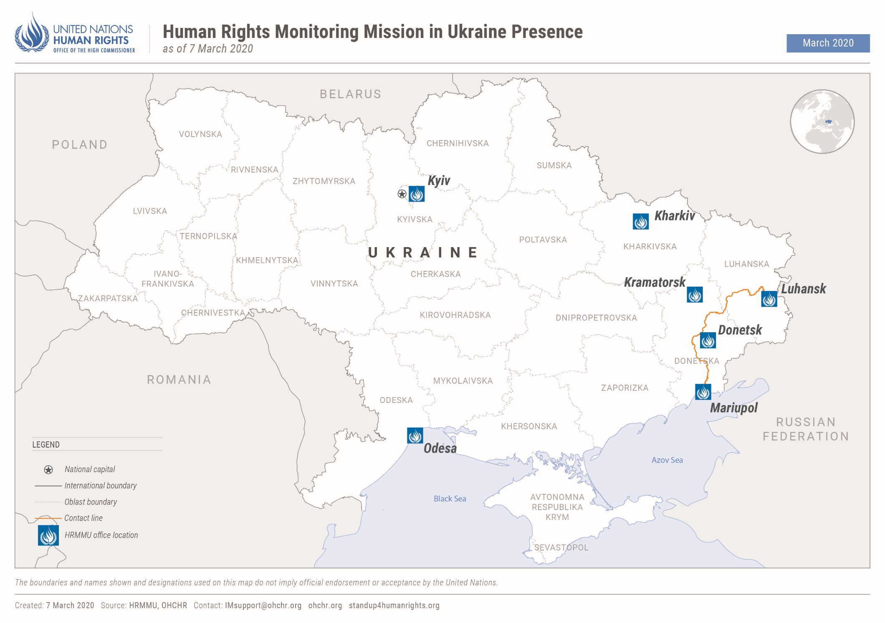
- Executive summary
- This twenty-ninth report by the Office of the United Nations High Commissioner for Human Rights (OHCHR) on the human rights situation in Ukraine covers the situation from 16 November 2019 to 15 February 2020. It is based on the work of the United Nations Human Rights Monitoring Mission in Ukraine (HRMMU).
- During the reporting period, OHCHR recorded two civilian deaths (both men) and 17 civilian injuries (13 men, three women, and one boy), a 54.8 per cent decrease compared with the previous reporting period (six killed and 36 injured). The total civilian casualties recorded in 2019 (27 killed and 140 injured) were 40.6 per cent lower than in 2018 (55 killed and 226 injured), and were the lowest annual civilian casualty figures for the entire conflict period.
- Parliament continued to develop draft laws on remedy and reparation for deaths and injuries of civilians, and for the loss of property, including housing, which could lead to a comprehensive state policy of remedy and reparation to civilian victims of the conflict. This has been lacking since 2014.
- The armed conflict continued to negatively impact the enjoyment of economic and social rights by the civilian population, especially the more than five million residents of the conflict-affected area and internally displaced persons (IDPs). Children, older persons and persons in vulnerable situations are at increased risk of being left behind in achieving sustainable development because of the conflict.
- Linking the payment of pensions to IDP registration deprives hundreds of thousands of pensioners access to their pensions. OHCHR regrets that the Parliament has not yet adopted legislation that would enable pensioners residing in territory controlled by the self-proclaimed ‘Donetsk people’s republic’ and self-proclaimed ‘Luhansk people’s republic’, and in localities along the contact line as well as IDPs to access their pension payments in Government-controlled territory without having to complete processes of registration and verification as IDPs.
- While crossing of the contact line has been facilitated for children under the age of 16, it remained a major challenge for civilians. OHCHR continued to observe long lines at crossing points and winter conditions exacerbated physical difficulties for people. The number of crossings of the contact line during the reporting period (1.3 million in both directions per month) was comparable with those reported throughout 2019.
- OHCHR remains gravely concerned by continued arbitrary detention, torture and ill-treatment of conflict-related detainees, both in Government-controlled territory and in territory controlled by the self-proclaimed ‘republics’. Fifty-two of the 56 people released by the self-proclaimed ‘republics’ and interviewed by OHCHR described having been subjected to torture and/or ill-treatment, including in some cases sexual violence, predominantly perpetrated by members of the ‘ministries of state security’ of the self-proclaimed ‘republics’. While OHCHR was not able to interview any of the 124 people released by the Government by the cut-off-date of this report (due to restrictions imposed on OHCHR operations in territory controlled by the self-proclaimed ‘republics’), OHCHR had previously documented the cases of 75 of them. Fifty-seven of these individuals had earlier reported having been subjected to torture or ill-treatment, including in some cases sexual violence, perpetrated mainly by the Security Service of Ukraine (SBU). OHCHR is also concerned that ad hoc arrangements of the Government to enable the release of detainees who had not been sentenced by the time of the release may jeopardize their due process rights and fair trial guarantees, as well as undermining the right to justice of victims and their relatives.
- Human rights violations within the administration of justice in conflict-related criminal cases continued. Impunity also remained pervasive, notably in cases related to the conflict, the violent deaths and killings at Maidan and in Odesa on 2 May 2014, and attacks on human rights defenders, activists and media workers. By contrast, National Police apprehended three suspects in the 2016 killing of journalist Pavel Sheremet.
- OHCHR welcomes the adoption of revisions to the Electoral Code which will facilitate voting by IDPs and economic migrants in the upcoming local elections. This will require the Central Electoral Commission to adopt a procedure to manage requests made by people who wish to change their voting address.
- Civic space was restricted by violent attacks and other incidents targeting civil society activists, media workers, and individuals perceived as belonging to minority groups, with nine incidents documented during the reporting period. Despite the risk of repercussions, in territory controlled by the self-proclaimed ‘republics’, social media remains the only platform available to express critical views. More positively, journalists Stanislav Aseyev and Oleh Halaziuk were released from detention in Donetsk, as a part of the simultaneous release on 29 December 2019.
- Law enforcement agencies, in general, successfully policed assemblies. However, as described in previous reports, in a number of documented cases, they failed to respond adequately to attacks by extreme right-wing groups and their affiliates, such as when journalists were attacked after attending a hearing in the Sheremet case.
- Despite the conclusions of the Venice Commission, which echoed OHCHR’s concerns regarding the State Language Law, and the legal deadline of 16 January 2020, the Cabinet of Ministers and Parliament have not yet drafted legislation on the realisation of rights of national minorities and indigenous people.
- In the Autonomous Republic of Crimea, and the city of Sevastopol, temporarily occupied by the Russian Federation (hereinafter Crimea), the tenth conscription campaign drafted approximately 3,000 men into the armed forces of the Russian Federation, in violation of international humanitarian law. Criminal prosecution was used as a means of pressure and punishment for draft evasion. In further violation of its obligations under international humanitarian law, the Russian Federation deported or forcibly transferred at least 186 individuals considered foreigners under Russian law, including 107 Ukrainian citizens whom the Russian Federation considered did not have residency rights in Crimea.
- During the reporting period, OHCHR provided the Government of Ukraine and other stakeholders with technical cooperation and capacity-building, such as trainings for members of the State Bureau of Investigation (SBI), the Civil-Military Coordination Unit of the Ministry of Defence (CIMIC) and other law enforcement agencies, as well as technical expertise on human rights issues, including during the human rights week in Parliament.
- While OHCHR enjoyed unimpeded access to places of detention in territory controlled by the Government, OHCHR operations in territory controlled by the self-proclaimed ‘republics’ have been severely restricted since June 2018 despite ongoing discussions.The continued denial of access to detention facilities, despite repeated requests, prevents OHCHR from monitoring the treatment of detainees and detention conditions. This is particularly concerning given the widespread nature of credible allegations of torture and ill-treatment. OHCHR therefore reiterates its call for independent international observers, including OHCHR, to have unimpeded, confidential access to places of detention and detainees.
- OHCHR methodology
- The report is based on information gathering during 52 field visits, 15 visits to places of detention, 118 trial hearings, eight assemblies and 129 (with 89 men and 40 women) in-depth interviews with victims and witnesses of human rights violations, as well as relatives of victims and their lawyers, Government representatives, members of civil society and other interlocutors. It also draws from information obtained from court documents, official records, open sources and other relevant material. Findings are based on verified information collected from primary and secondary sources that are assessed as credible and reliable. Findings are included in the report where the “reasonable grounds” standard of proof is met, namely where, based on a body of verified information, an ordinarily prudent observer would have reasonable grounds to believe that the facts took place as described and where legal conclusions are drawn, that these facts meet all the elements of a violation. While OHCHR cannot provide an exhaustive account of all human rights violations committed throughout Ukraine, it obtains and verifies information through a variety of means in line with its methodology, and bases its conclusions on verified individual cases.
- OHCHR applies the same standard of proof when documenting conflict-related civilian casualties. In some instances, documenting occurrences may take time before conclusions can be drawn, meaning that numbers of civilian casualties are revised as more information becomes available. OHCHR applies the “reasonable grounds” standard in attributing a civilian casualty to a particular party based on the geographic location where it occurred, the direction of fire, and the overall context surrounding the incident.
- Information in this report is used in full respect of informed consent by all sources as to its use as well as OHCHR’s assessment on the risk of harm that such use may cause. This may entail removing identifying details to ensure the confidentiality of sources.
- The report also draws on the engagements undertaken by Ukraine to implement the Sustainable Development Goals (SDGs) stemming from the UN Sustainable Development Summit in September 2015.
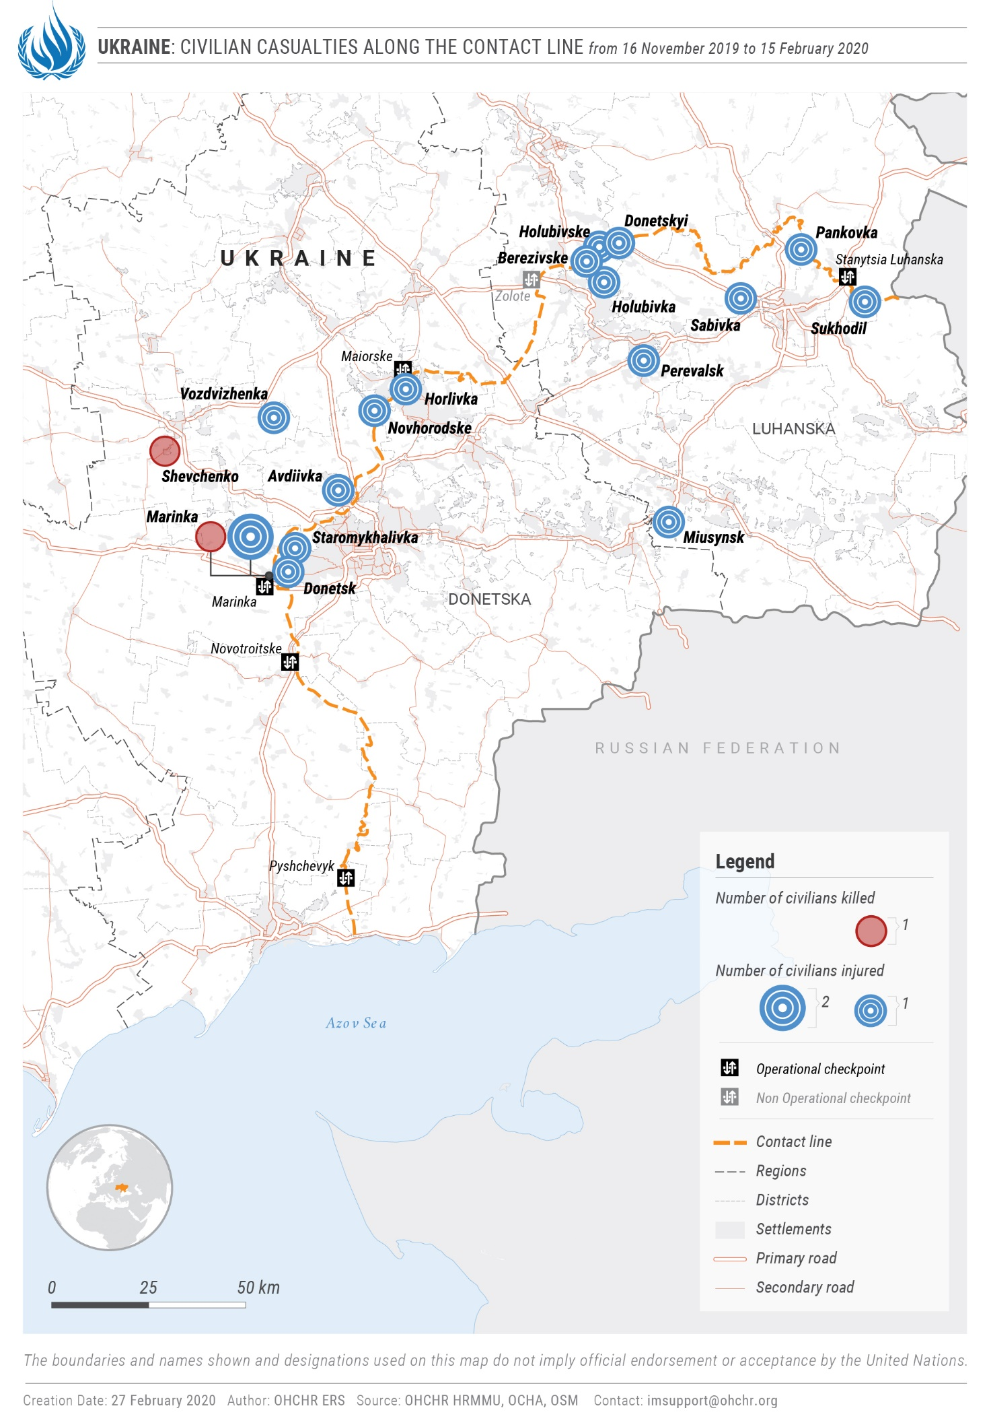
- Impact of hostilities
“What can we do to improve the situation? Stop the conflict.”

– A 70-year-old pensioner living in the conflict-affected area.

- On 29 December 2019, parties to the Trilateral Contact Group reiterated their commitment to an ‘unlimited’ ceasefire that commenced on 21 July 2019. Although the parties did not fully comply with the ceasefire, the reporting period was marked by an overall decrease in the number of ceasefire violations if compared with the previous reporting period, as observed by the OSCE Special Monitoring Mission to Ukraine (OSCE SMM). On 20 November 2019, Ukraine joined the Safe Schools Declaration, becoming the 100th country in the world to endorse this document.
A Conduct of hostilities and civilian casualties
1. Civilian casualties during the current reporting period
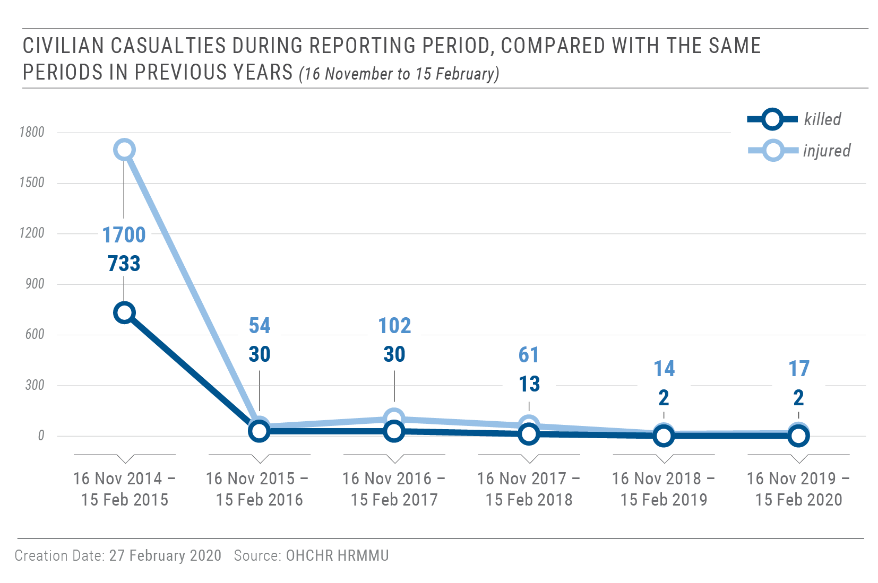
21. From 16 November 2019 to 15 February 2020, OHCHR recorded 19 conflict-related civilian casualties: two killed (both men) and 17 injured (13 men, three women, and one boy). This is a 54.8 per cent decrease compared with the previous reporting period of 16 August to 15 November 2019, when 42 civilian casualties (six killed and 36 injured) were recorded.

22. Shelling and small arms and light weapons (SALW) fire caused nine civilian casualties: one killed (a man) and eight injured (six men and two women). This is a 35.7 per cent decrease compared with the previous reporting period (when 14 were injured). Of those affected during the reporting period, three injured were recorded in territory controlled by ‘Donetsk people’s republic’, and four injured in territory controlled by ‘Luhansk people’s republic’, all attributable to the Government of Ukraine. One civilian was killed and one was injured in Government-controlled territory in Donetsk region, both attributable to armed groups of ‘Donetsk people’s republic’.
23. For example, on 18 December 2019, a man was killed by sniper fire while sitting on a bench next to his house in Government-controlled Marinka (Donetsk region). On 30 January 2020, a woman was injured by mortar shelling while at home in armed group-controlled Donetskyi (Luhansk region). On the same day, a man in armed group-controlled Holubivske (Luhansk region) was in the yard of his house when he was injured by shrapnel from a mortar round.
24. Mine-related incidents and the handling of explosive remnants of war (ERW) resulted in ten civilian casualties: one killed (a man) and nine injured (seven men, one woman and one boy). This is a 50 per cent decrease compared with the previous reporting period (when six were killed and 14 injured). Of those affected during the reporting period, five injured were recorded in territory controlled by ‘Luhansk people’s republic’; and one death and four injuries in Government-controlled territory in Donetsk region.
25. For example, on 6, 17 and 18 January 2020, three men were injured in mine-related incidents while walking near or fishing in Siverskyi Donets River (all in territory controlled by ‘Luhansk people’s republic’). This area is heavily contaminated by mines, booby traps and unexploded ordnance, and OHCHR has recorded dozens of such casualties there in previous years, especially in 2015 and 2016. On 11 January 2020, a man was killed by the detonation of an RPG-7 grenade which he had brought to his home from elsewhere in Government-controlled Shevchenko (Donetsk region).
2. Civilian casualties in 2019
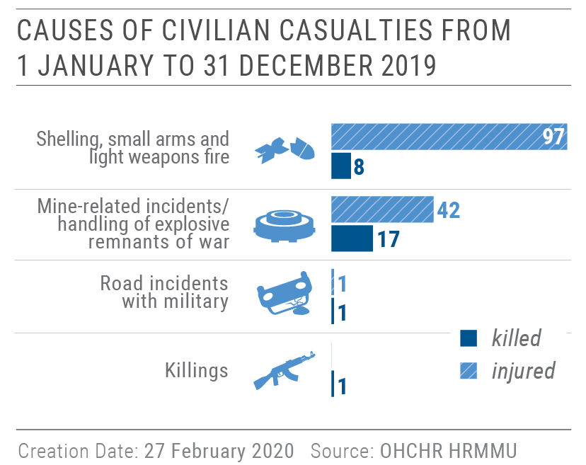
26. From 1 January to 31 December 2019, OHCHR recorded 167 conflict-related civilian casualties: 27 killed (16 men, 10 women and a boy) and 140 injured (80 men, 40 women, 11 boys and nine girls). This is a 40.6 per cent decrease compared with 2018 (281 casualties: 55 killed and 226 injured) and the lowest annual civilian casualty figures for the entire conflict period.

27. In 2019, 105 of the civilian casualties recorded were caused by shelling and SALW fire (eight killed and 97 injured), a 33.1 per cent decrease compared with 2018 (157 casualties: 21 killed and 136 injured). Of them: 85 (five killed and 80 injured; 81 per cent) were recorded in territory controlled by the self-proclaimed ‘republics’, 18 (three killed and 15 injured; 17.1 per cent) in Government-controlled territory, and two (both injuries) in ‘no man’s land’.
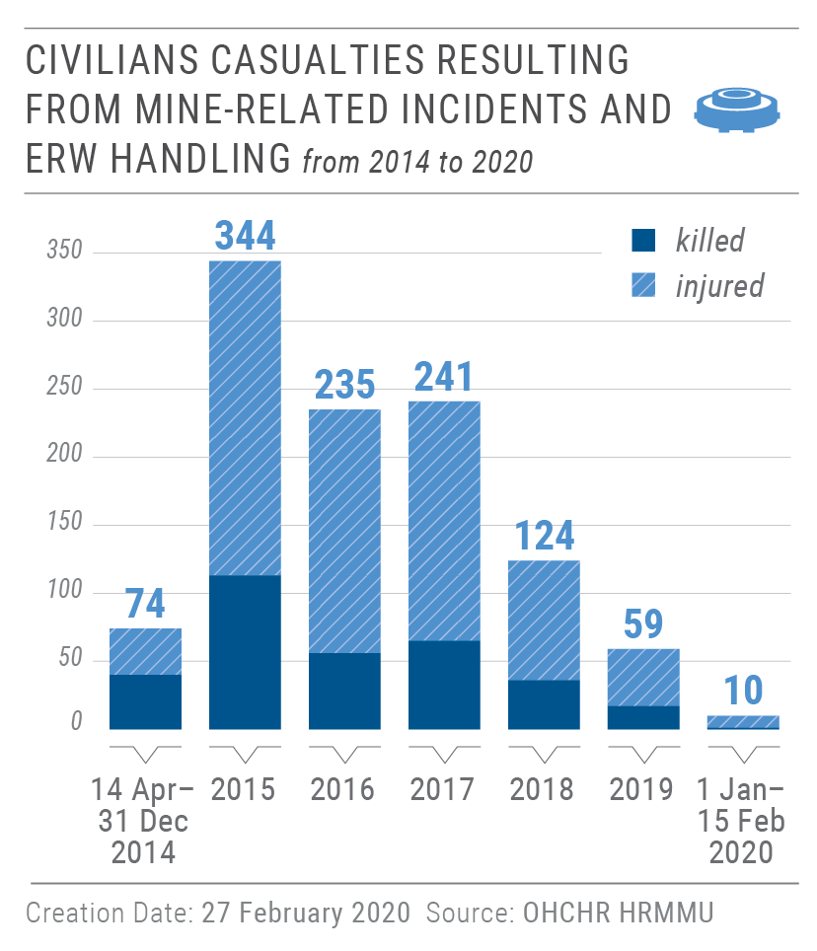
28. Fifty-nine of the recorded civilian casualties (17 killed and 42 injured) resulted from mine-related incidents and ERW handling, including 11 children (one killed and ten injured, all as a result of ERW handling). This is a 52.4 per cent decrease compared with 2018 (124 casualties: 36 killed and 88 injured).

3. Civilian casualties during entire conflict period
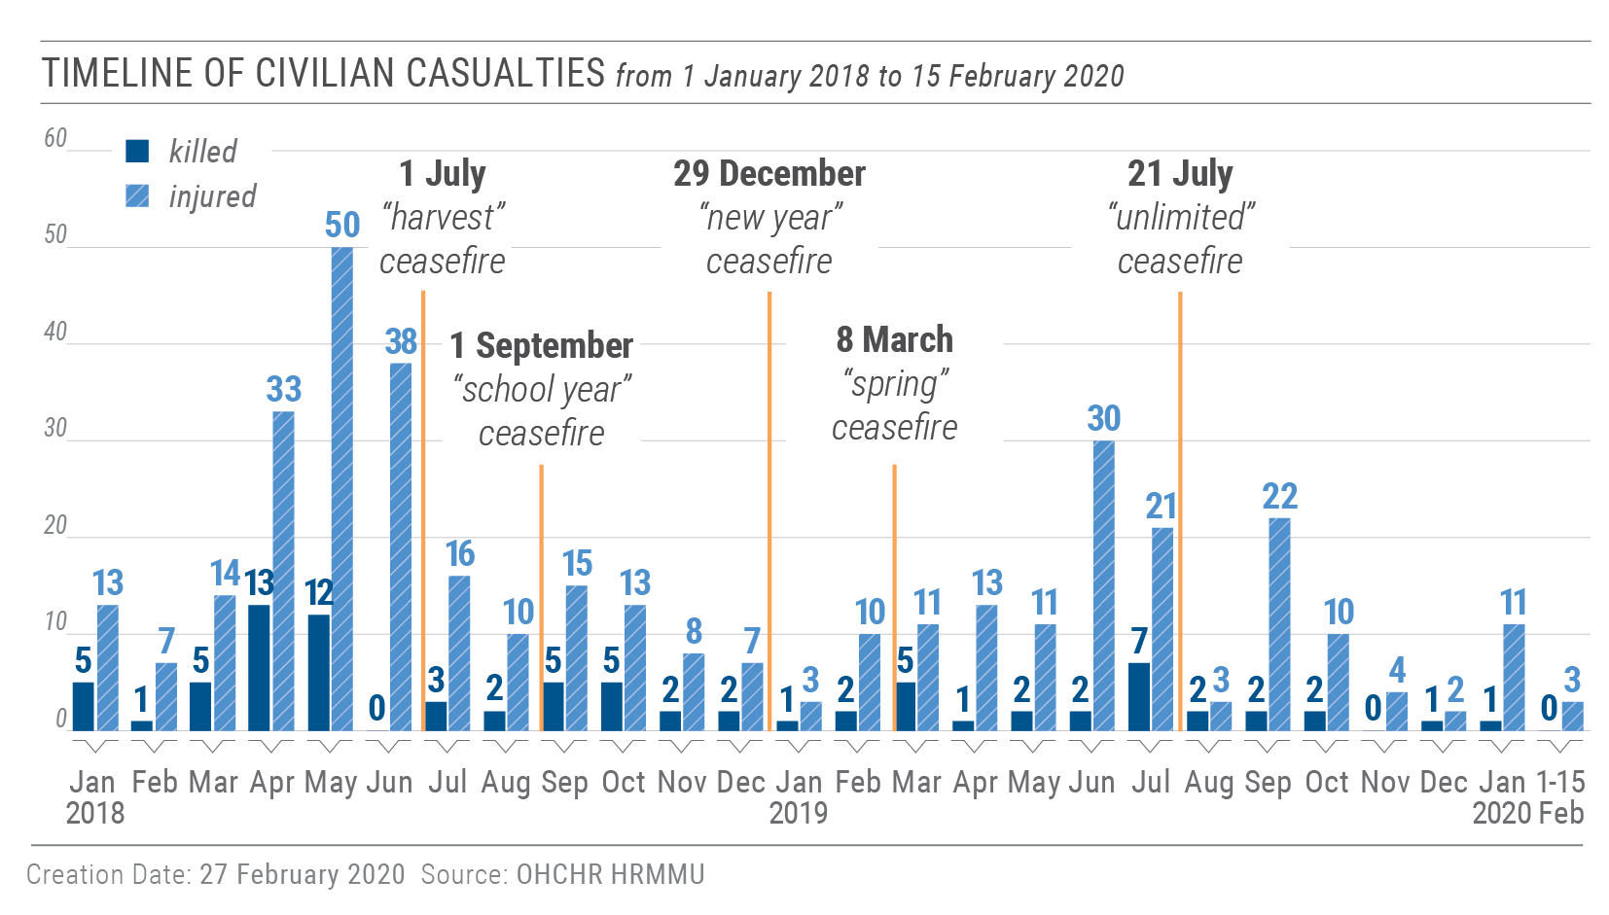
29. During the entire conflict period, from 14 April 2014 to 15 February 2020, OHCHR recorded in total 3,052 conflict-related civilian deaths (1,812 men, 1,056 women, 98 boys, 49 girls and 37 adults whose sex is unknown). Taking into account the 298 who perished on board of Malaysian Airlines flight MH17 on 17 July 2014, the total death toll of the conflict on civilians has reached at least 3,350. The number of injured civilians so far is estimated to exceed 7,000.

30. OHCHR recalls that preventing civilian casualties is not only required by international human rights and humanitarian law, but also contributes to the progressive obtainment of SDG 16, which aims to significantly reduce all forms of violence.

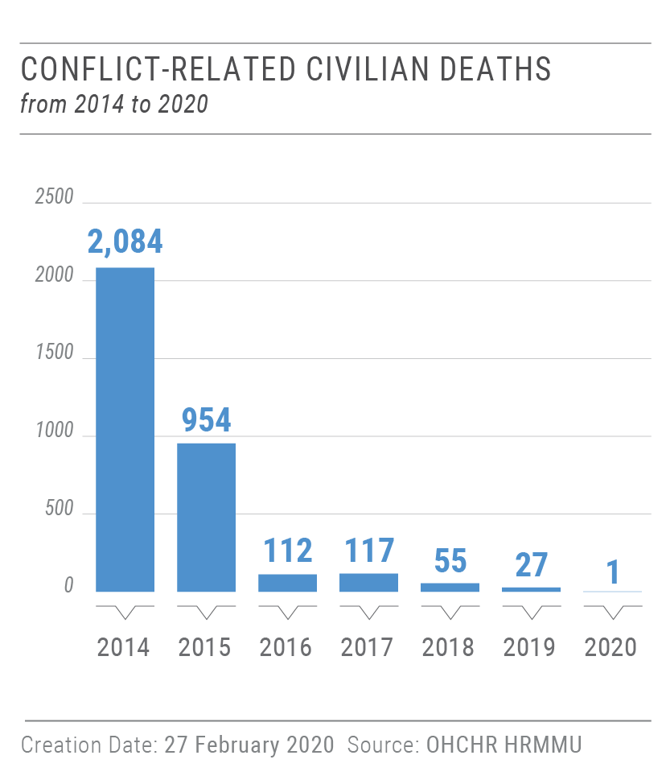
4. Total conflict-related casualties

31. OHCHR estimates the total number of conflict-related casualties in Ukraine (from 14 April 2014 to 15 February 2020) to be 41,000–44,000: 13,000-13,200 killed (at least 3,350 civilians, an estimated 4,100 Ukrainian forces and an estimated 5,650 members of armed groups); and 29,000-31,000 injured (approximately 7,000–9,000 civilians, 9,500–10,500 Ukrainian forces and 12,500-13,500 members of armed groups).

5. Remedy and reparation to civilian victims of the conflict
32. During the reporting period, the Parliament continued working on draft law No. 1115 ‘On the status and social protection of civilians who suffered as a result of hostilities and armed conflicts’. In December 2019, the Parliamentary Committees on Human Rights and on Social Policy, which co-sponsored the draft law, determined that the law would only cover remedy and reparation to civilians for loss of life and health resulting from hostilities, while reparation and compensation for the loss of property would be addressed by another draft law.
33. OHCHR welcomes the progressive development of these draft laws, and considers them an important step towards the establishment of a comprehensive national policy on remedy and reparation to civilian victims of the conflict.
34. OHCHR underlines, however, that the draft laws should comply with the Basic Principles and Guidelines on the Right to a Remedy and Reparation for Victims of Gross Violations of International Human Rights Law and Serious Violations of International Humanitarian Law and the updated Set of Principles for the protection and promotion of human rights through action to combat impunity. As noted by the United Nations Special Rapporteur on the promotion of truth, justice, reparation and guarantees of non-recurrence, domestic reparation programmes should be designed through processes that include consultation and participation of victims, particularly those in the most vulnerable situations. Victims should also have access to different forms of reparation, beyond compensation. Ensuring progress on these issues is in line with SDG 1, 5, 10 and 16.
35. OHCHR also welcomes the resumption, in January 2020, of the work of the Inter-Agency Commission to establish the nexus between disability and conflict-related injuries. The Commission did not meet between June 2019 and January 2020 because of the change in Government. OHCHR remains concerned that the number of cases considered by the Commission since it began its work in December 2018 remains very low (104 as of 15 February 2020).
B. Economic and social rights and freedom of movement of conflict-affected persons
“I’ve been fishing my whole life, but now the only thing I can fish for is mines.”

– A fisherman explains how the conflict has impacted him.

36. The armed conflict continued to negatively impact the enjoyment of economic and social rights by the civilian population, especially residents of the conflict-affected area and IDPs. The lack of markets and livelihood opportunities further exacerbated the dire socio-economic situation. Many young people leave the area in search of employment and financial stability, while those who remain, often older persons, suffer from a lack of basic services (particularly healthcare and transportation).
37. In addition to its obligations under international human rights law to create conditions for the realisation of an adequate standard of living and continuous improvement of living conditions, Ukraine is committed to the implementation of the SDGs, such as SDG 1 on eradicating poverty, which includes access to social protection and basic services; SDG 5 on gender equality; SDG 10 on reducing inequalities, which includes social and economic inclusion, adequate social protection as well as facilitating safe and responsible mobility of people; SGD 11 on sustainable cities and communities, which includes access to adequate, safe and affordable housing; and SGD 16 on peace, justice and strong institutions, which includes reducing all forms of violence, access to justice, and accountable, inclusive and transparent institutions and decision-making as well as enforcement of non-discriminatory laws and policies.
1. Right to social protection
38. Government policies requiring pensioners registered or residing in territory controlled by the self-proclaimed ‘republics’ to register as IDPs in Government-controlled territory and to regularly verify their IDP registration in order to receive their pensions remained in force. This has caused hundreds of thousands of pensioners to lose their pension payments. The policies also disproportionately affect women, who represent the majority of IDPs and persons crossing the contact line.
39. OHCHR regrets that the Parliament of Ukraine has still not adopted legislation that would provide the conflict-affected population registered or residing in armed group-controlled territory access to their pension. On 5 February, the Parliament tabled draft law No. 2083-d, which would have allowed pensioners to apply for and access their pensions either personally or through an authorised representative at any pension department in Government-controlled territory regardless of their place of residence. It would also have allowed for retroactive pension payments without time limitations for individuals residing in territory controlled by the self-proclaimed ‘republics’. OHCHR is concerned that the Government did not support the draft law on the argument that the State budget would be unable to cover the expenditure.
2. Housing, land and property rights
40. The 2030 Agenda for Sustainable Development, which Ukraine has committed to implementing, contains housing, property and land-related targets and indicators under SDGs 1 (no poverty), 2 (zero hunger), 5 (gender equality), 11 (sustainable cities and communities) and 15 (life on land), with links to several other SDGs, for instance SDG 3 (good health and well-being), 6 (clean water and sanitation) and 16 (peace, justice and strong institutions).
41. OHCHR notes positive developments regarding housing rights of the conflict-affected population, such as further amendments to Cabinet of Ministers Resolution No. 947, which would improve access to compensation for destroyed homes. For example, it would increase the maximum amount of compensation from UAH 300,000 to UAH 400,000 (approximately $12,300 to $16,400), which would be calculated based on the square footage of the destroyed home. OHCHR also welcomes the Parliamentary Committee on Human Rights establishment of a working group to develop the draft law on compensation for property that the population has lost due to the armed conflict in Donetsk and Luhansk regions and the occupation of Crimea.

Military use of civilian property

42. OHCHR continued to document the extended military use of civilian property without lease agreements and/or compensation. Residents of Government-controlled Avdiivka, Krasnohorivka, Marinka and Novotroitske (all in Donetsk region) informed OHCHR that their housing was being used by the military without compensation, and that some continued to receive utility bills generated by the military.

Lack of investigations into looting allegations

43. OHCHR continued to observe a lack of investigations into allegations of looting of civilian property by members of the military and law enforcement in locations of Donetsk region such as Avdiivka, Krasnohorivka, Marinka and Novotroitske.
3. Freedom of movement
“There are people like us living on the other side [of the contact line].”

– A man living in Zolote.

44. The average number of monthly crossings of the contact line remained steady at 1.3 million (in both directions), on par with average monthly figures for 2019. Despite some infrastructure improvements at entry-exit checkpoints (EECPs), such as the completion of the repair of the pedestrian bridge in Stanytsia Luhanska EECP on 20 November 2019, crossing the contact line remained challenging for many individuals, notably persons with disabilities and older persons; long queues and winter conditions further exacerbated difficulties. OHCHR welcomes discussions by the Trilateral Contact Group in Minsk on the opening of additional EECPs.
45. On 28 November 2019, Cabinet of Ministers resolution No. 815 entered into force, simplifying crossing of the contact line by children below the age of 14 with a birth certificate, in order to apply for a Ukrainian passport. OHCHR welcomes the efforts by the Ministry of Veterans, Temporarily Occupied Territories and IDPs and the State Border Guard Service of Ukraine to further amend the Resolution to allow children between the age of 14 and 16 to cross the contact line to Government-controlled territory with a birth certificate, up until May 2020.
46. OHCHR notes with concern reports that in January, residents in territory controlled by ‘Donetsk people’s republic’ faced difficulties moving around the territory. Individuals were reportedly randomly selected on the street for document checks, and those without ‘passports’ issued by ‘Donetsk people’s republic’ were taken to ‘police stations’ for “identification checks” lasting up to several hours. Ukrainian passports and other identification documents were not considered as ‘official documents’. Those who refused to go to the ‘police station’ were threatened with possible charges of ‘resisting authorities’. Individuals driving cars with Ukrainian licence plates were also taken to ‘police stations’ where they remained for several hours. Those who could not prove they had ‘licence plates’ issued by ‘Donetsk people’s republic’ were fined, reportedly in amount ranging from 500 to 1,500 RUB (approximately $8 to $23) and notified they would have to obtain such ‘licence plates’.
IV. Right to liberty and security of persons
“I’m ready to sign anything to be released from the SIZO. I will die if I stay another month.”

– A detainee speaking after having spent two and a half years in SIZO.

- Access to places of detention
47. In Government-controlled territory, OHCHR continued to enjoy full and unimpeded access to places of detention and detainees. During the reporting period, OHCHR interviewed 36 conflict-related detainees (34 men and 2 women) in pre-trial detention facilities in Bakhmut, Dnipro, Odesa, Starobilsk, Kharkiv, Mariupol and Zaporizhzhia and in a penal colony in Kharkiv.
48. By contrast, OHCHR continued to be denied access to detainees and places of detention in territory controlled by the self-proclaimed ‘republics’ in spite of the understanding reached during the Normandy Four summit of 9 December 2019 that “international organisations […] be granted full and unconditional access to all detained persons.” First-hand information received by OHCHR about grave human rights violations in places of detention make access for international monitors to places of detention and detainees in territory controlled by the self-proclaimed ‘republics’ an urgent priority.
B. Arbitrary detention, torture and ill-treatment
49. Cases of arbitrary detention, torture and ill-treatment continued to be documented by OHCHR, both in Government-controlled territory and in territory controlled by the self-proclaimed ‘republics’.
50. For example, OHCHR documented the case of a man who sought to avail himself of the ‘Come back home’ programme intended for members of armed groups. He contacted the SBU, which assured him that he was free to return to Ukraine from the Russian Federation without any repercussions if he cooperated with authorities. However, after crossing the Marinka EECP on 3 October 2019, he was immediately abducted by unidentified persons, reportedly because he had been named on the Myrotvorets website. He was driven to an unknown facility, thought to be close to Mariupol and handcuffed overnight to a railing. He was hit in the stomach and threatened with violence until he confessed to being a member of armed groups. Over the following few days, he was held in unofficial places of detention. On 8 October 2019, he was taken to Sievierodonetsk SBU and questioned without a lawyer. On 10 October, the Sievierodonetsk court remanded him to 60 days in detention. On 25 October, the prosecutor told him he could not use the SBU programme and his only chance of being released was to agree to a plea bargain and then consent to be ‘exchanged’. On 4 December, two SBU officers attempted to pressure him into agreeing to participate in the simultaneous release. He refused and on 11 December 2019 after his period of remand in custody expired, he was released. A criminal case against the man is ongoing, while he awaits the outcome of his complaint to the SBI for unlawful detention.
51. In territory controlled by ‘Donetsk people’s republic’, OHCHR continued to document cases of arbitrary detention during the reporting period, allegedly by the ‘department to combat organised crime’ and ‘ministry of state security’. During their ‘administrative detention’, victims were denied access to their lawyers and relatives, sometimes for months, which amounts to incommunicado detention.
52. In territory controlled by ‘Luhansk people’s republic’, the ‘ministry of interior’ and ‘ministry of state security’ detained individuals under ‘preventive arrest’ and held them incommunicado, contrary to international human rights standards.
53. For example, on 16 January 2020, an officer of the ‘ministry of state security’ detained a woman at Stanytsia Luhanska EECP. She was taken with a bag on her head to the premises of ‘ministry of state security’ in Luhansk, where she spent a night handcuffed to a chair. Her captors threatened to harm her family, interrogated her about cooperation with the SBU and submitted her to a polygraph test. On 21 January, after signing papers acknowledging the risks of spying on ‘Luhansk people’s republic’, she was released.
C. Situation in Oleksiivska penal colony No. 25
54. OHCHR monitored the situation at Oleksiivska penal colony No. 25 in Kharkiv and visited the colony on 10 January 2020 after concerns about torture and ill-treatment were raised. OHCHR received allegations that prisoners were subjected to extensive beatings, including with objects, suffocation, rape and threats of rape, and other forms of sexual violence, including forced nudity. Prison staff who allegedly participated in the torture and ill-treatment still work in the penal colony. The Kharkiv regional prosecutor’s office launched a number of investigations into allegations of torture and ill-treatment and of abuse of authority at the penal colony. International observers had already signalled issues at this penal colony in 2012.
V. Simultaneous release of detainees under the Minsk agreements
“You tell us more about human rights – and we will point lower next time!”

– A member of armed groups after a mock execution of a detainee
(shooting above his head).
.

55. On 29 December 2019, under the framework of the Minsk agreements and following the Normandy Four summit of 9 December 2019, a simultaneous release of detainees took place at EECP Mayorske (Donetsk region). This was the first major simultaneous release since 27 December 2017.
56. The Government of Ukraine released 141 detainees, 124 of whom (117 men and seven women), including 19 foreign citizens (18 men and one woman), were handed them over to representatives of the self-proclaimed ‘republics’ (during the handover of foreign citizens, diplomatic representatives of their home countries were present): 59 detainees (54 men and five women) to ‘Donetsk people’s republic’, and 65 detainees (63 men and two women) to ‘Luhansk people’s republic’. Seventeen released detainees decided to stay in Government-controlled territory.
57. The self-proclaimed ‘republics’ released 81 detainees (64 men and 17 women): 55 detainees (42 men, including eight military and 13 women) were released by the ‘Donetsk people’s republic’, and 26 detainees (22 men, including four military, and four women) by the ‘Luhansk people’s republic’. Seventy-six detainees (61 men, including 12 military, and 15 women) were handed over to the Government, while five decided to stay in territory controlled by the self-proclaimed ‘republics’: two men and two women in territory controlled by the ‘Donetsk people’s republic’ and one man in territory controlled by the ‘Luhansk people’s republic’.
58. In addition to the discussion in this section, a more detailed description of related human rights concerns can be found in Annex I to this report.
A. Arbitrary detention, torture and ill-treatment of detainees in Government-controlled territory
59. Due to the restrictions imposed on OHCHR operations in territory controlled by the self-proclaimed ‘republics’ since 2018, as of 15 February 2020, OHCHR was unable to interview any of the 124 detainees released by the Government. However, OHCHR had previously documented the cases of 75 of them while they were detained in Government-controlled territory.
60. The 75 cases showed a consistent pattern of arbitrary detention or procedural violations at the initial stages of detention (reported by 54 individuals, 72 per cent of the total) with the SBU being mainly responsible. Twenty-eight detainees reported being kept in unofficial places of detention incommunicado, such as SBU premises or unknown locations, for some period after their apprehension (usually several days), before being transferred to official places of detention. In at least 17 cases, formal registration of their detention was delayed for a period of one to four days from the day of actual apprehension.
61. Several interviewees told OHCHR they were denied access to legal counsel prior to giving a “confession” and were coerced into signing incriminating documents. In at least 32 cases, access to legal counsel was provided only after the first interrogation, and in 11 of these 32 cases, the interrogation was followed by a confession before a detainee saw a lawyer.
62. Fifty-seven of the 75 individuals reported having been subjected to torture or ill-treatment, mainly perpetrated by SBU officials to extract confessions or information and/or to punish or intimidate. Methods of torture and ill-treatment included beatings, asphyxiation (dry and wet), electric shocks, sexual violence (such as forced nudity and violence to the genitals), positional torture, water, food, sleep or toilet deprivation, isolation, mock executions, prolonged use of handcuffs, hooding, and threats of further torture, sexual violence, death or harm to family.
B. Arbitrary detention, torture and ill-treatment of detainees in the self-proclaimed ‘republics’
63. OHCHR interviewed 56 detainees released by the self-proclaimed ‘republics’ (45 men, including one military, and 11 women). The most common ‘charges’ against them were ‘espionage’, ‘incitement of hatred’, ‘storage of explosives’, ‘terrorist act’, ‘assistance to terrorist activity’, and ‘public calls for extremist activities’ in ‘Donetsk people’s republic’, and ‘creation of a criminal organisation’, ‘illegal acquisition and storage of weapons and ammunition’, ‘state treason’, and ‘illegal acquisition of information comprising state secrets’ in ‘Luhansk people’s republic’.
64. Though individual testimonies varied, OHCHR identified and further confirmed a consistent pattern of arbitrary detention, often amounting to enforced disappearance, torture and ill-treatment of conflict-related detainees in both self-proclaimed ‘republics’. OHCHR found that torture and ill-treatment of detainees was systematic during the initial stage of detention (which could last up to a year), with the risk for detainees to be subjected to torture and ill-treatment considerably decreasing after the ‘confession’ and especially after completion of ‘pre-trial investigations’.
65. Individuals interviewed by OHCHR had usually been apprehended by armed men wearing no insignia and in balaclavas who did not identify themselves. In most cases, they were not told why they were being detained. Upon apprehension or while being transported to their first place of detention, many detainees were blindfolded and/or handcuffed. Some were beaten or threatened with violence. The first place of detention was usually either the premises of the ‘ministry of state security’ (in Donetsk or Luhansk) or ‘Izoliatsiia’ detention facility (in Donetsk).
66. The majority of interviewed individuals were initially detained under ‘administrative arrest’ (in ‘Donetsk people’s republic’) or ‘preventive arrest’ (in ‘Luhansk people’s republic’), and held incommunicado without access to a lawyer. Some detainees were not informed about the reasons of their detention or ‘charges’ against them for a prolonged period. Relatives of those detained who enquired about their whereabouts were not provided with any information beyond confirmation, in a few instances, that the person was indeed detained.
67. In most cases, ‘investigative actions’ commenced immediately after the apprehension, with a few exceptions when detainees spent days or weeks in custody before any action was taken. ‘Investigative actions’ comprised mostly of interrogations either at the ‘ministry of state security’ or in the ‘Izoliatsiia’ detention facility (in Donetsk) or at the ‘ministry of state security’ (in Luhansk) by individuals who presented themselves as ‘officers’ of the ‘ministry of state security’ or did not identify themselves at all. Several detainees believed Russian “FSB officers” took part in interrogations, and some perceived them to be in a position of authority.
68. In most documented cases, the interrogators began by threatening detainees with violence or rape and made threats against their families if they refused to confess or otherwise cooperate with the ‘investigation’. Such threats were often accompanied by blows to the body or slaps to the face.
69. Fifty-two out of the 56 individuals interviewed by OHCHR reported having been subjected to torture or ill-treatment, sometimes including sexual violence, mostly during the interrogations, in order to extract confessions or information, in most cases, about working for the SBU. The frequency, intensity and length of the torture and ill-treatment varied considerably, however they usually continued until a detainee agreed to confess (orally, in writing or on video) or to provide information. Methods of torture and ill-treatment included beatings, electric shocks, asphyxiation (wet and dry), sexual violence, positional torture, removal of body parts (nails and teeth), deprivation of water, food, sleep or access to a toilet, mock executions, threats of violence or death and threats of harm to family. Testimony of the released detainees indicate that torture and ill-treatment was also carried out for punitive purposes and to humiliate and intimidate, including by personnel of some detention facilities. OHCHR identified a continuum of torture and ill-treatment that was often exacerbated by inhumane detention conditions, in particular in the ‘Izoliatsiia’ detention facility.
VI. Administration of justice and accountability
“It’s wartime, you are lucky to still be alive.”

– A ‘judge’ responds to a man’s complaint about being tortured in ‘Izoliatsiia’, during a ‘court hearing’ in Donetsk.

70. On 26 November 2019, the Government issued a communication to the United Nations Secretary-General notifying him of changes in the material and territorial scope of its derogation from the International Covenant on Civil and Political Rights (ICCPR) and the European Convention on Human Rights (ECHR). The Government withdrew its derogation from ICCPR article 14 and ECHR article 6 (on right to a fair trial) with regard to the transfer of territorial jurisdiction of cases from courts located in territory controlled by the self-proclaimed ‘republics’ to courts located in Government-controlled territory. The Government also stated that measures invoked in the area of the anti-terrorism operation – namely the extension of the maximum period of preventive detention of suspects in terrorism-related cases without a court review from 72 hours to 30 days and the transfer of certain powers held by investigative judges to prosecutors – are not applicable to the Joint Forces Operation which was enacted on 30 April 2018 (although formally these measures remain in force in national legislation).
71. This is the first time that the Government has altered the material scope of its derogation. OHCHR welcomes this positive development and encourages the Government to conduct regular and transparent reviews of the necessity and proportionality of its derogation and to lift it as soon as possible.
72. During the reporting period, OHCHR documented violations of fair trial rights, such as the rights to a public trial and to trial without undue delay, including in relation to the 29 December 2019 ‘simultaneous release’ of detainees, which has jeopardized the rights of both victims and defendants in conflict-related criminal cases.
73. Improving the administration of justice and countering impunity in line with OHCHR and other United Nations recommendations would significantly increase public confidence in the courts, which is an indicator to measure progress towards the realisation of SDG 16.
A. Impact of the simultaneous release of detainees on the rule of law
74. The simultaneous release of detainees on 29 December 2019 raises a number of human rights concerns in the sphere of administration of justice. Firstly, the release of individuals prosecuted for, or convicted of, human rights violations may deprive victims of justice, truth and redress. Secondly, the procedure under which individuals on trial were released may negatively affect their right to liberty should they appear for future trial hearings. These concerns had already been highlighted following the previous simultaneous release on 27 December 2017.
75. At least 47 detainees released and transferred to territory controlled by the self-proclaimed ‘republics’ had been convicted of various crimes and were serving their sentences. Notably, three men had been convicted of setting off an explosion at a pro-Maidan rally in Kharkiv on 22 February 2015 which killed two men, a boy and a police officer. On 28 December 2019, a court in Kharkiv found the three defendants guilty and sentenced them to life imprisonment. However, contrary to normal practice, the court released them from custody under a personal commitment to remain in their place of official residence pending the entry into force of the verdict. By transferring the convicts to territory controlled by the self-proclaimed ‘republics’, the authorities have allowed them to avoid serving their sentences and paying damages to the victims. OHCHR notes that although the simultaneous release of detainees is aimed at promoting peace and reconciliation, it should be balanced with Ukraine’s obligations to investigate and prosecute human rights violations and ensure victims’ right to an effective remedy.
76. Similarly, the release and transfer of defendants pending trial infringes upon victims’ right to justice, truth and redress. The release of five former Berkut officers (all men) being prosecuted for the killing of 48 male protesters and the attempted killing of another 80 protesters on 20 February 2014 in central Kyiv is particularly striking. On 28 December 2019, the court lifted the pre-trial detention and house arrest imposed on the defendants and the next day they were transferred to Donetsk and Luhansk as part of the simultaneous release. In interviews after being released, two of the Berkut officers underlined their intention to seek asylum in the Russian Federation and continue participating in court hearings via videoconference. OHCHR notes that two other accused returned to Kyiv on 8 February, allowing the trial against them to proceed.
77. According to the Prosecutor General’s Office of Ukraine, the trial of the released Berkut servicemen will continue, and defendants who fail to appear will be prosecuted in absentia. OHCHR reiterates its concern that in absentia proceedings in Ukraine do not comply with international human rights standards. The Criminal Procedure Code only allows for a retrial if the verdict has not yet been delivered, contrary to the Human Rights Committee’s position that retrial should be available for defendants at any time following initial proceedings in absentia. OHCHR notes that this non-compliance with international human rights standards may lead to rejections of future extradition requests. Further, it appears unlikely that such cases will in fact be pursued, as demonstrated by the lack of progress in cases against detainees simultaneously released on 27 December 2017.
78. Another concern is that the authorities facilitated breaches of court-ordered obligations imposed on the detainees. OHCHR is aware that, in line with Prosecutors’ requests, courts released 74 people from custody under their personal commitment not to leave their places of residence. By transferring these defendants to territory controlled by the self-proclaimed ‘republics’, Ukrainian authorities facilitated the violation of this commitment. Should those released appear for trial in the future, they risk being detained again without the possibility of release on bail.
B. Fair trial rights
79. Between 16 November 2019 and 15 February 2020, 78 verdicts were issued against 84 individuals in conflict-related criminal cases. Of these, two defendants were acquitted and 82 were found guilty, including 38 based on plea bargain agreements. Please see the following infographic for an overview of these findings.
80. During the reporting period, OHCHR documented three conflict-related criminal cases which were classified by judges as secret information in the unified court register. OHCHR is concerned about the impact of such classification on the defendants’ right to a public trial (an important safeguard for a fair trial) and on public confidence in the justice system. In one emblematic case, where the defendant complained to OHCHR of fair trial violations, the appeal court failed to publish its judgement, contrary to the law. OHCHR notes that even when the public is excluded from the trial, the judgment, including the essential findings, evidence and legal reasoning must be made public.
81. Undue delays continued to plague criminal proceedings in conflict-related cases. For example, in the case of an SBU officer accused of killing a civilian on 4 March 2017, a panel of judges was assigned to the case in September 2019 and recused themselves in January 2020 on spurious grounds. This was the second trial bench to recuse themselves, resulting in an overall delay of two years so far, during which time the accused remains in service. The authorities’ failure to ensure a prompt trial violates the rights of the victim’s relatives to an effective remedy and to a trial without undue delay.

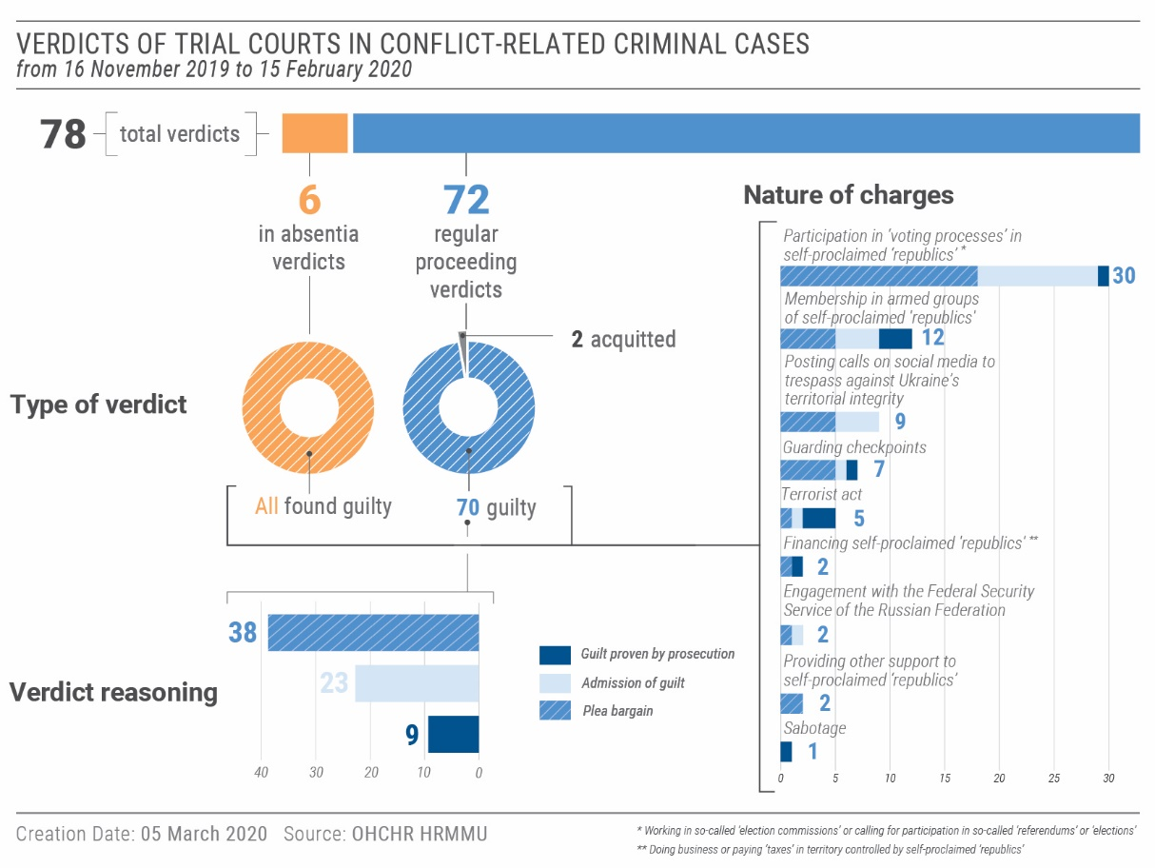
- C. Accountability for killings and violent deaths
82. Almost six years after the killings and violent deaths of individuals at Maidan between 21 January and 20 February 2014 and in Odesa on 2 May 2014, victims’ families are still seeking justice.
83. While some cases relating to the Maidan protests are now before the courts, there was no further progress in the identification of individual perpetrators responsible for the killings. In this regard, OHCHR welcomes amendments to the Law on the SBI which allowed for the transfer of investigators working on Maidan cases from the Prosecutor General’s Office to the SBI under a simplified procedure. OHCHR hopes that this will not only ensure that investigations are uninterrupted, but will also facilitate the identification of additional perpetrators.
84. The status of other criminal proceedings in relation to the killings and violent deaths during Maidan protests is illustrated below.
85. OHCHR notes the lack of progress in the vast majority of trials related to the 2 May 2014 clashes in Odesa that claimed the lives of 48 people. OHCHR is particularly concerned with the protracted nature of the case against 19 ‘pro-federalism’ supporters as the appeal review of the verdict has yet to start, more than two years since the appeal court registered the case.

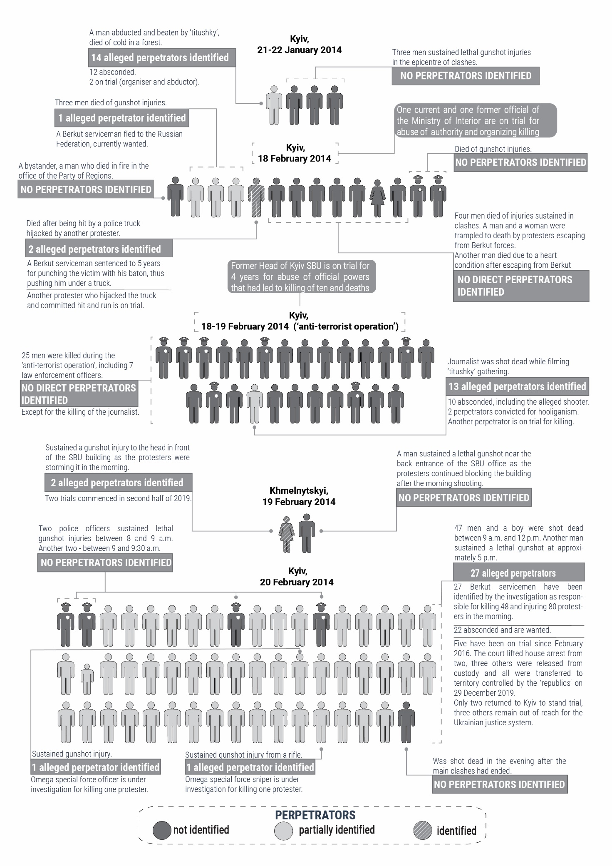
D. Territory controlled by self-proclaimed ‘republics’
Status of criminal proceedings in relation to the killings and violent deaths during the Maidan protests
86. As identified in previous OHCHR reports, both self-proclaimed ‘republics’ continued to process ‘criminal cases’ of individuals perceived to undermine security. In doing so, the self-proclaimed ‘republics’ are obliged to respect certain fair trial standards provided for in both international human rights law and international humanitarian law. At the same time, this obligation does not constitute recognition of the legitimacy of such ‘courts’ or ‘prosecutions’ conducted by the self-proclaimed ‘republics’.
87. OHCHR interviews with individuals released from detention in territory controlled by the self-proclaimed ‘republics’ on 29 December 2019 reveal systematic violations throughout 2018-2019 of the rights not to be compelled to testify against oneself or to confess guilt, to a public trial, to an independent and impartial tribunal and to legal counsel.
88. OHCHR is particularly concerned that ‘courts’ widely relied on confessions obtained through torture and coercion. Individuals suspected of having committed conflict-related ‘crimes’ in territory controlled by both self-proclaimed ‘republics’ told OHCHR that they were systematically subjected to torture and other forms of coercion by members of the ‘ministry of state security’ and ‘police’ and would not dare to withdraw self-incriminating testimony during ‘court’ proceedings for fear of being tortured again.
89. Serious concerns were also raised regarding manifestly biased judges and the violation of the right to presumption of innocence. All those interviewed indicated their ‘trials’ had been in camera, in violation of the right to a public hearing, and creating conditions for judges to express their bias freely.
90. OHCHR documented violations of the right to legal counsel in territory controlled by the self-proclaimed ‘republics’. While all those interviewed by OHCHR had access to ‘free legal aid’ lawyers from the beginning of the formal launch of ‘investigations’, they complained about the inaction of lawyers in defending them, and in some cases, about their lawyers’ collusion with the ‘prosecution’. In six cases, the ‘free legal aid’ lawyers assigned demanded remuneration from the detainees or their relatives. OHCHR also documented the systematic practice of assigning “witness” status to close relatives of detainees, thereby prevented them from assisting in the defence of detained relatives and from attending closed proceedings.
91. The character of the proceedings described above raise serious concerns regarding fair trial guarantees in conflict-related ‘criminal cases’ in territory controlled by the self-proclaimed ‘republics’. OHCHR notes that these violations are systematic and may amount to war crimes.
VII. Civic space and fundamental freedoms
“I’ve never felt so humiliated in my life.”

– A journalist who was physically attacked by alleged affiliates of extreme right-wing groups.

92. During this reporting period, OHCHR documented nine new attacks against journalists and other media workers, human rights defenders, civil activists and members of the LGBTI community. OHCHR monitored eight assemblies, the majority of which were effectively secured by law enforcement.
A. Right to vote
93. OHCHR welcomes the adoption of the revised text of the Electoral Code on 19 December 2019, which entered into force on 1 January 2020. It addresses long-standing recommendations made by OHCHR concerning the need to enfranchise IDPs and labour migrants in elections, including the upcoming local elections in autumn 2020. However, the Central Electoral Commission still needs to develop a procedure to manage individual requests to change voting addresses to ensure that the right to vote is fully implemented.
B. Freedom of opinion and expression and freedom of the media
94. OHCHR documented four physical attacks against media workers (two men and two women). On 30 November 2019, a journalist who worked at an online media outlet which exposes corruption in Mykolaiv city was beaten and attacked with pepper-spray near his home. As of 15 February 2020, the police investigation had made little headway.
95. On 12 December 2019, the National Police apprehended three suspects in the 2016 killing of well-known journalist Pavel Sheremet and charged them with murder. These proceedings came under media and public scrutiny as two of the suspects are former members of the armed forces and one is a well-known volunteer who supported the Ukrainian Armed Forces. Notably, during a hearing on 24 December 2019, three journalists covering the trial, including two women, who were representing media outlets often perceived as pro-Russian were attacked and threatened in two separate incidents which occurred inside the court premises and next to the court building. The male journalist was beaten and had an unidentified liquid thrown at him, while the women were pushed and threatened. Members and supporters of extreme right-wing groups took part in at least one of these incidents. One of the perpetrators was notified of suspicion and currently is under home arrest. In both incidents, law enforcement were present and failed to provide an adequate response.
96. In another attack on 30 November 2019, perpetrators beat and used pepper-spray against a civil society activist who exposed local governance issues in the Odesa region. Since the attack, the victim has continued to receive threats on social media and via a messaging app.
97. OHCHR is deeply concerned about the Government’s controversial initiative to develop legislation to combat dissemination of “disinformation”, which inter alia would introduce increased liability for the mere dissemination of false information, and strips online users of anonymity. These appear to be disproportionate measures and may negatively impact freedom of expression. OHCHR stresses that while countering disinformation may be a legitimate goal, restrictions on freedom of expression must comply with international standards. OHCHR encourages the Government to instead shift its focus to targeted prevention of cyber-attacks and countering malicious automated accounts (‘bot-farms’), invest in increasing the population’s level of media literacy and ensure public access to information as per global SDG target 16.10.
98. In territory controlled by the self-proclaimed ‘republics’, OHCHR continued to observe a lack of media coverage critical of or deviating from the perspectives of the ‘authorities’. Social media remained the only platform available for residents to express their criticism and views regarding the situation on the ground. For example, widespread criticism regarding delayed salaries and other benefits appeared on social media, but was not covered by local media. OHCHR notes that individuals are detained for their publications including information shared on social media.
99. In a further shrinking of the space for free expression, in ‘Luhansk people’s republic’, the list of ‘administrative offences’ was expanded to include dissemination, including online, of information offending human dignity, public morals and explicit disrespect to ‘authorities’. OHCHR notes that according to article 19 of the Universal Declaration of Human Rights, everyone has the right to freedom of opinion and expression, which includes the freedom to hold opinions without interference and to seek, receive and impart information and ideas through any media and regardless of frontiers.
100. OHCHR welcomes the release of journalists Stanislav Aseyev and Oleh Halaziuk on 29 December 2019. Both had been detained since 2017 by ‘authorities’ of ‘Donetsk people’s republic’.
C. Freedom of peaceful assembly and freedom of association
101. OHCHR monitored the conduct of law enforcement agencies and local authorities at eight assemblies during the reporting period, including those held on 21 November and 8-9 December 2019 in relation to developments around the Normandy Four Summit. The authorities sufficiently mitigated risks of violence and no security incidents were observed.
102. OHCHR notes the National Police’s efforts to secure assemblies organised by the LGBTI community on 22-23 November 2019 in Kyiv, including the transgender march held on 23 November concurrently with a counter-demonstration. Law enforcement effectively separated participants and counter-demonstrators, and immediately apprehended on site six of the most aggressive individuals involved in skirmishes who were charged with minor hooliganism and released.
103. OHCHR also notes the failure of authorities to accurately classify an attack which targeted political activity as obstructing the lawful activities of a political party. On 6 December 2019, individuals allegedly affiliated with an extreme-right wing group attacked five volunteers who were disseminating a political party newspaper at the Kyiv train station. At least two victims sustained light injuries. The ongoing investigation disregards the specific motive for the attack, classifying the incident as simple hooliganism, rather than taking into account the fact the victims were undertaking a political activity. Unidentified individuals also set the Kherson office of the same political party on fire and destroyed one of their campaigning tents in the region of Kharkiv.
104. The reluctance of law enforcement to accurately classify attacks with specific motives has been highlighted in previous OHCHR reports, in particular in regard to hate crimes.
D. Discrimination, violence and manifestations of intolerance against minorities
105. OHCHR documented three new attacks against representatives of the LGBTI community within the reporting period, and noted the failure of law enforcement authorities to effectively investigate previous attacks. In at least one case, victims of hate-motivated violence faced a biased attitude from law enforcement officials when attempting to submit a complaint.
106. On 26 November 2019, a group of individuals affiliated with an extreme right-wing group smeared chicken liver across the entrance of the PrideHub in Kharkiv and left objects which are used in traditional funeral rites, intimidating staff and visitors. Three weeks later, unknown perpetrators vandalized the building’s facade with slogans threatening the LGBTI community.
107. On 16 November 2019, two women were forcefully expelled from a bar in Odesa allegedly because of their perceived homosexual relationship. They reported the incident to the local police station, wherepolice officers initially refused to accept the complaint. The victims’ lawyer applied to the court, which ordered the police to register the case.
108. OHCHR remains concerned by the continued practice of local authorities introducing discriminatory measures targeting the LGBTI community. On 24 December 2019, Rivne city council voted to prohibit any public event organised by the LGBTI community on its territory, in particular in public places where children may be present. This not only violates the rights to freedom of assembly and freedom of expression, but also the Constitution.
109. In territory controlled by the self-proclaimed ‘republics’, the LGBTI community feels compelled to keep a low profile and abstain from visible activities for fear of persecution. OHCHR reiterates its concerns regarding LGBTI individuals’ inability to enjoy the full spectrum of their human rights.
- Language rights
110. On 9 December 2019, the European Commission for Democracy through Law (the Venice Commission) published its opinion on the Law on Ensuring the Functioning of Ukrainian as the State Language. The Venice Commission concluded that, largely due to the absence of special legislation on the protection and use of minority languages, the current legal framework fails to strike a fair balance between the legitimate aim of strengthening and promoting the Ukrainian language and sufficiently safeguarding language-related rights of national minorities, thus confirming concerns previously raised by OHCHR. OHCHR reiterates its call for the Cabinet of Ministers and Parliament to elaborate without undue delay and through broad, inclusive consultations with representatives of national minorities and indigenous peoples, a law on the realisation of the rights of indigenous peoples and national minorities of Ukraine, as also recommended by the Venice Commission.
111. On 16 January 2020, Parliament adopted the law on general secondary education, which affirms that both indigenous and minority languages may be taught as a subject, and be used as the medium of instruction for other subjects throughout secondary education in public schools, but at varying percentages as compared to Ukrainian. It also allows private schools to choose the language of instruction as long as the educational facility ensures its students master Ukrainian.
112. Overall, OHCHR considers that the legislation provides insufficient guarantees for the protection and use of minority languages in the absence of a law on the realisation of the rights of indigenous peoples and national minorities. The Venice Commission also raised concerns that the law on education grants preferential treatment to EU languages over other minority languages. Additionally, although the law on secondary education guarantees the instruction in the language of indigenous people along with instruction in Ukrainian, it fails to indicate the exact proportions. This raises concerns as to the level of protection provided for indigenous peoples’ linguistic rights. The law on the realisation of the rights of indigenous peoples and national minorities should also address this issue and provide appropriate protection for instruction the languages of indigenous peoples in school.
VIII. Human rights in the Autonomous Republic of Crimea and the city of Sevastopol, Ukraine, temporarily occupied by the Russian Federation
- Forced conscription
113. During the reporting period, the Russian Federation completed its tenth conscription campaign since the beginning of occupation, during which at least 3,000 men from Crimea were enlisted into the Russian armed forces. This brings the overall number of Crimean conscripts to at least 21,000 men. A contingent of the conscripts were sent to military bases in the Russian Federation.
114. The Russian Federation prosecutes Crimean residents for evading conscription into its armed forces. OHCHR identified 25 cases of draft evasion heard by courts in Crimea in 2019. Among these cases, OHCHR documented seven guilty verdicts. The crime of draft evasion is punishable under Russian Federation law by a fine or up to two years imprisonment. Within the 2019 verdicts documented, the defendants were sentenced to fines ranging from 15,000 to 50,000 RUB ($243 to $810). In one case during the reporting period, the Sudak city court convicted a resident of draft evasion for failure to report for a medical examination during the conscription campaign. The court ordered the return of the man’s conscription case files from the police to the local draft commission, indicating his likely enlistment in future conscription campaigns. Under Russian Federation legislation, a conviction for draft evasion does not absolve the conscript of the obligation to serve in the military.
115. OHCHR notes that, as an occupying Power, the Russian Federation is obliged under international humanitarian law to refrain from forcing protected persons to serve in its armed or auxiliary forces, and that no pressure or propaganda aimed at securing voluntary enlistment is permitted. Forced enlistment also adversely affects conscripts’ enjoyment of human rights, restricting their free movement and access to education and employment.
B. Forcible transfers, deportations and travel bans

“If the lawyer remains here, we will take you to a court and you will immediately be deported from there. You will only have more problems”.

– Russian Federal Migration Service employee
to a journalist during an interrogation.

116. According to the Russian Federation’s court registry, during 2019, Crimean courts ordered the deportation and forcible transfer of at least 191 individuals considered foreigners under Russian law, including 109 Ukrainian citizens (95 men and 14 women) whom the Russian Federation did not consider as having residency rights in Crimea. This is a more than twofold decrease in deportation orders against Ukrainian citizens compared to the two previous years. According to court judgements, the majority of victims of deportation or forcible transfer were not in “legitimate” employment, had no family and social ties on the peninsula, lost their identification documents, or had prior records for criminal or administrative offences. Upon expulsion, victims are frequently banned from entering the Russian Federation, which effectively prohibits them from returning to Crimea, for up to 10 years. OHCHR notes that in 2019, Crimean courts tended to show more leniency by imposing monetary fines instead of forcibly transferring Ukrainian citizens whose close relatives in Crimea held Russian citizenship (including civil partners, parents or children), who had lived in Crimea for a considerable amount of time or who had taken steps to acquire Russian citizenship or residency permits. However, in the following case, Russian Federation authorities deported Yalta-based journalist Yevhen Haivoronskyi, a Ukrainian citizen who had lived in Crimea since 2013. In December 2019, the Yalta city court found that as “a foreigner”, he had no right to reside in Crimea, fined Mr. Haivoronskyi for violating “the conditions of residence in the Russian Federation” and expelled him from Crimea. The Court found his Russian passport to be invalid. This is despite the fact that Mr. Haivoronskyi had previously received written confirmation of his Russian passport’s validity from the Ministry of Interior of the Russian Federation. Mr. Haivoronskyi was first deported to the Russian Federation where he was detained in the Centre for Temporary Detention of Foreigners in Krasnodar krai. After 10 days of detention there, he was taken to government-controlled territory in mainland Ukraine. The Russian Federal Security Service (FSB) issued an indefinite travel ban in his passport, effectively prohibiting him from entering and residing in Crimea.
117. On 18 January 2020, the FSB denied entry to Crimea to Ukrainian journalist Taras Ibrahimov and banned him from entry into Russian Federation territory until 2054, effectively denying his entry into and residence in Crimea. The authorities did not explain the specific grounds for the ban, and the official document provided contains only a reference to the general provision of the Russian legislation which cites grounds of national defence, security, public order, and public health. OHCHR recalls that the case follows a pattern of several similar entry bans issued to media workers since the beginning of the occupation and raises concerns about further narrowing of possibilities for independent reporting in Crimea.
118. Under international humanitarian law, individual or mass forcible transfers, as well as deportations of protected persons from occupied territory to the territory of the occupying Power, or to that of any other country, occupied or not, are prohibited regardless of their motive. In addition, by forcibly transferring Ukrainian citizens to mainland Ukraine, the Russian Federation contributes to internal displacement within Ukraine.
C. Freedom of movement
119. During the reporting period, two significant developments improved conditions for those who both work at and cross the Administrative Boundary Line (ABL) between mainland Ukraine and Crimea.
120. On 15 November 2019, the Ukrainian Government renovated and re-opened two crossing points, “Chonhar” and “Kalanchak”, at the ABL. As a result, crossing conditions in both places have improved significantly for pedestrians and those who travel by car.
121. In another positive development, on 24 December 2019, the Cabinet of Ministers of Ukraine adopted Resolution No. 1157, which simplified the freedom of movement of children between Crimea and mainland Ukraine. According to the Resolution, children below age 16 are allowed to cross the ABL in the direction from Crimea to mainland Ukraine if accompanied by at least one parent, and can return from the mainland to Crimea across the ABL accompanied by the same parent. Notarized approvals of the second parent are, therefore, no longer required. Moreover, children aged between 14 and 16 may cross the ABL in either direction unaccompanied if they study in mainland Ukraine and reside in Crimea. The Resolution entered into force on 9 February 2020.
IX. Technical cooperation and capacity-building
122. OHCHR regularly provides the Government and other stakeholders with technical cooperation and capacity-building to enhance the promotion and protection of human rights in Ukraine.
123. As part of human rights week celebrated by the Parliament from 2 to 6 December 2019, OHCHR made several presentations during parliamentary sessions, including on conflict related sexual violence, remedy and reparation, and minority rights and delivered the closing address of the week. OHCHR prepared briefing and communications materials on questions relating to lack of process in accountability proceedings for killings and violent deaths at Maidan. Legal analysis was also shared with the authorities with regard to legislative developments, namely recommendations to the parliamentary committee responsible for drafting a law on harmonisation of national criminal law with international criminal law and international humanitarian law.
124. As part of the global Free&Equal campaign, OHCHR trained 78 police officers (57 men and 21 women) on the protection of the rights of LGBTI in four sessions in Kyiv, Chernivtsi, Kharkiv and Mariupol.
125. Eighty-two university students and human rights defenders throughout Ukraine also benefitted from OHCHR expertise, including through presentations on women’s and human rights, on the application of human rights in armed conflict, and through the organisation of a series of human rights debates by students on issues such as human rights and climate change, LGBTI rights, the administration of justice, and freedom of expression.
126. OHCHR trained 19 investigators (including 3 women) of the SBI and other law enforcement agencies on effective investigation of torture in accordance with the Istanbul Protocol. Twenty-one military lawyers (including 3 women) and seven military officers (including five women) from CIMIC also received human rights training.
X. Conclusions and recommendations
127. A number of positive developments occurred over the reporting period, including the continued decrease in civilian casualties, steps made towards a comprehensive policy on remedy and reparation for civilian victims of the conflict, and measures taken to alleviate the effects of the conflict on the civilian population. However, more is needed to translate words into action, including on access to pensions and freedom of movement.
128. OHCHR notes that a number of concerns highlighted in past reports have not been addressed. This includes the impact of the conflict on economic and social rights, such as access to basic services, reports of arbitrary detention and torture, violations in relation to the administration of justice and fair trial rights, restricted fundamental freedoms, and discrimination, violence, and intolerance against minorities. Underlying all these issues is an ongoing lack of accountability, which OHCHR has identified as a major contributing factor to further human rights violations. Ukraine must combat impunity by ensuring accountability for all violations of international human rights and humanitarian law, regardless of the affiliation of the perpetrator or the identity of the victim, accompanied by the provision of remedy for all victims of violations.
129. The human rights situation in the self-proclaimed ‘republics’ remained grave. OHCHR notes that alongside reports of torture, arbitrary and incommunicado detention, ‘courts’ continue to violate fair trial rights by admitting forced confessions, resorting to closed ‘trials’ lacking independent and impartial tribunals, and denying access to legal counsel. Further, civic space remains severely restricted. Lifting all restrictions on OHCHR operations and granting OHCHR and other international observers access to places of detention and detainees in line with international standards, as agreed during the Normandy Four summit on 9 December, would contribute to addressing some of these human rights concerns.
130. The torture, ill-treatment and other violations described by detainees involved in the simultaneous release are of a systematic nature and may amount to war crimes. OHCHR recalls that all parties to the conflict have obligations under international human rights and humanitarian law. Individuals may be held criminally responsible, not only domestically, but internationally, when war crimes are committed.
131. In Crimea, the Russian Federation, as the occupying Power, violated a number of its obligations under international human rights and humanitarian law, notably by conscripting Crimean men into its armed forces, and forcibly transferring and deporting individuals to the Russian Federation.
132. OHCHR urges the implementation of the following recommendations, based on its findings from the current reporting period:
133. To the Ukrainian authorities:
To the Parliament and the Cabinet of Ministers:
a) prioritise the development of draft law No. 1115 on the status and social protection of civilian victims of the conflict, through broad and inclusive consultation with victims, and ensure it complies with relevant international standards;
b) prioritise adoption of a draft law that would establish a ground for the mechanism of restitution and compensation for housing, land and property lost due to the armed conflict and occupation of Crimea, prioritizing housing rights for the most vulnerable;
c) accelerate implementation of Cabinet of Minister’s resolution No. 947 of 18 December 2013, as amended on 10 July 2019, on compensation for housing destroyed due to the armed conflict;
d) prioritise adoption of a draft law that would enable access to a pension for all individuals, including those residing in armed group controlled territory and IDPs, including pensions accumulated in arrears;
e) amend the Criminal Procedure Code to allow for a full retrial of those tried in absentia upon their request at any time before or after the verdict in their cases has been delivered;
f) ensure the effective protection and realisation of the rights of all national minorities and indigenous peoples by addressing gaps in national legislation, including by elaborating, without undue delay and through broad and inclusive consultations with representatives of all national minorities and indigenous peoples, a law on the realisation of the rights of national minorities and indigenous peoples of Ukraine;
g) ensure that any law on “disinformation” fully complies with international standards on freedom of expression and focuses on targeted prevention of cyber-attacks and countering malicious automated accounts (‘bot-farms’), rather than regulating the activity of journalists.
To the Inter-agency commission on the derogation of the Government of Ukraine from the International Covenant on Civil and Political Rights and the Convention for the Protection of Human Rights and Fundamental Freedoms:
h) carry out regular periodic reviews of the necessity and proportionality of the Government’s derogation measures, publish the results of such reviews, and lift the derogation as soon as possible.
To the Central Electoral Commission:
i) adopt a procedure to manage requests received from individuals who wish to change their voting address.
To the Command of the Joint Forces Operations:
j). ensure that military representatives conclude lease agreements with the civilian population when using their property, which includes payment of utility bills and compensation for any damages caused by military personnel.
To the Prosecutor General’s Office, State Bureau of Investigation, military prosecutor’s office and law enforcement agencies:
k) ensure prompt, impartial and effective investigation, in line with international standards, of all cases of killings, extrajudicial executions, arbitrary detention, torture, ill-treatment and enforced disappearance, including those allegedly committed by State actors or individuals acting with State authorisation, support or acquiescence;
l) ensure effective and transparent investigation into allegations of looting committed by the military or law enforcement personnel;
m) ensure the appropriate classification and effective investigation of violent attacks against groups at risk (such as journalists, civic activists, members of the LGBTI community, national minorities and any others), and bring all perpetrators to account;
n) adequately ensure the physical security of journalists, including by reacting in a timely and effective manner when law enforcement agencies are present during an attack is taking place, or when one may occur.
To the judiciary and parties to criminal proceedings:
o) ensure the right to a public hearing in conflict-related criminal cases by making the general reasoning of verdicts in such cases available to the public;
p) ensure prompt trials by acting in good faith and avoiding unreasonable delays.
To State and local authorities:
q) publicly and systematically condemn all acts of violence directed at groups or individuals on the basis of race, sex, religion, language, national or ethnic origin, political or social opinion, sexual orientation, gender identity, place of residence, or any other grounds for discrimination prohibited under international human rights standards. Public expressions inciting violence towards any group should be equally condemned;
r) refrain from passing local acts or implementing local policies which discriminate against groups or individuals based on grounds prohibited by international human rights law, including sexual orientation or gender identity.
134. To the self-proclaimed ‘Donetsk people’s republic’ and self-proclaimed ‘Luhansk people’s republic’:
a) ensure unimpeded and confidential access by OHCHR and other international monitors to all places of deprivation of liberty in territory they control, and allow confidential interviews with detainees in accordance with international standards;
b) refrain from the practices of ‘preventive arrest’ and ‘administrative arrest’, and provide information on the whereabouts of all detainees to their families and lawyers;
c) immediately halt the practice of torture and ill-treatment of detainees in the custody of, or under ‘investigation’ by the ‘ministries of state security’ and refrain from using evidence or confessions obtained as a result of torture and ill-treatment;
d) treat all persons in detention humanely in all circumstances and ensure conditions of detention are in accordance with international standards;
e) respect the rights to freedoms of expression and opinion, peaceful assembly, association and religion or belief;
f) end the practice of processing of conflict-related ‘criminal cases’ in camera;
135. To all parties involved in the hostilities in Donetsk and Luhansk regions, including the Ukrainian Armed Forces and armed groups of self-proclaimed ‘Donetsk people’s republic’ and self-proclaimed ‘Luhansk people’s republic’:
a) strictly adhere to the ceasefire and security provisions of the Minsk agreements and to ‘unlimited’ ceasefire agreed within the Trilateral Contact Group in Minsk;
b) ensure full compliance with international humanitarian law principles of distinction, proportionality and precaution, including by immediately ceasing the use of weapons with indiscriminate effect in populated areas, particularly weapons with a wide impact area;
c) take all possible measures to minimize harm to the civilian population, including by positioning military objects outside of densely populated areas, and refraining from deliberately targeting civilians or civilian infrastructure, such as water facilities and power lines;
136. In the context of the Autonomous Republic of Crimea and the city of Sevastopol, Ukraine, temporarily occupied by the Russian Federation to the Government of the Russian Federation:
a) uphold its obligations as duty bearer under international human rights law in Crimea and respect obligations of an occupying Power pursuant to international humanitarian law;
b) human rights non-governmental organisations to Crimea, pursuant to General Assembly resolutions 71/205, 72/190, 73/263, and 74/168;
c) end the practice of forcible transfers and deportations of protected persons, including detainees, to areas outside the occupied territory;
d) refrain from compelling residents of Crimea to serve in the armed forces of the Russian Federation and end the practice of criminal prosecution for evading military conscription in Crimea.
137. To the international community:
a) continue using all diplomatic means to press all parties to immediately end hostilities, emphasising how the active armed conflict causes suffering of civilians and hampers prospects for stability, peace and reconciliation;
b) urge the Russian Federation to comply with its obligations as a duty bearer under international human rights law and as an occupying Power under international humanitarian law;
c) encourage the Russian Federation to grant international and regional human rights monitoring mechanisms unimpeded access to Crimea.

Annex I.
Arbitrary detention, torture and ill-treatment of conflict-related detainees as exemplified by cases of individuals simultaneously released under the Minsk agreements on 29 December 2019
- This annex summarizes OHCHR’s factual findings regarding arbitrary detention, torture
and ill-treatment of conflict-related detainees simultaneously released on 29 December 2019 by the Government and the self-proclaimed ‘republics’, rather than detailed information on individual cases in order to protect individuals and their families through strict adherence to the principles of informed consent and do no harm
- Arbitrary detention, torture and ill-treatment of detainees in Government-controlled territory
2. By 15 February 2020, OHCHR was unable to interview any of the 124 detainees released by the Government and handed over to representatives of the self-proclaimed ‘republics’ on 29 December 2019 because of restrictions imposed on OHCHR operations in territory controlled by the self-proclaimed ‘republics’. OHCHR, however, had previously documented the cases of 75 of them (68 men and seven women). Many of these cases have been reflected in previous public OHCHR reports on the human rights situation in Ukraine.
3. Of these 75 individuals, nine had been in detention since 2014, 25 since 2015, one since 2016, 13 since 2017, 18 since 2018 and nine since 2019. OHCHR believes that the following analysis of these 75 cases confirms the prevalence and patterns of arbitrary detention and procedural violations during the initial stage of detention, as well as of torture and ill-treatment of conflict-related detainees in Government-controlled territory documented since 2014.
4. The 75 cases showed a consistent pattern (54 cases, 72 percent of the total) of arbitrary detention or procedural violations at the initial stages of detention with the Security Service of Ukraine (SBU) being mainly responsible. The prevalence of being subjected to arbitrary detention or procedural violations at the initial stages of detention decreased for conflict-related detainees from 79 percent in 2014-2015 (27 out of 34 cases) to 63 per cent in 2018-2019 (17 out of 27 cases).
5. In at least 28 cases detainees were held incommunicado in unofficial places of detention: 12 were held in SBU premises (usually described by detainees as “basements”, such as those of Kharkiv, Mariupol and Zaporizhzhia SBU), and 16 in unknown places (including “basements”, “wagons”, “factories”, “rented apartments”, “hotel rooms”). The duration of this detention did not usually exceed several days, after which detainees were transferred to an official place of detention: ITT (temporary police detention facility) or SIZO (pre-trial detention facility).
6. In the 23 cases for which both the date of apprehension and date of formal registration of detention are known to OHCHR, only six detentions (26 per cent) were registered on the actual day of apprehension in accordance with the law. Of the remaining cases, eight detentions were registered on the following day after the arrest, five on the third day, three on the fourth day, and one on the fifth day.
7. Several detainees told OHCHR they were coerced into signing self-incriminating documents and were denied access to legal counsel as long as they did not confess. In 32 cases, access to legal counsel was provided only after the first interrogation, of which 11 cases resulted in a confession before a detainee saw a lawyer.
8. Of the 75 individuals whose cases were documented by OHCHR, 57 (76 per cent) reported having been subjected to torture or ill-treatment, including sexual violence, or threats of violence, with the SBU being mainly responsible. Of the seven women interviewed by OHCHR, three were subjected to physical torture or ill-treatment and threats, and two to threats only (including one threatened with sexual violence). Torture and ill-treatment were mainly used to extract confessions or to intimidate.

PREVALENCE OF TORTURE AND ILL-TREATMENT AMONG 75 DETAINEES WHOSE CASES WERE DOCUMENTED BY OHCHR
 | Number of detainees subjected to a specific method of torture or ill-treatment | Per cent of the total number of detainees interviewed by OHCHR
Beatings | 43 | 57.3
Asphyxiation (dry and wet) | 13 | 17.3
Electric shocks | 11 | 14.7
Sexual violence | 7 | 9.3
Positional torture | 4 | 5.3
Deprivation of water, food, sleep or toilet | 4 | 5.3
Mock executions | 11 | 14.7
Threats of death | 13 | 17.3
Threats of harm to family | 20 | 26.7
Threats of violence | 17 | 22.7
Threats of sexual violence | 7 | 9.3

9. The percentage of detainees subjected to various methods of torture and ill-treatment considerably decreased in 2018 and 2019 (based on the cases of 27 detainees) if compared with 2014 and 2015 (based on the cases of 34 detainees):

 | Change in the share of detainees subjected to a specific method of torture or ill-treatment in 2018-2019 as compared to 2014-2015, per cent
Beatings |  | Decrease from 76.5 to 37.0
Asphyxiation (dry and wet) |  | Decrease from 29.4 to 7.4
Electric shocks |  | Decrease from 32.4 to 0.0
Sexual violence |  | Decrease from 14.7 to 0.0
Mock executions |  | Decrease from 23.5 to 3.7
Threats of death |  | Decrease from 20.6 to 14.8
Threats of harm to family |  | Decrease from 38.2 to 11.1
Threats of violence |  | Decrease from 26.5 to 18.5
Threats of sexual violence |  | Decrease from 14.7 to 0.0

10. Amongst the interviewees who were subjected to arbitrary detention, torture and ill-treatment, at least twenty-four reported having complained directly to a judge in a hearing or lodged a formal complaint to a prosecutor or a judge through their lawyer. OHCHR is not aware of any complaints that have resulted in redress.
- Arbitrary detention, torture and-ill-treatment of detainees in territory controlled by the self-proclaimed ‘Donetsk people’s republic’
11. By 15 February 2020, OHCHR interviewed 39 (31 men, including one military, and eight women) out of the 51 released detainees whom the self-proclaimed ‘Donetsk people’s republic’ had handed over to the Government on 29 December 2019. One had been in detention since 2015, nine since 2016, 21 since 2017, five since 2018, and three since 2019.
12. Their testimonies further confirmed OHCHR’s previous findings of a consistent pattern of arbitrary detention, often amounting to enforced disappearance, and torture and ill-treatment of conflict-related detainees in territory controlled by ‘Donetsk people’s republic’. OHCHR found that torture and ill-treatment were widespread during the initial stage of detention, with torture and ill-treatment considerably decreasing after the completion of ‘pre-trial investigations’.

Apprehension
13. The majority of individuals interviewed had been apprehended by armed men wearing no insignia and in balaclavas who did not identify themselves. In most cases, they were not told why they were being detained. Many of them were blindfolded and handcuffed either immediately after the apprehension or on the way to the first place of detention. Nine reported being beaten immediately after the apprehension or while being transported to the first place of detention. For example, during his apprehension, one man was hit several times with brass knuckles to his chest and face, resulting in lasting bruises. While he was lying on the ground, the attacker pressed his head to the ground with his foot.

Initial period of detention
14. Initial places of detention were mostly either the premises of the ‘ministry of state security’ (in Donetsk and other cities), or the ‘Izoliatsiia’ detention facility in Donetsk. OHCHR observed that in the vast majority of cases, detainees were unaware of, or seriously confused about, their ‘procedural’ status. Initially they were not informed of the reasons for their detention or of the ‘charges’ against them. OHCHR understands that the majority of individuals were initially detained under the ‘administrative arrest’ procedure. Detainees were denied access to a lawyer or contact with the outside world during this time. Relatives of those detained who inquired about their whereabouts with various ‘authorities’ were either not provided with any information, or told that the person had not been detained. In only a few instances, the detention was confirmed. In one case, the mother of a detainee was informed by the ‘ministry of state security’ that they did not have him in their custody, while they interrogated and tortured him over this period. In another case, the wife of a detainee received the confirmation of his detention only after the 30-day ‘administrative arrest’ period had passed.

‘Investigation’ and related torture or ill-treatment
15. In most cases, ‘investigative actions’ began immediately after the apprehension, comprised of interrogations by ‘officers’ of the ‘ministry of state security’ or persons who did not identify themselves. Several detainees believe that “FSB officers” were also taking part in interrogations.
16. Detainees were interrogated either in the premises of the ‘ministry of state security’ or in the ‘Izoliatsiia’ detention facility. When taken for an interrogation and during the interrogation, detainees were often hooded (usually with a plastic bag) or blindfolded and handcuffed.
17. In most of the documented cases, interrogators immediately threatened detainees with death, physical violence, or rape, or that their relatives would be raped if they refuse to confess or otherwise cooperate with the ‘investigation’. For example, perpetrators threatened: “I gave you a chance to confess so you can stay healthy. If you don’t confess now, you will end up saying everything anyway, but you will also lose your health”; “your daughter will be raped right in front of you”; “we will gouge out your wife’s eyes”; and “we will rape your wife”. Such threats were often accompanied by blows to the body or slaps to the face, or with other actions meant to terrify, such as putting a gun to a detainee’s head or pointing it at his foot and threatening to shoot, “just because we can and no one will do anything about this”, or pressing a knife to detainee’s neck threatening to cut his throat. “It is 1937 for you here”, a detainee was told.
18. Thirty-seven of the 39 individuals interviewed by OHCHR reported having been subjected to torture or ill-treatment, mostly during interrogations. The major purpose of torture or ill-treatment was to extract a confession or information about the affiliation of the detainee or cooperation with the SBU. For example, a detainee was told: “No matter what, you will sign everything”. In a number of cases, men from the ‘ministry of state security’ tortured detainees without speaking or giving them time to confess. In one case, a detainee was subjected to electric shocks, and told to speak, but before he could say anything subjected to electric shocks again. This was repeated several times.
19. The number, intensity and duration of such torture sessions varied. They usually lasted or repeated until a detainee agreed to confess (orally, in writing or on video). One detainee told OHCHR: “I did not want to die, I told them what they wanted [a confession]”.
20. Some individuals showed OHCHR scars on their arms and legs. Some said they repeatedly lost consciousness because the pain was unbearable. One detainee told OHCHR that he was tortured every other day, but could not remember how many days this lasted because he lost track of time. He begged his torturers to kill him as he could not bear the pain anymore. Another detainee said he tried to commit suicide after being tortured because of the high level of pain.
21. One detainee told OHCHR that his cellmates told him they had been ordered by the ‘Izoliatsiia’ guards “to make him talk”, and therefore forced him to march in place all night long in the cell, saying “If you do not do it, they will hurt all of us”. Detainees told OHCHR that in ‘Izoliatsiia’, ‘press cells’ were set up, where detainees were intimidated or beaten by cellmates to make them confess. One detainee was threatened that he would be forced to perform oral sex on other detainees in a ‘press cell’ if he did not confess.

PREVALENCE OF TORTURE AND ILL-TREATMENT AMONG 39 DETAINEES INTERVIEWED BY OHCHR
 | Number of detainees subjected to a specific method of torture or ill-treatment | Per cent of the total number of detainees interviewed by OHCHR
Beatings | 32 | 82.1
Asphyxiation (dry and wet) | 11 | 28.2
Electric shocks | 19 | 48.7
Sexual violence | 9 | 23.1
Positional torture | 7 | 17.9
Deprivation of water, food, sleep or toilet | 6 | 15.4
Mock executions | 11 | 28.2
Threats of death | 11 | 28.2
Threats of harm to family | 12 | 30.8
Threats of violence | 17 | 43.6
Threats of sexual violence | 10 | 25.6

Beatings
22. Beatings were the most common method of torture used. Detainees were punched, kicked and hit with various objects (rifle butts, plastic pipes, metal bats, water bottles or wire) on all parts of their bodies, but especially their thighs, arms and chests. One detainee was hit on his head with books for half an hour. Some detainees believed their faces were spared from beating because they were expected to record a confession on camera. Many detainees described how their backs and legs were “black and blue” with large bruises from beatings during interrogations. One detainee told OHCHR that after he was beaten, the skin around his ribcage turned blue from extensive bruising and he had trouble breathing for several weeks. Four detainees said that the beatings caused their ribs to break. One of them described how he had problems breathing, avoided coughing, and could not touch his ribs without pain for months. Other detainees said they experienced frequent severe headaches as a result of beatings, or pain in their legs after walking or sitting. A detainee told OHCHR that his torturer pressed a soft-cover book against his head and hit it several times with a handgun’s butt. Two detainees told OHCHR they were forced to watch other detainees being beaten. Several detainees reported to OHCHR that a man died after beatings in ‘Izoliatsiia’.
23. In addition to the beatings during interrogations, ‘Izoliatsiia’ detainees told OHCHR that personnel and other detainees cooperating with the ‘administration’ would beat them to coerce them to confess or to punish them for their alleged pro-Ukraine views or for allegedly disobeying the rules or orders. One detainee was regularly beaten for a year while in ‘Izoliatsiia’ as punishment for his pro-Ukraine views. Guards stepped on his toes and used a baton to hit him on his heels and legs causing him severe pain. Another detainee said he was beaten daily to make him confess and needed help to stand or use the toilet.

Electric shocks
24. Use of electric shocks was one of the most common methods of torture. Electric shocks sourced from military field telephone apparatuses (TA) or stun guns were administered to detainees’ legs, feet, arms, necks, mouths, ears and genitals.
25. In ‘Izoliatsiia’, a separate room with a table and relevant equipment was used to administer electric shocks. For example, one detainee was tied to the table, handcuffed and hooded. Perpetrators attached one electrode to his genitalia and inserted a metal tube with a second electrode into his anus. He was subjected to painful electric shocks for several minutes, during which he lost consciousness several times. When he screamed, they put a cloth into his mouth. Another detainee told OHCHR that he was put on the table, hooded and with his arms and legs tied. Perpetrators attached electric wires to his feet and poured water on them. Some detainees held in ‘Izoliatsiia’ could not prevent themselves from urinating and defecating during electrocution.

Asphyxiation
26. OHCHR was informed of both dry and wet asphyxiation of detainees. One detainee told OHCHR that ‘operatives’ of the ‘ministry of state security’ and ‘Izoliatsiia’ personnel used waterboarding technique (pouring water on a tissue covering the face) to make him confess. They also held his head in a pool of water until he began suffocating. He said they tortured him mornings and evenings during several days of interrogations. Another detainee told OHCHR that upon his apprehension, local ‘police’ tortured him for three hours by putting a gas mask on him and stepping on the tube to restrict his airflow while also hitting his chest. Another detainee recalled that the men who apprehended him put a plastic bag over his head and tied it around his neck so he began suffocating. A woman, who was detained in ‘Izoliatsiia’, was also suffocated with a plastic bag.

Sexual violence
27. Nine detainees reported having been subjected to rape and other sexual violence during interrogations, mostly as a part of the torture by electric shocks (see para 25 above). One detainee told OHCHR that the perpetrators wrapped wires around his toe, inserted a metal rod into his anus and turned on the electricity. They used the wires on other parts of his body and poured water over him to increase the pain. Similarly, another detainee told OHCHR that the perpetrators tied him to a metal table, undressed him from the waist down, and wrapped wires around his toes and placed them between his buttocks. They repeated this, with wires inserted in his anus, and wrapped around his penis and scrotum. His genitalia was also repeatedly hit with a metal rod. As a result of this torture and sexual violence, the skin on his genitalia turned black and peeled off over several weeks.
28. After refusing to confess to espionage, one detainee was put in a cell where one of the cellmates took off his pants and attempted to force the victim to engage in oral sex. Another detainee said that he witnessed the head of the ‘Izoliatsiia’ detention facility come to the cell and order detainees to engage in oral sex.
29. One detainee told OHCHR that while in ‘Izoliatsiia’, he heard guards scream at female detainees on their way to the shower: “Go shave your [vaginas]. You are about to go upstairs to work it off”.
Penetrating injuries
30. One detainee told OHCHR that during interrogations in the ‘ministry of state security’, torturers drove needles under his fingernails. In another case, a detainee witnessed a guard cut a young man’s face with a knife.
Positional torture
31. Seven detainees were subjected to positional torture. One detainee told OHCHR that the ‘operatives’ of the ‘ministry of state security’ ordered him to stand next to a wall in a stress position with his legs spread and threatened that if he sat down, they would rape him. Another detainee reported that he was forced to stand for half a day with widespread legs and arms next to a wall. The guards would beat him whenever he moved.
Traumatic removal of body parts
32. Two detainees reported that their fingernails were torn out during interrogations. One told OHCHR that an ‘operative’ of the ‘ministry of state security’ tore off one of his fingernails and then started asking questions about his connections and work with Ukraine’s security services. Two other detainees told OHCHR that their teeth were crushed with pliers or pulled out.
Deprivation of water, food, sleep or toilet
33. Six detainees were deprived of water, food, sleep or toilet for various periods of time either as a punishment or to force confessions. One detainee told OHCHR that he was not given water or food for three days. Another detainee told OHCHR that ‘operatives’ of the ‘ministry of state security’ did not give him water for a few days because he was allegedly a “fascist” and “did not deserve to be treated humanely”. One detainee said that after torture and interrogation by ‘operatives’ of the ministry of state security’, he was forced to stay awake unless he confessed to terrorism.
Mock executions
34. Eleven out of 39 interviewed detainees were subjected to mock executions. For example, a detainee in ‘Izoliatsiia’ reported that ‘investigators’ fired a gun next to his head several times. Another detainee described how an interrogator in the ‘ministry of state security’ fired his machine gun several times next to him because he was “disappointed” that the victim did not confess to collaborating with Ukraine’s special services. He threatened the victim: “You have until morning to think about it. If we don’t like what you wrote, you won’t survive”. A third detainee told OHCHR that during the interrogation, an ‘operative’ of the ‘ministry of state security’ threatened to shoot him. The victim then heard the perpetrator load his gun, felt it pressed to his back and the trigger pulled, however it did not fire.
Participation of health professionals in torture
35. Several detainees reported that in ‘Izoliatsiia’, a health professional was present during their interrogations and torture. The man revived those who lost consciousness, and guided the perpetrators about how to torture to inflict maximum pain without causing death. He also examined detainees before the torture and asked about their medical conditions; measured their blood pressure or pulse; and gave injections. He told one detainee during torture: “We can kill you anytime we want”.
‘Post-confession’ period of detention
36. In most cases documented by OHCHR, torture stopped when a person agreed to confess in writing and on camera. In the majority of cases, after detainees agreed to confess, they were formally appointed an ‘investigator’ of the ‘ministry of state security’ and after the completion of the ‘pre-trial investigation’ were transferred to the Donetsk IVS (‘police isolator of temporary detention’), the Donetsk SIZO or to a ‘pre-trial detention block’ of the ‘ministry of state security’ in penal colony No. 97 in Makiivka. After detainees were ‘sentenced’, they served their ‘sentences’ in penal colonies (in most cases, colony No. 32 in Makiivka).
‘Izoliatsiia’ detention facility
37. Of the 39 detainees interviewed by OHCHR, 30 were held at ‘Izoliatsiia’ at some stage, where they spent from one to 20.5 months, with the median period being eight months.
38. Several detainees told OHCHR that the head of ‘Izoliatsiia’ in 2016-2018 personally beat and electrocuted detainees in between questions asked by interrogators. One detainee described him as “a cheerful sadist”, referring to the fact that he enjoyed violence and often beat and ill-treated detainees after interrogations were over. Several detainees believe that he beat detainees because “he liked to do it for fun”. The man liked to spread beatings over hours because, as one detainee described, “it amused him”. He told one detainee: “I am Hades and you are in hell.”
39. Two detainees told OHCHR that the head and other guards sprayed detainees with a high pressure water pump used for washing vehicles. Detainees were also forced to entertain ‘Izoliatsiia’ personnel by singing the anthem of the ‘Donetsk people’s republic’, kneeling and hitting themselves on their ears. When one detainee complained about his/her health condition, the head of the facility said: “Are you really in pain? I will call someone then who will make it even more painful”.
40. Several detainees alleged that the head raped female detainees and subjected them to sexual violence. One detainee told OHCHR that the man once summoned one of her cellmates and afterwards she heard screams coming from his office on the other floor. The cellmate returned hours later in torn clothes, visibly distraught and crying uncontrollably. She refused to talk about what had happened.
41. In describing their experiences, detainees stated: “We were treated like animals in ‘Izoliatsiia’. They wanted to kill all that is human in us”; “The main aim in ‘Izoliatsiia’ is to survive”; “Have you ever felt animal fear? That’s how I felt in ‘Izoliatsiia’”; “They simply kill people there”; “When I was moved to SIZO, I understood I will live. There [in Izoliatsiia] I had no rights. They could shoot me dead.”
C. Arbitrary detention, torture and-ill-treatment of detainees in territory controlled by the self-proclaimed ‘Luhansk people’s republic’
42. By 15 February 2020, OHCHR interviewed 17 (14 men and three women) out of the 25 released detainees whom the self-proclaimed ‘Luhansk people’s republic’ had handed over to the Government on 29 December 2019. Two had been in detention since 2015, two since 2016, five since 2017, and eight since 2018.
43. Once again, the testimonies confirmed a consistent pattern of arbitrary detention, often amounting to enforced disappearance, and torture and ill-treatment of detainees in territory controlled by ‘Luhansk people’s republic’. Torture and ill-treatment were widespread during the initial stage of detention, considerably decreasing after the completion of ‘pre-trial investigations’.
Apprehension
44. The majority of individuals interviewed by OHCHR had been apprehended by armed men in balaclavas and camouflage who did not identify themselves, were blindfolded or had a bag placed over their heads, and were handcuffed. Several individuals reported being subjected to beatings or electric shocks, or threatened with violence once immobilized. For example, upon apprehension, one detainee was brought to a minibus where the perpetrators attached wires to his legs, neck, ears and genitals and subjected him to electric shocks while demanding he confess to having cooperated with the SBU. He lost consciousness during the torture.
45. The majority of detainees were not informed of the reasons for their detention. One detainee told OHCHR that the perpetrators handcuffed her and said they needed to take her to Luhansk “for a talk”. Another detainee was told by the perpetrators that someone would come to talk to him in the morning and let him go. Several detainees were informed about their formal ‘charges’ months after their apprehension.
Initial period of detention
46. In the majority of cases, the first place of detention was either the premises of the ‘ministry of state security’ or in various units under the ‘ministry of interior’. Those initially brought to the premises of the ‘ministry of interior’ were subsequently transferred to the premises of the ‘ministry of state security’. While some detainees were held in the premises of the ‘ministry of state security’ for months, others were transferred to other detention facilities shortly after their apprehension.
47. OHCHR understands that the majority of those interviewed were initially detained under ‘preventive arrest’ and held incommunicado with no access to a lawyer or relatives. Relatives of detainees were not provided with information about their whereabouts or detention for long periods of time. For example, one detainee told OHCHR that during the first three months of his detention, he could not contact his relatives or send information to them. Another detainee held in the premises of the ‘ministry of state security’ was told, “While you are in the basement, no one would be able to find you”.
‘Investigation’ and related torture or ill-treatment
48. In most cases, ‘investigative actions’ began soon after the apprehension, with interrogations conducted in the premises of the ‘ministry of state security’ or the ‘ministry of interior’. The majority of detainees told OHCHR that they were interrogated by ‘operatives’ of the ‘ministry of state security’. Three detainees told OHCHR that they believe “FSB officers” also participated in interrogations based on their accents.
49. Most detainees were interrogated about their alleged affiliation or cooperation with the SBU. Detainees were forced to confess to working with the SBU, or to provide information about their past activities, plans and accomplices. Typical questions were: “Did you collect information about ‘LPR’ military forces and pass it to SBU?”; “Who you worked for? Who are your accomplices?”; “Who are your curators in the SBU? What is your call-sign?” One detainee was not questioned, as an ‘investigator’ stated there was enough evidence against him, and only given some papers to sign.
50. In the majority of cases, interrogators immediately threatened detainees with physical violence or rape, or that their relatives would be raped if they refused to confess or otherwise cooperate with the ‘investigation’. For example, one female detainee was told: “who knows if your family will wake up safely at home?’; another female detainee was told: “we will put you in a cell with male detainees”; one male detainee was told “we will detain your mother”; another male detainee was told “we will take your kids and your wife and rape them here”; and a third male detainee was told: “we won’t kill you, but we’ll give you a permanent disability”. Detainees told OHCHR they believed that threats were imminent and credible. In one case, an interrogator pointed a gun to the victim’s head and forced him to read a confession on camera.
51. All but two individuals interviewed by OHCHR reported having been subjected to torture or ill-treatment during interrogations. The most common purpose was to extract confessions about alleged affiliation or cooperation with the SBU, as well as to punish for it. For example, one detainee told OHCHR that three men in camouflage and balaclavas seated her with her hands cuffed behind the back of the chair, and stunned her with electric stun guns to her feet. Afterwards, they cuffed her hands in front, told her to stand and started punching her in the back. During this, they accused her of cooperating with the SBU. Another detainee told OHCHR that perpetrators taped him to a door which had been taken off its hinges, attached clamps to his ears and administered electric shocks with a TA. They then asked him about his cooperation with SBU and “foreign intelligence”. A third detainee told OHCHR that she was interrogated about her cooperation with the SBU and tortured every second day for three weeks.
52. As a result of the torture and ill-treatment, detainees were covered in bruises or developed limps. One male detainee told OHCHR that the torture sessions lasted for a month: “I was all bones, they did not give me food, or any pills”. Another detainee said that a doctor examined him after he was tortured and administered an injection because of his high blood pressure. The doctor told the ‘officer’ of the ‘ministry of state security’ who tortured the victim: “if you continue we might not be able to resuscitate him.” They let him rest for one day and beat him again the following day. A third detainee was warned that if he told anyone about his injuries, he “would not come out alive”.
PREVALENCE OF TORTURE AND ILL-TREATMENT AMONG 17 DETAINEES INTERVIEWED BY OHCHR
 | Number of detainees subjected to a specific method of torture or ill-treatment | Per cent of the total number of detainees interviewed by OHCHR
Beatings | 13 | 76.5
Asphyxiation (dry and wet) | 5 | 29.4
Electric shocks | 11 | 64.7
Sexual violence | 6 | 35.3
Penetrating injuries | 2 | 11.8
Mock executions | 1 | 5.9
Threats of death | 5 | 29.4
Threats of harm to family | 7 | 41.2
Threats of violence | 2 | 11.8
Threats of sexual violence | 1 | 5.9
Beatings
53. Beatings were the most common method of torture or ill-treatment. Detainees were punched, kicked and hit with various objects (books, sticks, handcuffs and bats) on different parts of the body. For example, one detainee told OHCHR that ‘officers’ of the ‘ministry of state security’ struck her face, ribs, back and chest with their hands, and hit her head with a book. Another detainee told OHCHR that perpetrators chained his hands to a hook on the wall, and beat him with punches, kicks, and batons in order to extract information from him. Afterwards, he saw blood in his urine. A third detainee was punched and kicked for about 15 minutes. While he was being beaten, he begged the perpetrators to loosen his handcuffs because they were painful, and he feared perpetrators would break his arms. They responded that it would not help because they would shoot him dead soon. A fourth man told OHCHR that he was handcuffed to the wall and beaten on the head, legs, and hands with batons.
Electric shocks
54. Electric shocks were generated by TAs or stun guns and administered to the legs, feet, arms, ears, head and genitals. Some victims told OHCHR that perpetrators poured water on them to facilitate conductivity of electric shocks. One detainee told OHCHR that perpetrators attached clamps to his ears and shocked him, which caused a spasm and shattered three of his teeth. The perpetrators repeatedly turned on the electricity when the victim was speaking, causing him to bite through his tongue several times.
Asphyxiation
55. Five detainees reported being subjected to asphyxiation. For example, one detainee was taped to a chair with her hands cuffed behind it. Her mouth was taped closed, and a bag was taped over her head, so she could not breathe. Another detainee told OHCHR that his torturers suffocated him with a plastic bag over his head while punching his chest. “They definitely knew where to hit. When I was already about to faint, they stopped the beating for a while to let me breath and recover, so that the beating could continue”, he said. A third detainee told OHCHR that perpetrators suffocated him with a plastic bag.
Penetrating injuries
56. In one case, perpetrators pierced a detainee’s ear lobe with a pencil. Another detainee told OHCHR that an ‘officer’ of the ‘ministry of state security’ cut his leg with a knife threatening to kill him, and then inflicted punches and a stun gun on the victim’s wound, causing severe pain.
Sexual violence
57. Sexual violence was mostly used as part of torture by electric shocks when electric wires were attached to genitals or by subjecting detainees to forced nudity. One detainee told OHCHR that officers of the ‘ministry of state security’ made him stand astride and kicked him in the genitals. Another detainee told OHCHR that he was stripped, chained to a chair and kicked in the chest.
Mock executions
58. One of the 17 individuals interviewed reported being subjected to four mock executions in the premises of the ‘ministry of state security’. Each time, the perpetrators told him: “let’s go, now we’ll shoot you.” He was then blindfolded and taken out to the yard where they fired and reloaded a gun near his head.
‘Post-confession’ period of detention
59. In most cases documented by OHCHR, the torture or ill-treatment stopped once a person confessed in writing or on camera. For example, one detainee told OHCHR that once he had made a confession, the beatings stopped. Another detainee, after having agreed to confess, was brought to an ‘operative’, who recorded his ‘confession’.
60. Several detainees, however, were tortured or ill-treated after they confessed. For example, one detainee told OHCHR that during his detention in the ‘ministry of state security’, after he signed confession papers, unknown men placed a plastic bag over his head and took him upstairs, where five people beat him for no apparent reason.
61. After obtaining confessions, ‘investigators’ of the ‘ministry of state security’ continued to manage these ‘cases’, including additional ‘investigatory’ actions. Several detainees told OHCHR that after their ‘preventive arrest’ was over, they were brought to the ‘court’ several times for extensions of their detention.
62. In the majority of cases, after detainees agreed to confess they were transferred from the premises of the ‘ministry of state security’ to the Luhansk SIZO, either directly or via the Luhansk IVS, where they spent one or several days.

* Reproduced as received in the language of submission only.
HRMMU was deployed on 14 March 2014 to monitor and report on the human rights situation throughout Ukraine, with particular attention to the Autonomous Republic of Crimea, eastern and southern regions of Ukraine, and to propose recommendations to the Government and other actors to address human rights concerns. For more information, see UN Human Rights Council, Report of the United Nations High Commissioner for Human Rights on the situation of human rights in Ukraine, 19 September 2014, A/HRC/27/75, paras. 7-8, available at www.ohchr.org/EN/HRBodies/HRC/RegularSessions/Session27/Documents/A-HRC-27-75_en.pdf.
The design and implementation of programmes aimed at providing remedy and reparation to civilian victims of the armed conflict does not mean that the Government of Ukraine is liable for all conflict-related damage and losses. For more details, see footnote 19 below.
Humanitarian Needs Overview 2020, p. 5.
Hereinafter ‘Donetsk people’s republic’ and ‘Luhansk people’s republic’ respectively. For brevity, they will be collectively referred to as self-proclaimed ‘republics’.
For more information, see para. 15.
General Assembly resolution 73/263, Situation of human rights in the Autonomous Republic of Crimea and the city of Sevastopol, Ukraine, A/RES/73/263 (22 December 2018), para. 11.
Art. 51, Geneva Convention IV.
Art. 49, Geneva Convention IV.
See OHCHR, Report on the human rights situation in Ukraine, 16 February to 15 May 2019, para. 20, available at www.ohchr.org/Documents/Countries/UA/ReportUkraine16Feb-15May2019_EN.pdf.
Ukraine will be reporting on the implementation of the 2030 Agenda through a Voluntary National Review in 2020. OHCHR aims to contribute to the relevant processes by systematically linking the main issues it reports on to the framework of the 2030 Agenda.
56,5 21 ceasefire violations from 16 November 2019 to 15 February 2020 versus 73,756 ceasefire violations from 16 August to 15 November 2019.
By doing so, Ukraine engages itself to, inter alia, collect data on attacks on educational facilities and related victims and on military use of schools and universities, to provide assistance to victims in a non-discriminatory manner, to seek to ensure the continuation of education during armed conflict, to support the re-establishment of educational facilities and to facilitate international cooperation and assistance to programmes working to prevent or respond to attacks on education. See https://ssd.protectingeducation.org.
Incidents in which civilians were killed or injured by mines (antipersonnel or anti-vehicle) or explosive devices triggered in the same way, such as booby traps, or by ERW inadvertently detonated by unsuspecting civilians.
Victims of ERW handling manipulate an ERW for a certain period of time and make additional efforts to detonate it (for instance, by trying to dismantle it), or were close to someone who was manipulating an ERW.
In 2018, civilian casualties caused by shelling and SALW fire were distributed as follows: 123 (78.3 per cent) were recorded in territory controlled by the self-proclaimed ‘republics’, 27 (17.2 per cent) in Government-controlled territory, and seven in ‘no man’s land’.
The data in the relevant table – mostly that of 2014 and 2015 – is incomplete.
Including deaths resulting from imprudent handling of weapons, road incidents, diseases while on service in the conflict zone, killings and suicides that account for some 30 per cent of the total.
Initial draft law of Ukraine, registered on 29 August 2019, available at https://w1.c1.rada.gov.ua/pls/zweb2/webproc4_1?pf3511=66399.
The design and implementation of programmes aimed at providing remedy and reparation to civilian victims of the armed conflict does not mean that the Government of Ukraine is liable for all conflict-related damages and losses. According to international law, the Government of Ukraine should provide reparation to victims for acts which it is responsible for and which constitute serious violations of international human rights law or international humanitarian law. In cases when other parties are responsible for such violations, these parties should provide reparation to the victims or compensate the Government of Ukraine if the latter has already provided reparation. If the parties responsible for the harm are unable or unwilling to meet their obligations, the Government of Ukraine should still endeavour to establish national programmes for reparation and assistance to victims.
A/RES/60 /147.
E/CN.4/2005/102.
Human Rights Council, Report of the United Nations Special Rapporteur on the promotion of truth, justice, reparation and guarantees of non-recurrence, 11 July 2019, A/HRC/42/45, para. 44, available at https://documents-dds-ny.un.org/doc/UNDOC/GEN/G19/213/93/PDF/G1921393.pdf?OpenElement.
For more information, see the Sustainable Development Goals Knowledge Platform, available at https://sustainabledevelopment.un.org/sdgs.
Created to implement law No. 2203-VIII ‘On amendments to the Law of Ukraine ‘On the status of war veterans and their social protection guarantees’ enhancing the social protection of participants of the anti-terrorist operation, of the Revolution of Dignity and of the family members of such persons’ of 17 November 2017 (entered into force on 24 February 2018).
The unemp loyment rate in the conflict-affected Donetsk and Luhansk regions, which used to be Ukraine’s industrial heartland, has become the highest nationwide; it now stands at 15 per cent, compared to the national average of 7.8 per cent. See Humanitarian Response Plan, p. 14 available at www.humanitarianresponse.info/sites/www.humanitarianresponse.info/files/documents/files/ukraine_2020_humanitarian_response_plan_en.pdf.
See Ministry of Economic Development, Trade and Agriculture, Sustainable Development Goals: Ukraine – 2017 Baseline Study, pp. 76, 82 and 109.
See Ministry of Economic Development and Trade, Sustainable Development Goals: Ukraine – 2017 National Baseline Report; OSCE Special Monitoring Mission, Checkpoints Along the Contact Line: Reasons Why Civilians Cross and the Challenges They Face.
Available at http://w 1.c1.rada.gov.ua/pls/zweb2/webproc4_1?pf3511=67473.
Available at https://zakon.rada.gov.ua/laws/show/947-2013-%D0%BF/print.
UNHCR and Right to Protection, “Checkpoints: People’s monthly crossings”, Eastern Ukraine Checkpoint Monitoring dashboard, available via www.unhcr.org/ua/en/resources (accessed on 15 February 2020).
As amended by Cabinet of Ministers resolution No. 953.
See OHCHR, Report on the human rights situation in Ukraine, 16 August to 15 November 2019, para. 40, available at www.ohchr.org/Documents/Countries/UA/28thReportUkraine_EN.pdf.
The amendments, dated 29 January 2020, are available at https://zakon.rada.gov.ua/laws/show/62-2020-%D0%BF#n6.
The full text of the summit’s communique is available at The Presidency of France, https://www.elysee.fr/en/emmanuel-macron/2019/12/09/paris-normandie-summit.
This programme, launched in August 2015 by the SBU, allows those who voluntarily leave armed groups to avoid criminal prosecution for their membership in the armed groups, so long as they have not participated in murder, torture, rape, attacks on businesses, institutions, organisations and other grave crimes, are willing to disclosure information on crimes related to the creation or activities of armed groups, and are prepared to assist in ending these activities.
OHCHR interview, 17 December 2019.
In accordance with the ‘law’ “on martial law” of the ‘Luhansk people’s republic’, ‘preventive arrest’ can be initiated and stopped based on a “motivated decision” of the ‘minister of state security’ or the ‘minister of internal affairs’ agreed with the ‘prosecutor general’ and can long up to 30 days, and can be extended to up 60 days in total. See also OHCHR, Report on the human rights situation in Ukraine, 16 November 2017 to 15 February 2018, para. 35, available at www.ohchr.org/Documents/Countries/UA/ReportUkraineNov2017-Feb2018_EN.pdf.
OHCHR interview, 4 February 2020.
Council of Europe, Report to the Ukrainian Government on the visit to Ukraine carried out by the European Committee for the Prevention of Torture and Inhuman or Degrading Treatment or Punishment (CPT) from 1 to 10 December 2012, 5 September 2013, para. 16, available at https://rm.coe.int/168069844d.
See OHCHR, Report on the human rights situation in Ukraine, 16 November 2017 to 15 February 2018, paras. 56-82.
Sixteen nationals of the Russian Federation, two nationals of Belarus, and a national of Brazil.
Those officially serving in the Ukrainian armed forces.
See para. 15 above.
Some of these cases were described in past OHCHR reports. See footnote 1 of Annex I to this report.
For more information on previous OHCHR findings on the treatment of conflict-related detainees in the self-proclaimed ‘republics’ in 2014-2017, see OHCHR, Report on the human rights situation in Ukraine, 16 November 2017 to 15 February 2018, paras. 67-72, and paras. 17-38 of related Annex II.
The FSB is the Federal Security Service of the Russian Federation. The term “FSB officers” is used as a shorthand by detainees to indicate anyone they suspected of originating from and acting on behalf of the Russian Federation. They based their statement on the Russian accent of the person.
Communication in accordance with the obligations of the Government of Ukraine under Article 4, para. 3, of the International Covenant on Civil and Political Rights, available at https://treaties.un.org/doc/Publication/CN/2019/CN.618.2019-Eng.pdf.
On 21 May 2015, the government derogated from certain provisions of the ICCPR, and the ECHR. See OHCHR Reports on the Human Rights Situation in Ukraine, 16 May to 15 August 2015, paras. 159-161 available at www.ohchr.org/Documents/Countries/UA/10thOHCHRreportUkraine.pdf, 16 May to 15 August 2016, paras. 15-17, available at ohchr.org/Documents/Countries/UA/Ukraine15thReport.pdf, 16 May to 15 August 2017, para. 160 available at www.ohchr.org/Documents/Countries/UA/UAReport19th_EN.pdf, 16 May to 15 August 2019, para. 20 available at www.ohchr.org/Documents/Countries/UA/UAReport19th_EN.pdf. The changes are connected to the enactment of law No. 2268 in February 2018 (Law of Ukraine ‘On particular aspects of public policy aimed at safeguarding the sovereignty of Ukraine over the temporarily occupied territory of the Donetsk and Luhansk regions of Ukraine’ No. 2268 of 18 January 2018) and the termination of the anti-terrorist operation in April 2018.
According to article 1 of the Law of Ukraine No. 1632-VII (dated 12 August 2014), because it is impossible for certain courts to administer justice in the area of conduct of the Joint Forces Operation, civil, administrative, commercial and criminal proceedings would fall under the jurisdiction of courts located in Government-controlled territory as determined by the President of the Supreme Court. The Government withdrew its derogation from article 14 of the ICCPR and article 6 of the ECHR based on the judgments of the European Court of Human Rights which found that this measure did not violate fair trial rights (European Court of Human Rights, Case of Khlebik v. Ukraine, application no. 2945/16, Judgement, 25 July 2017; European Court of Human Rights, Case of Tsezar and Others v. Ukraine, applications no. 73590/14, 73593/14, 73820/14, 4635/15, 5200/15, 5206/15, 7289/15, Judgement, 13 February 2018). The Government confirmed that the change of the rules on territorial jurisdiction of court cases, which had prompted the derogation from article 14, continues to apply.
On 19 April 2017, following OHCHR advocacy, the Government set up an Inter-agency Commission tasked with reviewing the scope and proportionality of derogation measures. However, its meetings as well as their outcomes have been closed to the public.
See Ministry of Economic Development, Trade and Agriculture, Sustainable Development Goals: Ukraine – 2017 Baseline Study, p. 108.
OHCHR, Report on the Human Rights Situation in Ukraine, 16 November 2017 to 15 February 2018, paras. 56-82.
See the verdict of Frunzenskyi district court of Kharkiv of 28 December 2019, available at http://reyestr.court.gov.ua/Review/86718700, which was envisaged to enter into force 30 days after being pronounced, if not appealed.
The court obliged the convicts to pay victims UAH 4.3 million (approximately $176,000) of non-pecuniary damages caused by the crime.
Interview published on 3 January 2020 [16:30], available at https://youtu.be/7ZWRqBGmar8.
Press statement of the Prosecutor General’s Office, 28 December 2019, available at https://old.gp.gov.ua/ua/news.html?_m=publications&_t=rec&id=263976. In this regard, OHCHR notes that none of the other Berkut personnel investigated in absentia for the same crime have been charged. According to the Prosecutor General’s Office, an in absentia investigation is being conducted in relation to 21 of 22 absconded Berkut officers suspected of killing 48 and attempted killing of 80 Maidan protesters on 20 February 2014, available at https://rrg.gp.gov.ua/reestr-kriminalnih-provadzhen/golovne-slidche-upravlinnja-generalnoi-prokuraturi-ukraini/zlochynne-pereshkodzhannya-rozsliduvannyam-zlochyniv-vchynenyh-pid-chas-revolyutsiyi-gidnosti.
OHCHR, Report on the human rights situation in Ukraine 16 May to 15 August 2018, para. 63, available at www.ohchr.org/Documents/Countries/UA/ReportUkraineMay-August2018_EN.pdf.
Article 323.4.
Annex to Views of the Human Rights Committee under Article 5, para. 4, of the Optional Protocol to the International Covenant on Civil and Political Rights, CCPR/C/66/D/699/1996/Corr.1, paras. 9.4-9.5. The European Court of Human Rights has also stated that the lack of opportunity to obtain a fresh determination of the charges against a person by a court in full respect of their defence rights, after they had been apprehended, constitutes a violation of the right to a fair trial. See, e.g., Colozza v Italy (para. 29), Sanader v. Croatia, para. 93.
None of the individuals whose trials were pending have been prosecuted in absentia since being released.
During bail hearings, the judge should consider the defendant’s compliance with previously imposed bail obligations and may impose pre-trial detention with no possibility of release on bail if previous bail obligations were violated. CPC art. 178 and 183(4).
Forty-seven men and 37 women.
Criminal proceedings No. 638/1423/18, 644/3991/16-к, 642/3251/18.
According to the Law of Ukraine ‘On Access to Judicial Decisions’, the register was established to ensure public access to court decisions.
Judgement of the Appeal Court of Kharkiv Region of 18 November 2019 in criminal case 638/1423/18.
According to the Law of Ukraine ‘On Access to Judicial Decisions’, e-copies of all court decisions shall be available to the public, except in cases specified by law.
Human Rights Committee, General Comment No 32, Article 14, Right to equality before courts and tribunals and to fair trial, para. 29, 23 August 2007, CCPR/C/GC/32, available at https://undocs.org/en/CCPR/C/GC/32.
The court ruled that the evidence submitted by the prosecutor at the bail hearing amounted to a disclosure of the records of the pre-trial investigation, and that their awareness of the findings of the pre-trial investigation could affect their impartiality hen considering the merits of the case. Ruling of the Kramatorsk city court of Donetsk region, 13 January 2020, available at http://reyestr.court.gov.ua/Review/86881957. OHCHR notes that Ukrainian law does not consider provision of such evidence during bail hearings to jeopardise the impartiality of judges.
The case was assigned to the first panel of judges of the Kramatorsk City court in mid-September 2019. A judge from the panel recused herself on 15 October 2019. The accused was suspended from service by the new panel of judges on 10 February 2020.
While 98 people died (84 protesters, 13 law enforcement and 1 bystander), the perpetrators of only two of these killings have been identified to date.
See OHCHR, Report on the human rights situation in Ukraine 16 August 15 November 2019, para. 63.
These include: (i) mass disorder in the city centre that resulted in six acts of killing imputed to 20 members of ‘pro-federalism’ groups; (ii) breach of duty, negligence and failure of the duty to rescue imputed to the former Head of Odesa regional department of the Ministry of Internal Affairs; (iii) killing of a member of ‘pro-federalism’ group during the mass disorder in the city centre imputed to a member of ‘pro-unity’ groups; (iv) failure to ensure the security of citizens, which led to deaths of 48 people, imputed to three former senior Odesa police officials; (v) failure of the duty to rescue people trapped in the burning House of Trade Unions imputed to five former officials of Odesa regional department of the State Emergency Service. For more information, see HRMMU briefing note on Accountability for Killings and Violent Deaths on 2 May 2014 in Odesa, available at www.un.org.ua/images/documents/4671/Accountability%20for%20Killings%20and%20Violent%20Deaths%20on%202%20May%202014%20in%20Odesa_1.pdf.
Verdict of Illichivskyi town court of Odesa region, 18 September 2017, available at http://reyestr.court.gov.ua/Review/68926870.
OHCHR, Report on the human rights situation in Ukraine, 16 May to 15 August 2018.
Non-State actors exercising government-like functions and control over a territory must respect human rights when their conduct affects the rights of individuals under their control. Committee on the Elimination of Discrimination against Women, General Recommendation No. 30 on women in conflict prevention, conflict and post-conflict situations, 1 November 2013, para. 16. See also United Nations Security Council resolution 2127 (2013), 5 December 2013, para. 17, strongly condemning “continued violations of international humanitarian law and the widespread human rights violations and abuses, perpetrated by armed groups” in the Central African Republic; Report of the International Commission of Inquiry to investigate all alleged violations of international human rights law in the Libyan Arab Jamahiriya, A/HRC/17/44, para. 72; and Report of the Secretary-General’s Panel of Experts on Accountability in Sri Lanka, 31 March 2011, para. 188.
Common Article 3 of the Geneva Conventions prohibits all parties to a conflict from “the passing of sentences and the carrying out of executions without previous judgment pronounced by a regularly constituted court, affording all the judicial guarantees which are recognized as indispensable by civilized peoples.”
See Part V. above.
Ten released detainees complained about the bias of judges against them.
Human Rights Committee, General Comment No 32, Article 14, Right to equality before courts and tribunals and to fair trial, para. 29, 23 August 2007, CCPR/C/GC/32.
Article 52.2 of the ‘criminal procedure code’ of ‘Luhansk people’s republic’ and article 44.2 of the ‘criminal procedure code’ of ‘Donetsk people’s republic’ allow a close relative of the ‘defendant’ to be involved in a trial as a “defender”, providing support and assistance to the defence, such as by observing the trial. However, the ‘legislation’ of both self-proclaimed ‘republics’ does not allow a person to be assigned both the status of witness and defender. In two documented cases, the ‘investigators’ assigned witness status to relatives of ‘defendants’ despite being aware that they would not provide any incriminating testimony, simply to prevent them from being able to access the ‘trial’ in their capacity as ‘defenders’, the only way they would have been able to be present during the hearings held in camera.
See article 8(c)(iv) of the Rome Statute of the International Criminal Court and Rule 156, ICRC, Customary IHL Database available at https://ihl-databases.icrc.org/customary-ihl/eng/docs/v1_rul_rule156.
Electoral Code of Ukraine No. 396-IX introduced amendments to the Law ‘On the State Register of Voters’ No. 698-V of 22 February 2007 which allow voters to change their voting address, which as a general rule was linked to the registered place of residence, by providing the local registry authority with supporting documents such as IDP registration certificates or lease agreements. It confirmed the prohibition of direct and indirect limitations of any kind in the process of exercising voting rights on the basis of race, skin colour, political, religious or other beliefs, gender, ethnic and social origin, financial situation, disability, health state, language or other grounds.
OHCHR interview, 16 January 2020.
OHCHR, Reports on the human rights situation in Ukraine, 16 May to 15 August 2016, para. 116 and 16 May to 15 August 2019, para. 84.
Two other suspects were already in custody, suspected of another violent crime.
OHCHR interview, 27 December 2019.
OHCHR interview, 27 January 2020.
Presidential decree No. 837/2019 ‘On urgent measure to implement reforms and strengthen the state’ of 8 November 2019, tasks the Cabinet of Ministers to develop a draft law to regulate media activities in Ukraine, setting out provisions on standards of news, mechanisms to prevent dissemination of unreliable information, how such information is to be refuted, prohibiting individuals and legal entities of an aggressor State from owning or financing media in Ukraine, and strengthening responsibility for violations of legislation on information.
The proposed legislation introduces criminal liability and increases administrative liability.
Any restrictions must be “provided by law”, may only be imposed for specific grounds set out in of article 19.3(a) and 19.3(b) of ICCPR and must conform to strict tests of necessity and proportionality. Human Rights Committee, General Comment No.34 on Article 19, Freedoms of opinion and expression, para. 22, 12 September 2011, CCPR/C/GC/34, available at www2.ohchr.org/english/bodies/hrc/docs/gc34.pdf.
OHCHR interview, 21 January 2020.
Article 170 of the Criminal Code of Ukraine, “Obstruction of the lawful activities of trade unions political parties, and civil society organisations”.
OHCHR interviews, 11 and 12 December 2019.
Authorities frequently classify attacks against members of the LGBTI community as hooliganism despite demonstrated discriminative motives. See OHCHR, Reports on the human rights situation in Ukraine, 16 August to 15 November 2018, para. 85, 16 May to 15 August 2019, para. 96, 16 November 2018 to 15 February 2019, para. 84, available at www.ohchr.org/Documents/Countries/UA/ReportUkraine16Nov2018-15Feb2019.pdf.
OHCHR interview, 24 January 2020.
LGBTI-friendly venue.
OHCHR interview, 27 November 2019.
OHCHR interview, 20 December 2019.
OHCHR interview, 7 December 2019.
Articles 34 and 39 of the Constitution.
Opinion No. 960/2019, adopted at the Venice Commission’s 121st Plenary Session, 6-7 December 2019, available at www.venice.coe.int/webforms/documents/default.aspx?pdffile=CDL-AD(2019)032-e.
See OHCHR, Reports on the human rights situation in Ukraine, 16 August to 15 November 2018, para. 84, 16 February to 15 May 2019, paras. 80-81, 16 May to 15 August 2019, paras. 98-100, 16 August to 15 November 2019, paras. 87-88.
The law ‘On ensuring the functioning of Ukrainian as the State language’ instructed the Cabinet of Ministers to submit to the Parliament a draft law on the realisation of the rights of indigenous peoples and national minorities of Ukraine by 16 January 2020.
Venice Commission, para. 139. The adoption of such legislation will support Ukraine’s commitment under SDG 10 and 16 to prevent manifestations of discrimination in society.
Draft law No. 0901 ‘On general secondary education’. As of 15 February 2020, it had not been signed by the President.
For official EU languages, pupils must receive at least 20 per cent of their education in Ukrainian starting from the 5th grade (no percentage is indicated prior to this grade), rising to 60 per cent during grades 10 to 12 (the last three years of mandatory education). For other minority languages, 80 per cent of instruction must be in Ukrainian starting from the 5th grade. The Venice Commission had recommended amending related provisions of the law on education on which the law on secondary education is based. See Opinion No. 902/2017 on the provisions of the law on education of 5 September 2017 which concern the use of the State language and minority and other languages in education available at www.venice.coe.int/webforms/documents/default.aspx?pdffile=CDL-AD(2017)030-e. See also OHCHR, Report on the human rights situation in Ukraine, 16 November 2017 to 15 February 2018, para. 136.
All figures are approximate and primarily based on periodic announcements by the Ministry of Defence of the Russian Federation. OHCHR notes that there are considerable discrepancies between individual sets of numbers made available by the Ministry at different times in the course of the conscription campaigns. For previously reported figures, see OHCHR, Report on the human rights situation in Ukraine, 16 November 2018 to 15 February 2019, para. 114 and 16 May to 15 August 2019, para. 112.
Forcible allocation of protected persons from Crimea to bases in the Russian Federation violates article 49 of Geneva Convention IV. Analysis of the periodic announcements indicate that over a half of men from Crimea conscripted during the latest campaign have been sent to the Russian Federation.
Under Article 328 of the Criminal Code of the Russian Federation.
These are the verdicts verifiable through the Russian court registry. As of 31 December 2019, the registry listed 68 cases of draft evasion in Crimea since 2017, but does not make verdicts publicly available in all cases. In total, OHCHR documented 35 guilty verdicts issued by courts in Crimea and available in the court registry. Given that the court registry does not necessarily list every criminal proceeding, it is possible that the actual figure of convictions is higher. For previously identified verdicts, see OHCHR report on the human rights situation in Ukraine, 16 May to 15 August 2019, para. 113.
Judgment of Sudak city court, case No. 1-116/2019, 21 November 2019.
Article 51, Geneva Convention IV.
See OHCHR, Report on the human rights situation in Ukraine, 16 November 2018 to 15 February 2019, para. 115.
The Russian Federation authorities in Crimea treat Ukrainian citizens who are residents on the peninsula as “foreigners”. As such, the courts in Crimea categorise the expulsion of Ukrainian citizens to mainland Ukraine as “deportations”.
During 2017, Crimean courts ordered the deportation of 512 individuals, 287 of whom are Ukrainian citizens. In 2018, 435 deportation orders were issued, 231 of them concerning Ukrainian citizens.
Judgment of the Feodosiia city court, 5 February 2019, case 5-33/2019.
Judgment of the Yevpatoriia city court, 16 September 2019, case 5-367/2019.
Judgment of the Alushta city court, 16 April 2019, case 5-128/2019; Judgment of the Kirovskiy district court, 1 April 2019, case 5-50/2019.
Judgment of the Kirovskiy district court, 25 July 2019, case 5-106/2019; Judgment of the Yalta city court, 25 April 2019, case 5-201/2019.
Judgment of the Armiansk city court, 3 August 2019, case 5-77/2019; Judgment of the Yalta city court, 22 March 2019, case 5-137/2019.
In some cases, the Russian FSB may impose travel bans for longer than ten years or even indefinitely.
Taras Ibrahimov has been reporting on developments in Crimea, including criminal cases against Crimean Tatars. He works for a Crimea-focused outlet of Radio Free Europe/Radio Liberty and cooperates with a number of other Ukrainian and foreign media outlets.
Earlier in 2019, the Russian Federal Migration Service fined Ibrahimov for conducting journalistic work in Crimea without accreditation from the Russian Ministry of Foreign Affairs.
See OHCHR, Report on the human rights situation in Ukraine, 16 November 2018 to15 February 2019, para. 112.
Article 49, Geneva Convention IV.
Available at https://zakon.rada.gov.ua/laws/show/1157-2019-%D0%BF.
For more information, see section VI.
Draft law No. 2689 “On amendments to certain legislative acts of Ukraine as to the implementation of norms of international criminal and international humanitarian law”, registered in the parliament by the Parliamentary Committee on Law Enforcement on 27 December 2019.
See, for instance, OHCHR reports on the human rights situation in Ukraine covering the following periods: 16 November 2018 to 15 February 2019, para. 51; 16 May to 15 August 2018, para. 47; 16 May to 15 August 2017, paras. 55 and 58; 16 February to 15 May 2017, para. 48; 16 May to 15 August 2016, para. 45; 16 February to 15 May 2016, para. 30; 16 November 2015 to 15 February 2016, paras. 53 and 103-104; and 16 May to 15 August 2015, para. 54.
According to International Covenant on Civil and Political Rights, article 9, no person shall be subjected to arbitrary detention. The United Nations Working Group on Arbitrary Detention considers arbitrary detention as cases of deprivation of liberty imposed arbitrarily or otherwise inconsistently with the relevant international standards set forth in the Universal Declaration of Human Rights or in the relevant international legal instruments.
The list of methods of torture and ill-treatment in this table is not exhaustive. Many detainees were subjected to several methods of torture or ill-treatment.
Specific detainees could be subjected to a specific method of torture several times during the period of their detention.
Including cases when detainees were beaten after being handcuffed or otherwise immobilised during their apprehension.
Including one case of blows to genitals, three cases of electric shocks to genitals, one case of incisions to genitals and two cases of forced nudity.
For more information on previous OHCHR findings on the treatment of conflict-related detainees in the self-proclaimed ‘republics’ in 2014-2017, see OHCHR, Report on the human rights situation in Ukraine, 16 November 2017 to 15 February 2018, paras. 67-72, and paras. 17-38 of related Annex II.
OHCHR interview, 15 January 2020.
During ‘administrative arrest’, individuals are held incommunicado for a 30-day period, after which the ‘prosecutor’ often issues an ‘order’ with new grounds for further ‘administrative arrest’ and detention. See also OHCHR, Report on the human rights situation in Ukraine, 16 November 2017 to 15 February 2018, para. 33.
OHCHR interview, 23 January 2020.
OHCHR interview, 15 January 2020.
They judged this on the basis of the person’s Russian accent, the fact that these individuals gave instructions to locals, and that their conduct was systematic and structured in contrast with the conduct of locals.
OHCHR interview, 10 January 2020.
OHCHR interview, 15 January 2020.
OHCHR interview, 15 January 2020.
OHCHR interview, 23 January 2020.
OHCHR interview, 20 January 2020.
OHCHR interview, 14 January 2020.
Referring to the purges in the Soviet Union of 1937-1938 when detainees were tortured and executed en masse. OHCHR interview, 15 January 2020.
OHCHR interview, 15 January 2020.
OHCHR interview, 14 January 2020.
OHCHR interview, 10 January 2020.
OHCHR interview, 15 January 2020.
OHCHR interview, 10 January 2020.
OHCHR interview, 23 January 2020.
OHCHR interview, 23 January 2020.
The list of methods of torture and ill-treatment in this table is not exhaustive. Many detainees were subjected to several methods of torture or ill-treatment.
Specific detainees could be subjected to a specific method of torture several times during the period of their detention.
Including cases when detainees were beaten after being handcuffed or otherwise immobilised during their apprehension.
Including one case of beatings to genitals and eight cases of electric shocks to genitals.
OHCHR interview, 14 January 2020.
OHCHR interviews, 13 and 14 January 2020.
OHCHR interview, 15 January 2020.
OHCHR interview, 15 January 2020.
OHCHR interviews, 13, 15, 21 and 22 January 2020.
OHCHR interviews, 21 and 16 January 2020.
OHCHR interviews, 10 and 15 January 2020.
OHCHR interview, 14 January 2020.
OHCHR interviews, 13 and 15 January 2020.
OHCHR interviews, 15, 22 and 23 January 2020.
OHCHR interviews, 13, 15 and 23 January 2020.
OHCHR interview, 23 January 2020.
OHCHR interview, 10 January 2020.
OHCHR interview, 15 January 2020.
OHCHR interview, 10 January 2020.
OHCHR interview, 15 January 2020.
OHCHR interview, 21 January 2020.
OHCHR interview, 16 January 2020.
OHCHR interview, 20 January 2020.
OHCHR interviews, 2, 13, 14 and 15 January 2020.
OHCHR interview, 13 January 2020.
OHCHR interview, 14 January 2020.
OHCHR interview, 23 January 2020.
OHCHR interview, 22 January 2020.
OHCHR interview, 20 January 2020.
OHCHR interview, 14 January 2020.
OHCHR interview, 2 January 2020.
OHCHR interview, 15 January 2020.
OHCHR interviews, 14 and 22 January 2020.
OHCHR interview, 14 January 2020.
OHCHR interview, 23 January 2020.
OHCHR interview, 15 January 2020.
OHCHR interview, 14 January 2020.
OHCHR interview, 23 January 2020.
OHCHR interviews, 20 and 23 January 2020.
OHCHR interview, 23 January 2020.
OHCHR interview, 2 January 2020.
OHCHR interview, 15 January 2020.
OHCHR cannot confirm whether this was one or several health professionals because detainees often had plastic bags over their heads.
OHCHR interview, 10 January 2020.
OHCHR interviews, 10 and 23 January 2020.
OHCHR interviews, 13 and 15 January 2020.
OHCHR interview, 23 January 2020.
OHCHR interview, 13 January 2020.
OHCHR interview, 16 January 2020.
OHCHR interview, 16 January 2020.
OHCHR interview, 13 January 2020.
OHCHR interview, 15 January 2020.
OHCHR interviews, 13 and 15 January 2020.
OHCHR interviews, 13 January 2020.
OHCHR interview, 13 January 2020.
OHCHR interview, 16 January 2020.
OHCHR interview, 24 January 2020.
OHCHR interview, 13 January 2020.
OHCHR interview, 15 January 2020.
OHCHR interview, 10 January 2020.
OHCHR interview, 15 January 2020.
OHCHR interview, 15 January 2020.
OHCHR interview, 16 January 2020.
OHCHR interview, 13 January 2020.
OHCHR interview, 14 January 2020.
OHCHR interviews, 2, 5, 13, 14, 16 and 17 January 2020.
‘Preventive arrest’ was introduced in February 2018. For more information, see footnote 37 in the body of the report.
OHCHR interviews, 5, 13 and 16 January 2020.
OHCHR interview, 14 January 2020.
OHCHR interview, 5 January 2020.
OHCHR interviews, 5 and 13 January 2020.
OHCHR interview, 16 January 2020.
OHCHR interview, 14 January 2020.
OHCHR interview, 14 January 2020.
OHCHR interview, 14 January 2020.
OHCHR interviews, 2 and 13 January 2020.
OHCHR interview, 20 January 2020.
OHCHR interview, 2 January 2020.
OHCHR interview, 16 January 2020.
OHCHR interview, 16 January 2020.
OHCHR interview, 3 January 2020.
OHCHR interview, 2 January 2020.
OHCHR interview, 2 January 2020.
OHCHR interview, 14 January 2020.
OHCHR interview, 20 January 2020.
OHCHR interviews, 14 and 16 January 2020.
OHCHR interviews, 14, 17 and 20 January 2020.
OHCHR interview, 16 January 2020.
OHCHR interview, 14 January 2020.
OHCHR interview, 16 January 2020.
The list of methods of torture and ill-treatment in this table is not exhaustive. Many detainees were subjected to several methods of torture or ill-treatment.
Specific detainees could be subjected to a specific method of torture several times during the period of their detention.
Including cases when detainees were beaten after being handcuffed or otherwise immobilised during their apprehension.
Including two cases of blows to genitals, two cases of electric shocks to genitals, and two cases of forced nudity.
OHCHR interview, 2 January 2020.
OHCHR interview, 14 January 2020.
OHCHR interview, 5 January 2020.
OHCHR interview, 3 January 2020.
OHCHR interviews, 3 and 13 January 2020.
OHCHR interview, 14 January 2020.
OHCHR interview, 20 January 2020.
OHCHR interview, 16 January 2020.
OHCHR interview, 16 January 2020.
OHCHR interview, 16 January 2020.
OHCHR interview, 16 January 2020.
OHCHR interview, 3 January 2020.
OHCHR interview, 16 January 2020.
OHCHR interview, 3 January 2020.
OHCHR interview, 5 January 2020.
OHCHR interviews, 3, 5, 13, 14 and 16 January 2020.
OHCHR interview, 16 January 2020.
OHCHR interview, 5 January 2020.
OHCHR interview, 14 January 2020.
OHCHR interview, 5 January 2020.

